**Repository:**

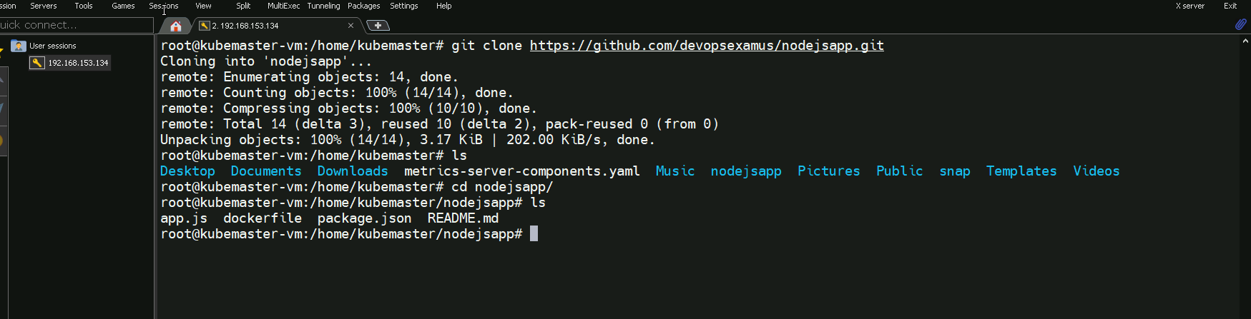

**Pipeline configuration:**

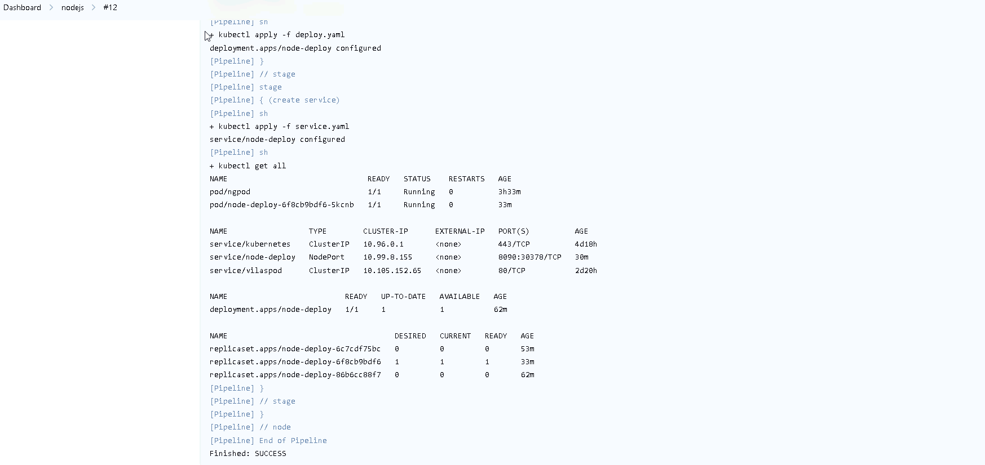

**Pipeline script:** we don’t have access to paste a pipeline script..attaching snapshot

**Deployment:**

**

**Nodejs app deployed:** 10.99.8.155:30378

