**yaml configuration for nginx pod**

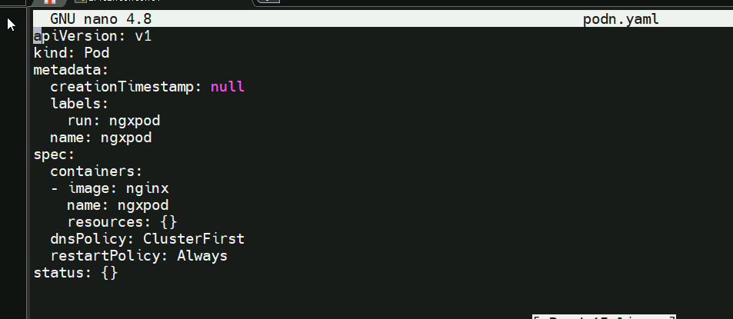

Pod created:

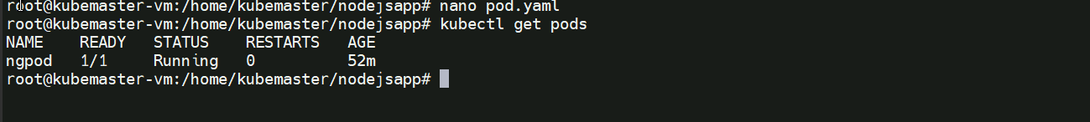

**volume configuration**

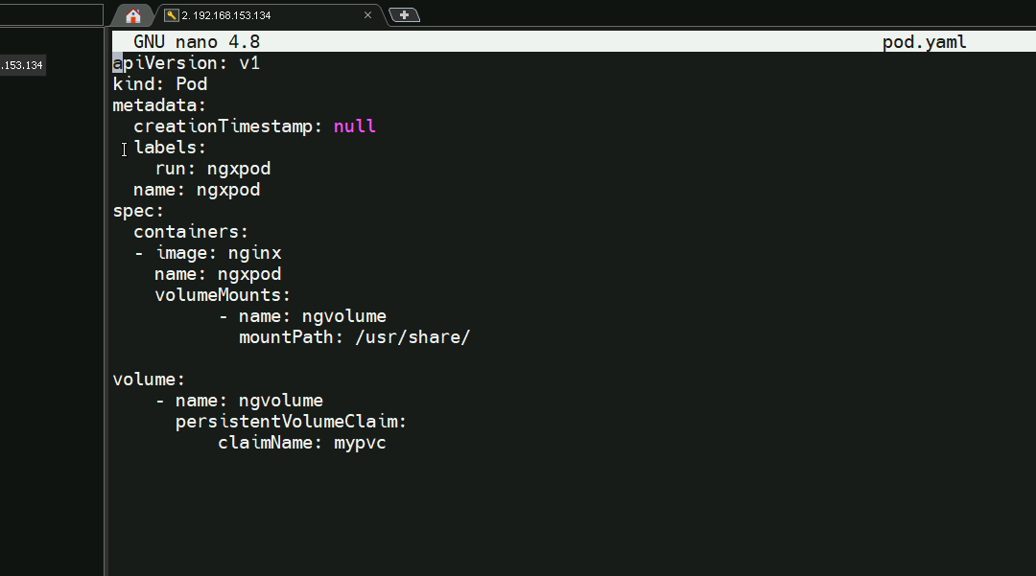

**File is created inside the container**

Iam creating a file inside

**Validation :** file is there

