LINUX BACKUP SYSTEM
PROJECT DOCUMENTATION
KLH University, Bachupally
Submitted by
Mahitha | 2520030469
Vineetha | 2520030149
Nityay | 2520030618
Under the Guidance of
S. Bheekya
Department of Computer Science and Engineering

CERTIFICATE
This is to certify that the project titled “Linux Backup System” has been carried out by Mahitha (2520030469), Vineetha (2520030149), and Nityay (2520030618) under the guidance of S. Bheekya at KLH University, Bachupally.
The project demonstrates the implementation of a file backup and synchronization system using the C programming language in the Linux environment.
Guide: S. Bheekya
Department: Computer Science and Engineering
Institution: KLH University, Bachupally

ACKNOWLEDGEMENT
We would like to express our sincere gratitude to our project guide, S. Bheekya, for providing guidance and support throughout the development of this project. We also thank KLH University, Bachupally, for providing the facilities and resources required to complete this project. Finally, we thank all team members for their cooperation and contributions.

ABSTRACT
The Linux Backup System is a file management and backup application developed using the C programming language in a Linux environment. Its main objective is to provide a simple method of protecting important files from accidental loss. The system maintains a source directory containing original files and a backup directory containing their copies. The application provides menu options for manual synchronization, automatic backup, viewing source and backup files, displaying file information, maintaining activity logs, and generating backup statistics. The project demonstrates Linux concepts such as file handling, directory management, process control, and system-level programming.

1. INTRODUCTION
Data is an important resource in any computer system. Accidental deletion, modification, or system failures can result in the loss of important information. A backup system helps prevent such data loss by maintaining additional copies of files. The Linux Backup System is designed to simplify file backup operations in Linux. Users can perform backups manually or use the automatic backup functionality provided by the application.

2. PROBLEM STATEMENT
Managing important files manually can be difficult and time-consuming. Users may forget to create backups, resulting in data loss when files are accidentally deleted or modified. A simple system is needed to create backups, synchronize original files with backup copies, perform automatic backups, monitor backup activities, and verify backed-up files.

3. OBJECTIVES
- Develop a file backup system using C in Linux.
- Provide manual file synchronization.
- Implement automatic backup functionality.
- Maintain separate source and backup directories.
- Provide options to view original and backed-up files.
- Maintain an activity log of backup operations.
- Display backup-related statistics.
- Demonstrate Linux file and directory handling.

4. TECHNOLOGIES USED
Technology | Purpose
C Programming | Application development
Ubuntu Linux | Operating environment
GCC Compiler | Compilation of C programs
Linux Terminal | Executing commands
Linux File System | Managing files and directories

5. SYSTEM REQUIREMENTS

5.1 Hardware Requirements
- Computer or laptop
- Minimum 4 GB RAM
- Sufficient storage space
- Keyboard and display

5.2 Software Requirements
- Ubuntu Linux
- GCC compiler
- C programming environment
- Linux terminal

6. SYSTEM ARCHITECTURE
The system follows a source-to-backup architecture:
SOURCE DIRECTORY → FILE SCANNING → BACKUP / SYNCHRONIZATION → BACKUP DIRECTORY → VERIFICATION

6.1 Main Components
Source Directory: Stores the original files that need to be backed up.
Backup Directory: Stores copies of the original files.
Backup Engine: Handles file copying and synchronization operations.
Automatic Backup Module: Provides automatic backup functionality.
Activity Logger: Maintains records of backup-related operations.
Menu Interface: Allows users to access the application features.

7. MENU OPTIONS AND FUNCTIONALITY

7.1 Manual Synchronization
Allows users to manually synchronize files between the source and backup directories. It copies or updates files when the user selects this option.

7.2 Start Automatic Backup
Starts the automatic backup process. The system performs backup operations without requiring the user to initiate every individual copy.

7.3 Stop Automatic Backup
Stops the automatic backup process when it is no longer required.

7.4 View Source Files
Displays the files available in the source directory so users can identify original files.

7.5 View Backup Files
Displays files stored in the backup directory to help verify the existence of backup copies.

7.6 View File Information
Displays available information about files, such as names, sizes, and modification details.

7.7 View Activity Log
Displays recorded backup activities and helps users track operations.

7.8 Backup Statistics
Displays backup-related information, such as the number of files backed up, depending on the implementation.

7.9 Exit
Terminates the application.

8. IMPLEMENTATION
The project is implemented using C programming in Ubuntu Linux. GCC is used to compile the source code into an executable program. The implementation involves accessing the source directory, scanning available files, identifying files that require backup, copying files into the backup directory, displaying backup information, recording activities, and accepting user choices through a menu-driven interface.

8.1 Important Linux Functions
Function | Description
opendir() | Opens a directory
readdir() | Reads directory entries
closedir() | Closes a directory
open() | Opens a file
read() | Reads file contents
write() | Writes file contents
close() | Closes a file
stat() | Retrieves file information
fork() | Creates a child process
These functions are relevant Linux/POSIX functions; include only those actually used in the submitted source code when describing the implementation.

9. ALGORITHM
- Start the application.
- Display the main menu.
- Accept the user’s choice.
- Perform the selected operation: synchronization, automatic backup control, file viewing, file information, activity log, or statistics.
- Display the operation result.
- Return to the main menu.
- If the user selects Exit, terminate the program.

10. EXECUTION PROCEDURE
The following commands are used to compile and execute the project in Ubuntu:
cd ~/LinuxBackup/LinuxBackup
gcc main.c -o main
./main

11. TESTING AND VALIDATION
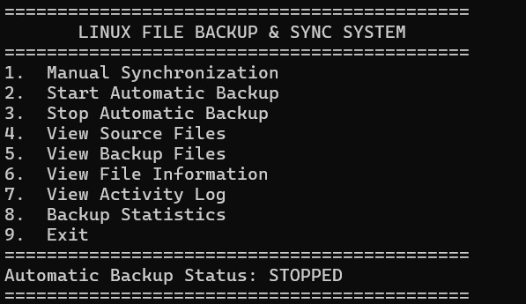
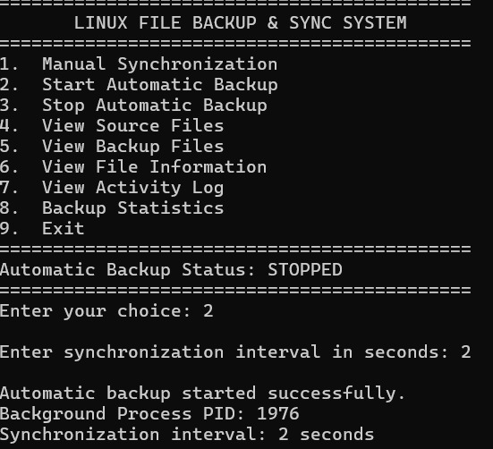
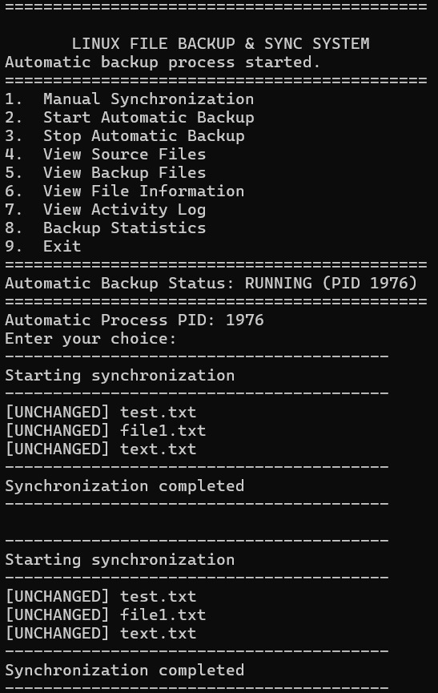
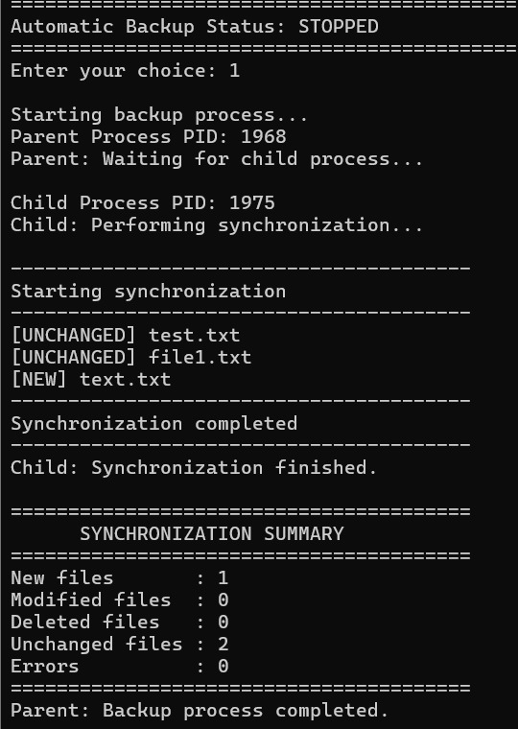

Test Case | Expected Result
Create a new source file | File appears in source directory
Perform manual synchronization | File is copied to backup
Start automatic backup | Automatic backup process starts
Stop automatic backup | Automatic process stops
View source files | Original files are displayed
View backup files | Backup copies are displayed
View activity log | Recorded operations are displayed
Compare original and backup | Matching files produce no differences

11.1 Backup Verification
The diff command checks whether the original and backup files have identical contents. No output indicates that no differences were found.
diff source/test.txt backup/test.txt
md5sum source/test.txt backup/test.txt
Matching MD5 checksums indicate matching file contents for this demonstration, but MD5 is not recommended for security-sensitive integrity verification.

12. ADVANTAGES
- Simple menu-driven interface.
- Reduces repeated manual backup effort.
- Helps prevent accidental data loss.
- Maintains separate original and backup directories.
- Supports backup verification.
- Demonstrates practical Linux system programming concepts.

13. LIMITATIONS
- Backup storage is limited by available disk space.
- The application depends on the Linux file system.
- Large files may require additional handling.
- A backup stored on the same physical device may not protect against hardware failure.
- The actual functionality depends on the implemented program logic.

14. FUTURE ENHANCEMENTS
- Cloud-based backup support.
- Incremental backups to reduce storage usage.
- File restoration functionality.
- Notifications for backup completion or errors.
- Encryption of backup files.
- Scheduled backups at specific intervals.
- Improved graphical user interface.
- Support for multiple directories.

15. CONCLUSION
The Linux Backup System demonstrates how file management and backup operations can be implemented using C programming in a Linux environment. The application provides a menu-driven interface for managing backup operations, viewing files, monitoring backup activities, and checking backup information. Through this project, the team gained practical knowledge of Linux file handling, directory operations, system programming, compilation, and execution. The project provides a foundation for developing more advanced backup and data protection applications.

16. REFERENCES
- The Linux man-pages project: https://man7.org/linux/man-pages/
- GNU GCC Documentation: https://gcc.gnu.org/onlinedocs/
- Ubuntu Documentation: https://help.ubuntu.com/
- Kernighan, B. W. and Ritchie, D. M., The C Programming Language.

