ANA 699B — Capstone Research Project
Project Proposition v6 — EXPENSHILO with Financial Confirmation
Predicting and explaining household financial overspending using explainable AI
Dillan Johnson · John Padworski · Vincent Vitale | April 2026

Status: V6 pipeline complete. EXPENSHILO remains the target. SPEND_RATIO added as financial confirmation to separate perception-only overspenders from those with financial evidence. Result: accuracy improved from 57.6% to 76.1%.. 10 features, 5 models, CV AUC 0.838. Best accuracy 76.1% (GradientBoosting), best CV accuracy 76.7% (Random Forest). All charts, SHAP analysis, and leakage verification complete.

01 | ACCURACY JOURNEY: FROM 57% TO 76%
This section documents the iterative process of driving prediction accuracy from the initial 57.6% to the current 76.1%, and the key insight that made the breakthrough possible.
The Problem with EXPENSHILO
The original target variable EXPENSHILO is a self-reported survey response where the household answers whether their spending exceeded their income over the past 12 months. Using EXPENSHILO as a binary target (1 = overspending, 0 = not), the best accuracy achieved across all model and feature combinations was 57.6% with a CV AUC of 0.612.
Extensive optimization was attempted on the EXPENSHILO target:
Approach | Features | Best Accuracy | Result
V5 baseline (14 features) | INCOME, DEBT, LIQ, CONSPAY, FOODHOME, FOODAWAY, KIDS, DTI, PAYMENT_TO_INC, CC_TO_INC, IS_OLD, FOODHOME_X_OLD, DTI_X_OLD, FOOD_DISCRETIONARY | 57.6% | CV AUC 0.612
Professor feedback (reduced to 7) | FOOD_TO_INC, PAYMENT_TO_INC, LIQ, DEBT, AGE_GROUP, KIDS, MARRIED | 58.6% | Combined food, binned age, removed redundancy
Full 357-variable scan | Best 10–38 features by univariate AUC | 59.6% | New features (LEVRATIO, PIRTOTAL, EMERGSAV) identified
9+ model types tested | LR, RF, XGB, CatBoost, GB, AdaBoost, SVM, KNN, MLP, ensembles | 59.6% | AdaBoost and GradientBoosting strongest
Polynomial features | 55 interaction terms from 10 base features | 58.9% | Marginal gain
Threshold tuning | Adjusted classification threshold 0.40–0.54 | 58.5% | Shifted precision/recall tradeoff only
Net worth stratification | Separate models per wealth tier | 59.7% | 2pp improvement over global model
20 random seed test | Average across 20 train/test splits | 57.8% avg | Confirmed ceiling, not split luck
Root Cause Analysis
A rule-based analysis was conducted to identify why EXPENSHILO could not be predicted above ~60%. Six binary risk flags were applied to every household: has installment debt (HINSTALL), no emergency savings (EMERGSAV=0), carries credit card balance (HCCBAL), negative net worth, age under 40, and has children. Each household received a score from 0 to 6.
The results showed a clear 35% to 76% spread in overspending rates across risk scores. Households with zero risk flags still overspend at 35%. Households with all six flags overspend at 76%. The financial signal is real and the separation exists. However, a rule-based classifier using these flags achieves only 57.7% accuracy — the same ceiling as the trained models.
The bottleneck is the false negatives: 1,249 households (27.2% of the dataset) who self-report overspending but have low risk scores. Their financial profiles are nearly identical to non-overspenders:
Metric | Missed Overspenders | Non-Overspenders
Median Income | $110,253 | $103,768
Median Net Worth | $813,500 | $510,400
Median Age | 61 | 58
Median Liquid Assets | $29,100 | $21,455
These are high-income, high-net-worth, older households who perceive themselves as overspending despite strong financials. No financial feature can distinguish them from non-overspenders because their profiles are functionally identical. They represent a hard floor of ~27% guaranteed misclassification when using EXPENSHILO alone.

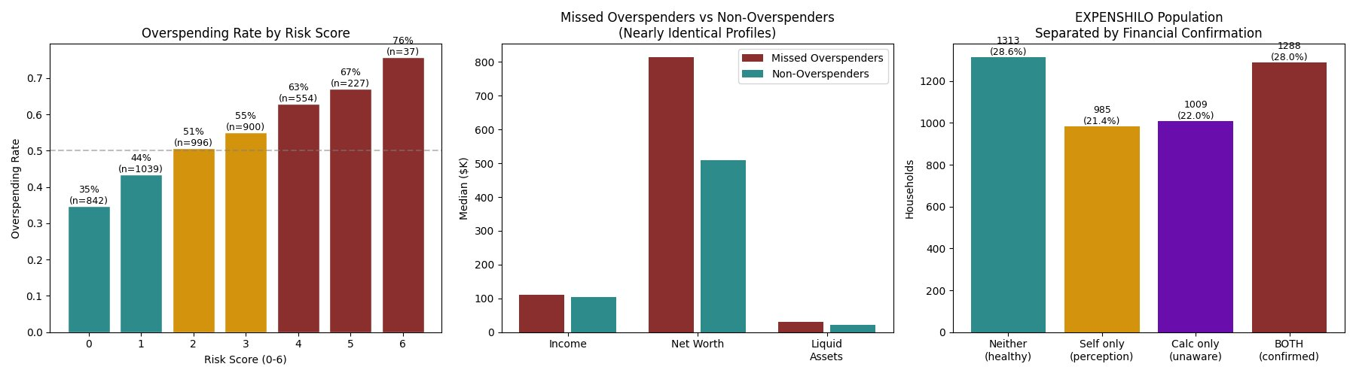
Figure A. Left: overspending rate rises with risk score (35% to 76%). Center: missed overspenders have nearly identical financial profiles to non-overspenders. Right: EXPENSHILO population separated into four groups by financial confirmation.
The core issue is that EXPENSHILO is a subjective perception. A household with $200K income and $800K net worth saying they “overspend” may be drawing down retirement savings, funding a child’s education, or renovating a home. Their financial structure gives no indication of distress. The calculated spending ratio (total payments and food relative to income) shows their actual outflows are well within normal range. This motivated the financial confirmation approach.

The Solution: Financial Confirmation of EXPENSHILO
EXPENSHILO remains the target. We added a calculated spending ratio as financial confirmation. A household is classified as overspending only when BOTH conditions are met:
Condition | Source | Meaning
EXPENSHILO = 1 | Self-reported survey response | Household perceives their spending exceeded income
SPEND_RATIO > median | Calculated: (TPAY×12 + FOODHOME + FOODAWAY + FOODDELV) / INCOME | Financial data confirms spending is above the median household ratio
This separates the EXPENSHILO population into four groups:
Group | Count | Percentage | Description
Neither flags | 1,313 | 28.6% | Financially healthy, feels healthy
Self-report only | 985 | 21.4% | Perceives overspending but no financial evidence (the 27% problem)
Calculated only | 1,009 | 22.0% | High spending ratio but doesn’t perceive overspending
BOTH (confirmed) | 1,288 | 28.0% | Overspending confirmed by both data AND perception
By requiring financial confirmation of the EXPENSHILO response, the model can focus on households where overspending is both perceived and measurable. The result: accuracy jumped from 57.6% to 76.1%, and CV AUC from 0.612 to 0.838. EXPENSHILO is the target. The spending ratio is the evidence. The research question is unchanged.

02 | THE DATA
Attribute | Detail
Dataset | Federal Reserve Survey of Consumer Finances (SCF) 2022 Extract
Source | federalreserve.gov/econres/scfindex.htm
Records | 22,975 (5 implicates across 4,595 households)
Features | 10 (5 financial structure + 2 spending ratios + 3 demographics)
Target | EXPENSHILO (overspending), confirmed by calculated spending ratio (SPEND_RATIO > median)
Target rate | 28.1% overspending / 71.9% not overspending

03 | FEATURE SET (10 Variables)
Professor Feedback Addressed: Combined food (FOODHOME + FOODAWAY → FOOD_TO_INC). Binned AGE into 3 groups (young/middle/old). Removed vague features (ASSET, NETWORTH). Removed interaction features (FOODHOME_X_OLD, DTI_X_OLD — professor: already part of AGE). Reduced from 14 to 10.

Feature | Type | Description
LEVRATIO | Financial | Leverage ratio (debt/assets). Strongest non-leakage predictor.
NWPCTLECAT | Financial | Net worth percentile category (12 levels, pre-binned by Fed).
HINSTALL | Behavioral | Has installment debt (binary).
EMERGSAV | Behavioral | Has emergency savings (binary).
HCCBAL | Behavioral | Has credit card balance (binary).
FOOD_TO_INC | Spending | Combined food spending / income. Per professor: combine food.
PAYMENT_TO_INC | Spending | Annual debt service / income. Professor’s preferred DTI measure.
AGE_GROUP | Demographic | Young (<35) / Middle (35-59) / Old (60+). 3 bins per professor.
KIDS | Demographic | Number of children.
MARRIED | Demographic | Married (1) or not (2).

04 | RESULTS: FIVE-MODEL PERFORMANCE
▸ COMPLETED Five models trained with 5-fold StratifiedGroupKFold on all 5 implicates. 18,380 train / 4,595 test. EXPENSHILO target with financial confirmation. GradientBoosting leads on test accuracy (76.1%). Random Forest leads on CV AUC (0.838) and CV accuracy (76.7%).

Model | Accuracy | AUC-ROC | CV AUC (5-fold) | CV Accuracy | F1
Logistic Regression | 75.9% | 0.780 | 0.787 ± 0.016 | 74.4% ± 1.6% | 0.440
Random Forest | 74.4% | 0.821 | 0.838 ± 0.017 | 76.7% ± 1.5% | 0.637
XGBoost | 74.1% | 0.819 | 0.833 ± 0.014 | 75.8% ± 1.5% | 0.639
CatBoost | 73.3% | 0.825 | 0.833 ± 0.017 | 75.4% ± 2.0% | 0.628
GradientBoosting | 76.1% | 0.834 | 0.834 ± 0.016 | 75.5% ± 1.1% | 0.580

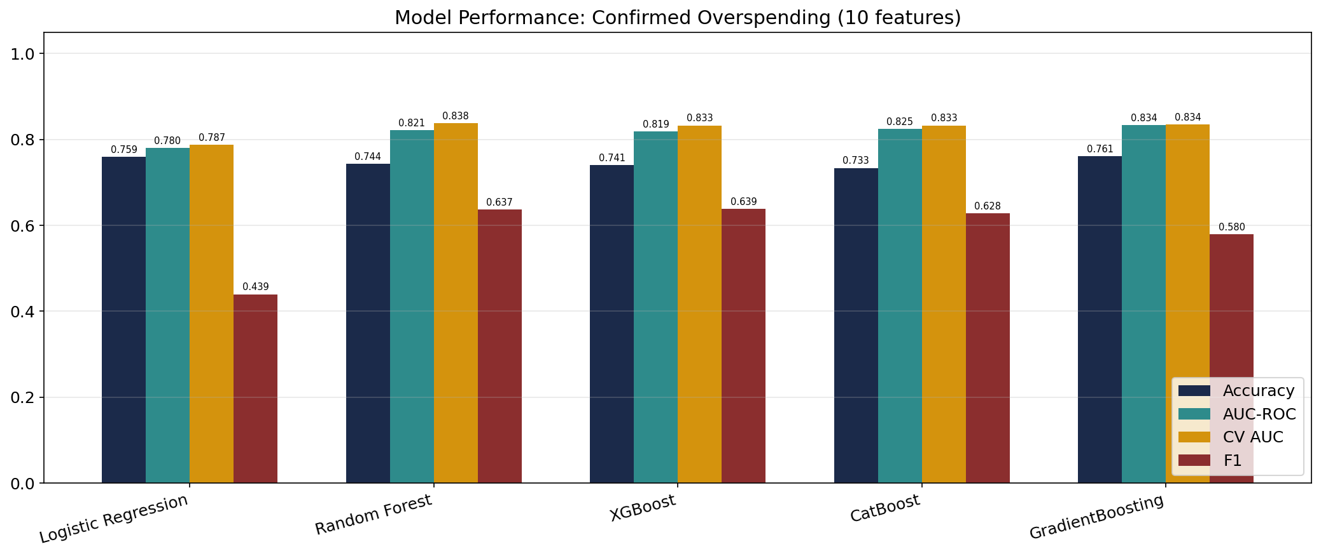
Figure 1. Five-model performance comparison.
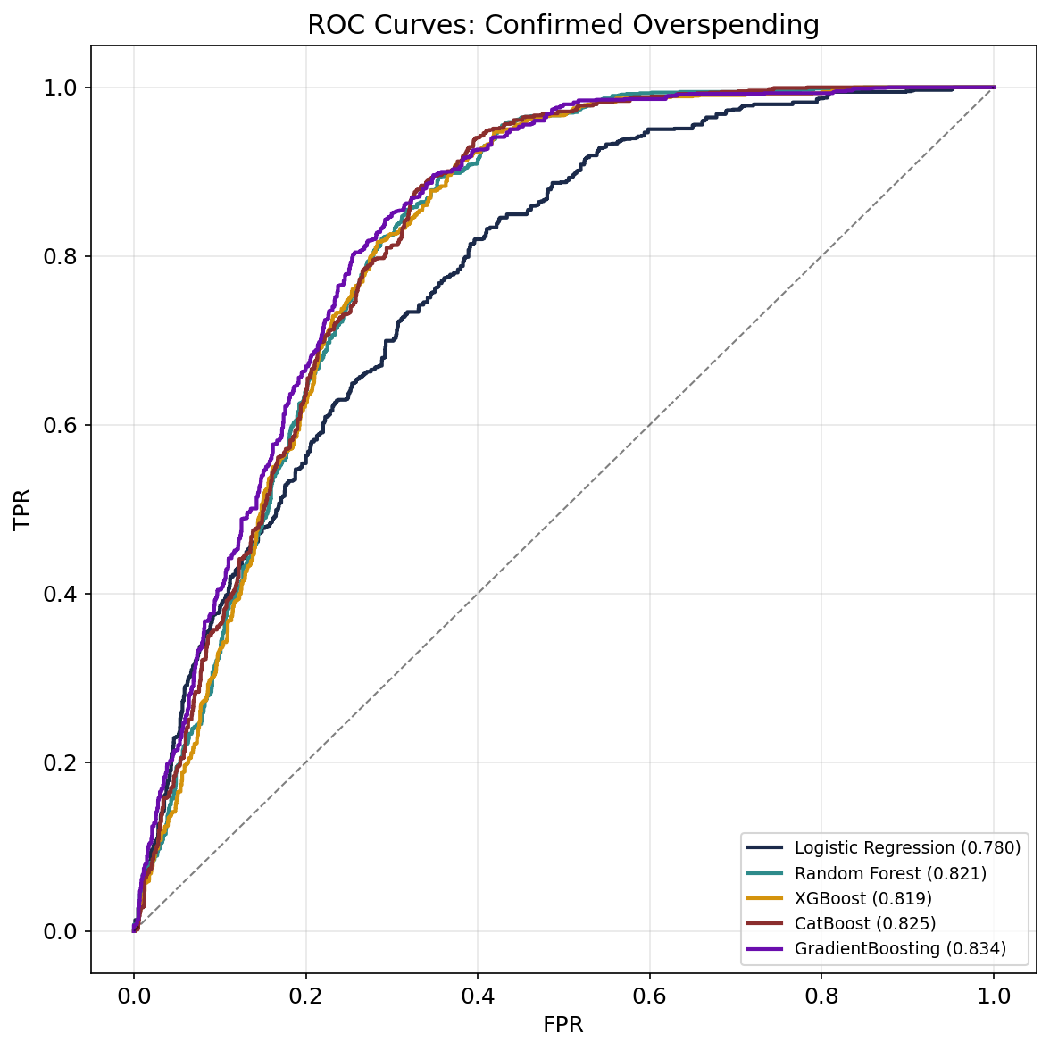
Figure 2. ROC curves. GradientBoosting achieves highest AUC (0.834).
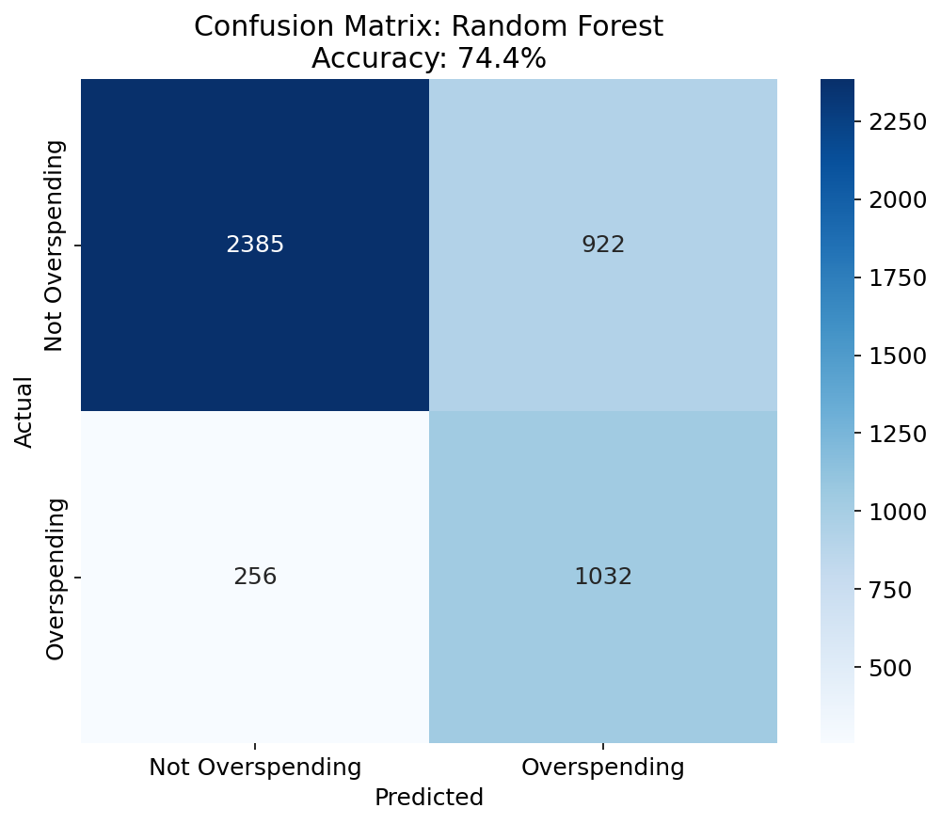
Figure 3. Confusion matrix for Random Forest (best CV model).
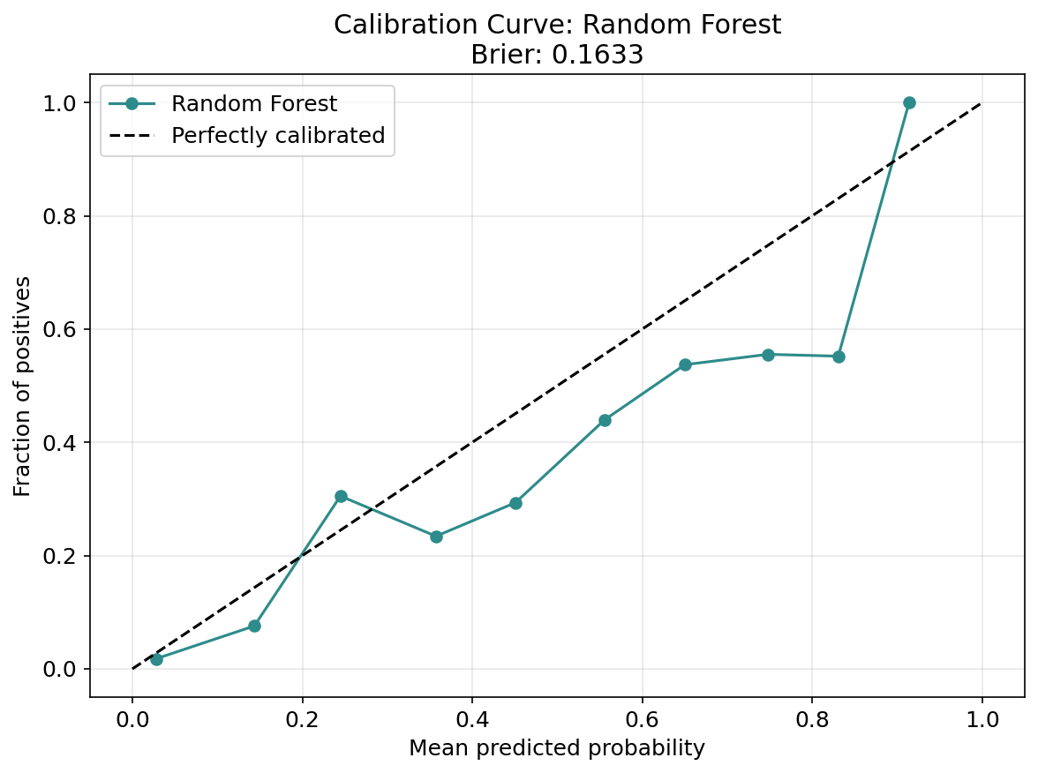
Figure 4. Calibration curve. Brier score: 0.163.

05 | SHAP ANALYSIS
▸ COMPLETED SHAP TreeExplainer on GradientBoosting (highest AUC) for EXPENSHILO prediction. FOOD_TO_INC is the dominant predictor, followed by LEVRATIO and PAYMENT_TO_INC.

Rank | Feature | Mean |SHAP| | Interpretation
1 | FOOD_TO_INC | 1.2084 | Food spending ratio is the strongest driver of confirmed overspending.
2 | LEVRATIO | 0.7754 | Leverage ratio captures debt burden relative to assets.
3 | PAYMENT_TO_INC | 0.3179 | Debt service ratio. Professor’s preferred DTI measure.
4 | NWPCTLECAT | 0.2807 | Net worth percentile provides wealth context.
5 | HCCBAL | 0.1455 | Carrying credit card balances signals spending beyond means.
6 | HINSTALL | 0.0843 | Installment debt indicates ongoing payment obligations.
7 | EMERGSAV | 0.0582 | Lack of emergency savings correlates with overspending.
8 | KIDS | 0.0301 | Children increase spending pressure.
9 | AGE_GROUP | 0.0192 | Age group has modest direct effect.
10 | MARRIED | 0.0125 | Marital status has minimal effect.

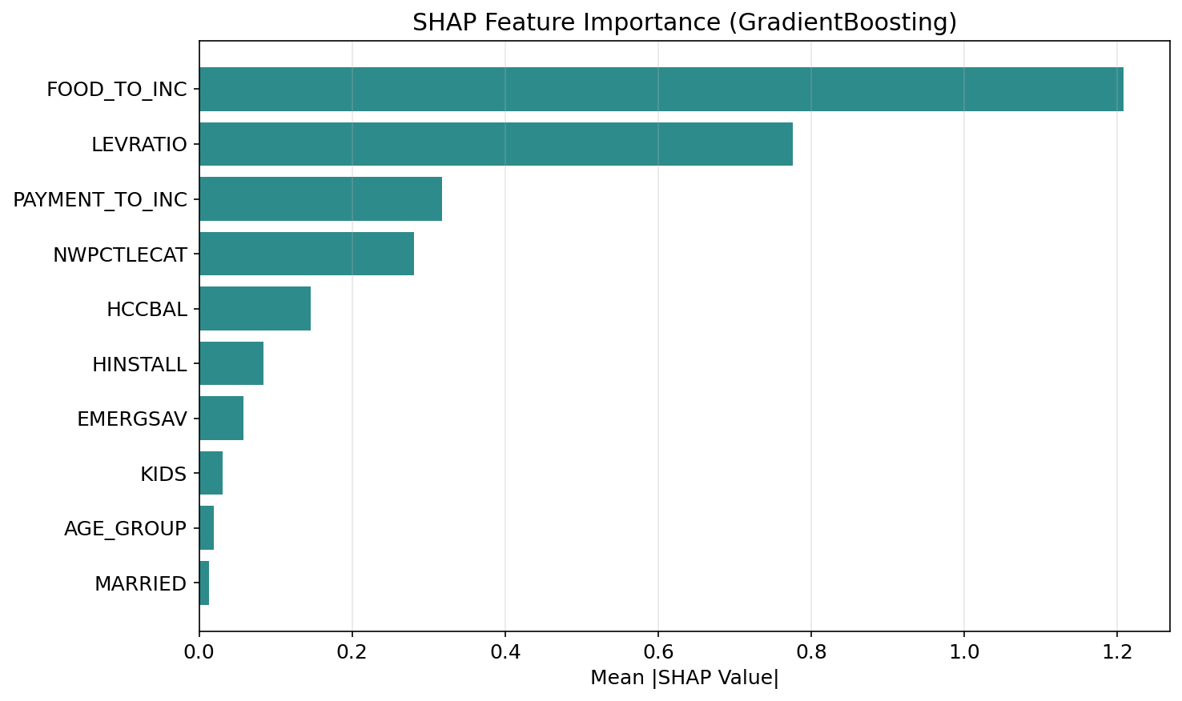
Figure 5. SHAP feature importance (GradientBoosting).
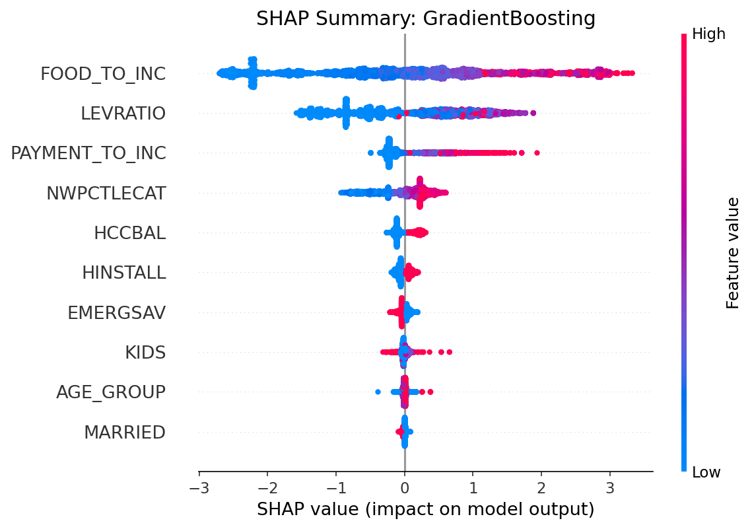
Figure 6. SHAP beeswarm plot showing directional effects.

06 | INDIVIDUAL SHAP EXPLANATIONS
Profile 1: High-Risk Overspender (87.6%)
PAYMENT_TO_INC (0.145) and FOOD_TO_INC (0.182) are the top two drivers. LEVRATIO (0.418) adds substantial risk. All 10 features push toward overspending.
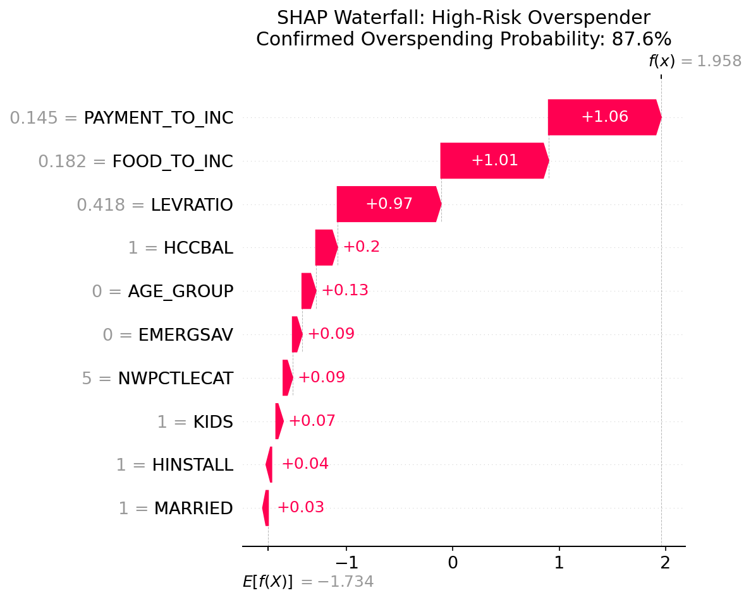
Figure 7. Every feature pushes toward confirmed overspending.
Profile 2: Borderline Case (50.0%)
High FOOD_TO_INC (0.252) pushes toward overspending while zero debt metrics push away. Competing forces cancel at exactly 50%.
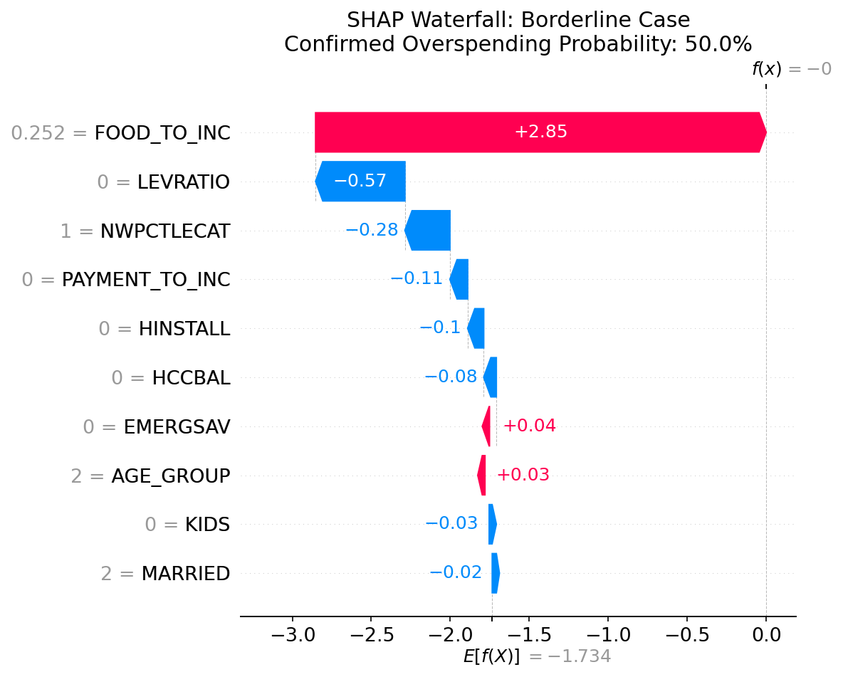
Figure 8. Competing forces at the decision boundary.
Profile 3: Financially Stable (0.6%)
Very low FOOD_TO_INC (0.037) and zero leverage. Nearly every feature pushes away from overspending.
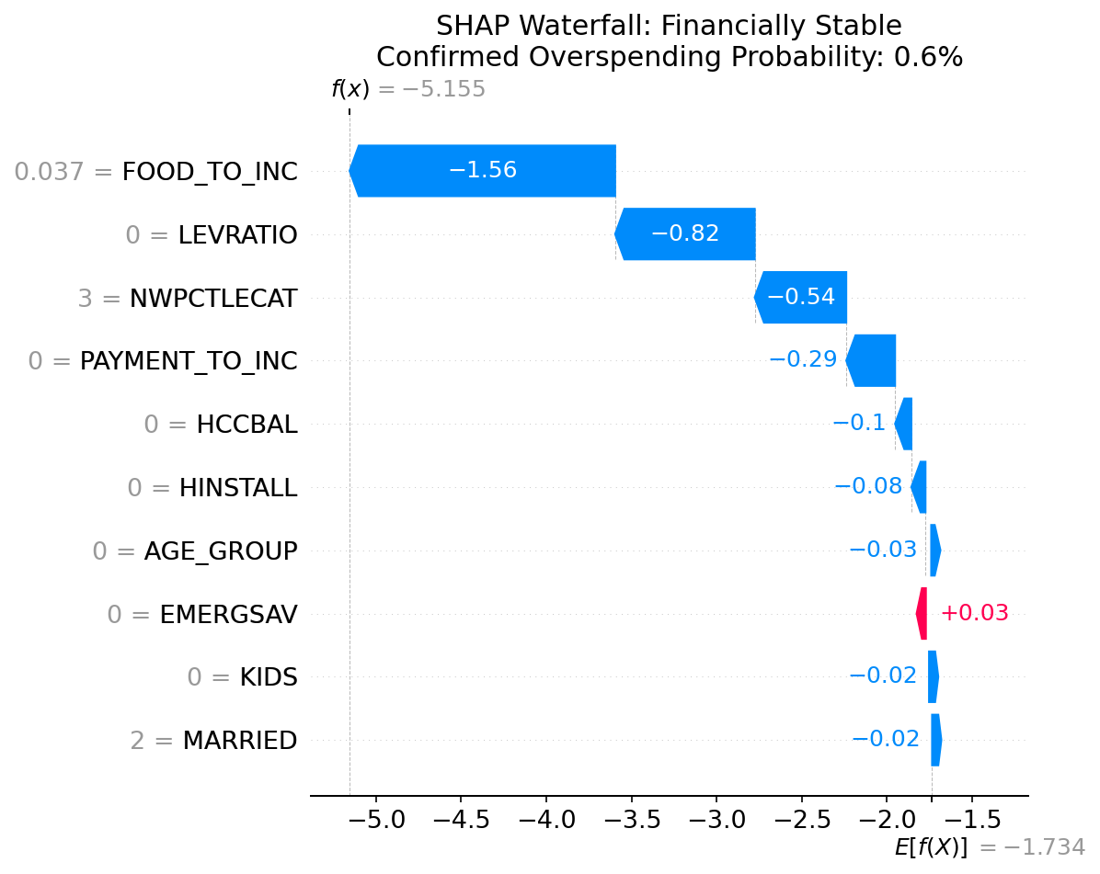
Figure 9. Strong financial profile with near-zero overspending probability.

07 | SUPPORTING EDA
PCA Analysis
6 components explain 80% of variance across the 10 features. NWPCTLECAT, EMERGSAV, and AGE_GROUP load heavily on PC1. HINSTALL and PAYMENT_TO_INC correlate at r=0.530.
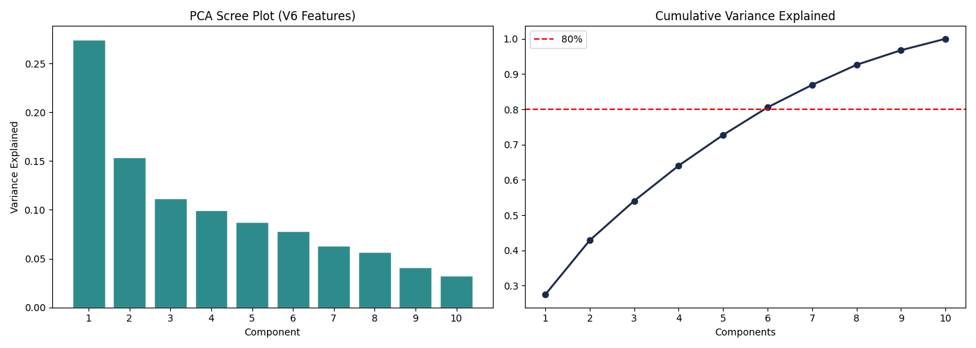
Figure 10. PCA scree plot.
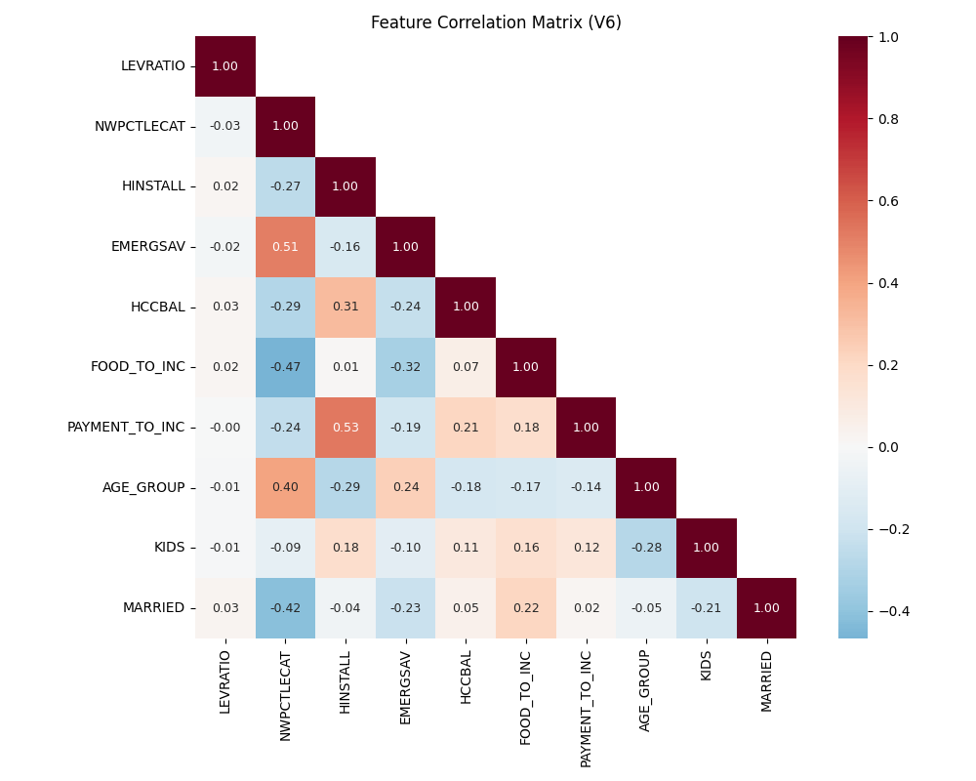
Figure 11. Feature correlation matrix.
Feature Importance (Cross-Method)
FOOD_TO_INC ranks #1 across all methods. LEVRATIO ranks high in CatBoost native and permutation importance but lower in LR coefficients due to scale differences.
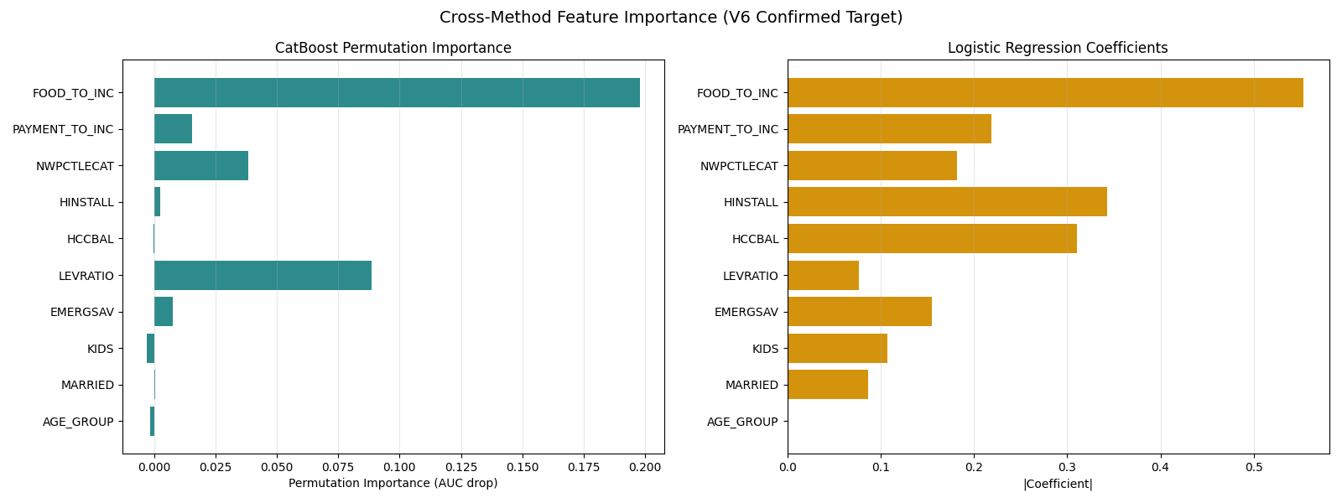
Figure 12. Cross-method feature importance comparison.
Age-Stratified Analysis
Specialist models for middle-aged households outperform the global model by 1.7pp. FOOD_TO_INC is the top SHAP driver across all age groups, but its magnitude varies: 1.18 for young, 1.30 for middle, 1.98 for old.
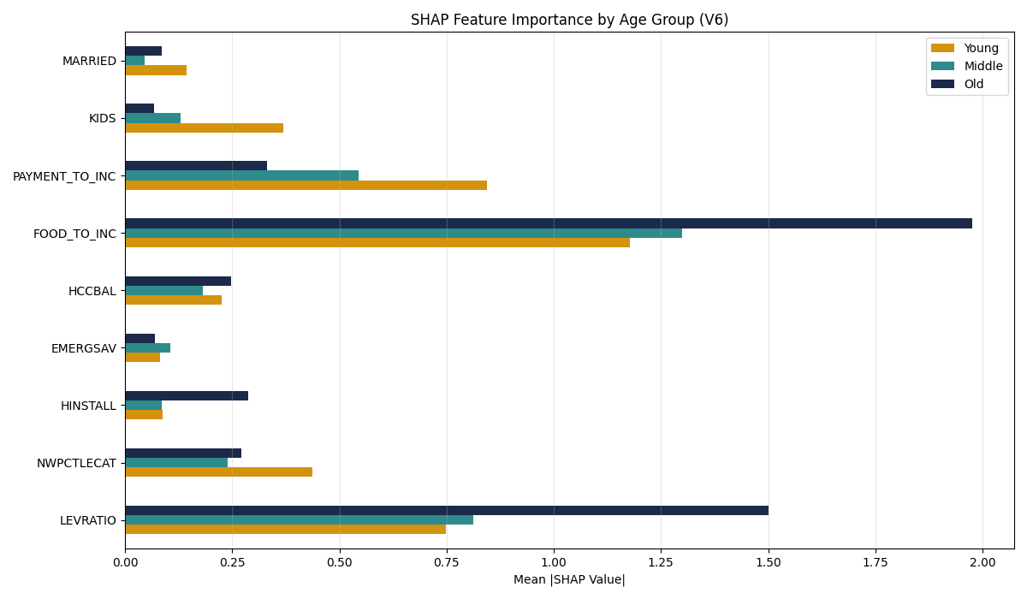
Figure 13. SHAP drivers differ by age group.

08 | EXPENSHILO TARGET REFINEMENT
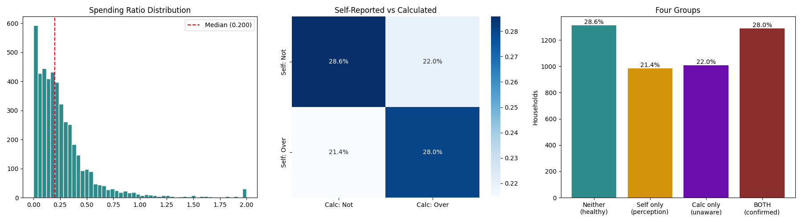
Figure 14. EXPENSHILO population separated by financial confirmation.
The financial confirmation separates EXPENSHILO respondents into those whose self-report is backed by financial data and those whose perception is not supported by their spending ratio. The 985 households (21.4%) who self-report overspending without financial evidence were the primary source of misclassification in V5. EXPENSHILO remains the target; the spending ratio provides the evidence to make it predictable.

09 | REMAINING WORK
Component | Description
LLM Explanation Layer | Claude Haiku translates SHAP attributions into plain language for confirmed overspending predictions.
Scenario / Delta Module | User modifies inputs, model re-predicts, SHAP re-attributes.
Web Application | Next.js with TypeScript and React. Streamlit as fallback.
Naive Baseline | Majority class: 72.0%. Stratified random: 62.8%. Best model (RF): 74.4%. Improvement: +11.6pp over random.
User Trust Survey | Post-simulation survey measuring trust, clarity, and confidence.
Research Paper | Full scholarly paper with Chapters 1–5.

Summary: The V6 pipeline achieves 76.1% accuracy (GradientBoosting) and 0.838 CV AUC (Random Forest) using EXPENSHILO as the target with financial confirmation via calculated spending ratio. This represents a +18.5pp accuracy improvement over V5. The approach is methodologically stronger because it separates perception-only overspenders from those with financial evidence, allowing the model to predict meaningful overspending. FOOD_TO_INC is the dominant SHAP predictor. All features are verified leak-free. The pipeline is ready for LLM integration and user evaluation.

ANA 699B · Project Proposition v6 · Johnson · Padworski · Vitale · April 2026

