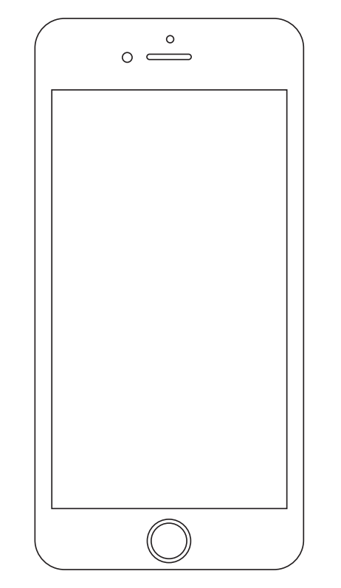

**FIND US**

**PARTNER WITH US**

PARTNER LOGIN

 REGISTRATION

**Our Mission**

***Mission Statement (who we are and what we are doing this for)***

**Our Goals**

***(Goals Statement)***

• • • •

•



***Powered by***

Font: Arial Narrow; 12; Bold; #ffffff

Font: Arial Narrow; 10; Italic; #ffffff

BG colour: #92D050



**FIND US**

**PARTNER WITH US**

MERCHANT LOCATOR

**Our Mission**

***Mission Statement (who we are and what we are doing this for)***

**Our Goals**

***(Goals Statement)***

• • • •

•

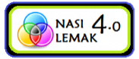

***Powered by***



***Powered by***

Find Your Nearest Collection Point

**Pick a City**

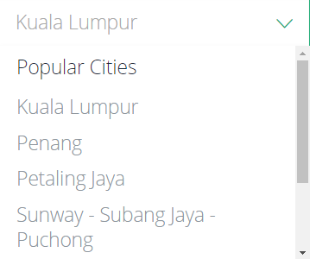

***Powered by***

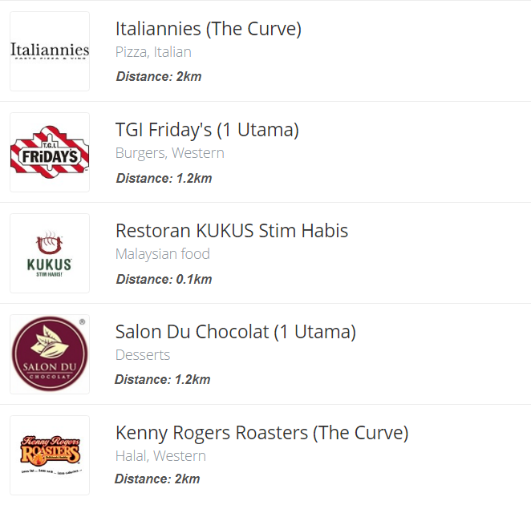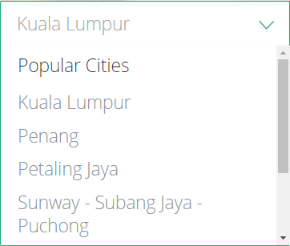

**Modify Location:**

6 Collection Points in this city

**Sort by:**

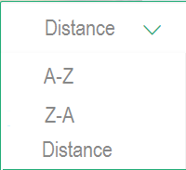

***Powered by***

Registration Form

**General**

**Role of Interest**

**Title**

**First Name**

**Last Name**

**Age**

**Contact Details**

**Company Name**

**Phone**

**Email**

**Street Name**

**City**

**Postcode**

**State**

SUBMIT

*Please select one*  **v**



***Powered by***

Sign-In Page

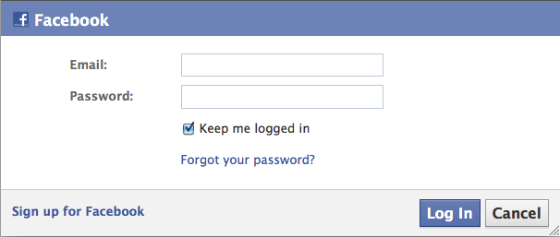

***Powered by***

Welcome  
Kenny Rogers Sdn. Bhd.

**TRANSACTION**

**MODIFY PROMO**

**STATISTICS**

**COLLECTION**



***Powered by***

Transaction

**Add New Records**

**Enter weight of items (in kg)**

**Add to Current List**

**Current List**

**Status:** In-Progress

**Action Record Number Weight (kg) Date of Transaction**  
| KR-1 0.58 2/24/2017 12:00PM

| KR-2 0.25 2/24/2017 03:00PM

| KR-3 0.85 2/25/2017 11:00AM

**Total Current Weight 1.68 kg**

**View History**