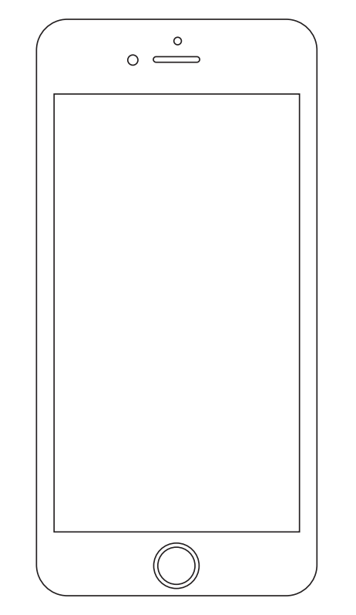

**FIND US**

**PARTNER WITH US**

PARTNER LOGIN

 REGISTRATION

**Our Mission**

***Mission Statement (who we are and what we are doing this for)***

**Our Goals**

***(Goals Statement)***

• • • •

•

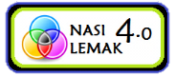

***Powered by***



**FIND US**

**PARTNER WITH US**

MERCHANT LOCATOR

**Our Mission**

***Mission Statement (who we are and what we are doing this for)***

**Our Goals**

***(Goals Statement)***

• • • •

•

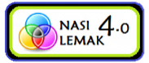

***Powered by***



***Powered by***

Find Your Nearest Collection Point

**Pick a City**

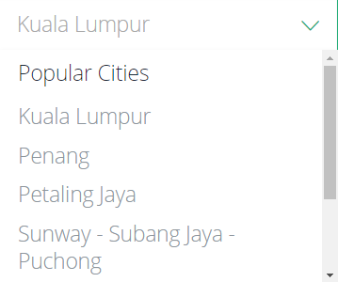

***Powered by***

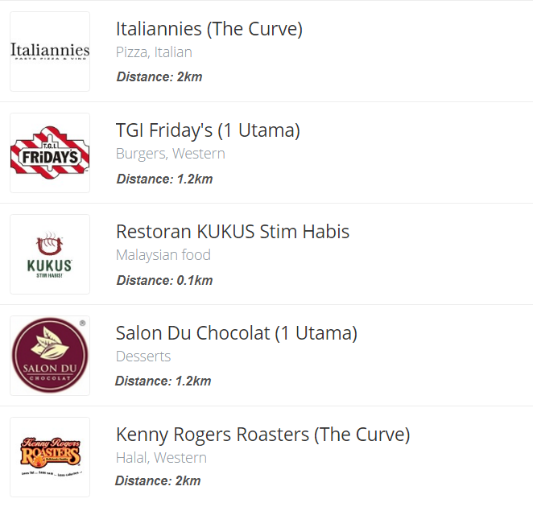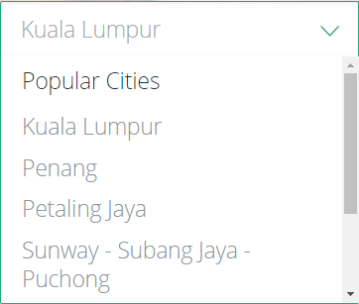

**Modify Location:**

6 Collection Points in this city

**Sort by:**

