**A Right not Granted[1]. A Wrong not Righted.**

*Spending and performance in Texan Public Schools*

By Vincent Carse

Abstract

I find a significant effect of spending, class size and teacher salary on 5th-grade standardised performance in Texan schools. I also find limited evidence to suggest competition-effects between neighbouring districts, but find insufficient evidence to suggest district-level resource-shocks impact student performance. I find evidence that districts ‘game’ school finance laws in order to increase their district revenues when faced with tax-ceilings.

Intro

The economics of public education remains a deeply contested field. Essential questions like the impact of class sizes on student performance, the importance of teacher quality and the fairness of local taxation continue to draw dispute between leading economists in the field [hedges vs hanushek]. Few can doubt the importance of these questions in designing policy.

I use two methods to estimate the educational return to spending in Texan public schools, which to my knowledge are previously unexplored. Arbitrary restrictions on tax rates due to the unconstitutionality of state-wide taxes induced some cash-starved districts to max out their tax rates, presenting windows in which their revenue was completely dependent on property values and state aid. Thus changes in revenue may have been exogenous to changes in school performance. Further to this, random fluctuations in the oil price provided positive and negative revenue shocks which may constitute a viable instrument for district revenue, allowing for a more plausible estimate of the causal impact of spending on school performance. Further to this I exploit the arbitrary nature of district borders to estimate the impact the prevalence of student and teacher sorting between districts in response to district changes.

[actual estimation details]

Texas is a strong subject for this study for several reasons. It sets a state-wide curriculum and requires common standardised testing by its primary and secondary students, removing the possibility of test or curriculum variation from biasing estimates of resource effects. It has a school finance system with several quirks which provide the possibility of exogenous variation in spending and other independent variables. Size ___ ? Moreover its public education system has been the subject of several previous detailed studies which can be built upon.

[results]

These results may be externally valid within American states which operate a hybrid local/state-funded education system.

The Educational Landscape

Texas is partitioned into 1026* independent school districts (ISDs), each a kind of local government with the power to tax property and allocate funds between the schools within it. This offers substantial across-district variation in tax rates, tax bases, funding decisions and revenue compositions to utilise. Districts are run by school boards; panels of trustees who are elected by the citizens of each community. [TEA school boards]. Some districts are vast, sprawling entities. Dallas ISD for instance educated over 150,000 students in 2018/19 with an operating budget of over $1.8b [TEA Dallas], while Cayuga ISD is home to just three schools: an elementary, middle and high school, and under 600 students [TEA Cayuga]. Thus while some districts also exhibit within-district variation, others do not.

Though some districts cater to non-public schools like charter, private, home or prison schools, these are not the subject of this paper. The system as a whole is coordinated by the Texas Educational Agency (TEA), which sets the curriculum and funding formulas by which all districts are governed.

Texas’ curriculum is standardised across all public schools and known as the Texas Essential Knowledge and Skills (TEKS), which was established in 1998. Between grades 3-11 students are required to complete a common standardised test based on the TEKS to pass to the next grade. This testing existed as the Texas Assessment of Academic Skills (TAAS) from ‘91/’92-‘01/’02, Texas Assessment of Knowledge and Skills (TAKS) from ‘02/’03-‘11/’12 and as the State of Texas Assessments of Academic Readiness (STAAR) since ‘12/’13. Testing is compulsory for students in public schools. These grades are reported as a ‘percentage passed’ figure for each grade within each campus, alongside a participation rate for the campus as a whole. As these tests must be passed for students to reach the next grade their distributions are extremely positively skewed. To deal with this ___. I also account for participation rates by…

[positively skewed performance]

School funding originates from a combination of local, state and federal revenue, but is ultimately allocated by political decisions made by the TEA, the State and Federal governments, and local districts themselves. This system has been described as ‘byzantine’ [court comment] but is particularly important to understand, as these decisions inform the interpretation of resource parameters. For instance a simple regression of reading and math performance on total district revenue both yield negative parameter estimates and explain a miniscule proportion of total variation in test scores. This may be surprising if we didn’t know that the TEA redistributes funding across districts in order to make the system fairer.

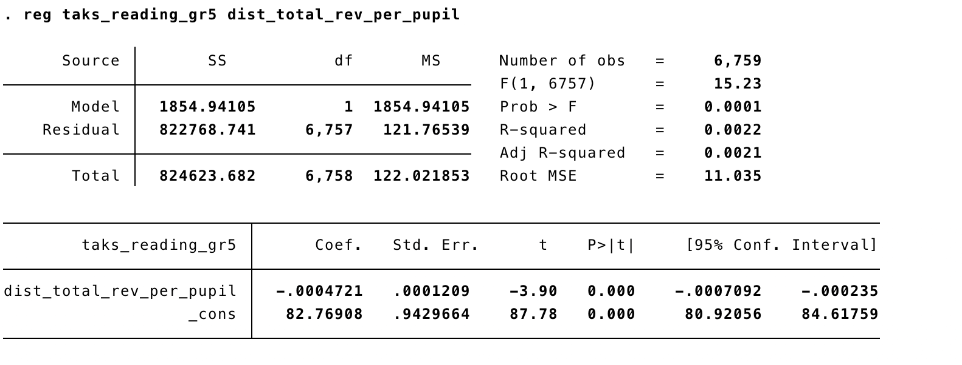

There is enormous variation in the per-pupil tax bases of each district[2], leading to vastly different local revenue collection. Not only does Texas have cities with wealthy residential suburbs and poor inner cities but it also boasts oil refineries, heavy manufacturing alongside vast rural areas. All of these are contained within school districts, and all are viable sources of taxation. To correct this inequality the TEA allocates funding across districts via the Foundation School Program (FSP), a series of formulas which calculate the contributions a district must make to the state and the state-aid a district receives.

The FSP operates under three ‘tiers’ of funding, a ‘guaranteed’ tier (Tier I) for all students, an ‘incentive’ tier (Tier II) and a separate tier for capital expenditures (Tier III). These tiers each have a system of contributions and receipts. Tier 3 does not concern the results in this paper. Funding levels are decided at the per pupil level, which is either measured using Average Daily Attendance (ADA) or Weighted Average Daily Attendance (WADA). WADA is decided by a range of weights…

Tier I funding centres on a ‘basic allotment’ of funding per pupil to be allocated to each district. This amount is set by the State legislature and was $5190/ADA in ‘19/’20. The basic allotment is then adjusted to account for differences in size, cost and programs offered between the districts. Districts must fund their Tier I entitlement from local revenue in proportion to their tax wealth and tax rate. CTR… Some districts are wealthy enough to self-fund their Tier I allocation, while poorer ones must rely a combination of local tax revenue and state support

Tier 2 is based around a district’s tax rate. For each penny of tax between $1.00 and $1.06 per $100 which a district sets, a district receives a variable dollar amount per WADA ($44.30 in ‘11/’12) and for each penny between $1.06 and $1.17 a district receives $31.95 per WADA. This tier is designed to encourage districts to raise their tax rates. Just as in Tier I some districts are also wealthy enough to self-fund their Tier II allocation, and others must rely on state and local sources.

While school boards have no direct control over the FSP, they make two decisions which influence their available funding: a tax rate to levy on property owners and a total number of ‘weighted’ students to report to the TEA. Weighted students… These directly affect their Tier II allocation.

The federal government provides funding for particular educational programs like child nutrition programs and special education.

Administration vs. instruction ratios

Teacher salaries, class sizes and hiring decisions are all made at the district level…

Parents have discretion in sending their children to schools of their choosing…

This system as described, while somewhat bureaucratic, may seem reasonable, and perhaps economically efficient. Districts pay into the two tiers of funding and receive a per pupil lump-sum in return. Rich districts are net contributors while poor districts are net recipients. Districts can control their available revenue by changing their tax rate and also have some discretion over the WADA they report to the TEA. One may think that, provided the guaranteed revenue levels are set appropriately, the system can also be self-funding.

However there are two added features to Texas’ school finance system which make it both perpetually underfunded and inefficient. First tax rates are capped at $1.17/$100. This means once a district hits this cap its only means of raising extra revenue is gaming the WADA system. Even this eventually reaches a limit, forcing the district to hope its property values rise. This naturally affects predominantly property-poor districts, as they raise less revenue per penny of taxation than rich ones. Secondly, in addition to the contributions they make via Tiers I and II, wealthy districts are also forced to contribute all of the revenue they generate above a certain level of wealth[3]. Each year TEA sets an upper bound on the wealth per WADA which a district can collect revenue from and then ‘recaptures’ all of the revenue generated by taxes on this proportion of wealth. For example Austin ISD paid $177m in 2014/15 on tax revenue it generated in excess of the $504,000/WADA cap. This means that once a district hits both the tax threshold and the recapture threshold it loses even the possibility of property booms generating extra revenue. While these are extremely inefficient, as they destroy wealth through negative capitalisation effects on property values, they present interesting settings for identification.

Lit Review

Much of the public education literature can be traced back to the Coleman Report (1966), a wide-ranging U.S. government study into the nature of public schooling in America. Many at the time interpreted the report’s findings as being that schools did not matter for the performance of students. It was argued that peer and family effects dominated value-added by schools.

Kreuger ’00

Hoxby ’04 studies the stability of the recapture system in Texas, in particular its effects on housing valuation. Hanushek and Rivkin ‘05 use a matched panel to compare the importance of teacher-level variation in Texan schools on student performance to the effects of commonly observed variables like class size and teacher salary.

Hanushek and Rivkin ’05 challenge the notion that observable inputs should have a causal impact on performance gains in students. They note that funding is allocated to schools which perform worse in order to help them improve, so we should not expect a positive funding parameter. They argue that teacher salary is calculated by a linear combination of years of experience and living-costs, and as experience is found to have no relation to performance neither variable should be expected to be positive.

‘Kaine challenge to Hanushek

Chetty ‘10

[Tiebout? Lazear?]

Data

The data used come several sources. From the TEA’s Public Education Information Management System (PEIMS) I form a panel of 957 elementary campuses recorded for each academic year between ‘02/’03-‘10/’11 inclusive. The panel I create is balanced as I drop all campuses for which there are missing entries __. At the campus level I extract variables for 3rd, 4th and 5th grade TAKS pass-rates in reading and maths, as well campus-level expenditure, average teacher salary and experience …. At the district level I extract total revenue as well as state, federal and local revenue, total wealth, recaptured wealth, oil and gas value, tax rates …. I convert nominal dollar figures into 2002 dollars by using inflation rates for the South from the BEA.

In addition to this I create proximity variables by accessing the Google Maps API and recording the distance of campuses within the district and in the neighbouring districts for each campus. These include a 10 minute radius variable, for the number of elementary schools within a 10 minute driving radius. I also create variables for key district information in neighbouring districts. For instance ___ elementary which borders __ ISD has __.

Selecting the panel in this manner offers several advantages over data used in other educational production function estimates. Firstly by choosing the ‘02/’03-‘10/’11 window I am able to avoid comparisons across different testing formats. During this period only the TAKS was used. Secondly by focusing on elementary schools and their performance in standardised tests I also dramatically reduce the severity of selection bias into and out of testing. By comparison studies which focus on the SAT/ACT scores as dependent variables often have difficulty overcoming selection into and out of testing based on ability. As the 3rd, 4th and 5th grade TAKS exams are relatively low stakes both for students and campuses, this reduces concerns about cheating or misreporting by campuses. Thirdly the administrative nature of these data mean that measurement error is unlikely ___. Finally having within-campus variation and panel data allows fixed effects to control for some omitted variables, providing an advantage over cross-sectional estimates.

Estimation Strategy

I begin by estimating the following educational production function:

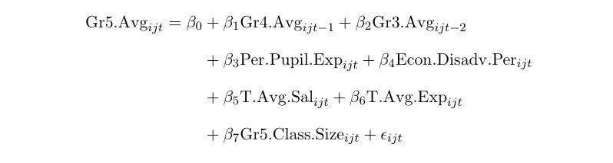

I use appropriately lagged 4th- and 3rd-grade test scores to account for student ability and the percentage of economically disadvantaged students to account for family characteristics. To these regressions I add campus-level and year-level fixed effects. Campus fixed-effects control for any time-invariant campus-level differences like geographical location or district management policies, while year fixed effects control for state-wide effects like test difficulty. The biases which remain are therefore all variables which vary within a campus over time by a non-constant amount. For example 5th grade teacher quality is almost certainly an omitted variable which varies within a campus over time by a non-constant amount, so is very likely to bias all of the variables despite the fixed effects.

The primary concern which remains is still the endogeneity of the resource parameters, so to establish exogeneity I first use instrumental variables.

Results

1. 1. The United States' constitution does not directly protect the right to education, nor does it imply any such right. This was the decision reached in San Antonio Independent School District v. Rodriguez (1973), a case which centred on the inequalities which natural result from a school financing system based on local property taxation. In particular it centred around the vastly different tax bases in two neighbouring Texan public school districts and the effect this had on the resources available to students in each district. The decision has stood ever since.

  
2. In Edgewood Independent School District v. Kirby (Tex 1989) it was found that the "[the] wealthiest district [have] over $ 14,000,000 of property wealth per student, while the poorest [have] approximately $ 20,000; this disparity reflects a 700 to 1 ratio".
3. This is the result of finance-equalisation legislation passed in 1993 and taken into effect in the 1993/94 school year. Though named 'Robin Hood' by the press, the nickname belied the widespread ire the legislation would draw from economists, lawmakers and parents (rich and poor alike), and the two further rounds of lawsuits it would face.