**City University of Hong Kong**

**School of Continuing and Professional Education**

**PROGRAMME - {173-19431}  
BSc (Hons) Information Technology for Business (3-yr Full Degree)  
Coventry University**

**302CEM Individual Report**

**Li Yat Long (55201950)**

Table of Contents

Introduction 3

Service Blueprint 3

Technical platform and architecture 4

Data interface 5

GitHub link 5

Team Dynamics and Project Management 6

Team structure 6

Team communication tools 7

Challenges facing 8

Evaluation of Agile SCRUM and Behaviour Driven Methodology/Tools 8

Prototyping 8

Agile Methodology 9

Product Roadmap 9

Project Charter 10

Project Plan 11

User Story 11

Product backlog 12

Sprint Backlog 13

Test Plan 13

Release Plan 14

Sprint planning meeting 14

Daily scrum 14

Sprint review meeting 14

Agile Principles 15

Behaviour Driven methodology 15

Evaluation of Pair Programming and Test Driven Development Methodologies/Tools 15

Version Control 19

Evaluation of different agile methodologies/tools 20

# Introduction

Our Team is aimed to develop an online menu ordering platform (UberEat) and order receive system of restaurant (Pizza Hut). The customers of UberEat are able to order the food from the UberEat app and its order will be sent to the Pizza Hut order receive system through node.js. Besides, the customer are able to check its order history with is status (including ‘submit’ and ‘prepared’), pay the order through various methods (including Credit Card and Cash) and choose the delivery location. On the other hand, the staff of Pizza Hut can download the order from the node.js, view all the order received and update the order status. All of the data like order record, membership and menu will be save to the sperate databases (UberEat database & Pizza Hut database) according to where the data belongs.

## Service Blueprint

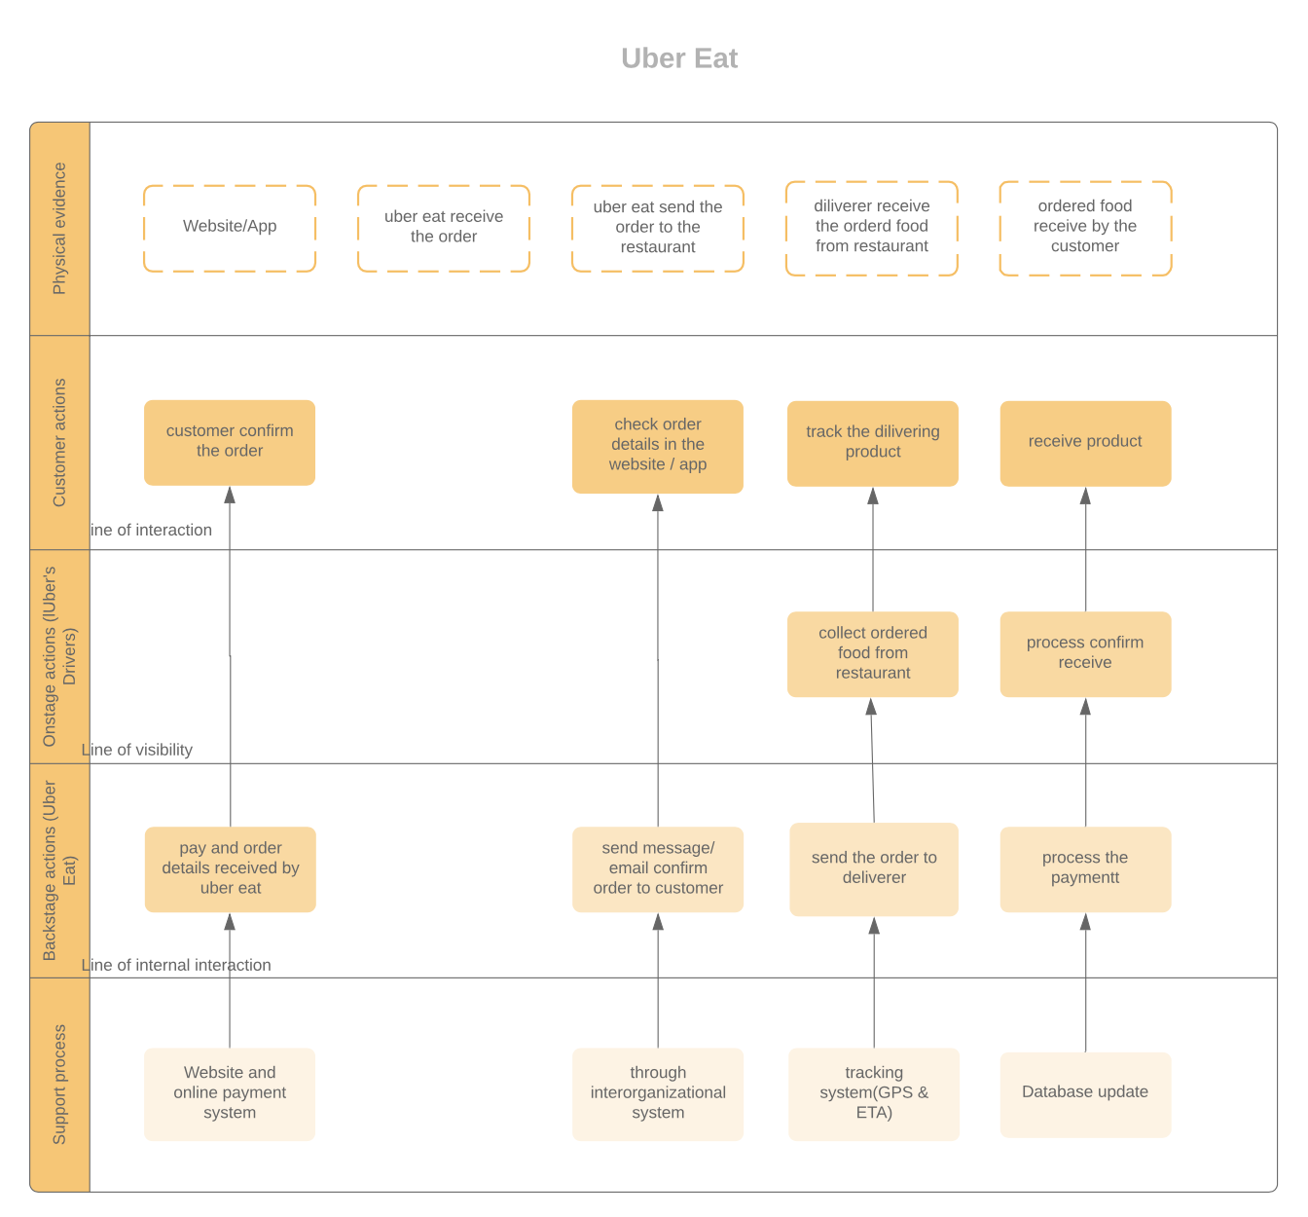

This is the Service Blueprint of UberEat, displaying the whole order process of the UberEat, including the order process and checking the order.

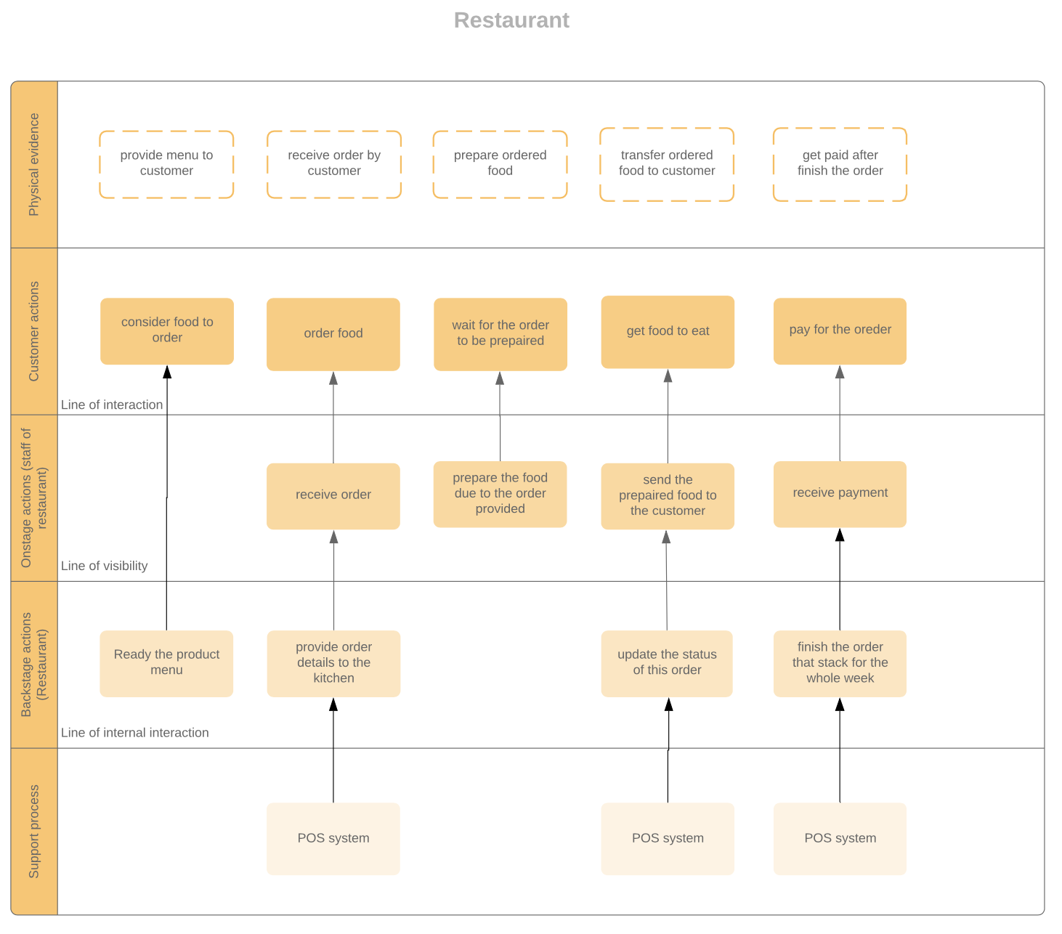

This is the Service Blueprint of PizzaHut, displaying the whole process from receive order to prepare the order.

## Technical platform and architecture

In this project, we are using machines running on Windows 10 with various of software including python3.6, xampp, JavaScripts and node.js installed to the computer.

The python is a programming language that are used to implement the two system: UberEat menu ordering system and PizzaHut order receive system.

The xampp is used in order to use its MySql feature which is the database used in both system mentioned above.

The node.js is used for handling the request of both UberEat menu ordering system and PizzaHut order receive system would like to pass/download the JSON file to/from the local host.

The JavaScripts is programming language that the execution and running of the node.js based on, including what need to receive/pass from/to the both python system and where to post and get the JSON file data.

## Data interface

We are using JSON as the data interface between the two python based system.

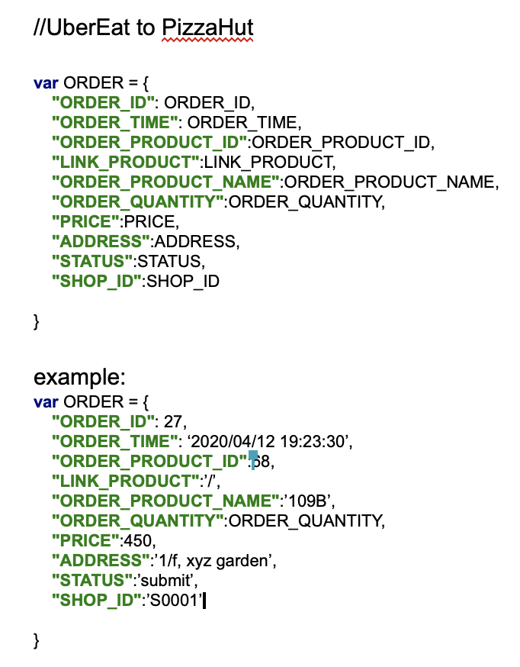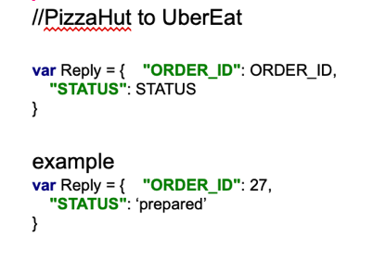

The left image shows the JSON from UberEat to Pizza Hut, which will be sent when the user submit the order, which is why it stores details like ‘ORDER_ID’, ‘ORDER_PRODUCT’ and ‘ADDRESS’.

The right image shows the JSON from Pizza Hut to UberEat, which will be sent when the staff of Pizza Hut update the status of the order.

## GitHub link

Group work (UberEat and Pizza Hut): <https://github.com/vincennt99v1123li/302_group.git>

Pair Programming: <https://github.com/vincennt99v1123li/302_pair>

# Team Dynamics and Project Management

## Team structure

Our team consist of five members, including Lam Yat Fung, Li Yat Long, Ma Kwan Yat, Poon Tat Man and Wong Tsun Wing.

|  |  |
| --- | --- |
| **Team Member** | **Responsibilities** |
| Lam Yat Fung | Programming, Testing |
| Li Yat Long (myself) | Database, Programming, UI Design, Testing |
| Ma Kwan Yat | Feature suggestion, Programming, Testing |
| Poon Tat Man | Database, Feature suggestion, Programming, Testing |
| Wong Tsun Wing | Database, Programming, Testing |

Lam Yat Fung

He is the one of the main members of implementing the both UberEat and Pizza Hut system, with his efficiency and quality of work, our team are able to implement the system features successfully.

Li Yat Long (myself)

I am the another main member of implementing the both UberEat and Pizza Hut system, with designing the User Interface and implement the some of the most important part like taking order. Besides, I usually take the role of coordinate each team member by spreading parts of work and holding online meeting.

Ma Kwan Yat

She provides ideas of the system like what features are needed to be implemented to the system, testing the software and implement some part of the program, with her knowledge and experience of these kind of software, our team are able to implement the system features successfully.

Poon Tat Man

He is the main member of implementing the database and programming and proving what is needed in our system, with his experience on creating database and programming, we can finish our group project on time with quality.

Wong Tsun Wing

He is the member of implementing a variety of area, including database, programming and testing. Although the lack of experience, his effort allows our group to achieve the expectation of features planned in the beginning.

## Team communication tools

We have used a few software to communicate between members, including WhatsApp, Skype and TeamViewer.

WhatsApp is mainly use for discuss and reserve the date of the next Skype meeting, share & discuss the latest ideas which is not too important, and posting screen capture image like bugs of the program & the problem in the database in order to enquire quick fix by another member.

Skype is used to hold regular meeting which is mainly 1 – 2 times per week. Through the regular meeting, we are able to divide our works to each member, discuss and plan what is needed in the system, which is especially important in early 2020 due to the problem of coronavirus resulting in stay at home.

The characteristics of TeamViewer allows user to remote another user’s computer using internet is the reason why it is used during pair programming which when one members is coding, the other member will check the logic of the program and fix the bug together. The method of using TeamViewer to fix bugs have also implemented when doing our UberEat and Pizza Hut system.

## Challenges facing

There are many challenges we faced during teamwork as there are serious experience level difference between members. Some members did not learned programming during secondary school, which they have faced more issues during coding as they are lacked of coding experience. They may not be able to find easier ways to fix bugs. Therefore, other experienced member need to spend extra time to help them to solve the problem and provide suggestion on how to solve the problem.

On the other hand, there are different ideas between members including what column is needed in the database and what features should be kept in the system, discussion and communication time is needed to let each members to express and understand others opinions.

# Evaluation of Agile SCRUM and Behaviour Driven Methodology/Tools

## Prototyping

We still use python to build prototype for both system. The prototype demonstrates the basic interface of both UberEat and Pizza Hut system, which we are able to click the button to simulate the process of order, login, update account and download the order in the Pizza Hut system. There is also a sample JSON file to simulate the process of transferring order from the UberEat system to the Pizza Hut system.

We choose python tools to build our prototype instead of using other prototyping tools like Adobe Experience Design is because the our group is not familiar with different prototyping tools, resulting in using python which is the most familiar programming language, to build the prototype and interface of our program. On the other hand, as the program will finally implemented by python, the build of prototype using python not only save time, but also ensure the interface is achievable by using tkinter of python.

The implementation of prototyping is important as it allow the group members to view the process of using the system and decide whether the flow is easy to use & suitable for the customer. Besides, prototype allow all of the members to have a better understanding of what is need in our system and represent as a guide of what the software look to prevent the code made by the groupmates not meet the requirement & standard.

Video of our prototype: <https://youtu.be/JsitjN9a8Zw>

## Agile Methodology

### Product Roadmap

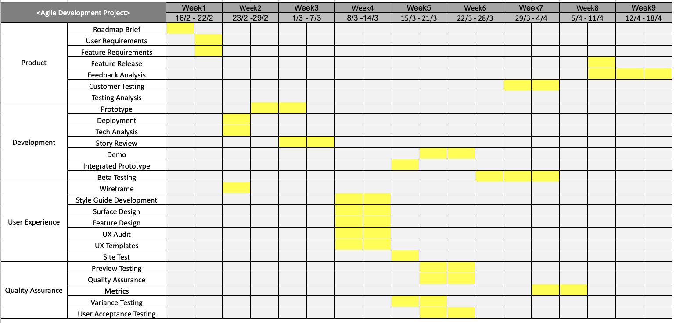

The concept of product roadmap is to describe the development process and time in the future, providing a high level and strategic plan. (Schuurman 2017). This can also be applied on our team’s roadmap through the date set for each development step, we could have a better vision and time management on what need to do next.

Project Charter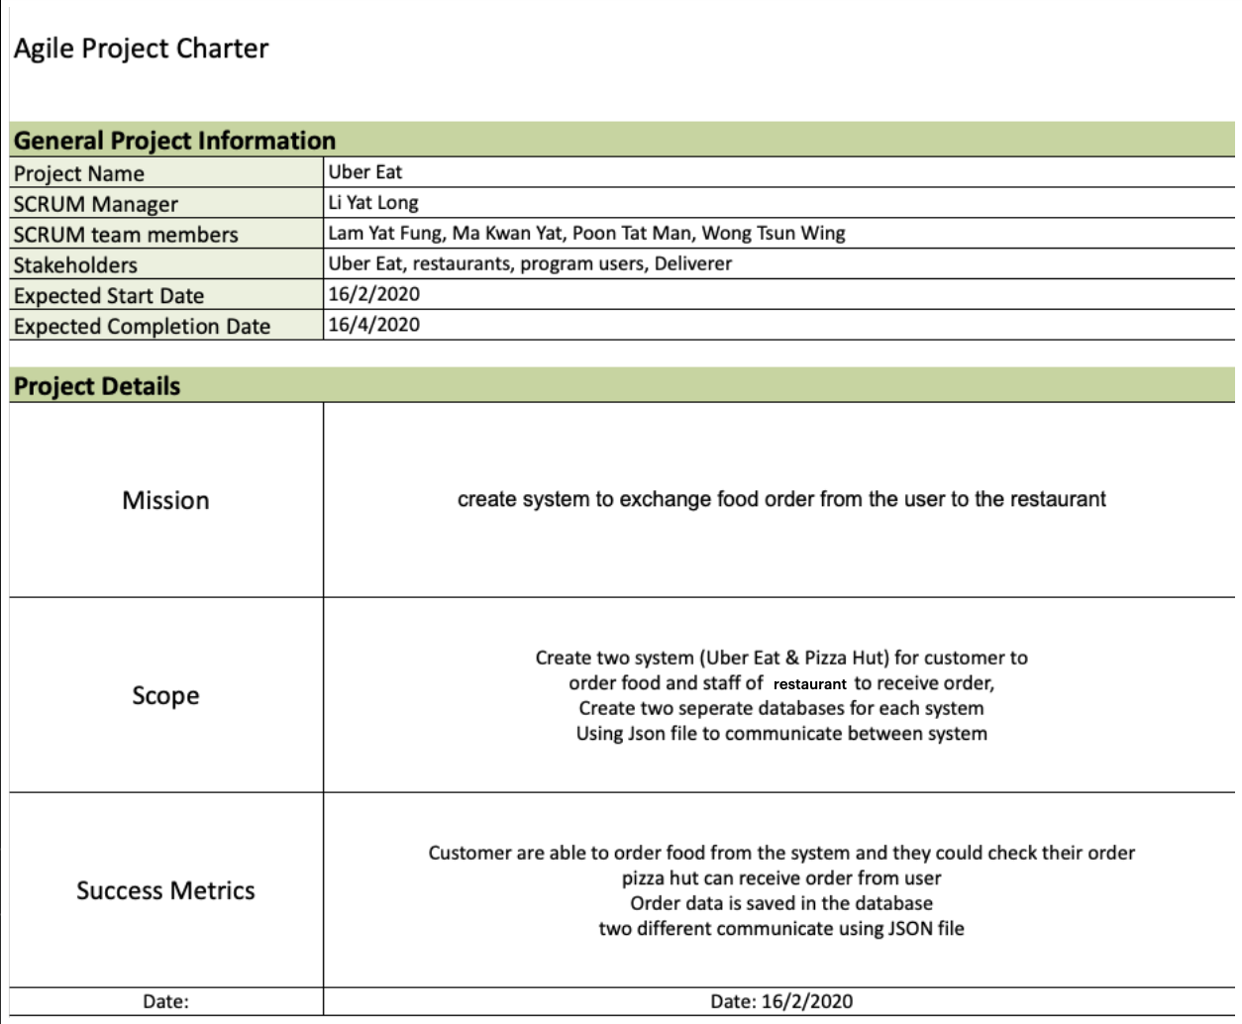

Project charter is important to establish the technical and business resources on a same page which is aimed to align stakeholder’s and team’s expectation (State of California 2020). Our project have also implemented the project charter, establishing the mission scope and success metrics of the project to prevent expectation different from the finish product.

Project Plan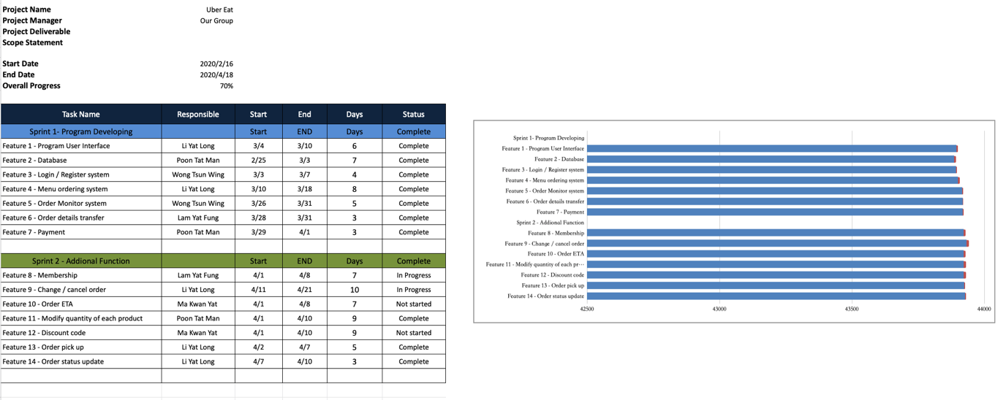The project plan shows the feature concluded from the user story, with responsible members, start/end date, days and status listed, providing a better organization on project time management to view wheatear the feature is finish or not.

User Story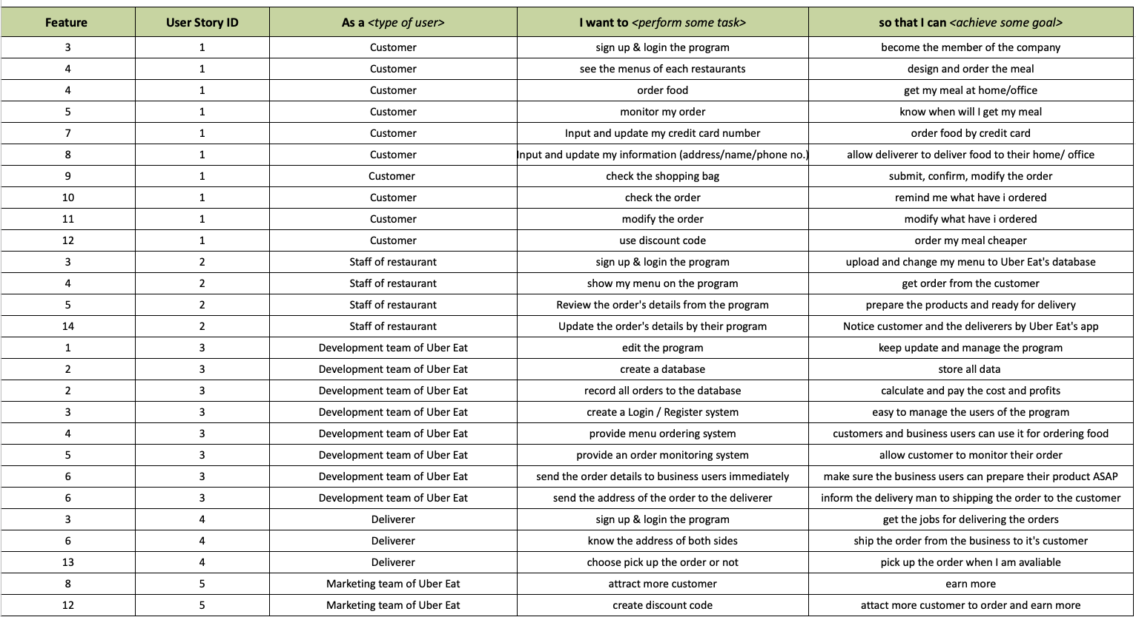

The user story is a plain language explanation of a feature request from users, with its plain language allows anyone (even without technical knowledge) to understand and request for a feature (ProductPlan 2019). In our project, we list out the what user want to do according to their type of user including customer/ staff of Pizza Hut/ development team/ deliverer and marketing team of UberEat. This help us define the feature codes grouped by features listed by the type of user. The ubiquitous language also allows users to fill the user story easily.

Product backlog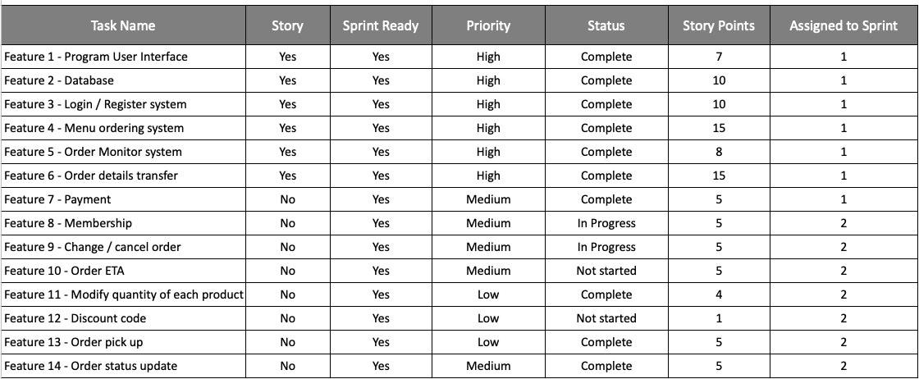

Product backlog is a single list that shows all new features, change to existing feature and other bug fix that the team may deliver (Agile Alliance 2020). In our case, the backlog list all our features listed with its priority which is according to story points (higher is better), status and assign to which sprint. This help our group have a better view to organise and decide the work priority.

Sprint Backlog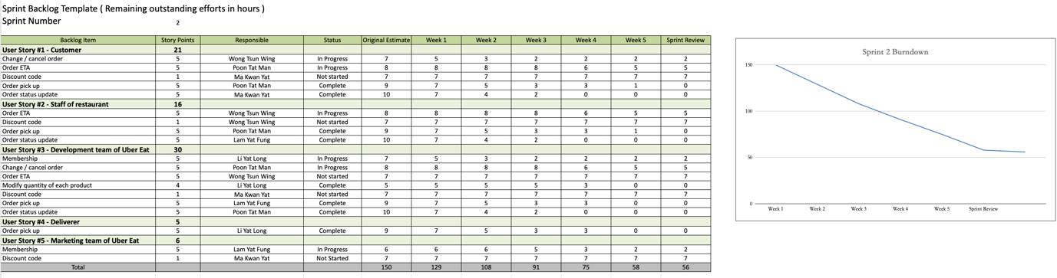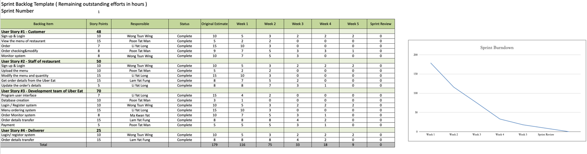

The sprint backlog list the items from the product backlog items according to their sprint, providing a highly-visible and real-time image of what the development team need to accomplish (Scrum.org 2020). Our team use the sprint backlog to calculate the hours-left of each feature in each week, the help us to arrange the human resources on each feature like this feature may need to find more people to develop.

Test Plan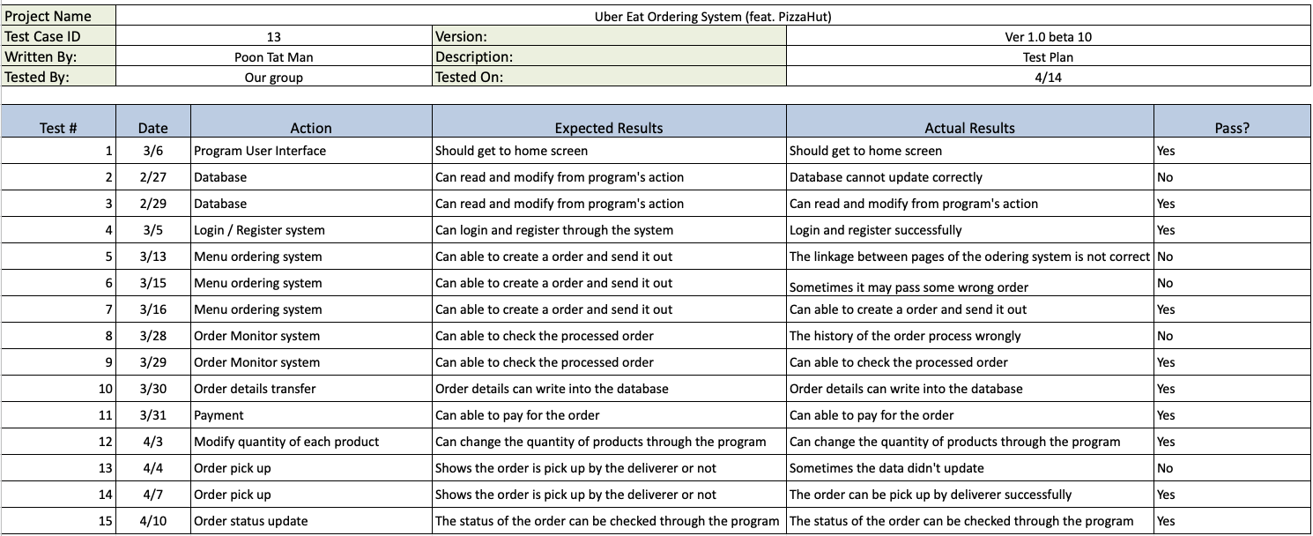

The test plan list out all the testing process of the system, with items like test date, action, expected result and actual result. This helps our team to quickly look for the items and feature with bugs which need a quick fix.

Release Plan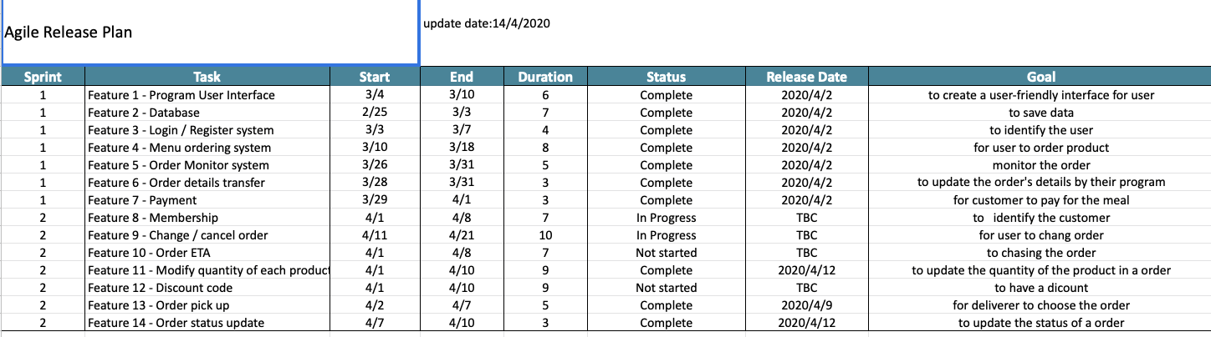

The release plan is a list that list out the expected release time of each feature, act as a goal of our team to deliver each feature.

### Sprint planning meeting

In scrum, every sprint start with a sprint planning meeting to establish the sprint

backlog and goal mentioned above, helping us to decide what should do in the next 2 – 4 weeks.

### Daily scrum

The short regular meeting method is also applied to our team, this help every members of the team to understand and track other members process including who is fall behind and may need help from others.

### Sprint review meeting

We reviewed the feature done by the groupmates at the end of each sprint which is useful to decide the goals of the next sprint as some feature may not be good enough and need to keep work on in the next sprint.

## Agile Principles

1. At regular Intervals, the Team reflects on how to become more effective, then tunes and adjusts its behaviour accordingly.
2. The Most Efficient and Effective Method of Conveying Information to and within a Development Team is face-to-face Communications.

The above agile principles allow our team to achieve successful project collaboration and project management.

For the first principle, regular meeting are always held in our team to review the results of the products. At the same time, we will also discuss the development process and ask if anyone have faced any difficulties during development. As some of the members have less experience on coding than others, other members will share their experience like how to solve some bugs, resulting in better quality and efficiency of the whole group. On the other hand, this could also be applied to the second principle as the results of the product is done by holding frequent meeting for members to share their thoughts.

## Behaviour Driven methodology

Advantages:

* All stockholders can have a clear view and strong understanding of the project though the communication and discussion or tools like user story which the language is understandable by everyone
* The result product can fulfil the business value and needs due to strong understanding of user needs

Disadvantages:

* There must be a user to work with in order to gain user story
* Time consuming as the needs to communicate and work with the clients

# Evaluation of Pair Programming and Test Driven Development Methodologies/Tools

In the pair programming assignment, I in charge of programming, analyse the tax calculation formula and testing.

We use unit test with a various test cases to test our program like the image below:

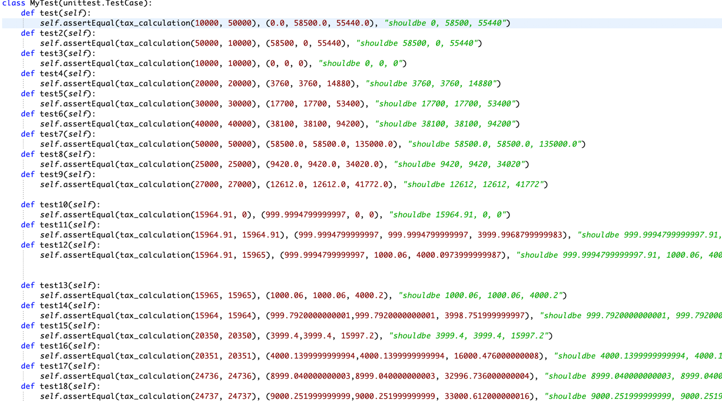

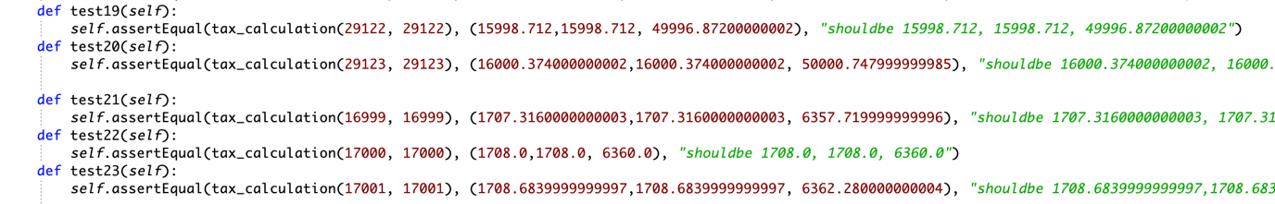

The unit test is a to test a individual units of sources code, with the framework in python (PyUnit) allowing automatic testing instead of manually input values to increase the reliability (Tutorialspoint 2020). This also explains why our program also implement the PyUnit with the above cases.

Unit testing tools advantages:

* Efficiency increase significantly, as the test case only need to type once and the computer will run all the test case at once
* Enhance reliability of the testing as every test are tested with the pre-set test case. Human input error is prevented

Unit testing tools disadvantages:

* Knowledge is needed in order learn how to use the testing tool
* May not to find failures of the program if the test case is not well-rounded
* Auto testing cannot simulate the real person using the system which may face difficulties when using the system

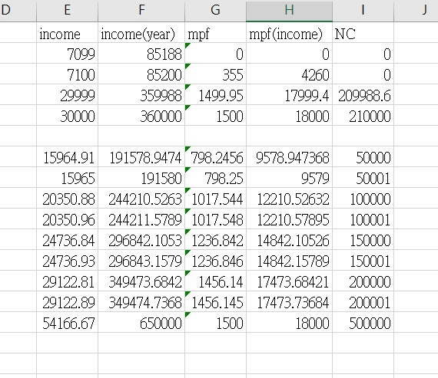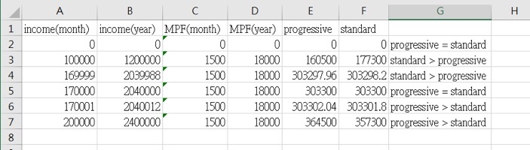

Test case is designed to meet the boundary case of each stages of tax rate. There are 5 stages of progressive tax including (2% of the first $50000, then 6%, 10%, 14% and 17% for the remaining) and there are also standard rate if the calculation found out that the tax calculated by standard rate is cheaper than progressive tax. Our Boundary test case are calculated by Excel to look for the boundary stage of the above 6 stages. The left image shows the monthly income to achieve net chargeable income in each stage, for example: $15965 to obtain net chargeable $50001, which is just $1 higher than the 1st $50000 of progressive tax. The left image shows as what income, calculated by standard rate is cheaper. The all above cases is input as a test case and compare to the government’s calculator to ensure the correctness. Extra valid case are also implemented to ensure the correctness of the results.

Black box testing means the tester do not know the structure of the program and white box testing is the opposite which the tester know the structure (Jain n.d.). In our assignment, as both me and my teammates are responsible on coding, only white box test have been implemented.

The concept of test driven programming is to add a test and allow the code to pass the test and continue to make new test and test the code until the program meet the requirements (Ambysoft Inc. 2020). This also implement to the development of the project as we will continue the process of testing if the code pass the if statement which is one of the criteria of the tax calculation.

Advantages:

* Shorter development lifecycle
* Eliminate bug and ensure the code meet the requirements

Disadvantages:

* Must have enough and full-range of test case to ensure the result
* Test case need to change rapidly if the design keeps changing

Pair programming include two programmers to share the same computer, one is call ‘driver’ to code and the other one is called ‘navigator’ which focus on pointing direction with swapping of two position happen regularly (Agile Alliance 2020). This method allows both me and my teammates have an opportunity to always share the thought, with the benefit to share some stills to my teammates who have less experience. However, this method lack of self-evaluation on code. For example, if my teammates found out a problem, I will directly told him what the problem instead try to solve the problem by himself, which is important to let him to gain experience.

# Version Control

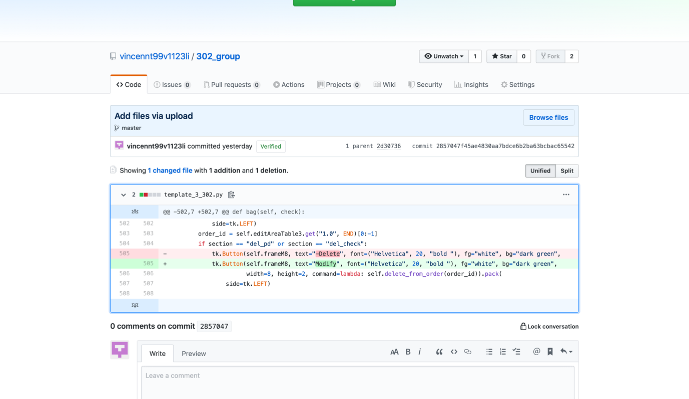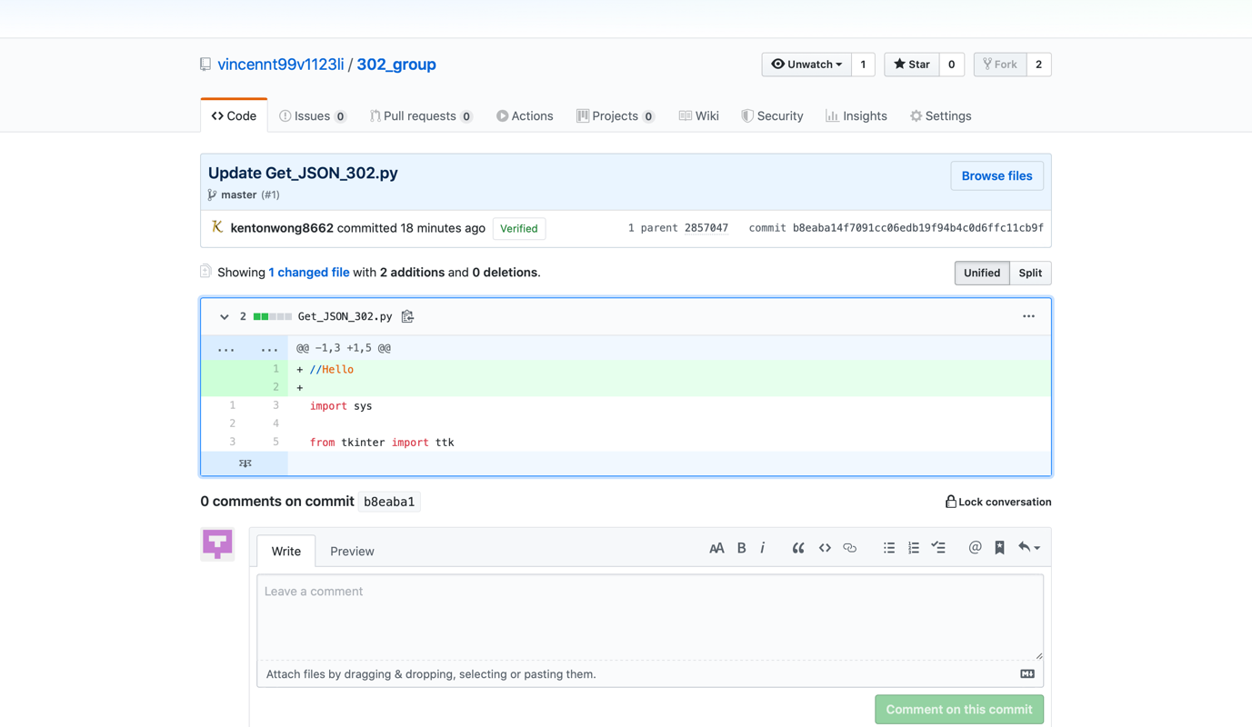

The advantages of using GitHub is that it is easily to view what have been change in the file, which is being demonstrated in the first image with the line 505 has changed. In the project we found out that GitHub is easy to use with one members to create repository and upload all files, and the other members can send request to the owner of the repository with changes of files. Then the owner can merge and saved the modify file to the repository with listed what have been modified by everyone.

# Evaluation of different agile methodologies/tools

Scrum focus on sprint, which each sprint is 2 - 4 weeks long, we will plan what are need to be done in each sprint, which is not allow to change and review how to improve and add new job in the next sprint. The scrum also allows members to work on job even with lower priority.

Extreme methodology have shorter iterations mainly 1 – 2 weeks, with restricted to do the priority first. However, it can handle changes on requirements.

Product like Microsoft Project allows the team to plan and generate the project plan digitally, saving time, allow quick modification and share to teammates. These tools allows upload online which all members in team can view the change real-time and know the status of the project and the leader can get the latest status of the project easily.

**List of Reference**

Agile Alliance (2020a) *Pair Programming* [online] available from

<[https://www.agilealliance.org/glossary/pairing/#q=~(infinite~false~filters~(postType~(~'page~'post~'aa_book~'aa_event_session~'aa_experience_report~'aa_glossary~'aa_research_paper~'aa_video)~tags~(~'pair*20programming))~searchTerm~'~sort~false~sortDirection~'asc~page~1)](https://www.agilealliance.org/glossary/pairing/#q=~(infinite~false~filters~(postType~(~'page~'post~'aa_book~'aa_event_session~'aa_experience_report~'aa_glossary~'aa_research_paper~'aa_video)~tags~(~'pair*20programming))~searchTerm~'~sort~false~sortDirection~'asc~page~1))> [16 April 2020]

Agile Alliance (2020b) *Product Backlog* [online] available from

<<https://www.agilealliance.org/glossary/backlog/#q=~(infinite~false~filters~(postType~(~'page~'post~'aa_book~'aa_event_session~'aa_experience_report~'aa_glossary~'aa_research_paper~'aa_video)~tags~(~'backlog))~searchTerm~'~sort~false~sortDirection~'asc~page~1)>> [15 April 2020]

Ambysoft Inc. (2020) *Introduction to Test Driven Development (TDD)* [online] available

from <<http://agiledata.org/essays/tdd.html>> [16 April 2020]

GeeksforGeeks (n.d.) *Differences between Black Box Testing vs White Box Testing* [online]

available from <<https://www.geeksforgeeks.org/differences-between-black-box-testing-vs-white-box-testing/>> [16 April 2020]

ProductPlan (2020) *User Story* [online] available from

<https://www.productplan.com/glossary/user-story/> [15 April 2020]

Scrum.org (2020) *What is a Sprint Backlog?* [online] available from

<<https://www.scrum.org/resources/what-is-a-sprint-backlog>> [16 April 2020]

Shuurman, R. (2020) *Tips for Agile product roadmaps & product roadmap examples* [online]

available from <<https://www.scrum.org/resources/blog/tips-agile-product-roadmaps-product-roadmap-examples>> [15 April 2020]

State of California (2020) *3.5.1 The Agile Project Charter* [online] available from

<<https://projectresources.cdt.ca.gov/agile/the-agile-project-charter/>> [15 April 2020]

Tutorialspoint (2020) *UnitTest Framework – Overview* [online] available from

<<https://www.tutorialspoint.com/unittest_framework/unittest_framework_overview.htm>> [16 April 2020]