# **Group 36**

21000018G Li Yat Long

22004967G Mui Yen Ching

22009664G Cheung Tsz Him

# **System Requirements**

## **1. Introduction**

#### **1.1 Purpose**

Advance Learning Centre is a local tutorial centre with 2 branches, serving more than a hundred of primary and secondary students every day. To facilitate an expansion of multiple new branches in new residential area where most residents are in a family with child, a class management system is proposed to improve the efficiency on current branches while reducing the demand of new officers in new branches.

***1.2 Intended Audience***

The intended Audience of the system are teachers, school officers and students.

#### **1.3 User Needs**

Currently, the centre relies on traditional paper base document including multiple of folders containing the timetable of all data of students, data of teachers and timetables each week of the whole centre.

Every time the student arrived the centre, the officer in the front desk will mark the record on the timetable table in addition to the receipt of each student. This results in long queue for taking attendance during peak hours (after schools’ lessons). As the officers cannot handle the demand of students, the attendance record often missing some students or some students absent from class appeared on the list, resulting confusion on teachers and officers. Some parents often complained about the difference between their attendance marked on their receipt and the official record, and claims that their student have not took the lesson and request a make-up lesson.

On the other hand, the lack of a unified system to manage all students, teachers and timetable data also results in data not up to date. For example, the changes in parents phone number may not be recorded in all documents, results in waste of searching time.

Implementing a unified system also enables better planning for the centre. Having a holistic view of the students’ timetable, the centre can design some ad-hoc classes, such as exam revision class, in the most favourable timeslot (no timetable crash), which allows more students to register.

A unified system managing the personal information, timetable, and attendance can highly solve the above situation, reducing the needs of manpower hence some of the existing staff can be repositioned to the new branches, and improving the customer and staff satisfaction towards the centre.

#### **1.4 Intended Use**

The class management system is designed to allow the students to take attendance by their own when attending classes, offer a platform for the centre to announce notification to staff or students, and check timetable and student/ staff information, which increase the efficiency of the current process and ensure the information is accurate.

#### **1.5 Scope**

An app for smart device including smartphone/ tablet/ pc with the ability to connect to RFID reader installed on centre will be developed to solve the following major objectives:

1. Increase the confirmation of student attendance

As mentioned, officer often made mistake on the attendance record with long queuing time in peak hours. It is significant to fix the problem to reduce complaints from parents and ensure the lesson can be started on time.

1. Decrease the workload of officer

Reducing the workload of officer allows to just mainly interact with system, instead of focusing on marking or searching on paper works increased the efficiency. Hence, less officer is required to a single centre and the redundant staff can be relocated to the new centres.

1. Ensure all the data is up to date

As mentioned, the data stored on different paper documents may vary. A centralized database is necessary to ensure all the data of single field is the same and up to date.

1. Allow students to receive latest information from school

Obtaining timetable and announcement instantly through internet increased efficiency and customer satisfaction.

## 2. **System Features and Requirements**

#### **2.1 Functional Requirements**

|  |  |
| --- | --- |
| Functional requirement No. | Description |
| 1 | Officers should be able to assign students information to an empty RFID card |
| 2 | Officers should be able to update students’ information to RFID card |
| 3 | Officers should be able to delete students’ information from RFID card |
| 4 | Officers should be able to view information of each student, staff, course, course’s timetable, and attendance record of each course |
| 5 | Officers should be able to append information of each student, staff, course, course’s timetable, and attendance record of each course |
| 6 | Officers should be able to delete information of each student, staff, course, course’s timetable, and attendance record of each course |
| 7 | Officers should be able to modify information of each student, staff, course, course’s timetable, and attendance record of each course |
| 8 | Officers should be able to send and broadcast notifications to all users or selected users |
| 9 | Officers should be able to receive notifications |
| 10 | Officer should be able to activate the RFID reader on the centre’s classroom to allow the student to take the attendance of specific course |
| 11 | Teachers should be able to activate the RFID reader on the centre’s classroom to allow the student to take the attendance of specific course |
| 12 | Teachers should be able to view information of each student attending their course |
| 13 | Teachers should be able to view their teaching timetable |
| 14 | Teachers should be able to view the student’s attendance record of each lesson (only the lesson they taught) |
| 15 | Teachers should be able to send and broadcast notifications to all users or selected users but limited to the students they taught) |
| 16 | Teachers should be able to receive notifications |
| 17 | Students should be able to append attendance record through RFID reader installed on each centre’s classroom |
| 18 | Student should be able to view their own timetable |
| 19 | Student should be able to view their own attendance record |
| 20 | Student should be able to receive notifications |
| 21 | Officer should be able to create/ delete account of all users |
| 22 | Officer/ students/ teacher should be able to change their password |
| 23 | Officer/ students/ teacher should be able login/ logout |

#### **2.4 Non-functional Requirements**

|  |  |
| --- | --- |
| Non-functional requirement No. | Description |
| 1 | The system should record the attendance of each student through RFID card and reader in less than 5 seconds |
| 2 | The system should record/ broadcast all other timetable, student info, notification changes in less than 5 mins |
| 3 | Attendance taking service available every day during business hours (e.g., 10am to 9pm) in 99.9% of time |
| 4 | All other service available 24/7 in 99.9% of time |
| 5 | Available in traditional/ simplified Chinese and English |
| 6 | Compatible on iOS 12 / Android 8/ Windows 10/ macOS 10.13 or above with similar performance, behaviour, and user experience |
| 7 | The system must be scalable enough to support 100000 visits at the same time while maintaining optimal performance. |
| 8 | Support two factor authentication |
| 9 | Application server and database server backup daily |
| 10 | Restore the system in less than 10 minutes if system is down |
| 11 | Team: application team, infrastructure team, on-site and off-site support engineer |
| 12 | Officers shall be able to use all the system functions after 1 hours of training. After this training, the average number of errors made by experienced users shall not exceed 2 per hour of system use. |
| 13 | Teachers/ students shall be able to use all the system functions after 15 mins of training. After this training, the average number of errors made by experienced users shall not exceed 2 per hour of system use. |

**System Design**

1. **Use case diagram**

1. **Class diagram**

1. **Sequence diagram**

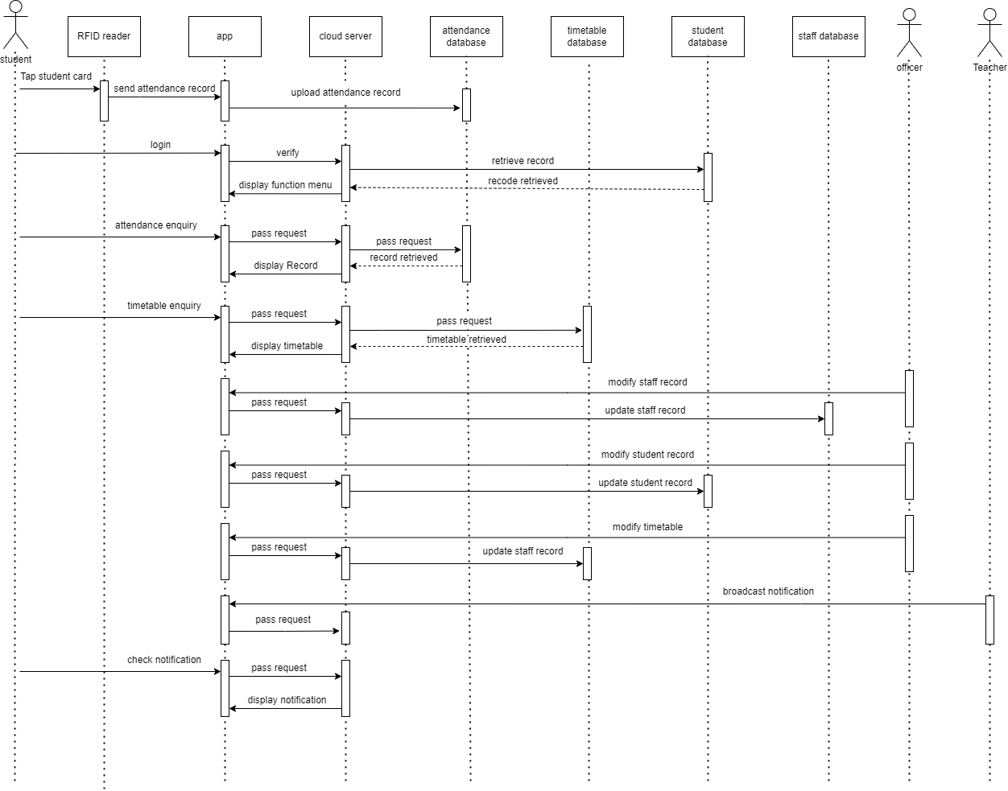

1. **Component diagram**

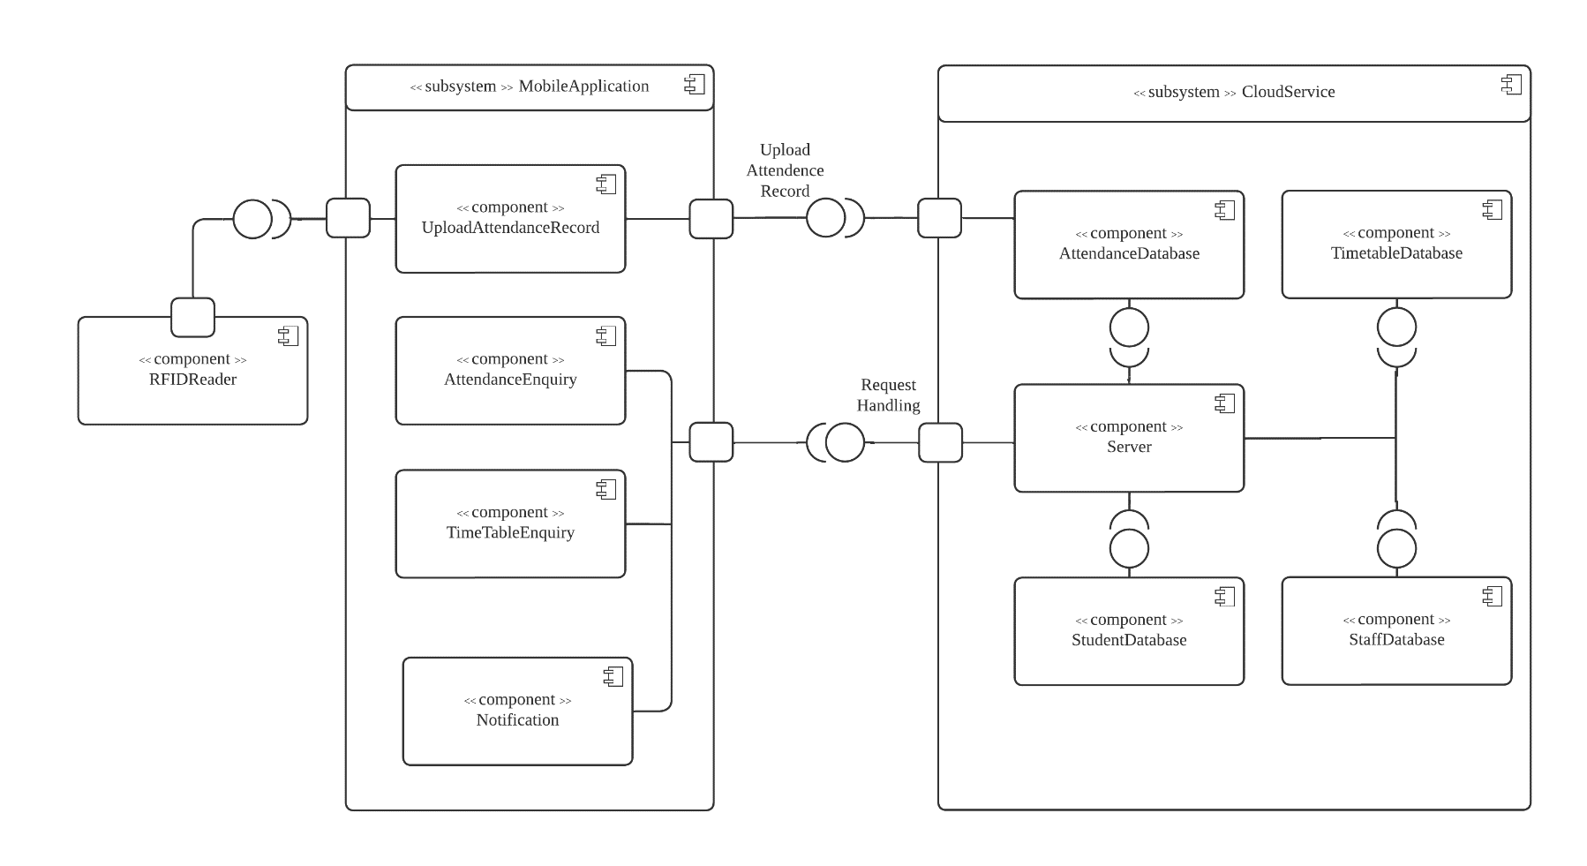

1. **Deployment Diagram**

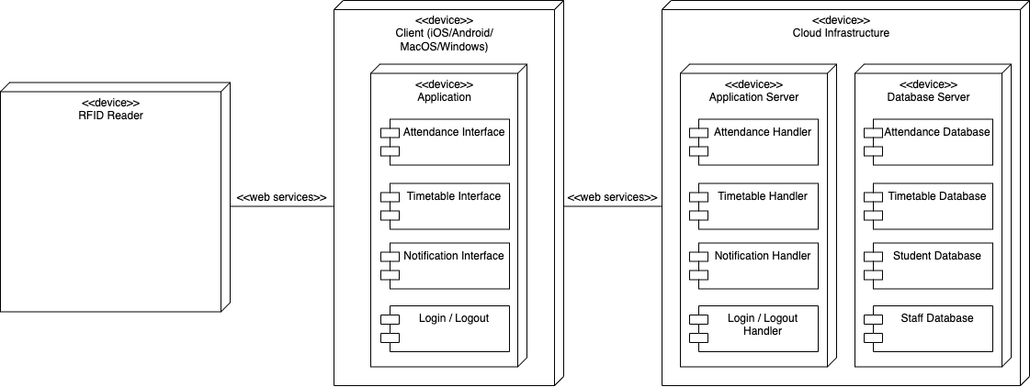

1. **Gantt Chart**

