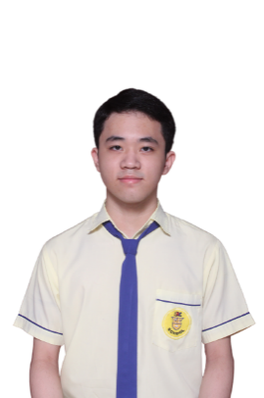**Vincent Dennis Judyanto**

+49 1633973568 | [vincentdennis.j@gmail.com](mailto:vincentdennis.j@gmail.com)

[github.com/vincent-dennis](https://github.com/vincent-dennis) | [linkedin.com/in/vincent-dennis-judyanto](https://www.linkedin.com/in/vincent-dennis-judyanto/)

**PROFILE**

Third-year Computer Engineering student with deepening in Software Engineering at the University of Duisburg-Essen, with high motivation to learn and grow. Working on becoming a competent engineer who can use my skills and knowledge to bring positive impact on the world. Currently interested in the field of Machine Learning and its ever-expanding application in our day-to-day life. I believe in continuous self-improvement and lifelong learning.

**EDUCATION**

**University of Duisburg-Essen** | B. Sc. Computer Engineering – Profile: Software Engineering October 2022 – Present

* **Grade**: 1.3 (German scale), 165/180 ECTS
* **Achievements**: Deutschlandstipendium 2024/25, Deutschlandstipendium 2023/24

**WORK EXPERIENCE & PROJECTS**

**Software Developer Intern** | adesso SE Düsseldorf April 2024 – July 2024

* Collaborated effectively with team members to plan and build software projects
* Developed a backend server for an AI use case generator, capable of identifying 5+ improvement areas and suggesting 3+ AI use cases for each area with respect to client company profile
* Automated Microsoft Forms response data extraction, parsing and transfer using Microsoft Power Automate
* Implemented programmatic report and diagram generation in various formats (PDF, pptx)
* Engaged in self-learning and practical exercises focused on Java programming, Spring Framework / Spring Boot, RESTful Architecture, and Prompt Engineering

**Academic Tutor and Lab Assistant** | University of Duisburg-Essen October 2023 – February 2024

* Taught and assisted students during weekly tutorial sessions for the courses Fundamental of Computer Engineering and Mechanics 1, answering questions and providing clear and accurate explanations on the course topics
* Led and supervised weekly Lab sessions in English and German for the course Fundamental of Computer Engineering (Grundlagen der Technischen Informatik), assisting 60+ students each week in completing the given tasks and homework by answering questions, explaining concepts and pointing out mistakes

**SpoTube Chrome Extension** | Personal Project September 2023

* Built a fully-functioning Chrome Browser Extension that grabs the titles and artists of up to 50 songs from a Spotify playlist, uses them to search for their matching YouTube videos and generates a YouTube playlist from them, all with the click of a button
* Demo and code can be found in my “portfolio” GitHub repository https://github.com/vincent-dennis/portfolio

**SKILLS & LANGUAGES**

**Programming languages, frameworks, technologies:**

* Python 3
* C/C++
* Java
* Git
* HTML/CSS, JavaScript
* SQL
* Flask, Django
* Spring Framework, Spring Boot
* LangChain
* ReportLab, PyPDF, PlantUML
* MATLAB

**Languages:**

* English (Bilingual, Band 8.5 IELTS)
* German (B2 CEFR)
* Bahasa Indonesia (First Language)