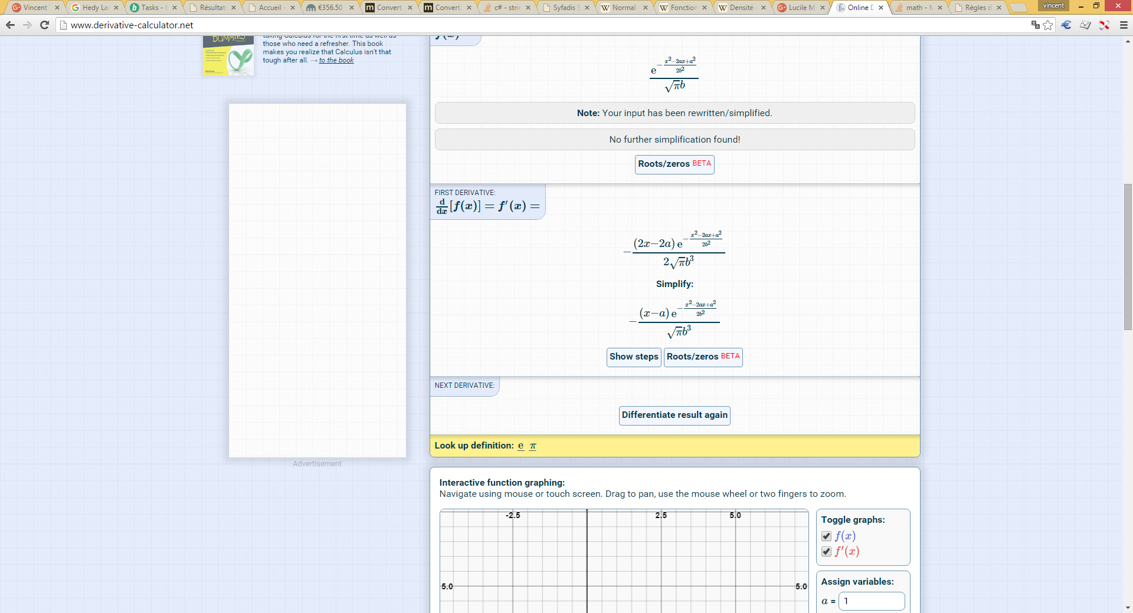

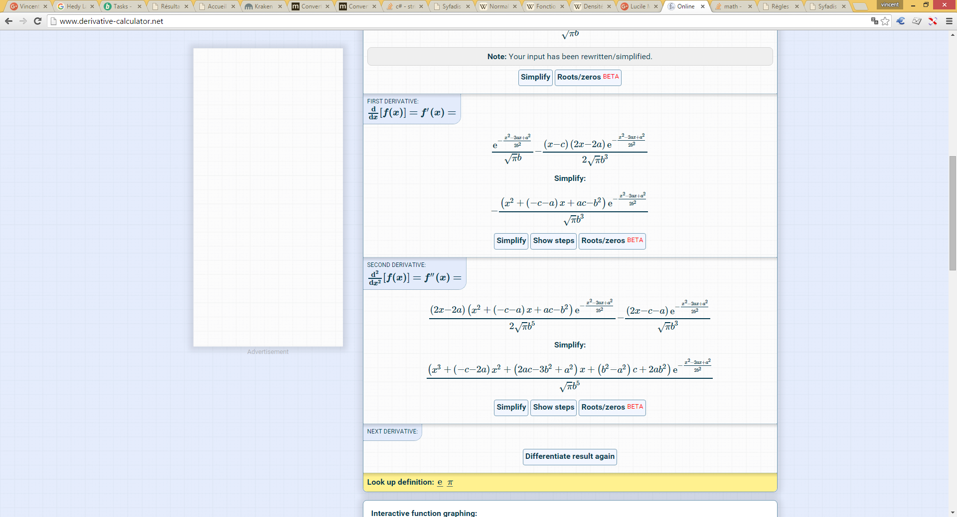

(x-c)\*e^(-(x-a)^2/(2\*b^2))/(b\*sqrt(pi))