Abstract

This project aimed at creating an application for the purpose of keeping a food diary, a log of all the food and drink a person has consumed over a given period; the purpose of this diary is as an aid to weight loss. This project had a specific bent in that the application was designed for those following a plant-based diet and part of the functionality was to inform the user whether or not a meal or item of food was vegan or vegetarian. The system was designed to have a user-friendly UI that was as free from clutter as possible and have relevant information immediately accessible. The system was designed to keep stored data consistent and be free from dirty data.

The architecture of the project was the MVC model. The model portion of the project was developed using SQLite. The view portion was developed in JavaFX and the controller portion was written in Java.

CONCLUSION NONSENSE

Introduction:

A food diary is a tool used for the purpose of achieving weight loss. In its simplest form, a food diary should include three things: a log of what is eaten (the name of the food), the portion of the food (how much of said food was eaten, logged ideally in some for of standardised measurement) and when it was eaten (that is, what part of the day and as part of what meal)[1]. These three factors we shall call PAT (portions, accuracy and time). The implementation of a food diary as a tool is as simple as writing down these details over a given period of time.

There are various factors that contribute to successful weight loss, and keeping a food diary in and of itself is of no use if a person is following a diet that leads to no weight loss; if a person is eating one thousand calories over their recommended intake, simply logging what they ate not change this fact, regardless of how much information they record in their diary.

However, the problem with prescribing or proscribing a set amount of calories for one to consume or specific types of food to be eaten is that many considerations must be in place before doing this (for example, whether or not a person has food allergies, their sex, their height, any existing health conditions they may have) and a great deal of information about the diet must be tailored specifically to the person following it; thus, no diet can be said to be optimal for weight loss [3].

Following on from this, the key advantage of the practice of keeping a food diary is that none of these considerations need be in place, so it is safe for anyone to do, and the efficacy of the practice of keeping a food diary has been shown by one study to increase the amount of weight lost by a person twofold [2]. The returns gained from following such a simple idea with no possibility of risk make keeping a food diary such an important resource.

The aim of this project is to produce an application that allows users to keep a food diary as easily as possible, with high regard to the values PAT.

NONSENSE ABOUT THE REST OF THE PROJECT

Background:
Food diary
Efficacy of the Food Diary
A study measuring by Hollis et Al (2008)[2] set out to improve long-term weight management and was conducted over six months. As one strategy deployed, participants were made to keep food diaries, on average 3.7 entries a week. The conclusion drawn from this research was that behavioural methods, including the keeping of a food journal were those that accounted for most weight lost. Hitti, M (2008) notes that of the study, those who kept a diary six days a week lost almost twice that of those that did not. We can see from this purely from the data that a sustained effort is an important variable when it comes to weight loss and the effective use of a food diary.

In the same article, a researcher from the study notes that the key reason behind this is accountability and awareness. Magee, E (2008), commenting on the same study, makes the insight that participants using food diaries will avoid eating certain things as they know they will have to write them down.

Another reason behind the efficacy of the diary is that habits can be drawn from a person’s eating patterns concerning what time of the day, what mealtime a person is consuming most calories. As well as the PAT values mentioned in the introduction, another variable that increases success is a person making dishes themselves rather than ordering them in, as doing this can allow for more precise measurements and calories to be estimated.

Food Diary Methodologies
Fuller et al (2017)[17] draw a distinction between two types of food diary, the weighed diary and estimate diary, where the estimate diary relies on common measurements (e.g. ‘half’, ‘teaspoon’) whereas weighed use precise measurements where food is weighed. The trade-off between the two is accuracy over exertion, with estimate diaries being less accurate but easier to maintain than the weighed.

The common issue with both is that they require ‘food literacy’, where the user must log food under certain specifications. The study notes that although a record for each day is optimal, the continued effort into keeping the diary over time means that more practical is a three day record.

From this we can abstract the there is a consideration to be made when it comes to establishing accuracy; it is not sufficient simply to pick the options that will guarantee the food diary to give the greatest accuracy, as sustained engagement with the system is a key factor as well.

User-rated Features of a Successful Food Diary
In the study by Fuller et al (2017), around 70% of participants reported that the electronic diary was easier to use than the traditional paper. A questionnaire given to participants identified the three highest-scoring features of the electronic food diary as (ranked in order of mean score):
- View of items on screen
- Ease of use
- Navigation

One of the lowest-rated features was, in fact, range of food and drink offered. Although not listed explicitly why in the research paper, tying in our research from
Food Diary Methodologies [NUMBER REFERENCE] we can make a reasonable assumption that the reason for this draws back to the idea of accuracy versus effort. The three reasons listed by the participants all had to do with the engagement of the system—not how well they logged calories. We can say, perhaps, that the average user is concerned more with the usability of the system rather than its accuracy. Relating back to what was discussed in the previous section, we can establish a clear theme: the food diary needs continued engagement by the user to be effective, and the user needs an engaging, intuitive experience from the food diary for it to be effective.

Limitations of the Electronic Food Diary
The study done by Fuller et al (2017) [7] covered the topic of the traditional paper food diary versus the electronic variant. The research indicated that people, on whole, enjoyed the use of the electronic variant but noted also the problems encountered.

One problem was food choice availability, though still marked above neutral, participants ranked the availability of food as one of the worse features, particularly, with regard to certain dietary requirements and culturally-specific foods. Such a problem may be exacerbated by the requirement of the system to focus exclusively on foods consumed in a plant-based diet. On the contrary, too much choice is noted as presenting the potential problem of having the system too complicated to use, so this must be regarded also.

Another issue, reported by Carter et al (2013) [27], concerned that of preset portion sizes, where the portion sizes of food consumed were not accurate, as they were preset by the system rather than inputted by users. This problem was noted also by Fuller et al (2017). Despite this problem, both participant groups in the respective studies preferred the electronic system over the paper one, with the reason cited as being ease of use and greater convenience.

People and Interaction
We have looked so far at the science behind the efficacy and implementation of food diaries. Another consideration we must make pertains to people in general and their interaction with food. For people to create a food diary, people must have eaten food, and, if they have made this food themselves, they must have bought the items from somewhere. A brief look at people’s shopping and eating habits will help in delivering a user-friendly experience.

Shopping
Pechey, R and Monsivais, P (2015) [21] found that the mean number of shopping trips made per month by the average British household was 6.86. On average, just under 40% of these people visited only one primary supermarket a month, with the average amount of shops visited being 2.5.

A survey by REFERENCE [21] notes that around 67% of those polled report buying the same ingredients in their food shop.

Eating Habits
A survey by REFERENCE [21] found that around 60% of those polled reported eating the same foods every day, rotating the meals eaten throughout the week, with 46% having certain days reserved for certain dishes. Only just over 25% polled reported a desire to change this repetitive behaviour.

Reinforcing this trend of repetition, another survey [22] reported that 77% of respondents ate the same lunch, more or less, every day in the last nine months.

Trends Drawn
From this brief look at people and their eating and shopping habits, we can see a pattern that the average person is dictated, in part, by habit. This information does not aid us in our research into the efficacy of the food diary or weight loss in general but instead provides us with information about people, our users. Given this trend of repetition we have established, we can consider this when designing some of the features of our application that ease in automation, hence ease of use. As we stated previously, the more easy to use the software is, the greater the value it produces.

Vegan and Vegetarianism
The motivation to include a marker of whether or not a dish is vegan or vegetarian is not one related to the keeping a food diary. Instead, this was borne of a desire to produce an application not already existing. There is data, however, that supports the decision to include this feature as part of our project.

It is difficult to say exactly what percentage of people in the UK follow a plan-based diet (that is, either vegan, vegetarian or a mixture of both), as there are few empirical studies available. At least 2%-3% of the population report to following a full-time vegetarian diet [23], and that figure ranges up to 14% [22].

Regardless, there is a trend in the UK towards more people following a plant-based diet [25] and so the PlantDiet application could be more relevant in the future.

Anecdotal evidence suggests that the way in which those identifying as vegetarians wishing to become vegan or incorporate more veganism into their diets can do so by using the same pattern identification as noted earlier in Food Diary Methodologies [NUMBER REFERENCE]. Therefore, it is not a great distraction to incorporate this feature into our project, as some of the same methodology can be applied.

Design:
Initial planning
From the background research discussed, we can plan out what out the specific functions our system must achieve and how these will be implemented.

The research highlighted several important needs of a successful food diary:
- Accuracy of calories logged
- Consistent engagement
- Mealtimes of food eaten logged

The user, as discussed in User-rated Features of a Successful Food Diary, is concerned with an engaging system that is convenient in use. The issues highlighted in Limitations of the Electronic Food Diary make clear that, for users, drawbacks concerning accuracy of portions and food choice are not major impediments to the use of the system.

From this, I decided to base the design of the system heavily predicated on these three system values and this umbrella-term user value.

This presents us with a challenge, as it is clear that accuracy and engagement exist on a scale and we must make decisions throughout the project that prioritise one over the other. Overall, I made the decision to incorporate both of these values, with a slight priority of usability over accuracy in places, as our research is quite clear in establishing that users themselves are willing to overlook complete accuracy where it gives them a better experience.

Following this decision, the choice of an estimate diary over weighted diary was chosen, for the same reasons as mentioned in the above.

To help make the estimate diary more accurate, I decided, based on the research in section Limitations of the Electronic Food Diary, to implement the use of real shop items and values and the ability for users to create their own dishes, as this would help to overcome the limitations noted concerning the use of preset meals. The use of real shop items was justified by the research from shopping and eating habits, where the trend was drawn that people are habitual in their supermarket choices eating habits. The idea behind this was that, though not as user-friendly and easy as using preset meals and calories, once the effort of creating the dish was done, it would have to be repeated in the future, and people could, in effect, be choosing preset meals and calories, but preset according to their own specifications. This same idea also carried over to the implementation of portion sizes, where greater accuracy could be achieved at minimal user effort.

The effect of these decisions was that we could recoup some of the lost accuracy from not using weighted measurements, and this would be greater in proportion to the extra effort required.

Functional and Non-Functional Requirements
From this initial planning the functional and non-functional requirements of the project can be created, the aim of which should be to implement the core design outlined. As mentioned in Project Management NUMBER, the project followed an iterative style of management, so more requirements were added as the project advanced and more of a picture of its functionality emerged.

Many of these requirements were not realised owing to a lack of time and also because, as the software became more complete, they did not fulfil the intended purpose
(this is expanded upon more in the evaluation section).

(Note, the subheadings here, added retroactively, denote with which part of the GUI the functional requirement accords).

General
- The system must have a provision for users to change their details
- The system must have a logbook function, where users can look at previous time periods
- The system could let us input our weight and track it over time
- The system must throw an error message if an unknown protocol is used

NewRegister
- The system must not permit the user to input incorrect data
- The system must not allow the user to proceed if any field is left blank

body
- The system must indicate how vegan the meal is
- The system must correctly log at which mealtime a meal was eaten
- The system must store the correct date a dish was logged
- The system must have a breakdown of how vegan each mealtime was
- The system must show how many calories per meal consumed, broken down into meal of the day
- The system must allow us to remove dishes from each meal time
- The system must allow us to set an amount of how much of each meal was eaten
- The system should have some sort of graph capability to allow us to see time-based breakdowns for how many calories we consumed
  - The day before
  - per week
  - per month
- The system must have a daily progress bar that fills up as we eat and warns us of how much we have left
- The system must have a button that allows users to exit the program

addDish
- The system must allow us to make our own preset meals
  - The system should let us modify them ad hoc
  - The system must allows a user to remove an item from the creation table
  - The system must allow us to specify quantity for the item in the meal
  - The system must allow the quantity value to be changed
  - The system must allow users to save a new dish
  - The system must allow users to delete a dish being created
- The system should have a grey out filter system, where based on the above, we can see which meals qualify as acceptable to eat
- The system should have a display of the most recently logged dished per mealtime
- The system must display a table of dishes created by the users
  - The table must display the name of the dish, the calories, and whether it is vegan or vegetarian
- The system should have a search bar that allows users manually to type in a dish name
  - The search bar should update in real time as users type
  - The search bar should filter the table based on the keyword(s) typed by the user

selectItem
- The system must display a list of subcategories upon hovering the mouse over parent categories
  - The system should not display anything if the mouse is not hovered over a parent category
- The system must allow users to choose a subcategory, which loads a list of items matching the subcategory chosen
- The system must have a search bar that allows users to type in manually an item name
  - The system must display a list of items matching the input
  - If no items are found, the system must display a message informing the user thus
- The system should have a filter system that allows us to choose which shop items can be bought from

ItemChooser
- The system must display a maximum of fifteen items per page
- The system must not display the ‘next’ button if fifteen items or fewer are displayed on the page
  - The system must display the ‘next’ button if over fifteen items are displayed on the page
- The system must not display the ‘previous’ button if the ‘next’ button has not been selected
  - The system must display the ‘previous’ button if the ‘next’ button has been selected
- If there are no items to display, the system must display a page of blank items
- The system should have a search bar that allows users to type in keywords
  - The system should have a button that users can press to perform a search based on the keyword(s) entered
  - The GUI should refresh and display choices based on these keywords

details
- The system must have a provision for users to change their details
  - The system must write these changes to the database
- The system must not allow users to leave fields blank or allow incorrect type input

DirectDish
- The system must allow us to mark a dish as vegan or vegetarian
- The system must allow us to name a dish
- The system must allow us to set an amount of calories
- The system must not allow users to leave fields blank or allow incorrect type input

editDish
- The system must allow users to change the amounts of items of the dish selected
  - The system must write these changes to the database upon pressing a button
- The system should allows users to rename the dish
- The system must not allow incorrect type input
- The system must allow users to add new items to a dish

NewDishPopup
- he system must not allow names to be blank
- The system should give an error message if an invalid input is given

Non-functional requirements
General
- The system must not throw unchecked exceptions
- The system must be able to store all dishes created in the database
- The system must store incorrect variable types
- The system must take no longer than 1.5 seconds to fulfil any request
- The system must have only one database connexion open at any given time
- The system must allow updates and insertions into the database to add new elements to the item relation

Project Management:
Aside from the functional requirements, before any other part of the project was planned or created, a style of project management was selected. “Requirements and architecture are two essential inter-related products in the software lifecycle” van Lamsweerde A (2003) [28]. Our method of project management must reflect our requirements.

For the structure of project management, an iterative strategy closely resembling the spiral model was chosen. A rigid, task-based system such as the waterfall model was dismissed immediately, as “The software process … involves feedback from one phase to another” [9] and the tight time frame meant that it was likely not every requirement was going to be implemented.

Also was the issue of a lack of developer experience and lack of knowledge regarding the system. The waterfall model is best deployed when steps can be sequentially ‘signed-off’ before the next one is considered, but this seems highly unrealistic to be achieved, as the lack of knowledge means that we are unsure at any given time whether or not our work is ‘signed-off’ or if it requires rewriting and planning.

The choice of the iterative method meant that code was produced based on the gathering of requirements, tested and then the operation of the application was reviewed with respect to its requirements. This is a key strength of an iterative approach, the ability to be flexible with requirements and the greater ease of correcting mistakes [10] and was suitable to a project in which the lack of developer experience and lesser availability of requirements meant that changes were almost certain.

A weakness of the iterative approach is that the “system structure tends to degrade as new increments are added” [11] and this was true of the project and will be expanded upon later in evaluation section.

Software Architecture
The first decision to make of development concerns on what platform the application will be run. Our research makes note that a mobile application may be a better choice of implementation rather than the desktop-based software used, so Android development is a good option. The platform of development chosen in the end, however, was a Windows desktop application. The reason for this decision was exclusively for developer familiarity. The research noted that the desktop-based apps used were still rated superior to the traditional paper food diary, so this gave justification to forgo Android development.

The software architecture chosen was the MVC model. No other alternative was considered. This was because of two reasons: partly because of developer familiarity, but mainly for the high level of loose coupling it provides, where the logic of the system can be performed in the controllers and model—a perfect choice as the entire point of a food diary is to log user information accurately and the view need not implement logic except to call the database.

To realise communication between the model and the view, a client-server model was selected, using a custom-defined protocol to pass messages. This was done primarily because of developer familiarity, but also because it tied in with some of the research mentioned in Food Diary Methodologies [NUMBER REFERENCE], where the idea of sharing one’s food diary with other users was a point highlighted as a predictor of greater weight loss.

The database of the system would be designed to include concurrency so that multiple users could access it at any given time. This implementation marked the need for the data to be ACID compliant, as the user’s engagement of the system should change only the data relevant to them.

I decided that, of the three components, the database (our model element) was to be prioritised with regard to planning and design, and the UI (our view) could be given least priority, as the whole system was designed for storing and viewing data, and the view needed only be functional rather than be particularly attractive. The MVC model was ideal for this decision, as it meant that the database could be designed before a word of code was ever written and the UI could be created later.

Model: The Database
The initial database created comprised of six relations (as shown below). This initial database was the result of the refinement of many previous informal drafts.

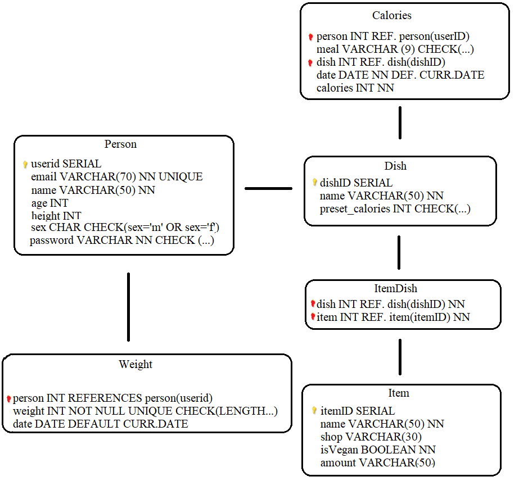

Figure 2: Initial Database ER Diagram

Relations
The entity Person would hold all of the details of the user, the ones that pertained to use of the system (e.g. height and sex) and the ones that would be used to achieve ACID compliancy (e.g. userid, email)

The associate entity calories would hold all the log of the meals eaten by the user and the date on which this was done. Foreign keys were used with regard to the person and dish entities.

The entity dish would hold all dishes created by user. The preset_calories column was the implementation of the need for accurate portion logging, so rather than a dish’s calories being calculated from the summation of its items, a different value could be set based on what amount of the dish users actually ate.

The associate entity ItemDish reflected the many-to-many relationship between the dish and item entities, as doing so eliminated redundancy of data repeated otherwise.

The entity Item would hold all of the individual items that comprised a dish and their relevant information.

The entity Weight would store a log of user weights that they reported.

These item and dish relations will build the foundation of storing information about the food eaten, with items of food bought comprise a dish.

Classes

The classes required to implement this system were designed were divided into two categories: the controllers and the server side. The initial draft of classes is shown below in Figure 3.

The thought behind the design of the classes was the standard programming principle of high cohesion, low coupling. This paradigm is so, as by keeping intra module functionality closely-related and inter module relations to a minimum, it increases the maintainability of software over time as more features are added and removed [29].

With our iterative approach to development, it is very likely that the information contained in the classes and even amount of classes is going to change, so we do not want to create a fledgling system that will require almost near rebuilding every time this occurs.

There is high coupling in places where the server is concerned, but this is fairly unavoidable, as the system needs the sever to operate. Otherwise, classes have only one or two interactions with other modules.

The cohesion aspect of the classes is not viewable from the diagram but can be seen in figure REFERENCE.

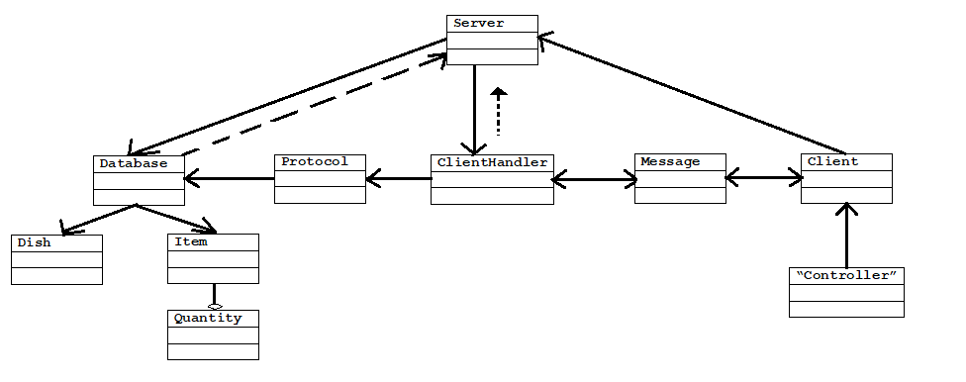
Figure 3, Initial Class Diagram

Class Entities
The Server class is the server of the model. The system cannot be started without it. The server class accepts client requests and starts a new ClientHandler object to send and receive data. It is responsible for opening a database connexion, using the Database class.

The Client class is where the application is run from. It connects to the server. It is used by the relevant Controller class (whichever one is used by the current window of the GUI) to send a Message object.

The Message class dictates exactly what type of data can be sent and received. The controller class can send only Strings but can receive ArrayList<ArrayList<Item>>, ArrayList<ArrayList<Dish>>, and ArrayList<ArrayList<String>>.

The ClientHandler is the multithreaded realisation of the Server class, created to achieve concurrency. This takes the Message object and passes it to the Protocol class. It needs the server open to achieve its operations.

The Protocol class is the implementation of the protocol element of the client-server model. It takes calls upon the relevant Database method as dictated by the Message object passed.

The Database class is the realisation of the database. It uses the Item and Dish classes to pass data objects.

The Dish class is a utility class used to pass data pertaining to the dish relation from the database when using a TableView object.

The Item class is a utility class used to pass data pertaining to the item relation from the database when using a TableView object.

The Quantity is an enumerated class used by the Item class to provide information to the GUI about what it should display for a given Item’s ‘amount’ property.

The Controller class mentioned was a placeholder representation of all the controllers used by their respective GUI windows.

The entire operation of the system relies on users storing the meals they have eaten which are comprised of items of food. As can be seen in Figure 1, the database will need to store a lot of information about these two entities; therefore, I saw it fit to create two classes to accommodate this (a meal eaten is identified as a ‘dish’ and an item of food inside the dish is an ‘item’.

The creation of the Dish and Item classes, though not a necessity, serve to aid in code readability and efficiency. For example, though possible to store all data as an array of Strings for an item, it is simply much easier for the developer to create a new object and pass in the appropriate values, or, when retrieving them, create a method to fetch the appropriate value; to fetch the itemID of an item (a value used by two foreign keys), we can simply call the method getID().

View: The GUI
In the previous section, mention was made of giving the MVC a lower priority than the other components. This seems contradictory given how usability of the software was placed as being a key feature of the system in our design brief.

The distinction drawn was that a functional GUI need not be attractive. Key features of a successful GUI include visibility, consistency, and predictability [30]. Another consideration is to provide feedback on screen so as to help inform users where mistakes were made [31]. Although an aesthetically pleasing GUI certainly does help aid user experience, the functional requirements of the system are what should guide us, and functionality of the database and implementation of our core features must take priority. Where
Prototype GUI windows are shown in REFERENCE.

Controller: The Controller Classes
The GUI element of the system was not fully realised at this stage of the project, as the implementation of certain features would be highly dependant on the time permitted. This was because GUI programming was the least in which I was experienced of all three components, so features had to be added during implementation, dependant on how easily they were to get functioning.

Several classes were instead created with blank methods inside (similar to an interface), where expected functionality would take place.

A more planned implementation could have seen greater adherence to prototyping and a more structured approach followed, possibly with initial use cases developed. This was a choice considered, but, relating back to what was discussed in SoftwareArchitecture REFERENCE, I decided a safer way to do this was to be flexible and create GUI windows as progress developed, as then the functionality could be written without need for a specific vision for a window, and then that functionality could be assigned to one window or another based on other factors (this would be made possible by our adherence to the high cohesion, low coupling paradigm followed).

PROJECT MANAGEMENT EVALUATION
and, indeed, this happened several times during the project and the problems that arose from this took valuable time out of the schedule to fix.

More stringent planning at the risk of suboptimal solutions would have benefited the project greatly; for example, the decision in week 7 to switch development to Android instead of Windows, whilst based well in research and would be the preferred choice were the project to be undertaken again, cost was ultimately aborted, losing close to a week’s worth of time for no return. It would have been a much more prudent choice, simply, to acknowledge the poor choice and work with it, as, by the end of the project window, I was very short on time and behind, greatly.
Implementation:
Software Architecture
Platform
The choice of platform chosen in our design phase was Windows. However, in week 7 of the project, the decision was made to switch our choice of RDMBS to SQLite (this is covered in the next section). As this change was to take place, the choice of platform was re-evaluated as well. We noted in our design brief that Android development was a more suitable platform, and, as SQLite is compatible with Android development and one of the more popular choices, the decision was made to switch to this.
This switch, however, was abandoned a week later, as, for reasons unknown, the IDE used would not accept the JUnit test facility, and this was deemed to important to compromise, so development was switched back to Windows.

Model
In the design section of the document, we noted that the system would be using a client-server system, the use of which would require a remote database to store data. As such, the RDBMS chosen was PostgreSQL, again for reasons of developer familiarity. During week 7 of the project, however, it became clear that this was a suboptimal solution for the requirements.

After re-evaluating the research and functional requirements, it became more apparent that a server was not necessary; the system is designed for one person to track their food diary and nothing more. Whilst we did previously make mention of the possibility of interaction with other users, this was a very brief point and a low priority functional requirement. There was very little research behind this feature, and aside from this, there is no need to interact with other users.

In fact, it would be less than ideal to use a client-server model, as this would bind us to requiring a connexion to a server to alter data in our table that makes no use of the server, a problem exacerbated by the fact that our research suggests that users should, ideally, add meals to the diary as soon as possible [4]. Ultimately, our server would be almost entirely superfluous, so it seemed a poor design choice to have the entire model component of our system dictated by this one feature.

The only part of the application that would benefit from a server would be the item relation, where all the food items that users build meals from are stored.

As there is no server, the application and all data held stored on the user’s machine, an embedded database is used. Again, the only key deficiency with this system is that the database of food items would be static and unable to be changed unless by the user or some sort of download, where an application containing new values to insert into the database could be run. Both are options that could ideally be implemented were the project to be realised more thoroughly, with emphasis on the latter.

As around four weeks’ worth of programming had already had been done, the Protocol class, responsible for passing Messages to the Database class to perform database, had already been implemented. So as not to disrupt work further, this was left in the program and still used even after the server was removed.

Following this and the decision was made to switch to SQLite. This was done so for two main reasons: developer familiarity and the need to use an embedded database.

PostgreSQL and SQLite are virtually identical in syntax, meaning that the bulk of the code already written could be kept. The only parts of SQL code that needed to be modified were those pertaining to date and boolean variables, as SQLite lacks these. The transition was very simple, as booleans were changed to ints and the dates stored as texts.

As well as being useful for developer familiarity and time saved rewriting existing code, SQLite is ACID compliant with transactions, a feature outlined in the abstract as one of the most important to consider for the project.

The drawbacks of using SQLite pertain mostly to its lack of concurrency and inability to handle large amounts of data efficiently [5]; for this project, however, this is not a problem, as our single-user approach and lack of any server mean that only one user will be sending queries at any time, so with correct implementation of our database in our controller classes, this will be of no consequence. In terms of data storage, the system is unlikely to come any near the 1TB maximum capacity suggested by the developers[6].

The one issue with using SQLite that we must take note of is the lack of guarantee of domain integrity[7], where variables types attempting to be stored in the database do not match the specification in the schema (e.g. an int stored in a column designated for Strings). To avoid this issue and any dirty data is may produce, testing is needed in the controllers of the system to stop users from inputting incorrect data types. This will be covered later on in the testing section.

Model: The Database

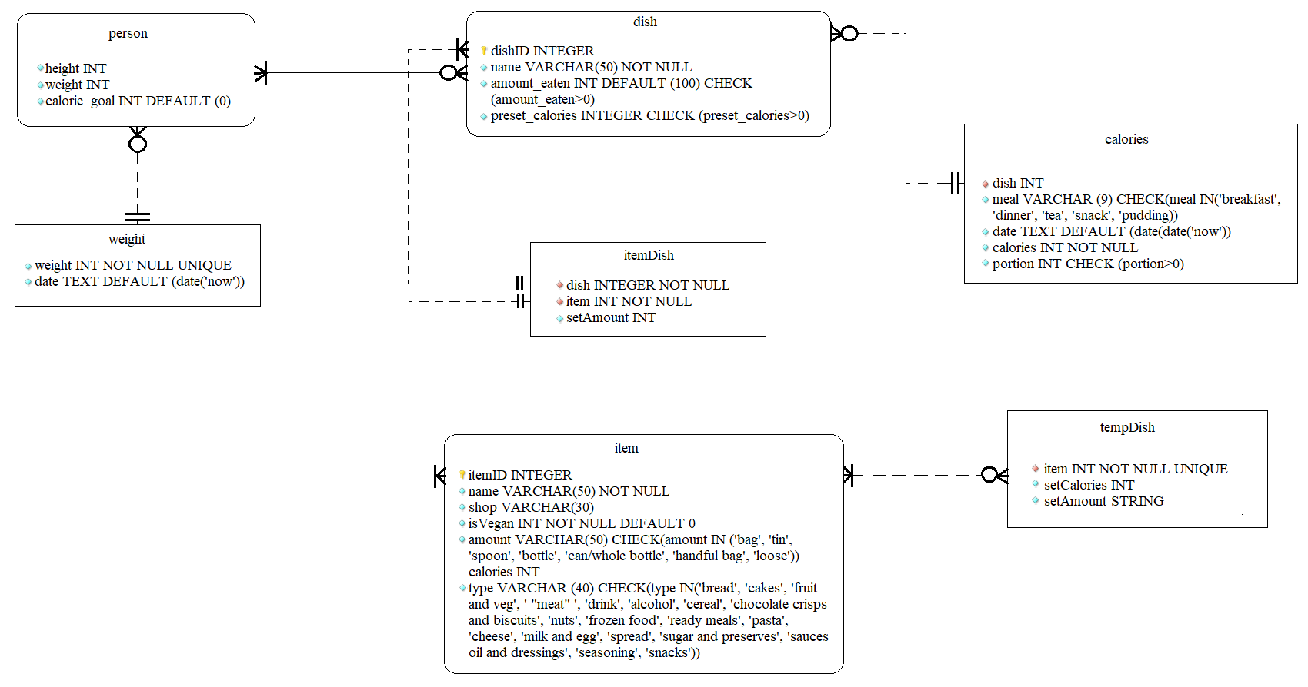
Figure 1: Final Database ER diagram

The database created in our design phase was never intended (as per out iterative approach) to be unchanging, and the actual implementation of it by the end of the project had many modifications. All the same relations from our design phase were kept, but a new one, tempDish was added in week 9. This was necessitated by the functional requirement REFERENCE, that users can build and store their own dishes.

Our dish relation is used to store three pieces of information about a dish: its name, the amount of it eaten, and the preset number of calories it has. These last two are used to fulfil our requirement that a dish must have a calorie value, but that this value is not equivalent to the portion eaten. With these values, the actual total calorific amount of the dish according to recipe can be logged, and then the amount eaten by only the user can be logged separately.

The item has six attributes. Aside from the obvious attributes, we note the values, shop, amount and type. The shop attribute allows us to track from which shop an item comes. This relates back to section initial planning where to achieve greater accuracy of calories, actual shop items would be logged.

The amount attribute allows us to implement the estimate-based measurement system of the food diary, as we are not using weights to record calories. Instead, via conjunction with the calories attribute of the item and our Quantities class, we can establish a measurement.

Additions pertain mostly to increased CHECK functions on columns (to prevent dirty data) and the remodelling of the calories and itemDish relations to aid in the logging of item and dish portions.

Implementing the Estimate-Based Measurement System
The Measurement
As we are using estimate measurements and not weights to measure our items, we need some way of attaching a measurement to an item. This could be done simply by percentage, where the user estimates roughly by percentage (e.g. if they used half a bag of mince, they would log the amount as 50%. But this is not user-friendly or intuitive as our research indicates it should be.

First, an amount if given to an item. This is difficult to do so accurately, as there is no standard that can be used. We do not need sharp accuracy though, as this is an estimate. To create this, I viewed a sample of recipes and devised it based on the amounts commonly used. For example, items that are measured cardinally, are classed as ‘loose’. Items that are measured by tablespoons or teaspoons are classed as ‘spoon’. Items classed by a percentage of the bag used are classed as ‘bag’. This amount is logged in the item relation and are controlled by a CHECK function, that no item can be logged without belonging to an amount.

The second component of this is the calorific value. How we log the calorific value is dependant on the item amount. Most of the time, calories are stored by the full amount in the container. This is because, the way the system works, the size of the item does not matter, except for two amount values (we shall explain why later).

The third component is the Quantities class. The quantities class features an enumeration called quantity. This quantity enum takes two elements as part of its constructor, the item container and a double value. An enum can take more than one container in its constructor. The container values correspond item amounts.

For example, the enum value ‘WHOLE’ can take four containers, ‘bag’, ‘tin’, ‘whole bottle’ and ‘can’ (but not ‘spoon’ or ‘handful bag’). The double value for ‘WHOLE’ is 1.0. What this means is that the enum ‘WHOLE’ has the double value 1.0. The value WHOLE is then multiplied by the calorific value of the item stored in the database and the portion size is gained.

Let us take a bag of pasta as an example. The item pasta comes from a particular shop and is logged as an item in the system, and it will have its calorific values logged. Let us suppose that the item is logged with a calorific value of 1000. The calorific value logged depends on its enumerated value (this will be covered later). If this bag of pasta is then used in a recipe (pictured below), we will need to specify a portion for it. As it is has the amount value ‘bag’ stored in the Item, it will have four enumerated values attached to it ‘WHOLE’, ‘HALF’, ‘THIRD’ and ‘QUARTER’.

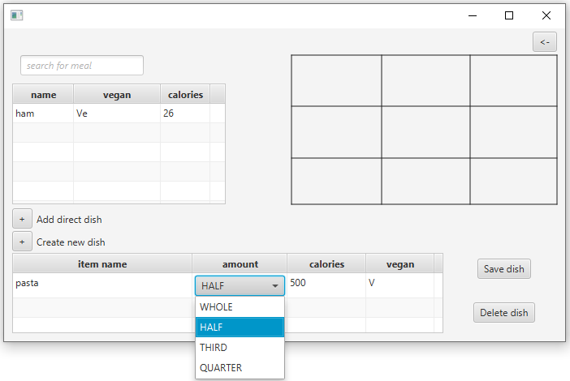
Figure X:

As we see from the above, if we select the value ‘HALF’ from the table, we know this corresponds to the enum value ‘HALF’, which has the value 0.5. The system then finds the calories stored for pasta, 1000 and multiplies it by this value, which gives us 500.

It does not matter how big the bag of pasta is, as half a 1kg bag and half a 250g bag is still 50% of the total. The only time this is different is with ‘spoon’ and ‘handful bag’, because these are measured not by percentage. A jar of peanut butter, for example, tends to list the serving suggestion by tablespoon, and a tablespoon is measured in millilitres [35]. To solve this problem, the calories for a jar of peanut butter would be stored by the tablespoon, not the total amount in the jar. The other measurement commonly found in recipes that tend to be measured by spoonfuls is teaspoon, and a teaspoon can be measured as a direct percentage of tablespoon (it is 3:1 ratio of tablespoons to teaspoons) [35].

This also reiterates the use of real shop items over generics, as now, though the portion size cannot be guaranteed (though a close approximation is hoped) the calories can, and we can recoup some of the losses to accuracy that we sacrificed in order to implement the more user-friendly estimate system.

Adding the Measurement to the TableView
The process that we must go through to get the calorie portion of an item is only the first element of implementing the feature. The second phase is loading those values into the table.

Our recipe builder table in figure x is created by instantiating a TableView object of type Item. To populate this table, we perform a database query that retrieves an object of type Item and load it in. Normally, this causes no problems, as we can simply use the convenient Java method setCellValueFactory(), and pass in the corresponding details from the Item class. As our Item class and item relation share the same attributes, this works perfectly. To get the name of the Item we want to load, we pass in the parameter ‘name’ to this method, which looks at the name value in our Item constructor that was set by the database.

This cannot be done for the amount, though, as if we did this, to our pasta item, the amount listed would be ‘bag’. Instead, we have to set a custom CellValueFactory, which takes much more time as the process is not as automated. The code snippet required to do this is listed in appendix. Instead, we now have to set up the ComboBox manually and pass in the appropriate values manually and then set the ComboBox to appear in the cell manually. This is made more difficult by the fact that amount of type ‘loose’ do not have a ComboBox dropdown menu, and must be typed in by the user, so we have to ensure that correct functionality applies.

The way in which this works is by use of attaching a listener to the ComboBox value. Whenever a change in the amount selected changes (e.g from ‘WHOLE’ to ‘HALF’), this updates the value of the calories column of the table. Because of this, we can’t simply set our Item class to use the calories amount stored in the database, as otherwise the database will simply load that value in, regardless. Instead, a new attribute was added to the Item class, caloriesBound, that, via this precise programming, will multiply the enumerated double of the amount selected from the ComboBox or the user-entered number if the amount is loose. The listener then calls the setCaloriesBound() method from Item and passes in the value. This value is then set by the calories column in the table.

Also, for a user-friendly experience, I decided that a user should be able to select an amount value of the item they have selected and add it to recipe builder, and the value chosen should remain selected along with the modified calories (as otherwise it will default upon leaving the page). This requires even more engineering, as now the program must check if there is a pre-existing portion stored, and if so, it.

Controller: The Controllers
The controller element of the project was written in Java. C++ was also considered, owing to its less verbose style of code. The choice to use Java was done almost exclusively for developer familiarity, but it has several benefits, nonetheless. It is platform independent (C++ is not) is a popular language for application development.

View: The GUI
The view element of the project was written in JavaFX, the current officially recommended GUI library for Java. This was a logical choice considering the controller is written in Java. Another choice considered was Swing, the previous GUI library officially recommended by the developers. Both are suitable choices, but JavaFX is noted [33] as being better suited for MVC development and is a better choice given developer familiarity.

Classes

The Dish and Item classes are used throughout the application to populate the many tables used. Their class variables reflect those of their respective database entity albeit with minor variations. The constructor for the Dish class has five variables passed through to it rather than the four that it has in its database entity, with this variable being an int that specifies if the dish is vegan or not. The query sent to the database when retrieving a Dish performs a CASE query, where all component items of the Dish from the itemDish table are checked to see if their respective item is vegetarian or not, and if one is, the dish is in turn marked as vegetarian rather than vegan.

This code, whilst not ideal for its lowering of the cohesion of the Dish class, was done for ease of development, as whether or not a dish is vegan is listed in every TableView it features in and therefore saves time performing separate queires.

Usability of the GUI
We outlined in our design specification that the GUI needs to be functional rather than particularly attractive and should incorporate features that aid the automation of the food diary.

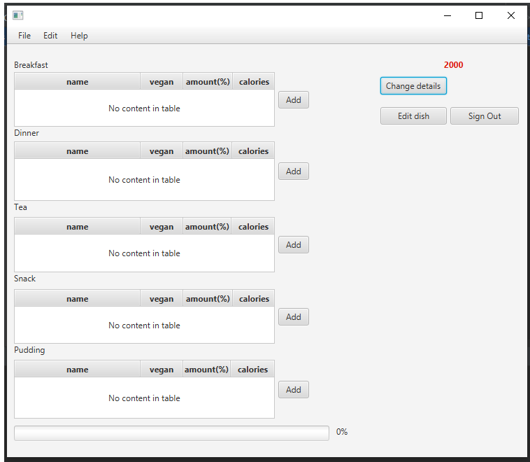

Figure X: body

The above is a picture of body.fxml, the de facto homepage of the application. This is the window that will load upon starting the program after the user has entered their details on the first use. We can see from here a few examples of where notions of usability have been factored into the design.

First the screen has been designed to be relatively free of clutter. As noted in our research, trying to implement too many features on one page can lead to a poor user experience, as it can be difficult to find the select features that one needs. When designing the

The calorie goal of the user is listed in the top right in red. This is entered o

The Operation of the PlantDiet Application
Adding An Entry Into the Log
To implement the core feature of the PlantDiet app, the calorie logging element, comprised several different components.

As seen in the above, the home screen on the application divides up the log into five different tables, each recording a different meal time (the classification of these was based on [34]).

Upon pressing the add button, the user is taken to the next screen, where a dish can be added.

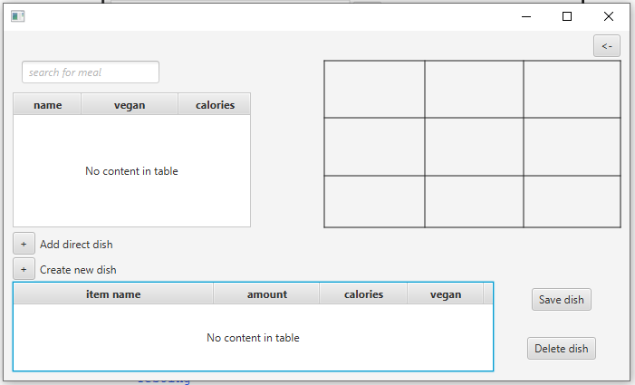
Figure X: addDish

Upon pressing ‘add direct dish’, the user is taken to the SelectItem window.

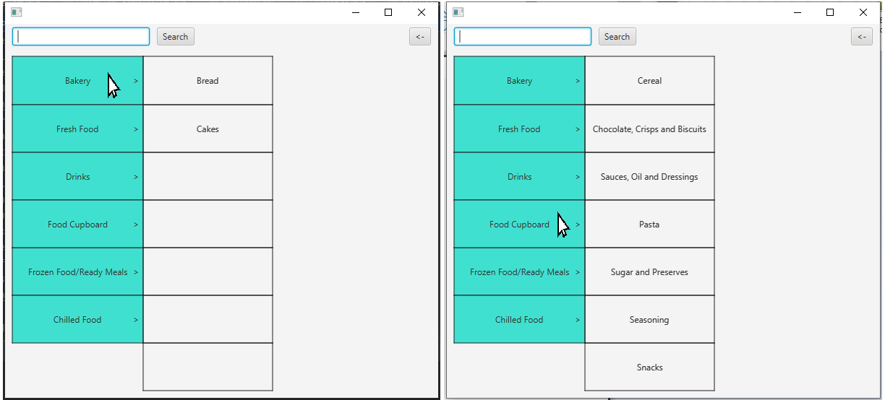
Figure X: ItemSelector

The user can hover the mouse over a category, whereupon a list of child categories will be displayed. Pressing the mouse once on a choice will take the user to the ItemChooser window.

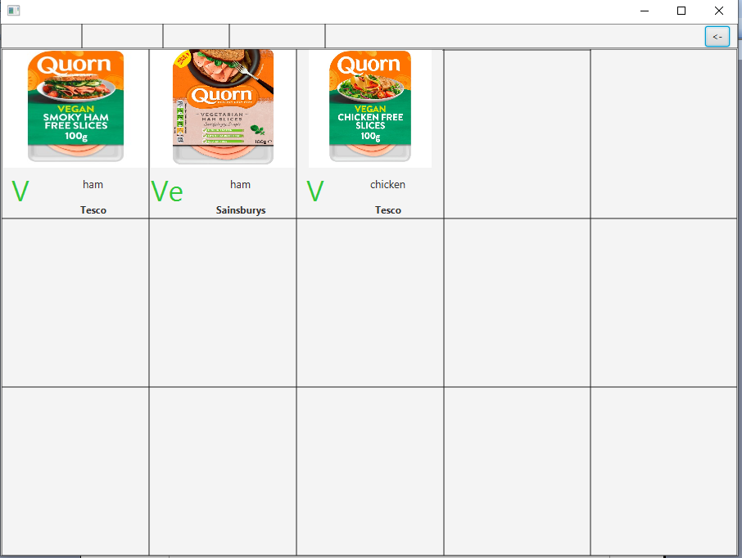
Figure X: ItemChooser

A list of items matching the type specified will be displayed. Double clicking an item will add it to the recipe.

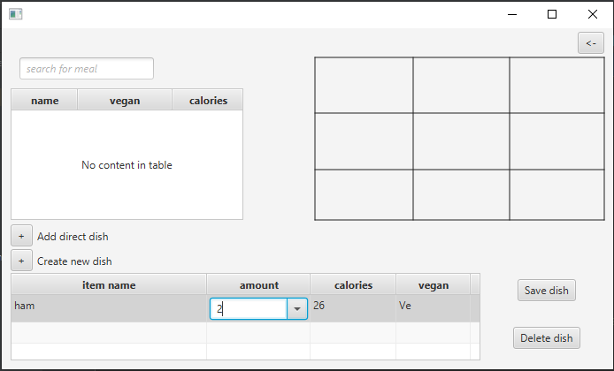
Figure X: The item is added
The item will now be added to the recipe. If the user double clicks the ‘save dish’ button, the recipe is added to the meal list, where it can be added into a respective meal time table and be logged in the database.

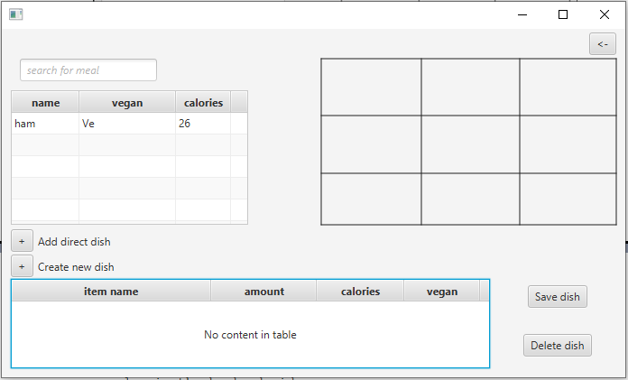

This process, though simple in appearance, is much more complex in the backend side, using five different database relations and six controller classes.

Upon the selection of a table, the BodyController Class instantiates an AddDishController object and initialises it using an FXML loader method (the method is kept in the Main class for reusability).

Testing
User testing
JUnit testing
The testing of the system was carried out both during development and then after, where a formal list of JUnit tests was drawn up. As explained in the design section, the database portion of the project was, by far, the most important, as the entire system is reliant on reading and writing to and from the system, and, as such, I deemed it necessary to focus the testing around the operation of the database.

An issue of JUnit testing is that it cannot directly test GUIs [15], so we are unable to test this directly. This is not important, however, as the MVC model of architecture we have deployed is designed explicitly to take logic features away from the view [REFERENCE], so we need be concerned only with our controllers and database.

Black Box Testing
Both black box and white box testing was used development, and both are necessary for any product to be considered sufficiently tested.

The issue of black box testing, however, is that it is primarily focused on user interaction, as the user does not know of the internal workings. Though useful, and deployed informally throughout development, the issue is that with a system so heavily predicated on the success of the database, the user may not notice errors that occur from their interaction with the software. As was mentioned in the previous section, the GUI does not contain the actual logic of operations; this is done in the database, but the database may be full of duplication and dirty data, but this is not visible to anyone without backend access and why errors occur can’t be evinced.

For example, we could write a series of black box tests, e.g.

‘Case 1: the user should not be able to add a dish to a meal table in the body if it is already present: expected result, item not added: outcome, pass’

And this test would be a good indicator that the particular part of the system is working; however, because of how the system is designed, that dish added will have data spread across several tables: the calories table, the dish table, the item table, and the itemDish table, and all the respective functions of these need be intact.

During development this informal test case was actually used, and appeared to have passed, but if fact, although the dish was not added to the table, it was being added into the database, and this was discovered only after a test method checkIsAddToTable() was written.

Therefore, though a formal list of black box test cases could be written, the functionality should, a priori, come from the correct functioning of the database, and the expected results of interacting with the system can be explained via an instructional guide of operations, so both of these together account for the black box testing.

White Box Testing
For white box testing, put succinctly, “the underlying hypothesis is that the program code (or architecture) corresponds to the customer requirements and the contractual or regulatory applicable standards.” [12] and this is the case, exactly. The user requires to read and write data, constantly. There is not a single function of the project that does not involve a database query; thus the very foundation of a functioning product is bound to its efficacy.

To implement this white box testing of the database, the JUnit test were devised during development, where, upon creating a new method in the Database class that dealt with interaction to the database, this would immediately have a test written in the DatabaseTest class. A preset set of debug data was created for the explicit purpose of testing different methods, with the idea that this data was controlled by the developer and therefore, in theory, the expected result of the method could be known.

The preferred structure of a test for a method was to pass in expected good data and expected bad data and assert that the method would succeed and fail, respectively. The theory behind this was that though an expected test may pass with good data, it could also produce false positives and pass with bad data [REFERENCE]. This was not always feasible, however, as during development, differing sets of debug data were used as more features were added, so writing a test case with assertEquals became problematic, as the test may have passed when written, but would fail later as more results were returned.

To work around this, the standard way of writing a test was to create a blank version of what the method was intended to produce. For example, if a method was supposed to return an ArrayList<ArrayList<Item>>, an ArrayList<ArrayList<Item>> with no data in it would be created, and the test would assertNotEquals this. Similarly with a boolean, the method would by default deliver a false, unless data was returned or an update to a table performed, in which case it would be true.

Owing to a lack of time (stemming in part to the laborious effort and time taken of having to create these tests) not all tests were carried out in this ‘one positive, one negative fashion’ and some have only one test associated with them. Also, owing to their very late implementation, not all database methods were tested. Overall, 33/36 database query methods were tested, giving us about 92% coverage.

Although some tests were written for some of the controller classes, these were deemed not necessary, as their working came from the database, and a simple combination of JUnit testing and an informal black box test was sufficient to judge their accuracy.

In the evaluation section of this report, however, it is noted that there are some errors and bugs that have resulted from a lack of black box testing, so formal testing would have been a good idea to implement.

Discussion:
Strengths
The Database
As was outlined in the design section, the most important consideration undertaken when designing the project was the need of a functioning, robust database free from dirty data where all user data could be stored and retrieved. This was the foundation of the entire project and the part given utmost priority.

The implementation of this was a success, as all but one of the database test cases were passed and only three lacked any tests, giving an overall coverage of 92%. No example of duplication, unsolicited deletion or any problem of this kind was found during the test phase. The difficulty surrounding the implementation of this design came from the high interplay between the relations; although the GUI ostensibly produces a simple case of data retrieval, modification or deletion from a user action, for efficiency and to reduce data redundancy, database queries frequently used joins to get the relevant data, some methods even involving multiple queries made in succession and others involving complicated joins.

For example the method getMealList() retrieved an array of dishes, and part of its functionality was to denote whether or not the dish contained any vegetarian items. While this could have been achieved simply by creating a column in the dish relation and retrieving it from there, such a design choice introduces redundancy, as we can extract this information from its respective itemDish entries.

Whilst certainly the more difficult choice to implement, this choice reflects the values outlined of in our design phase perfectly.

Testing
Throough testing was implemented as soon as the first database method was written and each database query would have a unit test written immediately after it to ensure its accuracy. Such a stringent implementation did slow down the workflow, as even the most basic of queries had tests attached to them; however, when dealing with a database of this design, with modifications performed frequently and relations often needing to be joined to achieve the desired result, the trade-off between time spent and outcome was favourable.

For example, up until week 11, all queries that delivered information pertaining to dishes did so by delivering an array of an array of Strings instead of the custom dish type we created. I made the decision to rewrite all these methods to return the dish type instead and the process of error-correcting all the newly introduced bugs from this switch was resolved in a matter of hours, as tests could simply be run, and any failures corrected.

This also allowed for the addition of the reset() method that defaulted the database back to predefined table schema and debug data (files tabledef.sql and tabledebugdata.sql, respectively) after each unit test was run. This ensured accuracy for each test and provided a very fast workflow without the need of manual modification.

Deficiencies
Testing
Whilst mentioned in the strengths section and highlighted for their value, the testing was not as thorough as was hoped. Whilst the basic principal of using formal white box test cases over black box test cases was correct, some errors still occurred. Whilst these could have been identified using white box testing, the way this would be done is difficult and taken a lot of time to implement, and the essence of black box, specification-based tests, would have discovered this much more easily.

Quantities
As mentioned earlier in the background research, one key point noted was the importance of accuracy in logging calories and the problem this poses with regard to ensuring accuracy and keeping it accessible.

As a response to this, it was my intention to forgo the received method of measuring out quantity, as this is a factor noted by people as a deterrent in remaining consistent with their progress [REFERENCE].

The enumerated class that I created ‘Quantities’ (implemented to display the ‘amount’ category of the item relation) to deal with this did not give me returns proportional to the problems it caused. Designing the class took a decent amount of time and implementing it in the controller took even longer, causing considerable delay, taking a week’s worth of work before it worked and even then more days were spent modifying it to fulfil the functional requirement of remembering the user’s choice.

Were the Quantities class implementation a good solution and fit for the problem it sought to solve, the trade-off of time would be mitigated; however, it still does not perform sufficient for need. For example, if a user creates a dish that is classed as ‘spoon’ and requires 4 tablespoons of said item, this is not possible to do, as the system gives only the choice to use a single tablespoon or teaspoon.

Also, the ‘amount’ category is too rigid and incomplete. Broccoli is a food that recipes often measure in heads or florets, but the system does not allow for this. We are also unable to change the ‘amount’ of a food respective to dish we are making; for example, sugar is classed as ‘spoon’ in our amount system and though this may be accurate for some dishes (we may put a teaspoon of sugar in a pad Thai), if we were making a cake, it is likely that we would need to use much more.

Despite its significant drawbacks, the Quantities class was successful in its aim of making measurements easier.
TALK ABOUT BUILDING A DISH

I feel the Quantities class choice has value and could be better implemented if more time were allowed, as it seems a much more intuitive way to measure items rather than by weight and, as a user, I felt it much less laborious to log foods doing it this way. Better implemented, it would allow users to change the amount classification respective to the dish and also, allow the users to switch to the traditional method of using weighing for greater accuracy were they still not satisfied.

Features and Requirements
As outlined in the functional requirements, the system had a list of requirements listed as ‘must’, but several of these were not met because of lack of time.

Functional requirement (NUMBER) was not met and was never even attempted. Though this was the case owing to a lack of time, another problem was that the entire vegan/vegetarian aspect of the project was not well researched and subject, mostly, to my own choices as a developer, therefore making it difficult to justify why this feature would be classed as a ‘must’ in the first place, and, really, it should have been classed as a ‘could’; I believe, therefore, it was a correct decision to cut this feature.

Another feature that wasn’t implemented was functional requirement (NUMBER), the log book. This was something better grounded in research and more valuable than functional requirement (NUMBER), and the omission of it weakens the efficacy of the system, as a large reason of keeping a food diary—as the name itself suggests—is as a diary, a journal where users can track their progress. As it stands, as soon as the day is done, the user can no longer see any data of what they have eaten.

This ultimately reduces the system to being useful in the short-term only and does not accord with the design and research particularly well; far greater priority should have been given to this feature.

Functional requirement (NUMBER) does account somewhat for the this idea of tracking progress (albeit in the short-term only) and the implementation of it I found, as a user, to be very useful in having a visual aid of our progress as was discussed in the research. On this same theme, it would have been a benefit to the tracking progress element of the design were functional requirement (NUMBER) able to be implemented also.

Project Management
An informal draft of time management was drawn up and submitted in the project proposal. This system would have seen the initial two weeks dedicated to planning and research, the weeks proceeding that dedicated to programming, two weeks given for testing and evaluation and a final two weeks spent writing the report.

Unfortunately, several setbacks and changes during development derailed this severely, and the last four weeks of testing and writing the report were instead condensed into a single week, a change that devalued the quality of the report written.

The cause of these developmental setbacks can be attributed largely to the lack of a structured schedule for programming. With hindsight, it is clear that not all of the features outlined could have been implemented with the time given, but no serious regard was given to which should be cut and which should be used.

Another large loss of time came from the aborted switch to Android, costing about a week. Although the switch would have been more suitable to the specifications of the project, it was too late in development to implement this, and too much code was already written. Were a better project structure in place, this could have been discarded immediately as too much of an encroachment on the project schedule and the project kept on track.

Conclusion:

Were the project to be undertaken again, a far more planned approach would be employed, paying more attention the functional requirements and ordering them into a hierarchy of importance, with strict deadlines on when each task must be completed.

I believe better planning would have spared some of the more egregious time-wasting decisions and the time saved in doing this would have proved sufficient to have the project realised as was originally intended.

