Instructions:

1, In the terminal, open the file and run it.

2 When the prompt pops up, input the data in format shown in the image.

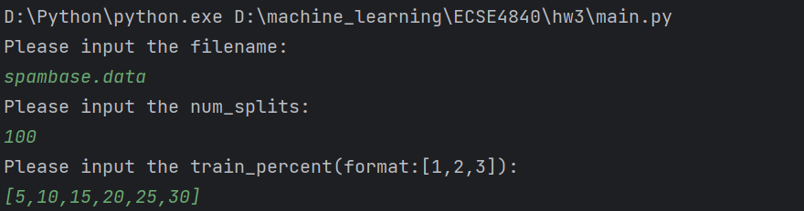

3 Then the result(mean and std for both methods) is shown in the terminal  
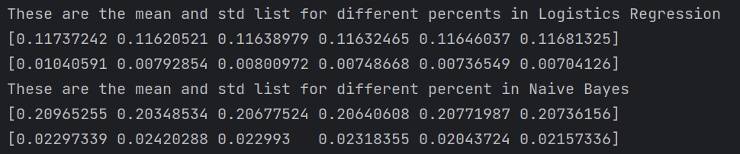

4 Finally, we can get the relative performance image.

The online code link is

<https://github.com/vincent-yangx/ECSE4840/blob/master/hw3.py>