Answer

**thinning**

**本次作業使用python, IDE為Spyder**

Description

1. Method of Algorithms of thinning operator
   1. Yokoi connectivity operator

It is same as HW6.Thus, I will not describe anymore.

* 1. Pair Relationship operator

From the previous Yokoi array.

Let state= (**Yokoi number =’1’ $∧$ at least one of Yokoi number neighbor =’1’**)

If the state condition established, output 1, otherwise=2

* 1. Connected Shrink operator

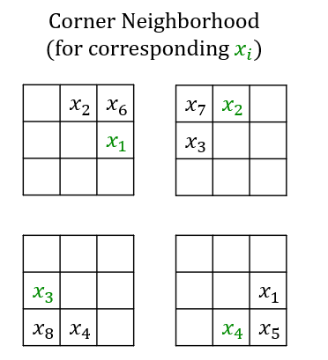for 4-connectivity

$h\left(b,c,d,e\right)=\left\{\begin{aligned}1 if b=c∧(b≠d ∨ b≠e) \\ 0 otherwise \end{aligned}\right.$

$$a_{1}=h(x_{0},x_{1},x_{6},x_{2})$$

$$a_{2}=h(x_{0},x_{2},x_{7},x_{3})$$

$$a_{3}=h(x_{0},x_{3},x_{8},x_{4})$$

$$a_{4}=h(x_{0},x_{4},x_{5},x_{1})$$

$$output=f\left(a_{1},a_{2},a_{3},a_{4},x_{0}\right)=\left\{\begin{aligned}g if exactly one of a_{1},a_{2},a_{3}{,a}_{4}=1 \\ x_{0} otherwise \end{aligned}\right.$$

**Input** : A+B

**Let A=**operating of f(h())in every pixel of (original symbolic image)

**Let B=**output of pair relationship

If the pixel in A =1 $∧$ B = 1, then output pixel =0, which means delete

**Repeat step1, step2, step3 until the last output never changed**

1. Source Code Description

**主程式:**

先做binary ，再做downsample，再做 thinning(Yokoi+pairRelationship +connectedShrink )

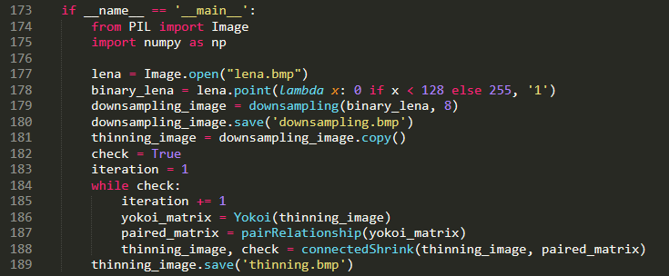

**Yokoi:**上次作業做過，不再重新說明

**pairRelationship:**

**如果yokoi matrix 的pixel 不等於’1’，output2，如果yokoi =’1’則4-connected也必須等於1**

**才會output=1，否則一律標為2**

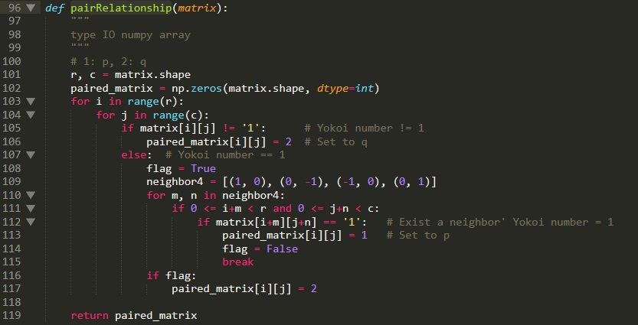

**connectedShrink:**

**如果yokoi 是1，並且經過計算的f(h(原圖))也等於1則將output=0，並flag=1，繼續重複流程**

