Answer

|  |  |
| --- | --- |
| Lena.bmp | Laplacian mask 1  Threshold =20 |
| Laplacian2  Thresholds:20 | Minimum variance Laplacian  Thresholds:15 |
| Laplacian of Gaussian  Thresholds:3000 | Difference of Gaussian  Thresholds:1 |

Algorithm

Each kernel of function

|  |  |
| --- | --- |
| 1. Laplacian mask 1, Threshold =20 | 1. Laplacian2, Thresholds:20 |
| 1. Minimum variance Laplacian, Thresholds:15 | 1. Laplacian of Gaussian, Thresholds:3000 |
| 1. Difference of Gaussian Thresholds:1 | |

Code description

本次作業使用python3.7，IDE使用Spyder

1. Main function:

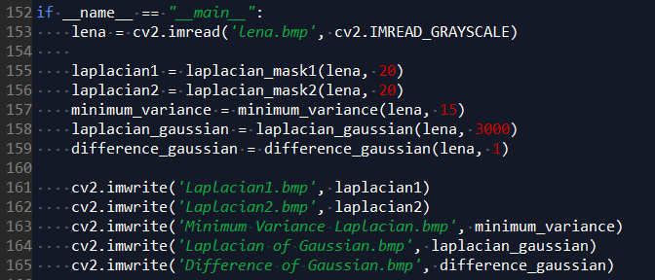

沒什麼特別，輸入格別function，再寫入bmp檔

1. get_label:

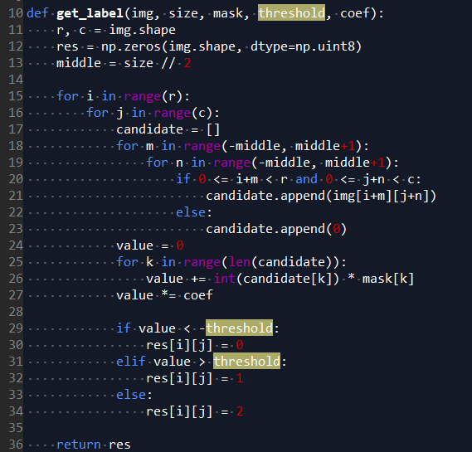

主要為判斷threshold以便往後做判定是否符合Zero Crossing Edge 條件

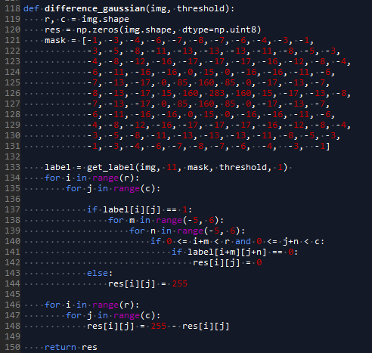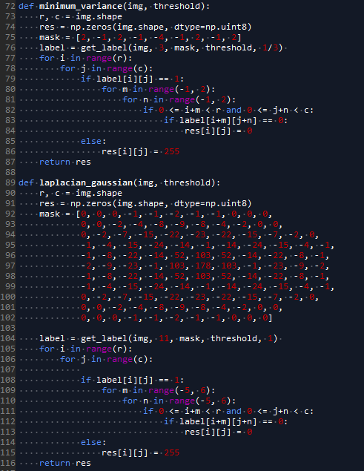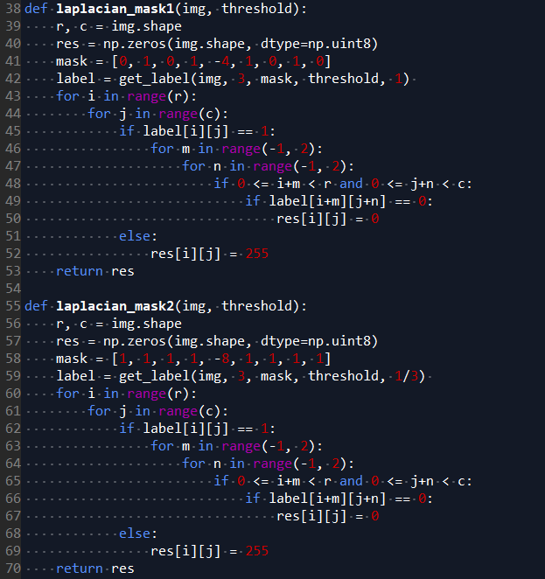

以上為五個mask 來判斷不同的梯度，也沒特別技巧，都依照上課PPT上去做