Answer

Yokoi connectivity number

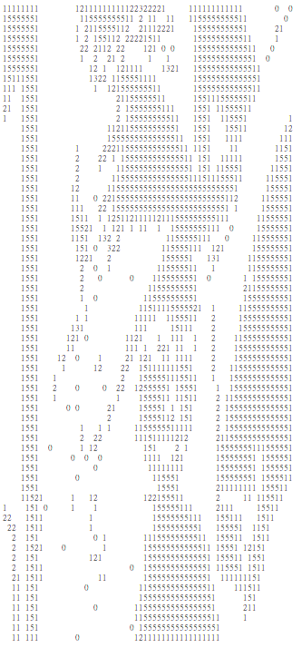

Description

1. Problem Formation
   1. Binarize the benchmark image Lena as in HW2 by 128
   2. using 8x8 blocks as a unit, take the topmost-left pixel as the down-sampled data, Down-sample Lena from 512x512 to 64x64
   3. Count the Yokoi connectivity number
   4. Result of this assignment is a 64x64 matrix. Please **align** the matrix within 1 single A4 page (using 4-connected).
2. Method of Algorithms

For 4-connectivity:

$$h\left(b,c,d,e\right)=\left\{\begin{aligned}q if b=c and (d≠b ∨e≠b) \\ r if b=c and (d=b∧e=b) \\ s if b≠c and (d=b∧e=b)\end{aligned}\right.$$

$$f(a_{1},a_{2},a_{3},a_{4})=\left\{\begin{aligned}5 if a_{1}=a_{2}=a_{3}=a_{4}=r \\ n where \#n\#=\#\#\#\#\#\#\#\#\#\#numberof\#\left\{a_{k} | a_{k}=q\right\}, otherwise\#\#\#\#\#\#\end{aligned}\right.$$

1. 本次作業使用python, IDE為Spyder
2. Source Code [HW6.py]說明如下

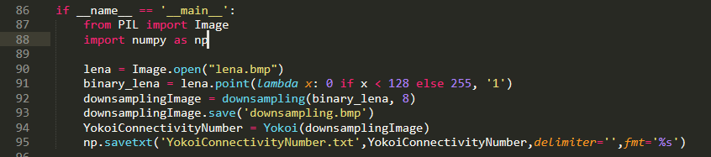**主程式**:

1. 先import會用到的library
2. 將lena圖讀進來
3. 進行binary 處理
4. 進行downsample, 8個取一個值
5. 進行yokoi 演算法
6. 最後將結果存為txt檔

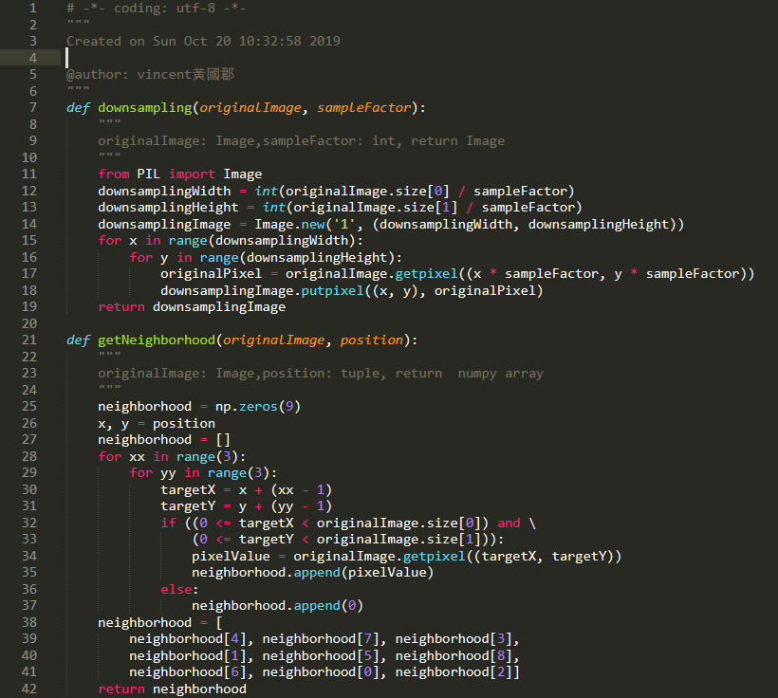

1. 將每一個pixel 值附近的九宮個取出
2. 重新排列成yokoi會用到的九宮格順序
3. 先import會用到的library
4. 取出sample後的大小
5. 建立新的output影像大小格式
6. 每sampleFactor的距離，將pixel取出來，放到output

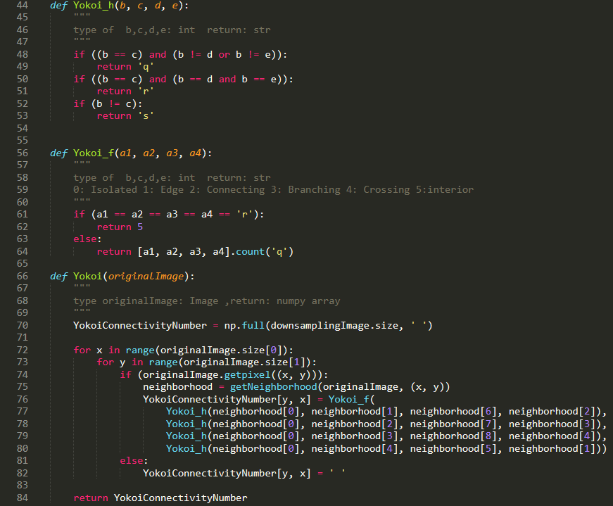

$$h\left(b,c,d,e\right)=\left\{\begin{aligned}q if b=c and (d≠b ∨e≠b) \\ r if b=c and (d=b∧e=b) \\ s if b≠c and (d=b∧e=b)\end{aligned}\right.$$

$$f(a_{1},a_{2},a_{3},a_{4})=\left\{\begin{aligned}5 if a_{1}=a_{2}=a_{3}=a_{4}=r \\ n where \#n\#=\#\#\#\#\#\#\#\#\#\#numberof\#\left\{a_{k} | a_{k}=q\right\}, otherwise\#\#\#\#\#\#\end{aligned}\right.$$

進行yokoi 運算，對每一個pixel進行f(h1(a,b,c,d), h2(a,b,c,d)………)

最後回傳array