|  |  |  |  |
| --- | --- | --- | --- |
| **Revision History** | | | |
| **Version** | **Date** | **Auteur** | **Description** |
| 001 | 05/12/16 | Gregory Amirthanathan | First version  Overview of Junit  How to start working with JUnit |
| 002 | 00/00/00 | Gregory Amirthanathan | Second version |
| 003 |  |  |  |
|  |  |  |  |

* What is Junit?
* JUnit is a unit testing framework for Java programming language.

## Features of Junit

* Junit is an open source framework, which is used for writing and running tests.
* Provides annotations to identify test methods.
* Provides assertions for testing expected results.
* Provides test runners for running tests.
* JUnit tests allow you to write codes faster, which increase quality.
* JUnit is elegantly simple. It is less complex and takes less time.
* JUnit tests can be run automatically and they check their own results and provide immediate feedback. There's no need to manually comb through a report of test results.
* JUnit tests can be organized into test suites containing test cases and even other test suites.
* JUnit shows test progress in a bar that is green if the test is running smoothly, and it turns red when a test fails.

## JUnit Framework can be easily integrated with either of the following −

* Eclipse
* Ant
* Maven

## Test JUnit Setup

Create a java class file name TestJunit

import org.junit.Test;

import static org.junit.Assert.assertEquals;

public class TestJunit {

@Test

public void testAdd() {

String str = "Junit is working fine";

assertEquals("Junit is working fine",str);

}

}

Execution status –

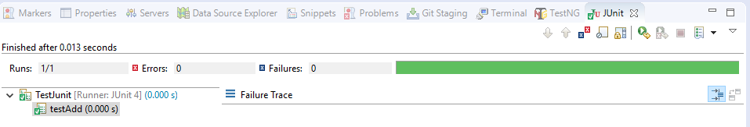

Create a java class file name TestRunner

import org.junit.runner.JUnitCore;

import org.junit.runner.Result;

import org.junit.runner.notification.Failure;

public class TestRunner {

public static void main(String[] args) {

Result result = JUnitCore.runClasses(TestJunit.class);

for (Failure failure : result.getFailures()) {

System.out.println(failure.toString());

}

System.out.println(result.wasSuccessful());

}

}

Execution status –

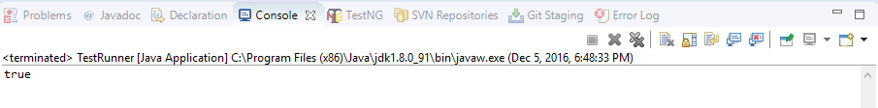

* Add Junit to Maven project

<dependency>

<groupId>junit</groupId>

<artifactId>junit</artifactId>

<version>4.12</version>

<scope>test</scope>

</dependency>

Run Maven build,

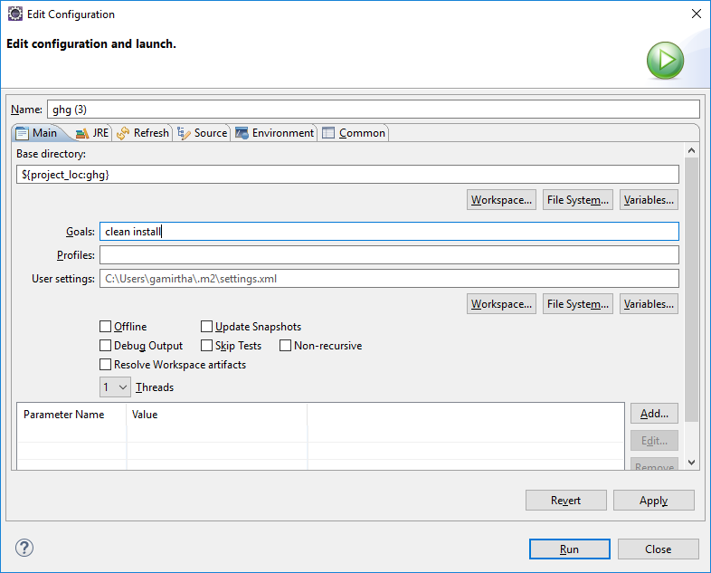

And see build status,

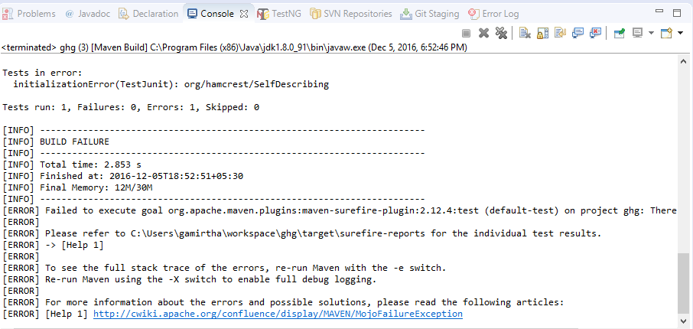

Note – Above status is failed, however adding library below helps.

## ADD Junit Library to Eclipse

A few steps you have to follow:

1. Right click on the project.
2. Choose Build Path Then from its menu choose Add Libraries.
3. Choose JUnit then click Next.
4. Choose JUnit4 then Finish.