1. **Convert any project to Maven project**

**Right click on project 🡪 Configure 🡪 Convert to Maven Project**

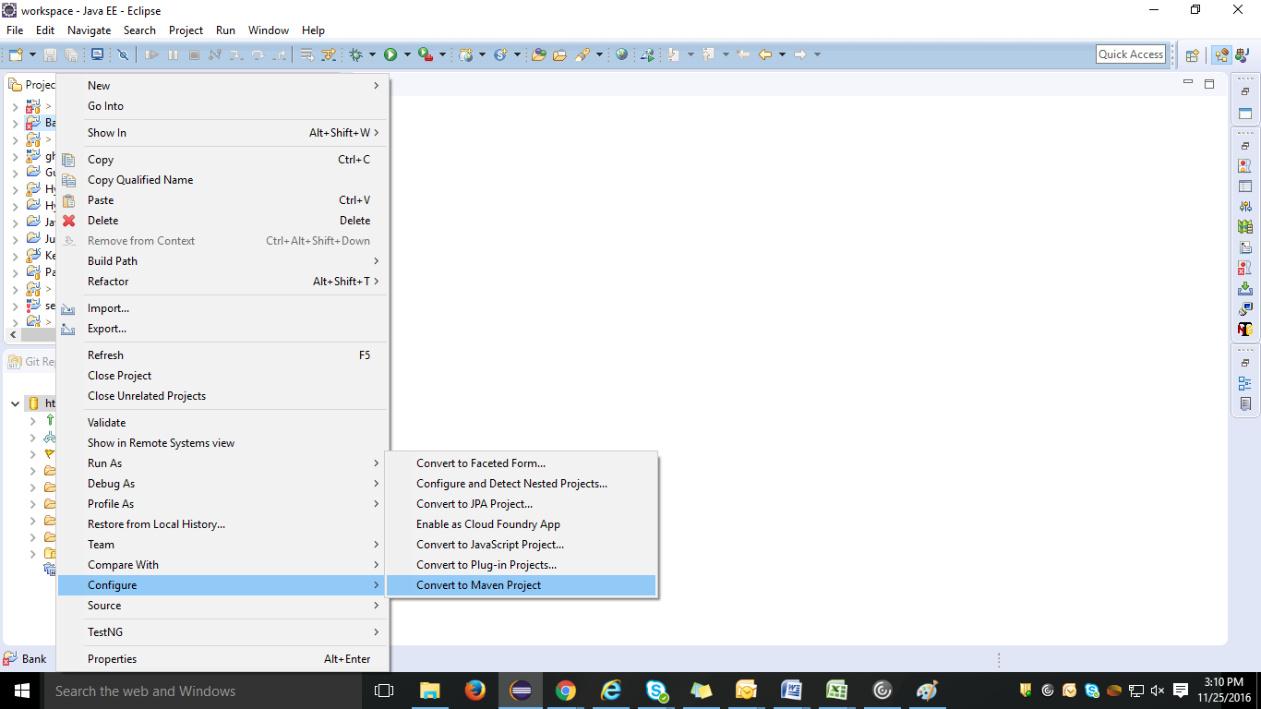

1. **Fill Group Id and Artifact Id**

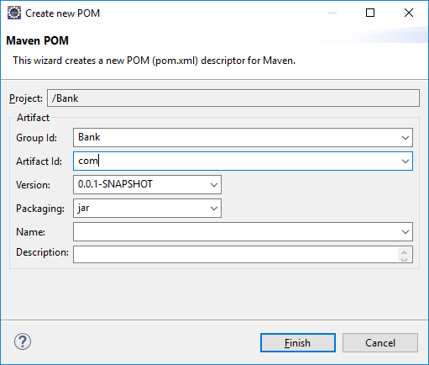

1. **Right click on project** 🡪 **Run As** 🡪 **Maven build (2nd option)**

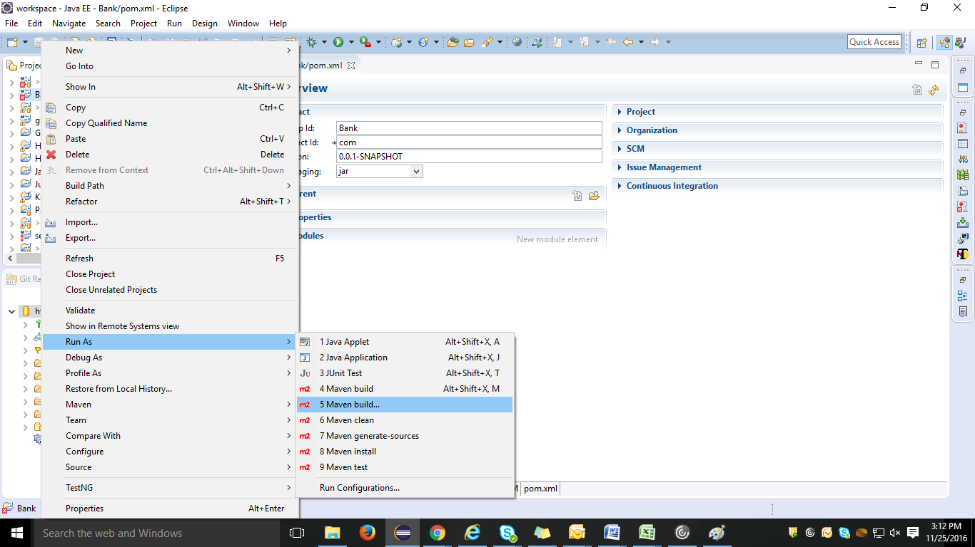

4**. Write ‘clean install’ in Goals field.** 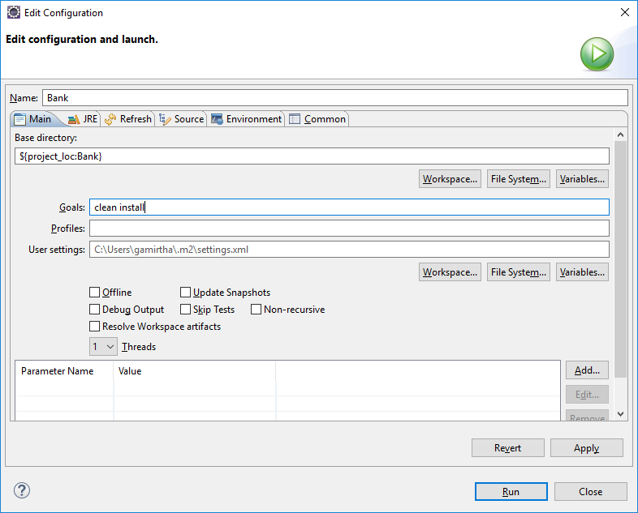

5. **Build Success message should be displayed and note ‘M’ sign will appear on the project icon**

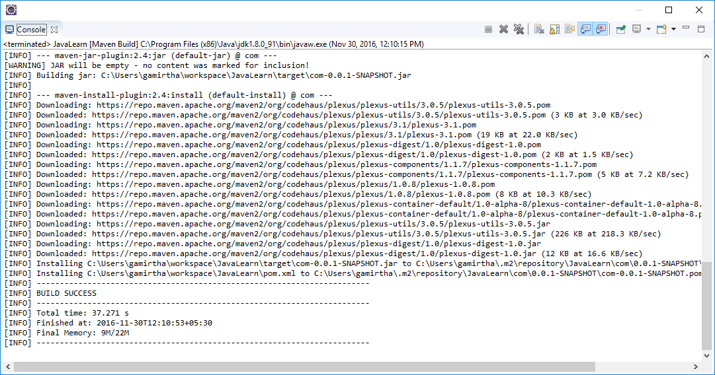

**If Build fails, follow below steps...**

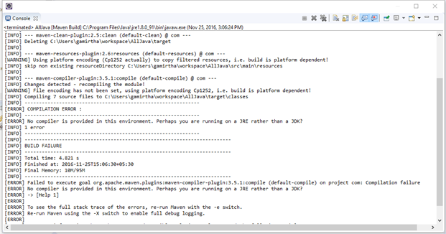

**Solution for No compiler is provided in this environment in Maven**

**Click on Windows > Click on preferences**

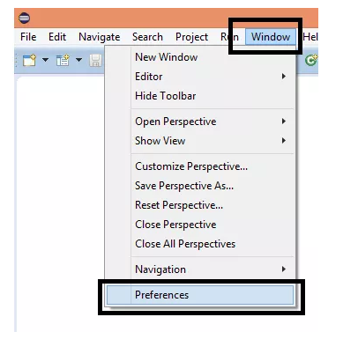

**Click on Java > Installed JRE’s**

**Here you will get JRE now we need to change it to JDK.**

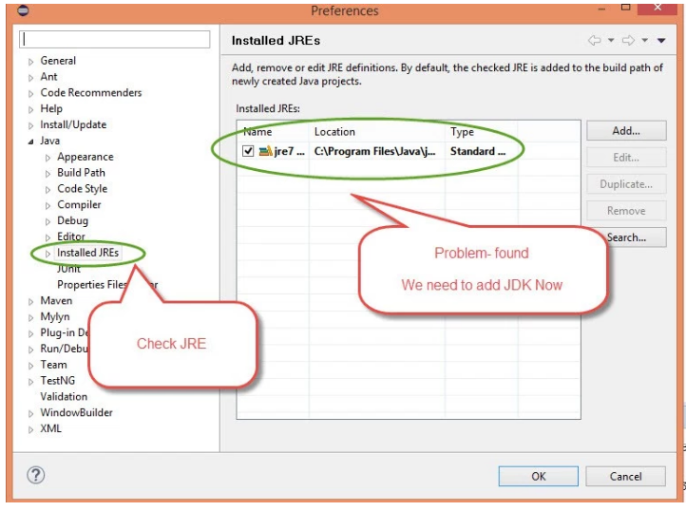

**Now we need to add JDK > Click on Add > Select Standard VM**

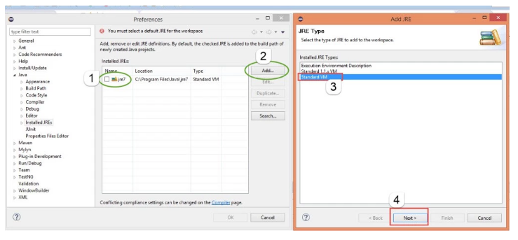

**Browser JDK where it is located. Generally, you will get JAVA in below location.**

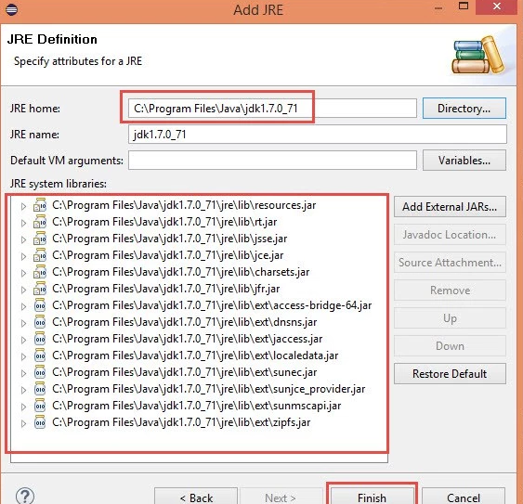

**Now once JDK set you are done.**

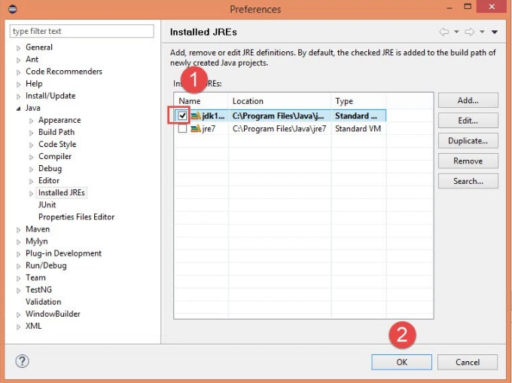

**Now you can run pom.xml file from Eclipse or through CMD and Run pom.xml file > Maven clean then Maven Install and Finally Maven build.**

**OR**

**Restart eclipse and perform step 3 & 4**