|  |  |  |  |
| --- | --- | --- | --- |
| **Revision History** | | | |
| **Version** | **Date** | **Auteur** | **Description** |
| 001 | 30/11/16 | Gregory Amirthanathan | First version  Convert a project to Maven Project |
| 002 | 02/12/16 | Gregory Amirthanathan | Second version  Maven Installation  Create a Maven Project using Eclipse IDE |
| 003 |  |  |  |
|  |  |  |  |

1. **Maven Installation**

Navigate to Maven official site and download stable version of Maven.

Maven Download- <https://maven.apache.org/download.cgi>

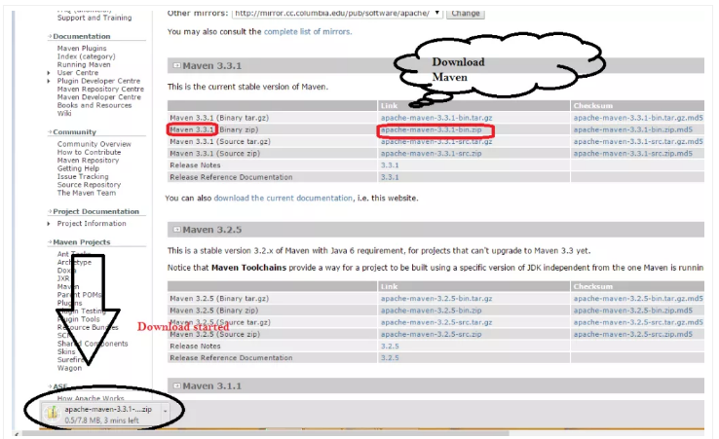

Unzip the download file and Check unzip folder – in our case folder name- apache-maven-3.3.1

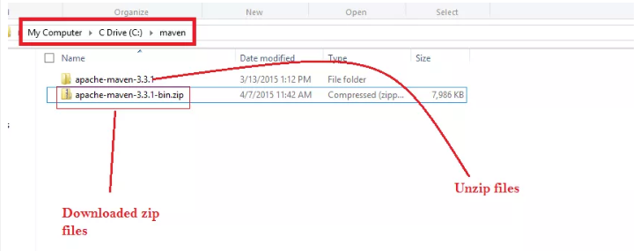

This is maven home directory and now we have to set path for the same

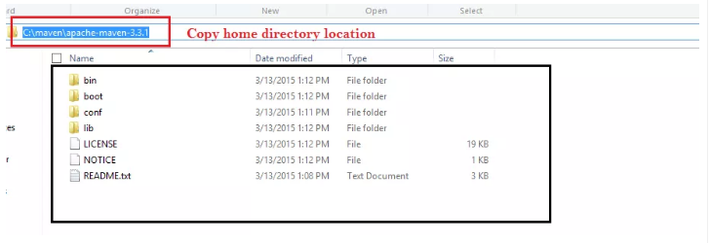

To set path variable- Right Click on my computer and Select property.

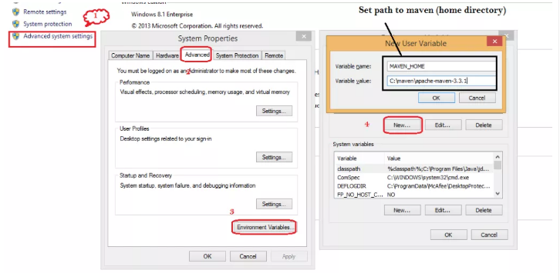

Now we need to set path variable also for System variable.

Note- Please do not touch other variable, Go to last point use ; and then enter path till bin folder.

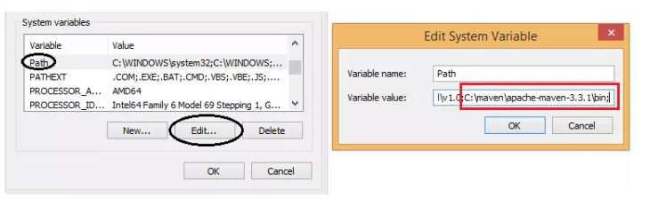

Click on save and apply.  You can verify now that Maven is installed or not.

Open command prompt and type mvn - version

If Maven is installed properly then you will get Maven version and Java version on Console.

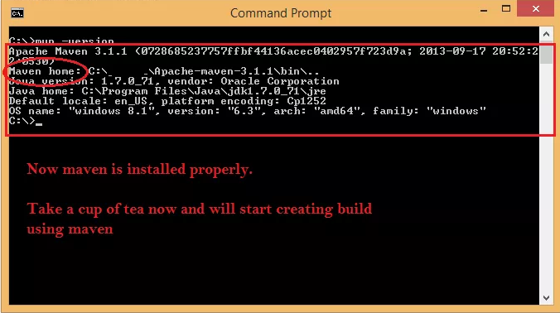

1. **Create a Maven Project using Eclipse IDE**

Go to File 🡪New 🡪Project

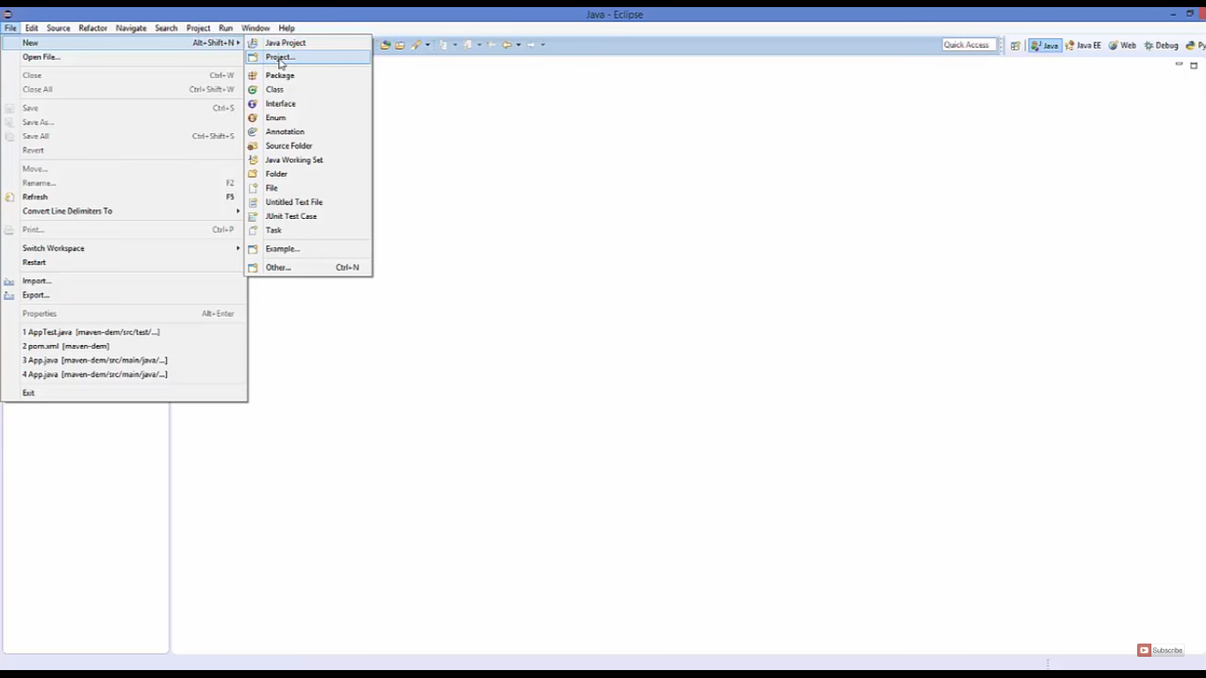

Select Maven Project

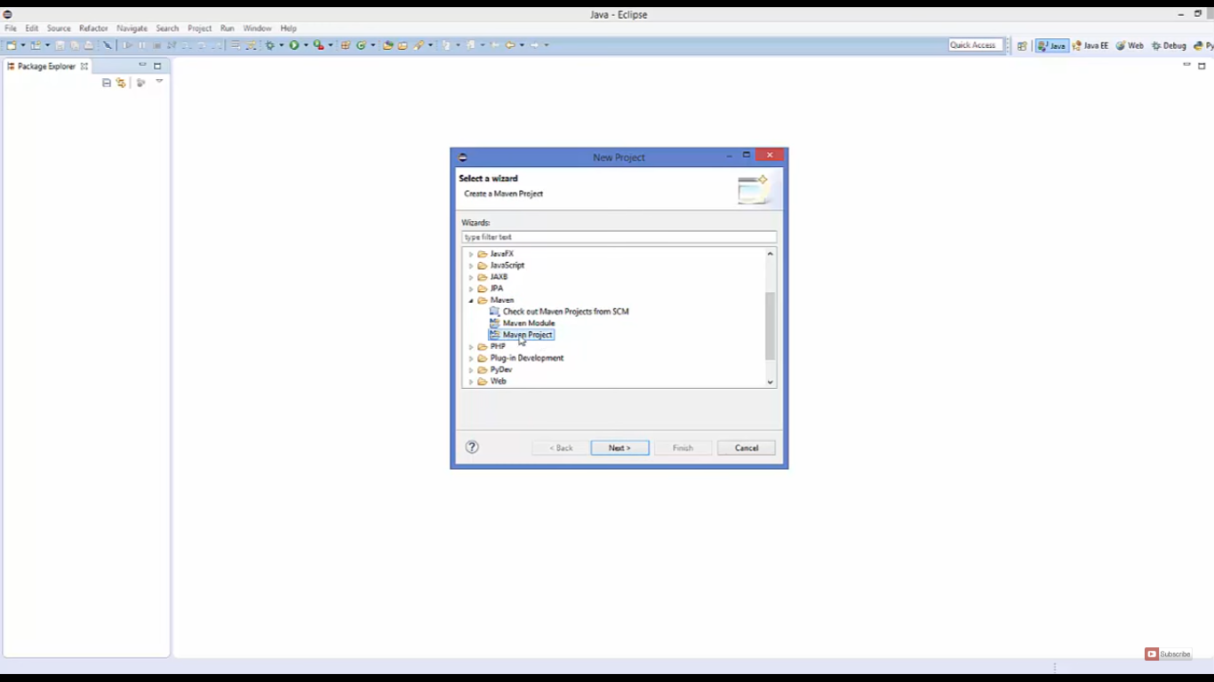

Tick the Create a simple …. checkbox

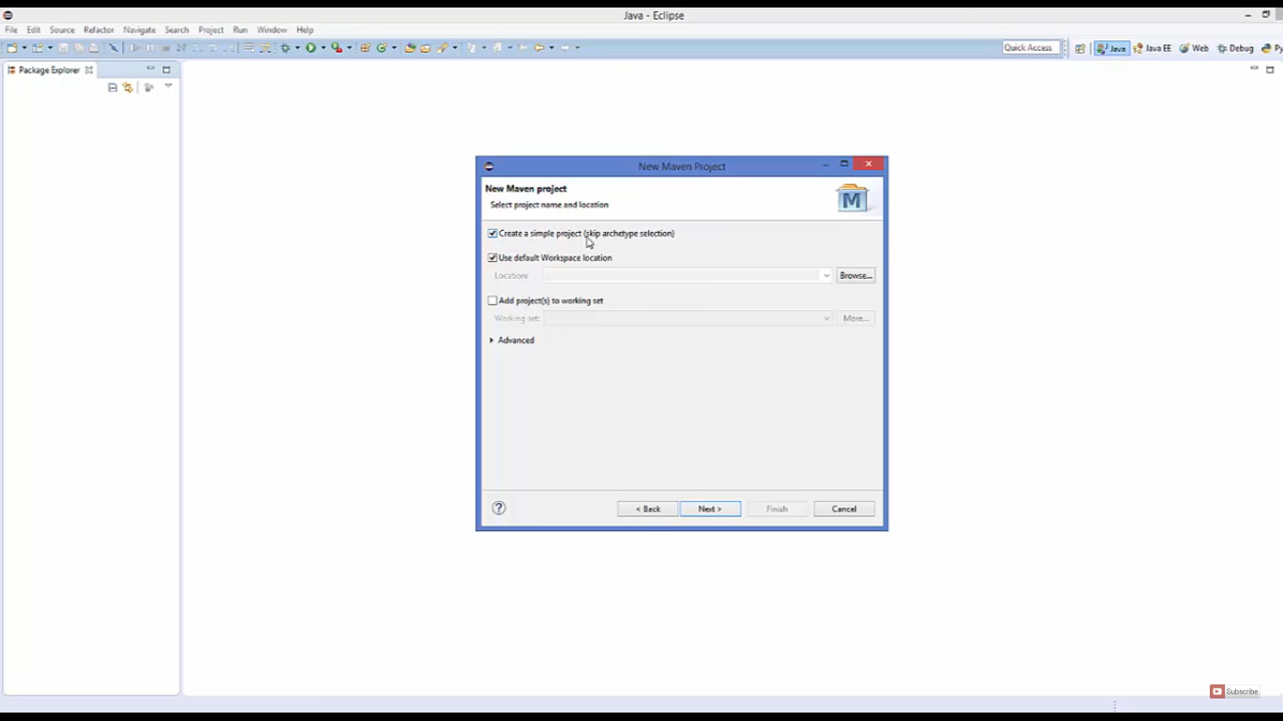

Enter Group Id , Artifact Id and click Finish

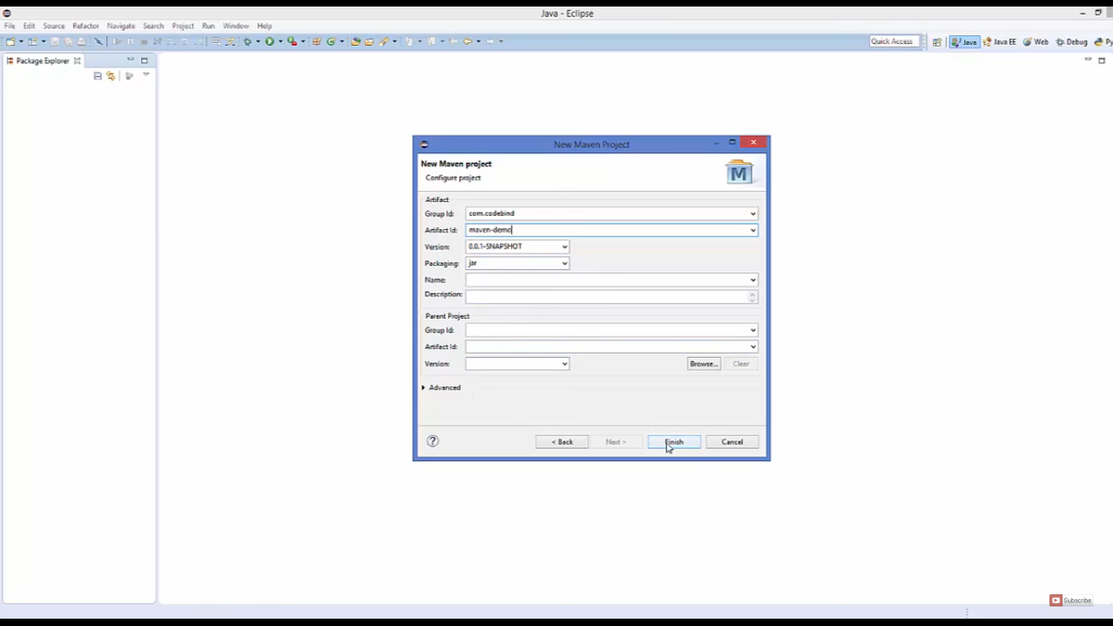

You can see Maven project created

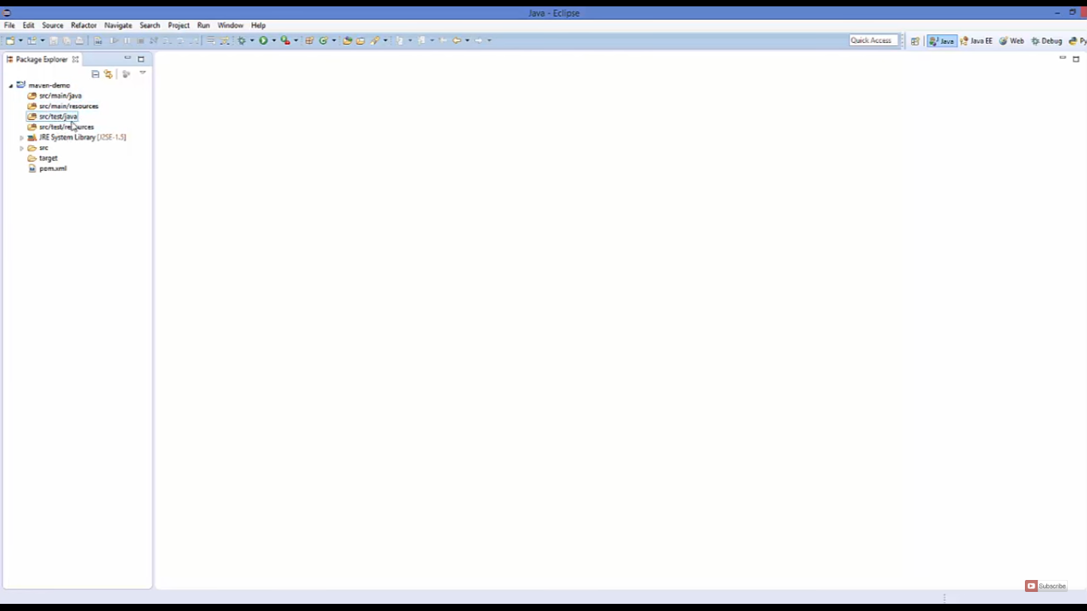

Adding dependency to pom.xml

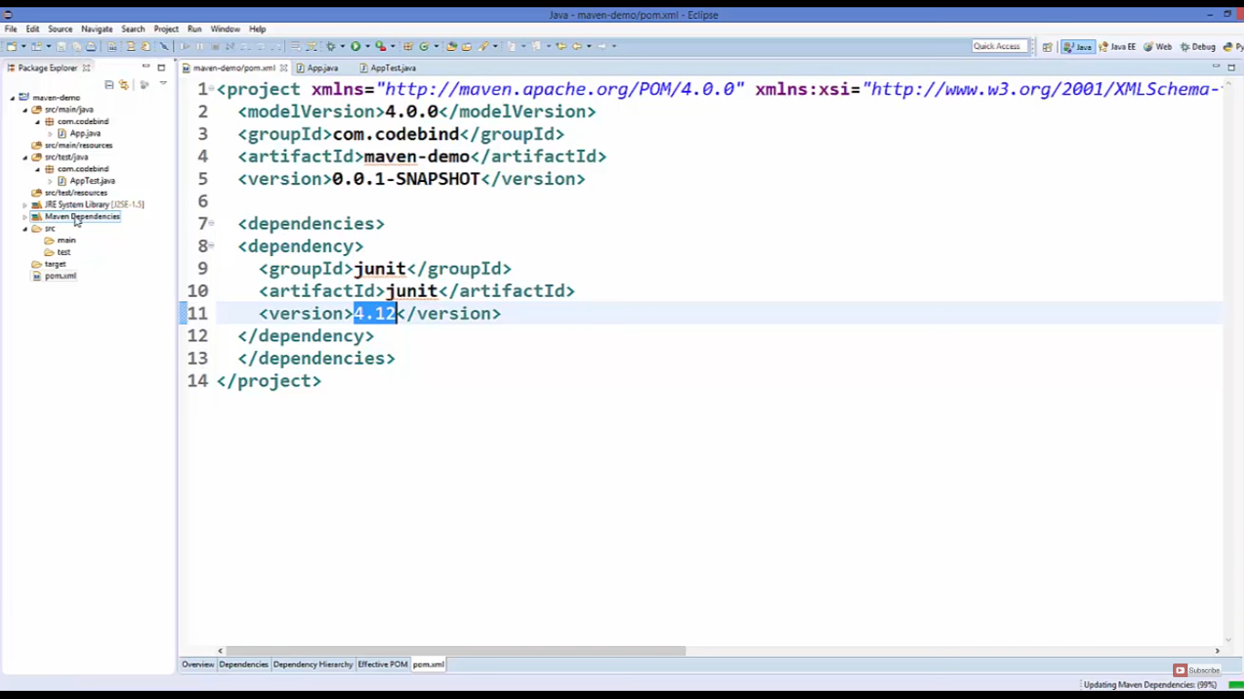

1. **Convert any project to Maven project**

Right click on project 🡪 Configure 🡪 Convert to Maven Project

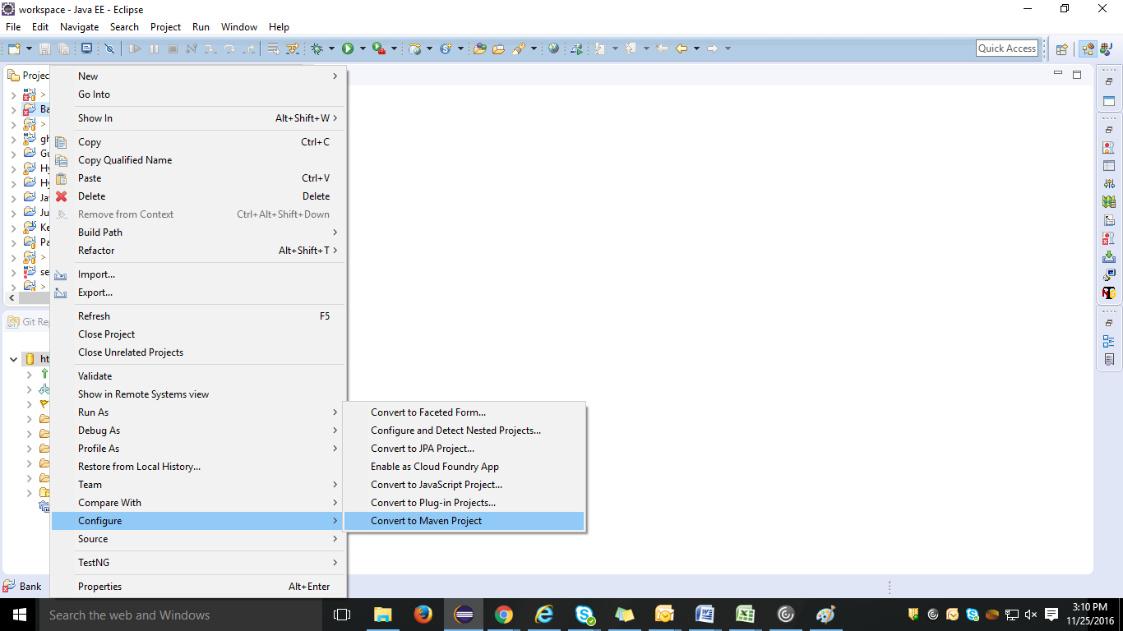

Fill Group Id and Artifact Id

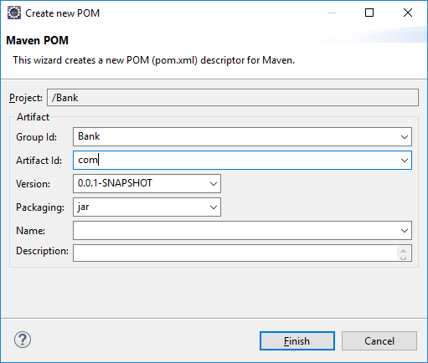

Right click on project 🡪 Run As 🡪 Maven build (2nd option)

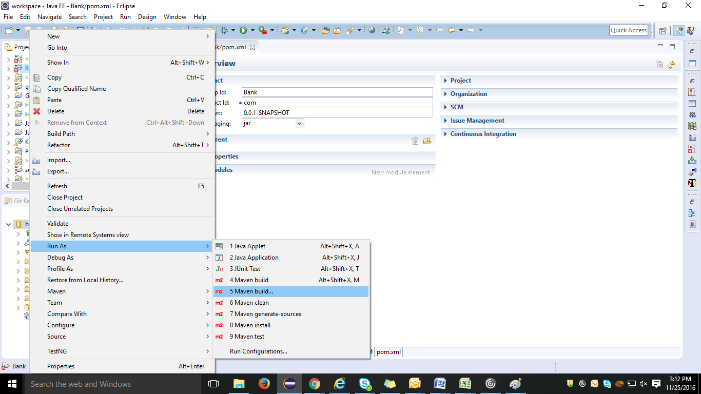

Write ‘clean install’ in Goals field. 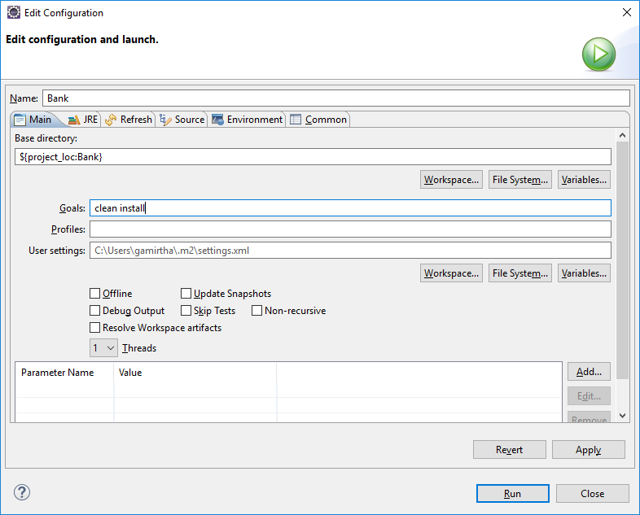

Build Success message should be displayed and note ‘M’ sign will appear on the project icon

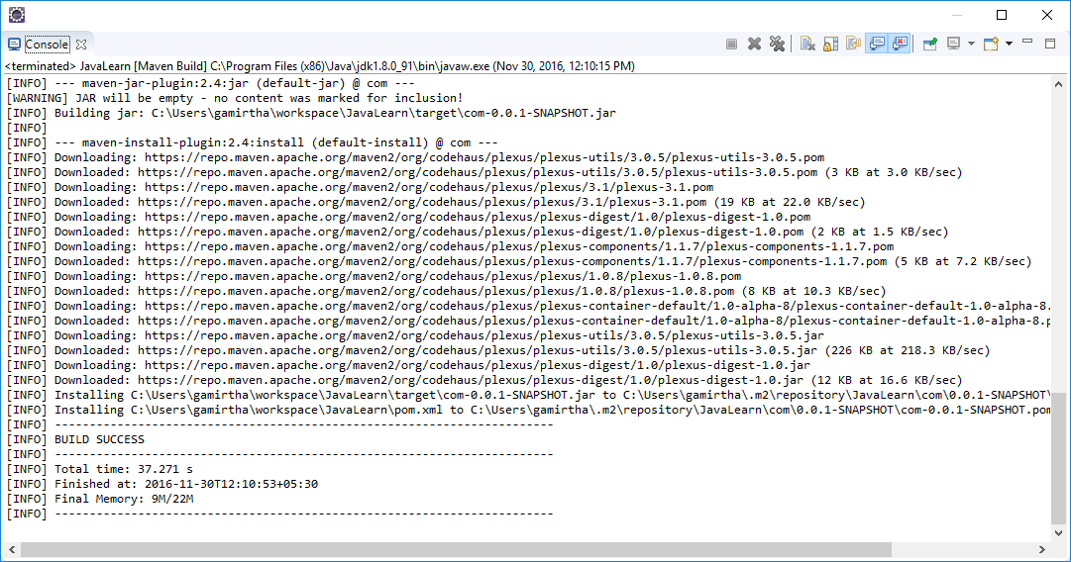

If Build fails, follow below steps...

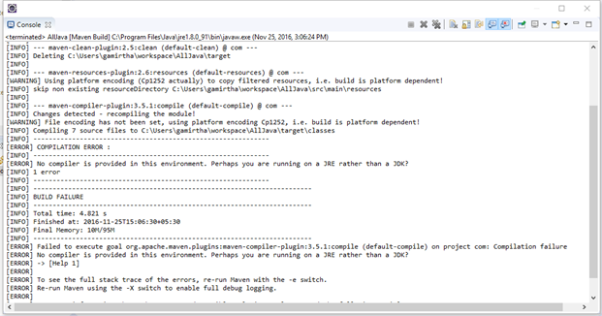

Solution for No compiler is provided in this environment in Maven

Click on Windows > Click on preferences

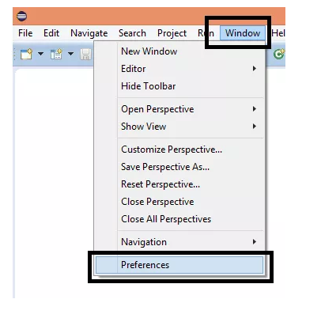

Click on Java > Installed JRE’s

Here you will get JRE now we need to change it to JDK.

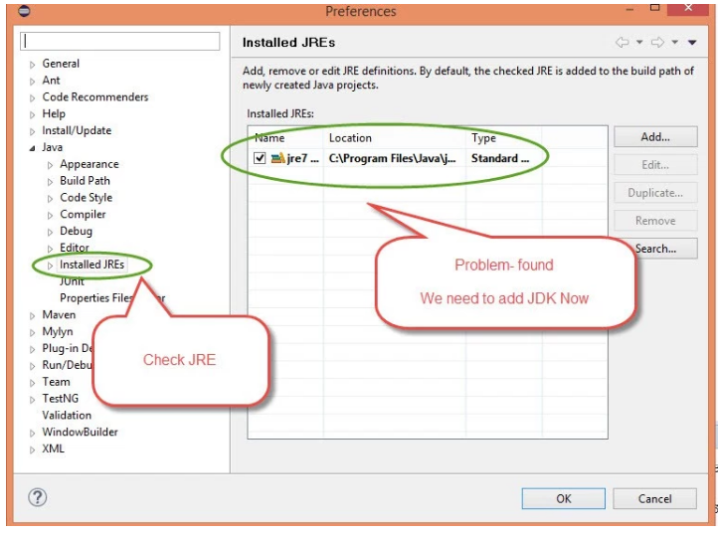

Now we need to add JDK > Click on Add > Select Standard VM

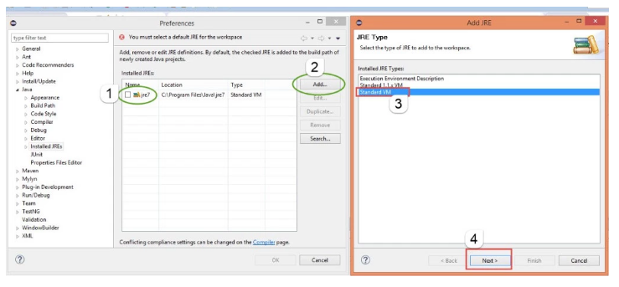

Browser JDK where it is located. Generally, you will get JAVA in below location.

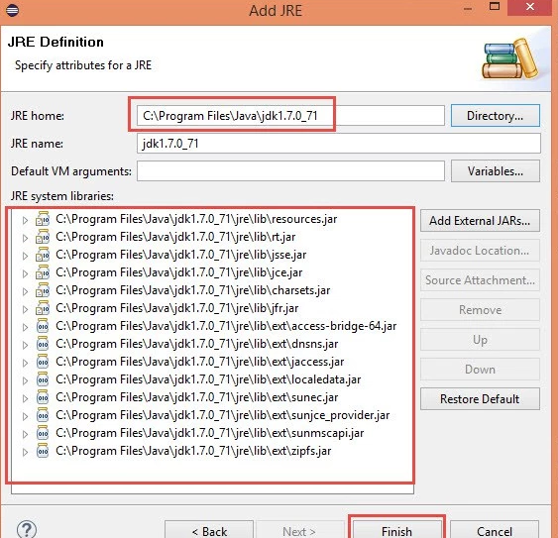

Now once JDK set you are done.

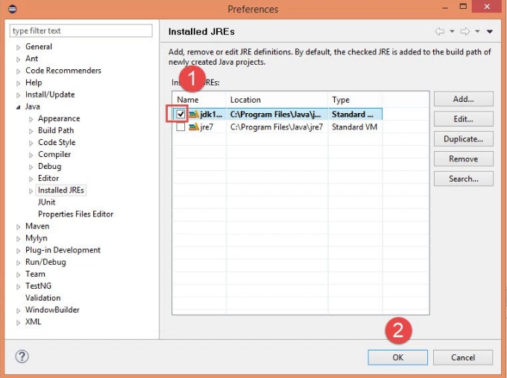

Now you can run pom.xml file from Eclipse or through CMD and Run pom.xml file > Maven clean then Maven Install and Finally Maven build.

OR

Restart eclipse and perform step 3 & 4