**What is TestNG  
Advantages of TestNG  
Install TestNG  
First Script using TestNG  
Creating Multiple Test using TestNG  
Checking Autogenerated XML  
Checking reports  
Adding details to your test**

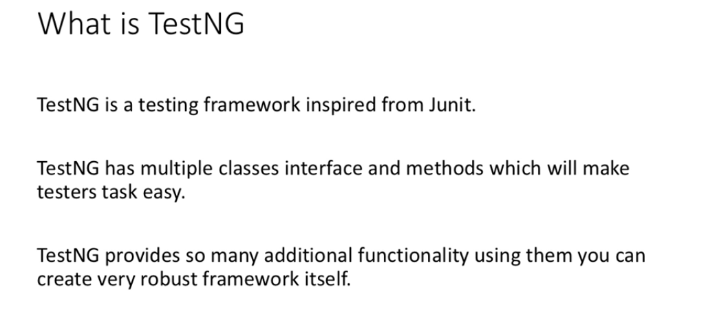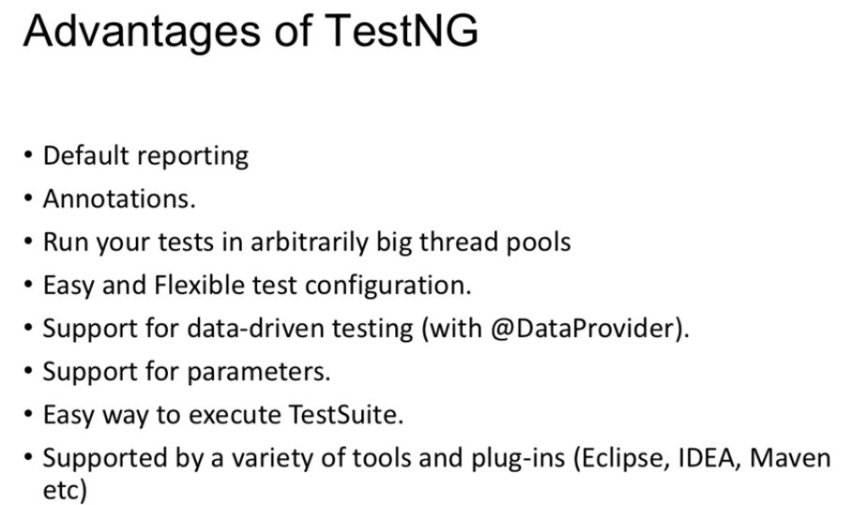

**TestNG – Testing Next Generation**

**Installation in eclipse – install it from eclipse marketplace**

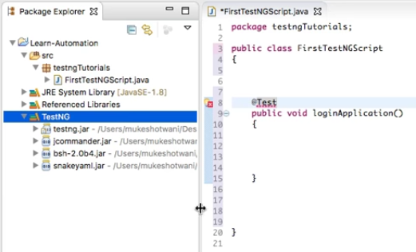

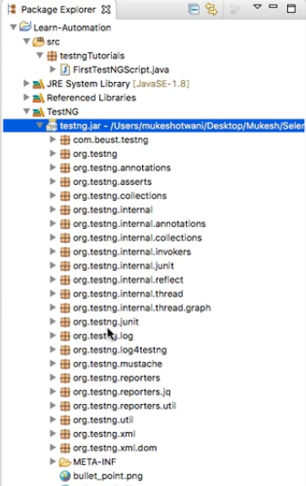

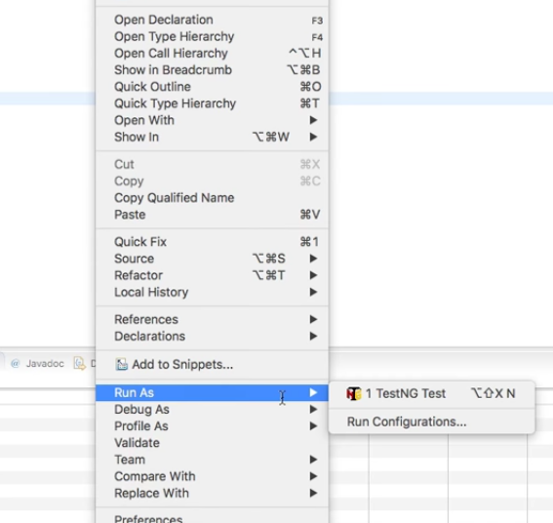

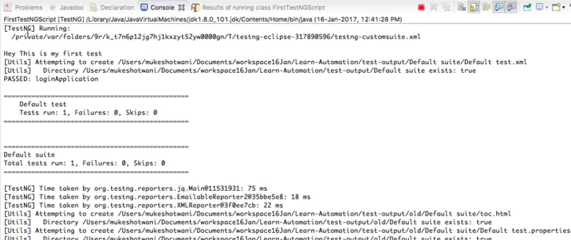

**TestNG runs test in alphabetical order**

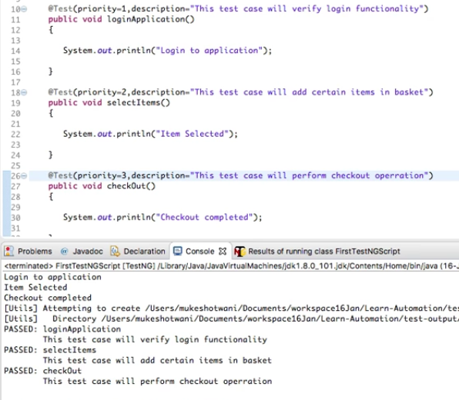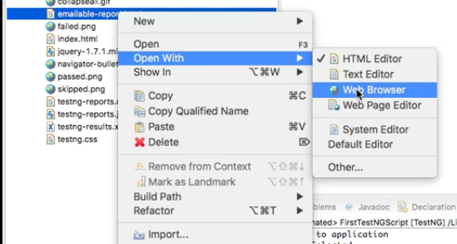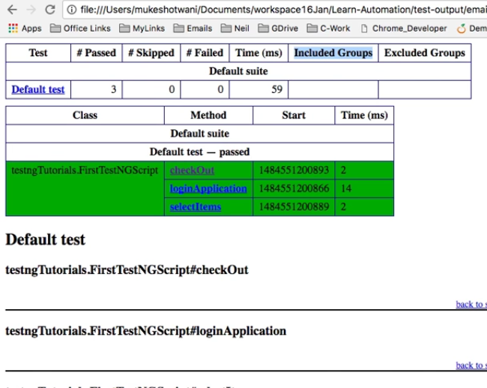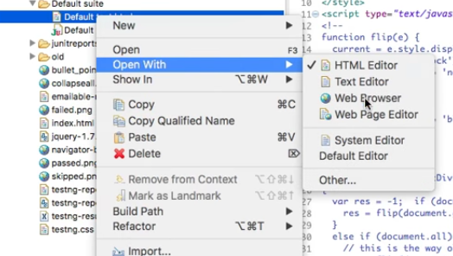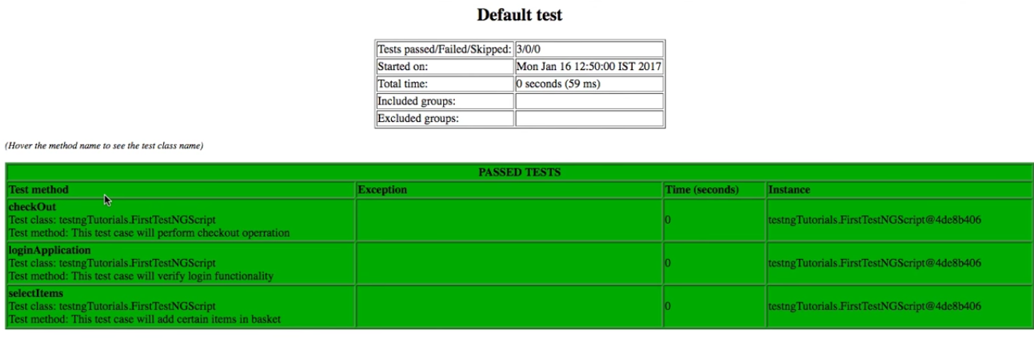

**Execution does not stops in case of failed scenarios**

**Possible to pass –ve values in annotation/priority**

