# Tortoise_SVN

1. Created SVN folder for code repository
2. Install SVN Tortoise



1. Create local folder. Right click -> TortoiseSVN -> Create repository here

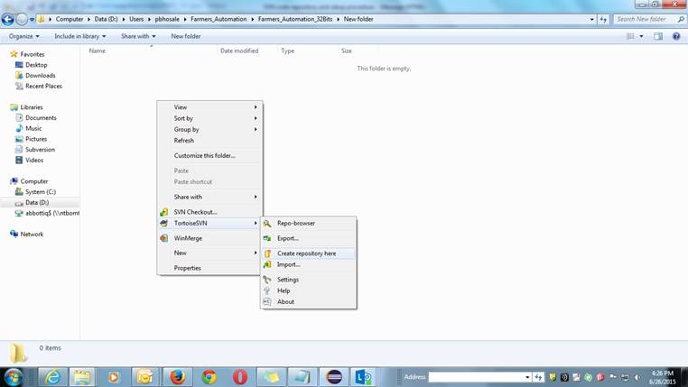

1. Add Workspace (Example: Project name) in the same folder.
2. Got to Repo-browser

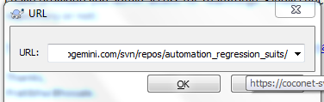

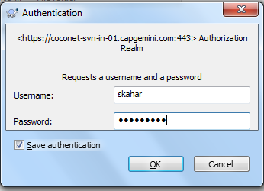

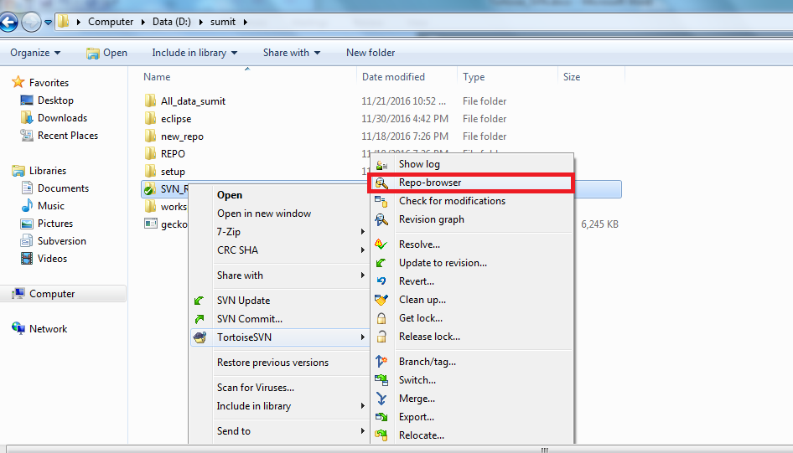

1. Got to the folder and click on checkout, verify checkout directory and click on OK.

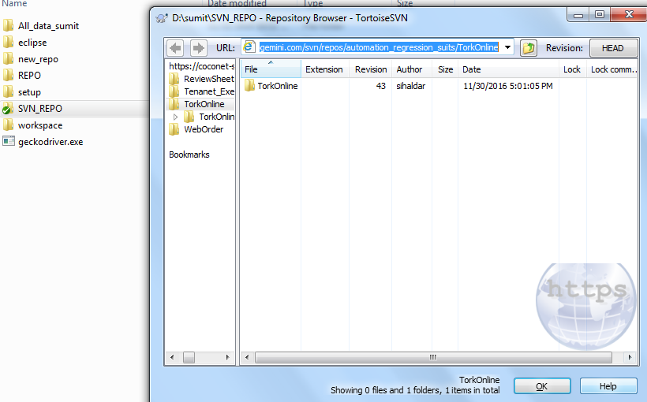

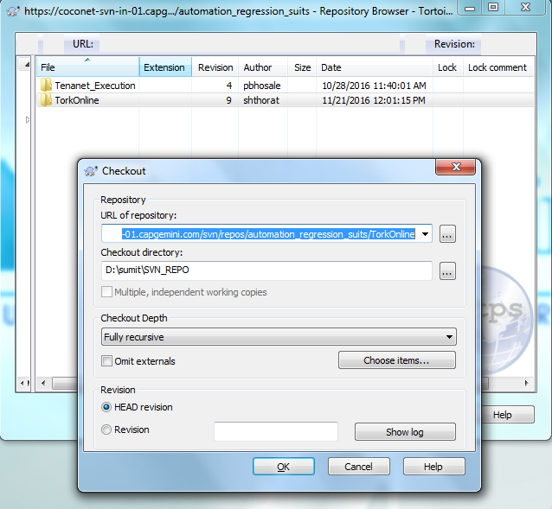

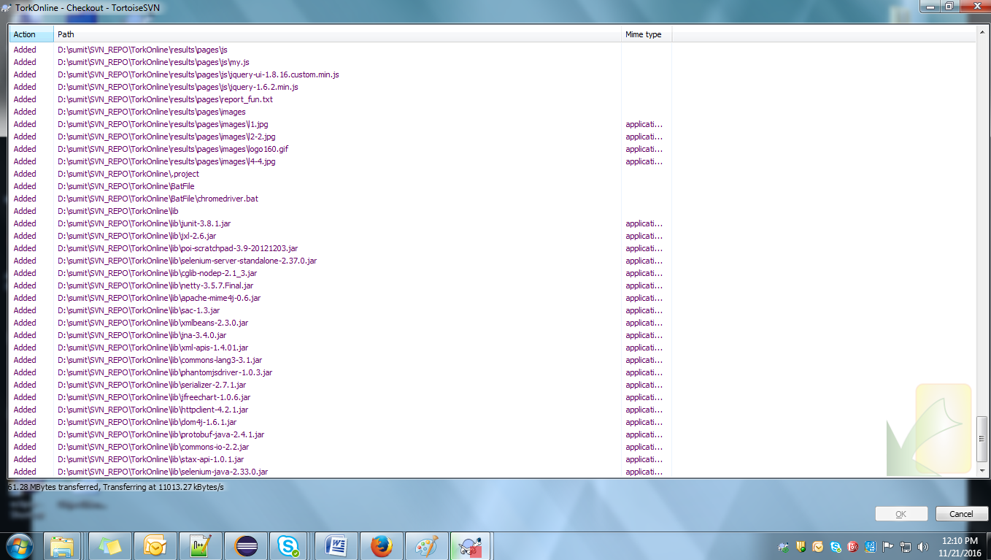

1. Check each and every file from your eclipse workspace and local SVN.

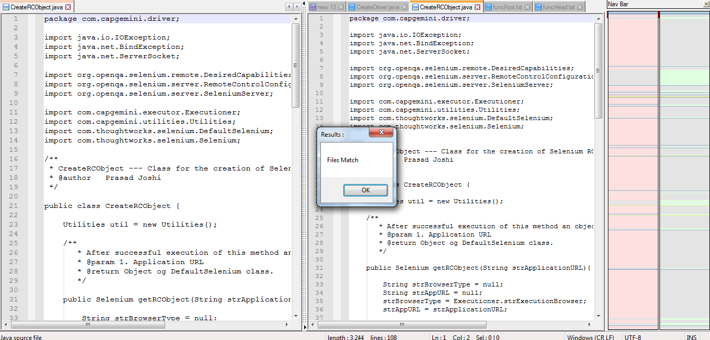

1. Update eclipse workspace accordingly. Once that is done, copy and paste the eclipse workspace to local repo.

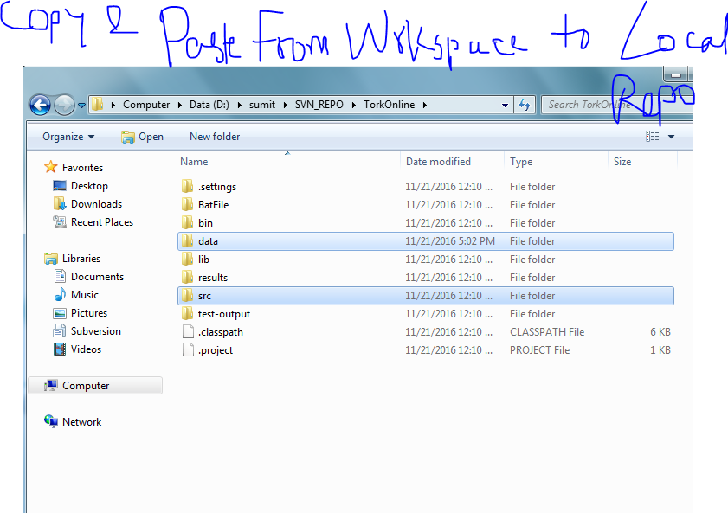

1. Right click local repo and click on svn update.

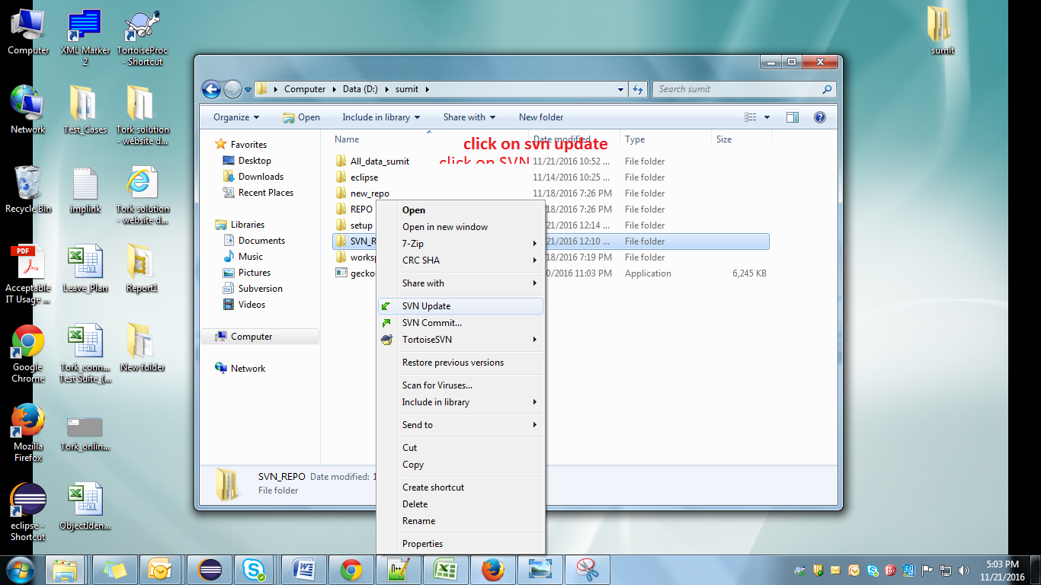

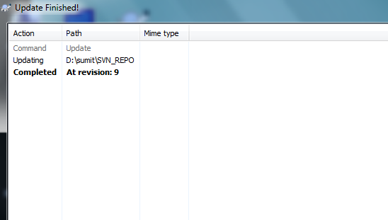

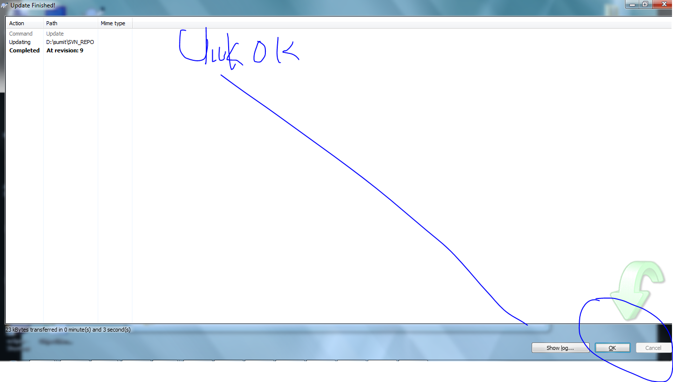

Note: we can also check revision details:

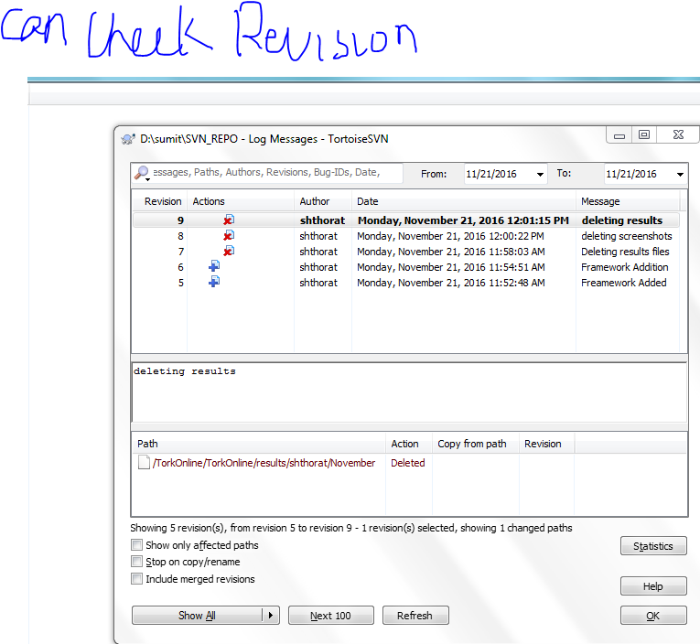

1. After that click on SVN commit, select all files which need to be committed and click on ok.

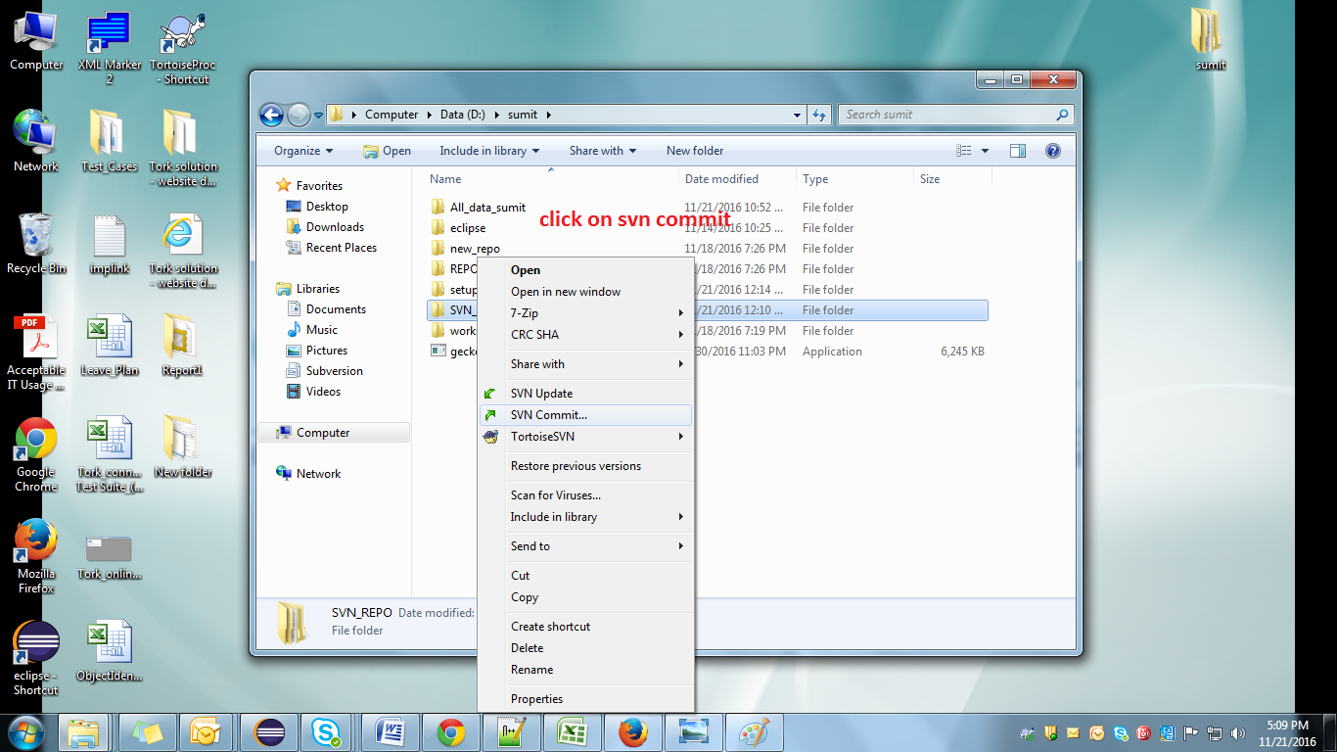

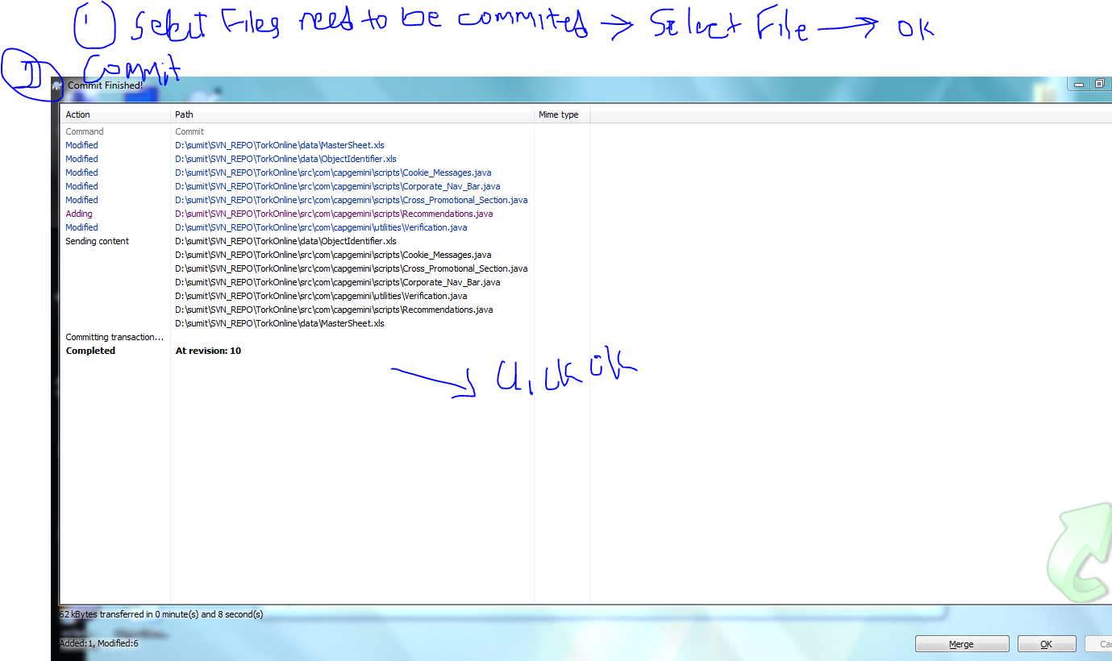

1. Verify commit is properly being done.

