Introduction to the Postman

* **What is Postman?**

**Postman**is a scalable **API testing tool** that quickly integrates into CI/CD pipeline. It started in 2012 as a side project by Abhinav Asthana to simplify **API** workflow in testing and development. **API stands for Application Programming Interface which allows software applications to communicate with each other via API call.**

**Postman** is a great tool when trying to dissect **RESTful APIs** made by others or test ones you have made yourself. It offers a sleek user interface with which to make HTML requests, without the hassle of writing a bunch of code just to test an **API**'s functionality.

* **Why use Postman?**

With over 4 million users nowadays, **Postman Software** has become a tool of choice for the following reasons:

1. **Accessibility** - To use **Postman tool**, one would just need to log-in to their own accounts making it easy to access files anytime, anywhere as long as a **Postman** application is installed on the computer.
2. **Use of Collections** - **Postman** lets users create collections for their **Postman API calls**. Each collection can create subfolders and multiple requests. This helps in organizing your test suites.
3. **Collaboration** - Collections and environments can be imported or exported making it easy to share files. A direct link can also be used to share collections.
4. **Creating Environments** - Having multiple environments aids in less repetition of tests as one can use the same collection but for a different environment. This is where parameterization will take place which we will discuss in further lessons.
5. **Creation of Tests** - Test checkpoints such as verifying for successful HTTP response status can be added to each **Postman API calls** which help ensure test coverage.
6. **Automation Testing** - Through the use of the Collection Runner or Newman, tests can be run in multiple iterations saving time for repetitive tests.
7. **Debugging**- **Postman** console helps to check what data has been retrieved making it easy to debug tests.
8. **Continuous Integration** - With its ability to support continuous integration, development practices are maintained.

* **How to Download and Install Postman?**

1) Go to <https://www.postman.com/downloads/> and choose your desired platform among Mac, Windows or Linux. Click Download.

2) Your download is in progress message should now display on the Apps page. Once the Postman download is completed, click on **Run**.

3) Installation starts

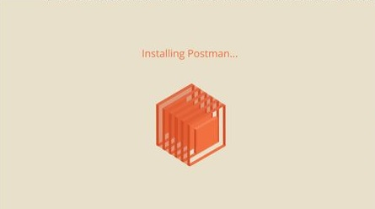

4) In the next window, **Sign up** for a**Postman Account**

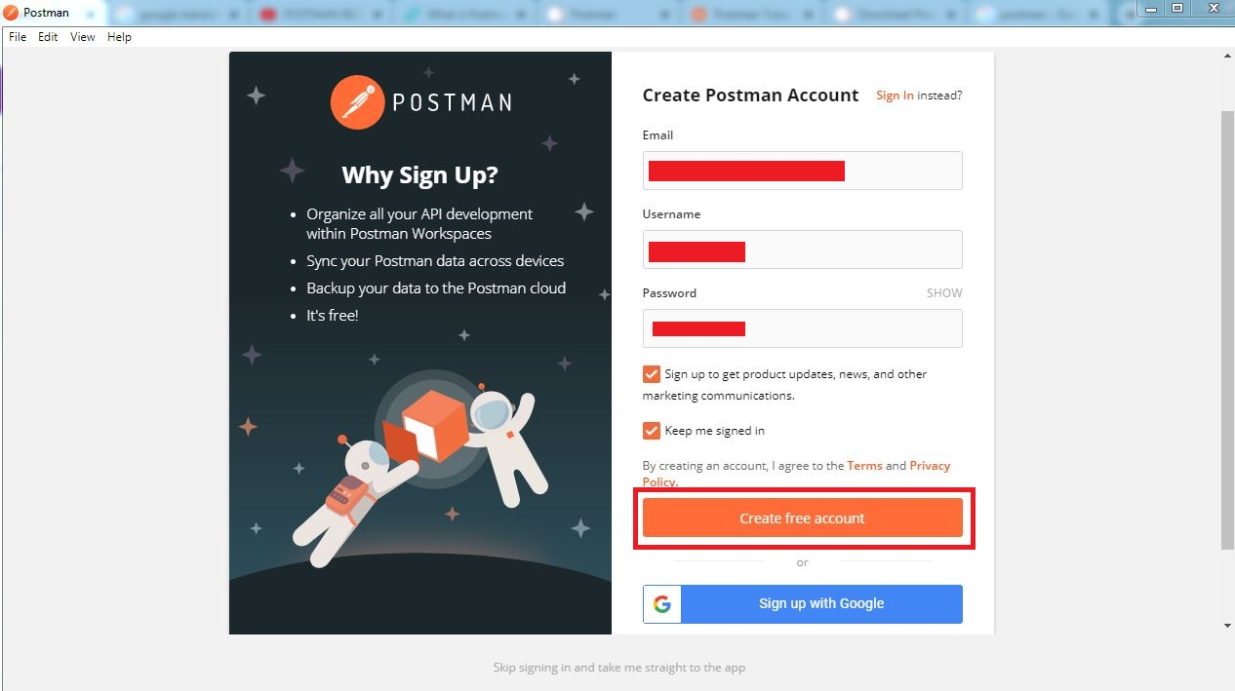

NOTE: There are two ways to sign up for a Postman account. One is to create an own Postman account, and the other is to use a Google account. Though Postman allows users to use the tool without logging in, signing up ensures that your collection is saved and can be accessed for later use.