Cantilever beam bending analysis

Problem description:
Consider the cantilever cylindrical beam show below. The beam is made from aluminium, which has a Young’s modulus of E = 74 GPa, a shear modulus of G = 25 GPa, and a Poisson’s ratio of ν = 0.33. The beam is 1025 mm in length (L = 1025 mm) and has a cylindrical section with D = 50 mm, and d = 45 mm. When a transverse load F is applied at some distance (L_{e} = 500 mm) along the beam length, a bending moment, M, is generated, where:
M = F(L_{e}-x) = $EI\frac{d^{2}y}{dx^{2}}$
The deflection of the beam is given by:
$\frac{d^{2}y}{dx^{2}}=\frac{F(L_{e}-x)}{EI} => y=\iint{\frac{F\left(L_{e}-x\right)}{EI}dx^{2}=}\frac{Fx^{2}}{6EI}(3L_{e}-x+\frac{C1}{x}+\frac{C2}{x^{2}})≈\frac{Fx^{2}}{6EI}(3L_{e}-x)$²
The second moment of area I for the tube is:
$$I=\frac{π}{64}(D^{4}-d^{4})$$
The deflection of the beam can be thus calculated by:
$$y=\frac{32Fx^{2}(3L_{e}-x)}{3π(D^{4}-d^{4})}$$

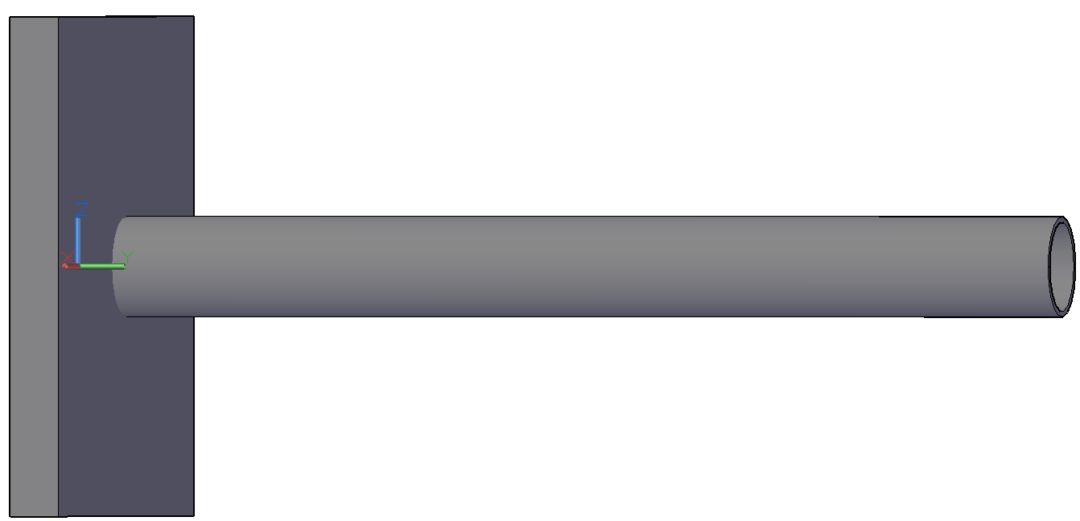
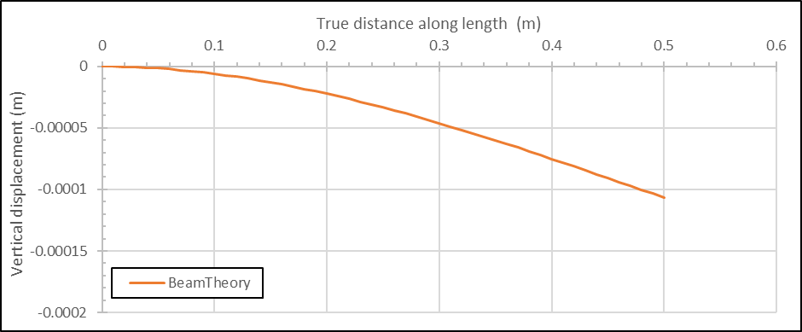
2.1 PARTS
+ Part Manager
+ Draw circle, define radius and depth
2.2 Create Partition Cell from each Part
+ Create Datum Plane: Offset from Principal Plane
+ Partition Cell: Use Datum Plane
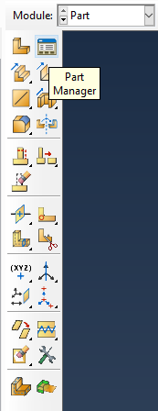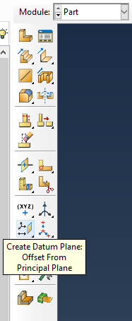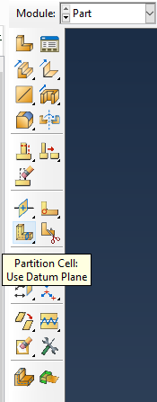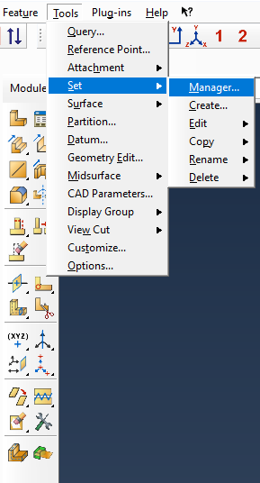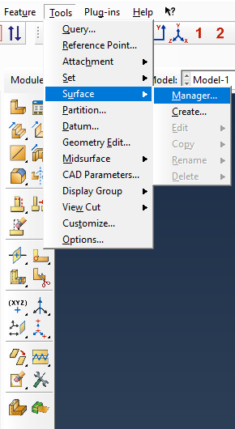
2.3 Create Set for each Part
+ Tool → Set → Manager
- Pile: 8 Cells
- Plug: 4 Cells
- Replacement: 4 Cells
- Soil: 8 Cells
2.4 Create Surface for each Part
+ Tool → Surface → Manger
- Pile:
* External Surface: Pile_Ext_Surf
* Internal Surface: Pile_Int_Surf
* Base Surface: Pile_Base_Surf
* Head Surface: Pile_Head_Surf
- Plug:
* External Surface: Plug_Ext_Surf
* Base Surface: Plug_Base_Surf
- Replacement:
* External Surface: Replacement_Ext_Surf
* Internal Surface: Replacement_Int_Surf
* Base Surface: Replacement_Base_Surf
- Soil:
* Internal Surface: Soil_Int_Surf
* Base Surface from Pile: Soil_Base_Pile
* Base Surface from Plug: Soil_Base_Plug
2.5 Create Reference Point for each Part

Useful links:
Washington University: ABAQUS/CAE User's Manual (v6.6) (wustl.edu)_44 The Partition toolset

Séance n°3_2024-09-17
3.1 Tools
+ Set
+ Surface
+ Reference point
3.2 PROPERTY
+ Material Manager
- Soil
* General Properties:
Mass Density: 1500 kg/m3
* Mechanical Properties:
Mohr Coulomb Plasticity: phi’ = 35, phi_dilation = 5, Cohesion Yield Stress = 100 kPa
- Steel
* General Properties:
Mass Density: 7800 kg/m3
* Mechanical Properties:
Elastic: E = 210x10^9, nv = 0.2
+ Section Manager
- Soil Section :
- Steel Section :
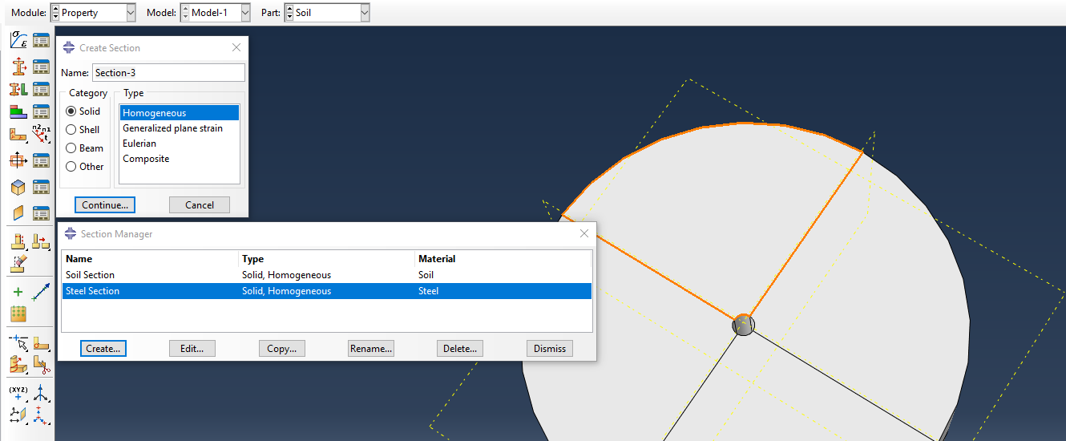
+ Section Assignement Manager
- Soil
- Pile
- Plug
- Replacement
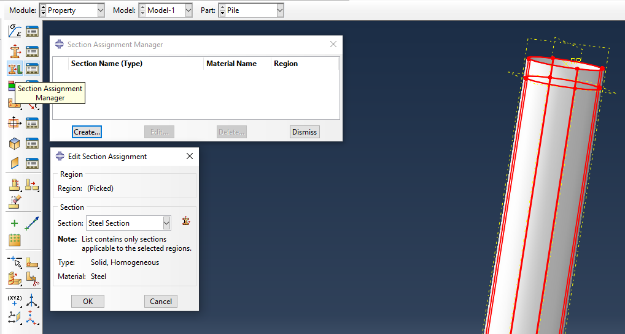
3.3 ASSEMBLY
When you create a part (零件), it exists in its own coordinate system, independent of other parts in the model. You need to use the Assembly module to create instances (实例) of your parts and to position the instances relative to each other in a global coordinate system, thus creating the assembly (装配).
Understanding the relationship between parts, part instances, and assemblies
A model contains only one assembly composed of instances of the parts.
- You create a part in the Part module. Each part is a distinct entity that can be modified and manipulated independently of other parts. Parts exist in their own coordinate system and have no knowledge of other parts.
- You define section properties in the Property module and also associate a material with a section. You use the Property module to assign these section properties to a part or to a selected region of a part.
- You create instances of your parts in the Assembly module, and you position those instances relative to each other in a global coordinate system to form the assembly. ABAQUS/CAE allows you to create either independent or dependent part instances.
- You use the Interaction and Load modules to complete the definition of the model by, for example, defining contact and applying items such as loads and boundary conditions. The Interaction and Load modules operate on the assembly.
- You use the Mesh module to mesh the assembly. You can do either of the following:
- Individually mesh each independent instance of a part in the assembly.
- Mesh the original part. ABAQUS/CAE then associates the mesh with each dependent instance of the part in the assembly.

Difference between a dependent and an independent part instance
- Dependent part instances (从属零件实例): A dependent part instance is only a pointer to the original part. It shares the geometry and the mesh of the original part. As a result, you can mesh the original part, but not the dependent instance.
- Independent part instances (独立零件实例): An independent part instance is a copy of the geometry of the original part. You cannot mesh a part from which you created an independent part instance; however, you can mesh the independent instance. In addition to meshing, you can perform most other operations on an independent instance; for example, you can add partitions and create virtual topology.

How do I decide whether to create a dependent or an independent part instance?
If your assembly contains identical part instances, you can save time by assembling dependent instances of the part. However, if your assembly contains a few part instances that are unrelated, dependent instances have little advantage over independent instances because each part is different, and you must create an instance of each part. ABAQUS/CAE creates dependent instances by default. Unless your assembly contains only a few parts, it is recommended that you work with dependent instances because of the memory savings and the resulting performance gain.

Changing from a dependent to an independent part instance or vice versa
Model Tree → Right click → Make Dependent or Make Independent

Sets and part instances
Part sets are transferred when you create a part instance. For example, you might create a set from a region of a part and use the Property module to assign a section to that set. When you instance the part in the Assembly module, ABAQUS creates part instance sets that refer to any part sets that you previously created. ABAQUS provides read-only access to these part instance sets in assembly-related modules. You cannot access a part instance set from the Set Manager; however, you can select an eligible part instance set during a procedure by clicking the Set button and selecting the set from the Region Selection dialog box that appears.

Creating the assembly
After you create a part instance, you apply a succession of position constraints and positioning operations to position it relative to other part instances in the global coordinate system.

Create a part instance:
- From the main menu bar, select Instance → Create to create a part instance from the parts in the model.
ABAQUS/CAE displays the Create Instance dialog box and a list of all the existing parts in the model.
Tip: You can also create a part instance using the tool from the Assembly module toolbox.
- From the list of parts, select the parts to instance. You can use a combination of [Ctrl]+Click and [Shift]+Click to select multiple parts.
A temporary image of the selected part instances appears in the current viewport.
ABAQUS/CAE positions the temporary images so that their origins coincide with the origin of the global coordinate system.
- By default, ABAQUS/CAE creates a Dependent part instance. If desired, toggle on Independent to create an independent part instance.
- If desired, toggle on Auto-offset from other instances to offset the new part instances.
- If you are satisfied that you have selected the correct part instances, click Apply from the Create Instance dialog box.
ABAQUS/CAE creates the part instances and applies an auto-offset if selected.
- To create additional part instances, repeat this procedure from Step 2.
When you have finished creating part instances, click Cancel to close the Create Instance dialog box.

+ Create instance (How to understand ‘set’ & ‘surface’?)
+ Translate instance_Display Group Manager_Part/Model instances_Replace
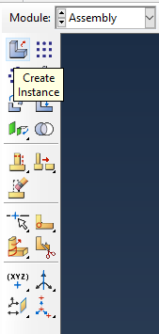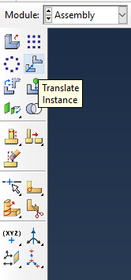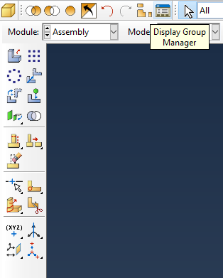
3.4 STEP
+ Stresses from soil self-weight:
- Step Manager → Create → Geostatic
* Basic:
> Time period: 1
> Nlgeom: Non-linear geometry mainly for large displacement
* Incrementation:
> Type: Automatic
> Max No of Increments: 10^9
> Increment size: Initial 0.25; Min 10^-10; Max 1
> Max displacement change: 10^-5
* Other:
> Equation solver:
§ Direct
§ Asymmetric
> Solution technique:
§ Full Newton
§ Convert severe discontinuity iteration: Propagate from previous step
+ Stresses from pile self-weight
+ Loading
- Field Output Manager (2024-12-04):
* Double click the Step Name
* Choose the parameters (stress or displacement…) that we want
2024-10-08 Séance n°4
4.1 Interaction
+ Constraint Manager
- Replacement – Soil
- Replacement – Plug
- Replacement Base – Soil
- Plug Base – Soil
- Relate RP to pile head surface
4.2 Load
+ Load manager
- Self-weight of soil
- Self-weight of pile
- Applied lateral load
+ Boundary condition
- Soil base without any movement and rotation
- Soil lateral without lateral movement
+ Pre-defined manager
- zero load on the top
- gamma time depth at the bottom
Initial : Conteneur est vide et il n’y a rien
Géostatique : (Step 1)
On a mis le sol dans le conteneur. Abaqus calcule les contraintes et déplacements à chaque point d’intégration (élément) du au poids de sol. Contrainte est zéro à la surface. Nous avons donnée une valeur à la pointe.
Anchor Position (Step 2)
On a enlevé le Replacement et a mis le pieu en même temps. Abaque calcule les contraintes supplémentaires dues au point du pieu.
Appliquer la charge extérieure (Step 3)
Abaque calcule les contraintes dues à la charge appliquée.

4.3 Demander un compte GLiCID
+ Link received
+ Account active with Nantes Univ. account, wait for ID and PSW

2024-11-25 Séance n°5
5.1 Mesh
+ Pile
- Vertical: 1m/1mesh
- Horizontal:
+ Plug
+ Replacement
+ Soil

Regarder à l’interieur de maillage
Cells

Assign element type
Reduced integration (1 point for the element)
Hourglass stiff -> 100

5.2 Job
Job Manager
File - Save Work Directory
Submit
Input File Job-1.inp (Changer soit dans Interface soit dans Input File)
Monitor

2024-12-01 Séance n°6
SANISAND & Hypoplastic sur Glicid
6.1: Changer le nom de modèle de sol, il faut changer et mettre à jour le nom de Section Manager, et mis à jour le Section Assignement
Material Manager :
Changer le nom de modèle constitutif de sol
Section Manager
Mettre à jour le Section de sol et changer son nom
Assignment Manager
Mettre à jour le assignment de chaque Part de sol (Plug, Replacement, Sol)

6.2 Ajouter Sanisand modèle
Material Manager :
Create a new modèle
General -> Density
Depvar - > No. Of parameters > ou = 19 (19 for Sanisand)
User Material -> value of the 19 parameters according to the order described in Umat.for file
Section Manager
Assignment Manager (Unseclect Mohr-Coulomb model)

6.3 Ajouter Hypoplastic modèle
Material Manager :
Create a new modèle
General -> Density
Depvar - > No. Of parameters > ou = 16 (19 for Sanisand)
User Material -> value of the 16 parameters according to the order described in Umat.for file
Section Manager
Assignment Manager (Unseclect Mohr-Coulomb model)

6.4 Lauch calculation in PC
Umat.for in a correct reporitory
Job -> Job Manager -> Create -> General -> User Supporting Files (Umat.for) -> Submit (Compiler problem)
Don’t Change the name of UMat.for
Values from Zheng Li

6.5 Glicid

Start – Search – Command – ssh-keygen
Clam.glicid.fr
MobaXterm
Create a Matlab file
Slurm file

Login : li-z-1@univ-nantes.fr
Password : OFe49EiGQTXEax2keoao

2024-12-04 Séance n°7
Find results from .ODB file:
Find Job summary from .STA file:
Find calculation time from MSG file:

