3-ANNEX A(informative)
DIAGRAMS

Figure 3-A.1. Layer I and II decoder flow chart

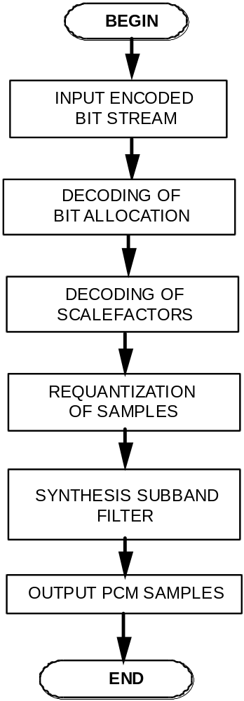

Figure 3-A.2. Synthesis subband filter flow chart

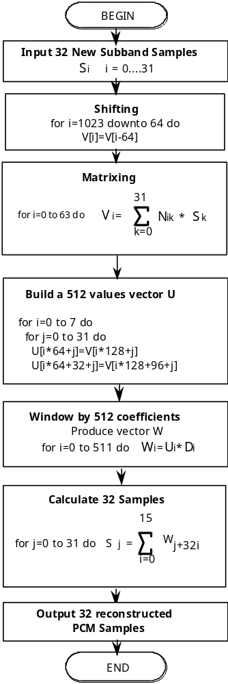
Figure 3-A.3. Layer III decoder flow chart

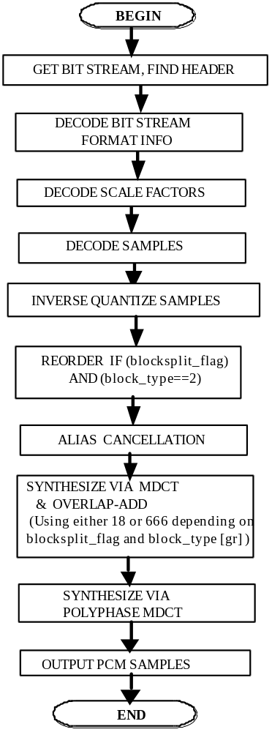
Figure 3-A.4. Layer III decoder diagram

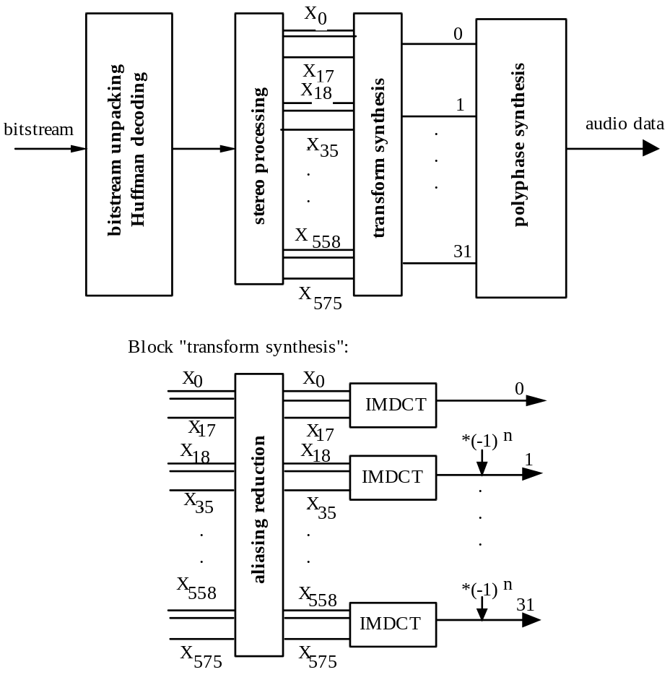
Figure 3-A.5. Layer III aliasing reduction encoder/decoder diagram

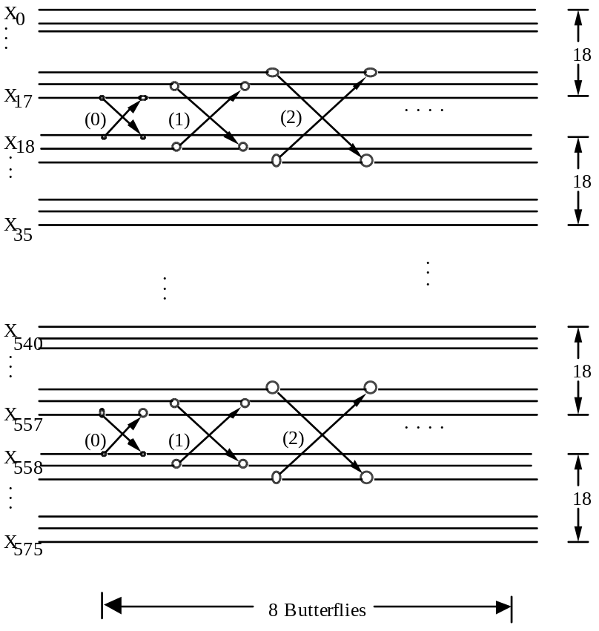

Figure 3-A.6. Layer III aliasing-butterfly, decoder

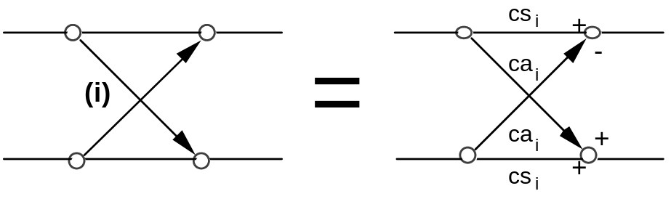

Figure 3-A.7.1. Layer III bitstream organization

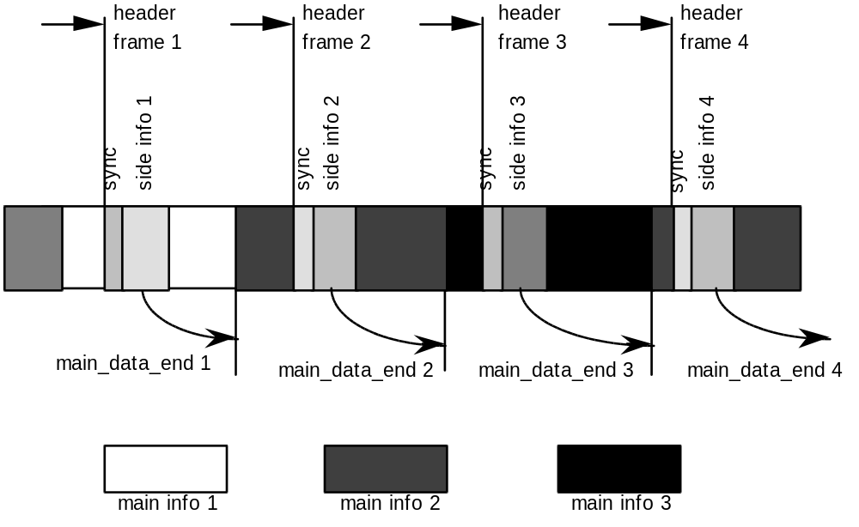

Figure 3-A.7.2. Layer III bitstream organization with peak demand at main info 3 and small demand at main info 2.

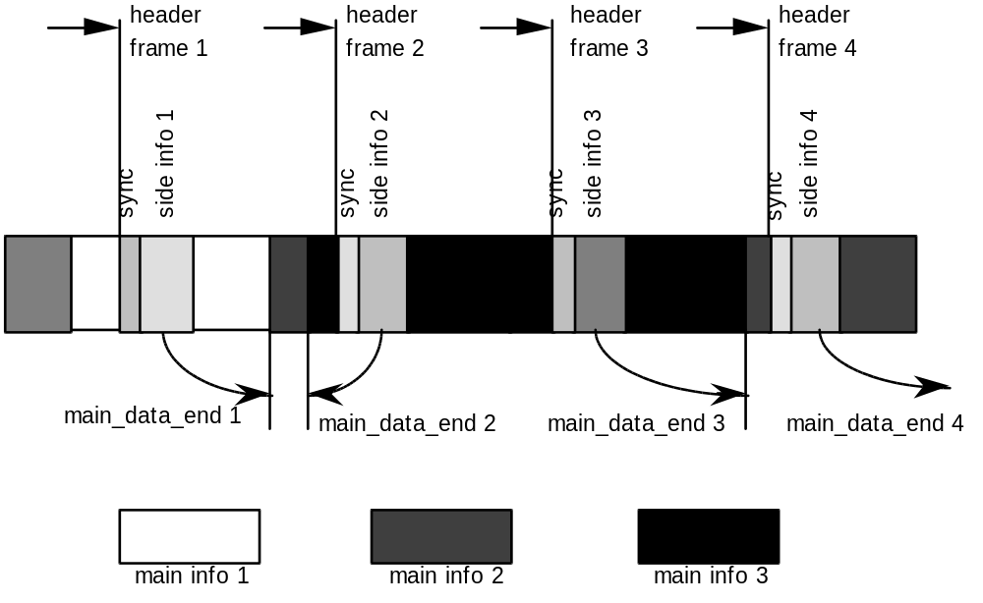

Note: 'info' means information

Figure 3-A.8. Layer III illustration of granules for frame with no block split in first granule and block split in second granule.

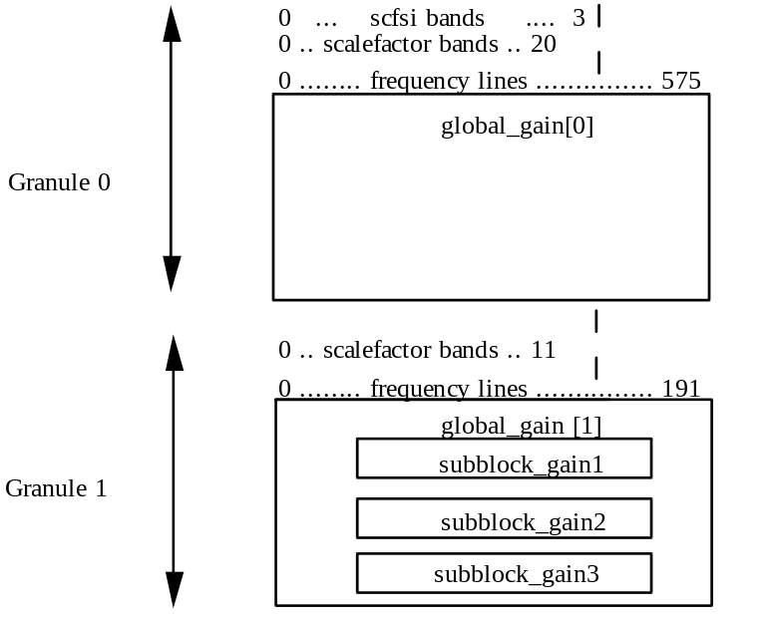

Figure 3-A.9. CRC-Check diagram

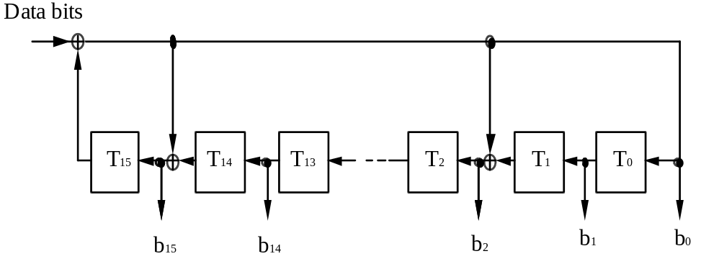

3-ANNEX B (normative)
TABLES

Table 3-B.1. Layer I,II scalefactors

index scalefactor index scalefactor
0 2.00000000000000 32 0.00123039165029
1 1.58740105196820 33 0.00097656250000
2 1.25992104989487 34 0.00077509816991
3 1.00000000000000 35 0.00061519582514
4 0.79370052598410 36 0.00048828125000
5 0.62996052494744 37 0.00038754908495
6 0.50000000000000 38 0.00030759791257
7 0.39685026299205 39 0.00024414062500
8 0.31498026247372 40 0.00019377454248
9 0.25000000000000 41 0.00015379895629
10 0.19842513149602 42 0.00012207031250
11 0.15749013123686 43 0.00009688727124
12 0.12500000000000 44 0.00007689947814
13 0.09921256574801 45 0.00006103515625
14 0.07874506561843 46 0.00004844363562
15 0.06250000000000 47 0.00003844973907
16 0.04960628287401 48 0.00003051757813
17 0.03937253280921 49 0.00002422181781
18 0.03125000000000 50 0.00001922486954
19 0.02480314143700 51 0.00001525878906
20 0.01968626640461 52 0.00001211090890
21 0.01562500000000 53 0.00000961243477
22 0.01240157071850 54 0.00000762939453
23 0.00984313320230 55 0.00000605545445
24 0.00781250000000 56 0.00000480621738
25 0.00620078535925 57 0.00000381469727
26 0.00492156660115 58 0.00000302772723
27 0.00390625000000 59 0.00000240310869
28 0.00310039267963 60 0.00000190734863
29 0.00246078330058 61 0.00000151386361
30 0.00195312500000 62 0.00000120155435
31 0.00155019633981

3-B.2. Layer II bit allocation tables

Table 3-B.2a Possible quantization per subband

Fs = 48 kHz Bit rates per channel = 56, 64, 80, 96, 112, 128, 160, 192 kbits/s,
and free format
Fs = 44.1 kHz Bit rates per channel = 56, 64, 80 kbits/s
Fs = 32 kHz Bit rates per channel = 56, 64, 80 kbits/s

index
sb nbal 0 1 2 3 4 5 6 7 8 9 10 11 12 13 14 15

SB0 4 - 3 7 15 31 63 127 255 511 1023 2047 4095 8191 16383 32767 65535
SB1 4 - 3 7 15 31 63 127 255 511 1023 2047 4095 8191 16383 32767 65535
SB2 4 - 3 7 15 31 63 127 255 511 1023 2047 4095 8191 16383 32767 65535
SB3 4 - 3 5 7 9 15 31 63 127 255 511 1023 2047 4095 8191 65535
SB4 4 - 3 5 7 9 15 31 63 127 255 511 1023 2047 4095 8191 65535
SB5 4 - 3 5 7 9 15 31 63 127 255 511 1023 2047 4095 8191 65535
SB6 4 - 3 5 7 9 15 31 63 127 255 511 1023 2047 4095 8191 65535
SB7 4 - 3 5 7 9 15 31 63 127 255 511 1023 2047 4095 8191 65535
SB8 4 - 3 5 7 9 15 31 63 127 255 511 1023 2047 4095 8191 65535
SB9 4 - 3 5 7 9 15 31 63 127 255 511 1023 2047 4095 8191 65535
SB10 4 - 3 5 7 9 15 31 63 127 255 511 1023 2047 4095 8191 65535
SB11 3 - 3 5 7 9 15 31 65535
SB12 3 - 3 5 7 9 15 31 65535
SB13 3 - 3 5 7 9 15 31 65535
SB14 3 - 3 5 7 9 15 31 65535
SB15 3 - 3 5 7 9 15 31 65535
SB16 3 - 3 5 7 9 15 31 65535
SB17 3 - 3 5 7 9 15 31 65535
SB18 3 - 3 5 7 9 15 31 65535
SB19 3 - 3 5 7 9 15 31 65535
SB20 3 - 3 5 7 9 15 31 65535
SB21 3 - 3 5 7 9 15 31 65535
SB22 3 - 3 5 7 9 15 31 65535
SB23 2 - 3 5 65535
SB24 2 - 3 5 65535
SB25 2 - 3 5 65535
SB26 2 - 3 5 65535
SB27 0 -
SB28 0 -
SB29 0 -
SB30 0 -
SB31 0 -

sblimit = 27
Sum of nbal = 88

Table 3-B.2b. Possible quantization per subband

Fs = 48 kHz -------------- not relevant --------------
Fs = 44.1 kHz Bitrates per channel = 96, 112, 128, 160, 192 kbits/s
and free format
Fs = 32 kHz Bitrates per channel = 96, 112, 128, 160, 192 kbits/s
and free format

index
sb nbal 0 1 2 3 4 5 6 7 8 9 10 11 12 13 14 15

SB0 4 - 3 7 15 31 63 127 255 511 1023 2047 4095 8191 16383 32767 65535
SB1 4 - 3 7 15 31 63 127 255 511 1023 2047 4095 8191 16383 32767 65535
SB2 4 - 3 7 15 31 63 127 255 511 1023 2047 4095 8191 16383 32767 65535
SB3 4 - 3 5 7 9 15 31 63 127 255 511 1023 2047 4095 8191 65535
SB4 4 - 3 5 7 9 15 31 63 127 255 511 1023 2047 4095 8191 65535
SB5 4 - 3 5 7 9 15 31 63 127 255 511 1023 2047 4095 8191 65535
SB6 4 - 3 5 7 9 15 31 63 127 255 511 1023 2047 4095 8191 65535
SB7 4 - 3 5 7 9 15 31 63 127 255 511 1023 2047 4095 8191 65535
SB8 4 - 3 5 7 9 15 31 63 127 255 511 1023 2047 4095 8191 65535
SB9 4 - 3 5 7 9 15 31 63 127 255 511 1023 2047 4095 8191 65535
SB10 4 - 3 5 7 9 15 31 63 127 255 511 1023 2047 4095 8191 65535
SB11 3 - 3 5 7 9 15 31 65535
SB12 3 - 3 5 7 9 15 31 65535
SB13 3 - 3 5 7 9 15 31 65535
SB14 3 - 3 5 7 9 15 31 65535
SB15 3 - 3 5 7 9 15 31 65535
SB16 3 - 3 5 7 9 15 31 65535
SB17 3 - 3 5 7 9 15 31 65535
SB18 3 - 3 5 7 9 15 31 65535
SB19 3 - 3 5 7 9 15 31 65535
SB20 3 - 3 5 7 9 15 31 65535
SB21 3 - 3 5 7 9 15 31 65535
SB22 3 - 3 5 7 9 15 31 65535
SB23 2 - 3 5 65535
SB24 2 - 3 5 65535
SB25 2 - 3 5 65535
SB26 2 - 3 5 65535
SB27 2 - 3 5 65535
SB28 2 - 3 5 65535
SB29 2 - 3 5 65535
SB30 0 -
SB31 0 -

sblimit = 30
Sum of nbal = 94

Table 3-B.2c. Possible quantization per subband

Fs = 48 kHz Bitrates per channel = 32, 48 kbits/s
Fs = 44.1 kHz Bitrates per channel = 32, 48 kbits/s
Fs = 32 kHz -------- not relevant --------

index
sb nbal 0 1 2 3 4 5 6 7 8 9 10 11 12 13 14 15

SB0 4 - 3 5 9 15 31 63 127 255 511 1023 2047 4095 8191 16383 32767
SB1 4 - 3 5 9 15 31 63 127 255 511 1023 2047 4095 8191 16383 32767
SB2 3 - 3 5 9 15 31 63 127
SB3 3 - 3 5 9 15 31 63 127
SB4 3 - 3 5 9 15 31 63 127
SB5 3 - 3 5 9 15 31 63 127
SB6 3 - 3 5 9 15 31 63 127
SB7 3 - 3 5 9 15 31 63 127
SB8 0 -
SB9 0 -
SB10 0 -
SB11 0 -
SB12 0 -
SB13 0 -
SB14 0 -
SB15 0 -
SB16 0 -
SB17 0 -
SB18 0 -
SB19 0 -
SB20 0 -
SB21 0 -
SB22 0 -
SB23 0 -
SB24 0 -
SB25 0 -
SB26 0 -
SB27 0 -
SB28 0 -
SB29 0 -
SB30 0 -
SB31 0 -

sblimit = 8
Sum of nbal = 26

Table 3-B.2d. Possible quantization per subband

Fs = 48 kHz ------- not relevant -------
Fs = 44.1kHz ------- not relevant -------
Fs = 32 kHz Bitrates per channel = 32, 48 kbits/s

index
sb nbal 0 1 2 3 4 5 6 7 8 9 10 11 12 13 14 15

SB0 4 - 3 5 9 15 31 63 127 255 511 1023 2047 4095 8191 16383 32767
SB1 4 - 3 5 9 15 31 63 127 255 511 1023 2047 4095 8191 16383 32767
SB2 3 - 3 5 9 15 31 63 127
SB3 3 - 3 5 9 15 31 63 127
SB4 3 - 3 5 9 15 31 63 127
SB5 3 - 3 5 9 15 31 63 127
SB6 3 - 3 5 9 15 31 63 127
SB7 3 - 3 5 9 15 31 63 127
SB8 3 - 3 5 9 15 31 63 127
SB9 3 - 3 5 9 15 31 63 127
SB10 3 - 3 5 9 15 31 63 127
SB11 3 - 3 5 9 15 31 63 127
SB12 0 -
SB13 0 -
SB14 0 -
SB15 0 -
SB16 0 -
SB17 0 -
SB18 0 -
SB19 0 -
SB20 0 -
SB21 0 -
SB22 0 -
SB23 0 -
SB24 0 -
SB25 0 -
SB26 0 -
SB27 0 -
SB28 0 -
SB29 0 -
SB30 0 -
SB31 0 -

Max. No. of active subbands = 12
Sum of nbal = 38

Table 3-B.3. Coefficients Di of the synthesis window

D[ 0]= 0.000000000 D[ 1]=-0.000015259 D[ 2]=-0.000015259 D[ 3]=-0.000015259
D[ 4]=-0.000015259 D[ 5]=-0.000015259 D[ 6]=-0.000015259 D[ 7]=-0.000030518
D[ 8]=-0.000030518 D[ 9]=-0.000030518 D[ 10]=-0.000030518 D[ 11]=-0.000045776
D[ 12]=-0.000045776 D[ 13]=-0.000061035 D[ 14]=-0.000061035 D[ 15]=-0.000076294
D[ 16]=-0.000076294 D[ 17]=-0.000091553 D[ 18]=-0.000106812 D[ 19]=-0.000106812
D[ 20]=-0.000122070 D[ 21]=-0.000137329 D[ 22]=-0.000152588 D[ 23]=-0.000167847
D[ 24]=-0.000198364 D[ 25]=-0.000213623 D[ 26]=-0.000244141 D[ 27]=-0.000259399
D[ 28]=-0.000289917 D[ 29]=-0.000320435 D[ 30]=-0.000366211 D[ 31]=-0.000396729
D[ 32]=-0.000442505 D[ 33]=-0.000473022 D[ 34]=-0.000534058 D[ 35]=-0.000579834
D[ 36]=-0.000625610 D[ 37]=-0.000686646 D[ 38]=-0.000747681 D[ 39]=-0.000808716
D[ 40]=-0.000885010 D[ 41]=-0.000961304 D[ 42]=-0.001037598 D[ 43]=-0.001113892
D[ 44]=-0.001205444 D[ 45]=-0.001296997 D[ 46]=-0.001388550 D[ 47]=-0.001480103
D[ 48]=-0.001586914 D[ 49]=-0.001693726 D[ 50]=-0.001785278 D[ 51]=-0.001907349
D[ 52]=-0.002014160 D[ 53]=-0.002120972 D[ 54]=-0.002243042 D[ 55]=-0.002349854
D[ 56]=-0.002456665 D[ 57]=-0.002578735 D[ 58]=-0.002685547 D[ 59]=-0.002792358
D[ 60]=-0.002899170 D[ 61]=-0.002990723 D[ 62]=-0.003082275 D[ 63]=-0.003173828
D[ 64]= 0.003250122 D[ 65]= 0.003326416 D[ 66]= 0.003387451 D[ 67]= 0.003433228
D[ 68]= 0.003463745 D[ 69]= 0.003479004 D[ 70]= 0.003479004 D[ 71]= 0.003463745
D[ 72]= 0.003417969 D[ 73]= 0.003372192 D[ 74]= 0.003280640 D[ 75]= 0.003173828
D[ 76]= 0.003051758 D[ 77]= 0.002883911 D[ 78]= 0.002700806 D[ 79]= 0.002487183
D[ 80]= 0.002227783 D[ 81]= 0.001937866 D[ 82]= 0.001617432 D[ 83]= 0.001266479
D[ 84]= 0.000869751 D[ 85]= 0.000442505 D[ 86]=-0.000030518 D[ 87]=-0.000549316
D[ 88]=-0.001098633 D[ 89]=-0.001693726 D[ 90]=-0.002334595 D[ 91]=-0.003005981
D[ 92]=-0.003723145 D[ 93]=-0.004486084 D[ 94]=-0.005294800 D[ 95]=-0.006118774
D[ 96]=-0.007003784 D[ 97]=-0.007919312 D[ 98]=-0.008865356 D[ 99]=-0.009841919
D[100]=-0.010848999 D[101]=-0.011886597 D[102]=-0.012939453 D[103]=-0.014022827
D[104]=-0.015121460 D[105]=-0.016235352 D[106]=-0.017349243 D[107]=-0.018463135
D[108]=-0.019577026 D[109]=-0.020690918 D[110]=-0.021789551 D[111]=-0.022857666
D[112]=-0.023910522 D[113]=-0.024932861 D[114]=-0.025909424 D[115]=-0.026840210
D[116]=-0.027725220 D[117]=-0.028533936 D[118]=-0.029281616 D[119]=-0.029937744
D[120]=-0.030532837 D[121]=-0.031005859 D[122]=-0.031387329 D[123]=-0.031661987
D[124]=-0.031814575 D[125]=-0.031845093 D[126]=-0.031738281 D[127]=-0.031478882
D[128]= 0.031082153 D[129]= 0.030517578 D[130]= 0.029785156 D[131]= 0.028884888
D[132]= 0.027801514 D[133]= 0.026535034 D[134]= 0.025085449 D[135]= 0.023422241
D[136]= 0.021575928 D[137]= 0.019531250 D[138]= 0.017257690 D[139]= 0.014801025
D[140]= 0.012115479 D[141]= 0.009231567 D[142]= 0.006134033 D[143]= 0.002822876
D[144]=-0.000686646 D[145]=-0.004394531 D[146]=-0.008316040 D[147]=-0.012420654
D[148]=-0.016708374 D[149]=-0.021179199 D[150]=-0.025817871 D[151]=-0.030609131
D[152]=-0.035552979 D[153]=-0.040634155 D[154]=-0.045837402 D[155]=-0.051132202
D[156]=-0.056533813 D[157]=-0.061996460 D[158]=-0.067520142 D[159]=-0.073059082
D[160]=-0.078628540 D[161]=-0.084182739 D[162]=-0.089706421 D[163]=-0.095169067
D[164]=-0.100540161 D[165]=-0.105819702 D[166]=-0.110946655 D[167]=-0.115921021
D[168]=-0.120697021 D[169]=-0.125259399 D[170]=-0.129562378 D[171]=-0.133590698
D[172]=-0.137298584 D[173]=-0.140670776 D[174]=-0.143676758 D[175]=-0.146255493
D[176]=-0.148422241 D[177]=-0.150115967 D[178]=-0.151306152 D[179]=-0.151962280
D[180]=-0.152069092 D[181]=-0.151596069 D[182]=-0.150497437 D[183]=-0.148773193
D[184]=-0.146362305 D[185]=-0.143264771 D[186]=-0.139450073 D[187]=-0.134887695
D[188]=-0.129577637 D[189]=-0.123474121 D[190]=-0.116577148 D[191]=-0.108856201
D[192]= 0.100311279 D[193]= 0.090927124 D[194]= 0.080688477 D[195]= 0.069595337
D[196]= 0.057617187 D[197]= 0.044784546 D[198]= 0.031082153 D[199]= 0.016510010
D[200]= 0.001068115 D[201]=-0.015228271 D[202]=-0.032379150 D[203]=-0.050354004
D[204]=-0.069168091 D[205]=-0.088775635 D[206]=-0.109161377 D[207]=-0.130310059
D[208]=-0.152206421 D[209]=-0.174789429 D[210]=-0.198059082 D[211]=-0.221984863
D[212]=-0.246505737 D[213]=-0.271591187 D[214]=-0.297210693 D[215]=-0.323318481
D[216]=-0.349868774 D[217]=-0.376800537 D[218]=-0.404083252 D[219]=-0.431655884
D[220]=-0.459472656 D[221]=-0.487472534 D[222]=-0.515609741 D[223]=-0.543823242
D[224]=-0.572036743 D[225]=-0.600219727 D[226]=-0.628295898 D[227]=-0.656219482
D[228]=-0.683914185 D[229]=-0.711318970 D[230]=-0.738372803 D[231]=-0.765029907
D[232]=-0.791213989 D[233]=-0.816864014 D[234]=-0.841949463 D[235]=-0.866363525
D[236]=-0.890090942 D[237]=-0.913055420 D[238]=-0.935195923 D[239]=-0.956481934
D[240]=-0.976852417 D[241]=-0.996246338 D[242]=-1.014617920 D[243]=-1.031936646
D[244]=-1.048156738 D[245]=-1.063217163 D[246]=-1.077117920 D[247]=-1.089782715
D[248]=-1.101211548 D[249]=-1.111373901 D[250]=-1.120223999 D[251]=-1.127746582
D[252]=-1.133926392 D[253]=-1.138763428 D[254]=-1.142211914 D[255]=-1.144287109
D[256]= 1.144989014 D[257]= 1.144287109 D[258]= 1.142211914 D[259]= 1.138763428
D[260]= 1.133926392 D[261]= 1.127746582 D[262]= 1.120223999 D[263]= 1.111373901
D[264]= 1.101211548 D[265]= 1.089782715 D[266]= 1.077117920 D[267]= 1.063217163
D[268]= 1.048156738 D[269]= 1.031936646 D[270]= 1.014617920 D[271]= 0.996246338
D[272]= 0.976852417 D[273]= 0.956481934 D[274]= 0.935195923 D[275]= 0.913055420
D[276]= 0.890090942 D[277]= 0.866363525 D[278]= 0.841949463 D[279]= 0.816864014
D[280]= 0.791213989 D[281]= 0.765029907 D[282]= 0.738372803 D[283]= 0.711318970
D[284]= 0.683914185 D[285]= 0.656219482 D[286]= 0.628295898 D[287]= 0.600219727
D[288]= 0.572036743 D[289]= 0.543823242 D[290]= 0.515609741 D[291]= 0.487472534
D[292]= 0.459472656 D[293]= 0.431655884 D[294]= 0.404083252 D[295]= 0.376800537
D[296]= 0.349868774 D[297]= 0.323318481 D[298]= 0.297210693 D[299]= 0.271591187
D[300]= 0.246505737 D[301]= 0.221984863 D[302]= 0.198059082 D[303]= 0.174789429
D[304]= 0.152206421 D[305]= 0.130310059 D[306]= 0.109161377 D[307]= 0.088775635
D[308]= 0.069168091 D[309]= 0.050354004 D[310]= 0.032379150 D[311]= 0.015228271
D[312]=-0.001068115 D[313]=-0.016510010 D[314]=-0.031082153 D[315]=-0.044784546
D[316]=-0.057617187 D[317]=-0.069595337 D[318]=-0.080688477 D[319]=-0.090927124
D[320]= 0.100311279 D[321]= 0.108856201 D[322]= 0.116577148 D[323]= 0.123474121
D[324]= 0.129577637 D[325]= 0.134887695 D[326]= 0.139450073 D[327]= 0.143264771
D[328]= 0.146362305 D[329]= 0.148773193 D[330]= 0.150497437 D[331]= 0.151596069
D[332]= 0.152069092 D[333]= 0.151962280 D[334]= 0.151306152 D[335]= 0.150115967
D[336]= 0.148422241 D[337]= 0.146255493 D[338]= 0.143676758 D[339]= 0.140670776
D[340]= 0.137298584 D[341]= 0.133590698 D[342]= 0.129562378 D[343]= 0.125259399
D[344]= 0.120697021 D[345]= 0.115921021 D[346]= 0.110946655 D[347]= 0.105819702
D[348]= 0.100540161 D[349]= 0.095169067 D[350]= 0.089706421 D[351]= 0.084182739
D[352]= 0.078628540 D[353]= 0.073059082 D[354]= 0.067520142 D[355]= 0.061996460
D[356]= 0.056533813 D[357]= 0.051132202 D[358]= 0.045837402 D[359]= 0.040634155
D[360]= 0.035552979 D[361]= 0.030609131 D[362]= 0.025817871 D[363]= 0.021179199
D[364]= 0.016708374 D[365]= 0.012420654 D[366]= 0.008316040 D[367]= 0.004394531
D[368]= 0.000686646 D[369]=-0.002822876 D[370]=-0.006134033 D[371]=-0.009231567
D[372]=-0.012115479 D[373]=-0.014801025 D[374]=-0.017257690 D[375]=-0.019531250
D[376]=-0.021575928 D[377]=-0.023422241 D[378]=-0.025085449 D[379]=-0.026535034
D[380]=-0.027801514 D[381]=-0.028884888 D[382]=-0.029785156 D[383]=-0.030517578
D[384]= 0.031082153 D[385]= 0.031478882 D[386]= 0.031738281 D[387]= 0.031845093
D[388]= 0.031814575 D[389]= 0.031661987 D[390]= 0.031387329 D[391]= 0.031005859
D[392]= 0.030532837 D[393]= 0.029937744 D[394]= 0.029281616 D[395]= 0.028533936
D[396]= 0.027725220 D[397]= 0.026840210 D[398]= 0.025909424 D[399]= 0.024932861
D[400]= 0.023910522 D[401]= 0.022857666 D[402]= 0.021789551 D[403]= 0.020690918
D[404]= 0.019577026 D[405]= 0.018463135 D[406]= 0.017349243 D[407]= 0.016235352
D[408]= 0.015121460 D[409]= 0.014022827 D[410]= 0.012939453 D[411]= 0.011886597
D[412]= 0.010848999 D[413]= 0.009841919 D[414]= 0.008865356 D[415]= 0.007919312
D[416]= 0.007003784 D[417]= 0.006118774 D[418]= 0.005294800 D[419]= 0.004486084
D[420]= 0.003723145 D[421]= 0.003005981 D[422]= 0.002334595 D[423]= 0.001693726
D[424]= 0.001098633 D[425]= 0.000549316 D[426]= 0.000030518 D[427]=-0.000442505
D[428]=-0.000869751 D[429]=-0.001266479 D[430]=-0.001617432 D[431]=-0.001937866
D[432]=-0.002227783 D[433]=-0.002487183 D[434]=-0.002700806 D[435]=-0.002883911
D[436]=-0.003051758 D[437]=-0.003173828 D[438]=-0.003280640 D[439]=-0.003372192
D[440]=-0.003417969 D[441]=-0.003463745 D[442]=-0.003479004 D[443]=-0.003479004
D[444]=-0.003463745 D[445]=-0.003433228 D[446]=-0.003387451 D[447]=-0.003326416
D[448]= 0.003250122 D[449]= 0.003173828 D[450]= 0.003082275 D[451]= 0.002990723
D[452]= 0.002899170 D[453]= 0.002792358 D[454]= 0.002685547 D[455]= 0.002578735
D[456]= 0.002456665 D[457]= 0.002349854 D[458]= 0.002243042 D[459]= 0.002120972
D[460]= 0.002014160 D[461]= 0.001907349 D[462]= 0.001785278 D[463]= 0.001693726
D[464]= 0.001586914 D[465]= 0.001480103 D[466]= 0.001388550 D[467]= 0.001296997
D[468]= 0.001205444 D[469]= 0.001113892 D[470]= 0.001037598 D[471]= 0.000961304
D[472]= 0.000885010 D[473]= 0.000808716 D[474]= 0.000747681 D[475]= 0.000686646
D[476]= 0.000625610 D[477]= 0.000579834 D[478]= 0.000534058 D[479]= 0.000473022
D[480]= 0.000442505 D[481]= 0.000396729 D[482]= 0.000366211 D[483]= 0.000320435
D[484]= 0.000289917 D[485]= 0.000259399 D[486]= 0.000244141 D[487]= 0.000213623
D[488]= 0.000198364 D[489]= 0.000167847 D[490]= 0.000152588 D[491]= 0.000137329
D[492]= 0.000122070 D[493]= 0.000106812 D[494]= 0.000106812 D[495]= 0.000091553
D[496]= 0.000076294 D[497]= 0.000076294 D[498]= 0.000061035 D[499]= 0.000061035
D[500]= 0.000045776 D[501]= 0.000045776 D[502]= 0.000030518 D[503]= 0.000030518
D[504]= 0.000030518 D[505]= 0.000030518 D[506]= 0.000015259 D[507]= 0.000015259
D[508]= 0.000015259 D[509]= 0.000015259 D[510]= 0.000015259 D[511]= 0.000015259

Table 3-B.4. Layer II classes of quantization

Number C D grouping Samples per Bits per
of steps codeword codeword
3 1.33333333333 0.50000000000 yes 3 5
5 1.60000000000 0.50000000000 yes 3 7
7 1.14285714286 0.25000000000 no 1 3
9 1.77777777777 0.50000000000 yes 3 10
15 1.06666666666 0.12500000000 no 1 4
31 1.03225806452 0.06250000000 no 1 5
63 1.01587301587 0.03125000000 no 1 6
127 1.00787401575 0.01562500000 no 1 7
255 1.00392156863 0.00781250000 no 1 8
511 1.00195694716 0.00390625000 no 1 9
1023 1.00097751711 0.00195312500 no 1 10
2047 1.00048851979 0.00097656250 no 1 11
4095 1.00024420024 0.00048828125 no 1 12
8191 1.00012208522 0.00024414063 no 1 13
16383 1.00006103888 0.00012207031 no 1 14
32767 1.00003051851 0.00006103516 no 1 15
65535 1.00001525902 0.00003051758 no 1 16

Table 3-B.5. Number of protected audio_data bits

Layer bit alloc. no. of bits no. of bits other
table no. single channel mode modes
I - 128 256
I I 3-B.2a 142 284
I I 3-B.2b 154 308
I I 3-B.2c 42 84
I I 3-B.2d 62 124
I I I - 136 256

Table 3-B.6. Layer III Preemphasis

0 0 0 0 0 0 0 0 0 0 0 1 1 1 1 2 2 3 3 3 2

Table 3-B.7. Huffman codes for Layer III

Huffman code table for quadruples (A)
Value hlen hcod
0000 1 1
0001 4 0101
0010 4 0100
0011 5 00101
0100 4 0110
0101 6 000101
0110 5 00100
0111 6 000100
1000 4 0111
1001 5 00011
1010 5 00110
1011 6 000000
1100 5 00111
1101 6 000010
1110 6 000011
1111 6 000001

Huffman code table for quadruples (B)
Value hlen hcod
0000 4 1111
0001 4 1110
0010 4 1101
0011 4 1100
0100 4 1011
0101 4 1010
0110 4 1001
0111 4 1000
1000 4 0111
1001 4 0110
1010 4 0101
1011 4 0100
1100 4 0011
1101 4 0010
1110 4 0001
1111 4 0000

Huffman code table 0
x y hlen
0 0 0

Huffman code table 1
x y hlen hcod
0 0 1 1
0 1 3 001
1 0 2 01
1 1 3 000

Huffman code table 2
x y hlen hcod
0 0 1 1
0 1 3 010
0 2 6 000001
1 0 3 011
1 1 3 001
1 2 5 00001
2 0 5 00011
2 1 5 00010
2 2 6 000000

Huffman code table 3
x y hlen hcod
0 0 2 11
0 1 2 10
0 2 6 000001
1 0 3 001
1 1 2 01
1 2 5 00001
2 0 5 00011
2 1 5 00010
2 2 6 000000

Huffman code table 4
not used

Huffman code table 5
x y hlen hcod
0 0 1 1
0 1 3 010
0 2 6 000110
0 3 7 0000101
1 0 3 011
1 1 3 001
1 2 6 000100
1 3 7 0000100
2 0 6 000111
2 1 6 000101
2 2 7 0000111
2 3 8 00000001
3 0 7 0000110
3 1 6 000001
3 2 7 0000001
3 3 8 00000000

Huffman code table 6
x y hlen hcod
0 0 3 111
0 1 3 011
0 2 5 00101
0 3 7 0000001
1 0 3 110
1 1 2 10
1 2 4 0011
1 3 5 00010
2 0 4 0101
2 1 4 0100
2 2 5 00100
2 3 6 000001
3 0 6 000011
3 1 5 00011
3 2 6 000010
3 3 7 0000000

Huffman code table 7
x y hlen hcod
0 0 1 1
0 1 3 010
0 2 6 001010
0 3 8 00010011
0 4 8 00010000
0 5 9 000001010
1 0 3 011
1 1 4 0011
1 2 6 000111
1 3 7 0001010
1 4 7 0000101
1 5 8 00000011
2 0 6 001011
2 1 5 00100
2 2 7 0001101
2 3 8 00010001
2 4 8 00001000
2 5 9 000000100
3 0 7 0001100
3 1 7 0001011
3 2 8 00010010
3 3 9 000001111
3 4 9 000001011
3 5 9 000000010
4 0 7 0000111
4 1 7 0000110
4 2 8 00001001
4 3 9 000001110
4 4 9 000000011
4 5 10 0000000001
5 0 8 00000110
5 1 8 00000100
5 2 9 000000101
5 3 10 0000000011
5 4 10 0000000010
5 5 10 0000000000

Huffman code table 8
x y hlen hcod
0 0 2 11
0 1 3 100
0 2 6 000110
0 3 8 00010010
0 4 8 00001100
0 5 9 000000101
1 0 3 101
1 1 2 01
1 2 4 0010
1 3 8 00010000
1 4 8 00001001
1 5 8 00000011
2 0 6 000111
2 1 4 0011
2 2 6 000101
2 3 8 00001110
2 4 8 00000111
2 5 9 000000011
3 0 8 00010011
3 1 8 00010001
3 2 8 00001111
3 3 9 000001101
3 4 9 000001010
3 5 10 0000000100
4 0 8 00001101
4 1 7 0000101
4 2 8 00001000
4 3 9 000001011
4 4 10 0000000101
4 5 10 0000000001
5 0 9 000001100
5 1 8 00000100
5 2 9 000000100
5 3 9 000000001
5 4 11 00000000001
5 5 11 00000000000

Huffman code table 9
x y hlen hcod
0 0 3 111
0 1 3 101
0 2 5 01001
0 3 6 001110
0 4 8 00001111
0 5 9 000000111
1 0 3 110
1 1 3 100
1 2 4 0101
1 3 5 00101
1 4 6 000110
1 5 8 00000111
2 0 4 0111
2 1 4 0110
2 2 5 01000
2 3 6 001000
2 4 7 0001000
2 5 8 00000101
3 0 6 001111
3 1 5 00110
3 2 6 001001
3 3 7 0001010
3 4 7 0000101
3 5 8 00000001
4 0 7 0001011
4 1 6 000111
4 2 7 0001001
4 3 7 0000110
4 4 8 00000100
4 5 9 000000001
5 0 8 00001110
5 1 7 0000100
5 2 8 00000110
5 3 8 00000010
5 4 9 000000110
5 5 9 000000000

Huffman code table 10
x y hlen hcod
0 0 1 1
0 1 3 010
0 2 6 001010
0 3 8 00010111
0 4 9 000100011
0 5 9 000011110
0 6 9 000001100
0 7 10 0000010001
1 0 3 011
1 1 4 0011
1 2 6 001000
1 3 7 0001100
1 4 8 00010010
1 5 9 000010101
1 6 8 00001100
1 7 8 00000111
2 0 6 001011
2 1 6 001001
2 2 7 0001111
2 3 8 00010101
2 4 9 000100000
2 5 10 0000101000
2 6 9 000010011
2 7 9 000000110
3 0 7 0001110
3 1 7 0001101
3 2 8 00010110
3 3 9 000100010
3 4 10 0000101110
3 5 10 0000010111
3 6 9 000010010
3 7 10 0000000111
4 0 8 00010100
4 1 8 00010011
4 2 9 000100001
4 3 10 0000101111
4 4 10 0000011011
4 5 10 0000010110
4 6 10 0000001001
4 7 10 0000000011
5 0 9 000011111
5 1 9 000010110
5 2 10 0000101001
5 3 10 0000011010
5 4 11 00000010101
5 5 11 00000010100
5 6 10 0000000101
5 7 11 00000000011
6 0 8 00001110
6 1 8 00001101
6 2 9 000001010
6 3 10 0000001011
6 4 10 0000010000
6 5 10 0000000110
6 6 11 00000000101
6 7 11 00000000001
7 0 9 000001001
7 1 8 00001000
7 2 9 000000111
7 3 10 0000001000
7 4 10 0000000100
7 5 11 00000000100
7 6 11 00000000010
7 7 11 00000000000

Huffman code table 11
x y hlen hcod
0 0 2 11
0 1 3 100
0 2 5 01010
0 3 7 0011000
0 4 8 00100010
0 5 9 000100001
0 6 8 00010101
0 7 9 000001111
1 0 3 101
1 1 3 011
1 2 4 0100
1 3 6 001010
1 4 8 00100000
1 5 8 00010001
1 6 7 0001011
1 7 8 00001010
2 0 5 01011
2 1 5 00111
2 2 6 001101
2 3 7 0010010
2 4 8 00011110
2 5 9 000011111
2 6 8 00010100
2 7 8 00000101
3 0 7 0011001
3 1 6 001011
3 2 7 0010011
3 3 9 000111011
3 4 8 00011011
3 5 10 0000010010
3 6 8 00001100
3 7 9 000000101
4 0 8 00100011
4 1 8 00100001
4 2 8 00011111
4 3 9 000111010
4 4 9 000011110
4 5 10 0000010000
4 6 9 000000111
4 7 10 0000000101
5 0 8 00011100
5 1 8 00011010
5 2 9 000100000
5 3 10 0000010011
5 4 10 0000010001
5 5 11 00000001111
5 6 10 0000001000
5 7 11 00000001110
6 0 8 00001110
6 1 7 0001100
6 2 7 0001001
6 3 8 00001101
6 4 9 000001110
6 5 10 0000001001
6 6 10 0000000100
6 7 10 0000000001
7 0 8 00001011
7 1 7 0000100
7 2 8 00000110
7 3 9 000000110
7 4 10 0000000110
7 5 10 0000000011
7 6 10 0000000010
7 7 10 0000000000

Huffman code table 12
x y hlen hcod
0 0 4 1001
0 1 3 110
0 2 5 10000
0 3 7 0100001
0 4 8 00101001
0 5 9 000100111
0 6 9 000100110
0 7 9 000011010
1 0 3 111
1 1 3 101
1 2 4 0110
1 3 5 01001
1 4 7 0010111
1 5 7 0010000
1 6 8 00011010
1 7 8 00001011
2 0 5 10001
2 1 4 0111
2 2 5 01011
2 3 6 001110
2 4 7 0010101
2 5 8 00011110
2 6 7 0001010
2 7 8 00000111
3 0 6 010001
3 1 5 01010
3 2 6 001111
3 3 6 001100
3 4 7 0010010
3 5 8 00011100
3 6 8 00001110
3 7 8 00000101
4 0 7 0100000
4 1 6 001101
4 2 7 0010110
4 3 7 0010011
4 4 8 00010010
4 5 8 00010000
4 6 8 00001001
4 7 9 000000101
5 0 8 00101000
5 1 7 0010001
5 2 8 00011111
5 3 8 00011101
5 4 8 00010001
5 5 9 000001101
5 6 8 00000100
5 7 9 000000010
6 0 8 00011011
6 1 7 0001100
6 2 7 0001011
6 3 8 00001111
6 4 8 00001010
6 5 9 000000111
6 6 9 000000100
6 7 10 0000000001
7 0 9 000011011
7 1 8 00001100
7 2 8 00001000
7 3 9 000001100
7 4 9 000000110
7 5 9 000000011
7 6 9 000000001
7 7 10 0000000000

Huffman code table 13
x y hlen hcod
0 0 1 1
0 1 4 0101
0 2 6 001110
0 3 7 0010101
0 4 8 00100010
0 5 9 000110011
0 6 9 000101110
0 7 10 0001000111
0 8 9 000101010
0 9 10 0000110100
0 10 11 00001000100
0 11 11 00000110100
0 12 12 000001000011
0 13 12 000000101100
0 14 13 0000000101011
0 15 13 0000000010011
1 0 3 011
1 1 4 0100
1 2 6 001100
1 3 7 0010011
1 4 8 00011111
1 5 8 00011010
1 6 9 000101100
1 7 9 000100001
1 8 9 000011111
1 9 9 000011000
1 10 10 0000100000
1 11 10 0000011000
1 12 11 00000011111
1 13 12 000000100011
1 14 12 000000010110
1 15 12 000000001110
2 0 6 001111
2 1 6 001101
2 2 7 0010111
2 3 8 00100100
2 4 9 000111011
2 5 9 000110001
2 6 10 0001001101
2 7 10 0001000001
2 8 9 000011101
2 9 10 0000101000
2 10 10 0000011110
2 11 11 00000101000
2 12 11 00000011011
2 13 12 000000100001
2 14 13 0000000101010
2 15 13 0000000010000
3 0 7 0010110
3 1 7 0010100
3 2 8 00100101
3 3 9 000111101
3 4 9 000111000
3 5 10 0001001111
3 6 10 0001001001
3 7 10 0001000000
3 8 10 0000101011
3 9 11 00001001100
3 10 11 00000111000
3 11 11 00000100101
3 12 11 00000011010
3 13 12 000000011111
3 14 13 0000000011001
3 15 13 0000000001110
4 0 8 00100011
4 1 7 0010000
4 2 9 000111100
4 3 9 000111001
4 4 10 0001100001
4 5 10 0001001011
4 6 11 00001110010
4 7 11 00001011011
4 8 10 0000110110
4 9 11 00001001001
4 10 11 00000110111
4 11 12 000000101001
4 12 12 000000110000
4 13 13 0000000110101
4 14 13 0000000010111
4 15 14 00000000011000
5 0 9 000111010
5 1 8 00011011
5 2 9 000110010
5 3 10 0001100000
5 4 10 0001001100
5 5 10 0001000110
5 6 11 00001011101
5 7 11 00001010100
5 8 11 00001001101
5 9 11 00000111010
5 10 12 000001001111
5 11 11 00000011101
5 12 13 0000001001010
5 13 13 0000000110001
5 14 14 00000000101001
5 15 14 00000000010001
6 0 9 000101111
6 1 9 000101101
6 2 10 0001001110
6 3 10 0001001010
6 4 11 00001110011
6 5 11 00001011110
6 6 11 00001011010
6 7 11 00001001111
6 8 11 00001000101
6 9 12 000001010011
6 10 12 000001000111
6 11 12 000000110010
6 12 13 0000000111011
6 13 13 0000000100110
6 14 14 00000000100100
6 15 14 00000000001111
7 0 10 0001001000
7 1 9 000100010
7 2 10 0000111000
7 3 11 00001011111
7 4 11 00001011100
7 5 11 00001010101
7 6 12 000001011011
7 7 12 000001011010
7 8 12 000001010110
7 9 12 000001001001
7 10 13 0000001001101
7 11 13 0000001000001
7 12 13 0000000110011
7 13 14 00000000101100
7 14 16 0000000000101011
7 15 16 0000000000101010
8 0 9 000101011
8 1 8 00010100
8 2 9 000011110
8 3 10 0000101100
8 4 10 0000110111
8 5 11 00001001110
8 6 11 00001001000
8 7 12 000001010111
8 8 12 000001001110
8 9 12 000000111101
8 10 12 000000101110
8 11 13 0000000110110
8 12 13 0000000100101
8 13 14 00000000011110
8 14 15 000000000010100
8 15 15 000000000010000
9 0 10 0000110101
9 1 9 000011001
9 2 10 0000101001
9 3 10 0000100101
9 4 11 00000101100
9 5 11 00000111011
9 6 11 00000110110
9 7 13 0000001010001
9 8 12 000001000010
9 9 13 0000001001100
9 10 13 0000000111001
9 11 14 00000000110110
9 12 14 00000000100101
9 13 14 00000000010010
9 14 16 0000000000100111
9 15 15 000000000001011
10 0 10 0000100011
10 1 10 0000100001
10 2 10 0000011111
10 3 11 00000111001
10 4 11 00000101010
10 5 12 000001010010
10 6 12 000001001000
10 7 13 0000001010000
10 8 12 000000101111
10 9 13 0000000111010
10 10 14 00000000110111
10 11 13 0000000010101
10 12 14 00000000010110
10 13 15 000000000011010
10 14 16 0000000000100110
10 15 17 00000000000010110
11 0 11 00000110101
11 1 10 0000011001
11 2 10 0000010111
11 3 11 00000100110
11 4 12 000001000110
11 5 12 000000111100
11 6 12 000000110011
11 7 12 000000100100
11 8 13 0000000110111
11 9 13 0000000011010
11 10 13 0000000100010
11 11 14 00000000010111
11 12 15 000000000011011
11 13 15 000000000001110
11 14 15 000000000001001
11 15 16 0000000000000111
12 0 11 00000100010
12 1 11 00000100000
12 2 11 00000011100
12 3 12 000000100111
12 4 12 000000110001
12 5 13 0000001001011
12 6 12 000000011110
12 7 13 0000000110100
12 8 14 00000000110000
12 9 14 00000000101000
12 10 15 000000000110100
12 11 15 000000000011100
12 12 15 000000000010010
12 13 16 0000000000010001
12 14 16 0000000000001001
12 15 16 0000000000000101
13 0 12 000000101101
13 1 11 00000010101
13 2 12 000000100010
13 3 13 0000001000000
13 4 13 0000000111000
13 5 13 0000000110010
13 6 14 00000000110001
13 7 14 00000000101101
13 8 14 00000000011111
13 9 14 00000000010011
13 10 14 00000000001100
13 11 15 000000000001111
13 12 16 0000000000001010
13 13 15 000000000000111
13 14 16 0000000000000110
13 15 16 0000000000000011
14 0 13 0000000110000
14 1 12 000000010111
14 2 12 000000010100
14 3 13 0000000100111
14 4 13 0000000100100
14 5 13 0000000100011
14 6 15 000000000110101
14 7 14 00000000010101
14 8 14 00000000010000
14 9 17 00000000000010111
14 10 15 000000000001101
14 11 15 000000000001010
14 12 15 000000000000110
14 13 17 00000000000000001
14 14 16 0000000000000100
14 15 16 0000000000000010
15 0 12 000000010000
15 1 12 000000001111
15 2 13 0000000010001
15 3 14 00000000011011
15 4 14 00000000011001
15 5 14 00000000010100
15 6 15 000000000011101
15 7 14 00000000001011
15 8 15 000000000010001
15 9 15 000000000001100
15 10 16 0000000000010000
15 11 16 0000000000001000
15 12 19 0000000000000000001
15 13 18 000000000000000001
15 14 19 0000000000000000000
15 15 16 0000000000000001

Huffman code table 14
not used

Huffman code table 15
x y hlen hcod
0 0 3 111
0 1 4 1100
0 2 5 10010
0 3 7 0110101
0 4 7 0101111
0 5 8 01001100
0 6 9 001111100
0 7 9 001101100
0 8 9 001011001
0 9 10 0001111011
0 10 10 0001101100
0 11 11 00001110111
0 12 11 00001101011
0 13 11 00001010001
0 14 12 000001111010
0 15 13 0000000111111
1 0 4 1101
1 1 3 101
1 2 5 10000
1 3 6 011011
1 4 7 0101110
1 5 7 0100100
1 6 8 00111101
1 7 8 00110011
1 8 8 00101010
1 9 9 001000110
1 10 9 000110100
1 11 10 0001010011
1 12 10 0001000001
1 13 10 0000101001
1 14 11 00000111011
1 15 11 00000100100
2 0 5 10011
2 1 5 10001
2 2 5 01111
2 3 6 011000
2 4 7 0101001
2 5 7 0100010
2 6 8 00111011
2 7 8 00110000
2 8 8 00101000
2 9 9 001000000
2 10 9 000110010
2 11 10 0001001110
2 12 10 0000111110
2 13 11 00001010000
2 14 11 00000111000
2 15 11 00000100001
3 0 6 011101
3 1 6 011100
3 2 6 011001
3 3 7 0101011
3 4 7 0100111
3 5 8 00111111
3 6 8 00110111
3 7 9 001011101
3 8 9 001001100
3 9 9 000111011
3 10 10 0001011101
3 11 10 0001001000
3 12 10 0000110110
3 13 11 00001001011
3 14 11 00000110010
3 15 11 00000011101
4 0 7 0110100
4 1 6 010110
4 2 7 0101010
4 3 7 0101000
4 4 8 01000011
4 5 8 00111001
4 6 9 001011111
4 7 9 001001111
4 8 9 001001000
4 9 9 000111001
4 10 10 0001011001
4 11 10 0001000101
4 12 10 0000110001
4 13 11 00001000010
4 14 11 00000101110
4 15 11 00000011011
5 0 8 01001101
5 1 7 0100101
5 2 7 0100011
5 3 8 01000010
5 4 8 00111010
5 5 8 00110100
5 6 9 001011011
5 7 9 001001010
5 8 9 000111110
5 9 9 000110000
5 10 10 0001001111
5 11 10 0000111111
5 12 11 00001011010
5 13 11 00000111110
5 14 11 00000101000
5 15 12 000000100110
6 0 9 001111101
6 1 7 0100000
6 2 8 00111100
6 3 8 00111000
6 4 8 00110010
6 5 9 001011100
6 6 9 001001110
6 7 9 001000001
6 8 9 000110111
6 9 10 0001010111
6 10 10 0001000111
6 11 10 0000110011
6 12 11 00001001001
6 13 11 00000110011
6 14 12 000001000110
6 15 12 000000011110
7 0 9 001101101
7 1 8 00110101
7 2 8 00110001
7 3 9 001011110
7 4 9 001011000
7 5 9 001001011
7 6 9 001000010
7 7 10 0001111010
7 8 10 0001011011
7 9 10 0001001001
7 10 10 0000111000
7 11 10 0000101010
7 12 11 00001000000
7 13 11 00000101100
7 14 11 00000010101
7 15 12 000000011001
8 0 9 001011010
8 1 8 00101011
8 2 8 00101001
8 3 9 001001101
8 4 9 001001001
8 5 9 000111111
8 6 9 000111000
8 7 10 0001011100
8 8 10 0001001101
8 9 10 0001000010
8 10 10 0000101111
8 11 11 00001000011
8 12 11 00000110000
8 13 12 000000110101
8 14 12 000000100100
8 15 12 000000010100
9 0 9 001000111
9 1 8 00100010
9 2 9 001000011
9 3 9 000111100
9 4 9 000111010
9 5 9 000110001
9 6 10 0001011000
9 7 10 0001001100
9 8 10 0001000011
9 9 11 00001101010
9 10 11 00001000111
9 11 11 00000110110
9 12 11 00000100110
9 13 12 000000100111
9 14 12 000000010111
9 15 12 000000001111
10 0 10 0001101101
10 1 9 000110101
10 2 9 000110011
10 3 9 000101111
10 4 10 0001011010
10 5 10 0001010010
10 6 10 0000111010
10 7 10 0000111001
10 8 10 0000110000
10 9 11 00001001000
10 10 11 00000111001
10 11 11 00000101001
10 12 11 00000010111
10 13 12 000000011011
10 14 13 0000000111110
10 15 12 000000001001
11 0 10 0001010110
11 1 9 000101010
11 2 9 000101000
11 3 9 000100101
11 4 10 0001000110
11 5 10 0001000000
11 6 10 0000110100
11 7 10 0000101011
11 8 11 00001000110
11 9 11 00000110111
11 10 11 00000101010
11 11 11 00000011001
11 12 12 000000011101
11 13 12 000000010010
11 14 12 000000001011
11 15 13 0000000001011
12 0 11 00001110110
12 1 10 0001000100
12 2 9 000011110
12 3 10 0000110111
12 4 10 0000110010
12 5 10 0000101110
12 6 11 00001001010
12 7 11 00001000001
12 8 11 00000110001
12 9 11 00000100111
12 10 11 00000011000
12 11 11 00000010000
12 12 12 000000010110
12 13 12 000000001101
12 14 13 0000000001110
12 15 13 0000000000111
13 0 11 00001011011
13 1 10 0000101100
13 2 10 0000100111
13 3 10 0000100110
13 4 10 0000100010
13 5 11 00000111111
13 6 11 00000110100
13 7 11 00000101101
13 8 11 00000011111
13 9 12 000000110100
13 10 12 000000011100
13 11 12 000000010011
13 12 12 000000001110
13 13 12 000000001000
13 14 13 0000000001001
13 15 13 0000000000011
14 0 12 000001111011
14 1 11 00000111100
14 2 11 00000111010
14 3 11 00000110101
14 4 11 00000101111
14 5 11 00000101011
14 6 11 00000100000
14 7 11 00000010110
14 8 12 000000100101
14 9 12 000000011000
14 10 12 000000010001
14 11 12 000000001100
14 12 13 0000000001111
14 13 13 0000000001010
14 14 12 000000000010
14 15 13 0000000000001
15 0 12 000001000111
15 1 11 00000100101
15 2 11 00000100010
15 3 11 00000011110
15 4 11 00000011100
15 5 11 00000010100
15 6 11 00000010001
15 7 12 000000011010
15 8 12 000000010101
15 9 12 000000010000
15 10 12 000000001010
15 11 12 000000000110
15 12 13 0000000001000
15 13 13 0000000000110
15 14 13 0000000000010
15 15 13 0000000000000

Huffman code table 16
ESC table, linbits=1
x y hlen hcod
0 0 1 1
0 1 4 0101
0 2 6 001110
0 3 8 00101100
0 4 9 001001010
0 5 9 000111111
0 6 10 0001101110
0 7 10 0001011101
0 8 11 00010101100
0 9 11 00010010101
0 10 11 00010001010
0 11 12 000011110010
0 12 12 000011100001
0 13 12 000011000011
0 14 13 0000101111000
0 15 9 000010001
1 0 3 011
1 1 4 0100
1 2 6 001100
1 3 7 0010100
1 4 8 00100011
1 5 9 000111110
1 6 9 000110101
1 7 9 000101111
1 8 10 0001010011
1 9 10 0001001011
1 10 10 0001000100
1 11 11 00001110111
1 12 12 000011001001
1 13 11 00001101011
1 14 12 000011001111
1 15 8 00001001
2 0 6 001111
2 1 6 001101
2 2 7 0010111
2 3 8 00100110
2 4 9 001000011
2 5 9 000111010
2 6 10 0001100111
2 7 10 0001011010
2 8 11 00010100001
2 9 10 0001001000
2 10 11 00001111111
2 11 11 00001110101
2 12 11 00001101110
2 13 12 000011010001
2 14 12 000011001110
2 15 9 000010000
3 0 8 00101101
3 1 7 0010101
3 2 8 00100111
3 3 9 001000101
3 4 9 001000000
3 5 10 0001110010
3 6 10 0001100011
3 7 10 0001010111
3 8 11 00010011110
3 9 11 00010001100
3 10 12 000011111100
3 11 12 000011010100
3 12 12 000011000111
3 13 13 0000110000011
3 14 13 0000101101101
3 15 10 0000011010
4 0 9 001001011
4 1 8 00100100
4 2 9 001000100
4 3 9 001000001
4 4 10 0001110011
4 5 10 0001100101
4 6 11 00010110011
4 7 11 00010100100
4 8 11 00010011011
4 9 12 000100001000
4 10 12 000011110110
4 11 12 000011100010
4 12 13 0000110001011
4 13 13 0000101111110
4 14 13 0000101101010
4 15 9 000001001
5 0 9 001000010
5 1 8 00011110
5 2 9 000111011
5 3 9 000111000
5 4 10 0001100110
5 5 11 00010111001
5 6 11 00010101101
5 7 12 000100001001
5 8 11 00010001110
5 9 12 000011111101
5 10 12 000011101000
5 11 13 0000110010000
5 12 13 0000110000100
5 13 13 0000101111010
5 14 14 00000110111101
5 15 10 0000010000
6 0 10 0001101111
6 1 9 000110110
6 2 9 000110100
6 3 10 0001100100
6 4 11 00010111000
6 5 11 00010110010
6 6 11 00010100000
6 7 11 00010000101
6 8 12 000100000001
6 9 12 000011110100
6 10 12 000011100100
6 11 12 000011011001
6 12 13 0000110000001
6 13 13 0000101101110
6 14 14 00001011001011
6 15 10 0000001010
7 0 10 0001100010
7 1 9 000110000
7 2 10 0001011011
7 3 10 0001011000
7 4 11 00010100101
7 5 11 00010011101
7 6 11 00010010100
7 7 12 000100000101
7 8 12 000011111000
7 9 13 0000110010111
7 10 13 0000110001101
7 11 13 0000101110100
7 12 13 0000101111100
7 13 15 000001101111001
7 14 15 000001101110100
7 15 10 0000001000
8 0 10 0001010101
8 1 10 0001010100
8 2 10 0001010001
8 3 11 00010011111
8 4 11 00010011100
8 5 11 00010001111
8 6 12 000100000100
8 7 12 000011111001
8 8 13 0000110101011
8 9 13 0000110010001
8 10 13 0000110001000
8 11 13 0000101111111
8 12 14 00001011010111
8 13 14 00001011001001
8 14 14 00001011000100
8 15 10 0000000111
9 0 11 00010011010
9 1 10 0001001100
9 2 10 0001001001
9 3 11 00010001101
9 4 11 00010000011
9 5 12 000100000000
9 6 12 000011110101
9 7 13 0000110101010
9 8 13 0000110010110
9 9 13 0000110001010
9 10 13 0000110000000
9 11 14 00001011011111
9 12 13 0000101100111
9 13 14 00001011000110
9 14 13 0000101100000
9 15 11 00000001011
10 0 11 00010001011
10 1 11 00010000001
10 2 10 0001000011
10 3 11 00001111101
10 4 12 000011110111
10 5 12 000011101001
10 6 12 000011100101
10 7 12 000011011011
10 8 13 0000110001001
10 9 14 00001011100111
10 10 14 00001011100001
10 11 14 00001011010000
10 12 15 000001101110101
10 13 15 000001101110010
10 14 14 00000110110111
10 15 10 0000000100
11 0 12 000011110011
11 1 11 00001111000
11 2 11 00001110110
11 3 11 00001110011
11 4 12 000011100011
11 5 12 000011011111
11 6 13 0000110001100
11 7 14 00001011101010
11 8 14 00001011100110
11 9 14 00001011100000
11 10 14 00001011010001
11 11 14 00001011001000
11 12 14 00001011000010
11 13 13 0000011011111
11 14 14 00000110110100
11 15 11 00000000110
12 0 12 000011001010
12 1 12 000011100000
12 2 12 000011011110
12 3 12 000011011010
12 4 12 000011011000
12 5 13 0000110000101
12 6 13 0000110000010
12 7 13 0000101111101
12 8 13 0000101101100
12 9 15 000001101111000
12 10 14 00000110111011
12 11 14 00001011000011
12 12 14 00000110111000
12 13 14 00000110110101
12 14 16 0000011011000000
12 15 11 00000000100
13 0 14 00001011101011
13 1 12 000011010011
13 2 12 000011010010
13 3 12 000011010000
13 4 13 0000101110010
13 5 13 0000101111011
13 6 14 00001011011110
13 7 14 00001011010011
13 8 14 00001011001010
13 9 16 0000011011000111
13 10 15 000001101110011
13 11 15 000001101101101
13 12 15 000001101101100
13 13 17 00000110110000011
13 14 15 000001101100001
13 15 11 00000000010
14 0 13 0000101111001
14 1 13 0000101110001
14 2 11 00001100110
14 3 12 000010111011
14 4 14 00001011010110
14 5 14 00001011010010
14 6 13 0000101100110
14 7 14 00001011000111
14 8 14 00001011000101
14 9 15 000001101100010
14 10 16 0000011011000110
14 11 15 000001101100111
14 12 17 00000110110000010
14 13 15 000001101100110
14 14 14 00000110110010
14 15 11 00000000000
15 0 9 000001100
15 1 8 00001010
15 2 8 00000111
15 3 9 000001011
15 4 9 000001010
15 5 10 0000010001
15 6 10 0000001011
15 7 10 0000001001
15 8 11 00000001101
15 9 11 00000001100
15 10 11 00000001010
15 11 11 00000000111
15 12 11 00000000101
15 13 11 00000000011
15 14 11 00000000001
15 15 8 00000011

Huffman code table 17
same as table 16, but linbits=2

Huffman code table 18
same as table 16, but linbits=3

Huffman code table 19
same as table 16, but linbits=4

Huffman code table 20
same as table 16, but linbits=6

Huffman code table 21
same as table 16, but linbits=8

Huffman code table 22
same as table 16, but linbits=10

Huffman code table 23
same as table 16, but linbits=13
Huffman code table 24
ESC table, linbits=4
x y hlen hcod
0 0 4 1111
0 1 4 1101
0 2 6 101110
0 3 7 1010000
0 4 8 10010010
0 5 9 100000110
0 6 9 011111000
0 7 10 0110110010
0 8 10 0110101010
0 9 11 01010011101
0 10 11 01010001101
0 11 11 01010001001
0 12 11 01001101101
0 13 11 01000000101
0 14 12 010000001000
0 15 9 001011000
1 0 4 1110
1 1 4 1100
1 2 5 10101
1 3 6 100110
1 4 7 1000111
1 5 8 10000010
1 6 8 01111010
1 7 9 011011000
1 8 9 011010001
1 9 9 011000110
1 10 10 0101000111
1 11 10 0101011001
1 12 10 0100111111
1 13 10 0100101001
1 14 10 0100010111
1 15 8 00101010
2 0 6 101111
2 1 5 10110
2 2 6 101001
2 3 7 1001010
2 4 7 1000100
2 5 8 10000000
2 6 8 01111000
2 7 9 011011101
2 8 9 011001111
2 9 9 011000010
2 10 9 010110110
2 11 10 0101010100
2 12 10 0100111011
2 13 10 0100100111
2 14 11 01000011101
2 15 7 0010010
3 0 7 1010001
3 1 6 100111
3 2 7 1001011
3 3 7 1000110
3 4 8 10000110
3 5 8 01111101
3 6 8 01110100
3 7 9 011011100
3 8 9 011001100
3 9 9 010111110
3 10 9 010110010
3 11 10 0101000101
3 12 10 0100110111
3 13 10 0100100101
3 14 10 0100001111
3 15 7 0010000
4 0 8 10010011
4 1 7 1001000
4 2 7 1000101
4 3 8 10000111
4 4 8 01111111
4 5 8 01110110
4 6 8 01110000
4 7 9 011010010
4 8 9 011001000
4 9 9 010111100
4 10 10 0101100000
4 11 10 0101000011
4 12 10 0100110010
4 13 10 0100011101
4 14 11 01000011100
4 15 7 0001110
5 0 9 100000111
5 1 7 1000010
5 2 8 10000001
5 3 8 01111110
5 4 8 01110111
5 5 8 01110010
5 6 9 011010110
5 7 9 011001010
5 8 9 011000000
5 9 9 010110100
5 10 10 0101010101
5 11 10 0100111101
5 12 10 0100101101
5 13 10 0100011001
5 14 10 0100000110
5 15 7 0001100
6 0 9 011111001
6 1 8 01111011
6 2 8 01111001
6 3 8 01110101
6 4 8 01110001
6 5 9 011010111
6 6 9 011001110
6 7 9 011000011
6 8 9 010111001
6 9 10 0101011011
6 10 10 0101001010
6 11 10 0100110100
6 12 10 0100100011
6 13 10 0100010000
6 14 11 01000001000
6 15 7 0001010
7 0 10 0110110011
7 1 8 01110011
7 2 8 01101111
7 3 8 01101101
7 4 9 011010011
7 5 9 011001011
7 6 9 011000100
7 7 9 010111011
7 8 10 0101100001
7 9 10 0101001100
7 10 10 0100111001
7 11 10 0100101010
7 12 10 0100011011
7 13 11 01000010011
7 14 11 00101111101
7 15 8 00010001
8 0 10 0110101011
8 1 9 011010100
8 2 9 011010000
8 3 9 011001101
8 4 9 011001001
8 5 9 011000001
8 6 9 010111010
8 7 9 010110001
8 8 9 010101001
8 9 10 0101000000
8 10 10 0100101111
8 11 10 0100011110
8 12 10 0100001100
8 13 11 01000000010
8 14 11 00101111001
8 15 8 00010000
9 0 10 0101001111
9 1 9 011000111
9 2 9 011000101
9 3 9 010111111
9 4 9 010111101
9 5 9 010110101
9 6 9 010101110
9 7 10 0101001101
9 8 10 0101000001
9 9 10 0100110001
9 10 10 0100100001
9 11 10 0100010011
9 12 11 01000001001
9 13 11 00101111011
9 14 11 00101110011
9 15 8 00001011
10 0 11 01010011100
10 1 9 010111000
10 2 9 010110111
10 3 9 010110011
10 4 9 010101111
10 5 10 0101011000
10 6 10 0101001011
10 7 10 0100111010
10 8 10 0100110000
10 9 10 0100100010
10 10 10 0100010101
10 11 11 01000010010
10 12 11 00101111111
10 13 11 00101110101
10 14 11 00101101110
10 15 8 00001010
11 0 11 01010001100
11 1 10 0101011010
11 2 9 010101011
11 3 9 010101000
11 4 9 010100100
11 5 10 0100111110
11 6 10 0100110101
11 7 10 0100101011
11 8 10 0100011111
11 9 10 0100010100
11 10 10 0100000111
11 11 11 01000000001
11 12 11 00101110111
11 13 11 00101110000
11 14 11 00101101010
11 15 8 00000110
12 0 11 01010001000
12 1 10 0101000010
12 2 10 0100111100
12 3 10 0100111000
12 4 10 0100110011
12 5 10 0100101110
12 6 10 0100100100
12 7 10 0100011100
12 8 10 0100001101
12 9 10 0100000101
12 10 11 01000000000
12 11 11 00101111000
12 12 11 00101110010
12 13 11 00101101100
12 14 11 00101100111
12 15 8 00000100
13 0 11 01001101100
13 1 10 0100101100
13 2 10 0100101000
13 3 10 0100100110
13 4 10 0100100000
13 5 10 0100011010
13 6 10 0100010001
13 7 10 0100001010
13 8 11 01000000011
13 9 11 00101111100
13 10 11 00101110110
13 11 11 00101110001
13 12 11 00101101101
13 13 11 00101101001
13 14 11 00101100101
13 15 8 00000010
14 0 12 010000001001
14 1 10 0100011000
14 2 10 0100010110
14 3 10 0100010010
14 4 10 0100001011
14 5 10 0100001000
14 6 10 0100000011
14 7 11 00101111110
14 8 11 00101111010
14 9 11 00101110100
14 10 11 00101101111
14 11 11 00101101011
14 12 11 00101101000
14 13 11 00101100110
14 14 11 00101100100
14 15 8 00000000
15 0 8 00101011
15 1 7 0010100
15 2 7 0010011
15 3 7 0010001
15 4 7 0001111
15 5 7 0001101
15 6 7 0001011
15 7 7 0001001
15 8 7 0000111
15 9 7 0000110
15 10 7 0000100
15 11 8 00000111
15 12 8 00000101
15 13 8 00000011
15 14 8 00000001
15 15 4 0011

Huffman code table 25
same as table 24, but linbits=5

Huffman code table 26
same as table 24, but linbits=6

Huffman code table 27
same as table 24, but linbits=7

Huffman code table 28
same as table 24, but linbits=8

Huffman code table 29
same as table 24, but linbits=9

Huffman code table 30
same as table 24, but linbits=11

Huffman code table 31
same as table 24, but linbits=13
Table 3-B.8. Layer III scalefactor bands

These tables list the width of each scalefactor band. There are 21 bands at each sampling frequency for long (type 0,1 or 3) windows and 12 bands each for short windows.

Table 3-B.8a. 32kHz sampling rate

long blocks:

scale factor width of index of index of
band band start end

0 4 0 3
1 4 4 7
2 4 8 11
3 4 12 15
4 4 16 19
5 4 20 23
6 6 24 29
7 6 30 35
8 8 36 43
9 10 44 53
10 12 54 65
11 16 66 81
12 20 82 101
13 24 102 125
14 30 126 155
15 38 156 193
16 46 194 239
17 56 240 295
18 68 296 363
19 84 364 447
20 102 448 549

short blocks:

scale factor width of index of index of
band band start end

0 4 0 3
1 4 4 7
2 4 8 11
3 4 12 15
4 6 16 21
5 8 22 29
6 12 30 41
7 16 42 57
8 20 58 77
9 26 78 103
10 34 104 137
11 42 138 179

Table 3-B.8b. 44.1kHz sampling rate

long blocks:

scale factor width of index of index of
band band start end

0 4 0 3
1 4 4 7
2 4 8 11
3 4 12 15
4 4 16 19
5 4 20 23
6 6 24 29
7 6 30 35
8 8 36 43
9 8 44 51
10 10 52 61
11 12 62 73
12 16 74 89
13 20 90 109
14 24 110 133
15 28 134 161
16 34 162 195
17 42 196 237
18 50 238 287
19 54 288 341
20 76 342 417

short blocks:

scale factor width of index of index of
band band start end

0 4 0 3
1 4 4 7
2 4 8 11
3 4 12 15
4 6 16 21
5 8 22 29
6 10 30 39
7 12 40 51
8 14 52 65
9 18 66 83
10 22 84 105
11 30 106 135

Table 3-B.8c. 48 kHz sampling rate

long blocks:

scale factor width of index of index of
band band start end

0 4 0 3
1 4 4 7
2 4 8 11
3 4 12 15
4 4 16 19
5 4 20 23
6 6 24 29
7 6 30 35
8 6 36 41
9 8 42 49
10 10 50 59
11 12 60 71
12 16 72 87
13 18 88 105
14 22 106 127
15 28 128 155
16 34 156 189
17 40 190 229
18 46 230 275
19 54 276 329
20 54 330 383

short blocks:

scale factor width of index of index of
band band start end

0 4 0 3
1 4 4 7
2 4 8 11
3 4 12 15
4 6 16 21
5 6 22 27
6 10 28 37
7 12 38 49
8 14 50 63
9 16 64 79
10 20 80 99
11 26 100 125

Table 3-B.9 Layer III coefficients for aliasing reduction:

(i) ci
------------------------------------
0 -0.6
1 -0.535
2 -0.33
3 -0.185
4 -0.095
5 -0.041
6 -0.0142
7 -0.0037

The butterfly coefficients csi and cai are calculated as follows:

