3-ANNEX C (informative)

THE ENCODING PROCESS

3-C.1 Encoder

3-C.1.1 Overview

For each of the Layers, an example of one suitable encoder with the corresponding flow-diagram is given in this annex. In subsequent clauses the analysis subband filter and the layer-specific encoding techniques are described. In Annex D two examples of psychoacoustic models, which are common to all layers, are described. A short introduction describes the overall philosophy.

INTRODUCTION

The MPEG-Audio algorithm is a psychoacoustic algorithm. The figure below shows the primary parts of a psychoacoustic algorithm.

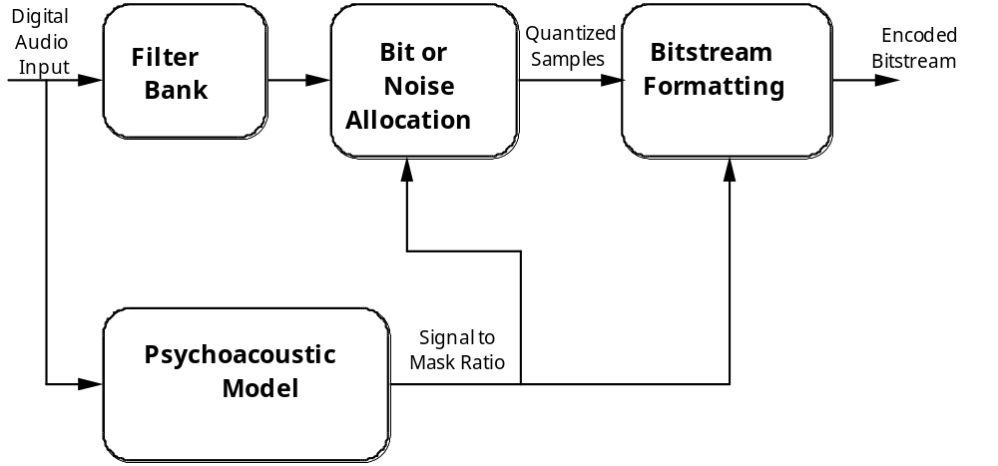

The four primary parts of the psychoacoustic encoder are:

1) The Filterbank:
The filterbank does a time to frequency mapping. There are two filterbanks used in the MPEG-Audio algorithm, each providing a specific mapping in time and frequency. These filterbanks are critically sampled (i.e. there are as many samples in the analyzed domain as there are in the time domain). These filterbanks provide the primary frequency separation for the encoder, and the reconstruction filters for the decoder. The output samples of the filterbank are quantized.

2) The Psychoacoustic Model:
The psychoacoustic model calculates a just noticable noise-level for each band in the filterbank. This noise level is used in the bit or noise allocation to determine the actual quantizers and quantizer levels. There are two psychoacoustic models presented in 3-Annex D. While they can both be applied to any layer of the MPEG-Audio algorithm, in practice Model 1 has been used for Layers I and II, and Model 2 for Layer III. In both psychoacoustic models, the final output of the model is a signal-to-mask ratio (SMR) for each band (Layers I and II) or group of bands (Layer III).

3) Bit or Noise Allocation:
The allocator looks at both the output samples from the and the SMR's from the psychoacoustic model, and adjusts the bit allocation (Layers I and II) or noise allocation (Layer III) in order to simultaneously meet both the bitrate requirements and the masking requirements. At low bitrates, these methods attempt to spend bits in a fashion that is psychoacousticly inoffensive when they cannot meet the psychoacoustic demand at the required bitrate.

4) The bitstream formatter:
The bitstream formatter takes the quantized filterbank outputs, the bit allocation (Layers I and II) or noise allocation (Layer III) and other required side information, and encodes and formats that information in an efficient fashion. In the case of Layer III, the Huffman codes are also inserted at this point.

The Filterbank

In Layers I and II, a filterbank with 32 subbands is used. In each subband, 12 or 36 samples are grouped for processing. In Layer III, the filterbank has a signal-dependant resolution, where there are either 6x32 or 18x32 frequency bands. In the case where there are 6x32 frequency samples, the 3 sets of each frequency are quantized separately.

Bit or Noise Allocation Method

There are two different bitrate control methods explained in this Annex. In Layers I and II this method is a bit allocation process, i.e. a number of bits is assigned to each sample (or group of samples) in each subband. The method for Layer III is a noise-allocation loop, where the quantizers are varied in an organized fashion, and the variable to be controlled is the actually injected noise. In either case, the result is a set of quantization parameters and quantized output samples that are given to the bistream formatter.

Bitstream Formatting

The bitstream formatter varies from layer to layer. In Layers I and II, a fixed PCM code is used for each subband sample, with the exception that in Layer II quantized samples may be grouped. In Layer III, Huffman codes are used to represent the quantized frequency samples. These Huffman codes are variable-length codes that allow for more efficient bitstream representation of the quantized samples at the cost of additional complexity.

3-C.1.2 Input High-Pass Filter

The encoding algorithms provide a frequency response down to DC. However, in applications where this is not a requirement, it is recommended that a high-pass filter be included at the input of the encoder. The cut-off frequency should be in the range of 2 to 10Hz.

The application of such a high-pass filter avoids an unneccessarily high bitrate requirement for the lowest subband and increases the overall audio quality.

3-C.1.3 Analysis Subband Filter

An analysis subband filterbank is used to split the broadband signal with sampling frequency fs into 32 equally spaced subbands with sampling frequencies fs/32. The flow chart of this process with the appropriate formulas is given in Figure 3-C.1 "ANALYSIS SUBBAND FILTER FLOW CHART". The analysis subband filtering includes the following steps:

- Input 32 audio samples.
- Build an input sample vector, X, of 512 elements. The 32 audiosamples are shifted in at positions 0 to 31, the most recent on at position 0, and the 32 oldestelements are shifted out.
- Window vector X by vector C. The coefficients are to be found in Table 3-C.1"COEFFICIENTS Ci FOR THE ANALYSIS WINDOW".
- Calculate the 64 values Yi according to the formula given in theflow chart.
- Calculate the 32 subband samples Si by matrixing. The coefficients for the matrix can be calculated by the following formula:

Mik = cos [(2i + 1)(k - 16)p/64] , for i = 0 to 31, and k = 0 to 63.

Table 3-C.1 Coefficients Ci of the Analysis Window

C[ 0]= 0.000000000 C[ 1]=-0.000000477 C[ 2]=-0.000000477 C[ 3]=-0.000000477
C[ 4]=-0.000000477 C[ 5]=-0.000000477 C[ 6]=-0.000000477 C[ 7]=-0.000000954
C[ 8]=-0.000000954 C[ 9]=-0.000000954 C[ 10]=-0.000000954 C[ 11]=-0.000001431
C[ 12]=-0.000001431 C[ 13]=-0.000001907 C[ 14]=-0.000001907 C[ 15]=-0.000002384
C[ 16]=-0.000002384 C[ 17]=-0.000002861 C[ 18]=-0.000003338 C[ 19]=-0.000003338
C[ 20]=-0.000003815 C[ 21]=-0.000004292 C[ 22]=-0.000004768 C[ 23]=-0.000005245
C[ 24]=-0.000006199 C[ 25]=-0.000006676 C[ 26]=-0.000007629 C[ 27]=-0.000008106
C[ 28]=-0.000009060 C[ 29]=-0.000010014 C[ 30]=-0.000011444 C[ 31]=-0.000012398
C[ 32]=-0.000013828 C[ 33]=-0.000014782 C[ 34]=-0.000016689 C[ 35]=-0.000018120
C[ 36]=-0.000019550 C[ 37]=-0.000021458 C[ 38]=-0.000023365 C[ 39]=-0.000025272
C[ 40]=-0.000027657 C[ 41]=-0.000030041 C[ 42]=-0.000032425 C[ 43]=-0.000034809
C[ 44]=-0.000037670 C[ 45]=-0.000040531 C[ 46]=-0.000043392 C[ 47]=-0.000046253
C[ 48]=-0.000049591 C[ 49]=-0.000052929 C[ 50]=-0.000055790 C[ 51]=-0.000059605
C[ 52]=-0.000062943 C[ 53]=-0.000066280 C[ 54]=-0.000070095 C[ 55]=-0.000073433
C[ 56]=-0.000076771 C[ 57]=-0.000080585 C[ 58]=-0.000083923 C[ 59]=-0.000087261
C[ 60]=-0.000090599 C[ 61]=-0.000093460 C[ 62]=-0.000096321 C[ 63]=-0.000099182
C[ 64]= 0.000101566 C[ 65]= 0.000103951 C[ 66]= 0.000105858 C[ 67]= 0.000107288
C[ 68]= 0.000108242 C[ 69]= 0.000108719 C[ 70]= 0.000108719 C[ 71]= 0.000108242
C[ 72]= 0.000106812 C[ 73]= 0.000105381 C[ 74]= 0.000102520 C[ 75]= 0.000099182
C[ 76]= 0.000095367 C[ 77]= 0.000090122 C[ 78]= 0.000084400 C[ 79]= 0.000077724
C[ 80]= 0.000069618 C[ 81]= 0.000060558 C[ 82]= 0.000050545 C[ 83]= 0.000039577
C[ 84]= 0.000027180 C[ 85]= 0.000013828 C[ 86]=-0.000000954 C[ 87]=-0.000017166
C[ 88]=-0.000034332 C[ 89]=-0.000052929 C[ 90]=-0.000072956 C[ 91]=-0.000093937
C[ 92]=-0.000116348 C[ 93]=-0.000140190 C[ 94]=-0.000165462 C[ 95]=-0.000191212
C[ 96]=-0.000218868 C[ 97]=-0.000247478 C[ 98]=-0.000277042 C[ 99]=-0.000307560
C[100]=-0.000339031 C[101]=-0.000371456 C[102]=-0.000404358 C[103]=-0.000438213
C[104]=-0.000472546 C[105]=-0.000507355 C[106]=-0.000542164 C[107]=-0.000576973
C[108]=-0.000611782 C[109]=-0.000646591 C[110]=-0.000680923 C[111]=-0.000714302
C[112]=-0.000747204 C[113]=-0.000779152 C[114]=-0.000809669 C[115]=-0.000838757
C[116]=-0.000866413 C[117]=-0.000891685 C[118]=-0.000915051 C[119]=-0.000935555
C[120]=-0.000954151 C[121]=-0.000968933 C[122]=-0.000980854 C[123]=-0.000989437
C[124]=-0.000994205 C[125]=-0.000995159 C[126]=-0.000991821 C[127]=-0.000983715
C[128]= 0.000971317 C[129]= 0.000953674 C[130]= 0.000930786 C[131]= 0.000902653
C[132]= 0.000868797 C[133]= 0.000829220 C[134]= 0.000783920 C[135]= 0.000731945
C[136]= 0.000674248 C[137]= 0.000610352 C[138]= 0.000539303 C[139]= 0.000462532
C[140]= 0.000378609 C[141]= 0.000288486 C[142]= 0.000191689 C[143]= 0.000088215
C[144]=-0.000021458 C[145]=-0.000137329 C[146]=-0.000259876 C[147]=-0.000388145
C[148]=-0.000522137 C[149]=-0.000661850 C[150]=-0.000806808 C[151]=-0.000956535
C[152]=-0.001111031 C[153]=-0.001269817 C[154]=-0.001432419 C[155]=-0.001597881
C[156]=-0.001766682 C[157]=-0.001937389 C[158]=-0.002110004 C[159]=-0.002283096
C[160]=-0.002457142 C[161]=-0.002630711 C[162]=-0.002803326 C[163]=-0.002974033
C[164]=-0.003141880 C[165]=-0.003306866 C[166]=-0.003467083 C[167]=-0.003622532
C[168]=-0.003771782 C[169]=-0.003914356 C[170]=-0.004048824 C[171]=-0.004174709
C[172]=-0.004290581 C[173]=-0.004395962 C[174]=-0.004489899 C[175]=-0.004570484
C[176]=-0.004638195 C[177]=-0.004691124 C[178]=-0.004728317 C[179]=-0.004748821
C[180]=-0.004752159 C[181]=-0.004737377 C[182]=-0.004703045 C[183]=-0.004649162
C[184]=-0.004573822 C[185]=-0.004477024 C[186]=-0.004357815 C[187]=-0.004215240
C[188]=-0.004049301 C[189]=-0.003858566 C[190]=-0.003643036 C[191]=-0.003401756
C[192]= 0.003134727 C[193]= 0.002841473 C[194]= 0.002521515 C[195]= 0.002174854
C[196]= 0.001800537 C[197]= 0.001399517 C[198]= 0.000971317 C[199]= 0.000515938
C[200]= 0.000033379 C[201]=-0.000475883 C[202]=-0.001011848 C[203]=-0.001573563
C[204]=-0.002161503 C[205]=-0.002774239 C[206]=-0.003411293 C[207]=-0.004072189
C[208]=-0.004756451 C[209]=-0.005462170 C[210]=-0.006189346 C[211]=-0.006937027
C[212]=-0.007703304 C[213]=-0.008487225 C[214]=-0.009287834 C[215]=-0.010103703
C[216]=-0.010933399 C[217]=-0.011775017 C[218]=-0.012627602 C[219]=-0.013489246
C[220]=-0.014358521 C[221]=-0.015233517 C[222]=-0.016112804 C[223]=-0.016994476
C[224]=-0.017876148 C[225]=-0.018756866 C[226]=-0.019634247 C[227]=-0.020506859
C[228]=-0.021372318 C[229]=-0.022228718 C[230]=-0.023074150 C[231]=-0.023907185
C[232]=-0.024725437 C[233]=-0.025527000 C[234]=-0.026310921 C[235]=-0.027073860
C[236]=-0.027815342 C[237]=-0.028532982 C[238]=-0.029224873 C[239]=-0.029890060
C[240]=-0.030526638 C[241]=-0.031132698 C[242]=-0.031706810 C[243]=-0.032248020
C[244]=-0.032754898 C[245]=-0.033225536 C[246]=-0.033659935 C[247]=-0.034055710
C[248]=-0.034412861 C[249]=-0.034730434 C[250]=-0.035007000 C[251]=-0.035242081
C[252]=-0.035435200 C[253]=-0.035586357 C[254]=-0.035694122 C[255]=-0.035758972
C[256]= 0.035780907 C[257]= 0.035758972 C[258]= 0.035694122 C[259]= 0.035586357
C[260]= 0.035435200 C[261]= 0.035242081 C[262]= 0.035007000 C[263]= 0.034730434
C[264]= 0.034412861 C[265]= 0.034055710 C[266]= 0.033659935 C[267]= 0.033225536
C[268]= 0.032754898 C[269]= 0.032248020 C[270]= 0.031706810 C[271]= 0.031132698
C[272]= 0.030526638 C[273]= 0.029890060 C[274]= 0.029224873 C[275]= 0.028532982
C[276]= 0.027815342 C[277]= 0.027073860 C[278]= 0.026310921 C[279]= 0.025527000
C[280]= 0.024725437 C[281]= 0.023907185 C[282]= 0.023074150 C[283]= 0.022228718
C[284]= 0.021372318 C[285]= 0.020506859 C[286]= 0.019634247 C[287]= 0.018756866
C[288]= 0.017876148 C[289]= 0.016994476 C[290]= 0.016112804 C[291]= 0.015233517
C[292]= 0.014358521 C[293]= 0.013489246 C[294]= 0.012627602 C[295]= 0.011775017
C[296]= 0.010933399 C[297]= 0.010103703 C[298]= 0.009287834 C[299]= 0.008487225
C[300]= 0.007703304 C[301]= 0.006937027 C[302]= 0.006189346 C[303]= 0.005462170
C[304]= 0.004756451 C[305]= 0.004072189 C[306]= 0.003411293 C[307]= 0.002774239
C[308]= 0.002161503 C[309]= 0.001573563 C[310]= 0.001011848 C[311]= 0.000475883
C[312]=-0.000033379 C[313]=-0.000515938 C[314]=-0.000971317 C[315]=-0.001399517
C[316]=-0.001800537 C[317]=-0.002174854 C[318]=-0.002521515 C[319]=-0.002841473
C[320]= 0.003134727 C[321]= 0.003401756 C[322]= 0.003643036 C[323]= 0.003858566
C[324]= 0.004049301 C[325]= 0.004215240 C[326]= 0.004357815 C[327]= 0.004477024
C[328]= 0.004573822 C[329]= 0.004649162 C[330]= 0.004703045 C[331]= 0.004737377
C[332]= 0.004752159 C[333]= 0.004748821 C[334]= 0.004728317 C[335]= 0.004691124
C[336]= 0.004638195 C[337]= 0.004570484 C[338]= 0.004489899 C[339]= 0.004395962
C[340]= 0.004290581 C[341]= 0.004174709 C[342]= 0.004048824 C[343]= 0.003914356
C[344]= 0.003771782 C[345]= 0.003622532 C[346]= 0.003467083 C[347]= 0.003306866
C[348]= 0.003141880 C[349]= 0.002974033 C[350]= 0.002803326 C[351]= 0.002630711
C[352]= 0.002457142 C[353]= 0.002283096 C[354]= 0.002110004 C[355]= 0.001937389
C[356]= 0.001766682 C[357]= 0.001597881 C[358]= 0.001432419 C[359]= 0.001269817
C[360]= 0.001111031 C[361]= 0.000956535 C[362]= 0.000806808 C[363]= 0.000661850
C[364]= 0.000522137 C[365]= 0.000388145 C[366]= 0.000259876 C[367]= 0.000137329
C[368]= 0.000021458 C[369]=-0.000088215 C[370]=-0.000191689 C[371]=-0.000288486
C[372]=-0.000378609 C[373]=-0.000462532 C[374]=-0.000539303 C[375]=-0.000610352
C[376]=-0.000674248 C[377]=-0.000731945 C[378]=-0.000783920 C[379]=-0.000829220
C[380]=-0.000868797 C[381]=-0.000902653 C[382]=-0.000930786 C[383]=-0.000953674
C[384]= 0.000971317 C[385]= 0.000983715 C[386]= 0.000991821 C[387]= 0.000995159
C[388]= 0.000994205 C[389]= 0.000989437 C[390]= 0.000980854 C[391]= 0.000968933
C[392]= 0.000954151 C[393]= 0.000935555 C[394]= 0.000915051 C[395]= 0.000891685
C[396]= 0.000866413 C[397]= 0.000838757 C[398]= 0.000809669 C[399]= 0.000779152
C[400]= 0.000747204 C[401]= 0.000714302 C[402]= 0.000680923 C[403]= 0.000646591
C[404]= 0.000611782 C[405]= 0.000576973 C[406]= 0.000542164 C[407]= 0.000507355
C[408]= 0.000472546 C[409]= 0.000438213 C[410]= 0.000404358 C[411]= 0.000371456
C[412]= 0.000339031 C[413]= 0.000307560 C[414]= 0.000277042 C[415]= 0.000247478
C[416]= 0.000218868 C[417]= 0.000191212 C[418]= 0.000165462 C[419]= 0.000140190
C[420]= 0.000116348 C[421]= 0.000093937 C[422]= 0.000072956 C[423]= 0.000052929
C[424]= 0.000034332 C[425]= 0.000017166 C[426]= 0.000000954 C[427]=-0.000013828
C[428]=-0.000027180 C[429]=-0.000039577 C[430]=-0.000050545 C[431]=-0.000060558
C[432]=-0.000069618 C[433]=-0.000077724 C[434]=-0.000084400 C[435]=-0.000090122
C[436]=-0.000095367 C[437]=-0.000099182 C[438]=-0.000102520 C[439]=-0.000105381
C[440]=-0.000106812 C[441]=-0.000108242 C[442]=-0.000108719 C[443]=-0.000108719
C[444]=-0.000108242 C[445]=-0.000107288 C[446]=-0.000105858 C[447]=-0.000103951
C[448]= 0.000101566 C[449]= 0.000099182 C[450]= 0.000096321 C[451]= 0.000093460
C[452]= 0.000090599 C[453]= 0.000087261 C[454]= 0.000083923 C[455]= 0.000080585
C[456]= 0.000076771 C[457]= 0.000073433 C[458]= 0.000070095 C[459]= 0.000066280
C[460]= 0.000062943 C[461]= 0.000059605 C[462]= 0.000055790 C[463]= 0.000052929
C[464]= 0.000049591 C[465]= 0.000046253 C[466]= 0.000043392 C[467]= 0.000040531
C[468]= 0.000037670 C[469]= 0.000034809 C[470]= 0.000032425 C[471]= 0.000030041
C[472]= 0.000027657 C[473]= 0.000025272 C[474]= 0.000023365 C[475]= 0.000021458
C[476]= 0.000019550 C[477]= 0.000018120 C[478]= 0.000016689 C[479]= 0.000014782
C[480]= 0.000013828 C[481]= 0.000012398 C[482]= 0.000011444 C[483]= 0.000010014
C[484]= 0.000009060 C[485]= 0.000008106 C[486]= 0.000007629 C[487]= 0.000006676
C[488]= 0.000006199 C[489]= 0.000005245 C[490]= 0.000004768 C[491]= 0.000004292
C[492]= 0.000003815 C[493]= 0.000003338 C[494]= 0.000003338 C[495]= 0.000002861
C[496]= 0.000002384 C[497]= 0.000002384 C[498]= 0.000001907 C[499]= 0.000001907
C[500]= 0.000001431 C[501]= 0.000001431 C[502]= 0.000000954 C[503]= 0.000000954
C[504]= 0.000000954 C[505]= 0.000000954 C[506]= 0.000000477 C[507]= 0.000000477
C[508]= 0.000000477 C[509]= 0.000000477 C[510]= 0.000000477 C[511]= 0.000000477

3-C.1.4 Psychoacoustic Models

Two examples of psychoacoustic models are presented in Annex D, "PSYCHOACOUSTIC MODELS".

3-C.1.5 Encoding

3-C.1.5.1 Layer I Encoding

1. Introduction

This clause describes a possible Layer I encoding method. The description is made according to Figure 3-C.2, "LAYERI, II ENCODER FLOW CHART".

2. Psychoacoustic Model

The calculation of the psychoacoustic parameters can be done either with Psychoacoustic Model I described in Annex D, clause 3-D.1. or with Psychoacoustic Model II as described in Annex D, clause 3-D.2. The FFT shiftlength equals 384 samples. Either model provides the signal-to-mask ratio for every subband.

3. Analysis Subband Filtering

The subband analysis is described in the clause 3-C.1.3, "ANALYSIS SUBBAND FILTER".

4. Scalefactor Calculation

The calculation of the scalefactor for each subband is performed every 12 subband samples. The maximum of the absolute value of these 12 samples is determined. The next largest value in 3-Annex B, Table 3-B.1., "LAYER I, II SCALEFACTORS" is used as the scalefactor.

5. Coding of Scalefactors

The index in the 3-Annex B, Table 3-B.1., "LAYER I ,II SCALEFACTORS" is represented by 6 bits, MSB first. The scalefactor is transmitted only if a non-zero number of bits has been allocated to the subband.

6. Bit Allocation

Before adjustment to a fixed bitrate, the number of bits that are available for coding the samples and the scalefactors must be determined. This number can be obtained by subtracting from the total number of bits available "cb", the numbers of bits needed for bit allocation "bbal", and the number of bits required for ancillary data "banc":

adb = cb - (bbal + banc)

The resulting number of bits can be used to code the subband samples and the scalefactors. The principle used in the allocation procedure is minimization of the total noise-to-mask ratio over the frame with the constraint that the number of bits used does not exceed the number of bits available for that frame. The possible number of bits allocated to one sample can be found in the table in clause 2.4.2.5 of the main part of the audio standard (Audio data, LayerI); the range is 0...15 bits, excluding an allocation of 1 bit.

The allocation procedure is an iterative procedure, where in each iteration step the number of levels of the subband samples of greatest benefit is increased.

First the mask-to-noise ratio "MNR" for each subband is calculated by subtracting from the signal-to-noise-ratio "SNR" the signal-to-mask-ratio "SMR":

MNR = SNR - SMR

The signal-to-noise-ratio can be found in the 3-Annex C, Table 3-C.2., "LAYER I SIGNAL-TO-NOISE-RATIOS". The signal-to-mask-ratio is the output of the psychoacoustic model.

Then zero bits are allocated to the samples and the scalefactors. The number of bits for the samples "bspl" and the number of bits for the scalefactors "bscf" are set to zero. Next an iterative procedure is started. Each iteration loop contains the following steps :
- Determination of the minimal MNR of all subbands.
- The accuracy of the quantization of the subband with the minimal MNR is increased by using the next higher number of bits.
- The new MNR of this subband is calculated.
- bspl is updated according to the additional number of bits required. If a non-zero number of bits is assigned to a subband for the first time, bscf has to be incremented by 6 bits. Then adb is calculated again using the formula: adb=cb-(bbal+bscf+bspl+banc)
The iterative procedure is repeated as long as adb is not less than any possible increase of bspl and bscf within one loop.

7. Quantization and Encoding of Subband Samples

A linear quantizer with a symmetric zero representation is used to quantize the subband samples. This representation prevents small value changes around zero from quantizing to different levels. Each of the subband samples is normalized by dividing its value by the scalefactor to obtain X, and quantized using the following formula :

- Calculate AX+B
- Take the N most significant bits.
- Invert the MSB.

A and B can be found in 3-Annex C, Table 3-C.3, "LAYER I QUANTIZATION COEFFICIENTS". N represents the necessary number of bits to encode the number of steps. The inversion of the most significant bit (MSB) is done in order to avoid the all ´1´ representation of the code, because the all ´1´ code is used for the synchronization word.

8. Coding of Bit Allocation

The 4-bit code for the allocation is given in clause 2.4.2.5, "Audio data LayerI", of the main part of the audio standard.

9. Formatting

The encoded subband information is transferred in frames (See also clauses 2.4.1.2, 2.4.1.3, 2.4.1.5 and 2.4.1.8 of the clause 2.4.1 "Specification of the Coded Audio Bitstream Syntax " of the main part of the audio standard. The number of slots in a frame varies with the sample frequency (Fs) and bitrate. Each frame contains information on 384 samples of the original input signal, so the frame rate is Fs/384.

Fs (kHz) Frame size (ms)
------------------------------------------
48 8
44.1 8.7074...
32 12

A frame may carry audio information from one or two channels.

The length of a slot in LayerI is 32 bits. The number of slots in a frame can be computed by this formula :

Number of slots/frame (N) = * 12

If this does not give an integer number the result is truncated and 'padding' is required. This means that the number of slots may vary between N and N + 1.

An overview of the Layer I format is given below:

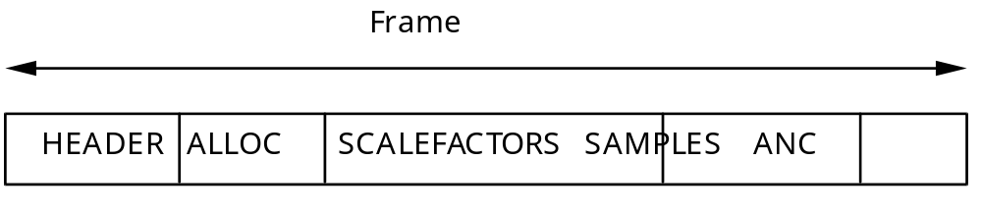

TABLE 3-C.2 LAYER I SIGNAL-TO-NOISE RATIOS

No. of steps SNR (dB)
0 0.00
3 7.00
7 16.00
15 25.28
31 31.59
63 37.75
127 43.84
255 49.89
511 55.93
1023 61.96
2047 67.98
4095 74.01
8191 80.03
16383 86.05
32767 92.01

TABLE 3-C.3 LAYER I QUANTIZATION COEFFICIENTS

No. of steps A B
3 0.750000000 -0.250000000
7 0.875000000 -0.125000000
15 0.937500000 -0.062500000
31 0.968750000 -0.031250000
63 0.984375000 -0.015625000
127 0.992187500 -0.007812500
255 0.996093750 -0.003906250
511 0.998046875 -0.001953125
1023 0.999023438 -0.000976563
2047 0.999511719 -0.000488281
4095 0.999755859 -0.000244141
8191 0.999877930 -0.000122070
16383 0.999938965 -0.000061035
32767 0.999969482 -0.000030518
3-C.1.5.2 Layer II Encoding

1. Introduction

This clause describes a possible Layer II encoding method. The description is made according to Figure 3-C.2, "LAYERI, II ENCODER FLOWCHART".

2. Psychoacoustic Model

The calculation of the psychoacoustic parameters can be done either with Psychoacoustic Model I described in Annex D, clause 3-D.1. or with Psychoacoustic Model II described in Annex D, clause 3-D.2. If Psychoacoustic Model I is used to calculate the psychoacoutic parameters, the FFT shiftlength is 1152 samples. If Psychoacoustic Model II is used, the calculation is performed twice with a shiftlength of 576 samples and the largest of each pair of signal to mask ratios is used. Either model provides the signal-to-mask ratio for every subband.

3. Analysis Subband Filter

The analysis subband filter is described in clause 3-C.1.3, "ANALYSIS SUBBAND FILTER".

4. Scalefactor Calculation

The calculation of the scalefactor for each subband is performed every 12 subband samples. The maximum of the absolute value of these 12 samples is determined. The next largest value in 3-Annex B, Table 3-B.1., "LAYER I, II TABLE OF SCALEFACTORS" is the scalefactor.

5. Coding of Scalefactors

A frame corresponds to 36 subband samples and therefore contains three scalefactors per subband. Define 'scf' as the index in Annex B, Table 3-B.1., "LAYER I, II SCALEFACTORS". First, the two differences dscf1 and dscf2 of the successive scalefactor indices scf1, scf2 and scf3 are calculated:

dscf1 = scf1 - scf2
dscf2 = scf2 - scf3

The class of each of the differences is determined as follows:

class. dscf
1 dscf <= -3
2 -3 < dscf < 0
3 dscf = 0
4 0 < dscf < 3
5 dscf >= 3

The pair of classes of differences indicate the entry point in Table 3-C.4., "LAYER II SCALEFACTOR TRANSMISSION PATTERNS". The "adjusted scalefactor pattern" gives the three scalefactors which are actually used. "1", "2" and "3" mean respectively the first, second and third scalefactor within a frame, "4" means the maximum of the three scalefactors. If, after this adjusting of scalefactors two or three are the same, not all scalefactors must be transmitted for a certain subband within one frame. Only the scalefactors indicated in the "transmission pattern" are transmitted. The information describing the number and the position of the scalefactors in each subband is called "scalefactor select information".

6. Coding of Scalefactor Select Information

The "scalefactor select information" (scfsi) is coded by a two bit word, which is also to be found in 3-ANNEX C, Table 3-C.4., "LAYER II SCALEFACTOR TRANSMISSION PATTERNS". Only the scfsi for the subbands which will get a nonzero bit allocation are transmitted.

7. Bit Allocation

Before adjustment to a fixed bitrate, the number of bits ,"adb", that are available for coding the samples and the scalefactors must be determined. This number can be obtained by subtracting from the total number of available bits "cb", the number of bits needed for bit allocation "bbal", and the number of bits "banc" required for ancillary data:

adb = cb - (bbal + banc)

The resulting number can be used to code the subband samples and the scalefactors. The principle used in the allocation procedure is minimization of the total noise-to-mask ratio over the frame with the constraint that the number of bits used does not exceed the number of bits available for that frame. Use is made of 3-Annex B, Table 3-B.2., "LAYER II POSSIBLE QUANTIZATIONS PER SUBBAND" that indicates for every subband the number of steps that may be used to quantize the samples. The number of bits required to represent these quantized samples can be derived from 3-Annex B, Table 3-B.4., "LAYER II CLASSES OF QUANTIZATION".

The allocation procedure is an iterative procedure where, in each iteration step the number of levels of the subband that has the greatest benefit is increased.

First the mask-to-noise ratio "MNR" for each subband is calculated by subtracting from the signal-to-noise-ratio "SNR" the signal-to-mask-ratio "SMR":

MNR = SNR - SMR

The signal-to-noise-ratio can be found in table 3-C.5. "LAYER II SIGNAL-TO-NOISE-RATIOS". The signal-to-mask-ratio is the output of the psychoacoustic model.

Then zero bits are allocated to the samples and the scalefactors. The number of bits for the samples "bspl" and the number of bits for the scalefactors "bscf" are set to zero. Next an iterative procedure is started. Each iteration loop contains the following steps :

- Determination of the minimal MNR of all subbands.

- The accuracy of the quantization of the subband with the minimal MNR is increased by using the next higher entry in the relevant Annex B, Table 3-B.2., "LAYER II POSSIBLE QUANTIZATIONS PER SUBBAND".

- The new MNR of this subband is calculated.

- bspl is updated according to the additional number of bits required. If a non-zero number of bits is assigned to a subband for the first time, bsel has to be updated, and bscf has to be updated according to the number of scalefactors required for this subband. Then adb is calculated again using the formula :

adb=cb-(bbal + bsel + bscf + bspl +banc)

The iterative procedure is repeated as long as adb is not less than any possible increase of bspl, bsel and bscf within one loop.

8. Quantization and Encoding of Subband Samples

Each of the 12 subband samples is normalized by dividing its value by the scale factor to obtain X and quantized using the following formula:

- Calculate A * X + B
- Take the N most significant bits.
- Invert the MSB

A and B can be found in the 3-ANNEX C, TABLE 3-C.6., "LAYER II QUANTIZATION COEFFICIENTS". Nrepresents the necessary number of bits to encode the number of steps. The inversion of the MSB is done in order to avoid the all '1' code that is used for the synchronization word.

Given the number of steps that the samples will be quantized to, 3-Annex B, Table 3-B.4., "LAYER II CLASSES OF QUANTIZATION" shows whether grouping will be used. If grouping is not required, the three samples are coded with individual codewords.

If grouping is required, three consecutive samples are coded as one codeword. Only one value vm, MSB first, is transmitted for this triplet. The relationships between the coded value vm (m=3,5,9) and the three consecutive subband samples x, y, z are:

v3 = 9z + 3y + x (v3 in 0... 26)
v5 = 25z + 5y + x (v5 in 0...124)
v9 = 81z + 9y + x (v9 in 0...728)

9. Coding of Bit Allocation

For the purpose of a more efficient coding, only a limited number of possible quantizations, which may be different for each subband, are allowed. Only the index with wordlength "nbal" in the relevant Annex B, Table 3-B.2., "LAYER II POSSIBLE QUANTZATIONS PER SUBBAND" is transmitted, MSB first.

10. Formatting

An overview of the Layer II format can be seen as follows:

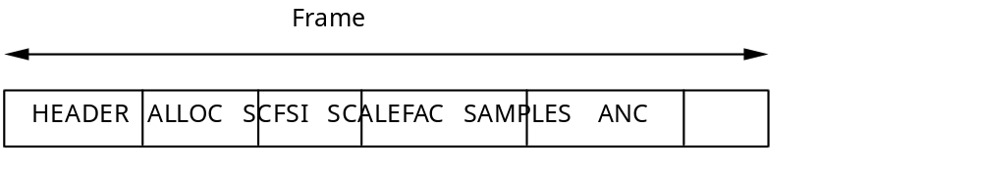

The differences compared to the Layer I format are:
- The length of a slot equals 8 bits.
- A new block scfsi containing the scalefactor select information has been introduced.
- The bit allocation information, scalefactors and samples have been subject to further coding (see the related clauses).

The details can be found in the clause 2.4.1 of the main part of this audio standard, "SPECIFICATION OF THE CODED AUDIO BITSTREAM SYNTAX " .

TABLE 3-C.4: LAYER II Scalefactor transmission patterns

Class1 Class2 Transmission pattern Select Information
1 1 1 2 3 0
1 2 1 2 2 3
1 3 1 2 2 3
1 4 1 3 3 3
1 5 1 2 3 0
2 1 1 1 3 1
2 2 1 1 1 2
2 3 1 1 1 2
2 4 4 4 4 2
2 5 1 1 3 1
3 1 1 1 1 2
3 2 1 1 1 2
3 3 1 1 1 2
3 4 3 3 3 2
3 5 1 1 3 1
4 1 2 2 2 2
4 2 2 2 2 2
4 3 2 2 2 2
4 4 3 3 3 2
4 5 1 2 3 0
5 1 1 2 3 0
5 2 1 2 2 3
5 3 1 2 2 3
5 4 1 3 3 3
5 5 1 2 3 0

TABLE 3-C.5: LAYER II SIGNAL-TO-NOISE RATIOS

No. of steps SNR (dB)
0 0.00
3 7.00
5 11.00
7 16.00
9 20.84
15 25.28
31 31.59
63 37.75
127 43.84
255 49.89
511 55.93
1023 61.96
2047 67.98
4095 74.01
8191 80.03
16383 86.05
32767 92.01
65535 98.01

TABLE 3-C.6: LAYER II QUANTIZATION COEFFICIENTS

No. of steps A B
3 0.750000000 -0.250000000
5 0.625000000 -0.375000000
7 0.875000000 -0.125000000
9 0.562500000 -0.437500000
15 0.937500000 -0.062500000
31 0.968750000 -0.031250000
63 0.984375000 -0.015625000
127 0.992187500 -0.007812500
255 0.996093750 -0.003906250
511 0.998046875 -0.001953125
1023 0.999023438 -0.000976563
2047 0.999511719 -0.000488281
4095 0.999755859 -0.000244141
8191 0.999877930 -0.000122070
16383 0.999938965 -0.000061035
32767 0.999969482 -0.000030518
65535 0.999984741 -0.000015259

FIGURE 3-C.1 Analysis subband filter flow chart

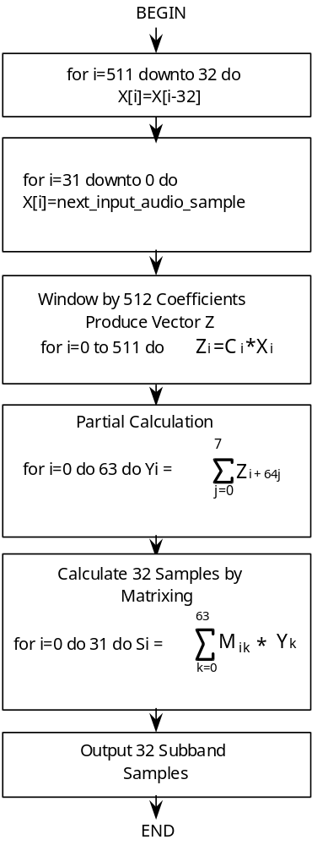

FIGURE 3-C.2 Layer I, II encoder flow chart

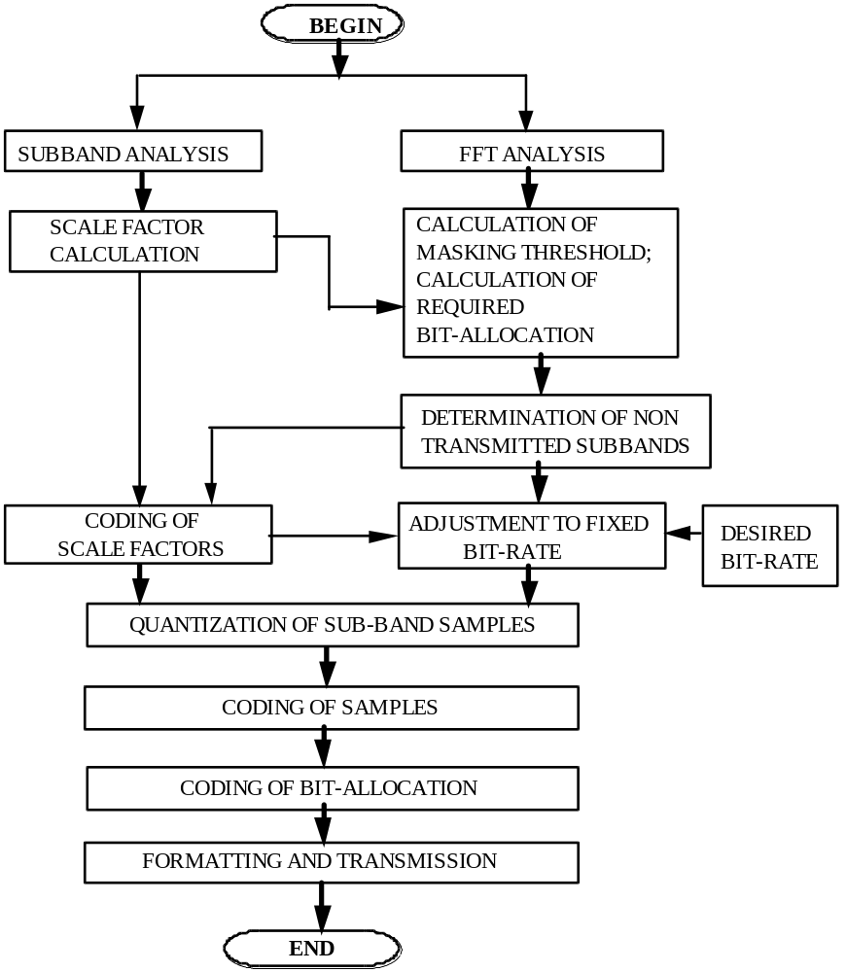

3-C.1.5.3 Layer III Encoding

1. Introduction

This clause describes a possible Layer III encoding method. The basic data flow is described by the general psychoacoustic coder block diagram. The basic blocks are described in more detail and below.

2. Psychoacoustic Model

The calculation of the psychoacoustic parameters can be done either with Psychoacoustic Model I described in Annex D, clause 3-D.1. or with Psychoacoustic Model II described in Annex D, clause 3-D.2. A description of modifications to Psychoacoustic Model II for use with Layer III can be found below. The model is run twice per block, using a shiftlength of 576 samples. A signal-to-mask-ratio is provided for every scale factor band

2.1. Adaptation of Psychoacoustic Model II for Layer III

For the use with Layer III encoding the psychoacoustic model 2 (Annex D, clause 3-D.2.) is modified as described below.

General Considerations:

The model is calculated twice in parallel. One computation is done with a shift length iblen of 192 samples (to be used with short blocks), the other is done with a shift length of 576 samples. For the shift length of 192 samples the block length of the FFT is changed to 256, and the parameters changed accordingly.

Change to Unpredictability Calculation:

The calculation of the unpredictability metric in Psychoacoustic Model II is changed.

- Calculation of the unpredictability
The unpredictability cw is calculated for the first 206 spectral lines. For the other spectral lines, the unpredicatblility is set to 0.4.
The unpredictability for the first 6 lines is calculated from the long FFT (window length = 1024, shiftlen = 576). For the spectral lines 6 upto 205 the unpredictability is calculated from the short FFT (window length 256, shiftlen = 192):

cw_l(w) for 0 = w < 6
cw( w) = { cw_s(w/4) for 6 = w < 206, w=6,10,14,...
0.4 for w = 206

cw_l is the unpredictability calculated from the long FFT, cw_s is the unpredictability calculated from the second short block out of three short blocks within one granule.

- The spreading function has been replaced:

If j = i tmpy= 3.0 (j -i)
else tmpy= 1.5(j-i) is used.

Only values of the spreading function greater than 10-6 are used. All other values are set to zero.

- For converting the unpredictability the parameters

conv1 = -0.299
conv2 = - 0.43

are used.

- The parameter NMT (noise masking tone) is set to 6.0 db for all threshold calculation partions. The parameter TMN (tone masking noise) is set to 29.0 db for all partitions.
For minval see table "threshold calculation partitions"

- The psychoacoustic entropy is estimated from the ratio thr/eb, where thr is the threshold and eb is the energy:

pe = - ? (cbwidthk • log( thrk/(ebk+1.) ))

where k indexes the threshold calculation partitions and cbwidth is the width of the threshold calculation partition (see tables).

- pre-echo control

The following constants are used for the control of pre-echo's (see block diagram):

rpelev = 2.
rpelev2 = 16.

- The threshold is not spread over the FFT lines. The threshold calculation partitions are converted directly to scalefactor bands. The first partition which is added to the scalefactor band is weighted with w1, the last with w2 (see table 3-Annex 3-C.8 "converting threshold calculation partitions to scalefactor bands"). The table contains also the number of partitions (cbw) converted to one scalefactor band (excluding the first and the last partition).
The parameters bo and bu are shown in the table 3-Annex 3-C.8 used for converting threshold calculation partitions to scalefactor bands.

- For short blocks a simplified version of the threshold calculation (constant signal to noise ratio) is used. The constants can be found in the columns "SNR (dB)" in table 3-Annex 3-C.7. below.

Tables:

Table 3-C.7: Threshold calculation partitions with following parameters:
width, minval, threshold in quiet, norm and bval:

Table 3-C.7a: Sampling_frequency = 48 kHz
long blocks

no. FFT-lines minval qthr norm bval
0 1 24.5 4.532 0.970 0.000
1 1 24.5 4.532 0.755 0.469
2 1 24.5 4.532 0.738 0.937
3 1 24.5 0.904 0.730 1.406
4 1 24.5 0.904 0.724 1.875
5 1 20 0.090 0.723 2.344
6 1 20 0.090 0.723 2.812
7 1 20 0.029 0.723 3.281
8 1 20 0.029 0.718 3.750
9 1 20 0.009 0.690 4.199
10 1 20 0.009 0.660 4.625
11 1 18 0.009 0.641 5.047
12 1 18 0.009 0.600 5.437
13 1 18 0.009 0.584 5.828
14 1 12 0.009 0.531 6.187
15 1 12 0.009 0.537 6.522
16 2 6 0.018 0.857 7.174
17 2 6 0.018 0.858 7.800
18 2 3 0.018 0.853 8.402
19 2 3 0.018 0.824 8.966
20 2 3 0.018 0.778 9.483
21 2 3 0.018 0.740 9.966
22 2 0 0.018 0.709 10.426
23 2 0 0.018 0.676 10.866
24 2 0 0.018 0.632 11.279
25 2 0 0.018 0.592 11.669
26 2 0 0.018 0.553 12.042
27 2 0 0.018 0.510 12.386
28 2 0 0.018 0.513 12.721
29 3 0 0.027 0.608 13.115
30 3 0 0.027 0.673 13.561
31 3 0 0.027 0.636 13.983
32 3 0 0.027 0.586 14.371
33 3 0 0.027 0.571 14.741
34 4 0 0.036 0.616 15.140
35 4 0 0.036 0.640 15.562
36 4 0 0.036 0.597 15.962
37 4 0 0.036 0.538 16.324
38 4 0 0.036 0.512 16.665
39 5 0 0.045 0.528 17.020
40 5 0 0.045 0.516 17.373
41 5 0 0.045 0.493 17.708
42 6 0 0.054 0.499 18.045
43 7 0 0.063 0.525 18.398
44 7 0 0.063 0.541 18.762
45 8 0 0.072 0.528 19.120
46 8 0 0.072 0.510 19.466
47 8 0 0.072 0.506 19.807
48 10 0 0.180 0.525 20.159
49 10 0 0.180 0.536 20.522
50 10 0 0.180 0.518 20.873
51 13 0 0.372 0.501 21.214
52 13 0 0.372 0.496 21.553
53 14 0 0.400 0.497 21.892
54 18 0 1.628 0.495 22.231
55 18 0 1.628 0.494 22.569
56 20 0 1.808 0.497 22.909
57 25 0 22.607 0.494 23.248
58 25 0 22.607 0.487 23.583
59 35 0 31.650 0.483 23.915
60 67 0 605.867 0.482 24.246
61 67 0 605.867 0.524 24.576

Table 3.-C.7b: Sampling_frequency = 44.1 kHz
long blocks

no. FFT-lines minval qthr norm bval
0 1 24.5 4.532 0.951 0.000
1 1 24.5 4.532 0.700 0.431
2 1 24.5 4.532 0.681 0.861
3 1 24.5 0.904 0.675 1.292
4 1 24.5 0.904 0.667 1.723
5 1 20 0.090 0.665 2.153
6 1 20 0.090 0.664 2.584
7 1 20 0.029 0.664 3.015
8 1 20 0.029 0.664 3.445
9 1 20 0.029 0.655 3.876
10 1 20 0.009 0.616 4.279
11 1 20 0.009 0.597 4.670
12 1 18 0.009 0.578 5.057
13 1 18 0.009 0.541 5.415
14 1 18 0.009 0.575 5.774
15 2 12 0.018 0.856 6.422
16 2 6 0.018 0.846 7.026
17 2 6 0.018 0.840 7.609
18 2 3 0.018 0.822 8.168
19 2 3 0.018 0.800 8.710
20 2 3 0.018 0.753 9.207
21 2 3 0.018 0.704 9.662
22 2 0 0.018 0.674 10.099
23 2 0 0.018 0.640 10.515
24 2 0 0.018 0.609 10.917
25 2 0 0.018 0.566 11.293
26 2 0 0.018 0.535 11.652
27 2 0 0.018 0.531 11.997
28 3 0 0.027 0.615 12.394
29 3 0 0.027 0.686 12.850
30 3 0 0.027 0.650 13.277
31 3 0 0.027 0.611 13.681
32 3 0 0.027 0.567 14.062
33 3 0 0.027 0.520 14.411
34 3 0 0.027 0.513 14.751
35 4 0 0.036 0.557 15.119
36 4 0 0.036 0.584 15.508
37 4 0 0.036 0.570 15.883
38 5 0 0.045 0.579 16.263
39 5 0 0.045 0.585 16.654
40 5 0 0.045 0.548 17.020
41 6 0 0.054 0.536 17.374
42 6 0 0.054 0.550 17.744
43 7 0 0.063 0.532 18.104
44 7 0 0.063 0.504 18.447
45 7 0 0.063 0.496 18.781
46 9 0 0.081 0.516 19.130
47 9 0 0.081 0.527 19.487
48 9 0 0.081 0.516 19.838
49 10 0 0.180 0.497 20.179
50 10 0 0.180 0.489 20.510
51 11 0 0.198 0.502 20.852
52 14 0 0.400 0.502 21.196
53 14 0 0.400 0.491 21.531
54 15 0 0.429 0.497 21.870
55 20 0 1.808 0.504 22.214
56 20 0 1.808 0.504 22.558
57 21 0 1.899 0.495 22.898
58 27 0 24.415 0.486 23.232
59 27 0 24.415 0.484 23.564
60 36 0 32.554 0.483 23.897
61 73 0 660.124 0.475 24.229
62 18 0 162.770 0.515 24.542

Table 3-C.7c: Sampling_frequency = 32 kHz
long blocks

no. FFT-lines minval qthr norm bval
0 2 24.5 9.064 0.997 0.312
1 2 24.5 9.064 0.893 0.937
2 2 24.5 1.808 0.881 1.562
3 2 20 0.181 0.873 2.187
4 2 20 0.181 0.872 2.812
5 2 20 0.057 0.871 3.437
6 2 20 0.018 0.860 4.045
7 2 20 0.018 0.839 4.625
8 2 18 0.018 0.812 5.173
9 2 18 0.018 0.784 5.698
10 2 12 0.018 0.741 6.184
11 2 12 0.018 0.697 6.634
12 2 6 0.018 0.674 7.070
13 2 6 0.018 0.651 7.492
14 2 6 0.018 0.633 7.905
15 2 3 0.018 0.611 8.305
16 2 3 0.018 0.589 8.695
17 2 3 0.018 0.575 9.064
18 3 3 0.027 0.654 9.483
19 3 3 0.027 0.724 9.966
20 3 0 0.027 0.701 10.425
21 3 0 0.027 0.673 10.866
22 3 0 0.027 0.631 11.279
23 3 0 0.027 0.592 11.669
24 3 0 0.027 0.553 12.042
25 3 0 0.027 0.510 12.386
26 3 0 0.027 0.505 12.721
27 4 0 0.036 0.562 13.091
28 4 0 0.036 0.598 13.488
29 4 0 0.036 0.589 13.873
30 5 0 0.045 0.607 14.268
31 5 0 0.045 0.620 14.679
32 5 0 0.045 0.580 15.067
33 5 0 0.045 0.532 15.424
34 5 0 0.045 0.517 15.771
35 6 0 0.054 0.517 16.120
36 6 0 0.054 0.509 16.466
37 6 0 0.054 0.506 16.807
38 8 0 0.072 0.522 17.158
39 8 0 0.072 0.531 17.518
40 8 0 0.072 0.519 17.869
41 10 0 0.090 0.512 18.215
42 10 0 0.090 0.509 18.562
43 10 0 0.090 0.497 18.902
44 12 0 0.108 0.494 19.239
45 12 0 0.108 0.501 19.579
46 13 0 0.117 0.507 19.925
47 14 0 0.252 0.502 20.269
48 14 0 0.252 0.493 20.606
49 16 0 0.289 0.497 20.944
50 20 0 0.572 0.506 21.288
51 20 0 0.572 0.510 21.635
52 23 0 0.658 0.504 21.979
53 27 0 2.441 0.496 22.319
54 27 0 2.441 0.493 22.656
55 32 0 2.894 0.490 22.993
56 37 0 33.458 0.483 23.326
57 37 0 33.458 0.458 23.656
58 12 0 10.851 0.500 23.937

Table 3-C.7d: Sampling_frequency = 48 kHz
short blocks

no. FFT-lines qthr norm SNR (db) bval
0 1 4.532 0.970 -8.240 0.000
1 1 0.904 0.755 -8.240 1.875
2 1 0.029 0.738 -8.240 3.750
3 1 0.009 0.730 -8.240 5.437
4 1 0.009 0.724 -8.240 6.857
5 1 0.009 0.723 -8.240 8.109
6 1 0.009 0.723 -8.240 9.237
7 1 0.009 0.723 -8.240 10.202
8 1 0.009 0.718 -8.240 11.083
9 1 0.009 0.690 -8.240 11.864
10 1 0.009 0.660 -7.447 12.553
11 1 0.009 0.641 -7.447 13.195
12 1 0.009 0.600 -7.447 13.781
13 1 0.009 0.584 -7.447 14.309
14 1 0.009 0.532 -7.447 14.803
15 1 0.009 0.537 -7.447 15.250
16 1 0.009 0.857 -7.447 15.667
17 1 0.009 0.858 -7.447 16.068
18 1 0.009 0.853 -7.447 16.409
19 2 0.018 0.824 -7.447 17.044
20 2 0.018 0.778 -6.990 17.607
21 2 0.018 0.740 -6.990 18.097
22 2 0.018 0.709 -6.990 18.528
23 2 0.018 0.676 -6.990 18.930
24 2 0.018 0.632 -6.990 19.295
25 2 0.018 0.592 -6.990 19.636
26 3 0.054 0.553 -6.990 20.038
27 3 0.054 0.510 -6.990 20.486
28 3 0.054 0.513 -6.990 20.900
29 4 0.114 0.608 -6.990 21.305
30 4 0.114 0.673 -6.020 21.722
31 5 0.452 0.637 -6.020 22.128
32 5 0.452 0.586 -6.020 22.512
33 5 0.452 0.571 -6.020 22.877
34 7 6.330 0.616 -5.229 23.241
35 7 6.330 0.640 -5.229 23.616
36 11 9.947 0.597 -5.229 23.974
37 17 153.727 0.538 -5.229 24.312

Table 3-C.7e: Sampling_frequency = 44.1 kHz
short blocks

no. FFT-lines qthr norm SNR (db) bval
0 1 4.532 0.952 -8.240 0.000
1 1 0.904 0.700 -8.240 1.723
2 1 0.029 0.681 -8.240 3.445
3 1 0.009 0.675 -8.240 5.057
4 1 0.009 0.667 -8.240 6.422
5 1 0.009 0.665 -8.240 7.609
6 1 0.009 0.664 -8.240 8.710
7 1 0.009 0.664 -8.240 9.662
8 1 0.009 0.664 -8.240 10.515
9 1 0.009 0.655 -8.240 11.293
10 1 0.009 0.616 -7.447 12.009
11 1 0.009 0.597 -7.447 12.625
12 1 0.009 0.578 -7.447 13.210
13 1 0.009 0.541 -7.447 13.748
14 1 0.009 0.575 -7.447 14.241
15 1 0.009 0.856 -7.447 14.695
16 1 0.009 0.846 -7.447 15.125
17 1 0.009 0.840 -7.447 15.508
18 1 0.009 0.822 -7.447 15.891
19 2 0.018 0.800 -7.447 16.537
20 2 0.018 0.753 -6.990 17.112
21 2 0.018 0.704 -6.990 17.620
22 2 0.018 0.674 -6.990 18.073
23 2 0.018 0.640 -6.990 18.470
24 2 0.018 0.609 -6.990 18.849
25 3 0.027 0.566 -6.990 19.271
26 3 0.027 0.535 -6.990 19.741
27 3 0.054 0.531 -6.990 20.177
28 3 0.054 0.615 -6.990 20.576
29 3 0.054 0.686 -6.990 20.950
30 4 0.114 0.650 -6.020 21.316
31 4 0.114 0.612 -6.020 21.699
32 5 0.452 0.567 -6.020 22.078
33 5 0.452 0.520 -6.020 22.438
34 5 0.452 0.513 -5.229 22.782
35 7 6.330 0.557 -5.229 23.133
36 7 6.330 0.584 -5.229 23.484
37 7 6.330 0.570 -5.229 23.828
38 19 171.813 0.578 -4.559 24.173

Table 3-C.7f: Sampling_frequency = 32 kHz
short blocks

no. FFT-lines qthr norm SNR (db) bval
0 1 4.532 0.997 -8.240 0.000
1 1 0.904 0.893 -8.240 1.250
2 1 0.090 0.881 -8.240 2.500
3 1 0.029 0.873 -8.240 3.750
4 1 0.009 0.872 -8.240 4.909
5 1 0.009 0.871 -8.240 5.958
6 1 0.009 0.860 -8.240 6.857
7 1 0.009 0.839 -8.240 7.700
8 1 0.009 0.812 -8.240 8.500
9 1 0.009 0.784 -8.240 9.237
10 1 0.009 0.741 -7.447 9.895
11 1 0.009 0.697 -7.447 10.500
12 1 0.009 0.674 -7.447 11.083
13 1 0.009 0.651 -7.447 11.604
14 1 0.009 0.633 -7.447 12.107
15 1 0.009 0.611 -7.447 12.554
16 1 0.009 0.589 -7.447 13.000
17 1 0.009 0.575 -7.447 13.391
18 1 0.009 0.654 -7.447 13.781
19 2 0.018 0.724 -7.447 14.474
20 2 0.018 0.701 -6.990 15.096
21 2 0.018 0.673 -6.990 15.667
22 2 0.018 0.631 -6.990 16.177
23 2 0.018 0.592 -6.990 16.636
24 2 0.018 0.553 -6.990 17.057
25 2 0.018 0.510 -6.990 17.429
26 2 0.018 0.506 -6.990 17.786
27 3 0.027 0.562 -6.990 18.177
28 3 0.027 0.598 -6.990 18.597
29 3 0.027 0.589 -6.990 18.994
30 3 0.027 0.607 -6.020 19.352
31 3 0.027 0.620 -6.020 19.693
32 4 0.072 0.580 -6.020 20.066
33 4 0.072 0.532 -6.020 20.461
34 4 0.072 0.517 -5.229 20.841
35 5 0.143 0.517 -5.229 21.201
36 5 0.143 0.509 -5.229 21.549
37 6 0.172 0.506 -5.229 21.911
38 7 0.633 0.522 -4.559 22.275
39 7 0.633 0.531 -4.559 22.625
40 8 0.723 0.519 -3.980 22.971
41 10 9.043 0.512 -3.980 23.321

Table 3-C.8: Tables for converting threshold calculation partitions to scalefactor bands

Table 3-C.8a: Sampling_frequency = 48 kHz
long blocks

no. sb cbw bu bo w1 w2
0 3 0 4 1.000 0.056
1 3 4 7 0.944 0.611
2 4 7 11 0.389 0.167
3 3 11 14 0.833 0.722
4 3 14 17 0.278 0.639
5 2 17 19 0.361 0.417
6 3 19 22 0.583 0.083
7 2 22 24 0.917 0.750
8 3 24 27 0.250 0.417
9 3 27 30 0.583 0.648
10 3 30 33 0.352 0.611
11 3 33 36 0.389 0.625
12 4 36 40 0.375 0.144
13 3 40 43 0.856 0.389
14 3 43 46 0.611 0.160
15 3 46 49 0.840 0.217
16 3 49 52 0.783 0.184
17 2 52 54 0.816 0.886
18 3 54 57 0.114 0.313
19 2 57 59 0.687 0.452
20 1 59 60 0.548 0.908

Table 3-C.8b: Sampling_frequency = 44.1 kHz
long blocks

no. sb cbw bu bo w1 w2
0 3 0 4 1.000 0.056
1 3 4 7 0.944 0.611
2 4 7 11 0.389 0.167
3 3 11 14 0.833 0.722
4 3 14 17 0.278 0.139
5 1 17 18 0.861 0.917
6 3 18 21 0.083 0.583
7 3 21 24 0.417 0.250
8 3 24 27 0.750 0.805
9 3 27 30 0.194 0.574
10 3 30 33 0.426 0.537
11 3 33 36 0.463 0.819
12 4 36 40 0.180 0.100
13 3 40 43 0.900 0.468
14 3 43 46 0.532 0.623
15 3 46 49 0.376 0.450
16 3 49 52 0.550 0.552
17 3 52 55 0.448 0.403
18 2 55 57 0.597 0.643
19 2 57 59 0.357 0.722
20 2 59 61 0.278 0.960

Table 3-C.8c: Sampling_frequency = 32 kHz
long blocks

no. sb cbw bu bo w1 w2
0 1 0 2 1.000 0.528
1 2 2 4 0.472 0.305
2 2 4 6 0.694 0.083
3 1 6 7 0.917 0.861
4 2 7 9 0.139 0.639
5 2 9 11 0.361 0.417
6 3 11 14 0.583 0.083
7 2 14 16 0.917 0.750
8 3 16 19 0.250 0.870
9 3 19 22 0.130 0.833
10 4 22 26 0.167 0.389
11 4 26 30 0.611 0.478
12 4 30 34 0.522 0.033
13 3 34 37 0.967 0.917
14 4 37 41 0.083 0.617
15 3 41 44 0.383 0.995
16 4 44 48 0.005 0.274
17 3 48 51 0.726 0.480
18 3 51 54 0.519 0.261
19 2 54 56 0.739 0.884
20 2 56 58 0.116 1.000

Table 3-C.8d: Sampling_frequency = 48 kHz
short blocks

no. sb cbw bu bo w1 w2
0 2 0 3 1.000 0.167
1 2 3 5 0.833 0.833
2 3 5 8 0.167 0.500
3 3 8 11 0.500 0.167
4 4 11 15 0.833 0.167
5 4 15 19 0.833 0.583
6 3 19 22 0.417 0.917
7 4 22 26 0.083 0.944
8 4 26 30 0.055 0.042
9 2 30 32 0.958 0.567
10 3 32 35 0.433 0.167
11 2 35 37 0.833 0.618

Table 3-C.8e: Sampling_frequency = 44.1 kHz
short blocks

no. sb cbw bu bo w1 w2
0 2 0 3 1.000 0.167
1 2 3 5 0.833 0.833
2 3 5 8 0.167 0.500
3 3 8 11 0.500 0.167
4 4 11 15 0.833 0.167
5 5 15 20 0.833 0.250
6 3 20 23 0.750 0.583
7 4 23 27 0.417 0.055
8 3 27 30 0.944 0.375
9 3 30 33 0.625 0.300
10 3 33 36 0.700 0.167
11 2 36 38 0.833 1.000

Table 3-C.8f: Sampling_frequency = 32 kHz
short blocks

no. sb cbw bu bo w1 w2
0 2 0 3 1.000 0.167
1 2 3 5 0.833 0.833
2 3 5 8 0.167 0.500
3 3 8 11 0.500 0.167
4 4 11 15 0.833 0.167
5 5 15 20 0.833 0.250
6 4 20 24 0.750 0.250
7 5 24 29 0.750 0.055
8 4 29 33 0.944 0.375
9 4 33 37 0.625 0.472
10 3 37 40 0.528 0.937
11 1 40 41 0.062 1.000

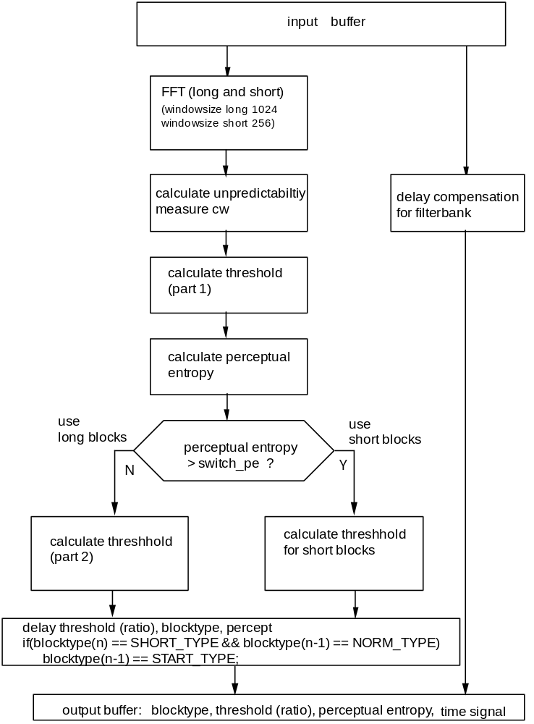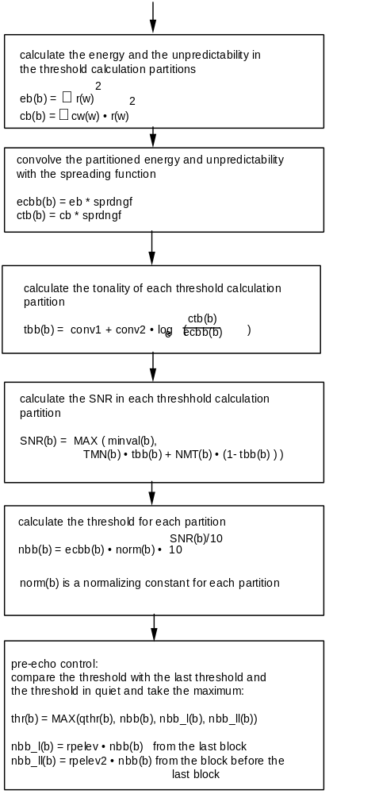

Block diagram psychoacoustic model II, layer III: calculate threshold (part 1)
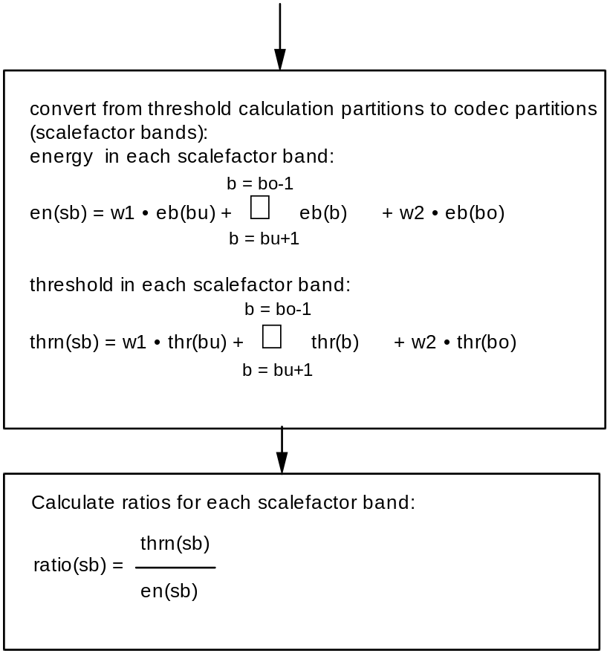

Block diagram psychoacoustic model II, layer III: calculate threshold (part 2)
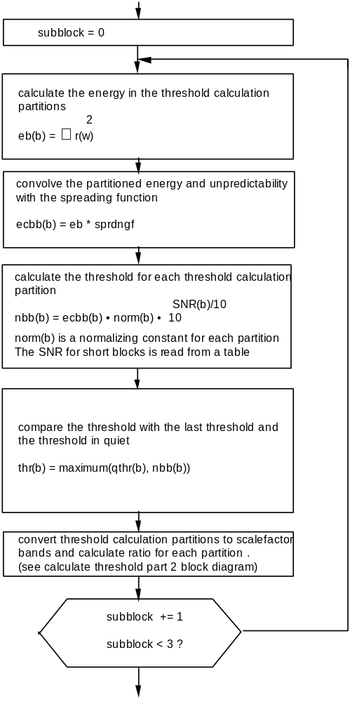

Block diagram psychoacoustic model II, layer III: calculate threshold for short blocks

Window switching decision:

The decision whether the filterbank should be switched to short windows is derived from the calculation of the masking threshold by calculating the estimate of the psychoacoustic entropy (PE) and switching when the PE exceeds the value 1800. If this condition is met, the sequence start (block_type=1), short (block_type=2), short, stop (block_type=3) is started. The figure below shows the possible state changes for the window switching logic.

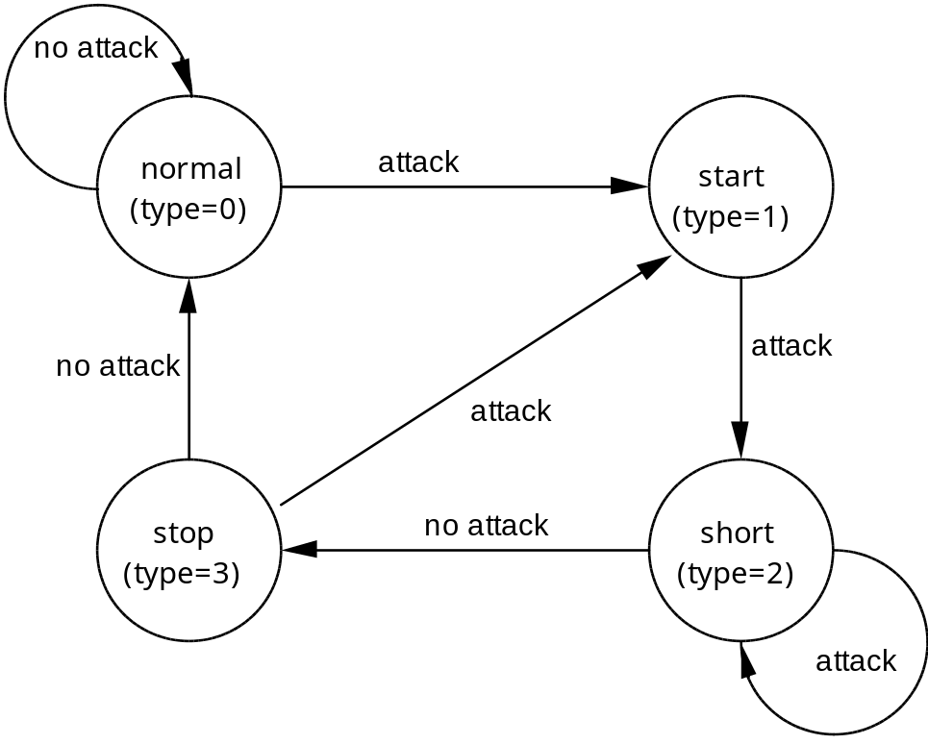

3. Analysis Part of the Hybrid Filterbank

The subband analysis of the polyphase filterbank is described in clause 3-C.1.3, "SUBBAND ANALYSIS FILTER". The output of the polyphase filterbank is the input to the subdivision using the MDCT. According to the output of the psychoacoustic model (variables blocksplit_flag and block_type) the window and transform types normal, start, short or stop are used.

18 consecutive output values of one granule and 18 output values of the granule before are assembled to one block of 36 samples.

Block type "normal"
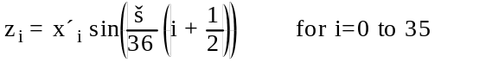

Block type "start"
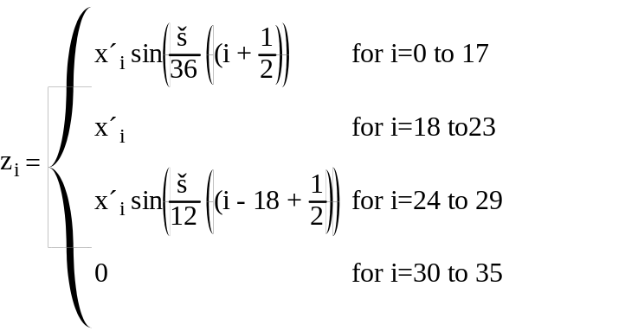

Block type "stop"
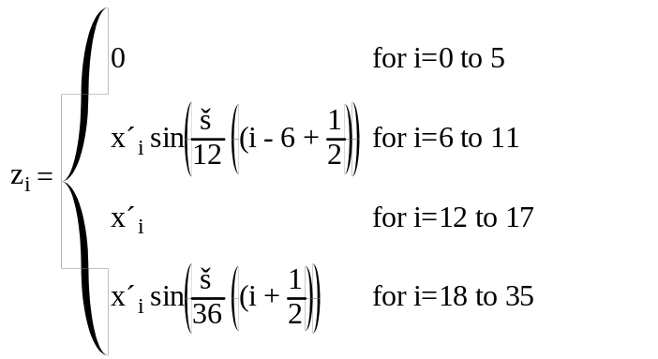
Block type "short"

The block of 36 samples is divided into three overlapping blocks:
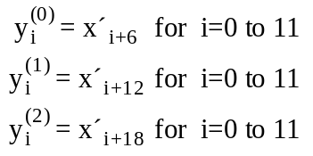
Each of the three small blocks is windowed separately:
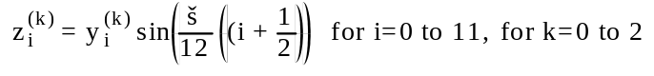

MDCT:

In the following n is the number of windowed samples. For short blocks n is 12, for long blocks n is 36. The analytical expression of the MDCT is:

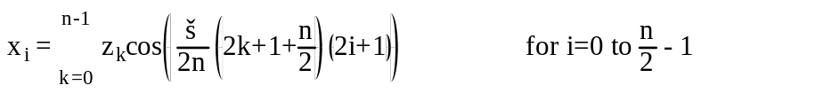

Aliasing-Butterfly, Encoder:

The calculation of aliasing reduction in the encoder is performed as in the decoder. The general procedure is shown in Fig. 3-Annex 3-A.5. The butterfly definition to be used in the encoder is shown below. The coefficients cai and csi can be found in 3-Annex Table 3-B.9

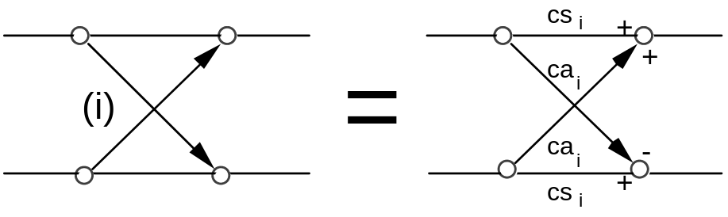

4. Calculation of average available bits

The average number of bits per granule is calculated from the frame size. The bitrate 64 kb/second is used as an example. At bitrate 64 kb/second at 48000 samples per second,

(64000 * 0.24 bits per frame) / (2 granules per frame) = 768 bits per granule

As the header takes 32 bits and the side information takes 17 bytes (136 bits) in single_channel mode, the average amount of available bits for the main_data for a granule is given by

mean_bits = 768 bits per granule - (32+136 bits per frame)/(2 granules per frame) = 684 bits per granule

Bit reservoir:

The bit reservoir can provide additional bits which may be used for the granule. The number of bits which are provided is determined within the iteration loops.

5. Quantization and Encoding of Frequency Domain Samples

The frequency domain data are quantized and coded within two nested iteration loops. Chapter 3-C1.5.4 contains a detailed description of these iteration loops.

6. Formatting

The details about the Layer III bitstream format can be found in the clause 2.4.4 of the main part of this audio standard, "SPECIFICATION OF THE CODED AUDIO BITSTREAM SYNTAX " . The formatting of the Huffman code words is described below:

The Huffman codewords are in sequence from low to high frequencies. In the iteration loops the following variables have been calculated and are used in encoding the Huffman codewords:

is(i), i=0...575 quantized frequency domain values
table_select[region] Huffman code table used for regions (region = 0, 1, 2)
region_adress1 defines the border between region 0 and 1
region_adress2 defines the border between region 1 and 2
max_value[region] maximum absolute value of quantized data in regions (region = 0, 1, 2)

The data are written to the bitstream according to the Huffman code syntax described in clause 2.4.2.7

The actual assembly of the Huffman code for the big_values part is described in a pseudo high level language:

for region number from 0 to 2
if table_select for this region is 0
nothing to do, all values in region are zero
else
if table_select for this region is > 15
an ESC-table is used: look up linbits value connected to the table used
for i = begin of region to end of region, count in pairs
x = is(i), y = is(i+1)
if x > 14
linbitsx = x - 15, x = 15
end if
signx = sign(x), x = abs(x)
if y > 14
linbitsy = y - 15, y = 15
end if
signy = sign(y), y = abs(y)
look for codeword = hcod([x][y]]) in table table_seletct
write hcod([x][y]), beginning with the leftmost bit, number of bits is hlen([x][y])
if x > 14
write linbitsx to the bitstream, number of bits is linbits
end if
if x != 0
write signx to bitstream
end if
if y > 14
write linbitsy to the bitstream, number of bits is linbits
end if
if y != 0
write signy to bitstream
end if
end do
else
no ESC-words are used in this region:
for i = beginning of region to end of region, count in pairs
x = is(i), y = is(i+1)
signx = sign(x), x = abs(x)
signy = sign(y), y = abs(y)
look for codeword = hcod([x][y]) in table table_seletct
write hcod([x][y]), beginning with the leftmost bit, number of bits is hlen([x][y])
if x != 0
write signx to bitstream
end if
if y != 0
write signy to bitstream
end if
end do
end if
end if
end for

A possible application for the private_bits is to use them as frame counter.
3-C.1.5.4 Layer III Iteration Loops

1. Introduction

The description of the Layer III loop module is subdivided into three levels. The top level is called "loops frame program". The loops frame program calls a subroutine named "outer iteraton loop" which calls the subroutine "inner iteration loop". For each level a corresponding flow diagram is shown.

The loops module quantizes an input vector of spectral data in an iterative process according to several demands. The inner loop quantizes the input vector and increases the quantizer step size until the output vector can be coded with the available amount of bit. After completion of the inner loop an outer loop checks the distortion of each scalefactor band and, if the allowed distortion is exceeded, amplifies the scalefactor band and calls the inner loop again.

Layer III loops module input:
(1) vector of the magnitudes of the spectral values xr(0..575)
(2) xmin(cb), the allowed distortion of the scalefactor bands
(3) blocksplit_flag which in conjunction with switch_point determines the number of scalefactor bands
(4) mean_bits (bit available for the Huffman coding and the coding of the scalefactors)
(5) more_bits, the number of bits in addition to the average number of bits, as demanded by the value of the psychoacoustic entropy for the granule:
more_bits = 3.1 * PE - (average number of bits)

Layer III loops module output:
(1) vector of quantized values ix(0..575)
(2) ifq(cb), the scalefactors
(3) qquant (quantizer step size information)
(4) number of unused bit available for later use
(5) preflag (loops preemphasis on/off)
(6) Huffman code related side information
- big_values (number of pairs of Huffman coded values, excluding "count1")
- count1table_select (Huffman code table of absolut values <= 1 at the upper end of the spectrum
- table_select[0..2](Huffman code table of regions)
- region_address1,2 (used to calculate boundaries between regions)
- part2_3_length

2. Preparatory Steps

2.1 Reset of all iteration variables

The scalefactors of the coder partitions scalefac[cb] are set to zero.

The counter qquant for the quantizer step size is reset to zero.

Preflag is reset to zero.

Scalefac_scale is reset to zero.

The inital value of quantanf is set as follows:

quantanf = system_const * loge(sfm),

where sfm is the spectral flatness measure and quantanf depends on the computational implementation of the encoder.

The spectral flatness measure sfm is given by

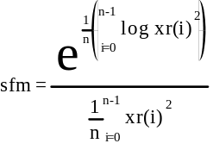

The value of system_const is chosen so that for all signals the first iteration of the inner loop for all signals comes out with a bit sum higher than the desired bitsum. By that it is ensured that the first call of the inner loop results in the solution which uses as many of the available bits as possible. In order to spare computing time it is desirable to minimize the number of iterations by adapting the value of quantanf to the bitrate and the signal statistics.

2.2 Bit reservoir control

Bits are saved to the reservoir when fewer than the mean_bits are used to code one granule. If bits are saved for a frame, the value of main_data_end is increased accordingly. See diagram 3-Annex 3-A.7.1.

The number of bits which are made available for the main_data (called "max_bits") is derived from the actual estimated threshold (the PE as calculated by the psychoacoustic model), the average number of bits (mean_bits) and the actual content of the bit reservoir. The number of bytes in the bit reservoir is given by main_data_end.

The actual rules for the control of the bit reservoir are given below:

- If a number of bytes available to the inner iteration loop is not used for the Huffman encoding or other main_data, the number is added to the bit reservoir.
- If the bit reservoir contains more than 0.8 times the maximum allowed content of the bit reservoir, all bytes exceeding this number are made available for main_data (in addition to mean_bits)
- If more_bits is greater than 100 bits, then max(more_bits/8, 0.6*main_data_end) bytes are taken from the bit reservoir and made available for main_data (in addition to mean_bits).
- After the actual loops computations have been completed, the number of bytes not used for main_data is added to the bit reservoir.
- If after the step above the number of bytes in the bit reservoir exceeds the maximum allowed content, stuffing bits are written to the bitstream and the content of the bit reservoir is adjusted accordingly.

2.3 Calculation of the scalefactor select information (scfsi)

The scfsi contains the information, which scalefactors (grouped in the scfsi_bands) of the first granule can also be used for the second granule. These scalefactors are therefore not transmitted, the gained bits can be used for the huffman coding.
To determine the usage of the scfsi, the following information of each granule must be stored:
1. The block type
2. The total energy of the granule:
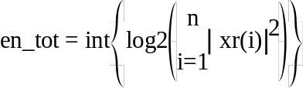
where n is the total number of spectral values
3. The energy of each scalefactor band:
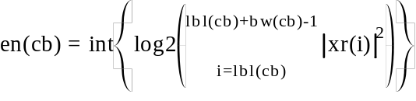
where lbl(cb) is the number of the first coefficient belonging to scalefactor band cb and bw(cb) is the number of coefficients within scalefactor band cb
4. The allowed distortion of each scalefactor band:
xmin(cb) is calculated by the psychoacoustic model.

The scalefactors of the first granule are always transmitted. When coding the second granule, the information of the two granules is compared. There are four criteria to determine if the scfsi can be used in general. If one of the four is not fulfilled, the scfsi is disabled (that means it is set to 0 in all scfsi_bands). The criteria are (index 0 means first, index 1 second granule):
1. The spectral values are not all zero
2. None of the granules contains short blocks
3.
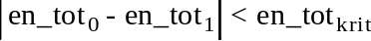
4.
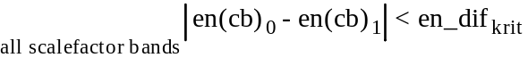
If the scfsi is not disabled after the tests above, there are two criterias for each scfsi_band, which have both to be fulfilled to enable scfsi (that means to set it to 1 in this scfsi_band):
1.
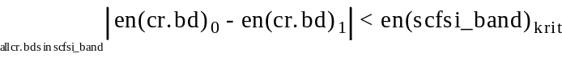

2.
The constants (with the index krit) have to be chosen so, that the scfsi is only enabled in case of similar energy/distortion.
Suggested values are:
en_tot = 10
en_dif = 100
en(scfsi_band) = 10 for each scfsi_band
xm(scfsi_band) = 10 for each scfsi_band

3. Outer Iteration Loop (distortion control loop)

The outer iteration loop controls the quantization noise which is produced by the quantization of the frequency domain lines within the inner iteration loop. The colouration of the noise is done by multiplikation of the lines within scalefactor bands with the actual scalefactors before doing the quantization. The following pseudo-code illustrates the multiplication.
do for each scalefactor band:
do from lower index to upper index of scale factor band
xr(i) = xr(i) * sqrt(2) ^ ((1 + scalefac_scale) * ifq(scalefactor band))
end do
end do
In the actual system the multiplication is done incrementally with just the increase of the scalefactors applied in each distortion control loop. This is described in clause 3.5 below.

The distortion loop is always starting with scalefac_scale = 0. If after some iterations the maximum length of the scalefactors would be exceeded (see scalefac_compress table in 2.4.2.7 and 3.5 below), then scalefac_scale is increased to the value 1 thus increasing the possible dynamic range of the scalefactors. In this case the actual scalefactors and frequency lines have to be corrected accordingly.

3.1 Saving of the scalefactors

The scalefactors of all scalefactor bands ifq(cb) as well as the quantizer step size qquant are saved. If the computation of the outer loop is cancelled without having reached a proper result this values together with the quantized spectrum give an approximation and can be transmitted.

3.2 Call of inner iteration loop

For each outer iteration loop (distortion control loop) the inner iteration loop (rate control loop) is called. The parameters are the frequency domain values (hybrid filterbank output) with the scalefactors applied to the values within the scalefactor bands and the number of bits which are available to the rate control loop. The result is the number of bits actually used and the quantized frequency lines ix(i).

3.3 Calculation of the distortion of the scalefactor bands

For each scalefactor band the actual distortion is calculated according to:

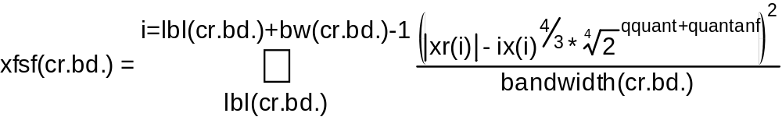
where lbl(cb) is the number of the coefficient representing the lowest frequency in a scalefactor band and bw(cb) is the number of coefficients within this band.

3.4 Preemphasis

The preemphasis option (switched on by setting preflag to a value of 1) provides the possibility to amplifiy the upper part of the spectrum according to the preemphasis tables, B.6 in the annex.

if preflag==1
{
xmin(j) = xmin(j) *ifqstep2*prefact(j)
for (i=lower limit of scalefactor band j; i <=upper limit of scalefactor band j; i++) {
xr(i) = xr(i) * ifqstepprefact(j)
}
}
The condition to switch on the preemphasis is up to the implementation. For example preemphasis could be switched on if in all of the upper 4 scalefactor bands the actual distortion exceeds the threshold after the first call of the inner loop.
If the second granule is being coded and scfsi is active in at least one scfsi_band, the preemphasis in the second granule is set equal to the setting in first granule.

3.5 Amplification of scalefactor bands which violate the masking threshold

All spectral values of the scalefactor bands which have a distortion that exceeds the allowed distortion are amplified by a factor of ifqstep. The value of ifqstep is transmitted by scalefac_scale.

if (xmin - xfsf) of scalefactor band j < 0
{
xmin(j) = xmin(j) * ifqstep2
ifq(j) = ifq(j) + 1
for (i=lower limit of scalefactor band; i <=upper limit of scalefactor band; i++) {
xr(i) = xr(i) * ifqstep
}
}

If the second granule is being coded and scfsi is active in at least one scfsi_band, the following steps have to be done:

1. ifqstep has to be set similar to the first granule
2. If it is the first iteration, the scalefactors of scalefactor bands in which scfsi is enabled have to be taken over from the first granule. The corresponding spectral values have to be amplified:
if ( scfsi according to scalefactor band j = 1)
{
ifq(j) = ifq(j)first granule
for (i=lower limit of scalefactor band; i <=upper limit of scalefactor band; i++)
{ xr(i) = xr(i) * ifqstepifq(j) }
}
3. If it is not the first iteration, the amplification must be prevented for scalefactor bands in which scfsi is enabled.

3.5 Conditions for the termination of the loops processing

Normally the loops processing terminates if there is no scalefactor band with more than the allowed distortion. However this is not always possible to obtain. In this case there are other conditions to terminate the outer loop. If

a) all scalefactor bands are already amplified
b) the amplification of at least one band exceeds the upper limit which is determined by the transmission format of the scalefactors. The upper limit is a scalefactor of 15 for scalefactor bands 0 through 10 and 7 for scalefactors 11 through 20.

the loops processing stops and by restoring the saved ifq(cb.) a useful output is available. For realtime implementation there might be a third condition added which terminates the loops in case of a lack of computing time.

4. Inner Iteration Loop (rate control loop)

The inner iteration loop does the actual quantization of the frequency domain data and prepares the formatting. The table selection, subdivision of the big_values range into regions and the selection of the quantizer step size takes place here.

4.1 Quantization

The quantization of the complete vector of spectral values is done according to

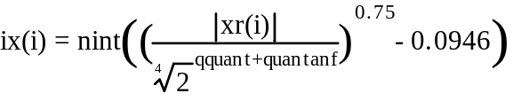

4.2 Test of the maximum of the quantized values

The maximum allowed quantized value is limited. This limit is set to constraint the table size if a table-lookup is used to requantize the quantized frequency lines. The limit is given by the possible values of the length identifier, "linbits", of values flagged with an ESC-code. Therefore before any bit counting is done the quantizer stepsize is increased by

qquant = qquant+1

until the maximum of the quantized values is within the range of the largest Huffman code table.

4.3 Calculation of the run length of zeros

The run length rzero of pairs of spectral coefficients quantized to zero on the upper end of the spectrum is counted and called "rzero".

4.4 Calculation of the run length of values less or equal one
The run length of quadrupels of spectral coefficients quantized to one or zero, following the rzero pairs of zeros, is calculated and called "count1"

4.5 Counting the bit necessary to code the values less or equal one

One Huffman code word is used to code one of the "count1" quadrupels. There are two different Huffman code books with corresponding code length tables (table A and table B in 3-Annex 3-B.7). The number of bits to code all the count1 quadrupels is given by:

bitsum_count1 = min( bitsum_table0 , bitsum_table1 )

where
count1table_0 is used to point to table A

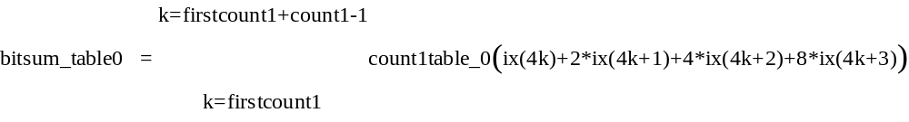
and
count1table_1 is used to point to table B
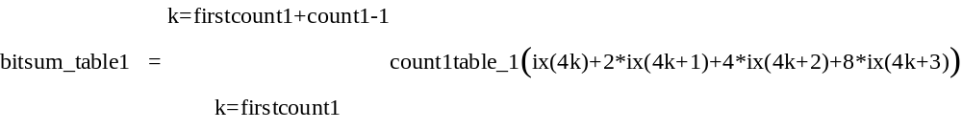
The information which table is used is transmitted by count1table_select, which is "0" for table A or "1" for table B, respectively.

4.6 Call of subroutine SUBDIVIDE

The number of pairs of quantized values not counted in "count1" or "rzero" is called bigvalues. SUBDIVIDE splits the scalefactor bands corresponding to this values into three groups. The last one, incomplete generally, counts as a complete one. Region_adress1/2 contains the number of scalefactor bands in the first and the last region, respectively. The number of scalefactor bands in the second region can be calculated using bigvalues. If bigvalues comprises only two scalefactor bands region_adress2 is set to zero. If there are less than two also region_adress1 is zero. The split strategy is up to the implementation. A very simple one for instance is to assign 1/3 of the scalefactor bands to the first and 1/4 to the last region.

Subdivide in case of blocksplit is done analoguous but only two subregions. Region_address 1 is set to a default in this case. This default is 8 in the case of split_point=0 and 9 in the case of split_point=1. Both this values point to the same absolute frequency.

4.7 Calculation of the code book for each subregion

There are 32 different Huffman code tables for the coding of pairs of quantized values available. They differ from each other in the maximum value that can be coded and in the signal statistic they are optimized for. Only codes for values < 16 are in the table. For values >=16 there are two tables provided where the largest value 15 is an escape character. In this case the value 15 is coded in an additional word using a linear PCM code with a word length called linbits. linbits can be calculated by taking the base 2 logarithm of the PCM code, which is x - max_table_entry (see clause 2.4.2.7).

A simple way to choose a table is to use the maximum of the quantized values in a subregion. Tables which have the same size are optimized for different signal statistics. Therefore additional coding gain can be achieved for example by trying all of this tables.

4.8 Counting of the bit necessary to code the values in the subregions

The number of bits necessary to code the quantized values of one subregion is given by:

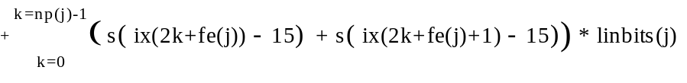

np(j): number of pairs in a sub region
fe(j): number of the first quantized value in a sub-region
bitz: table with Huffman code length

s(...) step function: if x >= 0 s(x) = 1
if x < 0 s(x) = 0
