3-ANNEX E (informative)
BIT SENSITIVITY TO ERRORS
3-E.1. General

This paragraph indicates the sensitivity of individual bits to random errors if application specific error protection is needed.This sensitivity is given for each bit by a value from 0 to 5, indicating the amount of degradation resulting from one isolated error :
5 catastrophic
4 very annoying
3 annoying
2 slightly annoying
1 audible
0 insensitive
The values are not the results of precise measurements, rather they rely upon knowledge of the codec. They assume the error detection scheme is not in use.

Some fields in the bit stream do not have a fixed length. All bits in this fields are rated for error sensitivity, even if not in use.

(For all layers, the header information is considered to have the highest sensitivity).

3-E.2. Layers I and II

Parameters #bit sensitivity
Bit allocation all bits 5
Scalefactors select information all bits 5
Scalefactors 5 (msb) 4
4 4
3 4
2 3
1 2
0 (lsb) 1
Subband samples (*) 8-16(msb) 3
5-7 2
3,4 1
(lsb)0-2 0

(*) according to the bit allocation

3-E.3. Layer III

Parameters #bit sensitivity
Scf_si all bits 5
Part2/3 _length all bits 4
Big_values all bits 3
Global_gain all bits 5
Scalefactor_select all bits 5
Blocksplit_flag all bits 5
Block_type all bits 4
Switch_frequency all bits 4
Table_select all bits 5
Region_adress1 all bits 3
Region_adress2 all bits 3
extension_bits (if present) all bits 0
Preflag 0 2
Scalefac_scale 0 2
Count1table_select 0 3
Subblock_gain 2 (msb) 4
1 3
0 (lsb) 2
Scalefac (**) 3 (msb) 3(2)
2 3(2)
1 2(1)
0 (lsb) 2(1)
Huffman codes (***) 0...n-1 3 - 0

(**) the scalefac length depends on scalefac_select.
The bit sensitivity values refer to the scalefac_scale value 1 (if 0 the value is in parenthesis).
(***) If n is the number of bits for Huffman coding in one block the bit sensivity decreases linearly from 3 to 0 as the bit number varies from 0 up to n, (from low to high frequency).

Note:
Rearrangement of the Huffman coded values:
To get better implicit error robustness for the low frequency part of the spectrum the Huffman coded values can be transmitted not in their logical order, but in an interleaved fashion.

If max_hlen is the maximum length of a Huffman codeword over the tables which are used to code the particular block and n is the number of bits used for Huffman coding of data in the block (not frame), then int(n/max_hlen) slots are filled with the first codewords, beginning from low frequencies. The remaining codewords are filled into the remaining place, again arranged from low to high frequencies.

After bit interleaving, the bit sensivity of bit k+i*int(n/max_hlen) decreases linearly from 3 to 0 as k varies from 0 up to int(n/max_hlen)-1, where i=0,...,max_hlen-1, and n is the number of bits for Huffman coding in one block.

This is the recommended practice for Layer III data for all channels where error robustness is important.
3-ANNEX F (informative)
ERROR CONCEALMENT

An optional feature of the coded bit stream is the CRC word which provides some error detection facility to the decoder. The Hamming distance of this error detection code is d=4, which allows for the detection of up to 3 single bit errors or for the detection of one error burst of up to 16 bit length. The amount and the position of the protected bits within one encoded audio frame generally depends on the layer, the mode, data rate, and sampling frequency.

This can be used to control an error concealment strategy in order to avoid severe impairments of the reconstructed signal due to errors in the most sensitive information.

Some basic techniques can be used for concealment, for instance information substitution, or muting. A simple substitution technique consists, when an erroneous frame occurs, of replacing it by the previous one (if error free).

3-ANNEX G (informative)
JOINT STEREO CODING
3-G.1. Intensity Stereo Coding Layer I, II

An optional joint stereo coding method used in Layers I and II is intensity stereo coding. Intensity stereo coding can be used to increase the audio quality and/or reduce the bitrate for stereophonic signals. The gain in bitrate is typically about 10 to 30 kbit/s. It requires negligible additional decoder complexity. The increase of encoder complexity is small. The encoder and decoder delay is not affected.

Psychoacoustic results indicate that at high frequencies (above about 2 kHz) the localization of the stereophonic image within a critical band is determined by the temporal envelope and not by the temporal fine structure of the audio signal.

The basic idea for intensity stereo coding is that for some subbands, instead of transmitting separate left and right subband samples only the sum-signal is transmitted, but with scalefactors for both the left and right channels, thus preserving the stereophonic image.

Flow diagrams of a stereo encoder and decoder, including intensity stereo mode, are shown in Figure 3-G.1 "GENERAL STEREO ENCODER FLOW-CHART" and Figure 3-G.2 "GENERAL STEREO DECODER FLOW-CHART". First, an estimation is made of the required bitrate for both left and right channel. If the required bitrate exceeds the available bitrate, the required bitrate can be decreased by setting a number of subbands to intensity stereo mode. Depending on the bitrate needed, subbands
16 to 31,
12 to 31,
8 to 31, or
4 to 31
can be set to intensity stereo mode. For the quantization of such combined subbands, the higher of the bit allocations for left and right channel is used.

The left and right subband signals of the subbands in joint stereo mode are added. These new subband signals are scaled in the normal way, but the originally determined scalefactors of the left and right subband signals are transmitted according to the bitstream syntax. Quantization of common subband samples, coding of common samples, and coding of common bit allocation are performed in the same way as in independent coding.

3-G.2. MS_Stereo and Intensity Stereo Coding Layer III

In Layer III a combination of ms_stereo mode (sum/difference) and intensity stereo mode can be used.

1) MS_stereo switching

MS_stereo mode is switched on if in joint stereo mode condition

< 0.8 *

is true. The values rli and rri correspond to the energies of the FFT line spectrum of the left and right channel calculated within the psychoacoustic model.

2) MS_stereo processing

- MS matrix

In MS_stereo mode the values of the normalized middle/side channel Mi/Si are transmitted instead of the left/right channel values Li/Ri:

Mi = and Si =

- Limitation of Si channel bandwith

All Si values above the highest scalefactor band are set to zero.

- Sparsing of Si channel

In every scalefactor band sb all pairs of small values (Si,Si+1) are set to zero:
if (Si2 + Si+12) < ssb * (Li2 + Li+12 + Ri2 + Ri+12) {
Si = 0; Si+1 = 0;
}

The following difference channel threshold coefficients apply to the scalefactor bands for block type != 2 (´long MDCT transforms´):

sb 0 1 2 3 4 5 6 7 8 9
------------------------------------------------------------------------------------------------------
ssb 0.0 0.0 0.0 0.0 0.0 0.10 0.10 0.10 0.10 0.10

sb 10 11 12 13 14 15 16 17 18 19 20
------------------------------------------------------------------------------------------------------
ssb 0.10 0.20 0.30 0.40 0.50 0.60 0.70 0.80 0.90 1.00 1.50

3) Intensity stereo processing

- Calculation of intensity stereo position

For each scalefactor band sb coded in intensity stereo the following steps are executed:

- is_possb = NINT( * arctan( ) )

- Li = Li + Ri for all indices i within the actual scalefactor band sb

- Ri = 0 for all indices i within the actual scalefactor band sb

- the intensity stereo position is_possb is transmitted instead of the scalefactor of the right channel (3 bits always, stereo positions 0..6, 7=illegal stereo position)

where L_Energysb/R_Energysb denote the signal energies of the left/right channel within the actual scalefactor band and Li/Ri are the transformed values.

Scalefactor bands of the right/difference channel containing only zeros after coding which do not belong to the intensity coded part should be transmitted with the scalefactor ´7´ to prevent intensity stereo decoding.

FIGURE 3-G.1 General Stereo Encoder Flow Chart

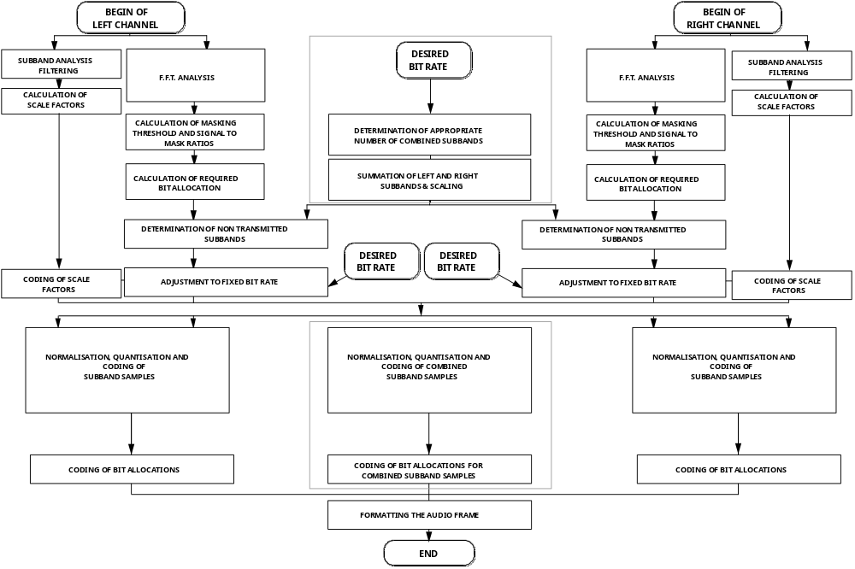



FIGURE 3-G.2 General Stereo Decoder Flow Chart

