Notes on the inversion of the task « paresse » or lazyness

07/09/2012
PART I
- Description of the task
4 cues are predictive of four conditions.
In each condition a binary choice (left of right) must be made.
Each choice leads to an effort to be performed and a reward.
- A : high effort (both choices), left better
- B : low effort (both choices), right better
- C : right harder, high reward (both choices)
- D : left harder, low reward (both choices)

When a feedback is not fixed and shared for choices, it is probabilistic.
Both feedback can take two value with one better than the other (lower effort or higher reward). Reward : 0.2€ and 0.4€.
Effort : 0.2 and 0.8 (for 20% and 80% of maximal grip force)

 | Proba best feedback | Proba worst feedback
Best side | 0.8 | 0.2
Worst side | 0.2 | 0.8

Quantitative info
- 96 trials
- 24 per condition

- Modeling of the task
  - Rules for data formatting

Decision must be encoded in a binary form. We choose:
- 0 : left
- 1 : right
To perform the inversion, we need to know the choice and both feedback (reward and effort).
We organize data in this order :
- 1 : decision
- 2 : reward
- 3 : effort
- 4 : total number of right choices
- 5: total number of left choices
- 6: number of big rewards given the right choices
- 7: number of big rewards given the left choices
- 8: number of small efforts given the right choices
- 9: number of small efforts given the left choices
The data from 4:9 are used to model the Ideal Baysian (see tabel of models below).

3. Models of learning

  - Reinforcement learning models
- Q-learning
- Win-Stay-Lose-Shift (Q-learning special case)
We model the learning of both effort and reward value
When an option is chosen, its values (X = Effort or Reward) are updated as follows:

Win-Stay-Lose-Shift model is a special case of Q-learning where the learning rate =1: the subject takes into account only the previous outcome;

3.2 Bias models
We assume that there is no learning on a trial-by-trial basis but the subject has some apriori biases towards left or the right hand. We tested the hypothesis where subject has separate bias per condition (4 bias parameters model) or just hand bias (1 bias parameter) across all conditions (e.g. preference for the right hand choices).

  - Ideal Bayesian Model: a version of the ideal observer who counts wins in rewards and efforts in each hand and updates his priors after every trial. Initial priors (at t=0) varies to account for possible beliefs of the subject that a particular hand choice might bring more rewards or less efforts in a particular condition (separate parameters per condition).
  - Some Bayesian Model “Haut niveau”

4. Discount type and Decision rules

- Decisions based on the two values : Effort discounted reward. Two types of discounts tested:
  - Linear discount

  - Hyperbolic discount
For all models except the Bias models where there are no values, two possible discount types are tested.

We always use a softmax mapping.
The values passed in the softmax differ depending on the model:

4.1. Q-learning models
Where is the subjective value of choice. (utility mapping from Qvalue)

  - Bias models: the values are set to 0 and the decision depends only on the bias term passed into the softmax:
g(x) = 1/(1+exp(bias))
  - Ideal Bayes: the values are the difference in the posterior prediction of the outcome for the right and left hand choices.
Hidden states
- : Qvalues
- : posterior beleifs about the best choice
Parameters
- Evolution parameters
  - : learning rate (shared or different)
- Observation parameters
  - : Softmax inverse temperature (decision noise)
  - : the decision bias (per hand or per condition)
  - : linear discount factor
  - : hyperbolic discount factor
  - : beta distribution parameters for Ideal Baysian model

TABLE MODELS
Discount Type | Linear Discount | Hyperbolic Discount | Hidden States | Evolution parameters | Observation parameters
Q-learning | + | + | Q-values | α | β, γ, bias = 0
 |  |  |  | α_{reward} α_{effort}
WSLS  (Q-learning special case) | + | + | Value of previous outcome | α= 1 | β, γ, bias = 0
BIAS_hand | --- | --- | --- | --- | One bias
BIAS condition | --- | --- | --- | --- | Four Biases per condition
Ideal Bayes | + | + | Posteriors  on the frequencies | --- | Beta-distribution for priors of frequencies  for rewards and efforts given the hand choice (α, β) x hand X outcome (reward, effort) = 8 params.
Bayesian Dynamical models

5. The choice of priors

Type | Parameter | Value | 95% | mapping | Justification
Decision parameters | Inverse temperature | N(0,1) | [-2,2] | Exp
 | Decision bias  (biases) | N(0,1) | [-2,2] | S(x+~1)
 | linear discount factor | N(0,1) | [-2,2] |  | Allow “positive” discounts where effort adds value to reward
 | hyperbolic discount factor | N(0,1) | [-2,2]
 | Beta-distribution  parameters alpha and beta | N(0,1) | [-2,2] | Exp | Only positive > 1  they correspond to counts of wins and failures
Evolution parameters | Learning rates | N(0,1) | [-2,2] | sigmoid | Learning rates between 0 and 1
Initial states | Initial Q values | N(0.5,1) |  |  | Allow the variance in the initial states
 | Initial bias | N(0.5,1)
 | Initial states for Ideal Bayes | N(0,0) |  |  | Fixed to 0?  Do we need them if we use beta-parameters in the g(x) as priors?

PART II RESULTS (hopefully coming soon)

1 : ALL MODELS
2 : LINEAR vs HYPERBOLIC DISCOUNT
3 : SHARED vs. DIFFERENT LEARNING RATES (within Q-learning model family).

PART III

Interpretation
…
Conclusion :
Q-learning is the champion

SUPPS*: Part IV : Seeking an effect of condition in the Q-learning models
Possible test of Q-learning winning model for additional bias effect: Testing effect of condition*
(what Vincent initially did and there were no bias per condition).
We compared 4 models
- The best model with no effect of condition
- A model in which different sets of parameters drives each condition
- A model in which different sets of parameters drives each group AB, CD of session
- A model in which different sets of parameters drives each group AB, CD of session and decision based on reward only in AB and effort only in CD

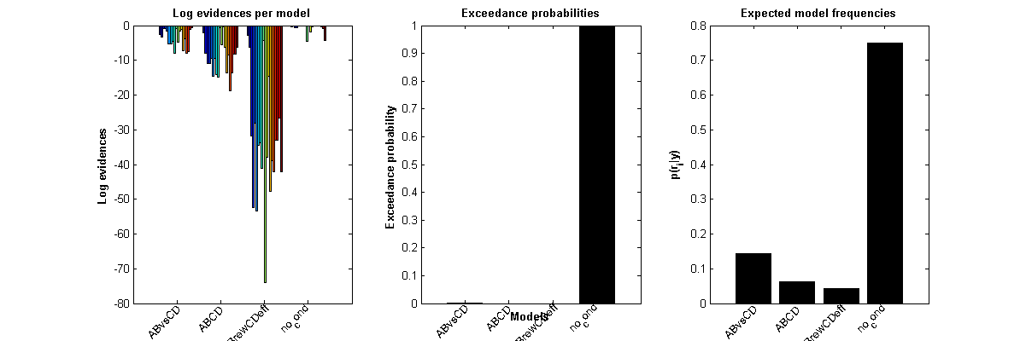

Conclusion
Adding parameters for each session do not give any extra explanatory power.
Subjects seem to act similarly for all conditions

IMPORTANT : Condition effect was done brutally.
Conditions could share some parameters (decision noise, bias) which was not done here.

