Sukabumi Vegetation LIDAR Analysis

**Importance of Stratified Random Sampling vs Random Sampling**

Stratified Random means that the number of random points in each class is proportional to the area represented in the raster, ensuring “even” accuracy across all classes regardless of area size. If it was just Random, there could be more accuracy points on one class than another than its relative area would warrant. This may reduce the accuracy of points in classes where there are fewer ground control points because that class may not have enough control points to ascertain truth from the noise.

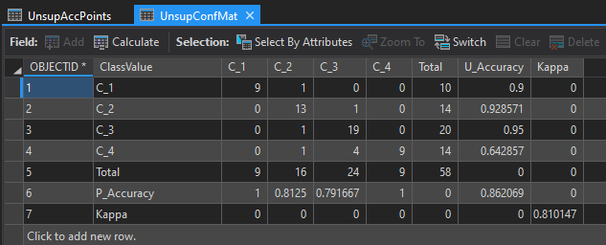 **LULC Accuracy**

Highest Producers accuracy was Class 1 and 4, which is Water and Crops, respectively, both with 100% accuracy; while the lowest was class was Class 3, which is Forest, at 0.79. I claimed in Lab 05 that “Classes 1 and 2 are easiest to differentiate while Classes 2 and 4 are most difficult to differentiate” so this does not seem to support my initial hypothesis/observation at the time.

The highest Users accuracy is Class 3, which is Forest; and the lowest was Class 4, which is Crops. This means that the unsupervised algorithm is most accurate with the Forest class while the least accurate on Crops.

At about 6% change, Developed to Crop was the largest change combination, while at nearly 0%, Water to Forest was the smallest change combination. Developed to Crop may arise out of a community-based shift on preferences for what the economy or society needed; instead of warehousing, for example, they may have shifted to growing more crops. At 0%, Water to Forest may just be misclassification that arose from using two different methodologies for these layers.

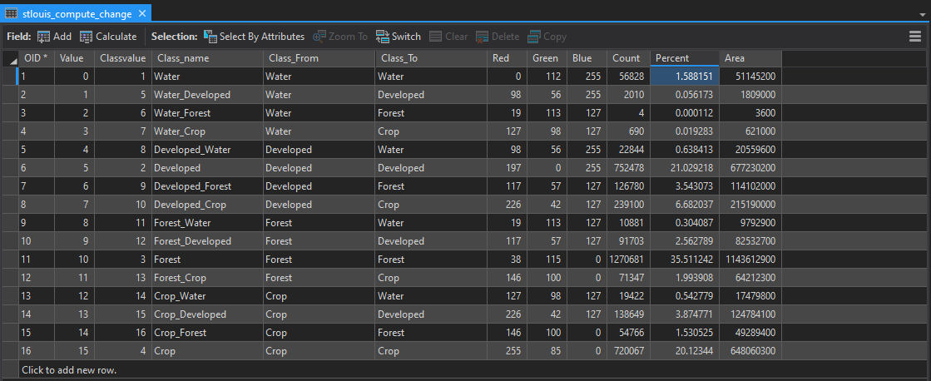It is useful to think in percentages and raw area because percentages along can be misleading in some circumstances. For example, a 1% change from a 100km2 area (1km2 change) is much larger than a 1% change in an 25km2 area (0.25km2 change), but without knowing the raw area we would have evaluated them as equally changed.

**Changes from 2003 Classification**

Visually it would appear that change is happening near human structures: beside roads and highways, around buildings and building complexes, in the middle or adjacent to cropland, and the like. I think this may be caused by human expansion, specifically clearing out land to make more space for new buildings or infrastructure for different purposes like residential or warehousing, or expanding cropland, roads and highways.

**Response Curves:**

