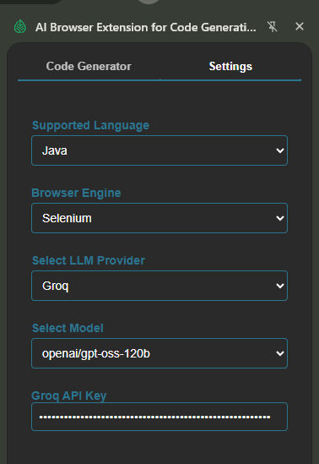
eset Chat

Feature: Create a new Lead in the OpenTaps CRM

As a QA engineer I want to verify that a lead can be created
using realistic South‑India data so that the form works end‑to‑end.

Scenario Outline: Successful lead creation with valid data
Given I open the Create Lead page
When I type "<company>" into the Company Name field
And I type "<firstName>" into the First Name field
And I type "<lastName>" into the Last Name field
And I select "<source>" from the Source dropdown
And I select "<campaign>" from the Marketing Campaign dropdown
And I type "<countryCode>" into the Country Code field
And I type "<areaCode>" into the Area Code field
And I type "<phone>" into the Phone Number field
And I type "<email>" into the E‑Mail Address field
And I type "<address1>" into the Address Line 1 field
And I type "<city>" into the City field
And I type "<zip>" into the Zip/Postal Code field
And I select "<country>" from the Country dropdown
And I click the Create Lead button
Then I should see a confirmation that the lead was created

Examples: South‑India realistic data
| company | firstName | lastName | source | campaign | countryCode | areaCode | phone | email | address1 | city | zip | country |
| "Infosys Ltd" | "Ravi" | "Kumar" | "Cold Call" | "Affiliate Sites" | "91" | "044" | "9876543210" | "ravi.kumar@infosys.com" | "No.12, MG Road" | "Chennai" | "600001"| "AFG" |
| "Wipro Technologies" | "Anita" | "Reddy" | "Conference" | "Automobile" | "91" | "080" | "9123456789" | "anita.reddy@wipro.com" | "Flat 5B, Brigade" | "Bangalore"| "560001"| "ALB" |
| "Tech Mahindra" | "Sanjay" | "Patel" | "Cold Call" | "Affiliate Sites" | "91" | "040" | "9988776655" | "sanjay.patel@mahindra.com"| "Suite 210, DLF" | "Hyderabad"| "500001"| "AFG" |

package com.leaftaps.stepdefs;

import io.cucumber.java.After;
import io.cucumber.java.Before;
import io.cucumber.java.en.*;

import org.openqa.selenium.*;
import org.openqa.selenium.chrome.ChromeDriver;
import org.openqa.selenium.support.ui.*;

import java.time.Duration;

public class CreateLeadStepDefinitions {

private WebDriver driver;
private WebDriverWait wait;
private final String baseUrl = "https://leaftaps.com/crmsfa/control/createLeadForm";

@Before
public void setUp() {
// Assuming chromedriver is on the system PATH
driver = new ChromeDriver();
wait = new WebDriverWait(driver, Duration.ofSeconds(15));
driver.manage().window().maximize();
}

@After
public void tearDown() {
if (driver != null) {
driver.quit();
}
}

@Given("I open the Create Lead page")
public void openCreateLeadPage() {
driver.get(baseUrl);
// Wait for the form to be present
wait.until(ExpectedConditions.visibilityOfElementLocated(By.id("createLeadForm")));
}

@When("I type {string} into the Company Name field")
public void typeCompanyName(String company) {
WebElement el = wait.until(
ExpectedConditions.elementToBeClickable(By.id("createLeadForm_companyName")));
el.clear();
el.sendKeys(company);
}

@When("I type {string} into the First Name field")
public void typeFirstName(String firstName) {
WebElement el = wait.until(
ExpectedConditions.elementToBeClickable(By.id("createLeadForm_firstName")));
el.clear();
el.sendKeys(firstName);
}

@When("I type {string} into the Last Name field")
public void typeLastName(String lastName) {
WebElement el = wait.until(
ExpectedConditions.elementToBeClickable(By.id("createLeadForm_lastName")));
el.clear();
el.sendKeys(lastName);
}

@When("I select {string} from the Source dropdown")
public void selectSource(String source) {
WebElement dropdown = wait.until(
ExpectedConditions.elementToBeClickable(By.id("createLeadForm_dataSourceId")));
new Select(dropdown).selectByVisibleText(source);
}

@When("I select {string} from the Marketing Campaign dropdown")
public void selectCampaign(String campaign) {
WebElement dropdown = wait.until(
ExpectedConditions.elementToBeClickable(By.id("createLeadForm_marketingCampaignId")));
new Select(dropdown).selectByVisibleText(campaign);
}

@When("I type {string} into the Country Code field")
public void typeCountryCode(String code) {
WebElement el = wait.until(
ExpectedConditions.elementToBeClickable(By.id("createLeadForm_primaryPhoneCountryCode")));
el.clear();
el.sendKeys(code);
}

@When("I type {string} into the Area Code field")
public void typeAreaCode(String area) {
WebElement el = wait.until(
ExpectedConditions.elementToBeClickable(By.id("createLeadForm_primaryPhoneAreaCode")));
el.clear();
el.sendKeys(area);
}

@When("I type {string} into the Phone Number field")
public void typePhoneNumber(String phone) {
WebElement el = wait.until(
ExpectedConditions.elementToBeClickable(By.id("createLeadForm_primaryPhoneNumber")));
el.clear();
el.sendKeys(phone);
}

@When("I type {string} into the E‑Mail Address field")
public void typeEmail(String email) {
WebElement el = wait.until(
ExpectedConditions.elementToBeClickable(By.id("createLeadForm_primaryEmail")));
el.clear();
el.sendKeys(email);
}

@When("I type {string} into the Address Line 1 field")
public void typeAddress1(String address) {
WebElement el = wait.until(
ExpectedConditions.elementToBeClickable(By.id("createLeadForm_generalAddress1")));
el.clear();
el.sendKeys(address);
}

@When("I type {string} into the City field")
public void typeCity(String city) {
WebElement el = wait.until(
ExpectedConditions.elementToBeClickable(By.id("createLeadForm_generalCity")));
el.clear();
el.sendKeys(city);
}

@When("I type {string} into the Zip/Postal Code field")
public void typeZip(String zip) {
WebElement el = wait.until(
ExpectedConditions.elementToBeClickable(By.id("createLeadForm_generalPostalCode")));
el.clear();
el.sendKeys(zip);
}

@When("I select {string} from the Country dropdown")
public void selectCountry(String country) {
WebElement dropdown = wait.until(
ExpectedConditions.elementToBeClickable(By.id("createLeadForm_generalCountryGeoId")));
new Select(dropdown).selectByVisibleText(country);
}

@When("I click the Create Lead button")
public void clickCreateLead() {
WebElement btn = wait.until(
ExpectedConditions.elementToBeClickable(By.xpath("//input[@value='Create Lead']")));
btn.click();
}

@Then("I should see a confirmation that the lead was created")
public void verifyLeadCreated() {
// After successful creation the application typically shows a page with the lead ID.
// We'll wait for a heading that contains the word "Lead" or a success message.
By successLocator = By.xpath("//*[contains(text(),'Lead') and contains(text(),'created')]");
WebElement successMsg = wait.until(ExpectedConditions.visibilityOfElementLocated(successLocator));
if (!successMsg.isDisplayed()) {
throw new AssertionError("Lead creation confirmation not displayed.");
}
}
}

Finetuned Model – ft:gpt-4o-mini-2024-07-18:testleaf-2::DY7HPOKt
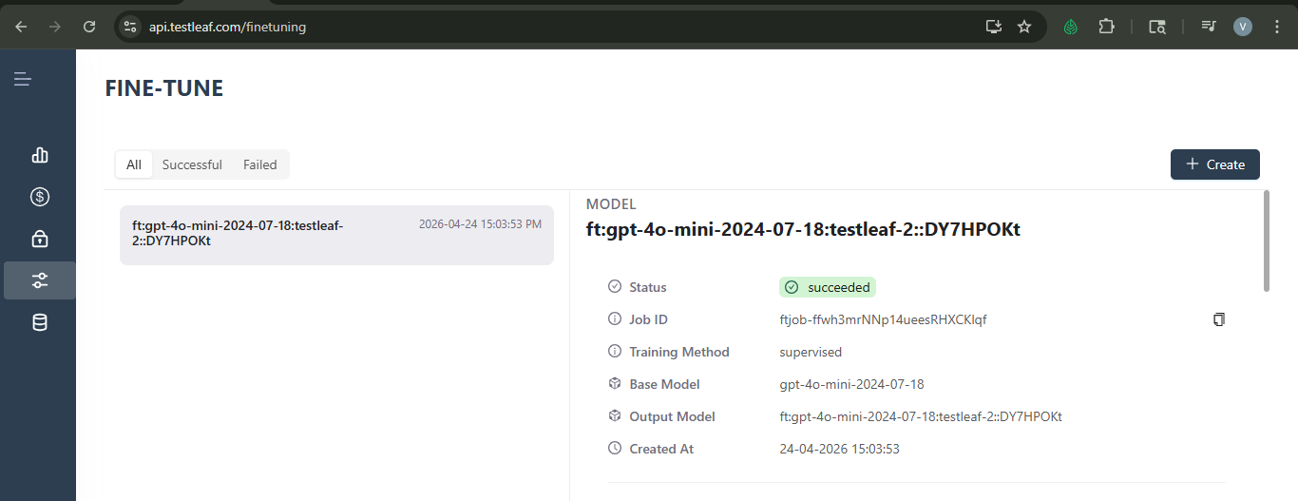
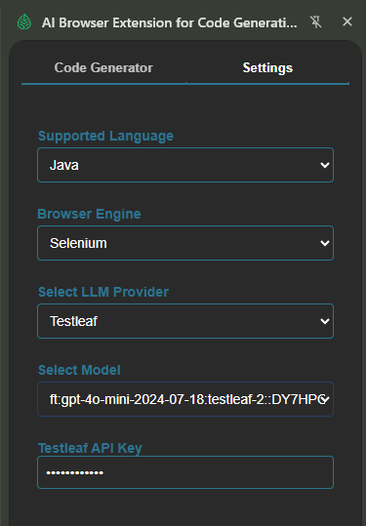
Feature: Create Lead in OpenTaps

Scenario Outline: Successful lead creation with valid details
Given I open the create lead page
When I enter "<companyName>" as the Company Name
And I enter "<firstName>" as the First Name
And I enter "<lastName>" as the Last Name
And I select "<dataSource>" as the Source
And I select "<marketingCampaign>" as the Marketing Campaign
And I click the Create Lead button
Then I should see the lead created successfully

Examples:
| companyName | firstName | lastName | dataSource | marketingCampaign |
| "Tata Consultancy" | "Rajesh" | "Kumar" | "Cold Call" | "Affiliate Sites" |
| "Infosys" | "Sita" | "Rani" | "Conference" | "Automobile" |
| "Wipro" | "Vikram" | "Singh" | "Cold Call" | "Affiliate Sites" |
| "HCL Technologies" | "Anita" | "Sharma" | "Conference" | "Automobile" |

package com.leaftaps.stepdefs;

import io.cucumber.java.en.*;
import org.openqa.selenium.*;
import org.openqa.selenium.chrome.ChromeDriver;
import org.openqa.selenium.support.ui.*;

public class CreateLeadStepDefinitions {
private WebDriver driver;
private WebDriverWait wait;

@io.cucumber.java.Before
public void setUp() {
System.setProperty("webdriver.chrome.driver", "path/to/chromedriver");
driver = new ChromeDriver();
wait = new WebDriverWait(driver, Duration.ofSeconds(10));
driver.manage().window().maximize();
}

@io.cucumber.java.After
public void tearDown() {
if (driver != null) driver.quit();
}

@Given("I open the create lead page")
public void openCreateLeadPage() {
driver.get("https://leaftaps.com/crmsfa/control/createLeadForm");
}

@When("I enter {string} as the Company Name")
public void enterCompanyName(String companyName) {
WebElement el = wait.until(ExpectedConditions.visibilityOfElementLocated(By.id("createLeadForm_companyName")));
el.sendKeys(companyName);
}

@When("I enter {string} as the First Name")
public void enterFirstName(String firstName) {
WebElement el = wait.until(ExpectedConditions.visibilityOfElementLocated(By.id("createLeadForm_firstName")));
el.sendKeys(firstName);
}

@When("I enter {string} as the Last Name")
public void enterLastName(String lastName) {
WebElement el = wait.until(ExpectedConditions.visibilityOfElementLocated(By.id("createLeadForm_lastName")));
el.sendKeys(lastName);
}

@When("I select {string} as the Source")
public void selectSource(String dataSource) {
WebElement el = wait.until(ExpectedConditions.elementToBeClickable(By.id("createLeadForm_dataSourceId")));
new Select(el).selectByVisibleText(dataSource);
}

@When("I select {string} as the Marketing Campaign")
public void selectMarketingCampaign(String marketingCampaign) {
WebElement el = wait.until(ExpectedConditions.elementToBeClickable(By.id("createLeadForm_marketingCampaignId")));
new Select(el).selectByVisibleText(marketingCampaign);
}

@When("I click the Create Lead button")
public void clickCreateLead() {
WebElement el = wait.until(ExpectedConditions.elementToBeClickable(By.name("submitButton")));
el.click();
}

@Then("I should see the lead created successfully")
public void verifyLeadCreation() {
WebElement successMessage = wait.until(ExpectedConditions.visibilityOfElementLocated(By.className("successMessage")));
assert successMessage.isDisplayed();
}
}

