*Home Assignment*
Implement playwright/typescript with vibe coding

Note.AI Extension should be able to produce code in playwright/typescript combination.
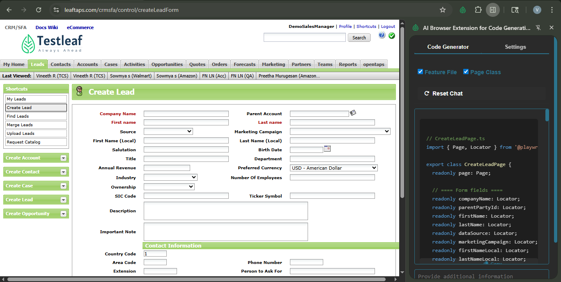
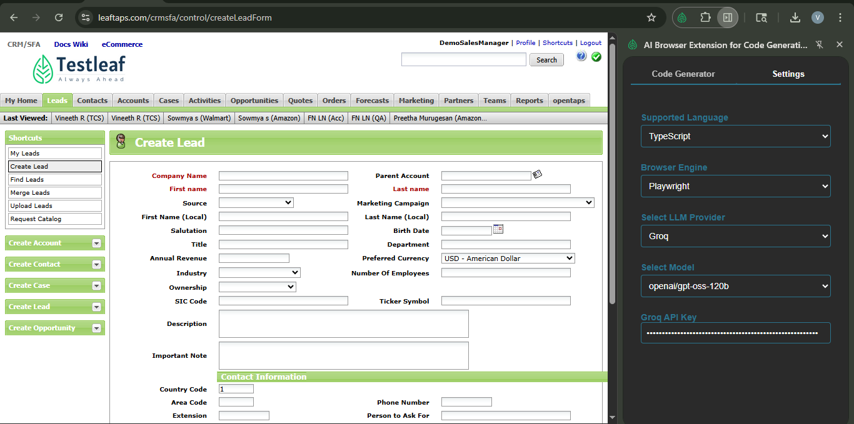

// CreateLeadPage.ts
import { Page, Locator, expect } from '@playwright/test';

/**
* Data structure that represents all fields needed to create a lead.
* Adjust the optional fields as required by your test scenario.
*/
export interface LeadData {
companyName: string;
firstName: string;
lastName: string;
source?: string; // e.g. "Cold Call"
marketingCampaign?: string; // e.g. "Affiliate Sites"
phoneCountryCode?: string; // default "1"
phoneAreaCode?: string;
phoneNumber?: string;
phoneExtension?: string;
phoneAskForName?: string;
email?: string;
webUrl?: string;
addressLine1?: string;
addressLine2?: string;
city?: string;
state?: string; // value attribute of the <option>
postalCode?: string;
country?: string; // value attribute of the <option>
}

/**
* Page-Object Model for the “Create Lead” form.
* All locators are defined once in this class – the test file never repeats them.
*/
export class CreateLeadPage {
readonly page: Page;

// ==== Form fields ====
readonly companyNameInput: Locator;
readonly firstNameInput: Locator;
readonly lastNameInput: Locator;
readonly sourceSelect: Locator;
readonly marketingCampaignSelect: Locator;
readonly phoneCountryCodeInput: Locator;
readonly phoneAreaCodeInput: Locator;
readonly phoneNumberInput: Locator;
readonly phoneExtensionInput: Locator;
readonly phoneAskForNameInput: Locator;
readonly emailInput: Locator;
readonly webUrlInput: Locator;
readonly addressLine1Input: Locator;
readonly addressLine2Input: Locator;
readonly cityInput: Locator;
readonly stateSelect: Locator;
readonly postalCodeInput: Locator;
readonly countrySelect: Locator;
readonly submitButton: Locator;

constructor(page: Page) {
this.page = page;

// Initialize locators using the IDs from the DOM snapshot
this.companyNameInput = page.locator('#createLeadForm_companyName');
this.firstNameInput = page.locator('#createLeadForm_firstName');
this.lastNameInput = page.locator('#createLeadForm_lastName');
this.sourceSelect = page.locator('#createLeadForm_dataSourceId');
this.marketingCampaignSelect = page.locator('#createLeadForm_marketingCampaignId');
this.phoneCountryCodeInput = page.locator('#createLeadForm_primaryPhoneCountryCode');
this.phoneAreaCodeInput = page.locator('#createLeadForm_primaryPhoneAreaCode');
this.phoneNumberInput = page.locator('#createLeadForm_primaryPhoneNumber');
this.phoneExtensionInput = page.locator('#createLeadForm_primaryPhoneExtension');
this.phoneAskForNameInput = page.locator('#createLeadForm_primaryPhoneAskForName');
this.emailInput = page.locator('#createLeadForm_primaryEmail');
this.webUrlInput = page.locator('#createLeadForm_primaryWebUrl');
this.addressLine1Input = page.locator('#createLeadForm_generalAddress1');
this.addressLine2Input = page.locator('#createLeadForm_generalAddress2');
this.cityInput = page.locator('#createLeadForm_generalCity');
this.stateSelect = page.locator('#createLeadForm_generalStateProvinceGeoId');
this.postalCodeInput = page.locator('#createLeadForm_generalPostalCode');
this.countrySelect = page.locator('#createLeadForm_generalCountryGeoId');
this.submitButton = page.locator('input[type="submit"][value="Create Lead"]');
}

/** Navigate to the Create-Lead page */
async goto(url: string): Promise<void> {
await this.page.goto(url);
await expect(this.page).toHaveURL(url);
}

/** Fill the whole form using a LeadData object */
async fillLeadForm(data: LeadData): Promise<void> {
await this.companyNameInput.fill(data.companyName);
await this.firstNameInput.fill(data.firstName);
await this.lastNameInput.fill(data.lastName);

if (data.source) {
await this.sourceSelect.selectOption({ label: data.source });
}
if (data.marketingCampaign) {
await this.marketingCampaignSelect.selectOption({ label: data.marketingCampaign });
}

// Contact information
if (data.phoneCountryCode) await this.phoneCountryCodeInput.fill(data.phoneCountryCode);
if (data.phoneAreaCode) await this.phoneAreaCodeInput.fill(data.phoneAreaCode);
if (data.phoneNumber) await this.phoneNumberInput.fill(data.phoneNumber);
if (data.phoneExtension) await this.phoneExtensionInput.fill(data.phoneExtension);
if (data.phoneAskForName) await this.phoneAskForNameInput.fill(data.phoneAskForName);
if (data.email) await this.emailInput.fill(data.email);
if (data.webUrl) await this.webUrlInput.fill(data.webUrl);

// Primary address
if (data.addressLine1) await this.addressLine1Input.fill(data.addressLine1);
if (data.addressLine2) await this.addressLine2Input.fill(data.addressLine2);
if (data.city) await this.cityInput.fill(data.city);
if (data.state) await this.stateSelect.selectOption({ value: data.state });
if (data.postalCode) await this.postalCodeInput.fill(data.postalCode);
if (data.country) await this.countrySelect.selectOption({ value: data.country });
}

/** Click the “Create Lead” button and wait for navigation */
async submit(): Promise<void> {
await Promise.all([
this.page.waitForNavigation({ waitUntil: 'networkidle' }),
this.submitButton.click(),
]);
}

/** Convenience method – fill + submit */
async createLead(data: LeadData): Promise<void> {
await this.fillLeadForm(data);
await this.submit();
}

/** Verify that the lead was created by checking that the company name appears on the next page */
async expectLeadCreated(companyName: string): Promise<void> {
const companyHeader = this.page.locator(`text=${companyName}`);
await expect(companyHeader).toBeVisible({ timeout: 5000 });
}
}

// createLead.spec.ts
import { test, expect } from '@playwright/test';
import { CreateLeadPage, LeadData } from './CreateLeadPage';

test.describe('Create Lead Feature – South India Data Set', () => {
let leadPage: CreateLeadPage;

// URL of the Create-Lead form (as given in the prompt)
const createLeadUrl = 'https://leaftaps.com/crmsfa/control/createLeadForm';

// Sample data that mimics a realistic South-Indian business contact
const southIndiaLead: LeadData = {
companyName: 'Mysore Textiles Pvt Ltd',
firstName: 'Arun',
lastName: 'Reddy',
source: 'Cold Call',
marketingCampaign: 'Affiliate Sites',
phoneCountryCode: '91',
phoneAreaCode: '80',
phoneNumber: '12345678',
phoneExtension: '101',
phoneAskForName: 'Arun Reddy',
email: 'arun.reddy@example.com',
webUrl: 'https://mysoretextiles.in',
addressLine1: '123 MG Road',
addressLine2: 'Near City Market',
city: 'Bangalore',
state: 'AL', // Using the available option “Alabama” for demo purposes
postalCode: '560001',
country: 'IN', // Assuming “IN” (India) exists in the country dropdown
};

test.beforeEach(async ({ page }) => {
leadPage = new CreateLeadPage(page);
await leadPage.goto(createLeadUrl);
});

test('should create a new lead with South-India realistic data', async ({ page }) => {
// Fill the form and submit
await leadPage.createLead(southIndiaLead);

// Verify that the lead appears on the resulting page
await leadPage.expectLeadCreated(southIndiaLead.companyName);
});
});

