Software Engineering Group Project

Maintenance Manual

|  |  |
| --- | --- |
| Author: | Mukhriz Bin Mustafa [mub11]  Alexander Gardemann [alg68] |
| Config Ref: | SE.G02.MaintenanceManual |
| Date: | 10th May 2022 |
| Version: | 1.0 |
| Status: | Release |

Department of Computer Science

Aberystwyth University

Aberystwyth

Ceredigion

SY23 3DB

Copyright © Aberystwyth University 2022

**CONTENTS**

1. Introduction 3

1.1 Purpose of this Document 3

1.2 Scope 3

1.3 Objectives 3

2. ITEMS IN THE DOCUMENT 3

2.1 Program Description 3

2.2 Program Structure 3

2.3 Algorithms 6

2.4 The main data areas 6

2.5 Files 6

2.6 Interfaces 8

2.7 Suggestions for improvements 8

2.8 Things to watch for when making changes 9

2.9 Physical limitations of the program 9

2.10 Rebuilding and Testing 9

REFERENCES 9

DOCUMENT HISTORY 10

# Introduction

## Purpose of this Document

The aim of the program maintenance manual should be to answer all the questions the maintainers would likely have, or at least to show them which part of our software can answer their questions.

## Scope

This document enables the maintainers to possibly find answers to the questions they might have. This must be

read by the maintainers.

This document is produced in accordance to SE.QA.10 [2]

## Objectives

The objective of this document is to both answer all the possible questions that might be raised.

# ITEMS IN THE DOCUMENT

## 2.1 Program Description

The aim of this program is to be a digital version of the classic board game Buccaneer. It supports 4 players playing on the same computer. Features include battling, trading and chance cards. The game is won when 20 units of treasure have been placed in a player’s port.

## 2.2 Program Structure

The structure can be improved by sorting Controller classes in a separate package to the main classes. Most main classes can also be packaged together for a better structure.

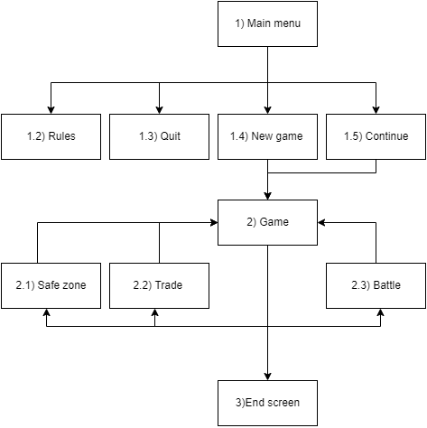

**Figure 1: Flow chart showing the basics of the main game design**

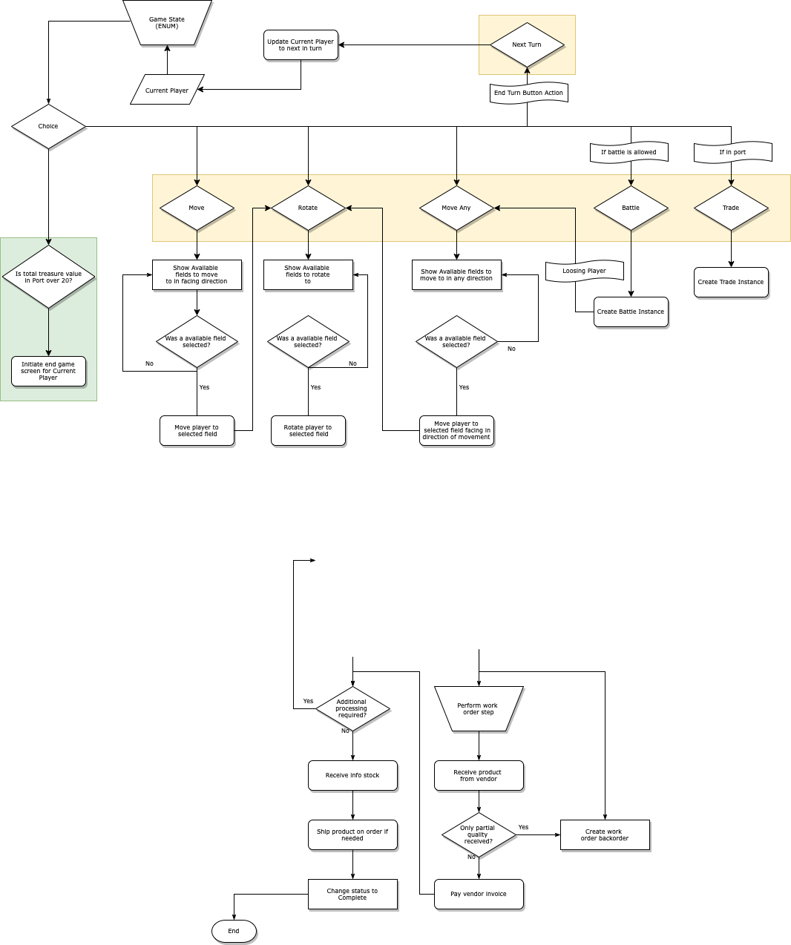

**Figure 2: Flow chart showing the main game class function in detail**

**Modules:**

1. **Main menu:** The purpose is to contain the options to start a game, continue the previously saved game, look at the rules and icons of the game and quit the program.
2. **Game:** The purpose of this module is to set up the game, with the moving & rotating, the placement of items, locations and players across the board.
3. **Safe Zone:** The purpose is to place treasures by players and save them so no other players can come to your port and trade them. Furthermore, the points from the safe zone and the ports together add up to the players final score.
4. **Trade:** The purpose is to allow players to trade treasures and crew cards in trading portst like Amsterdam and Venice, as well as other players ports.
5. **Battle:** The purpose is to allow players to attack each other to obtain treasure or crew cards, depending if a ship sails to the same square, the player which made the last move will attack, but if player one sail over player two’s position, player two can choose to attack.
6. **End screen:** The purpose of this is to show player who was won and the treasure the player has won with.

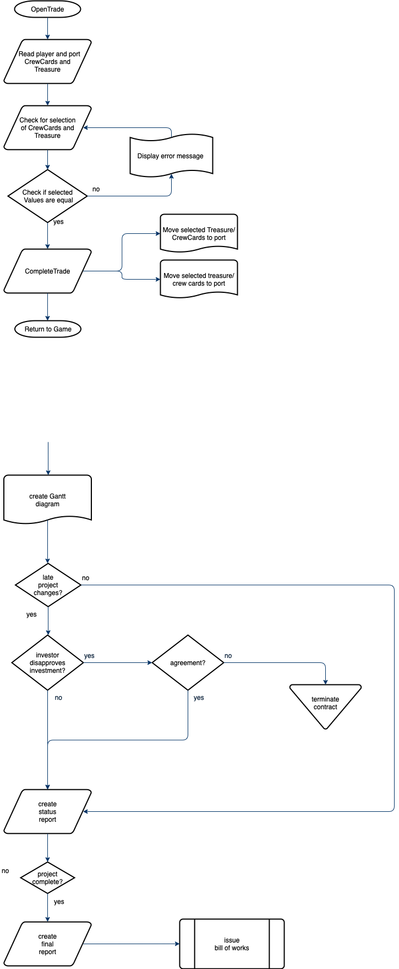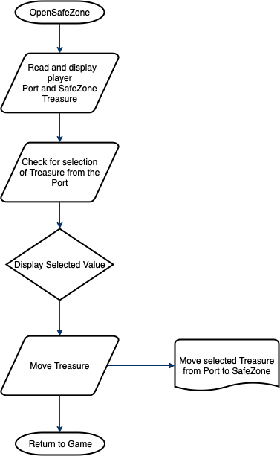

**Figure 3: Flow Chart showing the design of the trade and safezone mechanics**

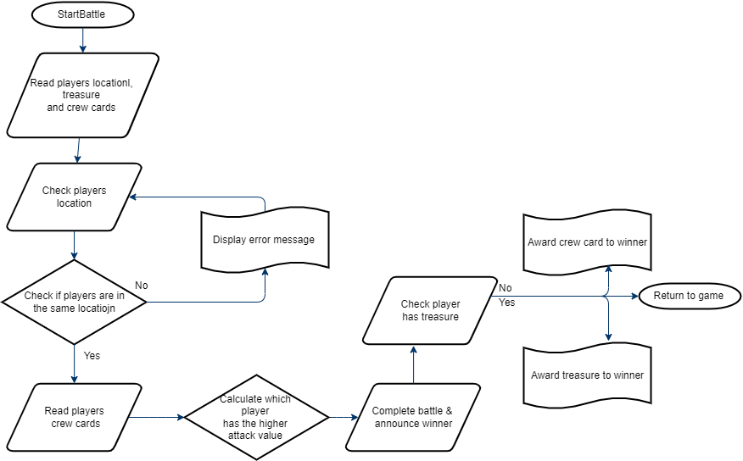

**Figure 4: Flowchart diagram for the desing of battle module.**

Methods are described and explained in Design Specification section 4 [1].

## 2.3 Algorithms

Significant algorithms are described and explained in Design Specification section 5.1 [1].

## 2.4 The main data areas

Significant data structures described and explained in Design Specification section 5.3 [1].

CrewCards for Player, Port and Island objects are stored as an ArrayList<CrewCard>.

ChanceCards are stored as an ArrayList<ChanceCards> in the ChanceCardManager class.

Board class holds arrays of ImagePattern for tiles, ports, bays and islands.

## 2.5 Files

The program assumes the following files exist:

Buccaneer_Application\players.json

Buccaneer_Application\src\main\resources\uk\ac\aber\cs221\gp02\background.fxml

Buccaneer_Application\src\main\resources\uk\ac\aber\cs221\gp02\BattleScreen.fxml

Buccaneer_Application\src\main\resources\uk\ac\aber\cs221\gp02\endScreen.fxml

Buccaneer_Application\src\main\resources\uk\ac\aber\cs221\gp02\game.fxml

Buccaneer_Application\src\main\resources\uk\ac\aber\cs221\gp02\main.css

Buccaneer_Application\src\main\resources\uk\ac\aber\cs221\gp02\mainMenu.fxml

Buccaneer_Application\src\main\resources\uk\ac\aber\cs221\gp02\nicknames.fxml

Buccaneer_Application\src\main\resources\uk\ac\aber\cs221\gp02\popup.fxml

Buccaneer_Application\src\main\resources\uk\ac\aber\cs221\gp02\rulesScreen.fxml

Buccaneer_Application\src\main\resources\uk\ac\aber\cs221\gp02\safeZone.fxml

Buccaneer_Application\src\main\resources\uk\ac\aber\cs221\gp02\tradeScreen.fxml

Buccaneer_Application\src\main\resources\uk\ac\aber\cs221\gp02\images\bg_boat.png

Buccaneer_Application\src\main\resources\uk\ac\aber\cs221\gp02\images\bg_island.png

Buccaneer_Application\src\main\resources\uk\ac\aber\cs221\gp02\images\bg_ocean.png

Buccaneer_Application\src\main\resources\uk\ac\aber\cs221\gp02\images\bg_ocean1.png

Buccaneer_Application\src\main\resources\uk\ac\aber\cs221\gp02\images\bg_ocean2.png

Buccaneer_Application\src\main\resources\uk\ac\aber\cs221\gp02\images\bg_ship.png

Buccaneer_Application\src\main\resources\uk\ac\aber\cs221\gp02\images\bg_sky.png

Buccaneer_Application\src\main\resources\uk\ac\aber\cs221\gp02\images\EndScreen.png

Buccaneer_Application\src\main\resources\uk\ac\aber\cs221\gp02\images\EndScreenScroll.png

Buccaneer_Application\src\main\resources\uk\ac\aber\cs221\gp02\images\EndScreenSunset.png

Buccaneer_Application\src\main\resources\uk\ac\aber\cs221\gp02\images\EndScreenWinner.png

Buccaneer_Application\src\main\resources\uk\ac\aber\cs221\gp02\images\GameRulesSlidesPNG\GameRules_1.png

Buccaneer_Application\src\main\resources\uk\ac\aber\cs221\gp02\images\GameRulesSlidesPNG\GameRules_2.png

Buccaneer_Application\src\main\resources\uk\ac\aber\cs221\gp02\images\GameRulesSlidesPNG\GameRules_3.png

Buccaneer_Application\src\main\resources\uk\ac\aber\cs221\gp02\images\GameRulesSlidesPNG\GameRules_4.png

Buccaneer_Application\src\main\resources\uk\ac\aber\cs221\gp02\images\GameRulesSlidesPNG\GameRules_5.png

Buccaneer_Application\src\main\resources\uk\ac\aber\cs221\gp02\images\GameRulesSlidesPNG\GameRules_6.png

Buccaneer_Application\src\main\resources\uk\ac\aber\cs221\gp02\images\GameRulesSlidesPNG\GameRules_7.png

Buccaneer_Application\src\main\resources\uk\ac\aber\cs221\gp02\images\GameRulesSlidesPNG\GameRules_8.png

Buccaneer_Application\src\main\resources\uk\ac\aber\cs221\gp02\images\GameRulesSlidesPNG\Icons_Scroll.png

Buccaneer_Application\src\main\resources\uk\ac\aber\cs221\gp02\textures\Anchor_bay.png

Buccaneer_Application\src\main\resources\uk\ac\aber\cs221\gp02\textures\background.png

Buccaneer_Application\src\main\resources\uk\ac\aber\cs221\gp02\textures\Bay.png

Buccaneer_Application\src\main\resources\uk\ac\aber\cs221\gp02\textures\BayA.png

Buccaneer_Application\src\main\resources\uk\ac\aber\cs221\gp02\textures\BayC.png

Buccaneer_Application\src\main\resources\uk\ac\aber\cs221\gp02\textures\BayM.png

Buccaneer_Application\src\main\resources\uk\ac\aber\cs221\gp02\textures\Dir_1.png

Buccaneer_Application\src\main\resources\uk\ac\aber\cs221\gp02\textures\Dir_2.png

Buccaneer_Application\src\main\resources\uk\ac\aber\cs221\gp02\textures\Dir_3.png

Buccaneer_Application\src\main\resources\uk\ac\aber\cs221\gp02\textures\Dir_4.png

Buccaneer_Application\src\main\resources\uk\ac\aber\cs221\gp02\textures\Dir_5.png

Buccaneer_Application\src\main\resources\uk\ac\aber\cs221\gp02\textures\Dir_6.png

Buccaneer_Application\src\main\resources\uk\ac\aber\cs221\gp02\textures\Dir_7.png

Buccaneer_Application\src\main\resources\uk\ac\aber\cs221\gp02\textures\Dir_8.png

Buccaneer_Application\src\main\resources\uk\ac\aber\cs221\gp02\textures\Dir_9.png

Buccaneer_Application\src\main\resources\uk\ac\aber\cs221\gp02\textures\Dir_10.png

Buccaneer_Application\src\main\resources\uk\ac\aber\cs221\gp02\textures\Dir_11.png

Buccaneer_Application\src\main\resources\uk\ac\aber\cs221\gp02\textures\Dir_12.png

Buccaneer_Application\src\main\resources\uk\ac\aber\cs221\gp02\textures\Dir_13.png

Buccaneer_Application\src\main\resources\uk\ac\aber\cs221\gp02\textures\Dir_14.png

Buccaneer_Application\src\main\resources\uk\ac\aber\cs221\gp02\textures\Dir_15.png

Buccaneer_Application\src\main\resources\uk\ac\aber\cs221\gp02\textures\Dir_16.png

Buccaneer_Application\src\main\resources\uk\ac\aber\cs221\gp02\textures\Dir_17.png

Buccaneer_Application\src\main\resources\uk\ac\aber\cs221\gp02\textures\Dir_18.png

Buccaneer_Application\src\main\resources\uk\ac\aber\cs221\gp02\textures\Dir_19.png

Buccaneer_Application\src\main\resources\uk\ac\aber\cs221\gp02\textures\Dir_20.png

Buccaneer_Application\src\main\resources\uk\ac\aber\cs221\gp02\textures\Dir_21.png

Buccaneer_Application\src\main\resources\uk\ac\aber\cs221\gp02\textures\Dir_22.png

Buccaneer_Application\src\main\resources\uk\ac\aber\cs221\gp02\textures\Dir_23.png

Buccaneer_Application\src\main\resources\uk\ac\aber\cs221\gp02\textures\Dir_24.png

Buccaneer_Application\src\main\resources\uk\ac\aber\cs221\gp02\textures\Dir_25.png

Buccaneer_Application\src\main\resources\uk\ac\aber\cs221\gp02\textures\Dir_26.png

Buccaneer_Application\src\main\resources\uk\ac\aber\cs221\gp02\textures\Dir_27.png

Buccaneer_Application\src\main\resources\uk\ac\aber\cs221\gp02\textures\Dir_28.png

Buccaneer_Application\src\main\resources\uk\ac\aber\cs221\gp02\textures\Dir_29.png

Buccaneer_Application\src\main\resources\uk\ac\aber\cs221\gp02\textures\Dir_30.png

Buccaneer_Application\src\main\resources\uk\ac\aber\cs221\gp02\textures\Dir_31.png

Buccaneer_Application\src\main\resources\uk\ac\aber\cs221\gp02\textures\Dir_32.png

Buccaneer_Application\src\main\resources\uk\ac\aber\cs221\gp02\textures\IslandF.png

Buccaneer_Application\src\main\resources\uk\ac\aber\cs221\gp02\textures\IsalndP.png

Buccaneer_Application\src\main\resources\uk\ac\aber\cs221\gp02\textures\IslandT.png

Buccaneer_Application\src\main\resources\uk\ac\aber\cs221\gp02\textures\moveTile.png

Buccaneer_Application\src\main\resources\uk\ac\aber\cs221\gp02\textures\Mud_bay.png

Buccaneer_Application\src\main\resources\uk\ac\aber\cs221\gp02\textures\Pearl.png

Buccaneer_Application\src\main\resources\uk\ac\aber\cs221\gp02\textures\PirateBlack.png

Buccaneer_Application\src\main\resources\uk\ac\aber\cs221\gp02\textures\PirateRed.png

Buccaneer_Application\src\main\resources\uk\ac\aber\cs221\gp02\textures\PortA.png

Buccaneer_Application\src\main\resources\uk\ac\aber\cs221\gp02\textures\PortC.png

Buccaneer_Application\src\main\resources\uk\ac\aber\cs221\gp02\textures\PortG.png

Buccaneer_Application\src\main\resources\uk\ac\aber\cs221\gp02\textures\PortL.png

Buccaneer_Application\src\main\resources\uk\ac\aber\cs221\gp02\textures\PortM.png

Buccaneer_Application\src\main\resources\uk\ac\aber\cs221\gp02\textures\PortV.png

Buccaneer_Application\src\main\resources\uk\ac\aber\cs221\gp02\textures\Scroll1.png

Buccaneer_Application\src\main\resources\uk\ac\aber\cs221\gp02\textures\Scroll2.png

Buccaneer_Application\src\main\resources\uk\ac\aber\cs221\gp02\textures\Scroll4.png

Buccaneer_Application\src\main\resources\uk\ac\aber\cs221\gp02\textures\Ship1.png

Buccaneer_Application\src\main\resources\uk\ac\aber\cs221\gp02\textures\Ship2.png

Buccaneer_Application\src\main\resources\uk\ac\aber\cs221\gp02\textures\Ship3.png

Buccaneer_Application\src\main\resources\uk\ac\aber\cs221\gp02\textures\Ship4.png

Buccaneer_Application\src\main\resources\uk\ac\aber\cs221\gp02\textures\TileDark.png

Buccaneer_Application\src\main\resources\uk\ac\aber\cs221\gp02\textures\TileDark1.png

Buccaneer_Application\src\main\resources\uk\ac\aber\cs221\gp02\textures\TileDark2.png

Buccaneer_Application\src\main\resources\uk\ac\aber\cs221\gp02\textures\TileLight.png

Buccaneer_Application\src\main\resources\uk\ac\aber\cs221\gp02\textures\TileLight1.png

Buccaneer_Application\src\main\resources\uk\ac\aber\cs221\gp02\textures\TileLight2.png

Buccaneer_Application\src\main\resources\uk\ac\aber\cs221\gp02\textures\treasure1.png

Buccaneer_Application\src\main\resources\uk\ac\aber\cs221\gp02\textures\treasure2.png

Buccaneer_Application\src\main\resources\uk\ac\aber\cs221\gp02\textures\treasure3.png

Buccaneer_Application\src\main\resources\uk\ac\aber\cs221\gp02\textures\treasure4.png

Buccaneer_Application\src\main\resources\uk\ac\aber\cs221\gp02\textures\treasure5.png

Buccaneer_Application\src\main\resources\uk\ac\aber\cs221\gp02\textures\treasureCard1.png

Buccaneer_Application\src\main\resources\uk\ac\aber\cs221\gp02\textures\treasureCard2.png

Buccaneer_Application\src\main\resources\uk\ac\aber\cs221\gp02\textures\treasureCard3.png

Buccaneer_Application\src\main\resources\uk\ac\aber\cs221\gp02\textures\treasureCard4.png

Buccaneer_Application\src\main\resources\uk\ac\aber\cs221\gp02\textures\treasureCard5.png

Buccaneer_Application\src\main\resources\uk\ac\aber\cs221\gp02\textures\wood.png

Buccaneer_Application\src\main\resources\uk\ac\aber\cs221\gp02\textures\woodlight.png

## 2.6 Interfaces

A display capable of at least 1280x720 or higher resolution is required for running the software to ensure that the whole game can fit on the screen. A mouse or other pointing device is required for operation of the software. A keyboard or other form of text entry is required for picking custom nicknames.

## 2.7 Suggestions for improvements

If more time was allocated improvements would include:

* Implementing chance cards that can be held by players to be used later in the game.
* Implementing Anchor Bay to assist some cards.
* Make home ports visually obvious which player’s port they are belong to (ie. same colours)
* Be able to hover over players to view their name, treasure, crew total.
* Move the chance card popup window to a less interrupting position / be able to move it if wanted
* It could be made possible to play with 2-4 players instead of a fixed 4.
* Maybe there could be a way to make the main menu animation less demanding on hardware (maybe render it into a video instead)

## 2.8 Things to watch for when making changes

Something to make sure doesn’t break when making changes is the saving/loading. After making changes the saving method should be checked to make sure all the necessary data is being saved to the JSON file. The loading method should also be checked to ensure that any new data is also loaded into the game when continuing.

## 2.9 Physical limitations of the program

Most modern computers will be able to run this program as it is overall very light in both processing and memory power. The game has been tested on Microsoft Windows, Linux and macOS. The most demanding part of the program is the animation on the title screen, with the rest of the game being very light. On average the program uses around 200-300 MB of RAM while it is running.

## 2.10 Rebuilding and Testing

In order to run the program (recommended: using intellij) make sure JavaFX, Maven Dependencies and JSON are installed and accessible anywhere inside the project. Also make sure that all the correct files are present such as java classes and all the resources for the game (FXML, image files and css).

# REFERENCES

[1] Software Engineering Group Projects: Design Specification. Adrian Debski, Alessandro Lewis, Alexander Gardemann, Alvaro Fernandez de la Fuente, David Hernandez Rodriguez, Khalid Ameen Aslam [kha9], Mukhriz Bin Mustafa, Vincent Azmi, Xander Davies. SE.G02.DesignSpec. 1.1 Release

[2] Software Engineering Group Projects: Producing the Final Report. C.W. Loftus. SE.QA.10. 2.4 Release

# DOCUMENT HISTORY

| *Version* | *Issue No.* | *Date* | *Changes made to document* | *Changed by* |
| --- | --- | --- | --- | --- |
| 0.1 | N/A | 10/05/22 | Started 2.2, 2.3, 2.4, 2.5, 2.7, 2.10 | via8 |
| 0.2 | N/A | 10/05/22 | Filled in Intro section. Formatted doc to follow template. | mub11 |
| 0.3 | N/A | 10/05/22 | Added Program Structure | alg68 |
| 0.4 | N/A | 10/05/22 | Added battle and main overview flowchart | dah73 |
| 1.0 | N/A | 10/05/22 | Final checks. Change version for release. | mub11 |
|  |  |  |  |  |
|  |  |  |  |  |
|  |  |  |  |  |