**SimCenter: National Center for Computational Engineering**

**Aircraft Performance Design Contest**

Goal: To inspire third- and fourth-year HS students to learn about Engineering and Design, motivate them to consider a career in a STEM-related field, and extend their Calculus abilities from simple function integration to numerical integration using principals already introduced in their Calculus courses.

Background: Using a computational simulation-based tutorial on the SimCenter website that incorporates a simple airfoil, students can gain an understanding of the basics of fluid mechanics in different flight regimes . Based on the computed solutions for pressure on the airfoil surface, students will be able to estimate net force acting on the airfoil.

Objective: Use the online fluid-flow simulator, tutorials, and online research to learn about one of the most important influences acting on an aircraft in flight -- net force due to changes in pressure --, and write a single five-page paper (with introduction and conclusion) explaining the results of your investigation for the following cases:

* For a low speed (Subsonic, Mach = 0.5[1]†) flow: Using various values of angle of attack‡, determine the change in net force based on changes in angle of attack[2]‡. Use angles of attack of -2°, 0°, +2°, +4°, and +6°.

Net force is calculated by integrating the surface pressure around the airfoil.

In order to do this without the need to write computer code (although a brief explanation of the conventions used to do so is provided in a Graduate Student tutorial on the website), please view the “Numeric Integration with Riemann Sums” portion of this document. This will help you calculate net force for the airfoil using the Cp plots supplied by running cases with the given constraints. Please consult the tutorial for HS students on the website for more background and instructions on using the solver.

Rules: Participants must be enrolled with junior or senior status in a high school in Tennesee, Georgia, or Alabama. Students must submit a five-page word processed report (any mathematics discussed can be typeset using MathType, Equation Editor (Insert…Object… in MS Word), or LaTex), double-spaced, using 12 point Arial or Times New Roman font, with 1 inch margins; this must include at least one self-made graph (on Excel, etc.) net force results for each of the three above cases, with axes labeled. If you do not wish to scan your hand drawn integrations, you may include copies or originals as an appendix. Entries will be judged for grammar, correctness of results, amount of content fit within constraints, and proper use of graphs.

Contact: Submissions can either be sent electronically (in MS Word, OpenOffice, or PDF format) to [Vincent-Betro@utc.edu](mailto:Vincent-Betro@utc.edu) OR via mail to:

Vincent Betro  
UTC SimCenter: STEM Outreach

701 E. MLK Blvd

Chattanooga, TN 37403

Deadline: Submissions must be RECEIVED by noon, February 22, 2010

Prizes: All participants will receive a certificate, and the top three authors will be notified of their status by February 26, 2010 and will each receive a special prize. There will be an awards ceremony at the SimCenter on March 16, 2010 at 10 am, where all entering students will be presented their awards and then given a tour of the facility!

**Numeric Integration with Riemann Sums**

As you know from your calculus courses, integrating a function over a given domain (a definite integral) gives the area under the given curve. However, what do we do to integrate a function that cannot be easily expressed in terms of variables in that domain (or where the function is not given explicitly, as in the case of the Cp plot below)?

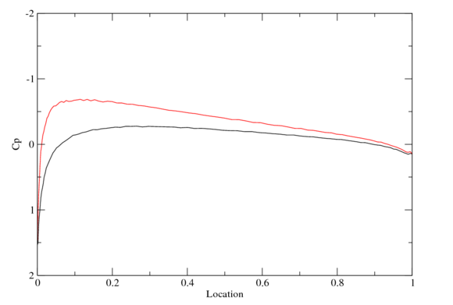

Consider the following function graph. If you knew the function itself[3]*, you could simply integrate algebraically: . But not knowing the function, your only choices are to break the area under the curve into rectangles and sum their areas, or do a difficult, computationally expensive curve fit and then integrate analytically. We choose the former, and this is called a Riemann Sum; you have been introduced to Riemann Sums both in the website tutorial and in your coursework. It is known that as you let  (in other words, you use successively smaller – i.e., “thinner” -- rectangles until the overshoot and undershoot become negligible), you will obtain better and better approximations to what would be obtained if  were known and could be evaluated using the definite integral seen above.

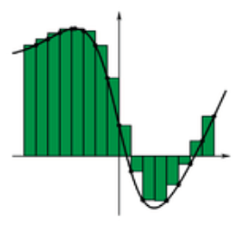

To apply this to the problem at hand, we need to plot the airfoil surface Cp’s obtained using the website solver and then subdivide the *x*-axis into some number of sub-intervals. The sketch below illustrates an example where each sub-interval is 0.1 in length; i.e., . As seen in the sketch below, we can draw lines to create rectangles where the top-right corner of each rectangle touches a Cp curve[4]+. Using this methodology, each rectangle will be  wide with a height of Cp (in the example below the green rectangle corresponds to the airfoil upper surface Cp and blue rectangle corresponds to the airfoil lower surface Cp). Determining these two areas (over the same ), summing over all intervals (10 in this example), and subtracting the bottom sum from the top sum will give you the signed area between the curves, which gives a quantity that is proportional to the net force acting on the airfoil.

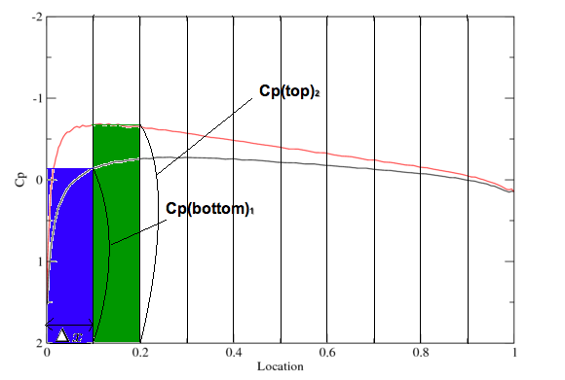

In equation form, the net force per unit width (into the paper) is given by



where the minus sign is by convention. However, this is not the full story because as seen in the above equation, force is a *vector* quantity, meaning it has both magnitude and direction. Computing the net force as given above provides only the magnitude of the force, but not its direction. Although determining the force’s direction will tell us how much of it is lift and how much is drag, doing that now is beyond the scope of this exercise. So, if we’re interested in only the net force magnitude, the above equation becomes



In terms of the pressure coefficient Cp the above becomes



where is the non-dimensional net force. Note this assumes that the body (airfoil) is symmetric. Using Riemann Sums, the above can be approximated by the relation



where the subscript “*i*” denotes a particular interval and *M* is the total number of intervals. The intention is to show how to numerically approximate an integral for which a simple curve cannot be easily fit, so your solution is only as good as the fineness of your sub-intervals. So, for each case, compute the above quantity with at least two  values (divide the grid into 10 and then into 20 rectangles, for instance) to see how the values change with the sub-intervals.

In this way, you can calculate the net force on the airfoil and create a graph of the various forces at different angles of attack for your project. Going through these processes will give you a better appreciation of how mathematics is used to obtain practical results.

1. † Mach number is the ratio formed by dividing velocity by the speed of sound.
2. ‡ Angle-of-Attack is the angle between the airfoil chord line and the oncoming air flow.
3. * For example, 
4. + Note that the sketch uses rectangles that are offset for illustrative purposes only; rectangles created from Cp’s for each surface are to be summed over all sub-intervals.