# Trippify Project

## Project Objective

* Create a web application named to plan and manage personal leisure travel plans

Phase 1 Objective:

* Build features to enable user to create their trip with traveller particulars, budgeting and trip details

## Features and Requirements

Phase 1 Draft Requirements:

* As a user, I should be able to login and logout of my account
* As a user, I should be able to create a new trip by using a form
* As a user, I should be able to input traveller details on 1st screen
* As a user, I should be able to input my budget details for the trip on 2nd screen
* As a user, I should be able to input my destination trip details on 3rd screen
* As a user, I’d like to be able to see summary data about my entire journey. This could include traveller, budget and destination details.
* As a user, I should be able to retrieve and view my trip details
* As a user, I should be able to amend my trip details a
* As a user, I should be able to delete my trip details

Essential Features:

|  |
| --- |
| User Login and Logout |
| Create new trip |
| Delete trip |
| Amend trip |
| Enter traveller details |
| Enter budgeting details |
| Enter trip details |

Non-Essential Features:

|  |
| --- |
| Change password |
| Show trip Summary |

Entities:

|  |
| --- |
| User |
| Budget |
| TripDetails |
| Particulars |

## Program Flow Chart

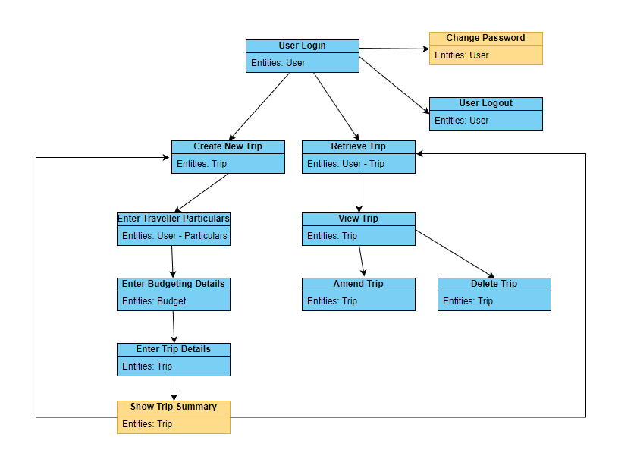

## Class Diagram

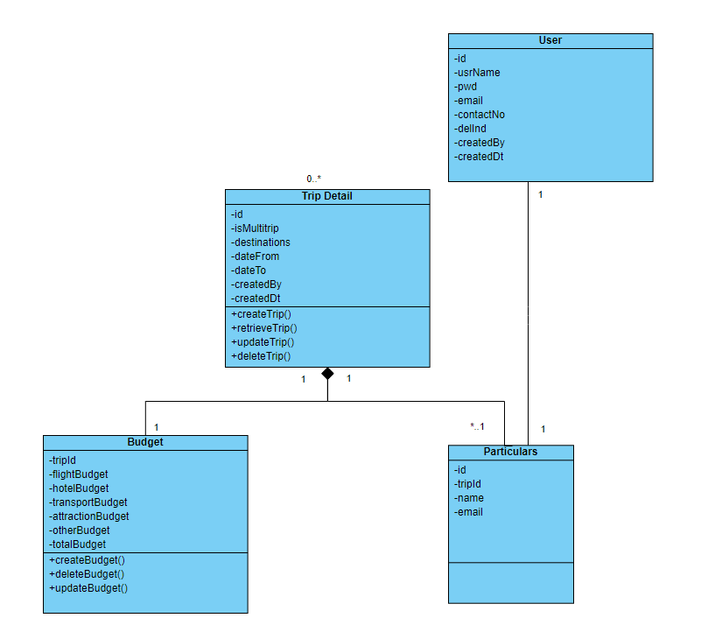

## Resources

Online resources with similar ideas:

<https://www.inspirock.com/>

<https://wanderlog.com/>