Extreme Programming with Eclipse

Part I: Test-driven development
Before you start: You should have Java and Eclipse installed on your laptop computer or a lab computer. If not, you can get Eclipse at download.eclipse. com . My colleague Dr. Craig Piercy has placed a beginner’s video tutorial on installing Eclipse at http://www.youtube.com/watch?v=rD-jyx8Wxgg.
Ready to write some Java code? Let’s go!
- Launch Eclipse. Choose File/New/ Dynamic Web Project. If you don’t see Dynamic Web Project in the New list, look in the New list under Other/Web. Name the project CreditCard. Accept all the default choices that the project creation wizard gives you, such as the source code folder, the J2EE version, and the server configuration.
- During the creation, you may see a message asking you if you’d like to open the Java EE perspective. In Eclipse, a perspective is a set of related windows typically used for working on a project. Accept this option. After creation, please check to see that you have the window open. If you don’t see it, use the Window/Perspective menu item to open the another perspective. Depending on your Eclipse configuration, either the “J2EE Perspective” or the “Web perspective” should work. In this perspective you should also see a row of tabs like this, which will enable us to monitor the execution of our Web projects.
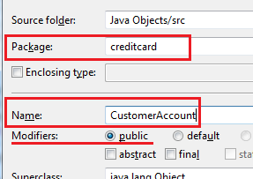
- In the Project Explorer view, select the project node . Note that this icon contains a little Earth symbol, representing the Web, and a J for Java. Right-click this node and choose New. Create a new public Java class, named CustomerAccount, in package creditcard. A package is a collection of related classes; a public class is one whose public members can be freely accessed by other classes. Please follow the typographical conventions for Java development:
  - Package names are in all lower-case.
  - Class names are in upper camel case, starting with a capital and using a capital to start a new word. Please, do not use spaces or punctuation in Java names!
If you have written Java classes with Eclipse before, you may recall that you typically create a main method to run the class from the console. Not this time! Our class will run in the context of a Web server.
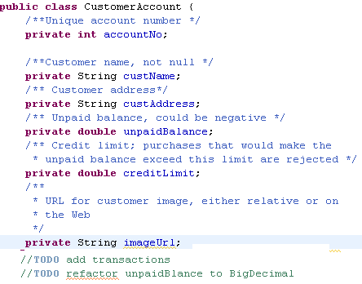
- In CustomerAccount, define the fields as shown at right. The fields are declared as private, meaning that other classes cannot freely access them. Later, we will write methods to allow controlled access to these data. Methods within the CustomerAccount class, however, have free access to all the fields.
You may see some warning icons . Rolling your mouse pointer over these items will reveal the message “the value of this variable is never used.” That’s OK; we will add code to reference these variables soon.
Make sure you have cleared up any Java syntax errors (white on red “X” ) before proceeding to the next part. Save all your files.
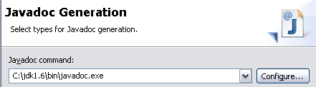
- Note the Javadoc-style comments, starting with /**. To see Javadoc in action, save the file and choose Project/Generate Javadoc. If this is your first time generating Javadocs, you will need to configure the wizard by pointing it to the javadoc.exe command program. In the example shown at right, the JDK was installed at C:\jdk1.6, and the javadoc command was found in the “bin” subdirectory. You can use the Configure button to search for your JDK; often, it is found in C:\Program Files\Java or C:\Program Files(x86)\Java. Once you find the JDK, look in the “bin” subdirectory to find the javadoc command. Windows may not display the “.exe” prefix, but that’s OK.
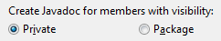
- Still in the Javadoc wizard, select the CreditCard project and choose to generate documentation for private class members. (When you have completed a class and distribute it to others, you will generate documentation for only public and protected class members. What we are seeing now is the developer’s view.)
- You should now see a node in the Package Explorer. Open this folder, find the file , and open it with a Web browser. You now have nicely HTML formatted documentation for your class, based on your JavaDoc comments. Way cool, eh?
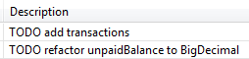
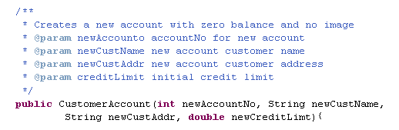
- Eclipse also uses your //TODO comments into a TODO list. To see the list, use the Window/ Show View menu item to select Tasks. (Not “Task List”). The word refactor means to change a working class to make it better – an Extreme Programming specialty!
- Add the declaration of the object constructor as shown at right. Here are some distinguishing features of constructors:
- Constructors have no return type (there is no type name between “public” and “CustomerAccount”;
- The name of the constructor method is the same as the class name;
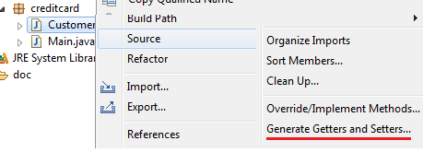
- The constructor specifies the data necessary to create an object. If you don’t define a constructor, Java will create a default constructor that fills all the object data with null and zero values. In my courses, you must always specify enough data to create a usable object.
- Note that we do not specify the initial unpaid balance, because it should always be zero. We call this a business logic rule, also known as a domain knowledge rule. The constructor allows us to “bake in” this knowledge, avoiding possible errors later on.

- We also don’t specify an image URL, because this will be an optional part of the customer account. Typically, a Web application that maintains user profiles starts each user with a “generic” head shot as shown at right. For our default image URL, use “generic.png.” We’ll need another method to add the imageURL if we have one.
- Because we have made the data members private, we now need to specify their access. Select the CustomerAccount node in the Project Explorer window, and choose Source/Generate Getters and Setters. Choose Select All and click OK. You now have 12 new methods to get and set all six of the data members.
- Next, we will prune down the data access. A public getter method allows another object to read the data within the class. According to our business logic, we are going to allow all the data to be read. However, public setter methods allow the data to be directly set to any desired value. This would go against our business logic in two cases:
  - Changing the account number after an account has been created is a recipe for disaster. Account numbers should be immutable (unchangeable). Delete the setAccountNumber method.
  - The unpaid balance can be changed, but only by making transactions such as credit card purchases or payments. We can also envision changing the account balance by voiding a transaction. However, it does not make business sense to directly set the unpaid balance to an arbitrary number. Therefore, delete the setUnpaidBalance method.
When this is done, you should be left with six getters and four setters.
- We now have defined enough methods to implement the first of our User Stories: “Admin creates customer account.” You may be ready to implement the constructor (that is, to type in the actual Java code), but wait! Extreme Programming adds an extra step that will save you many hours of elevated blood pressure later on – Unit Testing.
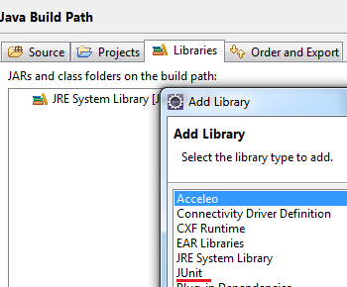
- Before generating Unit tests, you must add the JUnit library to your build path – this is the set of resources that Eclipse calls upon to build your project. In the Package Explorer view, select the Java Objects project and choose Properties. Under Java Build Path, click the Libraries tab and choose the JUnit library. When you have added this library, you should see the icon in your Package Explorer window.
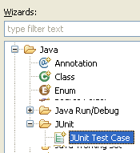
Now it’s time to create the unit tests. Select the CustomerAccount node in the Project Explorer window, and choose New/JUnit Test. If you don’t see JUnit Test in the new menu, click Other and explore for JUnit Test Case.
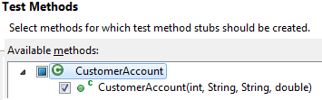
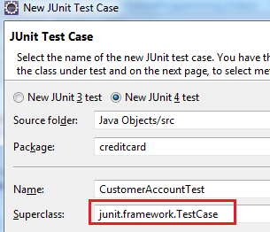
- In the JUnit wizard, leave all the default choices unchanged in the first screen, except for changing the Superclass as shown at left. This class contains all the JUnit testing infrastructure we will need to write test code. Instead of typing junit.framework.TestCase, try clicking the Browse button and searching for TestCase.
- Depending on your setup, you may get a screen asking you which methods to test. Select only the constructor as shown. Because all the other methods were auto-generated, there is no need to test them.
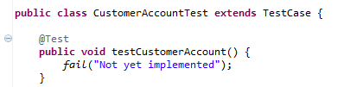
- You now see the following rather cryptic code. This is progress, you ask? All that is obvious is that this is some sort of test.
To me, the main problems with this code are the name testCustomerAccount, which is uninformative, and the lack of documentation as to what this code is supposed to do. What the code is supposed to do is test the constructor, so let’s change its name.
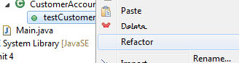
- Click on the little arrow pointing to testCustomerAccount in the Package Manager view. Select testCustomerAccount and choose Refactor/Rename. Change the name of the method to testConstructor. (Method names and data field names should be in lower camel case). Note: be sure you do not change the name of the class, CustomerAccountTest! Class names are in upper camel case, while method names are in lower camel case. More important, names must reflect the meaning of the items: the testConstructor method will test only that the constructor works correctly, while the CustomerAccountTest class will contain a whole suite of test methods to test all the capabilities of the CustomerAccount class.
- What’s the advantage of using Refactor to change the name of a method rather than just erasing the text in the editor? If there are calls to the method elsewhere in the code, Refactor will automatically change their names too. Because making code understandable is critical to making it work correctly, I urge you to be willing to change the names of stuff when they no longer make sense (that is, as your understanding improves). Refactoring is key to the “Embrace Change” mantra of Extreme Programming.
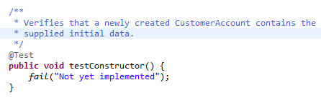
- Here is the code after refactoring and adding a comment (please follow suit by typing in the code yourself). The job of a test method is verifying that the class under test correctly carries out some part of its job. So far, all our CustomerAccount does is to contain data. Data is put into the object by its constructor, so the test code will construct a CustomerAccount object and verify that the newly created object has the correct data.
Note that the comment does not specify all the steps a method will take – it only promises what should be accomplished after the method has completed.
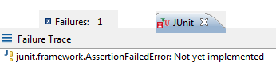
- What’s up with the fails statement? To see, select the TestCustomerAccount class and choose Run As /Junit Test. (You can’t run the testConstructor method alone – you must always run an entire class.) A new JUnit window should pop up, informing us that there was one test failure. Under Failure Trace, you will see the error occurs because the test was not implemented. If this doesn’t make sense, go to the restroom and run cold water over your head, then come back and we’ll talk.
The call to fail() means that we know the test is supposed to fail and we will tell you the reason.
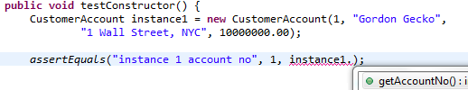
- Now let’s fix this by actually implementing the test. Here is where we must think hard about what we actually expect the CustomerAccount constructor to do: store data in an object. Here’s the start of the test code. We have created a new object, because that’s what constructors do. It’s conventional in writing test code to name the object we want to test either “instance” or “testee.” In this case we call it “instance1,” suggesting more instances to come. Here are a couple of notes about this code:
The first line declares this instance1 variable using the standard pattern:
type Variable-Name = Variable-Value
In the assertEquals statement, I typed the name of an object “instance1” followed by a dot. After a moment, Eclipse offers me a menu of possible choices.
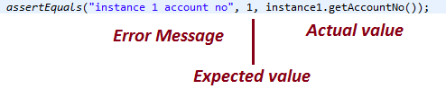
- Here is a deconstruction of the assertEquals method call. The job of a test method is:
- do nothing if the instance object is working correctly;
- raise an Exception if the instance object is not working as expected.
As you can see, the three inputs to assertEquals are the error message, the expected value, and the actual value.
Important note: when you have typed in this code, you must remove the default call to fail. It is no longer true that the test has not been implemented, because we have just started implementing it!
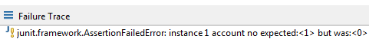
- Now let’s run this test. This time we get a different error, as shown at right. This is the correct test result – remember that we have yet to implement the constructor itself, so the test should fail.
- Here is the next line of test code. Enter this line.
- Add a third assertEquals to test the customer address.
- Add a fourth assertEquals to test the image URL. The expected value is “generic.png”. (Remember that we are using this file name for the shadowed headshot from step )
- The next test, of the unpaid balance, is a bit different. Because of the way Java represents the double data type, two double values could differ by an infinitesimal amount and still be not equal. (This is one of the reasons why we have a TODO item to replace doubles with BigDecimals). In JUnit tests, we must also specify the acceptable difference between two values. Two amounts of money are equal for all practical purposes if they differ by less than a penny. We have set the acceptable “delta” to one-tenth of that amount. If the instance 1 unpaid balance is within 0.001 of zero, the test will pass. This difference is large enough to cover the infinitesimal difference caused by the Java representation of the double values.
By the way, why is zero the expected value, even though we never specified the initial unpaid balance in the constructor?
- Add another assertion for the value of the credit limit. Since the creditLimit field is also a double, you will need a delta argument in this statement as well. Use the 0.001 value again.
- At this point you may check your work against the “Extreme Programming Part 1 Test code” file posted on eLC. Please ask us if there are any discrepancies you do not understand.
- Continue the test code by adding a second instance as shown (you may use your own name instead of mine!). Follow this declaration by six assertEquals statements. Remember to include “instance2” in the error message for each assertEquals, so we can tell which instance fails. In general, we try to test enough instances to make sure that the test does not pass just because of special values of the instance data.
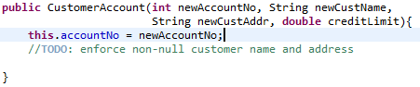
- Now we can actually implement the code! Thanks to Extreme Programming, we now have a significantly better understanding of what our code is supposed to do. Enter the following code, followed by five more assignment statements (not three!) to complete filling in the six data members of our class. Hint: the imageURL data member should be “generic.png”; what should the unpaid balance be for a newly created account?
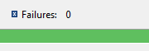
- The keyword stands for the object in which the code is written. It will come in handy for the setting the credit limit – since the constructor parameter creditLimit has the exact same name as one of our data members, a naming conflict could result. No problem! this.creditLimit is our data member, while just plain creditLimit is the method parameter.
- Now for the acid test! Save your CustomerAccount.java code and run TestCustomerAccount again. You should be rewarded with the coveted green bar!
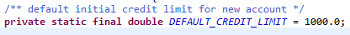
- You may define multiple constructors if there is a good reason to create an object with a different set of data. For example, there might be a default value for the initial credit limit (a value that is used if we don’t have reason to specify anything different). In this case, the default value would be a constant and declared this way. Declaring a variable as final means its value can never be changed (at least, without rewriting the code!) Declaring a variable as static means it has a single value shared among all objects in the class. Constants should be named with all upper case letters separated by underscores.
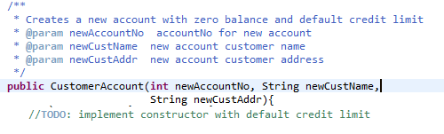
- Creating an account with the default credit limit requires less input data, so we can define a new constructor that takes only three parameters instead of four. Although these two constructors have the same method name, Java can tell which one to call based on the number of input parameters. This trick is called overloading a method name.
- The code shown at right has a revised spec comment and fewer input parameters. Type in the new constructor code as shown here. As always in Extreme Programming, we spec out the code and write the test code before actual implementation.
- Add the following line to the test code testConstructor method, followed by six assertEquals statements to test the expected values of all the data members, including unpaid balance and initial credit limit.
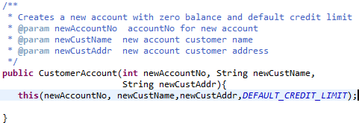
- Use the ‘creatively lazy’ method of calling one constructor from another, called constructor chaining, as shown below. Note the special syntax of the line starting with , which implements constructor chaining. Besides saving work, constructor chaining prevents from writing duplicate chunks of code that would require separate testing and debugging.
This completes your introduction to test-driven development! You can now proceed to Extreme Programming Part II.

Can’t find the Dynamic Web Project type anywhere? You may have the wrong version of Eclipse. In this case just make this a Java Project and continue. You won’t be able to complete the last part, The Web View. After class, see me about installing the correct version of Eclipse.
If it does not appear, you can browse for the file in your workspace folder – this is typically in the parent folder of your My Documents folder on Windows.
Many authors suggest creating a separate source corefolder to hold your test code. You would need to create this folder, named test_src, before generating the test code itself.
Are you paying attention? Students can easily get confused if they just type in the suggested code and don’t reflect on the directions. I frequently ask a discussion question about these particular steps in the first in-class exam and on the final.

