Extreme Programming with Eclipse

Part II: Handling Errors
Please do not start this part until you have completed Part I. All your JUnit tests should pass.

Designing for User Error
An important part of systems design is predicting the errors users are likely to make. This tends to be surprisingly difficult, because having written the software we know how it is “obviously” supposed to be used. Here is a tentative list of errors our users might make at this stage:
- Create a new account with a null name or address;
- Reset the name or address of an existing account to a null value;
- Create a new account with a negative credit limit;
- Reset the credit limit on an existing account to less than the unpaid balance;
- Create a new account with a credit limit larger than some specified maximum value, say $10,000,000;
- Reset the credit limit of an existing account to be larger than the maximum value.

Exceptions in Java
A standard technique for handling such errors in Java is to throw an Exception. When this happens, control is immediately transferred to the designated error handler for this Exception. In the cases listed above, our error handler should politely inform the user of the error and give them another chance to enter the data.
Open a Web browser window to http://download.oracle.com/javase/6/docs/api/java/lang/Exception.html, where you will see the documentation for the Exception class in Java. The most important point for us is the list of direct subclasses, which are specific types of errors defined in Java. We can also define our own application-specific Exception subclasses. Most of the Exceptions on the list are quite specialized and not appropriate for us, but click on the RuntimeException link. Here you see another collection of runtime exceptions. Click on InvalidArgumentException – this one seems appropriate for our application.

The NullPointerException
Of course, exceptions also arise from errors in our code. The most common of these is the NullPointerException, so let’s practice its use.
- Launch Eclipse.
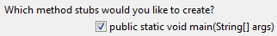
- In the Package Explorer view, select the project node and create a new public Java class, named Main, in package creditcard. Because this class is in the same package as our CustomerAccount class, it can access that class. In the wizard, specify that a main method should be created. This will allow us to directly run the code in this class.
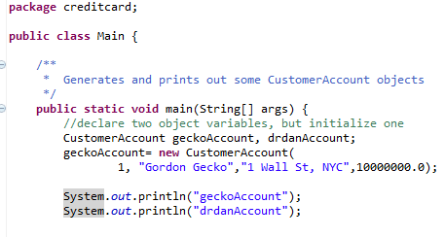
- Inside the main method, type the code shown. The first line declares two CustomerAccount object variables, and the second line initializes the first of these. The second, uninitialized object will be the source of our Exception.
- Eclipse has a number of useful keyboard shortcuts. Try typing sysout followed by Ctrl-Space. Eclipse expands this into System.out.println();
- Run this code by selecting its node in the Package Manager view and choosing Run As/Java Application. You should see an output window in which Java prints out the strings “geckoAccount” and “drdanAccount.”
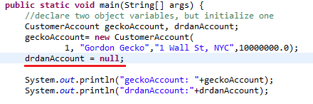
- Now edit the code and add references to the actual objects, as shown. Don’t forget the colon and space, which provide important legibility. Run again and examine the results. When we tell Java to print out an object, its default behavior is to just print out the memory address where the object’s data is stored. The actual address of geckoAccount may be different on your computer.
The address is given in hexadecimal notation, using 16 digits 0-9 and A-F instead of the usual ten digits. Computer wonks like hex notation because 16 is a power of 2, so that hex values more directly represent the underlying binary architecture of the computer.
Because we have not initialized the drdanAccount object, Java has not allocated space to store its data. Since the memory address “points to” the actual data, the value in drdanAccount is called a null pointer.
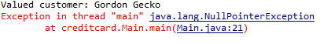
- So far, there has been no error. The problem occurs when we try to dereference the null pointer; that is, to follow the pointer to its nonexistent destination. Add the following code and run once more. This time, a NullPointerException is raised. Since no error handler has been defined for this error, the whole program croaks. Not a good outcome!

Catching Exceptions
- In this example, the Exception caused our code to “blow up” and stop executing. This is actually OK if the error was caused by a coding blunder on our part. In this case we will simply fix the error ourselves.
- Sometimes, however, the problem is caused by bad data entered by the user. In this case, we can catch the Exception. Edit the code as shown here:
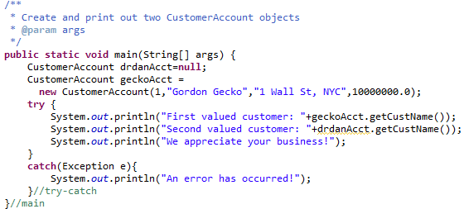
Here we place the part of the code that might cause an error into the try block, and the code that responds to the error in the catch block. Both blocks must be used together, so we call this setup a try-catch structure. I like commenting my right braces, to keep track of which block each right brace is closing.
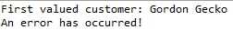
- Run the Main class again. You should get this output:
- When the error occurred (attempting to access the methods of the drdanAcct object, which was null), control immediately jumps to the catch block. The code that prints out “We appreciate your business!” does not get a chance to execute.
- This error message is not very informative, however. Often in developing code, we want to know what kind of Exception was thrown and what message that Exception contains. This “boilerplate” code will do the trick:
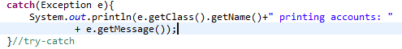
- Try running the code again. This time the error message is a bit more informative:

Fixing the problem
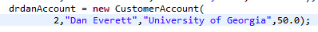
- When you run into a NullPointerException in your code, the cause is usually that you have referenced the data inside an object variable without initializing it Add the following code to fix the error by initializing the drdanAccount object. Run it again – the problem should now be fixed.

Deliberately throwing Exceptions
- Now we will edit the CustomerAccount constructor to throw an IllegalArgumentException if any of the error conditions specified above occurs. Edit the code as shown, adding a couple of lines:
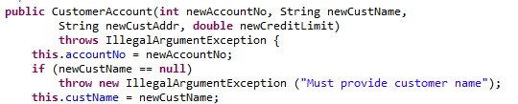
- We have added:
  - A @throws clause in the spec comment to define when the Exception will be thrown;
  - A throws clause in the function header, indicating that the Exception might be thrown;
  - A throw statement that actually throws the Exception. We’ll start with only one error condition.
Note that the Exception we throw is itself an object, and so is created with the new keyword. When creating Exceptions, we always add an error message.
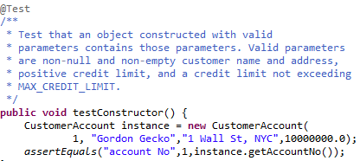
- Save this code and re-open the CustomerAccountTest class. Our changes to the CustomerAccount design have changed what we expect the code to do, so we need to adapt the test class accordingly. First, we’ll alter the spec comment on the test code method as follows. Note that rather than vaguely specifying “valid” input parameters, we should try to specify which parameter values are OK.
- Try re-running your test code. It should still pass, since the Exception should not be raised.

Testing Exceptions
- Now we need to verify that the Exceptions are raised when they should be. Add a second test method as follows. Note the indicative name and spec comment. Recall that the fail method causes the test to immediately fail, no matter what!
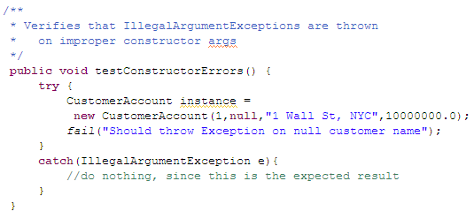
When this test runs, the expected value is that attempting to create an account should throw an IllegalArgumentException. If this happens, control will jump immediately to the catch clause, bypassing the fail call. But if an IllegalArgumentException is not thrown, control passes sequentially to the fails call, which fails the test. By the way, this code illustrates the unusual case of an empty catch clause. In writing code, you frequently encounter the compiler error : “Exception must be caught or declared to be thrown.” You can always mollify the compiler by adding an empty catch clause, but doing so is very dangerous – the empty catch clause will swallow the error and you won’t know where your code went south.
When your code indicates that an Exception may be raised, you must ask yourself what the application should do in this case. If the Exception is raised because of a user error, the appropriate action is to politely inform the user. In this case, the Exception was raised because we deliberately provoked it, and indicates a passed test. Test code is supposed to do nothing when the test passes, so that’s why the catch clause is empty in this unusual case.
- Now run the test; it should pass. Yay!
Note that this code tests for the specific Exception type IllegalArgumentException. If the CustomerAccount constructor throws any other type of Exception, the test will create an error.

Null vs. empty Strings
- Add a second test case as follows, and run the test again
.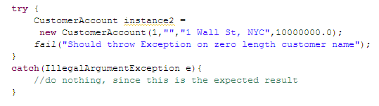 Unfortunately, the test fails, because a null string is not the same as an empty string. (A String is an object; a null String variable contains a null pointer, while an empty String variable contains a pointer to some memory that contains zero characters).
- Go back to the CustomerAccount code and fix it as follows.
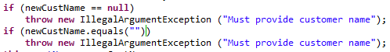
- Note that to compare the content of two Strings, you should use the equals method instead of the == comparison operator. There is a coding subtlety here: if custName is null, then attempting to check its length would create a NullPointerException. That’s why the constructor must first test for a null argument; if the custName is null, then the code will not attempt to find its length.

- Here’s a coder’s trick: you can collapse both of these tests into a single test, as shown. The double vertical bar means “OR”.
- Java is internally configured for short-circuit Boolean evaluation: if the first part of the OR is true, then Java knows that the whole condition must be true, so it does not evaluate the second part. This saves us from attempting to find the length of a null String. As you can see, the code is significantly shorter. The disadvantage is that the error message no longer distinguishes between a null String and an empty one; but this distinction is not important to our application. In either case, the user should fix the error by providing a nonempty customer name.
Once you have got this far, the rest is fairly routine coding.
- Inside testConstructorErrors(), add test cases for null and empty customer addresses. These tests should initially fail.
- Bring the implementation code into compliance with the new tests by editing the CustomerAccount constructor to throw an IllegalArgumentException on null or empty customer address.
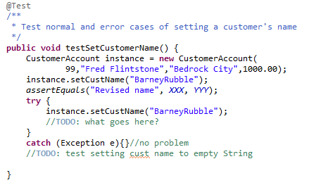
- We need to also prevent the user from resetting a customer name to an empty or null value. In the test code, create a new testSetCustomerName() method. Please give it a good spec comment! Note that in order to call setCustomerName, we need to have a CustomerAccount object. Here is the start of the code:

- Note that we need to include test cases both for correctly setting the customer name and for illegally trying to set it to a null or empty value. We use getCustomerName() to verify that the customer name has been correctly set – it is not enough just to verify that it does not raise an Exception.
- Edit the setCustomerName method to pass the test. You can copy and paste code from the constructor, but think about what you are doing. Also, please add an appropriate spec comment. My coding guidelines allow you to skip the spec for auto-generated getXXX and setXXX methods, but once you modify this code you must spec it out.
- Repeat the previous two steps for the setCustomerAddress method.
- Go back to testConstructorErrors and add a test for creating an account with a negative credit limit.
- Edit the constructor to bring it into compliance with your new test. Be sure to provide an informative error message when you throw the IllegalArgumentException.
- Create a new testSetCreditLimit() method. This should specify that setCreditLimit should throw an IllegalArgumentException if the credit limit is less than the unpaid balance. Again, you should also include at least one test case where setting the credit limit should succeed and at least one case where it should fail. Be sure to provide informative error messages.
- Finally, we need to set the maximum credit limit to $10,000,000. To do this you will need to define a new named constant MAX_CREDIT_LIMIT in the CustomerAccount class. Just follow the pattern by which we created the DEFAULT_CREDIT_LIMIT constant.
- Add a new test case to testSetCreditLimit to test setting the credit limit too high. Bring the implementation code into compliance. When you throw the Exception, it will be helpful to let the user know the maximum credit limit, so they can put in a correct value next time.
Congratulations! We have now finished Interation 2 of the Credit Card project. Upload Main.java, CustomerAccount.java, and TestCustomerAccount.java to the eLC assignment and Submit. You are now certifiably competent with Java Exceptions. Sort of.

