SOFTWARE PROJECT

REQUIREMENTS

|  |  |  |  |
| --- | --- | --- | --- |
| ID | Nom | Type | Description |
| REQ_1 | Base function | F | The application allows exchanging messages between users. |
| REQ_2 | User | F | Each user needs to create an account first |
| REQ_3 | Reliability | F | Message exchange must be reliable and simple. |
| REQ_4 | Costless | F | Message exchange must be available at no cost. |
| REQ_5 | Portability | NF | The software is available on PC Windows |
| REQ_6 | Versions | NF | The software is available as desktop version |
| REQ_7 | Group | F | The software will allow exchanging messages in a group of users which is created by the administrator of the group |
| REQ_8 | Group-size | F | A group may have a maximum size of 6 users |
| REQ_9 | Data save | F | Conversation are saved in a persistent way |
| REQ_10 | Chat search | F | One can search through all his chat |

USER STORY / ACCEPTANCE CRITERIA / CONSTRAINT STORY:

|  |  |
| --- | --- |
| US_WA_1  As a user, I need to exchange messages with other people in order to communicate with them | AC_WA_1  From the desktop app window, you can send message to different contacts.  The messages will be sent at no cost and the app will be very easy to use. |
| US_WA_2  As a user, I need to speak to several people at the same time in order to share information faster than doing it for each of them. | AC_WA_2  From the desktop app window, you will be able to create a chat group with at most 6 users. |
| US_WA_3  As a user, I want to choose the person I want to send my message to in order to speak to someone specifically | AC_WA_3  From the contact window, you will be able to access your contact list and then choose a contact and send a message.  From the chat window you will be able to browse all the conversation in order to send a message to someone which you have sent a message previously |
| US_WA_4  As a user, I want to read messages sent to me some time ago in order to remember previous conversations. | AC_WA_4  In the desktop app, all the messages will be saved in a persistent way so that you can find a record of their previous conversations in the rooms until they delete them. |
| //CS_1  //Every message will be encrypted to assure security. |  |
| CS_2  The software is a desktop software and will be available from windows |  |
| CS_4  The system shall be written in Java |  |
| CS_5  The database will be able to store at least 50 users and more |  |
| CS_6  The database will respond 100% of the time in less than 5 seconds |  |

LIST OF USERS :

The app can be use by everyone (man or woman) but from the age of 15 years and till 100 years.

SEQUENCE DIAGRAM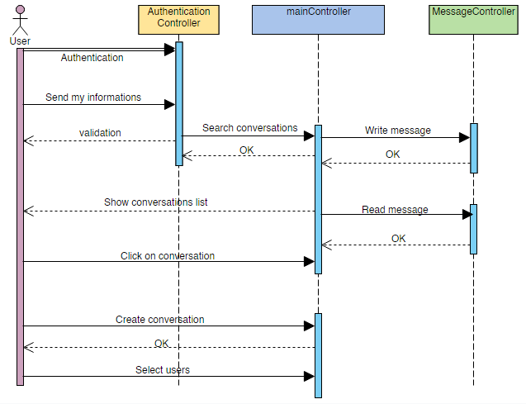

USE CASE DIAGRAM:

