HCI – Final Project Proposal

Vincent Cote

Graham Panchuk

# Introduction

Video games are a form of entertainment that have gradually gained popularity over the last 40 or so years. One very significant genre of video games is Role Playing Games (RPG), and there have been many different takes on the genre – from sci-fi to fantasy. One aspect of the genre that is often overlooked by fans is that these games all originate from the original RPG games: table top games. Probably the most well-known table top RPG is Dungeons and Dragons (D&D). For those unfamiliar, table top role playing games are played face to face around a table with pencils, paper, and dice. Unlike a video game, where all your character’s stats, inventory, and spells are saved as part of the game, table top games require the player to keep track of all these attributes and items. To do this most players use a character sheet, most of which is filled out at character creation but is also edited throughout the course of the game.

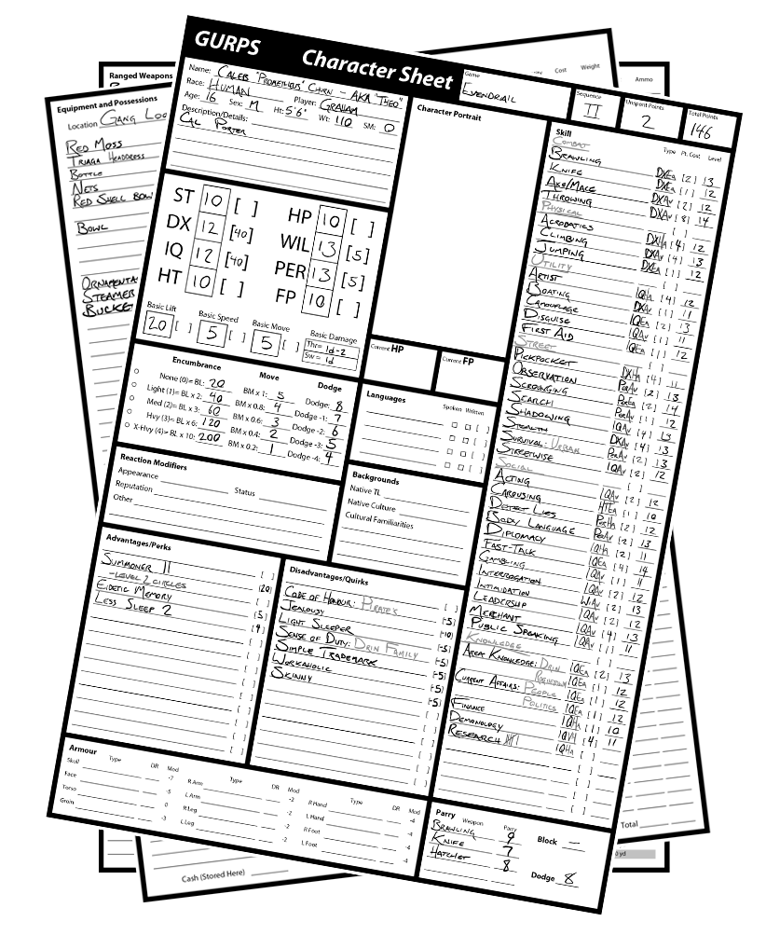

The application we are proposing will allow users to bring the character sheet into the digital world. This will support users by allowing them to create and maintain organized character sheets more efficiently. For any given character, some attributes (which are numerical values) will be mathematically derived from others. Our app will be able to make these calculations for the player. We plan on calling our character sheet application “RoleSlayer”.

# User Interaction Requirements

### Character Creation

The most obvious user requirement of the application will be character creation. Table top games are not always as concrete as a video games. For example, the group may decide on different rules or make up some of their own. We want to give players as much flexibility as possible. To achieve this we plan to offer the player a guided or unguided character creation tool. The guided creation tool will prompt the user for specific values and character information such as attributes, skills, and biographical information. The unguided approach will simply create a blank character sheet and allow the user to modify it to meet their needs.

### Character Expansion

During the course of the game a player learns new skills and abilities (e.g. spells). “RoleSlayer” will offer a dedicated interface to expand and keep track of these skills. Once a new skill has been entered, there will be a textbox to allow the user to keep pertinent details or notes.

### Inventory Management

Another important part of the character sheet is the ability to manage the character’s inventory. Throughout a game the user will receive, use, sell, or even lose items. “RoleSlayer” will provide the player with a dedicated inventory space which will facilitate inventory management. The app will let users sort items by type (weapon, armor, consumable, etc.), or alphabetically. The player will be able to choose from a pre-existing list of items or create new items that meet their needs.

### Character Notes

A campaign can last anywhere from a few hours to multiple years. It is important that the application allows the user a means of keeping track of any story events, character names, or other information they may wish to recall later in the game. The character notes area will simply offer the user a screen to write notes about their campaign. This section will have an add button to create new notes as needed.

# Interaction Concepts

### Cognitive

External Cognition: “RoleSlayer”’s primary function is to help a player keep track of the various statistics, events, and calculations that are important throughout a roleplaying campaign. This reduces the stress inherent in trying to recall information or make calculations by having that information readily at-hand on a mobile device.

The option to be guided through character creation or not facilitates new player’s learning of the character creation process and the rule system.

### Social

Coordination: “RoleSlayer” allows users to have their character sheets – normally left at home or wherever you play – on them at all times. With busy schedules, most roleplaying groups can only play every week or two, but Role Slayer allows players to plan and discuss the campaign on the fly, enhancing the game when the next session does happen. If every player in a particular campaign is in the same place at the same time, it may even lead to an impromptu session!

### Emotional

Expressive Interface: Recent popularity of video games has led to a lot of gamers taking the step from the controller to the tabletop, but it can be an intimidating process to give up a graphical interface and simply use one’s imagination. Role Slayer helps ease this process by including icons and graphics common in the video gaming world to represent different menus, attributes, and items.