
CX002-3-3-INTRODUCTION TO WEB PROGRAMMING

Assessment Mode: INDIVIDUAL
Instructions:
- The project is to be carried out individually
- Complete this cover sheet and attach it to your project

Student Name | : Vincent Claude Michel Dubois
Student ID | : TP056963
Intake | : UCFEFREI1908
Lecturer’s Name | : SYED MOHD ZAHID BIN SYED ZAINAL ARIFFIN
Hand-out Date | : 03/10/2019
Hand-in Date | : 29/11/2019
Presentation Date | : 03/12/2019 - 10:35 - 11:35

Table of content
1) Gantt chart 3
2) Introduction and objectives of the project 4
3) System design 4
4) Implementation 4
5) User guide 5
A) Customer 5
B) Administrator 8
6) References 12

1) Gantt chart
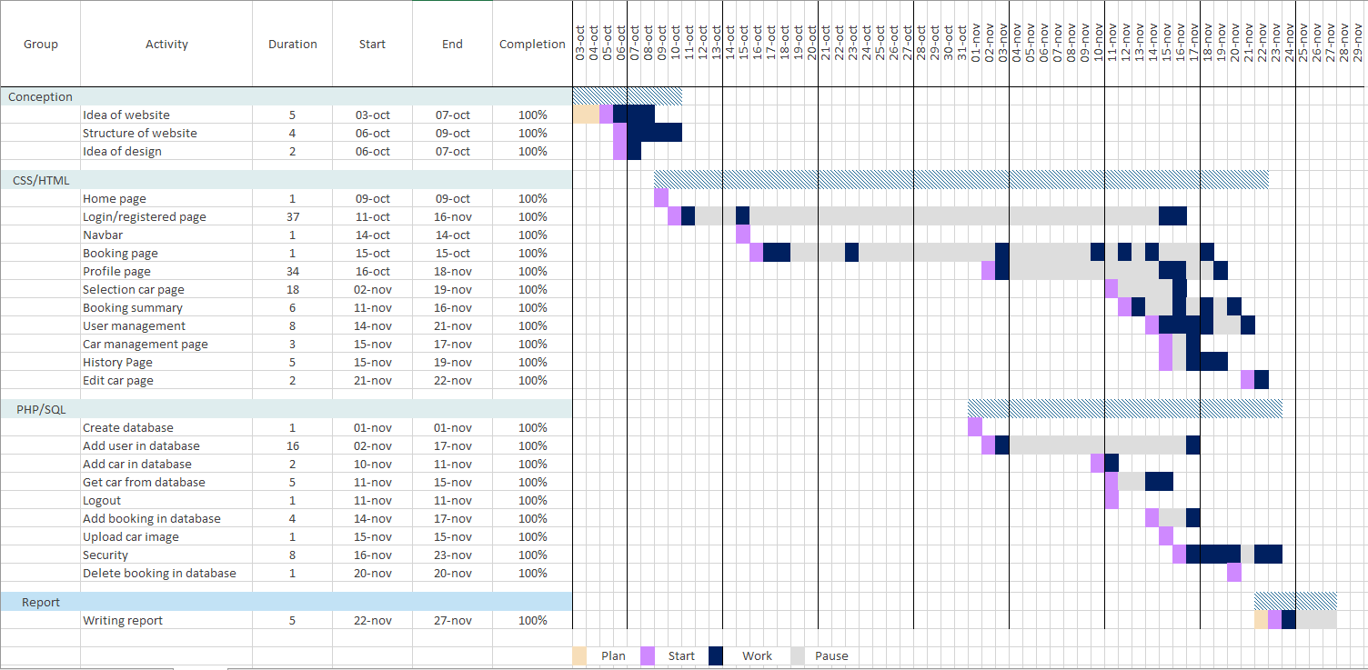
ACTUALISER AVEC LE RAPPORT
A Gantt chart is a useful kind of diagram used in project management to visualize how well a project progress.
On the horizontal axis, we can see the different groups and tasks, the number of days to complete the task, the begin date and the end date of the task and if the percentage of completion of the task.
On the vertical axis, we can read the duration of each task.

2) Introduction and objectives of the project

3) System design

A) Flow chart

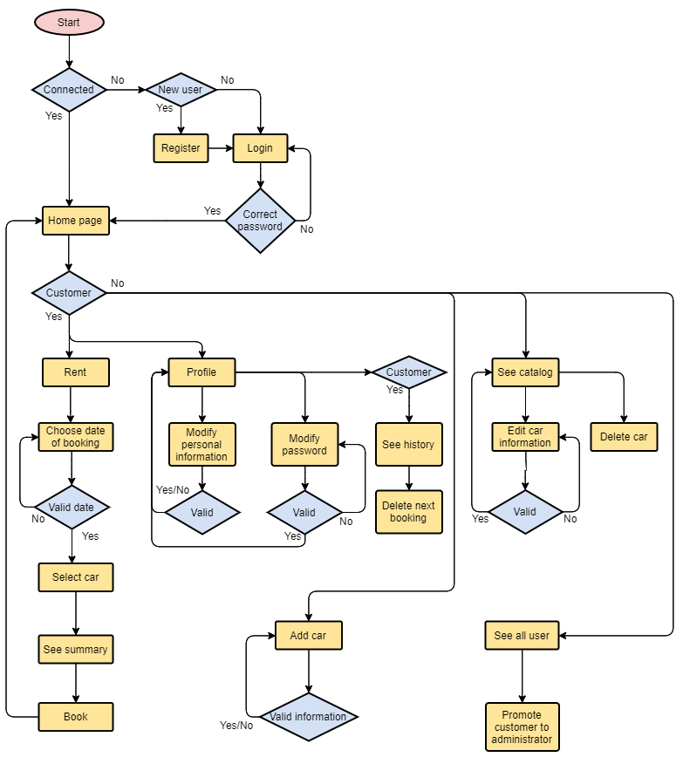

B) Story board

The following pictures describe the storyboard of the website. Grey squares represent images, blue square represents text fields entered by the user, and yellow boxes represents the buttons.
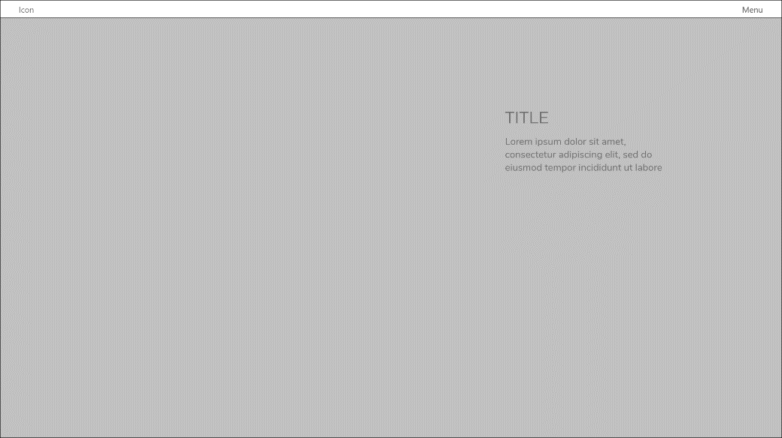 | Home Page

Login page | 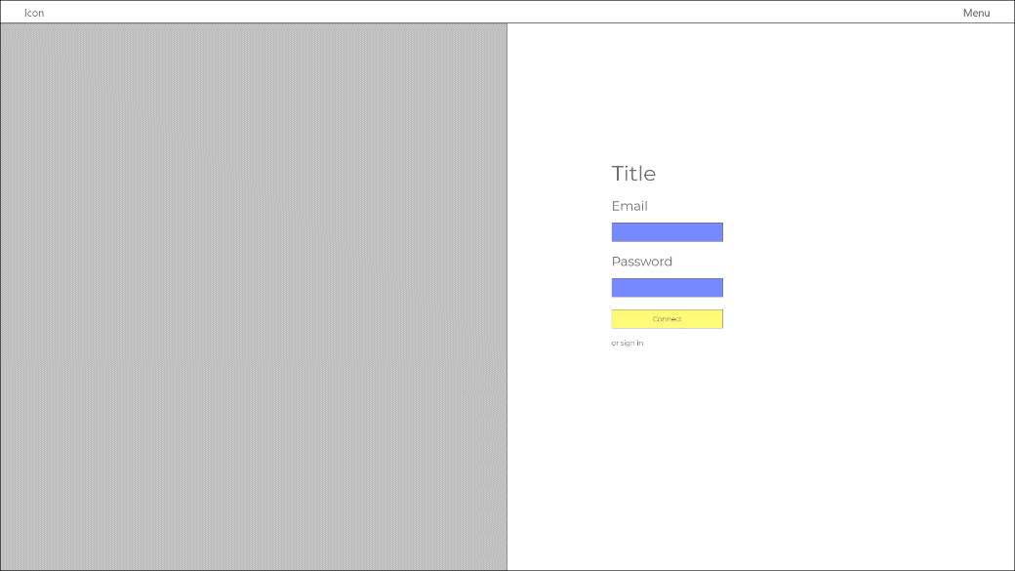

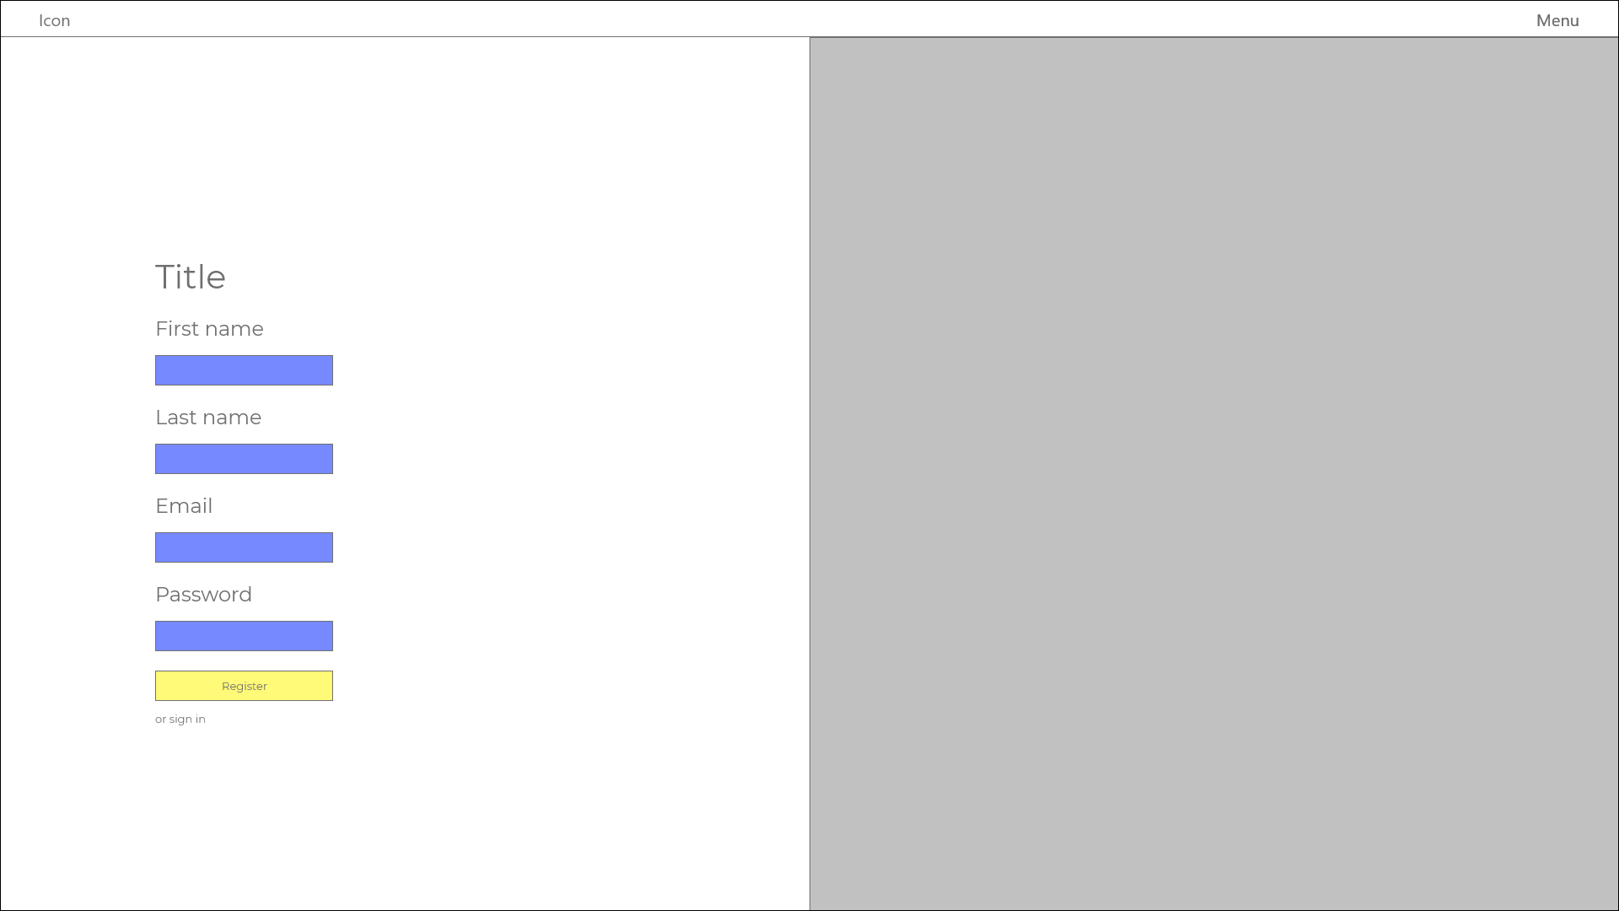 | Register page

Profile customer | 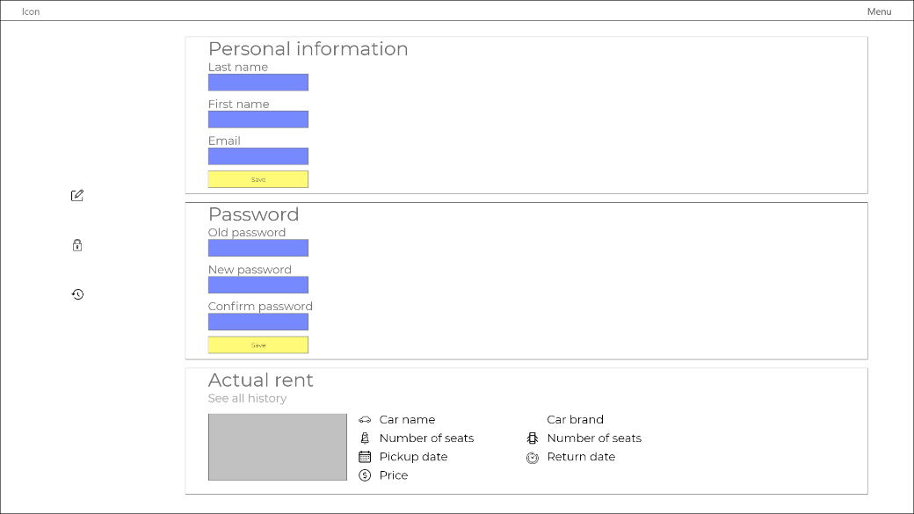

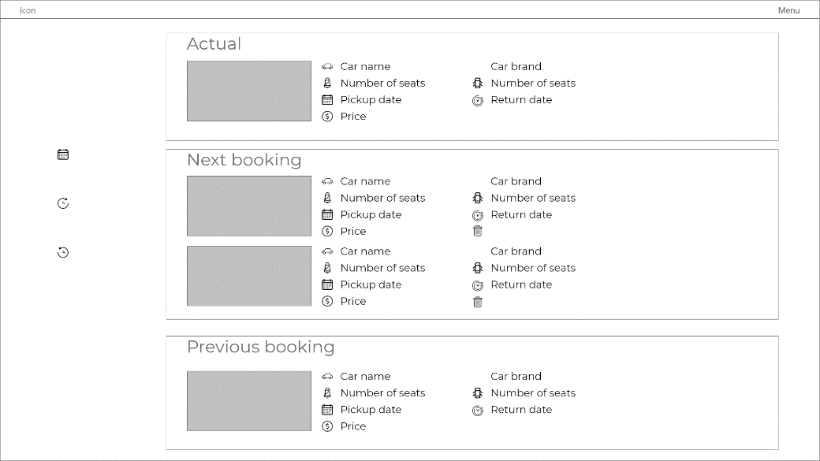 | Booking history

Profile administrator | 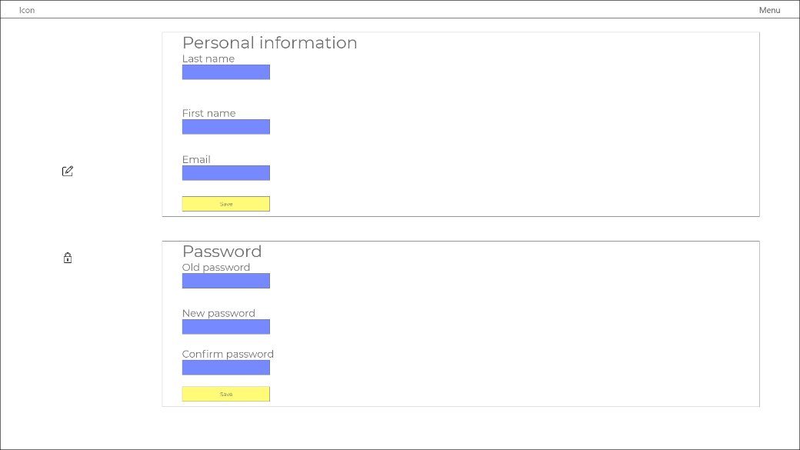

Booking page | 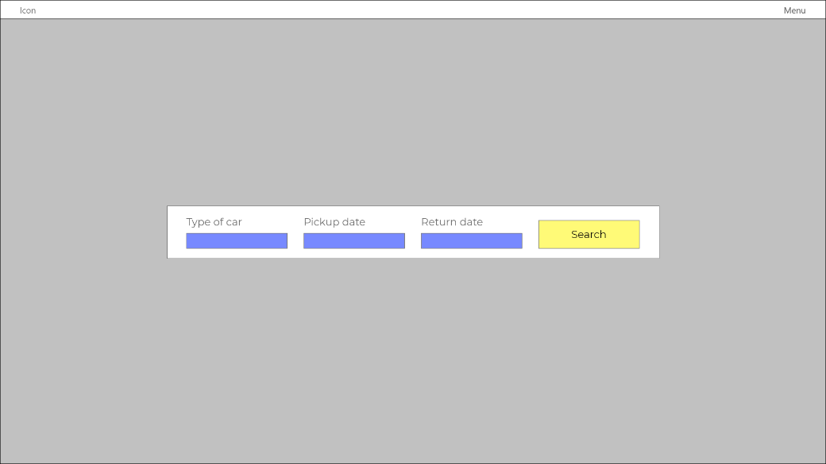

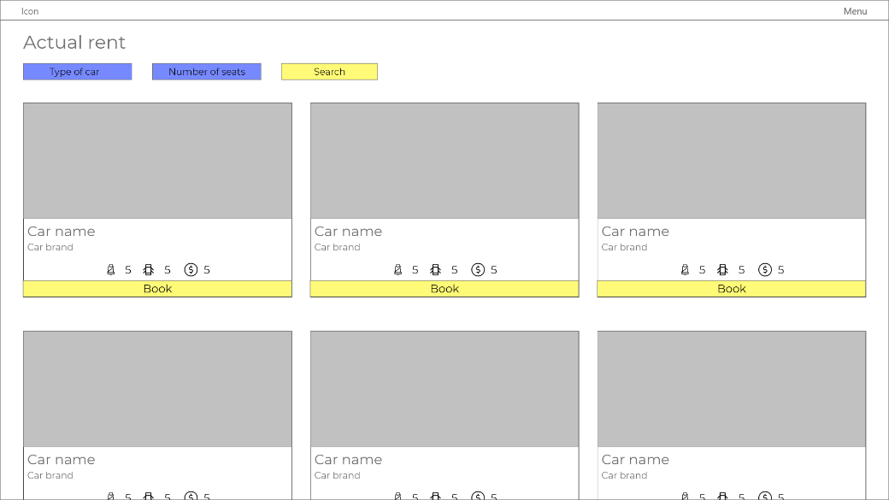 | Profile page

Booking summary | 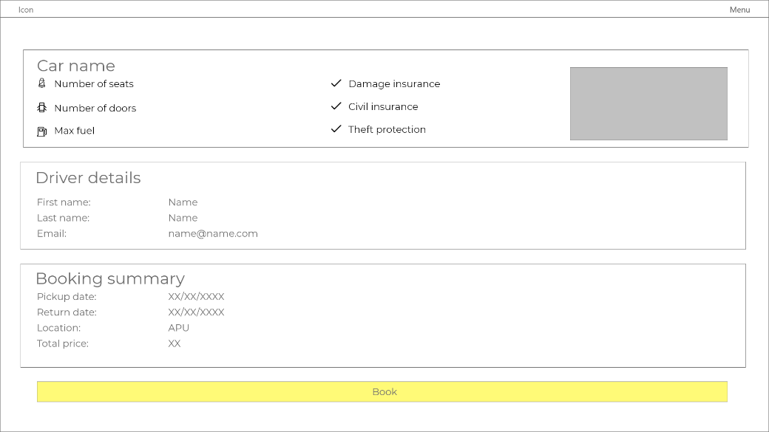

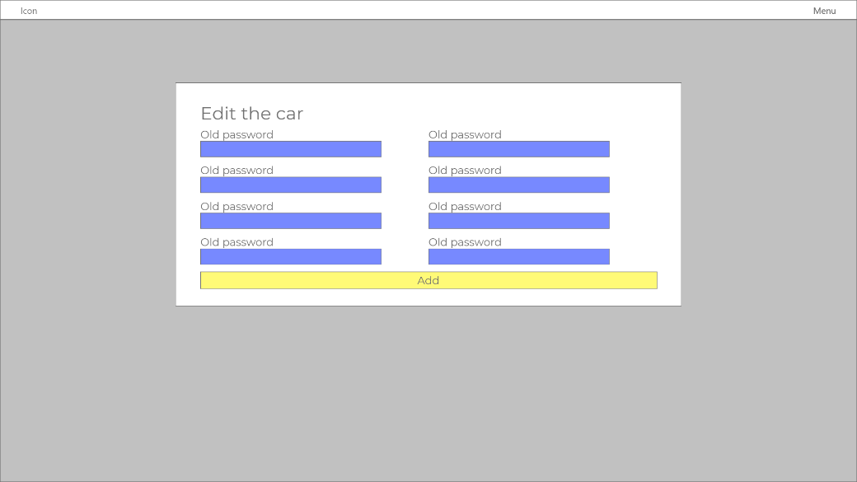 | Add car

Car catalog | 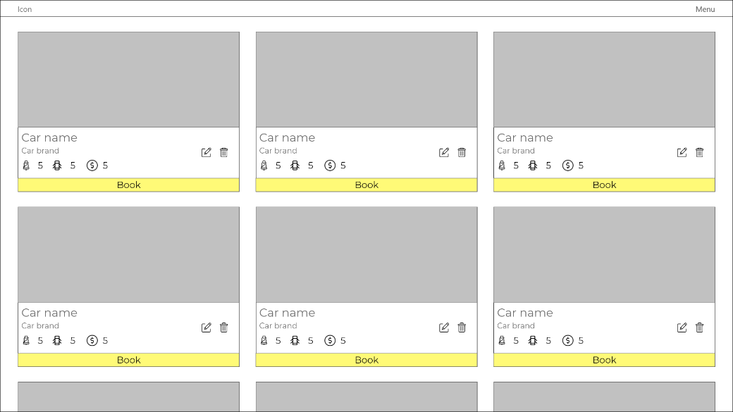

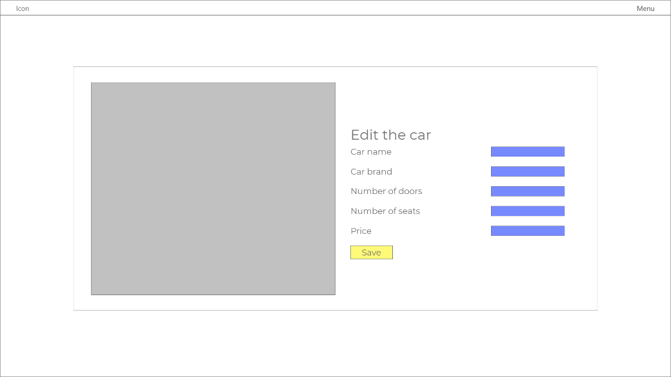 | Edit car

User management | 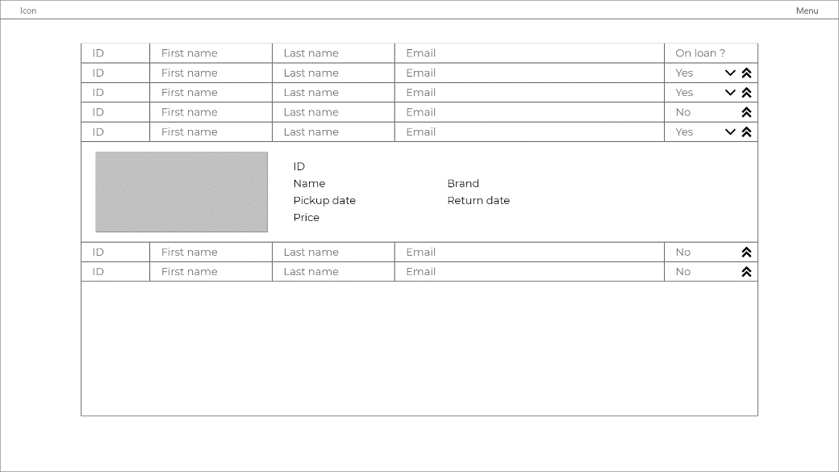

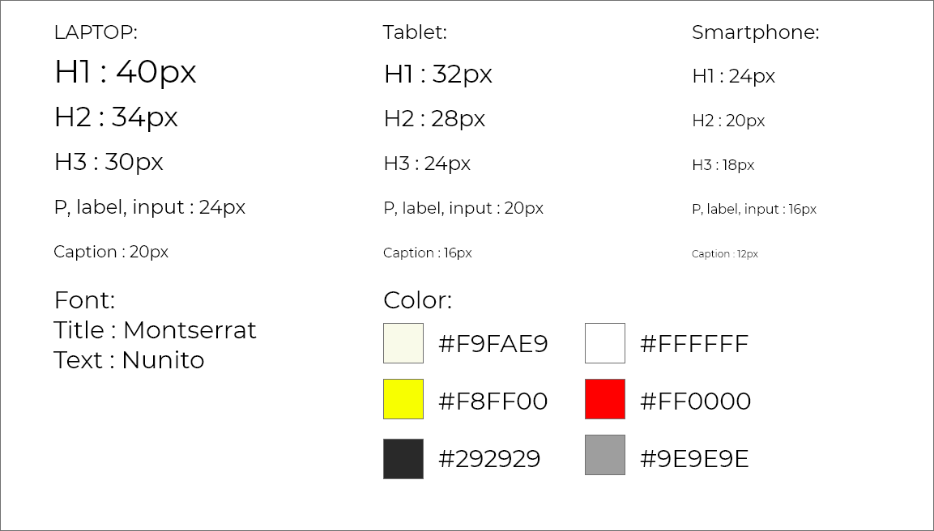

4) Implementation

5) User guide

A) Customer

Ajouter suppression booking

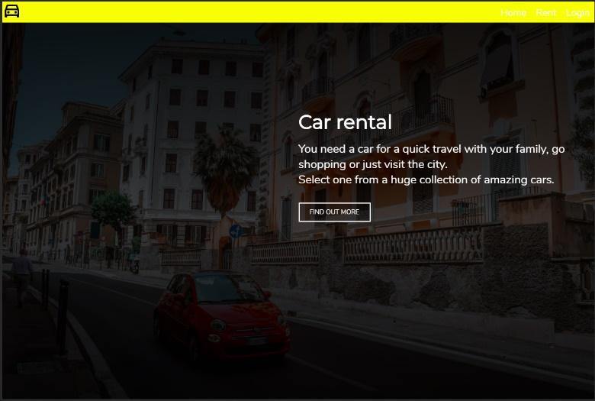
When you first arrive on the website, you will arrive on the main page. This main page let you scroll through the different categories of rental the website proposes. Car for a quick trip or longer one, special car for special events like a gleaming Ferrari or a London taxi cab, or trucks if you go in a new city with all your stuff.

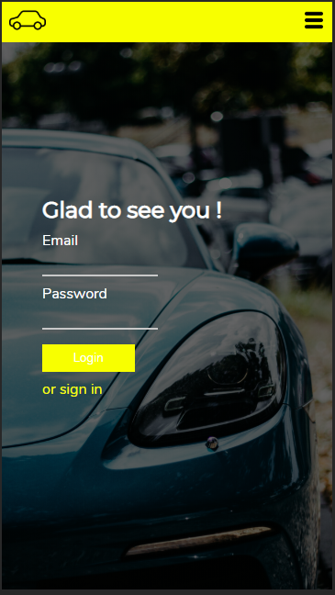
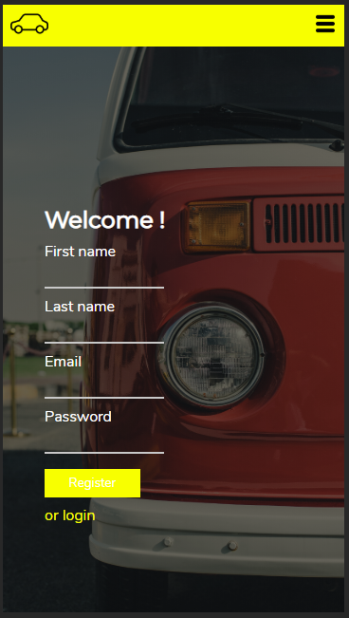
The first thing to do if you want to book any car of the catalog is to login by clicking on the button in the navbar. If you have not an account yet. You can register by filling the register form. You only need to provide your first name, your last name, an email address and a password.
When your account has been created, you can now login and start to rent cars.

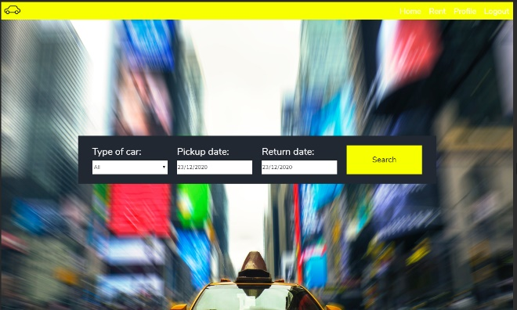
This is the first step to book any kind of car. Choosing the type of car you want. The pickup date, the date you will collect the car at the agency, and the return date, the day you will return the car. Note that you cannot book a car for only half a day (pickup the morning, return the evening). You can only book for one day minimum.
You have access to this menu by clicking on the rent button in the navbar.

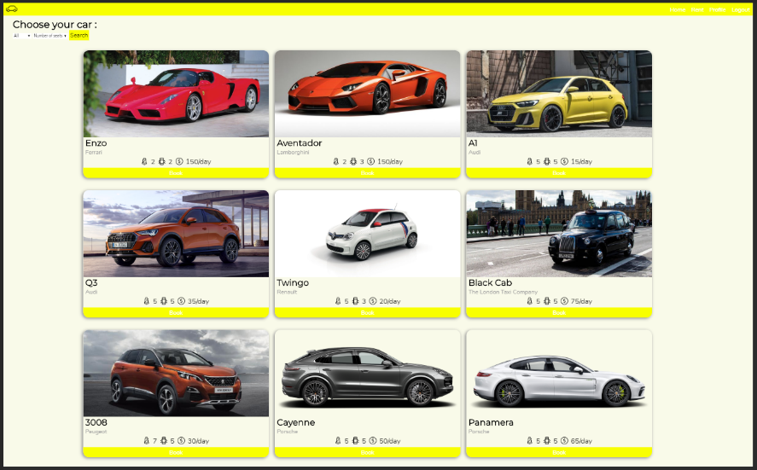
Once it is done, you can not see all the car in the catalog that are available for the period of time that you want. For each car, you have the following information. The name, the brand, how many seats, how many doors and the price per day of location. Moreover, you see a photo the car. If you want to change the pickup and return date. You must go to the previous page.
Last, you can filter the car by type and number of seats by selecting the filter you want to apply and relaunch the research in the top left corner.
When you have found the car of your dream, you only have to click on “Book” under the car to access to the recap of your booking.

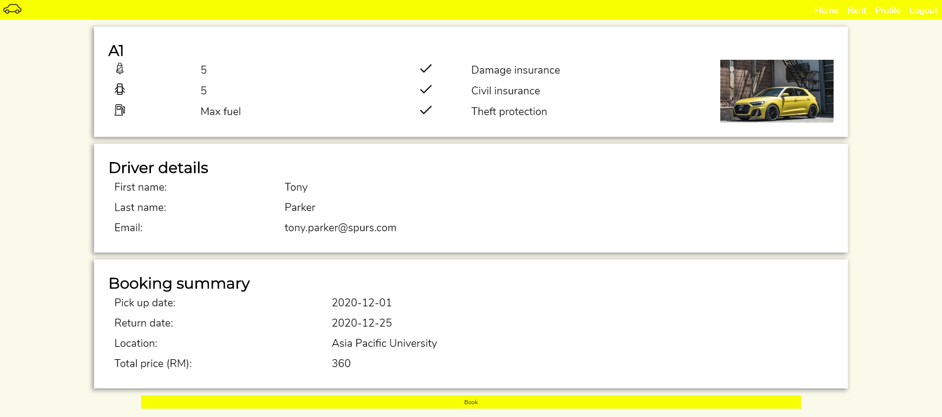
This page will recap all the information you have entered to book the car.
The first part recaps the details of the car, its name, number of seats, number of doors. All booking includes fuel, insurances and theft protection.
The second part will recap your personal information, your first name, last name and email address.
The third and last part will tell you when the pickup date and return date are, where you must go the get it and the total price you will have to pay. If all is ok, you only have to click on “Book” to confirm. You will be redirect to the main page.
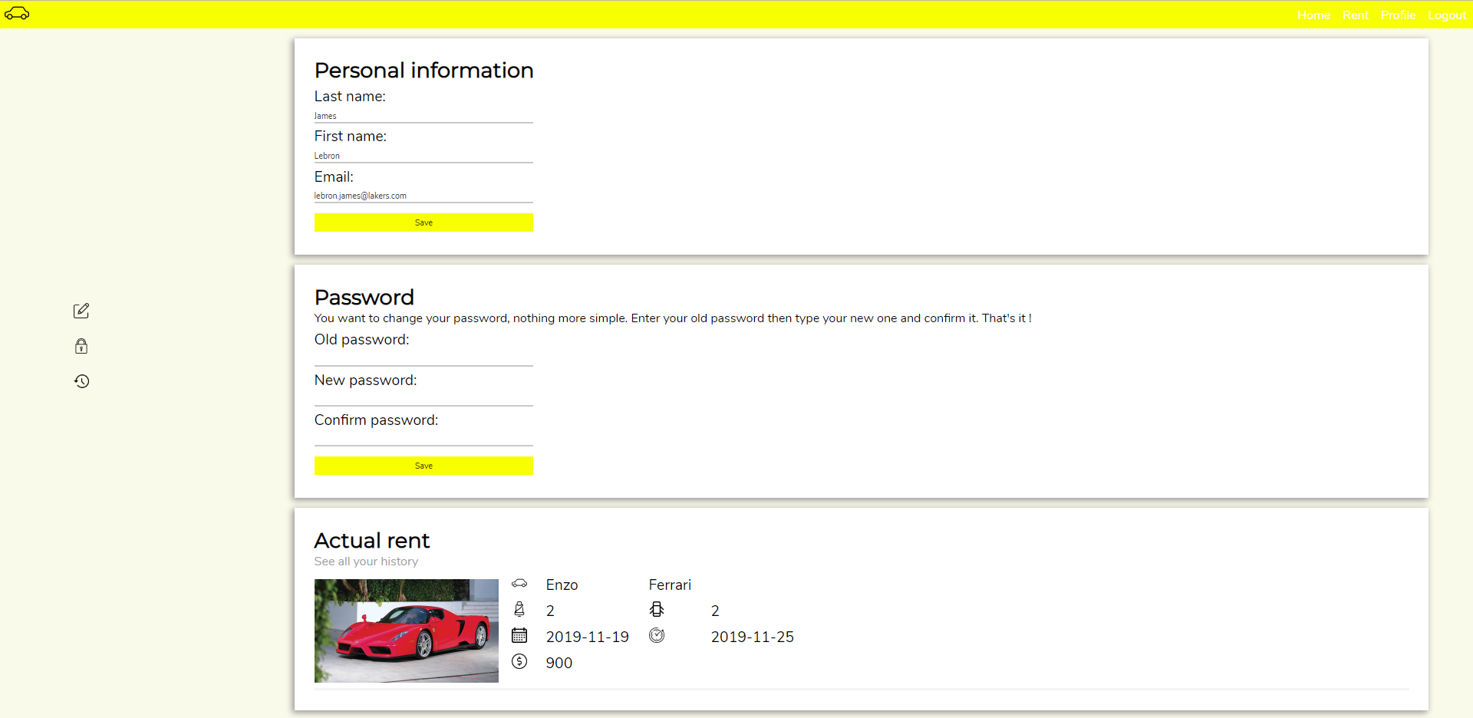
Also, you can consult your profile and booking history by clicking on the profile button.
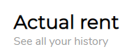
You will be able to edit your personal information like your first name, last name or email as well as your password. To modify it, you must type your previous password, find a new one and confirm it. Do not forget to save otherwise modification will not be saved.
Moreover, you will see the information of your actual rent in the last part. You can also click on “See all your history” to see your previous, next and actual bookings.

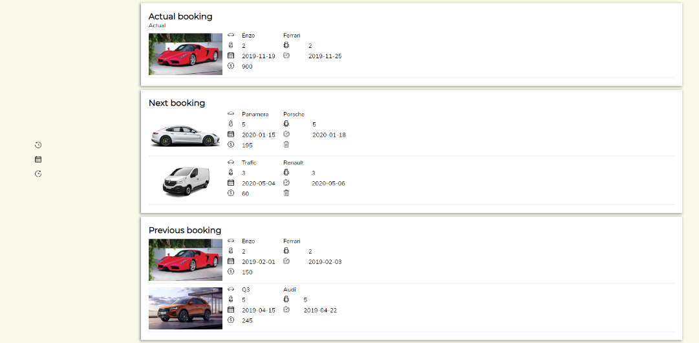
Your history is divided into three parts. Your actual booking, your next booking and your previous ones. On each line you will see all the information about the booking.
Note that if the list is to long you can click on one the three icon on the left of the screen to access to the part of the history that you want.


Previous
Next
Actual
In case, you change your mind and you do not want a car (among the incoming booking), you can delete a booking by hitting the bin icon on the right of the price.
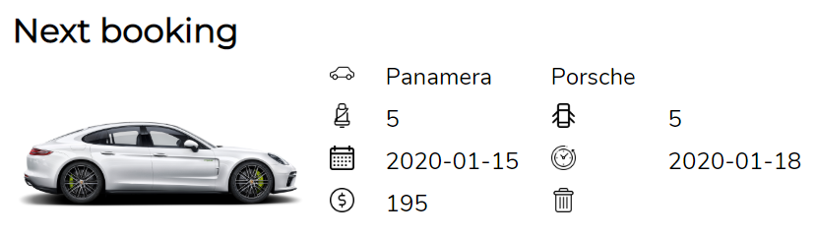
Last, when you want to exit the site, you can logout first or you will be automatically when you close the window.

B) Administrator

Administrator of the system will access to the admin section of the website as the customer access to the customer section. Namely by login with an administrator account. An administrator should create a customer account and be promote administrator by another one to has admin access. When you are login with an administrator account, you have access to management part of the site accessible in the navbar.
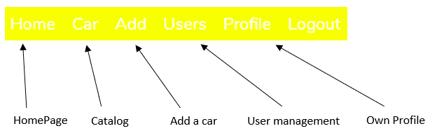
The first management is the “Car” page.
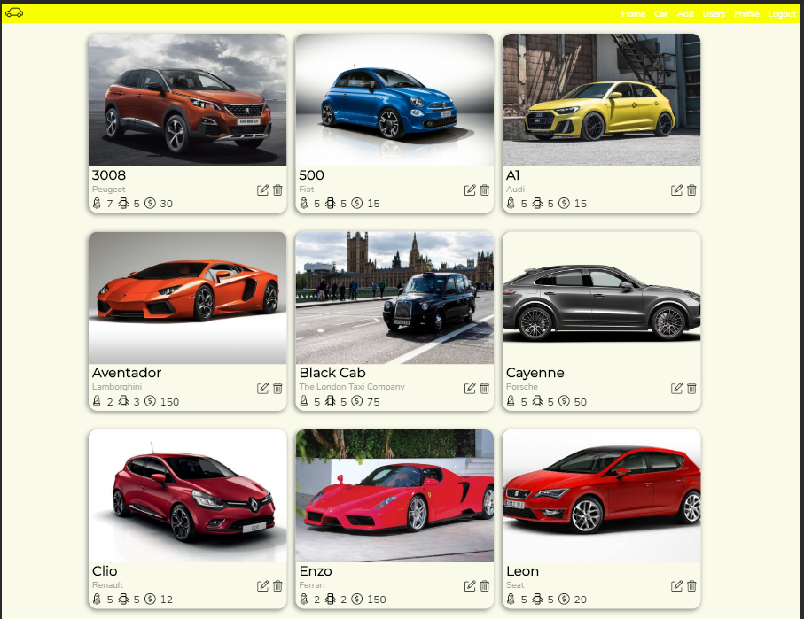


This page let you see all the catalog of car available order alphabetically. For each car, you can see the details of the car and do two actions, delete the car of the catalog (bin icon) or edit its characteristics (pen icon).
If you delete the car, all booking that has been done with this car will be deleted.
If you want to edit the car, you only need to click on the pen icon.

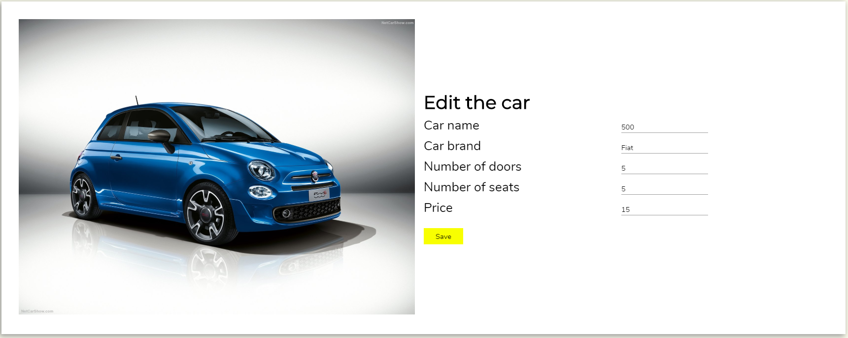
Once again, you will see all the information of the car but, this time, you will be able to modify all the information about the car except its photo. Always hit the save button, to save you modifications otherwise anything will be change.
Moreover, you can a car to this catalog by hitting “Add” in the navbar.
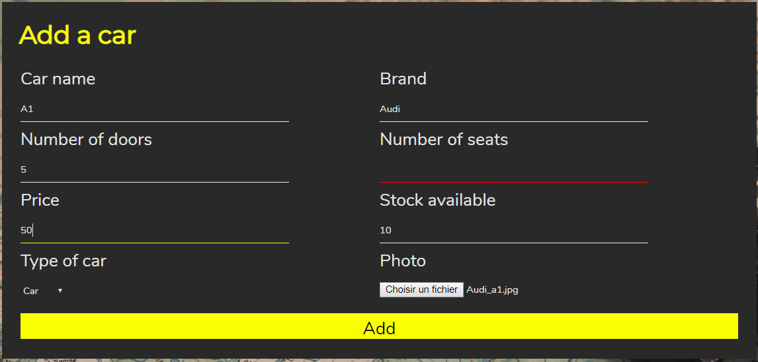
You must enter the name of the car, the brand, the number of doors, number of seats, the price per day, the stock available and a photo of the car. All fields must be completed. The selected field is yellow and the ones with incorrect value are in red. When you have finished, hit the yellow “Add” button.
Last exclusive administration page is the customer management page. You will be able to see all the customer registered in the system.
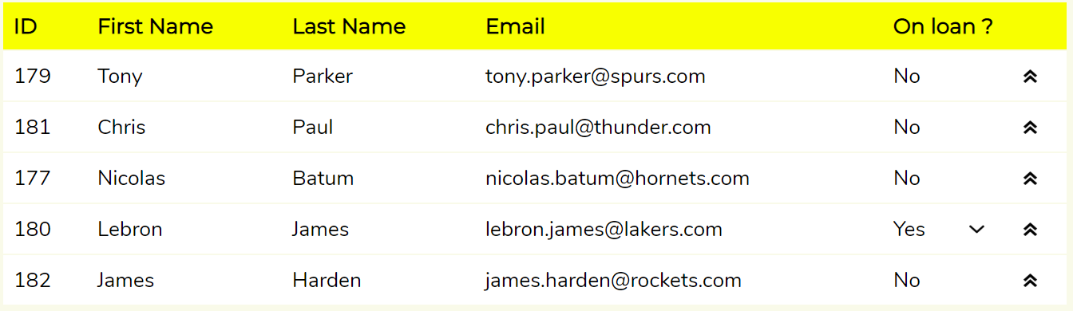
Information about customers will be display in a table. You will see the ID of the customer, its first name, last name and email address. If the customer currently has a rented car, a little down arrow will appear. If you click on the arrow the information the information about the booking will be displayed.
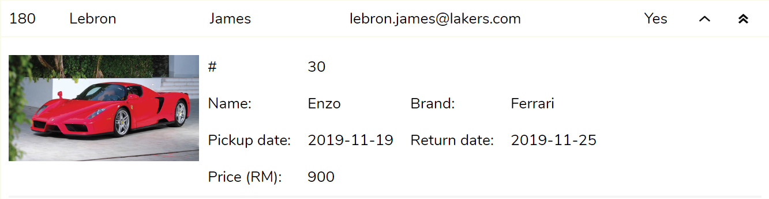
Last, the double up arrows at the end of the line will be used to promote a customer to administrator.
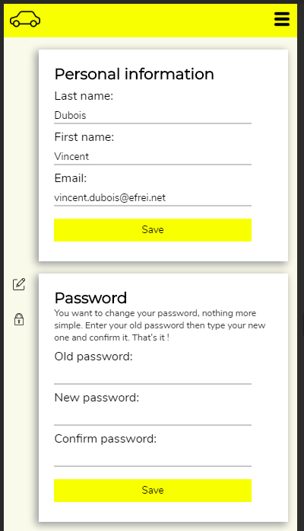
Finally, you will be able to edit your personal information in the “Profile” tab.
You will be able to edit your personal information like your first name, last name or email as well as your password. To modify it, you must type your previous password, find a new one and confirm it. Do not forget to save otherwise modification will not be saved.

6) References

