 | MSINGI TECHNOLOGIES LTD  Software • IT Systems


College/Institution Management System (CIMS)
One platform from application to graduation for NACTVET-registered institutions
Document 06: System Architecture
Architecture principles, technology stack, components, multi-tenancy, security, integrations, deployment, operations and key decisions.
Document | Document 06: System Architecture
Document Status | Version 3.5 — updated to the system as built after the October 2026 completion batches, for stakeholder review
Prepared For | Institutions registered by NACTVET to deliver NVA and NTA programmes, their governing boards and management
System Scope | Online Admission, Student Registry, Academic Structure, Teaching & Attendance, Assessment & Examination (NTA and NVA), Finance & Fees (GePG), Hostel, Industrial Practical Training, Clearance & Graduation, Student Portal, Reports and Integrations
Prepared By | Msingi Technologies Ltd
Prepared Date | October 2026
Classification | Confidential — For Stakeholder Review

Document Control
This section records the versions of this System Architecture, who prepared each one and what changed, so that readers know they are working from the current approved text.
Version | Date | Prepared By | Description
1.0 | October 2026 | Project Team | Initial planning version (generic institution).
2.0 | October 2026 | Msingi Technologies Ltd | Re-baselined for NACTVET-registered NVA/NTA institutions, each with its own online admission system; content expanded and aligned across the document suite.
3.0 | October 2026 | Msingi Technologies Ltd | Updated to the system as built (development build, October 2026): what is built, what is partly built and what remains, with corrected technology, data model and plan. The version 2.0 requirements stay the baseline.
3.1 | October 2026 | Msingi Technologies Ltd | Architecture as built (section 12) and the delivery note brought up to date after the completion batches (campuses and transfers; instalments, penalties and discounts; email; two-step sign-in, API clients and personal-data requests; data import and document uploads; configurable approval stages; alumni and tracer surveys; government adapters, deployment and load tests; the staff back-office in Kiswahili), including the frontend upgrade to Vite 8 and React Router 7. The version 2.0 design stays the target.
3.2 | October 2026 | Msingi Technologies Ltd | Section 12 updated after Batch 9 (go-live hardening): passwords of at least 10 characters; scheduled jobs run once across several instances; the web app split into bundles loaded on demand; WCAG accessibility fixes; end-to-end tests in three browsers and security scans (Trivy, OWASP ZAP baseline, npm audit) in CI.
3.3 | October 2026 | Msingi Technologies Ltd | Preamble added to every section; "Architecture As Built" renumbered from 13 to 12 (there was no section 12).
3.4 | October 2026 | Msingi Technologies Ltd | Section 12 updated after Batch 10: late-registration fee, application-fee reminders, waivers proposed when a status change takes effect, hostel bed changes with the fee difference, refunds of fees paid (hostel check-out and cancellation), and the entry-rule test tool. Abbreviations and glossary table added (section 1.2). Section 12.1: Spring Boot upgraded from 3.3 to 3.5.
3.5 | October 2026 | Msingi Technologies Ltd | Section 12 updated after Batch 11: timetabling. Teaching venues, the weekly class timetable with clash checks, the examination timetable with venues and invigilators, publishing to students (with SMS), and personal timetables for lecturers and students.

Review and Approval
The people listed below review this System Architecture and confirm, by signing, that it is accepted as the basis for the work that follows.
Role | Name | Signature | Date
Managing Director, Msingi Technologies Ltd
Project Manager, Msingi Technologies Ltd
Project Sponsor (Institution)
Principal / Head of Institution

Related Documents
CIMS is described in a set of eight documents, each written for a different purpose and audience. This table shows where each topic is covered, so a reader can go straight to the document that answers their question.
No. | Document | Purpose
01 | Concept Note | Why the system is needed, the vision, value to stakeholders and the delivery model.
02 | Business Requirements Document | Stakeholders, business requirements, business rules and success measures.
03 | System Requirements Specification | Functional and non-functional requirements, roles, use cases and traceability.
04 | Business Process Document | End-to-end institutional workflows with actors, controls and service levels.
05 | Database Design | Data model, table catalogue, constraints, multi-tenancy and data governance.
06 | System Architecture (this document) | Technology stack, components, security, integrations, deployment and operations.
07 | Development Plan and Cost Estimate | Release plan, team, effort-based budget, pricing model and risks.

Table of Contents

1. Introduction 5
1.1 Architecture principles 5
1.2 Abbreviations and glossary 5
2. System Context 8
3. Logical Architecture 8
3.1 Presentation tier 9
3.2 Application tier 9
3.3 Background processing 10
4. Technology Stack 10
5. Multi-Tenancy Architecture 11
6. Security Architecture 12
6.1 Identity and access 12
6.2 Data protection 12
6.3 Application and infrastructure security 12
6.4 Compliance 13
7. Integration Architecture 13
8. Deployment Architecture 14
8.1 Cloud service (Option A) 14
8.2 Dedicated installation (Option B) 16
8.3 Environments 16
8.4 Delivery pipeline 16
9. Performance, Scalability and Availability 17
10. Operations and Support 17
11. Architecture Decision Records (Summary) 17
12. Architecture As Built (October 2026) 18
12.1 Technology stack as built 18
12.2 Modules 20
12.3 Integration adapters 21
12.4 Path to the target architecture 21

If page numbers are not shown, right-click the table and choose Update Field.

1. Introduction
This section explains what this architecture document covers and the principles that guided the design. Architecture means how the system is put together and run; it decides how secure, reliable and affordable CIMS is.
This document describes how CIMS is built and run. It turns the non-functional requirements in Document 03 into concrete architecture choices and records the key decisions so that institutions, auditors and future developers understand why the system is built the way it is.

1.1 Architecture principles
The principles are the guiding choices behind every design decision, each with what it means for CIMS in practice.
Principle | What it means for CIMS
Modular monolith first | One deployable application with strictly separated modules. Simple to run and debug for a small team, and each module can later be extracted into a service if load or team size requires it.
Multi-tenant by design | Every request, query, file and message is tenant-aware; isolation is enforced at application and database level.
Configuration over customisation | Institution differences (regulations, fees, workflows, templates, branding) are configuration, so all institutions run the same code and receive the same upgrades.
Secure by default | Least privilege, encryption everywhere, MFA for privileged users, audited actions, OWASP ASVS Level 2.
Integration resilience | External systems will be slow or unavailable at times; CIMS queues, retries and keeps working.
Open standards and open source | No per-user licences; standard protocols (OIDC, REST, OpenAPI) avoid vendor lock-in.
Automate everything | Infrastructure as code, automated tests and deployments, monitoring and alerting.

As built: CIMS is a modular monolith (one Spring Boot application, modules as Java packages); every request, query and message is tenant-aware with row-level security in the database; institution differences are configuration (regulations, fees, templates wording, entry rules, clearance gates, thresholds); outside systems sit behind ports with simulated and live adapters. Section 12 records where the build differs from this design.

1.2 Abbreviations and glossary
This table explains the abbreviations and specialised terms used in this document, so that readers from any office can follow it. Only terms that appear in this document are listed.
Term | Meaning
ACSEE | Advanced Certificate of Secondary Education Examination (Form Six), results from NECTA.
Admission window | A period, for one academic year and intake, during which applicants can apply for the programmes offered.
API | Application Programming Interface: the way two systems exchange data automatically.
ASVS | Application Security Verification Standard (OWASP): a checklist of security requirements used for review.
AVN | Award Verification Number issued by NACTVET for NTA awards, used to verify prior qualifications.
CI / CD | Continuous integration / continuous delivery: every change is built and tested automatically, and released by an automated pipeline.
CIMS | College/Institution Management System, the system these documents describe.
Clearance gate | A fees rule that must be met before registration, examinations, results, hostel or graduation.
Control number | The GePG number used to pay an invoice through a bank or mobile money.
CSEE | Certificate of Secondary Education Examination (Form Four), results from NECTA.
CSV | Comma-separated values: a plain spreadsheet file that most systems can import and export.
DAST | Dynamic application security testing: scanning the running system for weaknesses.
Docker / Kubernetes | Software that packages and runs CIMS and its parts on servers (Docker), and runs them across many servers (Kubernetes).
DR | Disaster recovery: restoring the service at another site after a major failure.
EAT | East Africa Time (UTC+3), the time zone CIMS uses.
ERP | Enterprise resource planning system, for example the government MUSE financial system.
Flyway | The tool that applies database migrations in order when CIMS starts.
GePG | Government electronic Payment Gateway: issues control numbers and confirms payments for public institutions.
GFS code | Government Finance Statistics code: the revenue classification of a fee item used by GePG and MUSE.
GPA | Grade point average for a semester or year, computed under the regulations of the award level.
Hand-over | Registry turning an accepted applicant into a student: record, registration number and portal sign-in.
HESLB | Higher Education Students' Loans Board: funds eligible students in eligible programmes.
HSTS | HTTP Strict Transport Security: tells browsers to use only encrypted (HTTPS) connections.
ID card | Student identity card, printed from CIMS with a verification code.
Invigilator | A member of staff who supervises candidates during an examination paper.
IPT | Industrial practical training: assessed field attachment in a workplace.
JSON / JSONB | JavaScript Object Notation: a text format for structured data; JSONB is PostgreSQL's stored form of it.
JWT | JSON Web Token: the signed sign-in token CIMS issues.
Keycloak | An open-source sign-in server that could provide single sign-on across systems in future.
MFA | Multi-factor authentication: signing in with a password and a second proof, such as a code from an authenticator app (two-step sign-in).
Migration | A numbered script that changes the database structure; applied in order by Flyway and never edited once applied.
MUSE | The government financial management (ERP) system to which public institutions post revenue.
NACTVET | National Council for Technical and Vocational Education and Training: the regulator of TVET institutions and awards.
NECTA | National Examinations Council of Tanzania: source of CSEE and ACSEE results.
NIDA / NIN | National Identification Authority / National Identification Number.
NOAS | NACTE/NACTVET Online Admission System, the earlier central admission system.
NTA | National Technical Award, Levels 4–8 (Basic Technician Certificate to Bachelor Degree).
NVA | National Vocational Award, Levels I–III (certificates of competence, awarded through VETA).
OIDC / SSO | OpenID Connect / single sign-on: one sign-in shared by several systems.
OTP | One-time password: a short code sent by SMS to verify a phone number.
OWASP | Open Worldwide Application Security Project, which publishes security standards such as the Top 10 and ASVS.
Payment reference | The number a private institution's payer quotes when paying into its own bank or mobile-money account.
PDF | Portable Document Format, used for letters, statements, certificates and reports.
PDPA | Personal Data Protection Act, 2022 (Tanzania).
PostgreSQL | The open-source database CIMS stores its data in.
PWA | Progressive web app: a website that can be installed on a phone like an app.
QR code | A square barcode printed on documents; scanning it opens the verification page.
REST | The common style of web API that CIMS uses to exchange data with other systems.
RLS | Row-level security: the database rule that each institution sees only its own rows.
RPO / RTO | Recovery point objective (how much data may be lost) / recovery time objective (how long a recovery may take).
Segregation of duties | The rule that the person who prepares or requests something cannot also approve it.
Simulator | A stand-in for an outside system (for example NACTVET or GePG) used for testing until the live interface is available.
SMS | Short message service: text messages to mobile phones.
SMTP | Simple Mail Transfer Protocol, used to send email.
TAMISEMI | President's Office – Regional Administration and Local Government, which selects some students centrally.
Tenant | One institution's isolated space within the shared CIMS platform, with its own branding, users, data and settings.
TLS | Transport Layer Security: the encryption behind HTTPS.
UAT | User acceptance testing: the institution tests the system before accepting it.
UI | User interface: the screens people use.
Waiver | An approved reduction of what a student owes on an invoice.
WAL | Write-ahead log: PostgreSQL's change log, archived for point-in-time recovery.
WCAG | Web Content Accessibility Guidelines; CIMS targets version 2.1, levels A and AA.
XML | Extensible Markup Language, the message format GePG uses.
ZAP | OWASP Zed Attack Proxy: the tool that scans the running web app in continuous integration.

2. System Context
The system context shows CIMS as a single box with the people who use it and the outside systems it exchanges data with. It sets the boundary of what CIMS is responsible for.
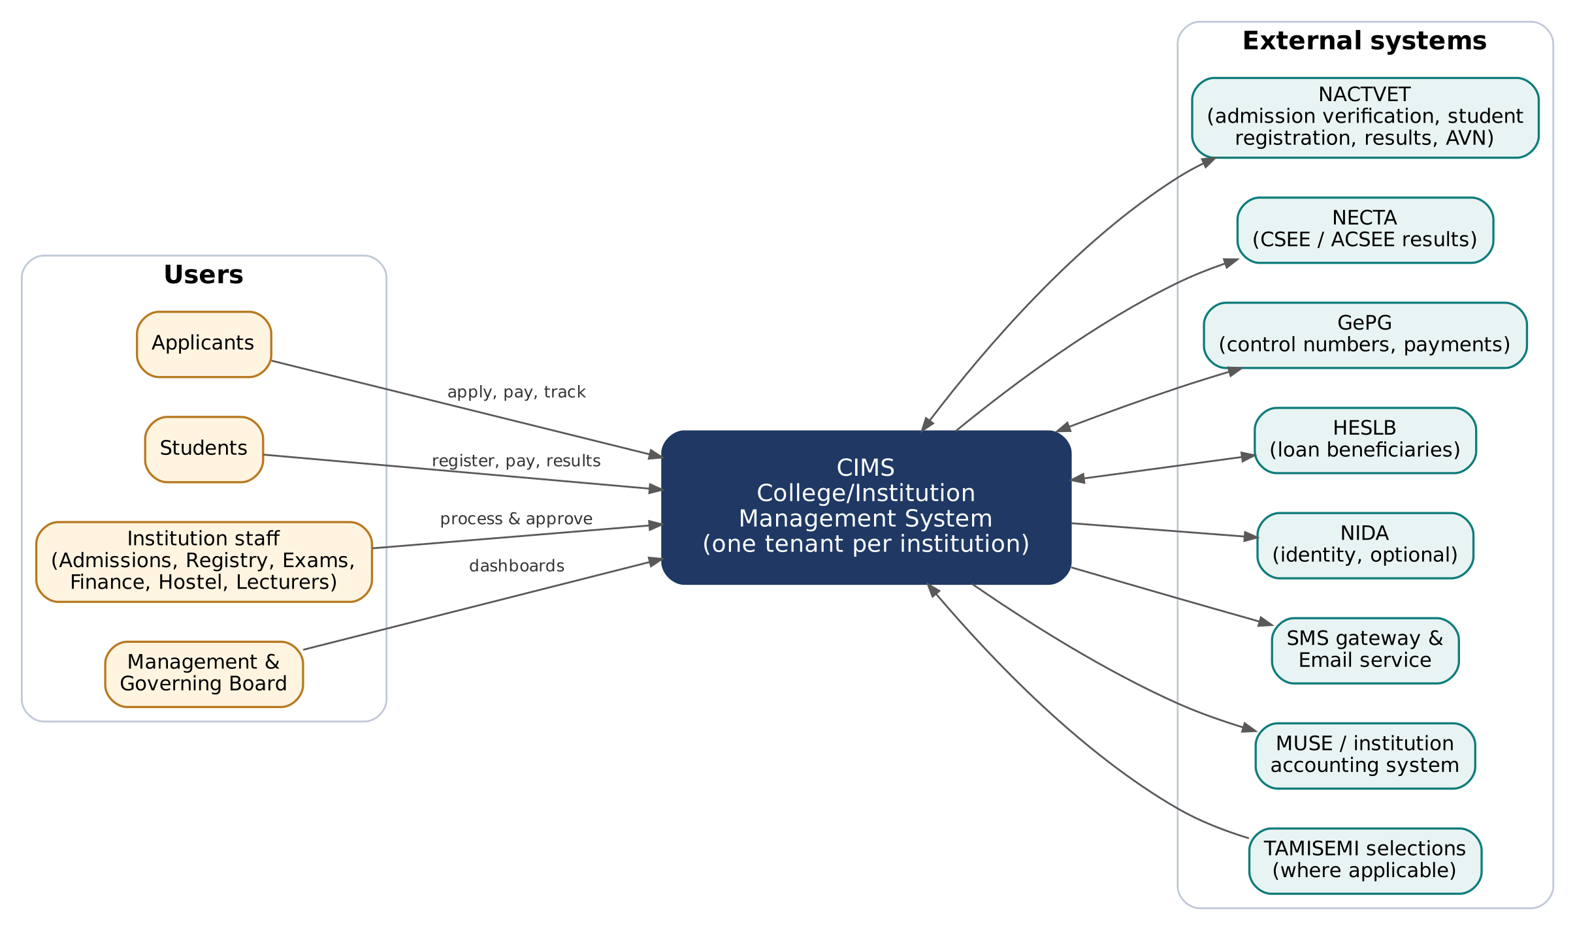
Figure 1: System context
Applicants, students, staff and management use CIMS through web browsers on phones and computers. CIMS exchanges data with NACTVET, NECTA, GePG, HESLB, NIDA, SMS and email gateways, the institution's accounting system (e.g. MUSE) and, where applicable, TAMISEMI selection data.

3. Logical Architecture
The logical architecture opens the box: it shows the main parts of CIMS (the portals people use, the application that applies the rules, and background processing) and how they work together.
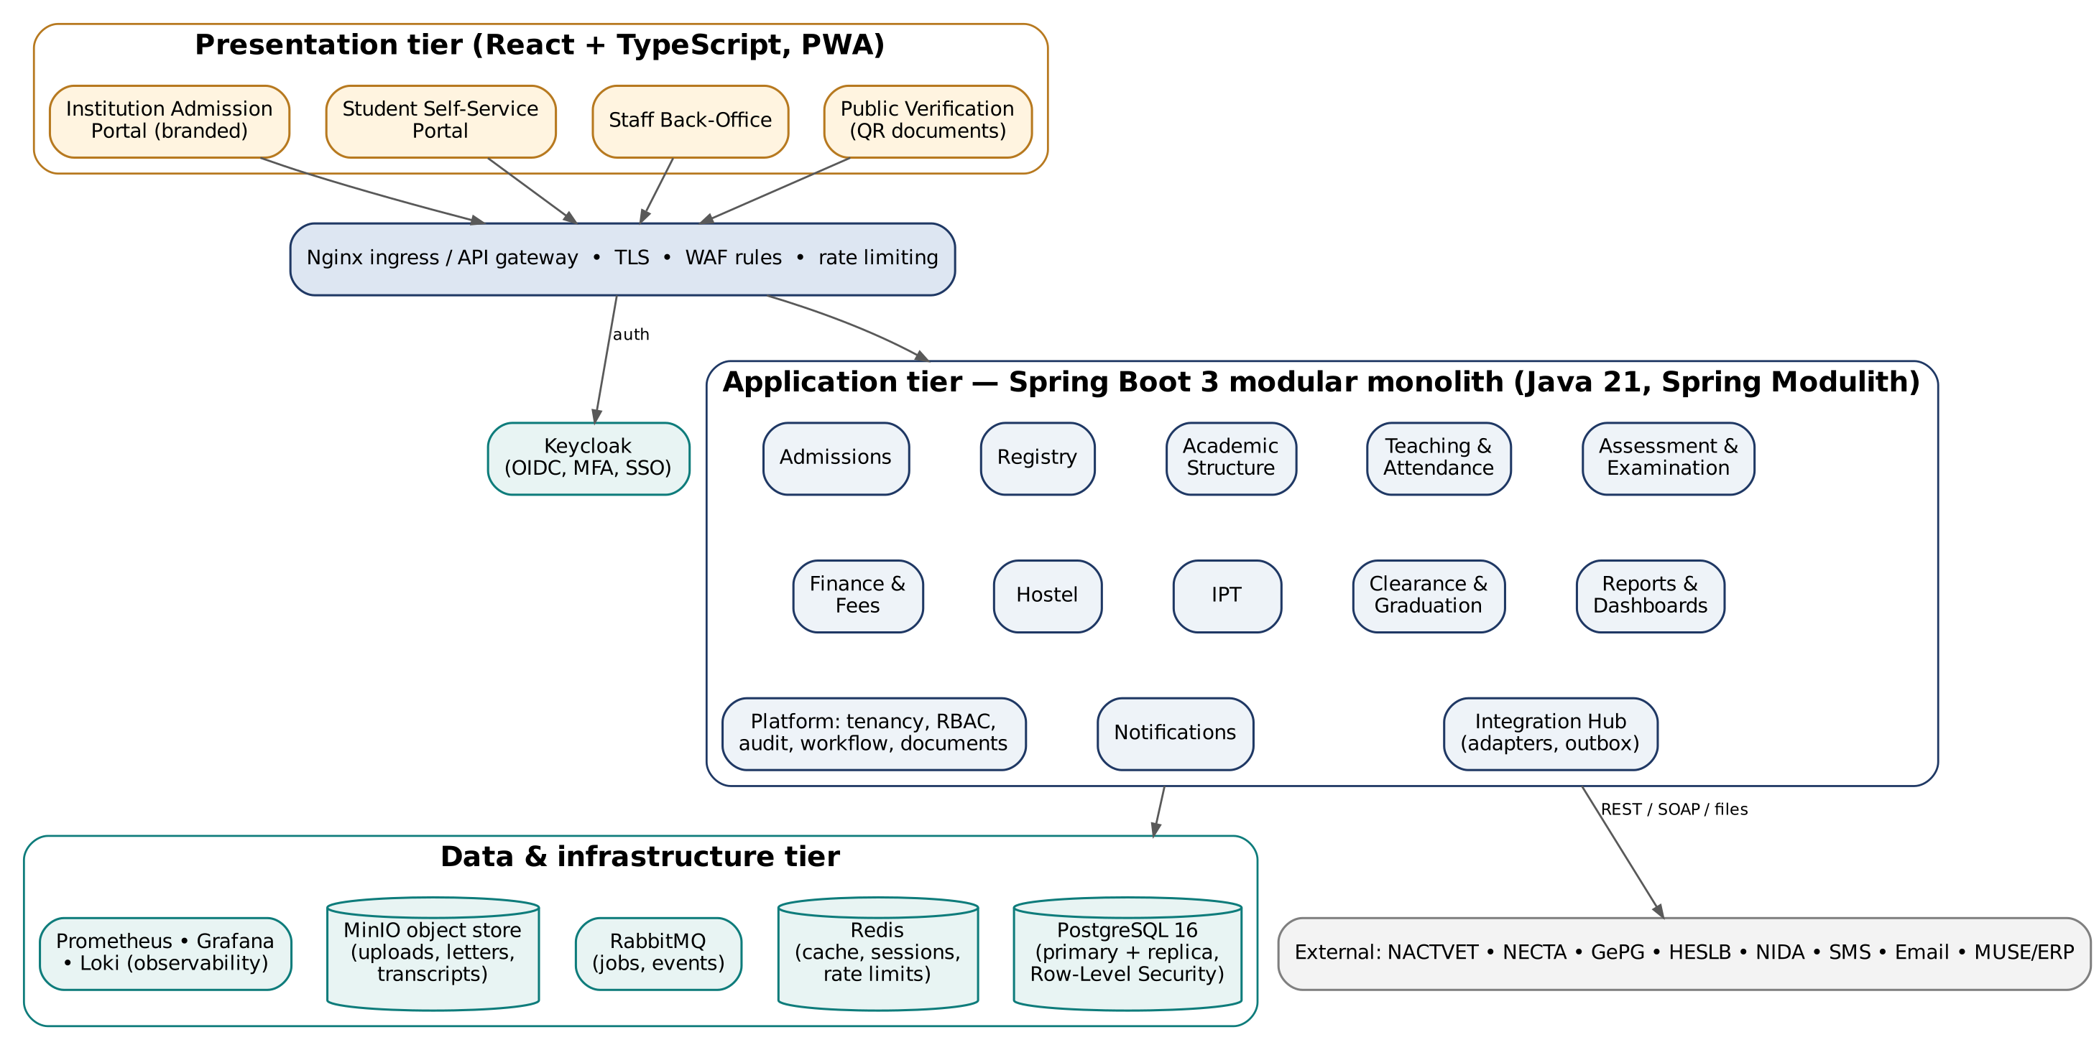
Figure 2: Logical architecture (containers and modules)

3.1 Presentation tier
The presentation tier is what people see: the admission portal, the student portal and the staff back-office, all used in a web browser on a phone or computer.
- Admission Portal: public, institution-branded single-page application; optimised for low bandwidth (small bundles, image compression, progressive loading).
- Student Portal: installable progressive web app (PWA) for phones, with offline caching of timetable, results and receipts.
- Staff Back-Office: role-based workspace with data grids, bulk actions, approvals inbox and dashboards.
- Public Verification: lightweight page for QR verification of letters, transcripts and certificates.

3.2 Application tier
The application tier is where the institution's rules are applied and data is saved. This sub-section explains how it is organised into separate modules.
A Spring Boot 3 application on Java 21 organised with Spring Modulith. Each module owns its schema, exposes a public API (Java interfaces and REST endpoints) and communicates with other modules through published domain events — for example, OfferAccepted (Admissions) triggers student creation (Registry) and first-year invoicing (Finance). Module boundaries are verified by automated architecture tests.
Module | Responsibility | Key events published
Admissions | Windows, applications, eligibility, selection, NACTVET verification, offers. | ApplicationSubmitted, ApplicantSelected, OfferAccepted
Registry | Students, registration, status, transfers. | StudentCreated, SemesterRegistered, StatusChanged
Academic Structure | Programmes, curricula, modules, calendar, regulations. | CurriculumPublished
Teaching & Attendance | Offerings, allocations, timetables, attendance. | AttendanceThresholdBreached
Assessment & Examination | Marks, approvals, GPA, progression, publication. | ResultsConfirmed, ResultsPublished
Finance & Fees | Fees, invoices, GePG, payments, reconciliation, clearance. | InvoiceIssued, PaymentReceived, ClearanceChanged
Hostel | Inventory, applications, allocation. | BedAllocated, AllocationReleased
IPT | Placements, logbooks, assessment. | IptResultSubmitted
Clearance & Graduation | Clearance, graduands, documents, verification. | StudentCleared, DocumentIssued
Reports & Dashboards | Report catalogue, dashboards, scheduled reports. | —
Notifications | SMS, email, in-app; templates; delivery tracking. | MessageDelivered
Integration Hub | Adapters for external systems; outbox; message log. | ExternalCallFailed
Platform | Tenancy, users, RBAC, workflow engine, documents, audit. | WorkflowCompleted

3.3 Background processing
Some work is too long or too large to do while a user waits, such as bulk invoicing or report generation. This sub-section explains how that work runs in the background.
Long or bulk work runs in worker processes fed by RabbitMQ: bulk invoicing, GPA computation, report generation, bulk SMS, NACTVET file generation and integration retries. Users see job progress and receive a notification when the job completes. Scheduled jobs (reconciliation, retention, reminders) use a cluster-safe scheduler (ShedLock).
As built: there is no separate worker or message broker yet. Bulk work (billing runs, result computation, bulk SMS, file generation) runs in the request or in seven scheduled jobs inside the application, and SMS leave through a database outbox. This is sufficient for pilot volumes; workers and a broker are added when load requires (section 12.4).

4. Technology Stack
This section lists the technologies chosen for each layer of CIMS and the reason for each choice, favouring proven, open-source tools with skills available in Tanzania.
Layer | Technology | Rationale
Frontend | React 18, TypeScript, Vite, MUI, React Query, i18next (English/Kiswahili) | Mature ecosystem, strong typing, PWA support, wide local skills base.
Backend | Java 21 LTS, Spring Boot 3.x, Spring Modulith, Spring Security, Spring Data JPA | Long-term support, enterprise-grade, excellent for transactional systems; team experience on national systems.
Database | PostgreSQL 16 with Row-Level Security, pg_trgm; Flyway migrations | Robust, open source, strong integrity and JSONB features.
Identity | Keycloak (OpenID Connect, MFA via TOTP/SMS OTP) | Standards-based SSO, per-institution branded login, MFA and password policies out of the box.
Caching | Redis | Sessions, rate limiting, reference-data cache, OTP storage.
Messaging | RabbitMQ | Reliable queues for jobs, notifications and integrations.
File storage | MinIO (S3-compatible), server-side encryption | Documents, uploads, generated PDFs; portable to any S3 store.
Documents and reports | JasperReports (PDF), Apache POI (Excel), ZXing (QR codes) | Pixel-accurate letters, transcripts and certificates.
Rules | JSON rule documents evaluated by an internal rules engine (JSON Schema validated) | Entry requirements and regulations configurable per institution.
Resilience | Resilience4j (retries, circuit breakers, timeouts); transactional outbox | Stable behaviour when external systems fail.
API | REST/JSON, OpenAPI 3 (springdoc), OAuth2 client credentials for integrations | Self-documenting, standard integrations.
Containers and orchestration | Docker; Kubernetes (k3s/RKE2) for cloud; Docker Compose for small dedicated installs | Portable, scalable, repeatable deployments.
Ingress and TLS | Nginx Ingress, cert-manager (automatic certificates per institution domain) | Custom domains per tenant without manual certificate work.
Observability | Prometheus, Grafana, Loki, OpenTelemetry tracing, Alertmanager | Metrics, logs, traces and alerts in one place.
CI/CD and quality | GitLab CI or GitHub Actions; SonarQube; OWASP Dependency-Check; Trivy image scanning; OWASP ZAP | Automated build, test, scan and deploy.
Testing | JUnit 5, Testcontainers, Playwright (end-to-end), k6 (load) | Realistic tests against real PostgreSQL, RabbitMQ and browsers.

5. Multi-Tenancy Architecture
Many institutions share one platform. This section explains how the architecture identifies each institution and keeps its data, users and settings separate from all others.
Concern | Design
Tenant resolution | From host name (e.g. apply.college.ac.tz, sis.college.ac.tz) mapped in tenant_domains; cross-checked with the tenant claim in the user token.
Identity | One Keycloak realm per institution, giving each its own branded login page, password policy and user base; platform staff use a separate administrative realm.
Data | Shared schema with tenant_id and PostgreSQL Row-Level Security (Document 05, section 3).
Files | Object keys prefixed by tenant; bucket policies deny cross-tenant access.
Messages and jobs | Every message carries tenant_id; workers set tenant context before processing.
Configuration | Branding, regulations, fees, workflows, templates and integration credentials stored per tenant; secrets in a vault.
Noisy neighbours | Per-tenant rate limits and job quotas; large tenants can be given dedicated worker pools or databases.
Onboarding | Automated tenant provisioning: realm, domains, certificates, default roles and templates in under one hour.

As built: the tenant comes from the host name (tenant_domains) or, for the single-page application, the X-Tenant header; it must match the tenant in the user's token. One token issuer serves all institutions instead of a Keycloak realm per institution. Data isolation is by forced row-level security; there is no file store to partition. Onboarding is one step in the platform console (institution, addresses, programmes from the NACTVET catalogue, first administrator).

6. Security Architecture
Institutions entrust CIMS with personal, academic and financial records. This section describes how the system protects them, from sign-in to storage, and how it meets the law.

6.1 Identity and access
This sub-section explains how users prove who they are and how the system decides what each person may see and do.
- OpenID Connect authorisation code flow with PKCE for all web clients; short-lived access tokens (5 minutes) with refresh tokens.
- MFA mandatory for privileged roles (administrators, examinations, finance approvers, registry); optional for others.
- Role-based access control with data scopes (campus, department, programme, offering, hostel) checked on every request; attribute checks for ownership (students see only their own data).
- Segregation of duties enforced by workflow rules (e.g. a lecturer cannot approve their own marks).
- Quarterly user access review report for each institution.

6.2 Data protection
This sub-section explains how data is protected in transit and at rest, including encryption of the most sensitive fields.
- TLS 1.2+ externally and between internal services; HSTS on all portals.
- Encryption at rest for database volumes, backups and object storage; application-level encryption for restricted fields (e.g. NIN).
- Secrets (database passwords, GePG certificates, API keys) held in HashiCorp Vault or Kubernetes sealed secrets; never in code.
- Personal data masked in logs; exports of personal data audited.

6.3 Application and infrastructure security
This sub-section explains how the software and servers are protected against attack, from secure coding practice to monitoring.
- Secure development lifecycle: threat modelling per module, code review, static analysis, dependency and container scanning in CI.
- Protection against OWASP Top 10: parameterised queries, output encoding, CSRF protection, strict content security policy, file upload scanning (ClamAV) and type checks.
- Rate limiting and bot protection on public endpoints (application, OTP, verification).
- Network segmentation: only the ingress is public; databases and queues on private networks; administrative access via VPN and bastion with MFA.
- Independent penetration test before each major release; vulnerability remediation SLAs (critical 72 hours, high 14 days).
- Security event logging and alerting (failed logins, privilege changes, unusual exports).

6.4 Compliance
This sub-section shows how CIMS meets each legal and policy framework that applies to it, such as the Personal Data Protection Act.
Framework | How CIMS complies
Personal Data Protection Act, 2022 | Privacy by design, consent, retention, data subject requests, processor agreements, breach response procedure, hosting in Tanzania.
e-Government Authority standards (public institutions) | Alignment with e-GA security and system development standards; GovESB integration where mandated; hosting at the government data centre on request.
OWASP ASVS Level 2 | Verification checklist used in design reviews and penetration tests.
Public finance controls | GePG integration per specification; immutable financial records; reconciliation and audit reports.

As built (security): role and scope checks on every request; segregation of duties in the software; account lock-out after 5 failed sign-ins; strong password rules; forced change of temporary passwords; sessions ended when roles change or an account is disabled; rate limits on public look-ups, OTP and verification; HSTS and a strict content security policy; personal data masked in logs and exports audited; a start-up guard that refuses a database role able to bypass row-level security. Not yet in place: MFA, secrets vault, file upload scanning (there are no uploads besides images checked by content), penetration test, network segmentation (comes with hosting).

7. Integration Architecture
CIMS exchanges data with NACTVET, NECTA, GePG, HESLB and other systems. This section explains how those connections are built so that a failure in an outside system never loses data or blocks the institution's work.
All external communication goes through the Integration Hub module. Each external system has an adapter that hides protocol details from business modules. Business modules write an event to the transactional outbox in the same database transaction as the business change; a relay publishes it to RabbitMQ and the adapter calls the external system with retries and circuit breakers. Every request and response is logged with a correlation ID.
System | Mode | Data exchanged | Resilience / fallback
NECTA | REST API (synchronous with timeout) | CSEE/ACSEE results by index number. | Cache results; background retry; manual verification path.
NACTVET | API where provided; otherwise generated files in NACTVET templates + outcome import | Admission verification, student registration, results, graduands, AVN verification. | Pre-validation before submission; versioned templates; outcome reconciliation.
GePG | Signed XML/JSON messages over HTTPS per GePG specification | Bills, control numbers, payment notifications, reconciliation. | Idempotent notification handling; daily reconciliation catches missed callbacks.
HESLB | File/API as provided | Beneficiary lists, disbursements, registration confirmation. | Import validation and exception reports.
NIDA | API via approved channel | Identity verification (optional). | Non-blocking; manual verification.
SMS gateway | REST API (local aggregators) | Outbound SMS, delivery reports. | Failover to secondary provider.
Email | SMTP / API | Notifications, letters. | Queue and retry.
MUSE / ERP | File export or API | Summarised fee postings. | Export batches with control totals.
GovESB | Per e-GA specification | Government-to-government exchanges where mandated. | Adapter isolates changes.

As built: each external system is a Java port with a simulated and a live adapter chosen by configuration; every call is recorded (operation, outcome, duration, reference only) in the integration call log shown in the platform console and to each institution's Auditor. Section 12.3 lists the adapters.

8. Deployment Architecture
This section explains where and how CIMS runs: as a shared cloud service or installed for one institution, the environments used from development to production, and how new versions are delivered.

8.1 Cloud service (Option A)
This sub-section describes the shared cloud service hosted in Tanzania, the default way institutions use CIMS.
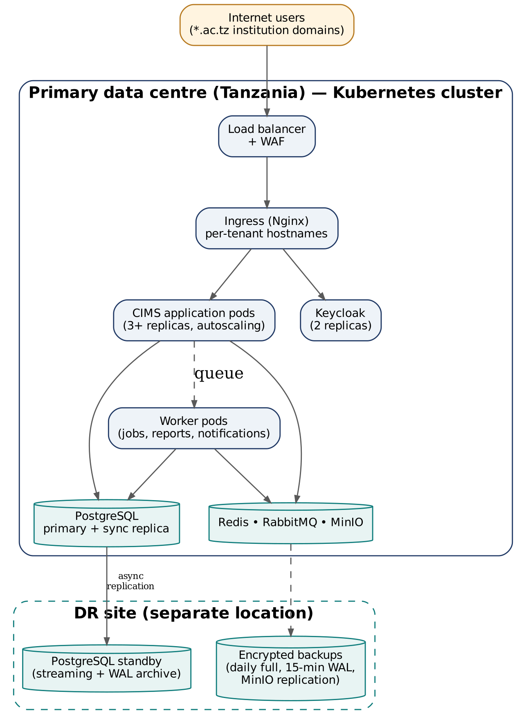
Figure 3: Cloud deployment topology
The production platform runs in a Tier III data centre in Tanzania on a Kubernetes cluster with at least three worker nodes. Application and worker pods scale horizontally; PostgreSQL runs as a primary with a synchronous replica, and a standby at a separate disaster-recovery site receives streamed changes and archived WAL.
Component (initial production) | Sizing | Notes
Kubernetes worker nodes | 3 × 8 vCPU / 32 GB RAM | Application, workers, Keycloak, Redis, RabbitMQ.
PostgreSQL | 2 × 8 vCPU / 32 GB RAM, 1 TB NVMe | Primary + synchronous replica.
Object storage | 4 TB usable (MinIO, erasure coded) | Grows with tenants.
DR site | 1 × DB standby, backup storage 6 TB | Warm standby.
Monitoring | 1 × 4 vCPU / 16 GB RAM | Prometheus, Grafana, Loki.

This initial footprint serves approximately 30–50 institutions; capacity is added node by node as tenants grow.

8.2 Dedicated installation (Option B)
Some institutions may need CIMS on their own servers. This sub-section gives the minimum infrastructure for such an installation.
Profile | Minimum infrastructure
Small (up to 2,000 students) | 2 VMs: application (8 vCPU / 16 GB) and database (4 vCPU / 16 GB, 500 GB SSD); Docker Compose; off-site backup.
Large (above 2,000 students) | 4–5 VMs: 2 application, 1 database primary + 1 replica, 1 monitoring/backup; or a small Kubernetes cluster.

8.3 Environments
Software passes through several environments before it reaches institutions. The table explains the purpose of each.
Environment | Purpose
Development | Developer integration; ephemeral preview environments per merge request.
Test (SIT) | System integration testing with simulators for GePG, NECTA and NACTVET.
Staging / UAT | Production-like; user acceptance testing with external test environments; migration rehearsals.
Production | Live service.
Disaster recovery | Standby at separate site; tested twice a year.

8.4 Delivery pipeline
The delivery pipeline is the automated sequence of checks every change passes before release. It keeps quality high and releases predictable.
- Commit → build, unit tests, static analysis (SonarQube), dependency scan.
- Integration tests with Testcontainers; architecture (module boundary) tests; tenant isolation tests.
- Container image build, vulnerability scan (Trivy), signing.
- Automatic deploy to Test; end-to-end tests (Playwright); DAST scan (OWASP ZAP).
- Approved promotion to Staging; performance tests (k6) before releases.
- Production deploy by rolling update (zero downtime); database migrations backward compatible; automatic rollback on failed health checks.
As built: GitHub Actions runs the backend tests against PostgreSQL and the frontend type check, unit tests and build on every change, with a separate load-test workflow (k6). A production Docker Compose stack runs PostgreSQL with WAL archiving, the backend, and the frontend behind an Nginx TLS proxy, with an encrypted backup service (daily backups kept 35 days, monthly for 12 months) whose restore is tested; the backend refuses to start in production with development settings. Kubernetes, image signing and scanning, and the test and staging environments are set up with production hosting.

9. Performance, Scalability and Availability
This section explains how CIMS stays fast during peaks such as application deadlines and results publication, how it grows with more institutions, and how it stays available.
Concern | Approach
Peak events | Application deadlines and results publication can multiply traffic many times. Mitigation: horizontal autoscaling, Redis caching of read-heavy data (programme catalogue, published results), CDN/static caching of portal assets, queue-based processing of submissions and notifications, and a load test at 2× expected peak before each admission window.
Bulk processing | Batch jobs chunked and parallelised in workers; progress tracking; no long-running HTTP requests.
Database | Connection pooling (HikariCP/PgBouncer); read replica for reports; partitioned large tables; query performance budgets in CI.
High availability | No single point of failure in production: multiple application replicas across nodes, database replication with automated failover (Patroni), redundant ingress.
Disaster recovery | RPO 15 minutes, RTO 4 hours; documented and rehearsed runbooks.
Maintenance | Rolling upgrades without downtime; announced maintenance windows outside 07:00–22:00 EAT for infrastructure work.

10. Operations and Support
This section describes how the running system is watched, supported and kept healthy after go-live.
- Monitoring: service health, latency, error rates, queue depth, integration success rates, certificate expiry and disk usage per environment, with alerts to the on-call engineer.
- Logging and tracing: structured JSON logs with tenant and correlation IDs; distributed tracing across modules and integrations.
- Status page: public service status and incident communication for institutions.
- Support model: tiered support (institution super-users → Msingi Technologies service desk → Msingi engineering team) with severity-based response targets defined in Document 07.
- Capacity management: monthly review of usage trends ahead of admission and examination peaks.

11. Architecture Decision Records (Summary)
An architecture decision record captures an important design choice, the alternatives considered and why the choice was made. This summary lets future teams understand and revisit those decisions.
ADR | Decision | Alternatives considered | Reason
01 | Modular monolith (Spring Modulith) | Microservices from day one | Lower operational complexity and cost for the expected scale; clean boundaries keep the option to split later.
02 | Shared schema multi-tenancy with RLS | Schema-per-tenant; database-per-tenant | Lowest cost and simplest upgrades for many small tenants; RLS gives strong isolation; database-per-tenant still possible for large clients.
03 | Java 21 / Spring Boot 3 backend | Laravel (PHP), Node.js | Strong typing and transaction management for financial and examination data; team experience on national systems.
04 | React + TypeScript frontend | Angular | Single framework across portals; PWA support; team alignment.
05 | Keycloak for identity | Custom JWT authentication | Standards-based MFA, SSO and password policies without custom security code.
06 | Configurable rules (JSON) for entry requirements and regulations | Hard-coded rules | Regulations differ by institution and change over time; configuration avoids code releases.
07 | Transactional outbox for integrations | Direct synchronous calls | Guarantees no lost or duplicate external messages when systems fail.
08 | File-based fallback for NACTVET interfaces | API-only | Not every regulator interface offers an API; the business process stays the same when an API becomes available.
09 | Hosting in Tanzania | International cloud regions | Data residency expectations for public data, PDPA compliance and latency.

As built: ADRs 01–04, 06, 08 and 09 hold as decided. ADR-05 is deferred: the build uses its own token issuer (custom JWT authentication, with two-step sign-in) behind a standard OAuth2 resource server, so Keycloak can be introduced without changing the modules. ADR-07 is applied to SMS and email (outboxes); calls to NECTA, NACTVET, GePG, HESLB, NIDA, MUSE and TAMISEMI are made directly with timeouts and logged, and GePG callbacks are idempotent.

12. Architecture As Built (October 2026)
This section describes the architecture as actually built by October 2026 and where it deliberately differs from the target design above, so that stakeholders can see both the present state and the way forward.
This section records the architecture of the development build for version 3.1. The design above remains the target; the differences are deliberate simplifications for the build and pilot phase, each with a path to the target.

12.1 Technology stack as built
The table compares the technologies planned in section 4 with those used in the built system.
Layer | Planned (section 4) | As built
Frontend | React 18, TypeScript, Vite, MUI, React Query, i18next | React 18.3, TypeScript 5, Vite 8, MUI 6, TanStack Query 5, React Router 7, i18next. The admission and student portals use i18next; the staff back-office is translated as it renders by a JSX runtime of its own with a dictionary of about 4,000 entries, so every screen is in English and Kiswahili. One application serves the admission portal, student portal, staff back-office, platform console and verification page; served by Nginx. Installable, with a service worker that keeps the app shell (never personal data) available offline. Each part (admission portal, student portal, back-office, platform console) is a separate bundle fetched when first opened, and the Kiswahili dictionary only when Kiswahili is chosen, so the admission portal starts with about 200 kB compressed.
Backend | Java 21, Spring Boot 3, Spring Modulith, Spring Security, Spring Data JPA | Java 21, Spring Boot 3.5.12 (the supported line, moved from 3.3.4 in October 2026 so that security fixes keep coming; PostgreSQL JDBC driver 42.7.12), Spring Security (OAuth2 resource server), Spring Data JPA and JdbcTemplate, Bean Validation, Actuator. Modules are Java packages talking through services and Spring application events; Spring Modulith is not used.
Database | PostgreSQL 16 with RLS, pg_trgm; Flyway | PostgreSQL 16 with forced row-level security; Flyway V1–V52. pg_trgm is not used yet.
Identity | Keycloak (OIDC, MFA) | CIMS issues its own signed JWT access tokens (60 minutes, configurable) for staff, applicants, students and platform staff; Keycloak-ready because the backend is a standard OAuth2 resource server. Two-step sign-in with an authenticator app (recovery codes, SMS fall-back) for the roles each institution chooses; idle sign-out per user type; connected systems receive OAuth2 client-credential tokens.
Caching | Redis | Not used. Rate limits and OTP state are held in the application and database.
Messaging and jobs | RabbitMQ, ShedLock | Not used. SMS and email go through transactional outbox tables sent after commit with retries; thirteen scheduled jobs run inside the application (check-in closing, SMS retries, email retries, window closing, offer expiry, hostel release, status changes, fee reminders and penalties, scheduled reports, retention, integration log clean-up, helpdesk targets and escalation, Msingi billing). Each job takes a database lock first (job_locks, as ShedLock does), so it runs once when several instances run.
File storage | MinIO (S3) | Not used. Generated documents are rendered on request from stored data; photos and uploaded application documents (size-limited, checked by content) are kept in the database.
Documents and reports | JasperReports, Apache POI, ZXing | openhtmltopdf (HTML templates to PDF) for letters, receipts, statements, certificates, ID cards and class lists; Apache POI for Excel; ZXing for QR codes.
Rules | JSON rule documents and internal engine | As planned for entry requirements (JSON on window programmes); regulations are relational (grade and classification bands).
Resilience | Resilience4j, transactional outbox | Outboxes for SMS and email; timeouts on outside calls; simulated and live adapters per integration, each call logged. Resilience4j not used.
API | REST/JSON, OpenAPI 3, OAuth2 client credentials | REST/JSON with OpenAPI 3 (springdoc, Swagger UI); RFC 7807 error responses. Connected systems use OAuth2 client credentials with scopes on a read-only integration API (programmes, students, results, payments).
Containers | Docker; Kubernetes; Docker Compose | Dockerfiles for the backend, the frontend and the two simulators (nactvet-mock, gov-mocks); a development Compose stack and a production Compose stack with TLS proxy, WAL archiving and backups. Kubernetes manifests not written yet.
Ingress, observability, CI/CD | Nginx Ingress, cert-manager; Prometheus, Grafana, Loki; GitLab CI or GitHub Actions; SonarQube, Trivy, ZAP | GitHub Actions for continuous integration, end-to-end and accessibility tests in three browsers, Trivy and OWASP ZAP baseline scans, and load tests; Nginx TLS proxy in the production stack; Actuator health and Prometheus metrics, reachable inside the network only. Grafana, Loki and SonarQube come with production hosting.
Testing | JUnit 5, Testcontainers, Playwright, k6 | JUnit 5 with Spring Boot tests against a real PostgreSQL database (250 tests) and Vitest unit tests for the frontend; Playwright end-to-end and axe accessibility tests in Chromium, Firefox and WebKit; simulators of NACTVET (nactvet-mock) and of GePG, HESLB, NIDA, MUSE and TAMISEMI (gov-mocks); k6 and Locust load tests (100 users on the development machine: no errors, p95 37 ms, p99 1.0 s).

12.2 Modules
This sub-section lists the modules (code packages) of the built system and what each is responsible for.
The backend has 507 Java source files (about 55,000 lines) in these packages; the frontend has 106 TypeScript files (about 26,000 lines).
Package | Responsibility
platform | Tenancy (host or X-Tenant header), security and sign-in, users and roles, branding, audit trail, numbering; two-step sign-in, API clients, personal-data requests and retention, letter templates.
console | Msingi platform console: institutions, NACTVET catalogue, platform users, integration health.
console.billing | Msingi billing: contracts, invoices prepared by the daily job, payments recorded or reported by Msingi's payment collector (signed notifications), credit, statements, reminders and suspension for non-payment; invoice, receipt and statement PDFs; the institution administrators' subscription page.
academic | Years, intakes, departments, programmes, modules, curricula, calendar; campuses, faculties, student categories.
admission | Windows, applicants, applications, eligibility, selection, NACTVET verification, offers, letters; document uploads, external selections.
registry | Hand-over, students, first and semester registration, status changes, ID cards; programme and campus transfers, National Identification Numbers, NACTVET registration, data import.
teaching | Offerings, class and examination timetables, attendance, self check-in, eligibility, My teaching.
exams | Regulations, marks, moderation, result sheets, resits, amendments, appeals, transcripts, NVA competence; approval stages, results from before CIMS.
finance | Fees, billing, GePG, payments, reconciliation, accounts and clearance, sponsors, adjustments, finance overview; instalment reminders and penalties, discount schemes, HESLB, MUSE postings.
hostel, ipt, graduation | Hostels and repairs; industrial practical training; clearance, graduations and certificates; alumni and tracer surveys.
portal | Student portal services, notices, change requests, next steps.
notification | Message templates, outbox, dispatcher, bulk campaigns, SMS bundles; email outbox.
helpdesk | Help pages, requests routed by category to the answering office, targets and the escalation job, knowledge base; support tickets to Msingi (helpdesk.support); the built-in assistant (helpdesk.assistant: a ranked text index with English and Kiswahili word groups and typo matching, kept per institution in memory and rebuilt when answers or requests change; no data leaves the system).
reporting, approvals | Report catalogue and exports, dashboards and overviews; the approvals list; scheduled reports.
integration, reference | NECTA, NACTVET, HESLB, NIDA, MUSE, TAMISEMI and NHIF clients, the institution's integration settings, integration call log; administrative areas and school lists.

12.3 Integration adapters
This sub-section lists each connection to an outside system as built, the setting that switches it between test and live, and its current state.
System | Mode setting | Adapter
NECTA | CIMS_NECTA_MODE = simulated | live | SimulatedNectaClient / LiveNectaClient (NECTA results API, key NECTA_API_KEY).
NACTVET awards | CIMS_NACTVET_AWARDS_MODE | Particulars service as in NOAS (NACTE_AUTHORIZATION, NACTE_API_CODE).
NACTVET catalogue | CIMS_NACTVET_CATALOGUE_MODE | institutionprogrammeall service for the platform console.
NACTVET verification | CIMS_NACTVET_MODE = simulated | live | SimulatedNactvetGateway / LiveNactvetGateway, following NOAS's integration with NACTVET: applicants uploaded one programme at a time to api/upload (an array wrapping a heading with the payment reference of the verification fee and each applicant's particulars), outcomes pulled page by page from NACTVET's verification feedback (api-out-service/verifiedresultsall) by year and intake and matched to the batch, NACTVET's response codes read as NOAS reads them; the multiple-admission confirmation path is still a placeholder; endpoint paths configurable; tested against nactvet-mock. File channel (same template) always available.
GePG | CIMS_GEPG_MODE = simulated | live | SimulatedGepgGateway / live adapter with GePG's signed XML (bills, control numbers by callback, payments, reconciliation requests), tested against the gov-mocks GePG simulator with test keys; reconciliation files can still be imported. Each institution's SP code, sub SP code, system id and GFS code are on its Integrations page.
SMS | CIMS_SMS_MODE = simulated | SimulatedSmsGateway behind the SmsGateway port; outbox, retries, signed delivery reports.
NACTVET registration and results | CIMS_NACTVET_SUBMISSION_MODE | Student registration and results submission with status follow-up; endpoint paths configurable until NACTVET issues them; tested against nactvet-mock.
HESLB | CIMS_HESLB_MODE | Registration data out, beneficiaries in as capped sponsorships, disbursements recorded; placeholder endpoints until HESLB issues its interface.
NIDA | CIMS_NIDA_MODE | National Identification Number checked against name and date of birth; the number is stored encrypted.
MUSE | CIMS_MUSE_MODE | Summarised postings per period by GFS code, each period once; postings CSV for other systems.
TAMISEMI | CIMS_TAMISEMI_MODE | Selections fetched into the checked import, then verified and offered like other applicants.
NHIF | CIMS_NHIF_MODE = simulated | live | SimulatedNhifClient / LiveNhifClient (JSON over HTTPS, X-Api-Key): card verification, student-package registration in batches and their status; paths configurable until NHIF issues its interface; tested against gov-mocks.
Collections outside GePG | CIMS_COLLECTION_MODE = simulated | statement | Payment references for private and faith-based institutions, confirmed by a signed collector callback or by importing the day's mobile money or bank statement.
Email | CIMS_EMAIL_MODE = simulated | smtp | Outbox with retries and attachments, sent by SMTP (Mailpit in development).

12.4 Path to the target architecture
This sub-section sets out the steps that will take the built system to the full target architecture as the number of institutions grows.
- Identity: introduce Keycloak (one realm per institution) if single sign-on is needed; two-step sign-in is already built into CIMS's own issuer and the backend validates standard OAuth2 tokens.
- Scale-out: run several backend instances behind the ingress (scheduled jobs already take a database lock); move bulk work to workers with a broker when volumes require.
- Integrations: switch GePG to live with each institution's certificates; wire the live HESLB, NIDA, MUSE, TAMISEMI and NACTVET registration and results endpoints as each body issues them; add the SMS aggregator adapter; connect to GovESB where mandated.
- Operations: Kubernetes manifests, ingress with automatic certificates, Grafana and Loki on the existing metrics and logs, the peak load test on staging hardware and an independent penetration test before go-live. Continuous integration with dependency, secret and Dockerfile scanning, a ZAP baseline and browser tests, backups with point-in-time recovery and load-test scripts are in place.
- Documents: move uploaded documents to object storage if volumes require; today they are kept in the database, size-limited.

