 | MSINGI TECHNOLOGIES LTD  Software • IT Systems


College/Institution Management System (CIMS)
One platform from application to graduation for NACTVET-registered institutions
Document 04: Business Process Document
End-to-end institutional workflows with actors, system support, controls, exceptions and service levels.
Document | Document 04: Business Process Document
Document Status | Draft Version 2.0 — for stakeholder review
Prepared For | Institutions registered by NACTVET to deliver NVA and NTA programmes, their governing boards and management
System Scope | Online Admission, Student Registry, Academic Structure, Teaching & Attendance, Assessment & Examination (NTA and NVA), Finance & Fees (GePG), Hostel, Industrial Practical Training, Clearance & Graduation, Student Portal, Reports and Integrations
Prepared By | Msingi Technologies Ltd
Prepared Date | October 2026
Classification | Confidential — For Stakeholder Review

Document Control
Version | Date | Prepared By | Description
1.0 | October 2026 | Project Team | Initial planning version (generic institution).
2.0 | October 2026 | Msingi Technologies Ltd | Re-baselined for NACTVET-registered NVA/NTA institutions, each with its own online admission system; content expanded and aligned across the document suite.

Review and Approval
Role | Name | Signature | Date
Managing Director, Msingi Technologies Ltd
Project Manager, Msingi Technologies Ltd
Project Sponsor (Institution)
Principal / Head of Institution

Related Documents
No. | Document | Purpose
01 | Concept Note | Why the system is needed, the vision, value to stakeholders and the delivery model.
02 | Business Requirements Document | Stakeholders, business requirements, business rules and success measures.
03 | System Requirements Specification | Functional and non-functional requirements, roles, use cases and traceability.
04 | Business Process Document (this document) | End-to-end institutional workflows with actors, controls and service levels.
05 | Database Design | Data model, table catalogue, constraints, multi-tenancy and data governance.
06 | System Architecture | Technology stack, components, security, integrations, deployment and operations.
07 | Development Plan and Cost Estimate | Release plan, team, effort-based budget, pricing model and risks.

Table of Contents

If page numbers are not shown, right-click the table and choose Update Field.

1. Introduction
This document describes the to-be business processes that CIMS supports in a NACTVET-registered institution. Each process lists its purpose, trigger, actors, steps, system controls, exceptions and service levels. Process IDs (BP-nn) are referenced in the traceability matrix of Document 03. Role names match the roles defined in Document 03, section 3.

1.1 Process architecture
Processes follow the student lifecycle: plan the intake, recruit and admit, register, teach and assess, progress, train in industry, clear and graduate. Finance, hostel, communication and reporting processes support every stage.
Process group | Processes
A. Admission | BP-01 Admission window setup; BP-02 Online application and fee payment; BP-03 Eligibility, ranking and selection; BP-04 NACTVET verification and offer acceptance
B. Registration and records | BP-05 Student registration; BP-14 Student status changes
C. Finance | BP-06 Fee billing, payment and reconciliation; BP-17 Sponsorship, waivers and refunds
D. Teaching and assessment | BP-07 Module allocation and attendance; BP-08 NTA assessment and results approval; BP-09 NVA competence assessment; BP-10 Supplementary, special and carry-over examinations; BP-11 Remarking and appeals
E. Campus services | BP-12 Hostel application and allocation; BP-13 Industrial practical training
F. Completion | BP-15 Clearance and graduation; BP-16 Document verification

1.2 Academic calendar alignment
Period (typical September intake) | Key processes
March – April | BP-01 configure programmes, capacity, entry rules and fees for the coming year.
May – July | BP-02 applications open; BP-03 selection rounds.
July – September | BP-04 NACTVET verification, confirmation and offer acceptance; BP-06 first invoices.
September – October | BP-05 registration; BP-12 hostel allocation; BP-07 teaching starts.
November – February | BP-07/08/09 assessment; semester examinations; results approval and publication.
March – July | Second semester; March intake (where offered) repeats group A in a shorter cycle.
July – September | BP-10 supplementary examinations; BP-13 IPT; BP-15 clearance and graduation.

2. Admission Processes
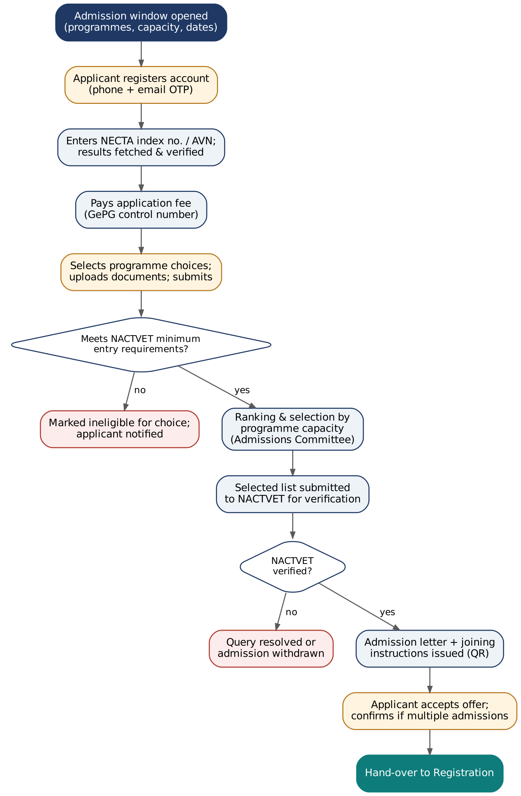
Figure 1: Admission flow overview (BP-01 to BP-04)

BP-01 Admission Window Setup
Purpose | Prepare the intake so that the portal shows correct programmes, capacity, entry requirements and fees.
Trigger | Academic calendar milestone; approval of programme capacity by management.
Actors | Admissions Officer, Deputy Principal (Academic), Bursar, Institution Administrator.
Inputs → Outputs | Approved programme list and capacity, NACTVET entry requirements, fees → published admission window.
Requirements | FR-ADM-03, FR-ADM-04, FR-ACA-01, FR-FIN-01.

# | Actor | Activity | System support / control
1 | Deputy Principal (Academic) | Confirms programmes on offer and capacity for the intake. | Programmes listed from the academic structure; capacity cannot exceed accredited capacity.
2 | Admissions Officer | Creates the admission window: dates, intake, number of choices, application fee. | Validation of dates against academic calendar.
3 | Admissions Officer | Reviews entry requirement rules per programme (copied from the previous year). | Rule editor with test tool: enter sample results, see eligible/ineligible.
4 | Bursar | Confirms the application fee and first-year fee structure. | Fee structure effective for the new academic year.
5 | Deputy Principal (Academic) | Approves the window for publication. | Approval recorded; portal goes live on the opening date automatically.

Service level / KPI
- Window configured and approved at least 2 weeks before opening.

BP-02 Online Application and Fee Payment
Purpose | Allow applicants to apply completely online with verified qualifications.
Trigger | Admission window opens.
Actors | Applicant, GePG, NECTA, NACTVET (AVN), Admissions Officer.
Inputs → Outputs | Applicant details, index numbers/AVN, documents, payment → submitted application with reference number.
Requirements | FR-ADM-01 to FR-ADM-09.

# | Actor | Activity | System support / control
1 | Applicant | Creates an account with phone number and email. | SMS OTP verification; duplicate accounts prevented by phone and NECTA index.
2 | Applicant | Enters CSEE/ACSEE index numbers and/or AVN. | Results fetched from NECTA/NACTVET and stored as verified qualifications.
3 | Applicant | Completes personal, contact, next-of-kin and sponsor details; uploads documents. | Mandatory field and file type/size checks; Kiswahili or English interface.
4 | Applicant | Requests to pay the application fee. | Bill sent to GePG; control number displayed and sent by SMS.
5 | Applicant | Pays through bank or mobile money. | GePG payment notification marks fee paid and unlocks programme choices.
6 | Applicant | Selects programme choices in order of preference. | Eligibility shown per choice; ineligible choices cannot be submitted.
7 | Applicant | Reviews and submits. | Reference number issued; confirmation SMS/email; application locked.

Exceptions
- NECTA unavailable: application saved; results fetched automatically when service returns.
- Result mismatch or foreign qualification: routed to Admissions Officer for manual verification with equivalence evidence.
- Payment not confirmed: reminders at 24 and 72 hours; control number regenerated on request.

Service level / KPI
- Applicant can complete an application in under 20 minutes on a smartphone.
- Payment reflected within 5 minutes of GePG notification.

BP-03 Eligibility, Ranking and Selection
Purpose | Select the best qualified eligible applicants within capacity, fairly and transparently.
Trigger | Selection round date reached (one or more rounds per window).
Actors | Admissions Officer, Admissions Committee, Head of Department (advisory).
Inputs → Outputs | Submitted applications → approved selection list.
Requirements | FR-ADM-09, FR-ADM-10, FR-ADM-11.

# | Actor | Activity | System support / control
1 | Admissions Officer | Runs eligibility re-check for all submitted applications. | Rules engine re-evaluates using verified results; exceptions listed.
2 | Admissions Officer | Resolves manual verification items. | Decision and evidence recorded in audit trail.
3 | Admissions Officer | Runs ranking per programme. | Ranking by configured criteria; ties broken by configured order; proposal within capacity.
4 | Admissions Committee | Reviews the proposed list and statistics (gender, region, qualification). | Dashboard and printable committee report.
5 | Admissions Committee | Approves or adjusts the list. | Adjustments require reason; final list locked as Selected.

Exceptions
- Capacity changed after ranking: re-run ranking; previous list kept for audit.

Service level / KPI
- Selection round completed within 5 working days of the round date.

BP-04 NACTVET Verification and Offer Acceptance
Purpose | Have selected applicants verified by NACTVET and convert them into confirmed admissions.
Trigger | Selection list approved.
Actors | Admissions Officer, NACTVET, Applicant.
Inputs → Outputs | Selected list → verified admissions with confirmation codes, admission letters, accepted offers.
Requirements | FR-ADM-12 to FR-ADM-15.

# | Actor | Activity | System support / control
1 | Admissions Officer | Generates the NACTVET verification submission. | Submission produced via API or in NACTVET template; pre-validation catches missing fields.
2 | Admissions Officer | Submits to NACTVET and imports outcomes. | Per-applicant status: verified, queried, rejected; confirmation code stored.
3 | Admissions Officer | Resolves queries (e.g. wrong index number) and resubmits. | Query reasons tracked until closed.
4 | System | Issues admission letters and joining instructions to verified applicants. | Letter with QR code; SMS and email notification.
5 | Applicant | Accepts offer (and confirms this institution if admitted elsewhere) before deadline. | Acceptance recorded; first-year invoice generated.
6 | Admissions Officer | Fills places not accepted from the next ranked eligible applicants. | Next-round selection follows BP-03 and this process.

Exceptions
- NACTVET rejects an applicant: admission withdrawn; applicant notified with reason.
- Externally selected students (e.g. TAMISEMI): imported and processed from step 2.

Service level / KPI
- At least 95% of submissions verified without query.
- Admission letters issued within 2 working days of verification.

3. Registration and Records Processes

BP-05 Student Registration
Purpose | Register new and continuing students for the semester/year.
Trigger | Registration period opens in the academic calendar.
Actors | Student, Registry Officer, Accountant, Hostel Warden.
Inputs → Outputs | Accepted applicant or continuing student → registered student on class and examination lists.
Requirements | FR-REG-01 to FR-REG-03, FR-REG-07, FR-FIN-06.

# | Actor | Activity | System support / control
1 | Registry Officer | Converts accepted applicants into students (first years). | Student record created from application; registration number generated.
2 | Student | Logs into the student portal, confirms details and modules. | Core modules pre-selected from curriculum; electives within rules.
3 | System | Checks financial clearance for registration. | Gate threshold applied (e.g. registration fee and first instalment paid).
4 | Student | Submits original documents for verification at first registration. | Document checklist recorded by Registry.
5 | Registry Officer | Approves registration. | Student appears on class lists; ID card can be printed; NACTVET registration submission prepared.

Exceptions
- Late registration: allowed within configured window with penalty fee.
- Clearance not met: registration pending; student notified of balance and control number.

Service level / KPI
- 90% of students registered within two weeks of the semester start.

BP-14 Student Status Changes
Purpose | Record postponement, resumption, suspension, discontinuation, withdrawal, transfer and death with proper approval.
Trigger | Student request, examination decision or disciplinary decision.
Actors | Student, Head of Department, Registry Officer, Deputy Principal (Academic).
Inputs → Outputs | Request with evidence → approved status change with effective date.
Requirements | FR-REG-04, FR-REG-05.

# | Actor | Activity | System support / control
1 | Student / Officer | Submits request with reason and documents. | Request form per change type.
2 | Head of Department | Recommends. | Workflow step with comments.
3 | Deputy Principal (Academic) | Approves or rejects. | Approval recorded.
4 | System | Applies status, adjusts invoices (per policy) and notifies offices. | Status history kept; class lists and clearance updated.

4. Finance Processes
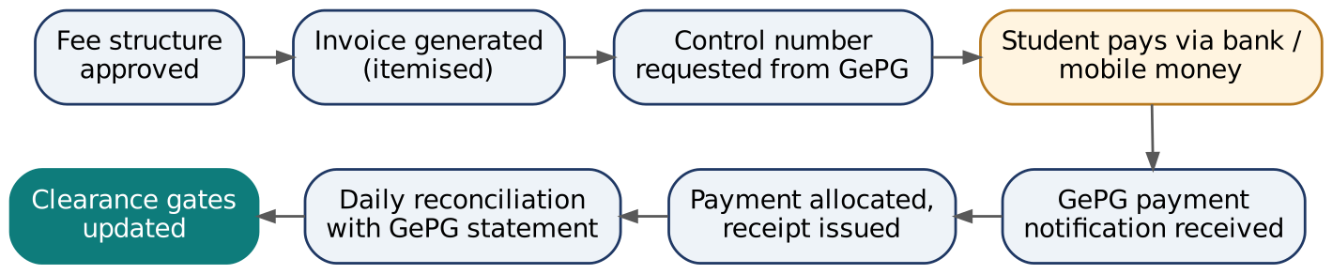
Figure 2: Fee billing and payment flow (BP-06)

BP-06 Fee Billing, Payment and Reconciliation
Purpose | Bill every student correctly and collect all fees through GePG with automatic receipting.
Trigger | Billing events (acceptance, registration, hostel allocation, supplementary registration) or scheduled billing.
Actors | Bursar, Accountant, Student, GePG.
Inputs → Outputs | Approved fee structure → invoices, control numbers, receipts, reconciled collections.
Requirements | FR-FIN-01 to FR-FIN-06, FR-FIN-12.

# | Actor | Activity | System support / control
1 | Bursar | Approves fee structure for the academic year. | Versioned with effective dates; changes audited.
2 | System | Generates itemised invoices on billing events. | Bulk or individual; duplicate prevention.
3 | System | Obtains a GePG control number per invoice. | Signed request; retries on failure; SMS to student.
4 | Student | Pays via bank or mobile money. | —
5 | System | Receives payment notification, allocates to invoice lines, issues receipt. | Real-time balance; clearance gates recalculated.
6 | Accountant | Reviews daily reconciliation exceptions. | GePG reconciliation file matched automatically; unmatched items listed.
7 | Bursar | Signs off monthly reconciliation and posts summary to MUSE/accounting. | Export file or API (R3).

Exceptions
- Overpayment: held as credit and applied to next invoice or refunded via BP-17.
- Payment to expired control number: matched by GePG reference in reconciliation.

Service level / KPI
- At least 98% of payments auto-matched.
- Reconciliation exceptions cleared within 3 working days.

BP-17 Sponsorship, Waivers and Refunds
Purpose | Handle third-party funding and financial adjustments with control.
Trigger | Sponsor letter, HESLB beneficiary list, waiver application, refund request.
Actors | Accountant, Bursar, Principal (above threshold), Sponsor/HESLB.
Inputs → Outputs | Funding or adjustment request → sponsor invoices, credit notes, approved refunds.
Requirements | FR-FIN-07 to FR-FIN-10.

# | Actor | Activity | System support / control
1 | Accountant | Registers sponsor and sponsored students, or imports HESLB list. | Sponsor share of each fee item defined.
2 | System | Splits invoices between student and sponsor. | Sponsor invoice and statement produced.
3 | Accountant | Records waiver/refund request with evidence. | Policy checks (eligibility, limits).
4 | Bursar / Principal | Approves per threshold (two levels above limit). | Credit note or refund voucher generated; audit trail.

5. Teaching and Assessment Processes

BP-07 Module Allocation and Attendance
Purpose | Assign teaching and track attendance for examination eligibility.
Trigger | Semester planning.
Actors | Head of Department, Lecturer, Examinations Officer.
Inputs → Outputs | Curriculum and registrations → module offerings, class lists, attendance records.
Requirements | FR-TCH-01 to FR-TCH-04.

# | Actor | Activity | System support / control
1 | Head of Department | Creates module offerings and allocates lecturers/assessors. | Offerings generated from curriculum; workload view per lecturer.
2 | Lecturer | Views class list and records attendance per session. | Web or tablet; offline-tolerant entry.
3 | System | Computes attendance percentage. | Students below threshold flagged to HoD and student.
4 | Examinations Officer | Uses attendance in examination eligibility. | Exemptions require reason and approval.

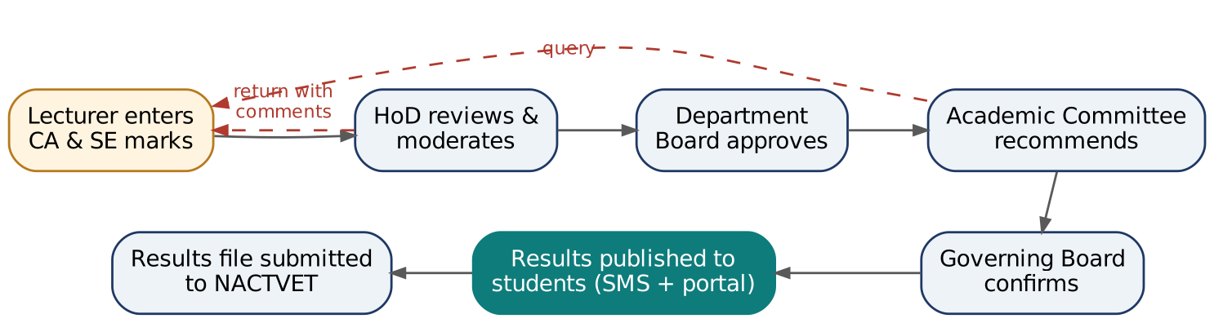
Figure 3: NTA results approval workflow (BP-08)

BP-08 NTA Assessment and Results Approval
Purpose | Produce accurate, approved and traceable NTA results.
Trigger | Assessment plan approved; marks windows open per calendar.
Actors | Lecturer, Head of Department, Department Board, Examinations Officer, Academic Committee, Governing Board.
Inputs → Outputs | Assessment marks → approved results, GPA, progression decisions, published results, NACTVET results file.
Requirements | FR-EXM-01 to FR-EXM-07, FR-EXM-10, FR-EXM-11.

# | Actor | Activity | System support / control
1 | Lecturer | Defines/confirms assessment plan and enters CA marks during the semester. | Component weights validated against curriculum.
2 | Examinations Officer | Generates examination eligibility lists and opens SE marks window. | Attendance, CA and financial clearance combined.
3 | Lecturer | Enters SE marks and submits. | Screen or Excel upload; range checks; submission locks lecturer editing.
4 | Head of Department | Reviews and moderates; returns with comments if needed. | Grade distribution and anomaly flags.
5 | Department Board | Approves department results. | Decision recorded by Board Secretary.
6 | Examinations Officer | Runs GPA and progression computation. | Regulations applied; proposed decisions per student.
7 | Academic Committee | Reviews and recommends results and decisions. | Committee report generated.
8 | Governing Board | Confirms results. | Results locked; amendments only through authorised workflow.
9 | Examinations Officer | Publishes results and submits to NACTVET. | SMS + portal; NACTVET file generated; submission recorded.

Exceptions
- Missing marks: student marked incomplete with reason (e.g. absent with permission → special exam).
- Post-approval error: amendment request with justification, re-approval and full audit.

Service level / KPI
- Provisional results within the period set by regulations (e.g. 3 weeks after examinations).

BP-09 NVA Competence Assessment
Purpose | Record competence-based assessment for NVA programmes.
Trigger | Unit or module assessment scheduled; trade test period.
Actors | Assessor, Head of Department, Examinations Officer.
Inputs → Outputs | Assessment tasks and evidence → unit outcomes (competent / not yet competent) and award eligibility.
Requirements | FR-EXM-09.

# | Actor | Activity | System support / control
1 | Head of Department | Sets units, tasks and evidence requirements from the curriculum. | Unit structure from academic module.
2 | Assessor | Assesses trainees on practical and theory tasks; records outcome and evidence reference. | Tablet-friendly entry; date and assessor captured.
3 | Head of Department | Verifies outcomes. | Approval workflow as configured.
4 | Examinations Officer | Confirms award eligibility and submits to NACTVET. | Re-assessment scheduled for not-yet-competent units.

BP-10 Supplementary, Special and Carry-over Examinations
Purpose | Give eligible students further assessment opportunities under the regulations.
Trigger | Publication of results with supplementary, special or carry-over decisions.
Actors | Student, Examinations Officer, Lecturer, Accountant.
Inputs → Outputs | Progression decisions → registrations, marks and updated results.
Requirements | FR-EXM-08.

# | Actor | Activity | System support / control
1 | Student | Registers for supplementary/special examination and pays fee if applicable. | Only eligible modules listed; invoice generated.
2 | Examinations Officer | Schedules examinations and opens marks window. | Eligibility and payment checked.
3 | Lecturer | Enters marks. | Capping rules applied automatically (e.g. maximum C).
4 | Approving bodies | Approve as in BP-08. | Final status (pass, carry-over, repeat, discontinue) set.

BP-11 Remarking and Appeals
Purpose | Handle disputes over results fairly and transparently.
Trigger | Student applies within the appeal period after publication.
Actors | Student, Examinations Officer, Head of Department, internal examiner.
Inputs → Outputs | Appeal → decision, possible amended result.
Requirements | FR-EXM-12.

# | Actor | Activity | System support / control
1 | Student | Submits remark/appeal request and pays fee. | Period and eligible modules enforced.
2 | Examinations Officer | Assigns examiner. | Conflict of interest check (not the original lecturer).
3 | Examiner / HoD | Records outcome. | Original and new marks kept.
4 | Academic Committee | Approves amendment if any. | Result amended with audit; student notified.

6. Campus Service Processes

BP-12 Hostel Application and Allocation
Purpose | Allocate beds fairly and ensure occupancy is paid for.
Trigger | Hostel application window opens.
Actors | Student, Hostel Warden, Dean of Students, Accountant.
Inputs → Outputs | Applications and bed inventory → allocations, hostel invoices, occupancy.
Requirements | FR-HST-01 to FR-HST-06.

# | Actor | Activity | System support / control
1 | Hostel Warden | Updates bed inventory and opens the window. | Gender designation and status per bed.
2 | Student | Applies with preferences. | Only registered students can apply.
3 | System / Warden | Allocates beds by priority rules. | One active allocation per bed enforced by the database.
4 | System | Invoices hostel fee; releases allocation if unpaid after configured days. | Released beds return to pool; waiting list offered.
5 | Hostel Warden | Checks students in and out. | Inventory condition, damages and charges recorded.

Service level / KPI
- No double allocation; occupancy report always current.

BP-13 Industrial Practical Training (IPT)
Purpose | Manage field attachment as an assessed part of the programme.
Trigger | IPT period in the academic calendar.
Actors | IPT Coordinator, Student, workplace supervisor, institution supervisor.
Inputs → Outputs | Eligible students → placements, logbooks, IPT results.
Requirements | FR-IPT-01 to FR-IPT-03.

# | Actor | Activity | System support / control
1 | IPT Coordinator | Registers placement organisations and assigns students. | Placement letters generated.
2 | Student | Fills electronic logbook. | Weekly entries; supervisor visibility.
3 | Supervisors | Assess the student. | Assessment form; visit records.
4 | IPT Coordinator | Submits IPT results to examination. | Results flow into BP-08 approvals.

7. Completion Processes

BP-15 Clearance and Graduation
Purpose | Confirm that finalists have met all academic and other obligations and issue awards.
Trigger | Final results confirmed by the Governing Board.
Actors | Student, clearance officers (department, library, hostel, finance, sports), Registry Officer, Governing Board.
Inputs → Outputs | Final results and clearance → graduand list, transcripts, certificates.
Requirements | FR-GRD-01 to FR-GRD-04.

# | Actor | Activity | System support / control
1 | Student | Starts online clearance. | Offices notified; outstanding items shown.
2 | Clearance officers | Clear or hold with reason. | Finance clearance automatic from balance.
3 | Registry Officer | Generates graduand list. | Only students with approved award and full clearance.
4 | Governing Board | Approves graduands. | Approval recorded; NACTVET graduand submission prepared.
5 | Registry Officer | Issues transcripts and certificates. | Unique verification number and QR code; issue log.

BP-16 Document Verification
Purpose | Let employers, institutions and agencies verify CIMS-issued documents instantly.
Trigger | Third party scans QR code or enters verification number.
Actors | Third party, Registry Officer (for formal requests).
Inputs → Outputs | Verification code → authenticity confirmation.
Requirements | FR-GRD-04.

# | Actor | Activity | System support / control
1 | Third party | Scans QR code or enters number on public verification page. | Rate-limited public endpoint.
2 | System | Displays document type, name, programme, award and issue date if valid. | Minimal personal data shown; access logged.

8. Process Controls Summary
Control | Where applied
Segregation of duties | Marks entry vs approval; invoice creation vs waiver approval; selection proposal vs committee approval.
Approval workflows | Admission selection, results, status changes, waivers/refunds above thresholds, results amendments.
Automated validation | Entry requirements, capacity, clearance gates, grading rules, bed allocation uniqueness.
Audit trail | All create/update/approve actions on applications, marks, invoices, payments, statuses and allocations.
Reconciliation | Daily GePG reconciliation; NACTVET submission outcome tracking.
Notifications | Applicants and students informed at each key event, reducing enquiries and disputes.

