 | MSINGI TECHNOLOGIES LTD  Software • IT Systems


College/Institution Management System (CIMS)
One platform from application to graduation for NACTVET-registered institutions
Document 08: User Manual
Step-by-step instructions, with screenshots, for applicants, students, every institution role and Msingi platform staff using CIMS as built in October 2026.
Document | Document 08: User Manual
Document Status | Version 1.4 — for the system as built, October 2026 (after Batch 11)
Prepared For | Applicants, students, staff of NACTVET-registered institutions using CIMS, and Msingi Technologies support staff
System Scope | Online Admission, Student Registry, Academic Structure, Teaching & Attendance, Assessment & Examination (NTA and NVA), Finance & Fees (GePG), Hostel, Industrial Practical Training, Clearance & Graduation, Student Portal, Reports and Integrations
Prepared By | Msingi Technologies Ltd
Prepared Date | October 2026
Classification | For institution and Msingi staff use

Document Control
This section records the versions of this User Manual, who prepared each one and what changed, so that readers know they are working from the current approved text.
Version | Date | Prepared By | Description
1.0 | October 2026 | Msingi Technologies Ltd | First edition: user manual for the system as built, with screenshots from the demonstration institution.
1.1 | October 2026 | Msingi Technologies Ltd | New sections for the features added in the completion batches: two-step sign-in and My account, the back-office in Kiswahili, document uploads, campuses and transfers, National Identification Numbers, data import, letter wording, integrations, security and personal data, email and scheduled reports, instalments, penalties and schemes, approval stages, results across years, workplace assessment links, alumni and tracer surveys; SMS list updated.
1.2 | October 2026 | Msingi Technologies Ltd | Passwords now need at least 10 characters (section 2.3).
1.3 | October 2026 | Msingi Technologies Ltd | Late-registration fee, application-fee reminders, Test entry rules (9.10), moving a student to another bed (18.4), refunds of fees paid and requests raised by CIMS; SMS list updated. Abbreviations and glossary table added (Appendix A).
1.4 | October 2026 | Msingi Technologies Ltd | Timetables: your timetable in the student portal (4.11), the class timetable and venues (8.6), classes of a department's modules (11.5), My timetable for lecturers (12.6) and the examination timetable (14.12); modules prepared from the curricula; SMS list updated; links to pages a role cannot open, or to steps not ready yet, shown faint (5.1); applicants add their email and see their personal-data rights on the last application step (3.11); the email is added during the application only, not on the student profile (4.10); health insurance with NHIF: students' own cards checked with NHIF or registration through the institution after paying the contribution (4.10, 6.10, 10.12, 15.8); the PREM number from NECTA with the Form Four results (3.1) and the applicant profile, with Edit buttons, on the last application step (3.8); NACTVET verification by API as NOAS does it: the payment reference of the verification fee, uploads one programme at a time and outcomes read from NACTVET's verification feedback (9.6).

Review and Approval
The people listed below review this User Manual and confirm, by signing, that it is accepted as the basis for the work that follows.
Role | Name | Signature | Date
Managing Director, Msingi Technologies Ltd
Project Manager, Msingi Technologies Ltd
Project Sponsor (Institution)
Principal / Head of Institution

Related Documents
CIMS is described in a set of eight documents, each written for a different purpose and audience. This table shows where each topic is covered, so a reader can go straight to the document that answers their question.
No. | Document | Purpose
01 | Concept Note | Why the system is needed, the vision, value to stakeholders and the delivery model.
02 | Business Requirements Document | Stakeholders, business requirements, business rules and success measures.
03 | System Requirements Specification | Functional and non-functional requirements, roles, use cases and traceability.
04 | Business Process Document | End-to-end institutional workflows with actors, controls and service levels.
05 | Database Design | Data model, table catalogue, constraints, multi-tenancy and data governance.
06 | System Architecture | Technology stack, components, security, integrations, deployment and operations.
07 | Development Plan and Cost Estimate | Release plan, team, effort-based budget, pricing model and risks.
08 | User Manual (this document) | Step-by-step use of every portal and role, with screenshots.

Contents

1. Introduction 11
1.1 How this manual is organised 11
1.2 Conventions 11
2. Getting Started 12
2.1 The portals 12
2.2 Signing in 13
2.3 Passwords 13
2.4 Language 13
2.5 Installing the student portal on a phone 13
2.6 Roles and where to find them in this manual 14
2.7 Two-step sign-in and My account 14
3. Applicants: Applying Online 16
3.1 Sign up with your Form Four index number 16
3.2 Create your account and verify your phone 17
3.3 Start an application 18
3.4 Personal details 19
3.5 Pay the application fee 20
3.6 Other qualifications 20
3.7 Choose programmes 21
3.8 Applicant profile and submit 22
3.9 Accept your offer and download the admission letter 24
3.10 Verify a document 25
3.11 Upload documents and add your email 26
4. Students: The Student Portal 26
4.1 Home: what to do next 27
4.2 Fees and payments 27
4.3 Register for the semester 28
4.4 Results, statements, resits and appeals 29
4.5 Attendance and checking in to a class 30
4.6 Hostel and repairs 31
4.7 Industrial practical training (IPT) 31
4.8 Clearance for graduation 32
4.9 Notices and profile 33
4.10 Campus, transfers, National ID, health insurance and your data 34
4.11 Your timetable 35
5. Staff: Common Features 37
5.1 The screen layout 37
5.2 Dashboard 37
5.3 Approvals 38
5.4 Reports 38
5.5 Notices 39
5.6 Messages (SMS) 40
5.7 Email and scheduled reports 42
6. Institution Administrator 42
6.1 Staff users and roles 43
6.2 Institution profile and campus photo 43
6.3 Decisions that need a second person 44
6.4 Audit trail 44
6.5 Two-step sign-in and sign-out times 46
6.6 Connected systems (API) 46
6.7 Personal data requests and retention 47
6.8 Data import 47
6.9 Letter wording 48
6.10 Integrations 48
6.11 Campuses, departments and faculties 49
7. Principal / Management Viewer 50
7.1 Institution overview 50
7.2 Approving large waivers and refunds 51
8. Deputy Principal (Academic) 52
8.1 Academic calendar 52
8.2 Approving a curriculum 52
8.3 Examination regulations 53
8.4 Selection rounds, results, exemptions and status changes 54
8.5 Programme and campus transfers 56
8.6 Class timetable and venues 56
9. Admissions Officer 60
9.1 Create an admission window 60
9.2 Close, reopen or extend a window 61
9.3 Find and review applicants 62
9.4 Check declared qualifications 62
9.5 Run selection 62
9.6 Submit to NACTVET and record outcomes 63
9.7 Follow offers and issue admission letters 65
9.8 Documents applicants upload 66
9.9 Students selected by TAMISEMI or another body 66
9.10 Test entry rules 66
10. Registrar / Registry Officer 67
10.1 Hand over accepted applicants 67
10.2 First registration at reporting 68
10.3 Approve semester registrations 69
10.4 Student status changes 70
10.5 ID cards and detail-change requests 71
10.6 Clearance offices 71
10.7 Graduations and certificates 71
10.8 Programme and campus transfers 73
10.9 National Identification Numbers 73
10.10 NACTVET student registration 73
10.11 Alumni and tracer surveys 73
10.12 Health insurance (NHIF) 74
11. Head of Department and Programme Coordinator 75
11.1 Prepare a curriculum 75
11.2 Allocate lecturers 76
11.3 Moderate marks 77
11.4 Other decisions 78
11.5 Classes of your department's modules 79
12. Lecturer / Tutor 79
12.1 My teaching 79
12.2 Record attendance 80
12.3 Self check-in with a QR code 81
12.4 Enter marks 82
12.5 Class lists, remarks and IPT supervision 83
12.6 My timetable 84
13. Assessor (NVA) 84
13.1 Record competence outcomes 84
14. Examinations Officer 86
14.1 Set up modules and the marks window 86
14.2 Examination eligibility 86
14.3 Result sheets 87
14.4 NACTVET results submission 88
14.5 Supplementary and special examinations 88
14.6 Remarks and appeals 89
14.7 Result amendments 90
14.8 NVA competence units and award lists 91
14.9 Statements of results 92
14.10 Marks entry dates per item and approval stages 93
14.11 Results across years 93
14.12 Examination timetable 93
15. Bursar / Finance Manager 95
15.1 Finance overview 95
15.2 Collection targets and postings 96
15.3 Approve fee structures, waivers and refunds 97
15.4 Monthly reconciliation sign-off 98
15.5 Instalments, reminders and penalties 99
15.6 Discount and scholarship schemes 99
15.7 MUSE postings 100
15.8 Health insurance contributions 100
16. Accountant / Finance Officer 100
16.1 Fee items and fee structures 100
16.2 Billing and clearance rules 101
16.3 Daily GePG reconciliation 102
16.4 Sponsors 103
16.5 Request a waiver or refund 104
16.6 Fees by intake and student category 106
16.7 HESLB exchange 106
17. Sponsor Officer 106
18. Dean of Students / Hostel Warden 108
18.1 Inventory, fees and windows 108
18.2 Allocate beds 108
18.3 Check-in, check-out and repairs 109
18.4 Move a student to another bed 111
19. IPT Coordinator 111
20. Clearance Officer 113
21. Auditor 114
22. Msingi Platform Administrator 115
22.1 Onboard an institution 115
22.2 Manage an institution 116
22.3 Integration health and audit 117
Appendix A. Abbreviations and glossary 119
Appendix B. Common Messages 121
Appendix C. SMS Messages 122

List of Tables

Table 1: How the manual is organised 11
Table 2: Conventions used in this manual 11
Table 3: CIMS portals and who uses them 12
Table 4: Roles, landing pages and chapters 14
Table 5: Abbreviations and glossary 120
Table 6: Common messages and what to do 121
Table 7: Automatic SMS messages by area 122

List of Figures

Figure 1: The admission portal home page 12
Figure 2: My account: two-step sign-in, password, email and personal data 15
Figure 3: The admission portal on a phone 16
Figure 4: Confirming your NECTA results 17
Figure 5: Creating the applicant account 18
Figure 6: Choosing the admission window 18
Figure 7: Personal details step 19
Figure 8: The GePG control number for the application fee 20
Figure 9: Adding an NTA award 21
Figure 10: Choosing programmes 22
Figure 11: The applicant profile on the last step, with Edit buttons 23
Figure 12: Application submitted, with its reference number 24
Figure 13: An accepted offer with the admission letter 25
Figure 14: Student sign-in and the home page 27
Figure 15: Fees, control numbers and receipts 28
Figure 16: Semester registration 29
Figure 17: Results with remarks and appeals 30
Figure 18: Self check-in and attendance on the home page 31
Figure 19: Hostel and IPT on the home page 32
Figure 20: Clearance and graduation 33
Figure 21: Notices and profile 34
Figure 22: Health insurance on the student profile, waiting for payment 35
Figure 23: Campus and transfers on the student profile 35
Figure 24: Your timetable in the student portal 36
Figure 25: The staff back-office: menu and dashboard 37
Figure 26: The Approvals list 38
Figure 27: The report catalogue 39
Figure 28: Writing a notice 40
Figure 29: Sending a bulk SMS 41
Figure 30: Messages › Email: the email outbox and scheduled reports 42
Figure 31: Creating a staff account 43
Figure 32: Institution page with the campus photo 44
Figure 33: The audit trail 45
Figure 34: Security & privacy: two-step sign-in and sign-out times 46
Figure 35: Data import with a checked file 47
Figure 36: Letter wording with the values that can be inserted 48
Figure 37: Integrations: codes and connections 49
Figure 38: Campuses 50
Figure 39: Institution overview for the Principal 51
Figure 40: Academic calendar 52
Figure 41: A draft curriculum waiting for approval 53
Figure 42: Examination regulations 54
Figure 43: Status changes in progress 55
Figure 44: Registry › Transfers 56
Figure 45: Teaching › Timetable: the week, the clash checks and the modules of the semester 58
Figure 46: Adding a class 59
Figure 47: Teaching › Timetable › Venues 60
Figure 48: Creating an admission window 61
Figure 49: An admission window with its programmes and joining instructions 61
Figure 50: The Applicants list 62
Figure 51: A selection round with ranked applicants 63
Figure 52: NACTVET verification and offers 64
Figure 53: Submissions to NACTVET with Fetch outcomes 64
Figure 54: Offers and admission letters 65
Figure 55: Documents applicants upload, on the window page 66
Figure 56: Testing entry rules with a sample applicant 67
Figure 57: Registration hand-over 68
Figure 58: A student record with first registration, ID card and fees 69
Figure 59: Semester registration 70
Figure 60: Requesting a status change 71
Figure 61: A graduation with graduands and certificates 72
Figure 62: Alumni 74
Figure 63: Registry › Health insurance 75
Figure 64: Curricula and the module catalogue 76
Figure 65: Modules of the semester with their stage 77
Figure 66: Moderating a module's marks 78
Figure 67: My teaching 80
Figure 68: Recording a class session 81
Figure 69: Starting self check-in 82
Figure 70: Entering marks for a module 83
Figure 71: My timetable for a lecturer 84
Figure 72: A competence unit with outcomes per task 85
Figure 73: The Examinations office board 86
Figure 74: Examination eligibility per module 87
Figure 75: A class result sheet through to publication 88
Figure 76: Opening supplementary and special examinations 89
Figure 77: Remarks and appeals 90
Figure 78: A result amendment waiting for the administrator 91
Figure 79: Competence units for a semester 92
Figure 80: Approval stages for module results 93
Figure 81: Examinations › Exam timetable 94
Figure 82: Adding an examination paper 95
Figure 83: The Finance overview 96
Figure 84: Setting collection targets 97
Figure 85: Waivers and refunds waiting for approval 98
Figure 86: Instalments and reminders 99
Figure 87: Fee structures 101
Figure 88: Fee items with GFS codes and priority 101
Figure 89: Clearance rules 102
Figure 90: GePG reconciliation by day 103
Figure 91: A sponsor with sponsored students and invoices 104
Figure 92: Requesting a waiver or refund 105
Figure 93: The Sponsor Officer's view 107
Figure 94: Hostels and rooms 108
Figure 95: Hostel allocation 109
Figure 96: Repairs 110
Figure 97: Moving a student to another bed 111
Figure 98: Industrial practical training placements 112
Figure 99: IPT periods 112
Figure 100: The clearance queue of an office 113
Figure 101: The audit trail as seen by the Auditor 114
Figure 102: Platform overview 115
Figure 103: Onboarding an institution 116
Figure 104: An institution in the platform console 117
Figure 105: Integration health 118

Part A — Getting Started

1. Introduction
This chapter explains what the manual covers, how it is organised and the conventions it uses, so that each reader can go straight to the chapter for their role.
This manual explains, step by step, how to use the College/Institution Management System (CIMS) as built in October 2026. It covers every kind of user: applicants, students, each office in the institution and Msingi Technologies' platform staff. The screenshots come from the Msingi Demo Technical College, the demonstration institution that ships with the system, so names, numbers and dates are examples.

1.1 How this manual is organised
The manual is divided into parts by type of user. The table shows which chapters each reader needs.
Part | Chapters | Read it if you are
A. Getting started | 1–2 | Everyone: the portals, signing in, passwords, language and roles.
B. Applicants and students | 3–4 | An applicant applying online, or a student using the student portal (or staff who support them).
C. Institution staff | 5–21 | Staff in the back-office. Chapter 5 applies to all staff; then read the chapter of each role you hold.
D. Msingi platform | 22 | Msingi Technologies staff who onboard and support institutions.
Appendices | A–C | Glossary, common messages and what to do, and the SMS messages CIMS sends.
Table 1: How the manual is organised

1.2 Conventions
The manual uses a few conventions for buttons, menu paths, tips and warnings. Knowing them makes the instructions quicker to follow.
Convention | Meaning
Bold text | A button, tab, menu item or field exactly as it appears on screen, for example Sign in.
Menu › Page | A path through the menu, for example Admissions › Admission windows.
Numbered steps | Do them in order. A step that depends on a setting says so.
Tip | A shortcut or something that saves time.
Note | A rule the system enforces, or what happens behind the scenes.
Development mode | Items such as "Simulate payment" or a code shown on screen appear only in the test system, never in production.
Table 2: Conventions used in this manual

2. Getting Started
This chapter covers what every user needs before starting: the portals, signing in, passwords, language, roles and protecting an account. Read it first, whatever your role.

2.1 The portals
This section explains the different portals of CIMS (admission, student, staff and verification) and who uses each.
CIMS has one web address per institution (for example apply.college.ac.tz) and several portals on it. They work on a phone, tablet or computer in any modern browser; nothing needs installing.
Portal | Address | Who uses it
Admission portal | / | Applicants: read about programmes, apply, pay the application fee, follow the application, accept an offer and download the admission letter.
Student portal | /student | Registered students: fees, registration, results, attendance, hostel, IPT, clearance and notices. Can be installed on a phone like an app.
Staff back-office | /staff | Institution staff, each seeing only the menus of their roles.
Verification page | /verify | Anyone checking an admission letter, statement of results, certificate or ID card.
Platform console | /platform | Msingi Technologies staff only.
Table 3: CIMS portals and who uses them
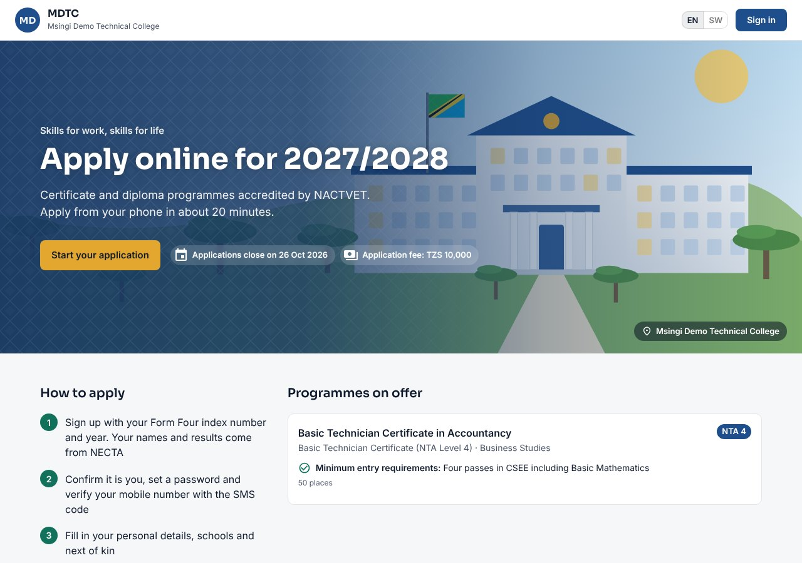
Figure 1: The admission portal home page

2.2 Signing in
This section explains where and how each kind of user signs in, and what to do if a password is forgotten.
Each portal has its own sign-in page:
- Applicants sign in at Sign in on the admission portal with their mobile number, email or Form Four index number and password.
- Students sign in at /student with their registration number or mobile number and the same password they used as applicants.
- Staff sign in at /staff with the Username and Password given by the Institution Administrator.
- Msingi staff sign in at /platform with their platform account.
- Open the portal address in your browser.
- Type your username (or registration number, phone or index number) and password.
- Click Sign in. You land on the page for your role (for example My teaching for a lecturer or Finance overview for the Bursar).
Note: After five wrong passwords in a row the account is locked. The Institution Administrator unlocks staff accounts (section 6.1); applicants and students should contact the institution.

2.3 Passwords
This section explains the password rules and how to change a password, which protect every account from misuse.
Passwords must have at least 10 characters with an upper-case letter, a lower-case letter, a digit and a special character. The sign-up form ticks off each rule as you type and asks for the password twice.
- First staff sign-in: the administrator gives you a temporary password. CIMS asks you to choose your own before anything else.
- Changing your password: staff click Change password at the bottom of the menu; enter the current password and the new one twice.
- Forgotten password (applicants and students): click Forgot password?, enter your mobile number, type the code sent by SMS and choose a new password.
- Forgotten password (staff): ask the Institution Administrator to reset it (section 6.1).

2.4 Language
This section explains how to switch any part of CIMS between English and Kiswahili.
Every part of CIMS is in English and Kiswahili. On the admission and student portals click **EN** or **SW** at the top of the page; on the staff back-office choose **English** or **Kiswahili** on the sign-in page or at the bottom of the menu. Staff screens change at once, and the choice is kept with your account, so it follows you to another computer. Names, codes and anything people typed are shown as recorded.

2.5 Installing the student portal on a phone
Students can install the student portal on their phone like an app. This section explains how on Android and iPhone.
- Open the student portal in Chrome (Android) or Safari (iPhone).
- Android: open the browser menu and choose Install app or Add to Home screen. iPhone: tap Share, then Add to Home Screen.
- Open CIMS from the new icon. It opens full screen like an app; your data is always fetched fresh and never stored on the phone.

2.6 Roles and where to find them in this manual
Each staff member holds one or more roles that decide what they see. This section lists the roles and the chapter of this manual for each.
A person can hold several roles; the menu shows the pages of all of them. The table lists the 20 roles, the page each lands on after signing in, and the chapter that covers it.
Role | Lands on | Chapter
Applicant | My application | 3
Student | Student portal home | 4
Institution Administrator | Dashboard | 6
Principal / Management Viewer | Dashboard (Institution overview) | 7
Deputy Principal (Academic) | Dashboard | 8
Admissions Officer | Dashboard (admissions) | 9
Registrar / Registry Officer | Dashboard | 10
Head of Department | Dashboard | 11
Programme Coordinator | My teaching | 11
Lecturer / Tutor | My teaching | 12
Assessor (NVA) | My teaching | 13
Examinations Officer | Examinations office | 14
Bursar / Finance Manager | Finance overview | 15
Accountant / Finance Officer | Finance overview | 16
Sponsor Officer | Their sponsor's page | 17
Dean of Students / Hostel Warden | Hostels | 18
IPT Coordinator | Industrial training | 19
Clearance Officer | Clearance | 20
Auditor | Dashboard | 21
Platform Administrator (Msingi) | Platform overview | 22
Table 4: Roles, landing pages and chapters

2.7 Two-step sign-in and My account
This section explains how staff protect their account with a code from an authenticator app, and how to manage their own account details and sessions.
Two-step sign-in protects a staff account with a 6-digit code from an authenticator app (for example Google Authenticator or Microsoft Authenticator) as well as the password. The Institution Administrator decides who must use it (section 6.5); anyone may switch it on for their own account.
- Click My account at the bottom of the menu. Under Two-step sign-in click Set up.
- Open your authenticator app and scan the QR code. If you cannot scan it, enter the key shown under the code.
- Type the 6-digit code the app shows and confirm.
- Write down or print the recovery codes and click I have saved them. Each code works once, if you lose your phone.
From then on, after your password CIMS asks for the code. If SMS is offered, Send me a code by SMS instead sends a code to the phone on your account. If your role requires two-step sign-in and it is not set up, CIMS opens the set-up first.
My account also holds your password, your Email (confirmed with a code sent to it; staff need a confirmed email to receive scheduled reports) and Your personal data: Download my data gives a copy of everything held about you, and Make a request asks for a correction, erasure or objection, answered within 30 days.
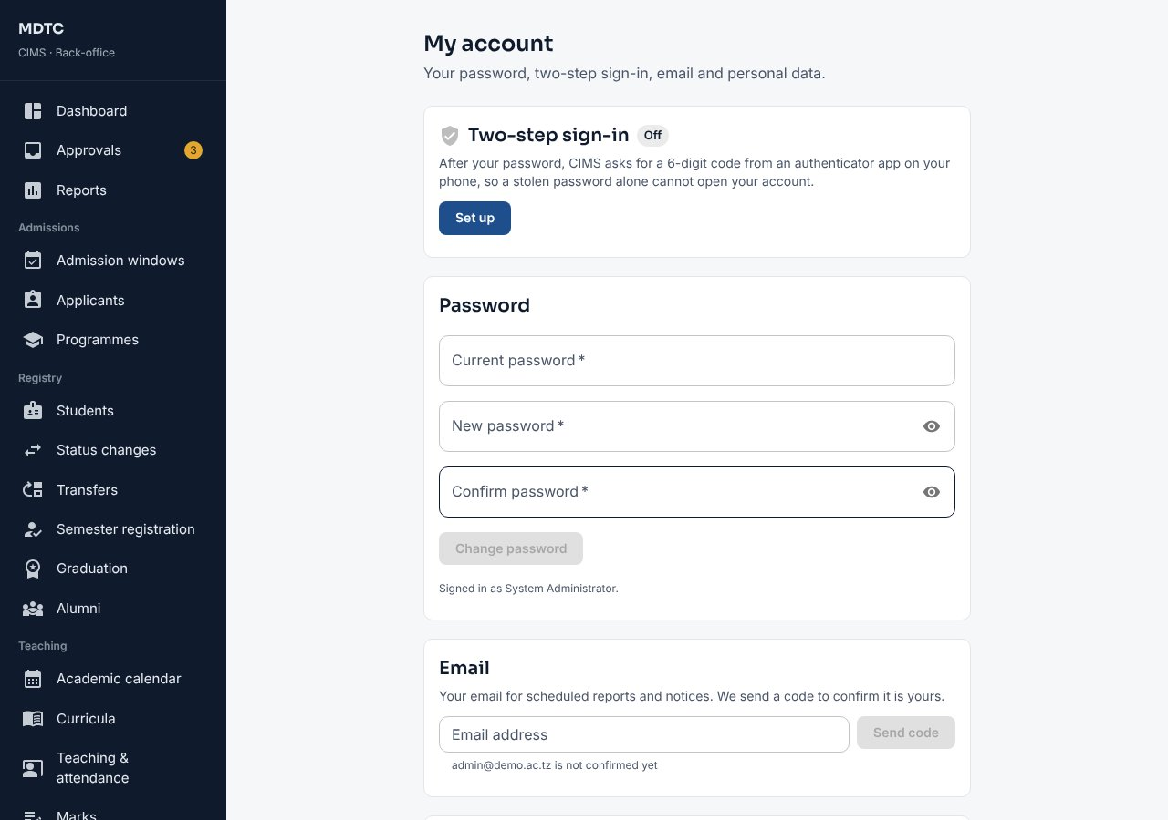
Figure 2: My account: two-step sign-in, password, email and personal data
Note: After a period without activity CIMS signs you out, with a warning a minute before (Stay signed in keeps you in). The time is set per user type by the administrator.
Part B — Applicants and Students

3. Applicants: Applying Online
This chapter is for applicants. It walks through applying online from the institution's admission portal: signing up, entering details, paying the fee, choosing programmes, submitting and accepting an offer.
Applicants apply from the institution's admission portal. The whole application takes about 20 minutes on a phone. Before starting, have your Form Four (CSEE) index number and year, a mobile number that can receive SMS, and a way to pay the application fee (bank or mobile money).
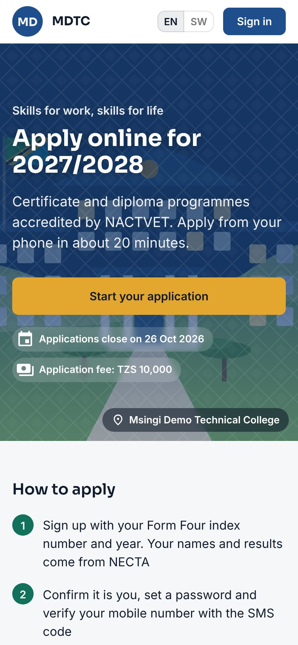
Figure 3: The admission portal on a phone

3.1 Sign up with your Form Four index number
The first step is to find your Form Four results with your index number. This section explains how.
- On the home page click Start your application.
- Type your Form Four index number (for example S0101/0001) and choose the Year of examination.
- Click Find my results. CIMS fetches your names, sex, school, results and PREM number from NECTA.
- Check the details. If they are yours click Yes, this is me; otherwise click Not me — change the index number.
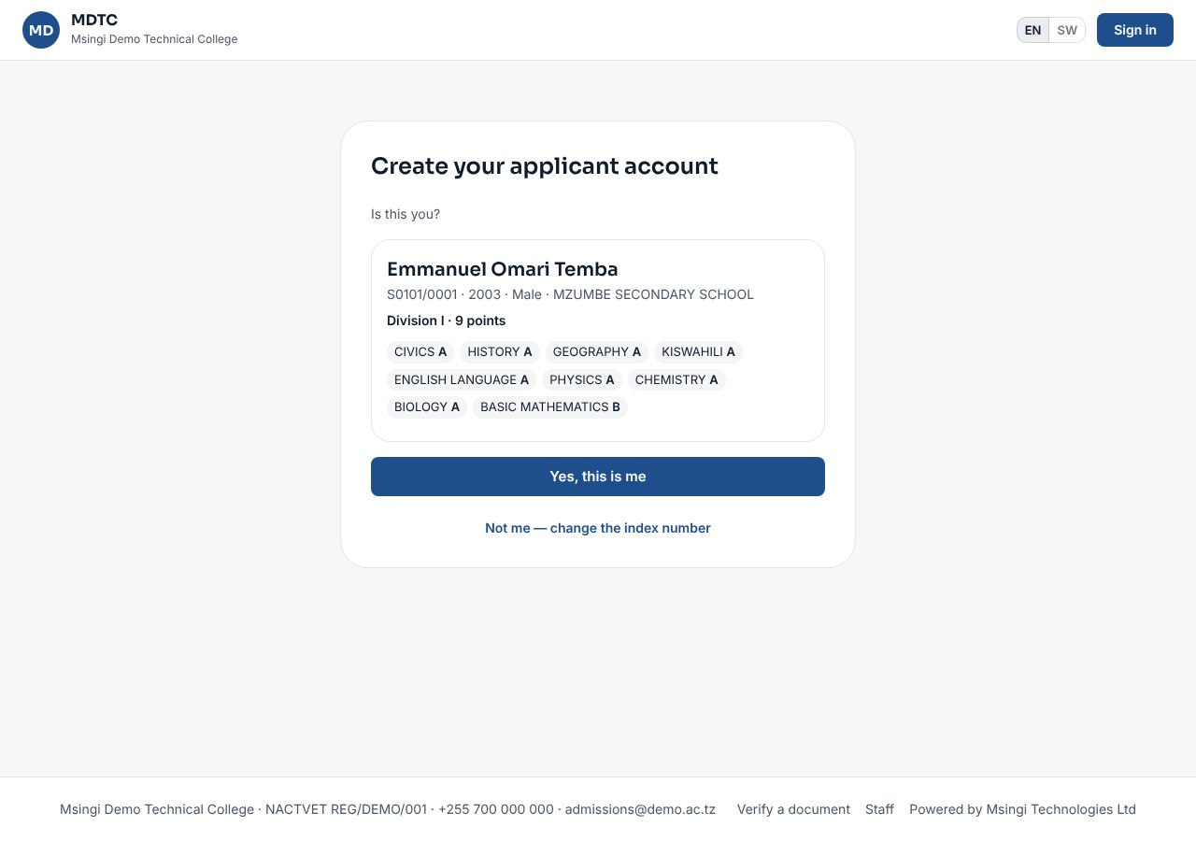
Figure 4: Confirming your NECTA results
Note: Your names are taken exactly as NECTA has them and cannot be changed later in the portal. Each index number and year can have only one account.

3.2 Create your account and verify your phone
This section explains how to create your account with a mobile number and password, and confirm the number with the code sent by SMS.
- Enter your Mobile number and, if you wish, an Email.
- Choose a Password that meets every rule shown, and type it again in Confirm password.
- Click the privacy notice link to read how the institution uses your personal data. Click I have read it and agree at the foot of the notice (this ticks the box for you), or close it and tick the box yourself, then click Create account.
- CIMS sends a code by SMS. Type it in Verification code and click Verify. Use Send a new code if it does not arrive.
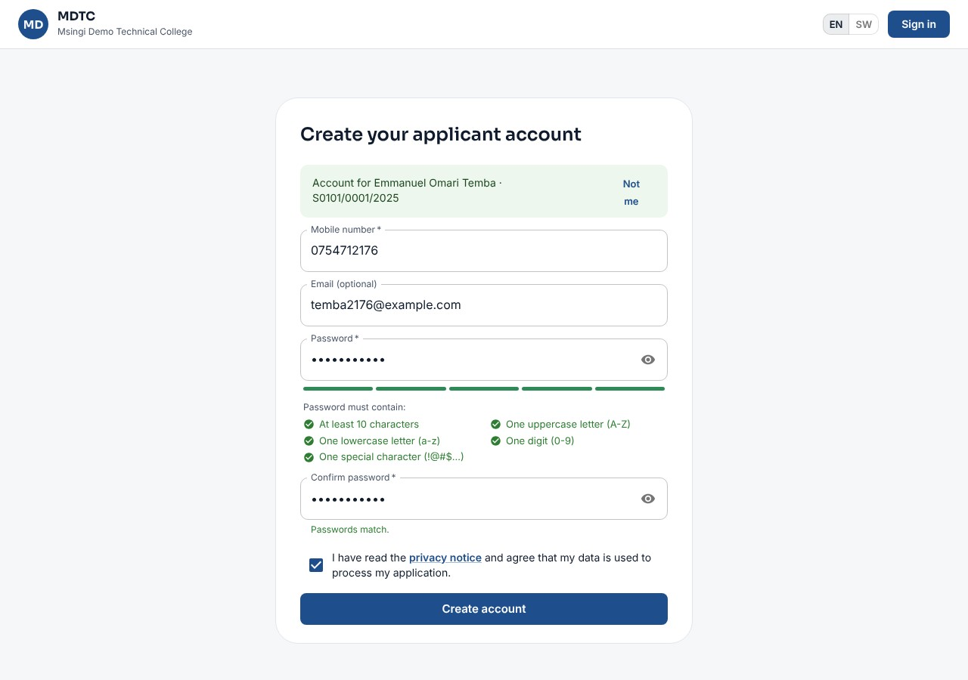
Figure 5: Creating the applicant account

3.3 Start an application
This section explains how to start an application in an open admission window.
After verifying your phone you see My application with the admission windows that are open, their closing date and fee. Click Start your application under the intake you want. The application then has six steps shown at the top: Results, Personal details, Application fee, Other qualifications, Programmes and Applicant profile (with Documents before the last one when the window asks for documents).
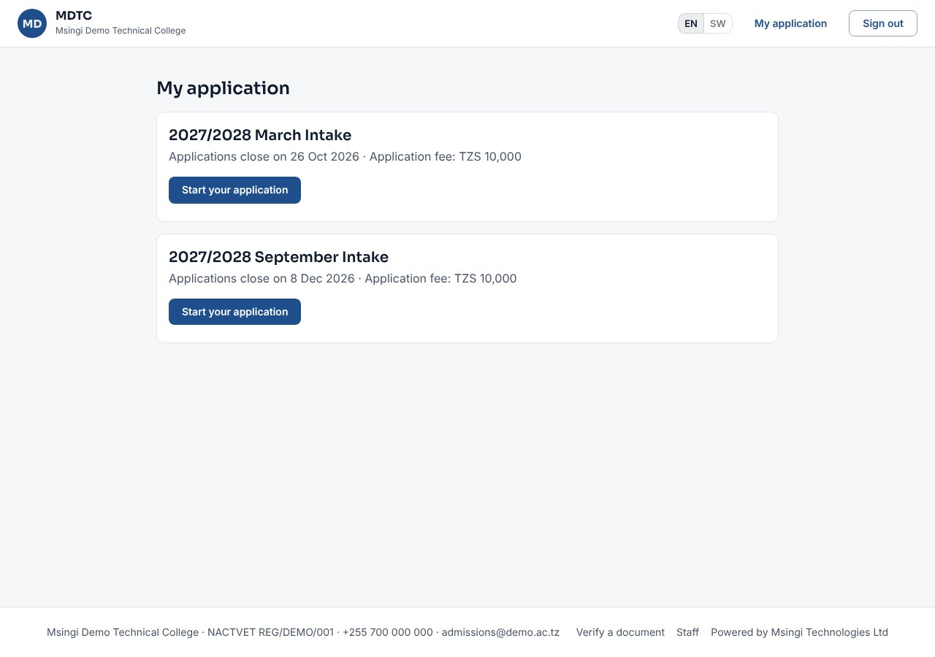
Figure 6: Choosing the admission window

3.4 Personal details
This section explains how to fill in your personal details, address and next of kin.
- Fill in Sex, Date of birth and Nationality (your name is already filled from NECTA).
- Choose where you live: Region, then District, Ward and Village / street (each list opens once the one before is chosen).
- Under Education history, start typing your Primary school and pick it from the list (type it in full if it is not listed). Your O-level school comes from NECTA.
- Under Next of kin, enter the Full name, Relationship (for example Mother, Father or Guardian) and Mobile number of a parent or guardian, and optionally their email and address.
- Click Save & continue.
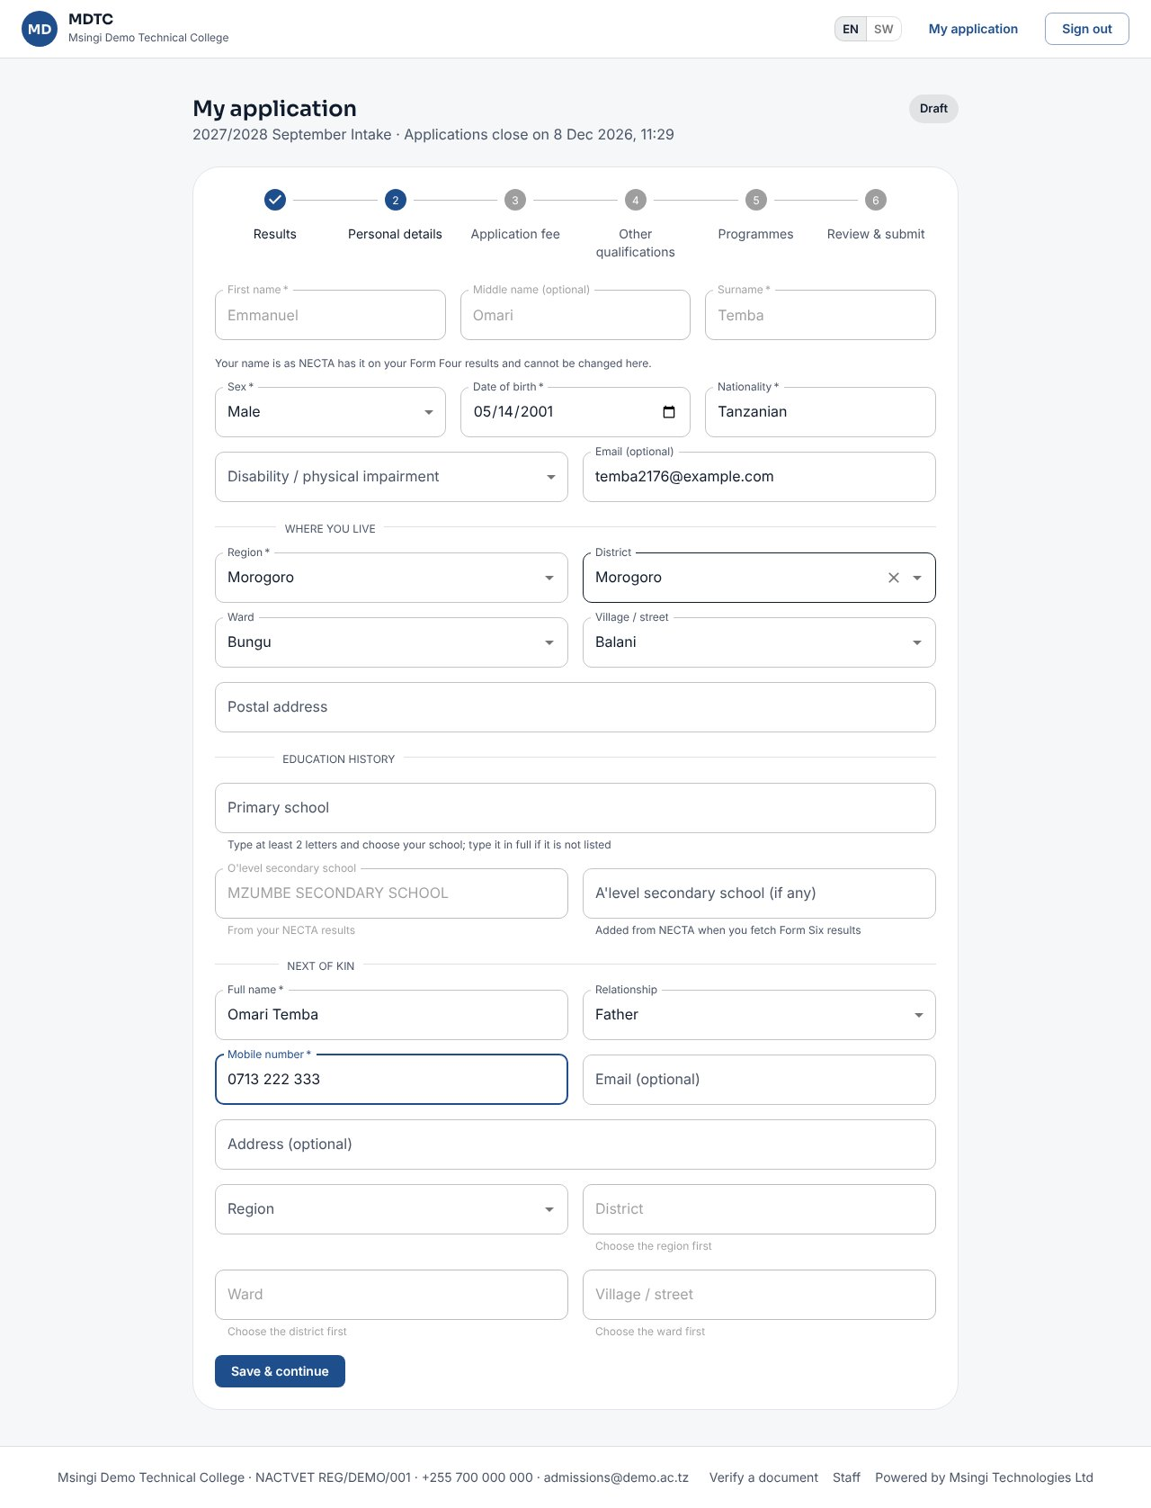
Figure 7: Personal details step

3.5 Pay the application fee
An application is processed only after the fee is paid. This section explains how to get a control number and pay.
- Click Get control number. CIMS shows a GePG control number and sends it by SMS.
- Pay the amount through your bank or mobile money (M-Pesa, Tigo Pesa, Airtel Money, HaloPesa) using the control number.
- When GePG confirms the payment the step shows Application fee paid with the invoice number. Click Continue.
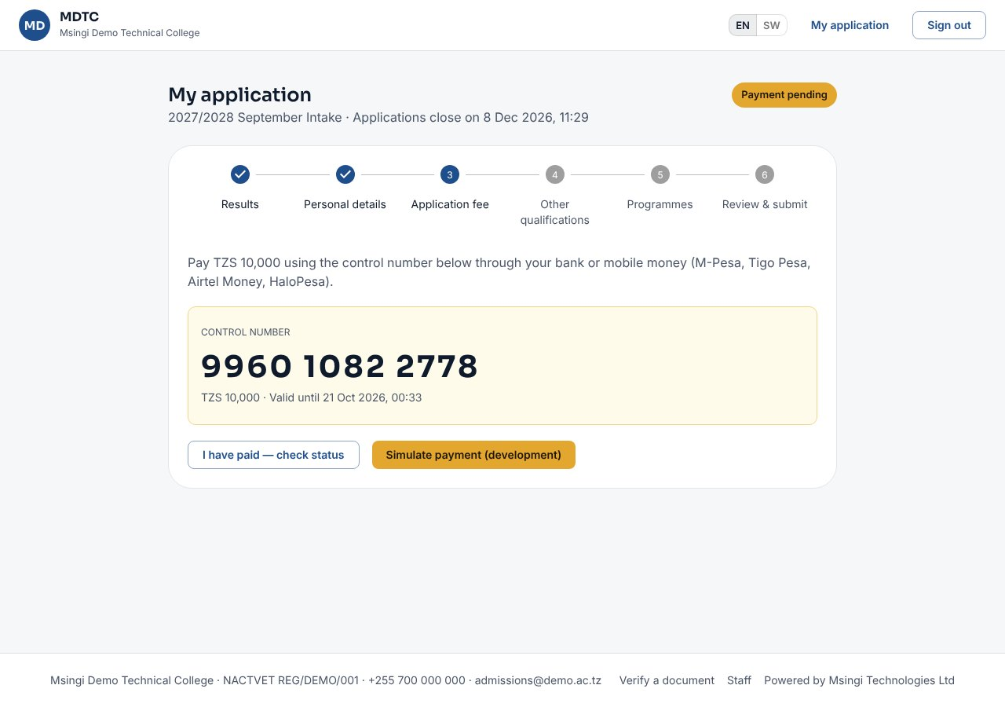
Figure 8: The GePG control number for the application fee
Tip: You can close the page after getting the control number. Sign in again later; the payment shows once GePG confirms it.

3.6 Other qualifications
This section explains how to add any other qualifications you hold, which may open more programmes to you.
Add any other award you hold, or continue without one. The choices are Other CSEE / ACSEE sitting, NTA award, NVA (VETA) award, Other non-NTA award and No other award.
- Other CSEE / ACSEE sitting: enter the index number and year; results come from NECTA.
- NTA award: enter your NACTVET registration number and graduation year; CIMS fetches the award, programme, level and GPA from NACTVET and checks the names match yours.
- NVA or other award: describe the award; the Admissions Office checks it against your certificate before it counts.
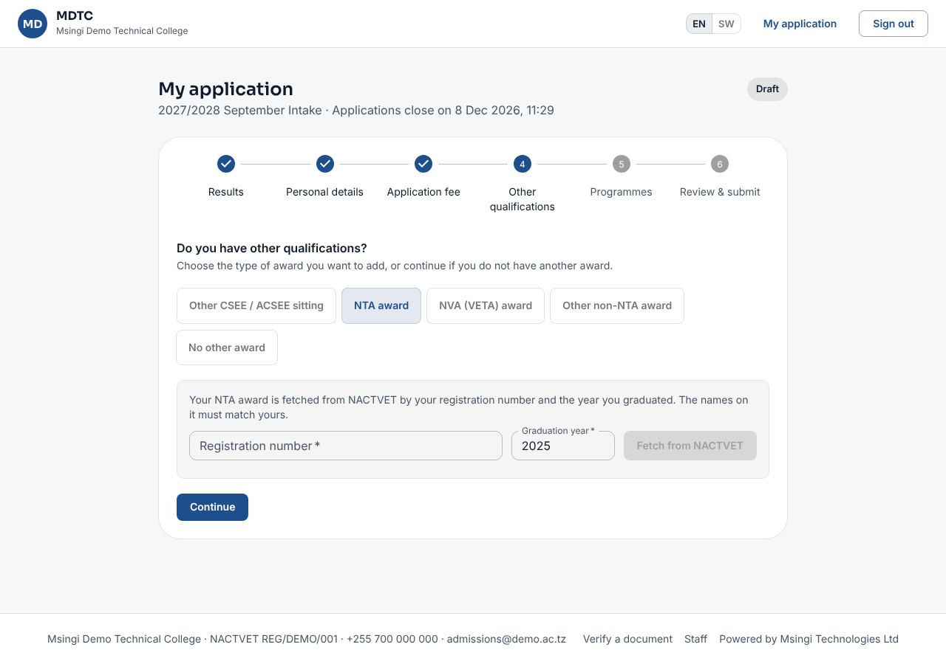
Figure 9: Adding an NTA award

3.7 Choose programmes
This section explains how to choose up to three programmes in order of preference and see whether you qualify for each.
- The list shows only programmes open to your level. Each says You qualify or explains why not; click Why? for the reasons.
- Tick up to three programmes in order of preference (your first tick is your first choice).
- Click Save choices.
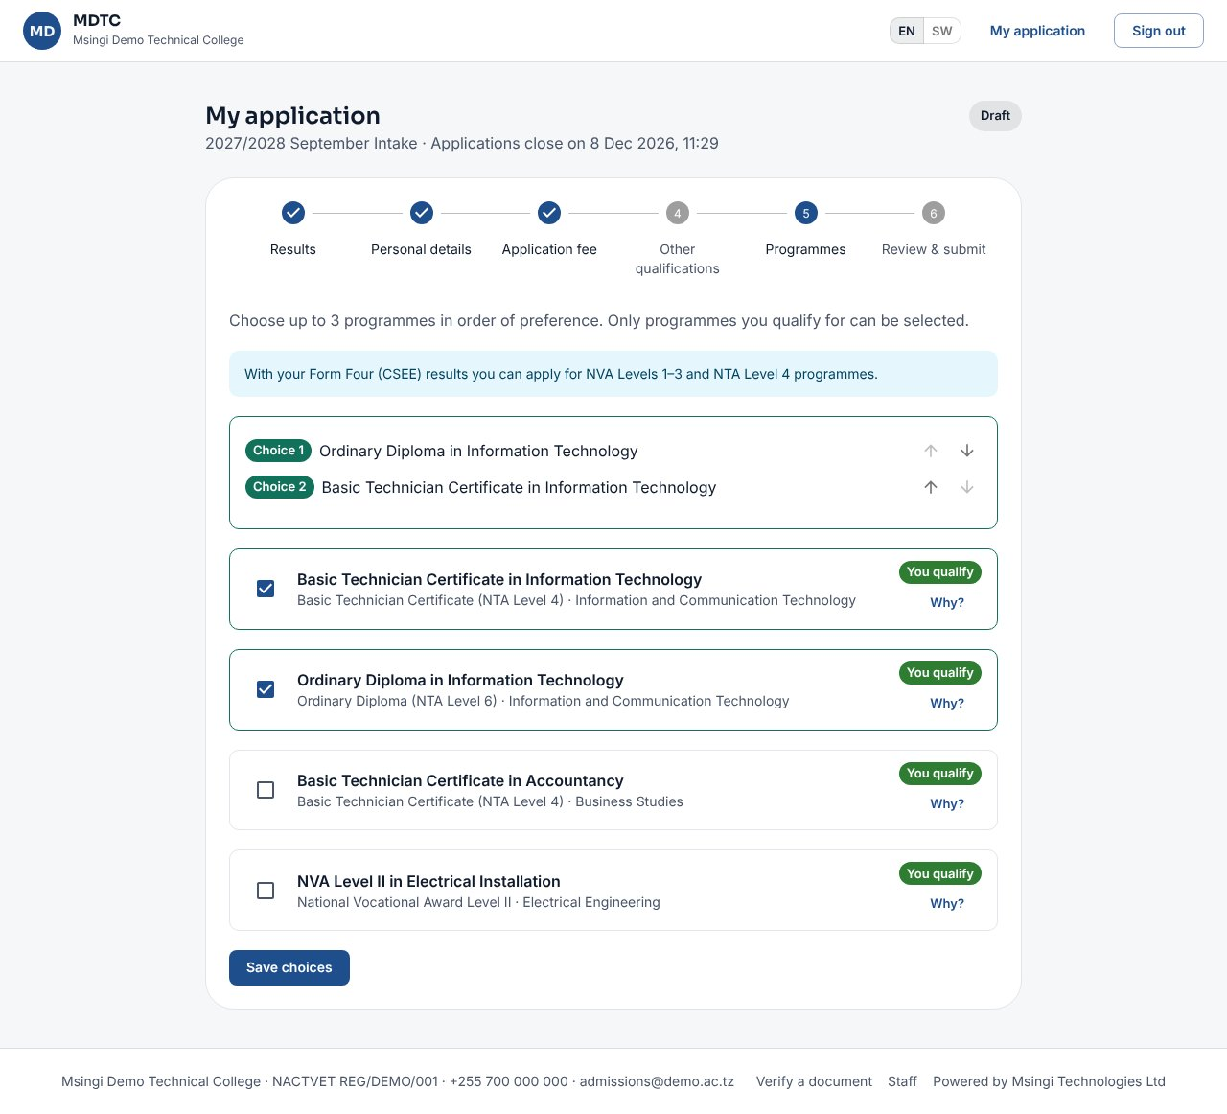
Figure 10: Choosing programmes

3.8 Applicant profile and submit
This section explains how to check your applicant profile, change any part of it, and submit your application.
- The last step, Applicant profile, shows everything your application holds: personal details (with your NECTA index number and PREM number), Form Four results, other qualifications, programme choices, the fee and any documents.
- Click Edit beside Personal details, Other qualifications or Programme choices to change that part: its step opens, you save, and you come back to Applicant profile. Anything still to do is listed above the Submit button.
- Click Submit application. You receive a reference number on screen and by SMS.
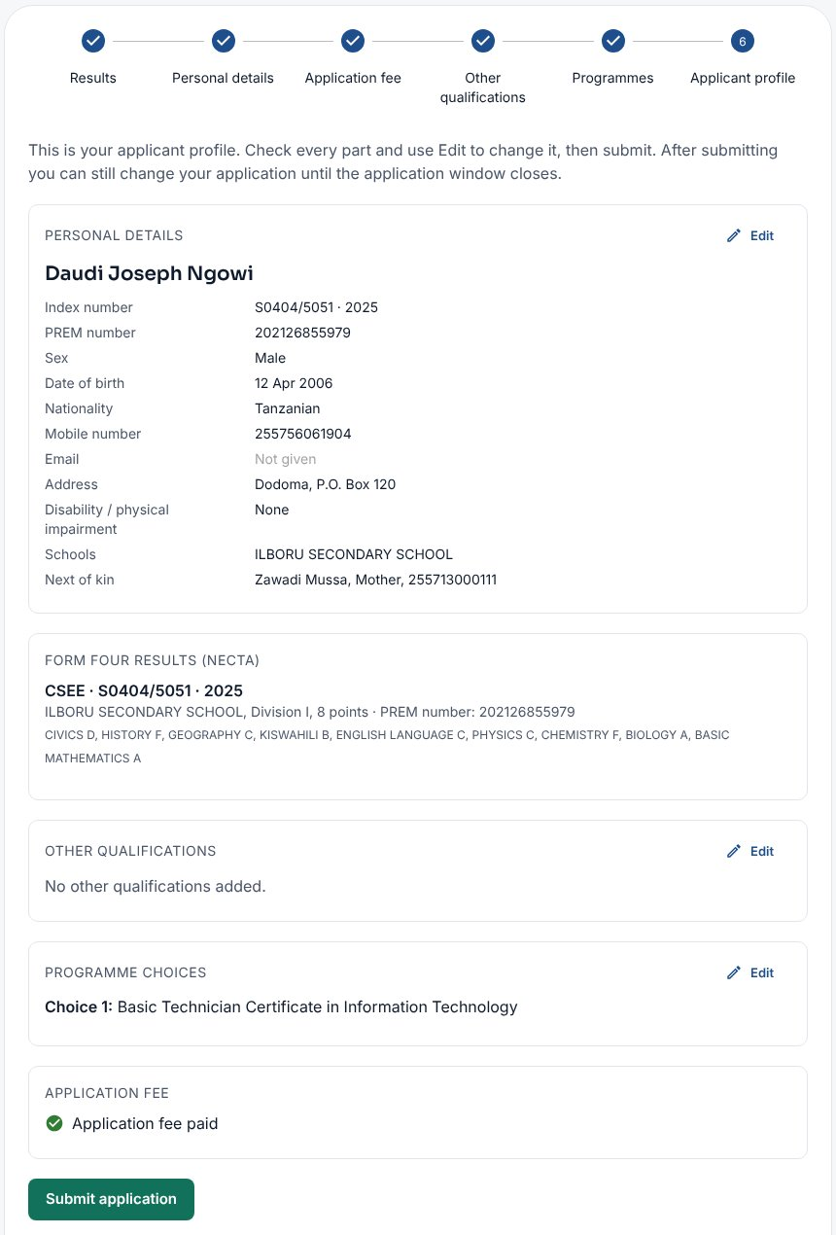
Figure 11: The applicant profile on the last step, with Edit buttons
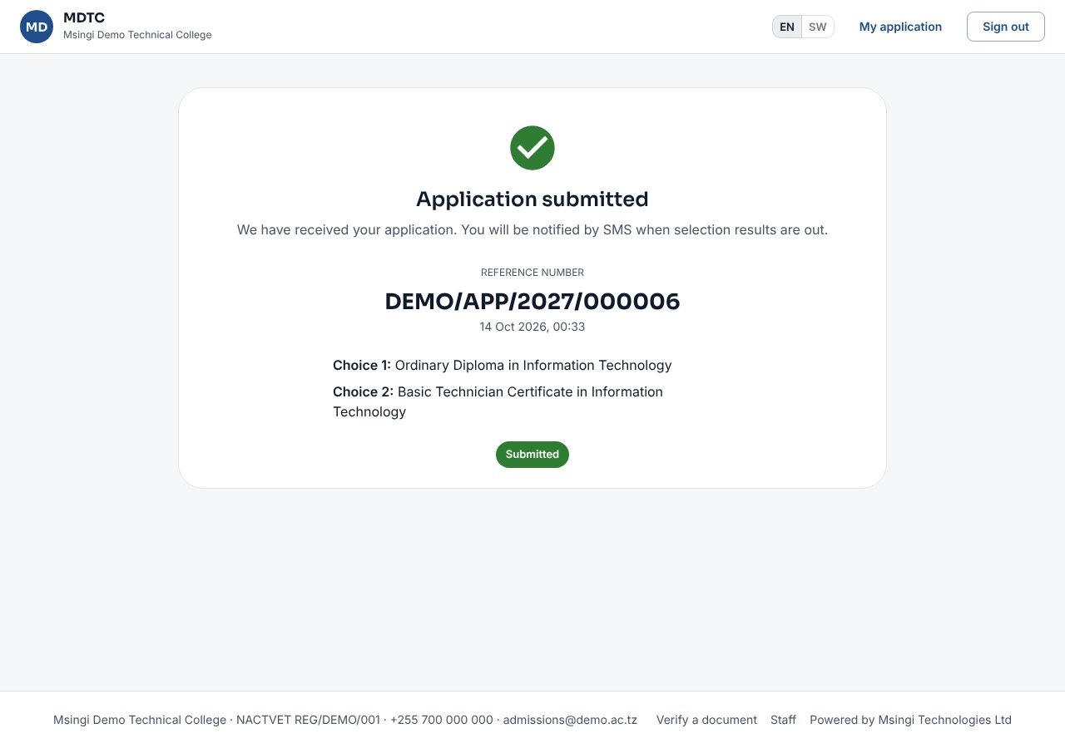
Figure 12: Application submitted, with its reference number
Note: Until the window closes and selection starts, you can still change your details, qualifications and choices; the application stays submitted.

3.9 Accept your offer and download the admission letter
This section explains how to accept or decline an offer of admission and download your admission letter.
When NACTVET verifies a selected applicant, CIMS makes an offer and sends an SMS. Sign in to the admission portal to answer it before the deadline shown.
- Sign in and open My application.
- If you were admitted by more than one institution, type the NACTVET confirmation code sent to you by NACTVET.
- Click Accept offer (or Decline, with an optional reason).
- After accepting, click Download admission letter. The fees invoice for the year, with its control number, appears below.
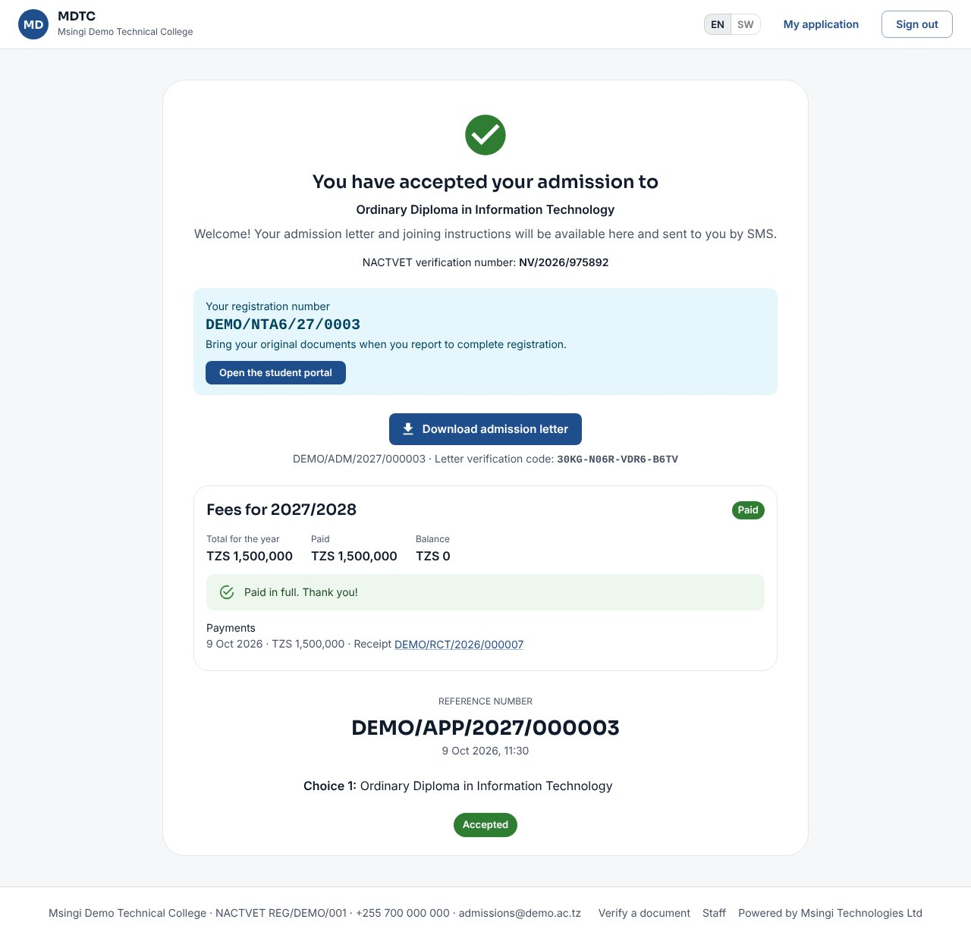
Figure 13: An accepted offer with the admission letter
Note: An offer that is not answered by its deadline lapses automatically and the place goes to the next applicant.

3.10 Verify a document
Anyone can check that a document issued by CIMS is genuine. This section explains how.
- Scan the QR code on an admission letter, statement of results, certificate or ID card, or open Verify a document at the bottom of any portal page.
- Type the Verification code printed on the document and click Verify.
- CIMS shows the document type, name, programme and whether it is valid, superseded or revoked.

3.11 Upload documents and add your email
This section explains how to upload documents the institution asks for and add or confirm an email address.
When the window asks for documents (for example a birth certificate), a Documents step appears before you submit.
- For each document click Upload and choose a clear scan or photo: PDF, JPG or PNG, within the size shown.
- Required documents must be uploaded before you can submit; optional ones may be added later until the window closes.
- If the office does not accept a document you get an SMS with the reason; open the application and upload it again.
On the last step of the application (Applicant profile), under Email, you can add an email address. CIMS sends a 6-digit code to confirm it; once confirmed, your admission letter and messages also come by email. Your personal data, on the same step, lets you download what the institution holds about you or make a request (section 2.7); Read the privacy notice opens the notice you agreed to.

4. Students: The Student Portal
This chapter is for students. It explains each part of the student portal: what to do next, fees, registration, results, attendance, hostel, training, clearance and your profile.
Once Registry has handed you over from admissions you are a student. Sign in at /student with your registration number (or mobile number) and the password you used as an applicant. The bottom bar has Home, Register, Results, Fees and Profile.
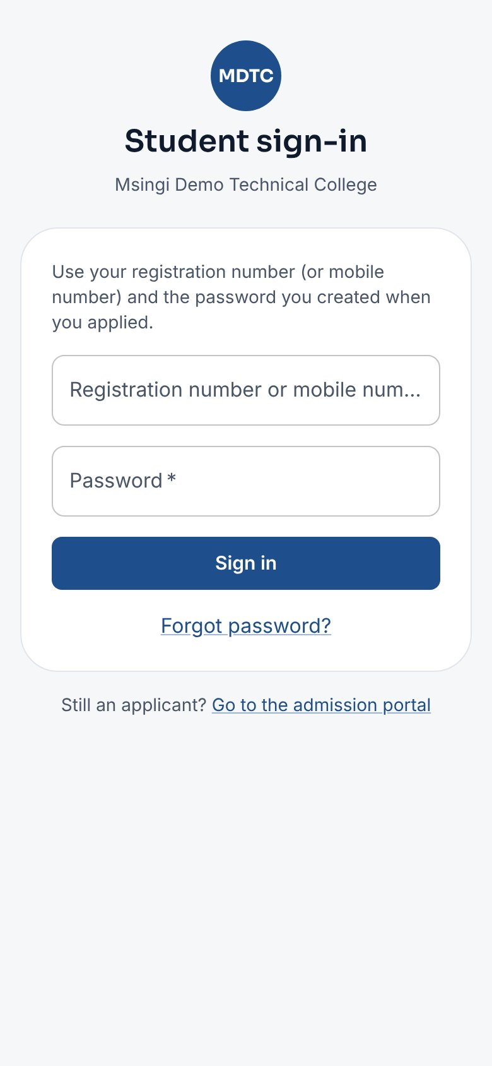 | 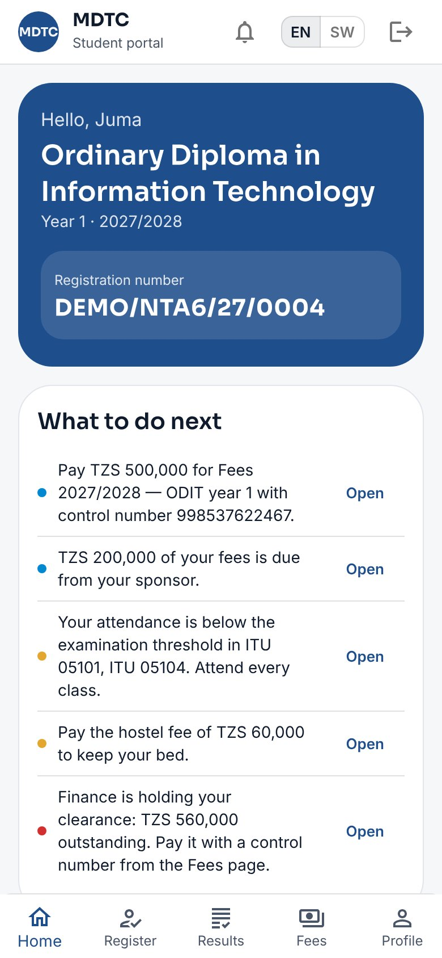
Figure 14: Student sign-in and the home page

4.1 Home: what to do next
The home page tells you what needs your attention. This section explains how to use it.
The home page starts with What to do next: a short list of what needs your attention, each with Open. Examples: register for the semester, pay an invoice with its control number, the share still due from your sponsor, attendance below the examination threshold, supplementary examinations open, a hostel fee to pay, an IPT placement to request, or an office holding your clearance. Below it are your fee balance, clearance, hostel, IPT, attendance and the latest notices.

4.2 Fees and payments
This section explains how to see your invoices, pay fees with a control number and download receipts.
- Tap Fees. You see what was billed, what you have paid and the balance.
- Each invoice shows its Control number. Pay through your bank or mobile money using that number; you can pay in parts.
- Payments appear under Payment history, each with Receipt (PDF) to download.
- If a sponsor pays part of your fees, a green note says which sponsor, what share and how much is still due from them. That amount counts towards your clearance until the sponsor pays.
- What it covers on an invoice lists the fee items.
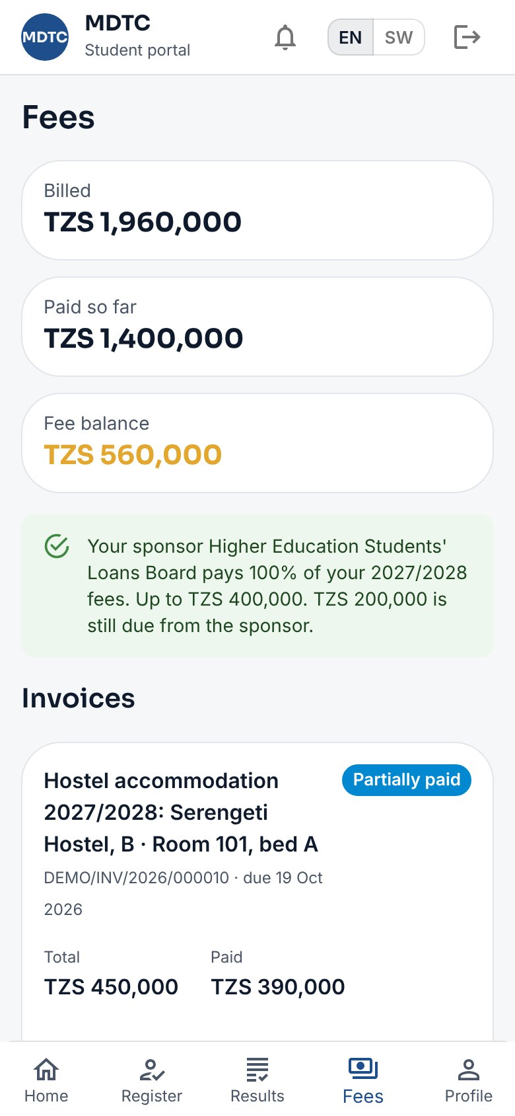
Figure 15: Fees, control numbers and receipts

4.3 Register for the semester
Every student must register each semester. This section explains how to choose modules and submit your registration.
- Tap Register while registration is open (the dates are shown).
- Check the core modules and choose your electives.
- Confirm your details and submit. CIMS checks your fee clearance; a late registration is flagged and, when the semester has a late registration fee, billed once: pay it with the control number shown on the page and sent by SMS.
- Registry approves the registration (you get an SMS) or returns it with a note. You can change electives until it is approved.
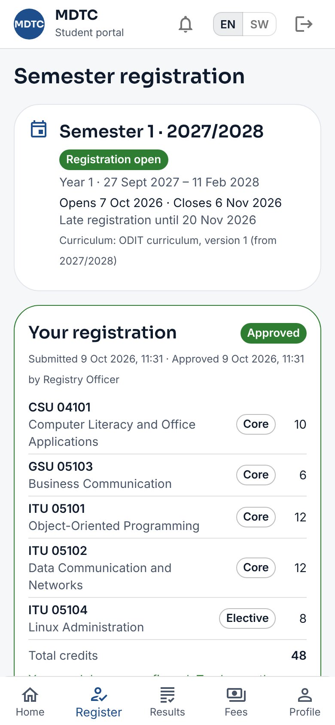
Figure 16: Semester registration

4.4 Results, statements, resits and appeals
This section explains how to see your results, download a statement, register for resits and ask for a remark or appeal.
- Results shows each published semester with grades, GPA, CGPA and the decision. Results are withheld if you have not met the results fees rule.
- Statement of results downloads a PDF with a QR code that anyone can verify.
- If you have a supplementary or special examination decision and registration is open, choose the modules and pay the fee by control number.
- To ask for a re-mark or appeal, under Remarks and appeals choose the Module and the Request, explain Why?, then Send request and pay the fee. Follow it under My requests.
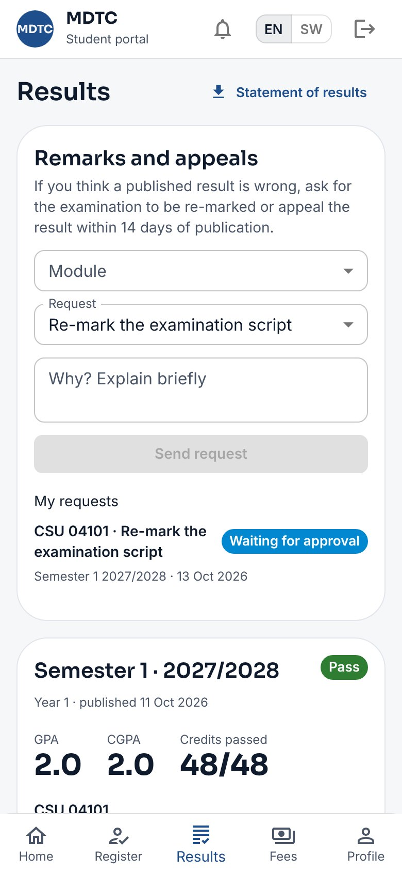
Figure 17: Results with remarks and appeals

4.5 Attendance and checking in to a class
Attendance decides whether you may sit examinations. This section explains how to see your attendance and check in to a class with a QR code.
The home page shows your attendance per module and whether you may sit the examination. When a lecturer starts self check-in:
- Scan the QR code on the lecturer's screen with your phone camera, or tap Check in to a class.
- Type the six-digit Code shown (it changes every 20 seconds) and tap Check in.
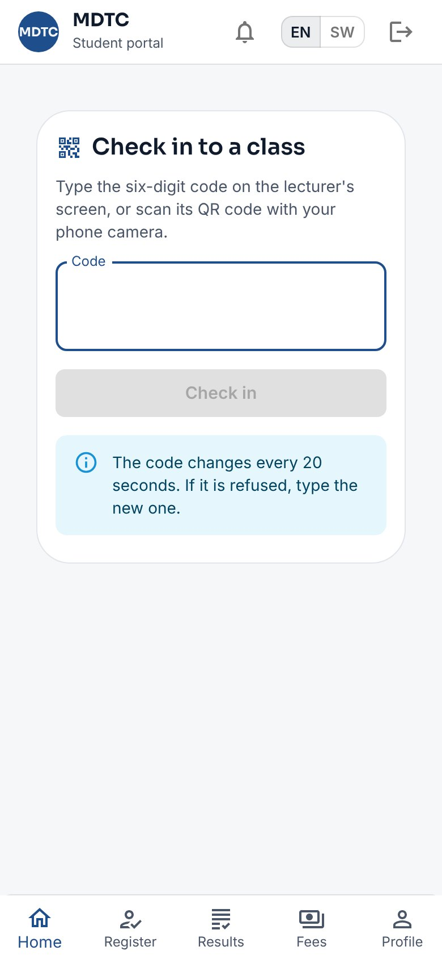 | 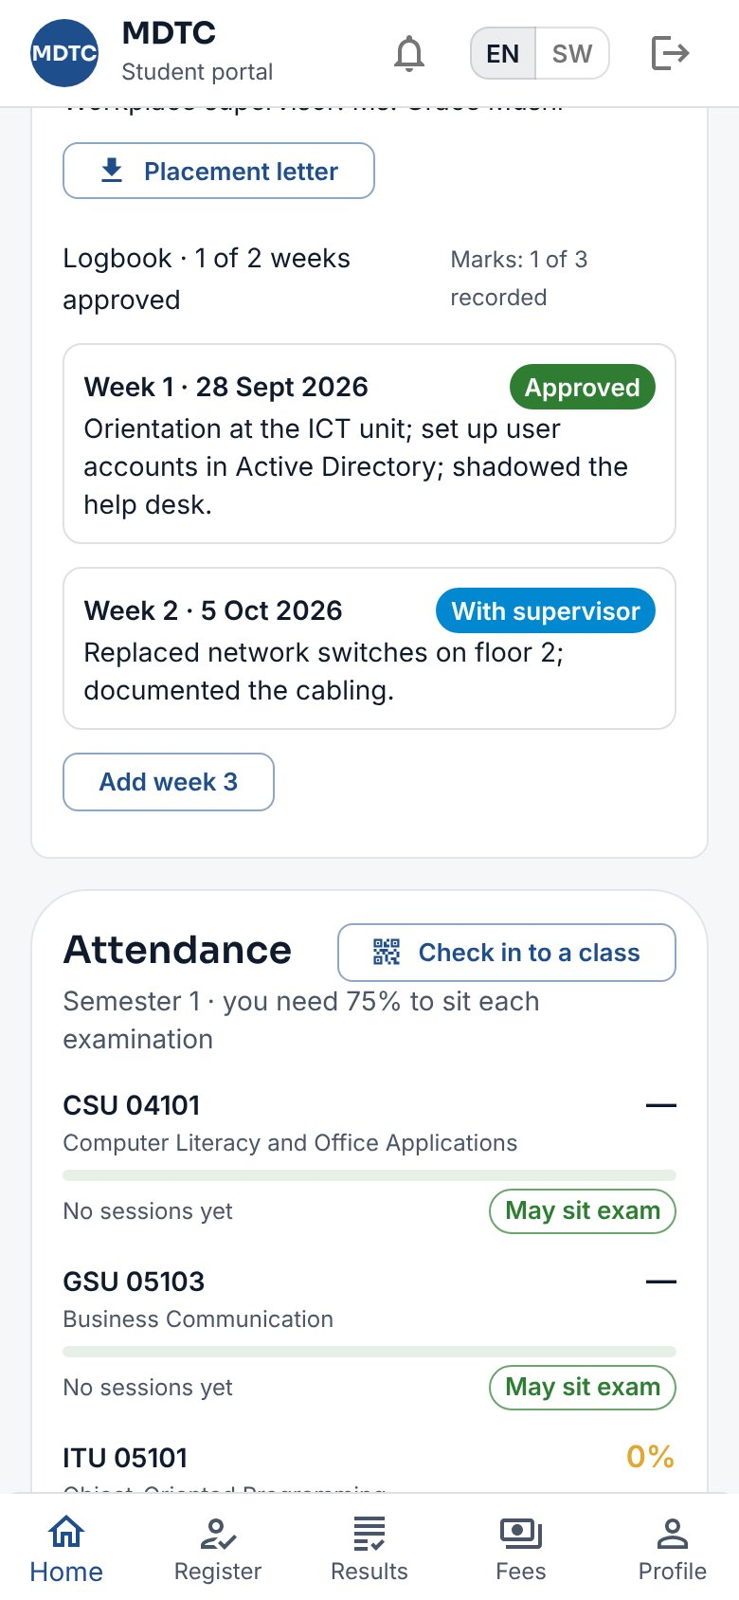
Figure 18: Self check-in and attendance on the home page

4.6 Hostel and repairs
This section explains how to apply for a hostel place, see your allocation and report repairs.
- When a hostel application window is open, apply from the Hostel card with up to three hostel choices, a room type and any special needs.
- If you are allocated a bed, pay the hostel fee by its control number before the date shown, or the bed is released.
- To report a problem in your room, tap Report a repair, describe it and send. You get an SMS as it is fixed.

4.7 Industrial practical training (IPT)
This section explains how to request a placement for industrial practical training, download your letter and keep your logbook.
- When an IPT period is taking requests, propose a placement (an organisation in the list or a new one).
- Once confirmed, download your Placement letter.
- Each week tap Add week, write what you did, save a draft and submit it. Your institution supervisor approves it or returns it with a comment.
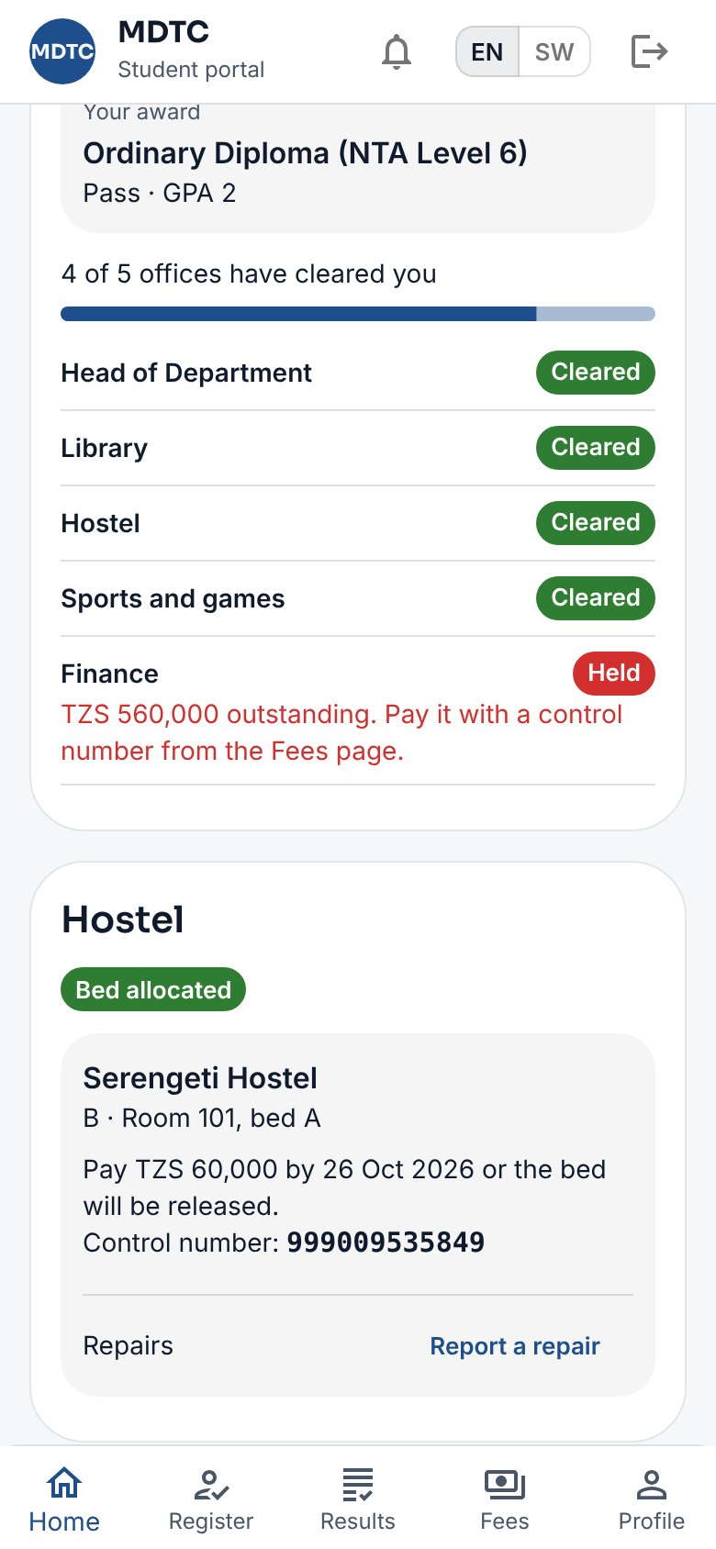 | 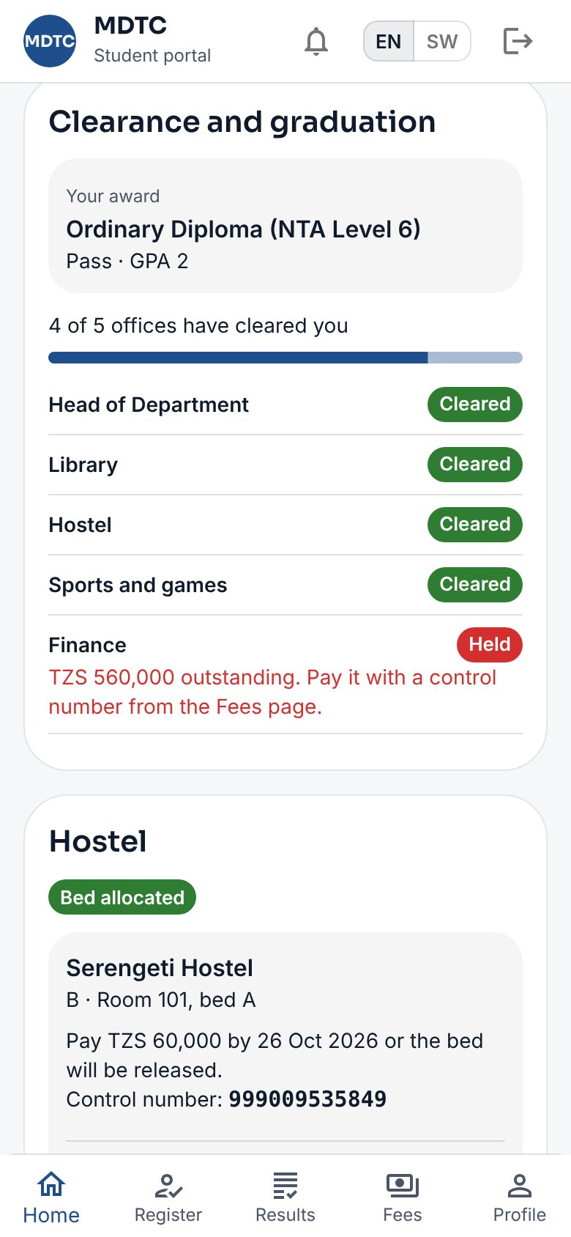
Figure 19: Hostel and IPT on the home page

4.8 Clearance for graduation
Before graduating, every office must clear you. This section explains how to follow your clearance.
When you have completed your programme, the Clearance and graduation card shows your award and each office. Start clearance there; each office clears you or holds you with a reason (sent by SMS). Finance clears itself when you owe nothing.
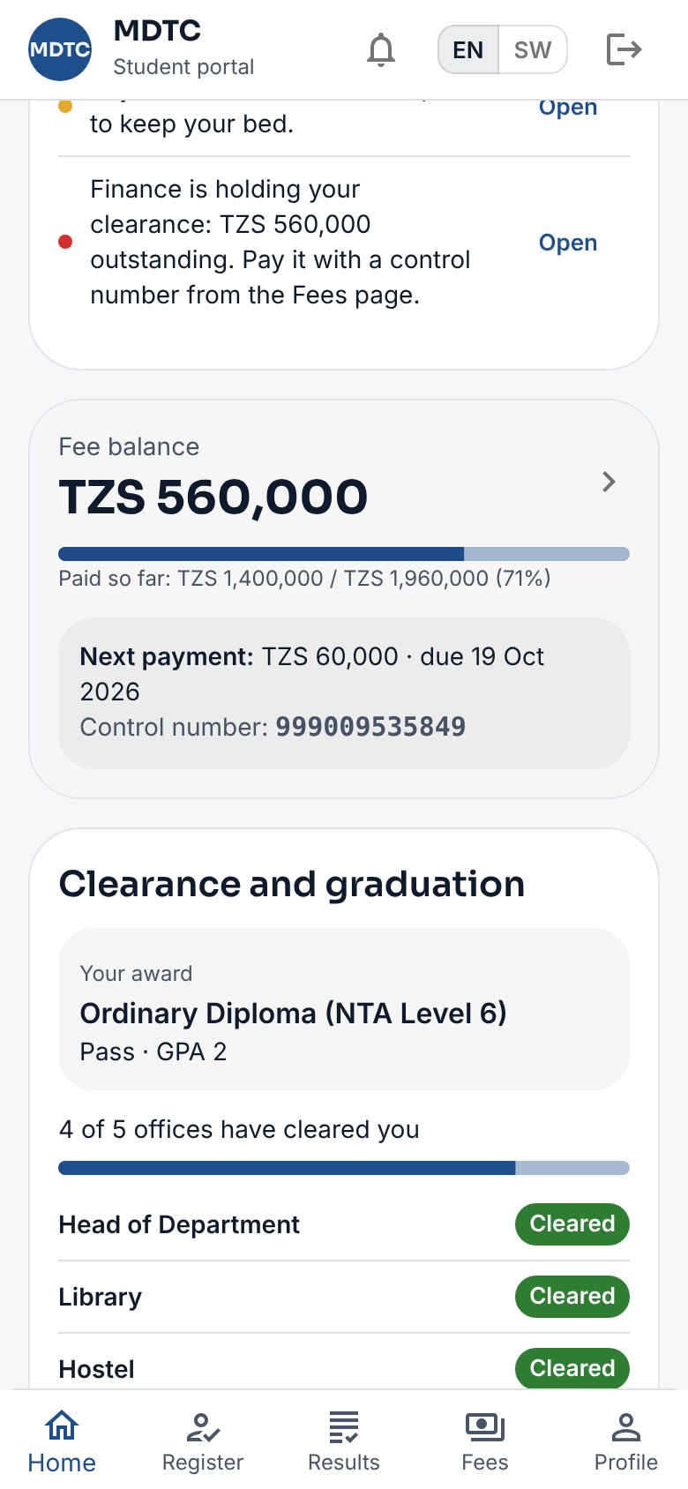
Figure 20: Clearance and graduation

4.9 Notices and profile
This section explains where to read the institution's notices and how to see and correct your profile.
- Notices (the bell at the top) lists notices from the institution for all students or your programme.
- Profile shows your programme and details. To correct a detail tap Request a correction; Registry approves or rejects it with a reason. A name or date of birth change needs the original documents.
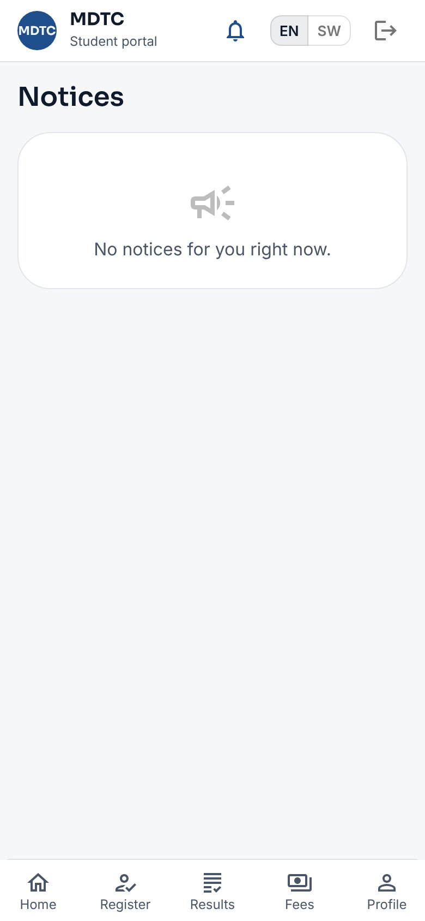 | 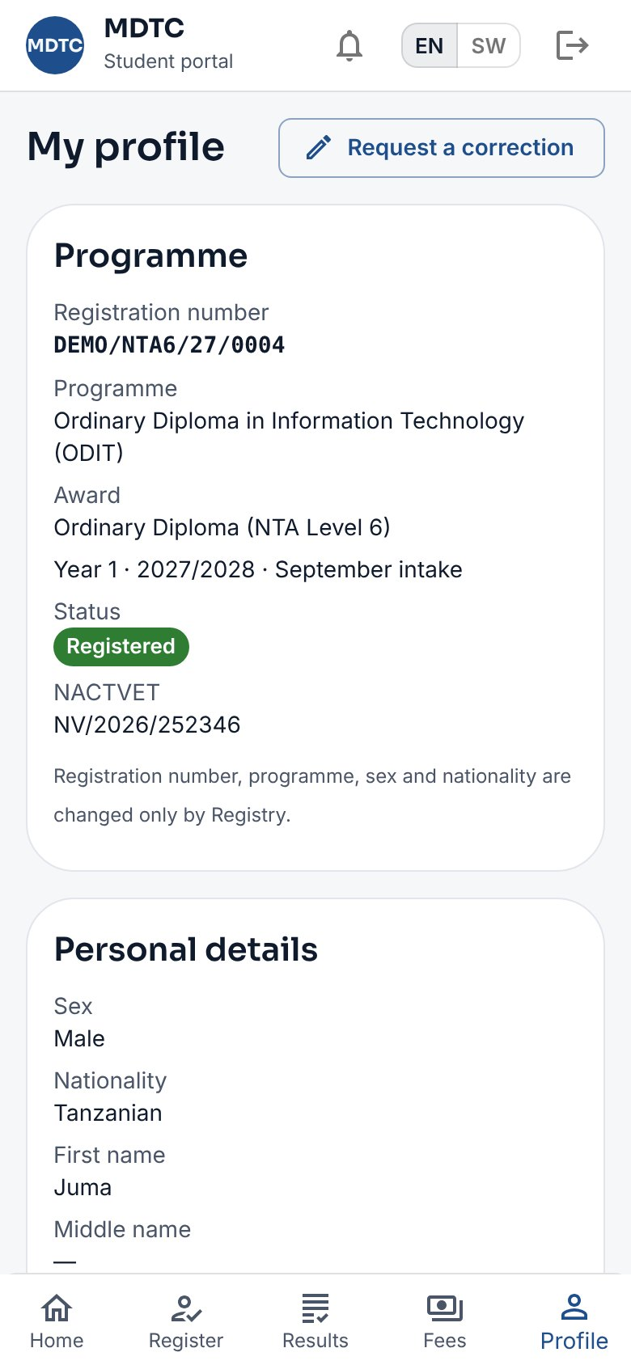
Figure 21: Notices and profile

4.10 Campus, transfers, National ID, health insurance and your data
This section explains how to ask for a programme or campus transfer, add your National ID, and ask about the personal data the institution holds about you.
Open Profile in the student portal.
- Campus and transfers shows your campus. Click Ask for a transfer to move to another programme or campus, choose it, say why and click Send request. Registry checks it, the Head of the new department recommends and the Deputy Principal (Academic) decides; you are told by SMS. Your registration number stays the same.
- National ID (NIN): type the 20-digit number on your NIDA ID card and click Save. CIMS checks it with NIDA against your name and date of birth and shows the result (for example Confirmed by NIDA or Details differ at NIDA).
- Health insurance (NHIF): if you already have an NHIF card (for example through a parent), type its number and click Check my card. CIMS checks it with NHIF: it must be active, not expired and in your name.
- If you have no card, click I do not have an NHIF card and confirm. You are billed NHIF's student contribution with a control number; once you pay, the institution registers you with NHIF and your card number comes to you by SMS. If you find your own card before paying, give it and the bill is cancelled.
- Your personal data: download your data or make a request, as in section 2.7.
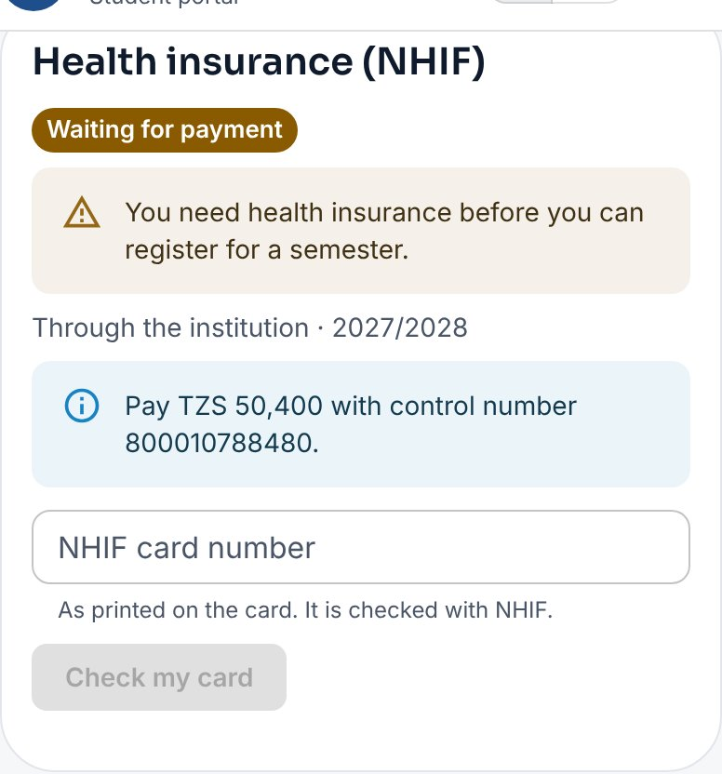
Figure 22: Health insurance on the student profile, waiting for payment
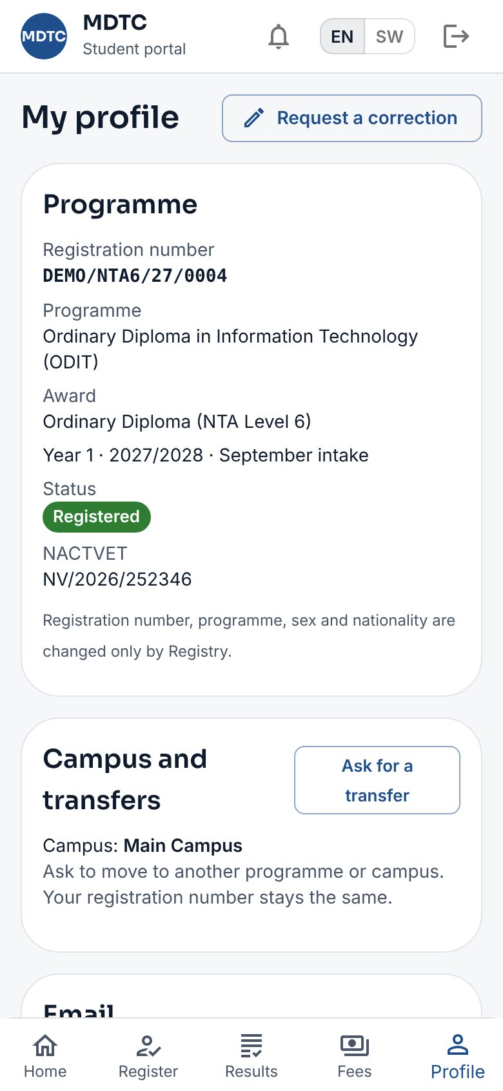
Figure 23: Campus and transfers on the student profile

4.11 Your timetable
This section explains where to find your classes and examination papers for the semester you are registered for.
- Tap Timetable in the student portal.
- Under My classes each day lists your classes: the time, the module, the type (lecture, tutorial, practical or seminar) and group if any, the venue and the lecturer. A class marked Changed was moved after the timetable was published.
- Under My examinations each paper shows its date, time and venue(s), once the Examinations Office has published the examination timetable.
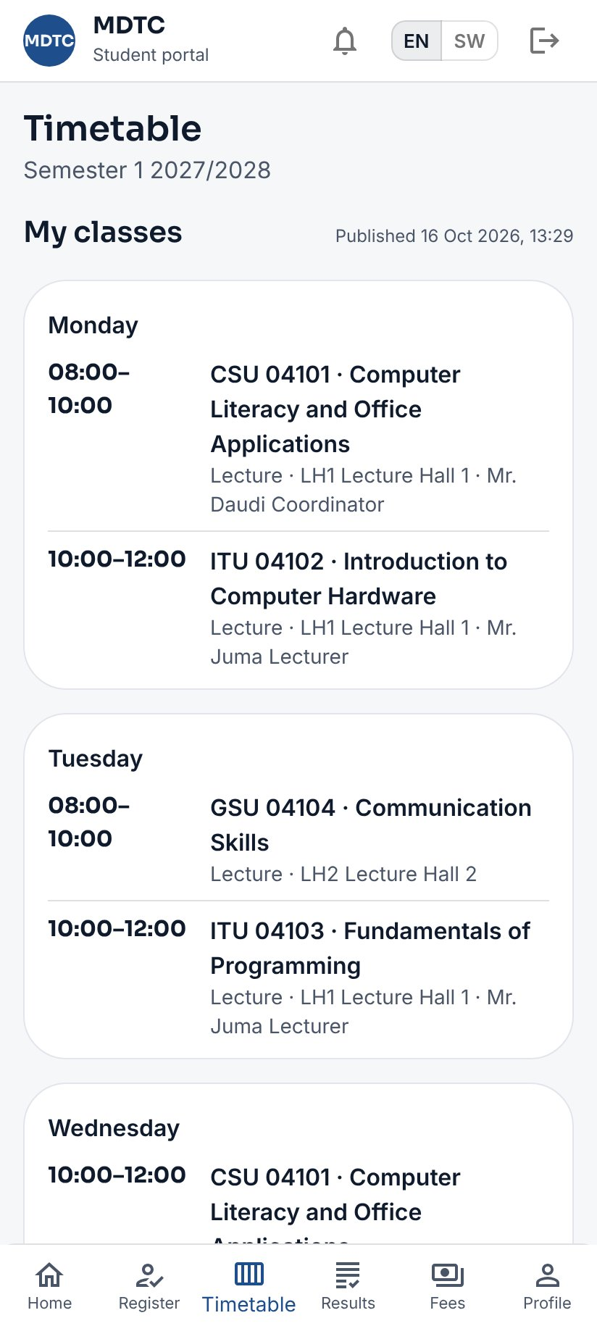
Figure 24: Your timetable in the student portal
Note: You get an SMS when each timetable is published. You may sit a paper only if you are on its eligibility list (attendance, coursework and fees).
Part C — Institution Staff

5. Staff: Common Features
This chapter covers the features every staff member uses, whatever their role: the screen layout, dashboard, approvals, reports, notices and messages.
Every staff member uses the same back-office at /staff. This chapter covers what is common to all roles.

5.1 The screen layout
This section explains how the back-office screen is arranged and how to find your way around it.
- The menu on the left is grouped by area (Admissions, Registry, Teaching, Examinations, Student services, Finance, Communication, Administration). It shows only the pages your roles can open. Inside a page, a link or button that leads to a page your roles cannot open, or to a step that is not ready yet (for example the selection steps of a window that has not opened), is shown faint and cannot be clicked; point at it to see why.
- At the bottom of the menu are your name and roles (and your department or programme if your role is limited to one), Change password and Sign out.
- Lists can be filtered and searched at the top; most have Excel or CSV downloads. Every export is recorded in the audit trail.
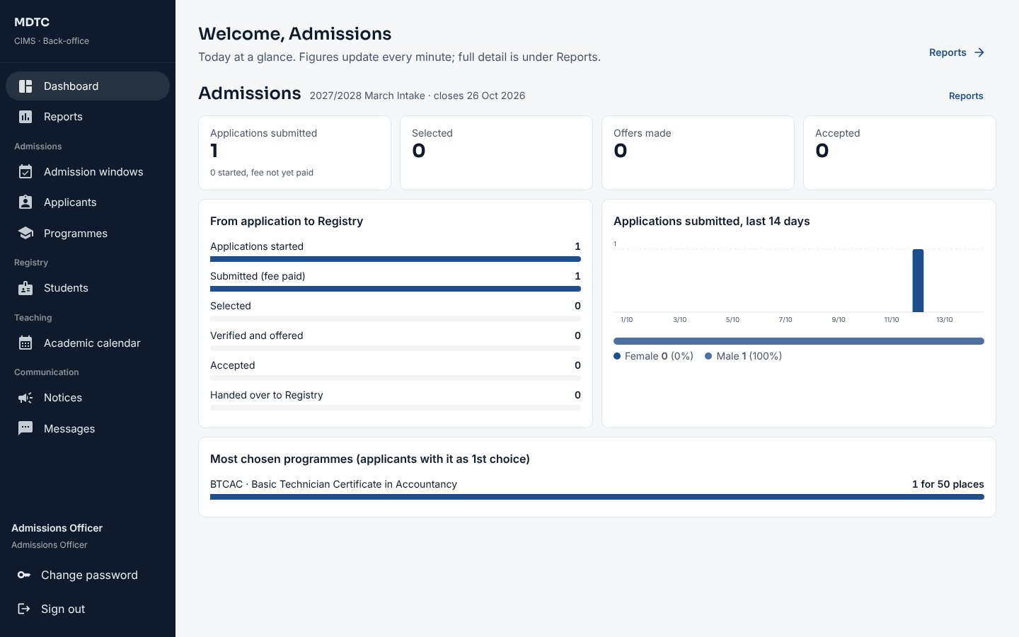
Figure 25: The staff back-office: menu and dashboard

5.2 Dashboard
This section explains the dashboard, which shows the day's figures for your area of work.
The Dashboard shows today's figures for your area (admissions funnel, students, collections and debtors), refreshed every minute. Roles with a work page of their own land there instead: My teaching, Examinations office, Finance overview, Hostels, Industrial training or Clearance.

5.3 Approvals
Many actions need a second person's approval. This section explains how to find and decide everything waiting for you.
Approvals lists everything waiting for your decision (selection rounds, curricula, class results, exemptions, result amendments, graduand lists, module results, resit marks, competence verification, status changes, appeals, waivers and refunds), grouped by the body deciding and oldest first. The number beside the menu item is how many wait for you.
- Click Approvals in the menu.
- Click Review on an item. It opens the page where the full record is.
- Decide there (approve, return with a comment, or reject with a reason).
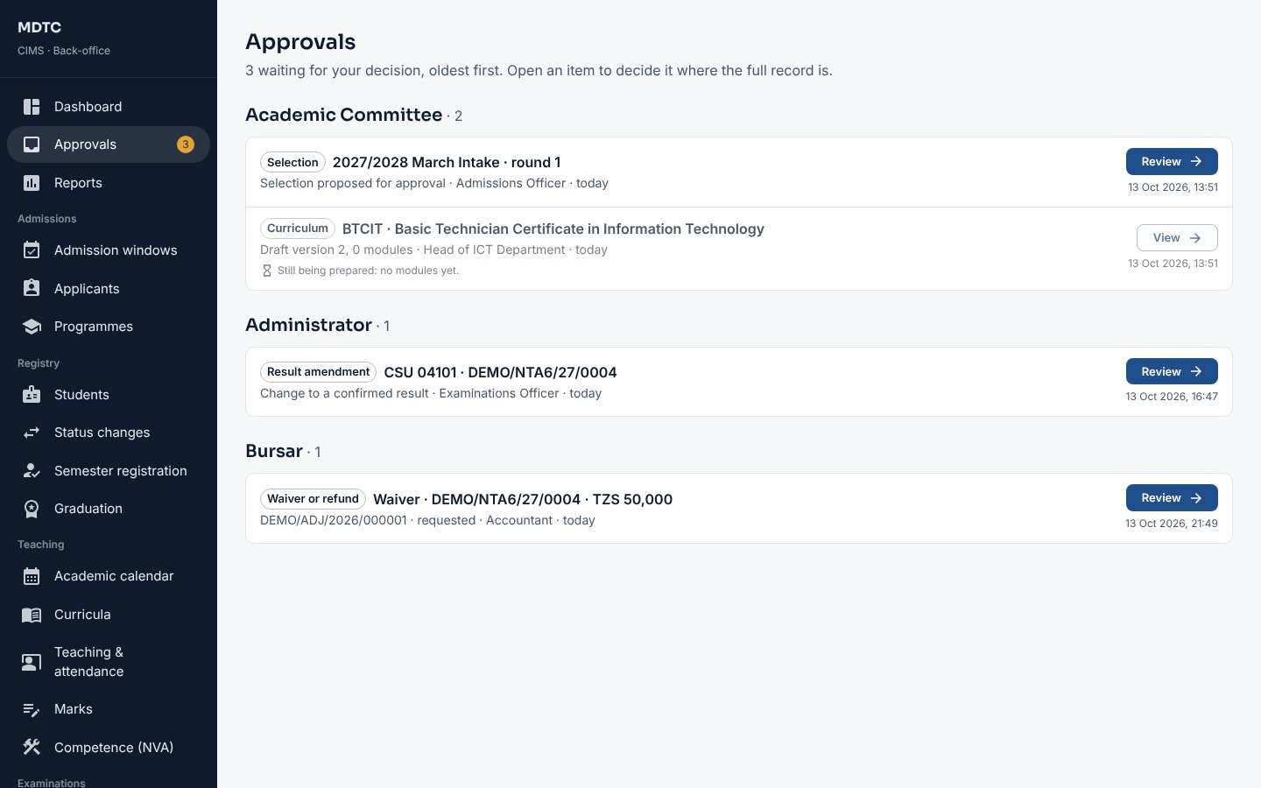
Figure 26: The Approvals list
Note: Your own submissions appear as View but you cannot decide them: CIMS enforces segregation of duties.

5.4 Reports
This section explains how to run a report, filter it and export it to Excel or PDF.
- Click Reports. The catalogue shows the reports your roles may run, grouped by area with their codes (for example ADM-01).
- Choose a report and set the filters (academic year, intake, programme, sex, status, period, as offered).
- View it on screen, or click Excel or PDF to download.
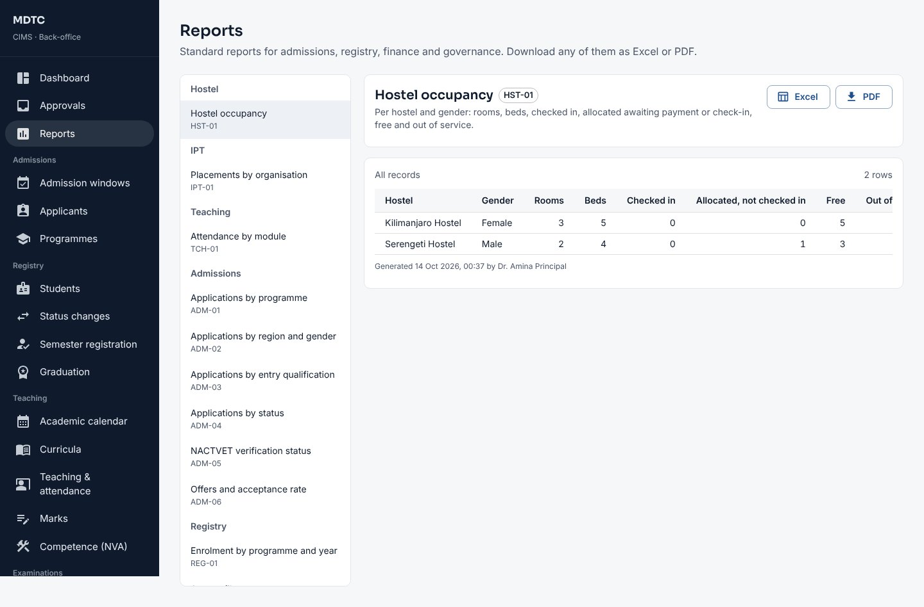
Figure 27: The report catalogue

5.5 Notices
This section explains how to publish a notice to all students or to a programme and year.
- Open Communication › Notices and click New notice.
- Type the Title and Notice, choose the Category and the audience (all students, or a Programme and Year of study).
- Optionally set Remove from the portal on and tick Pin to the top.
- Click Save as draft, then Publish: now or at a set time, optionally with an SMS alert. Students see it on the portal and you can see who read it.
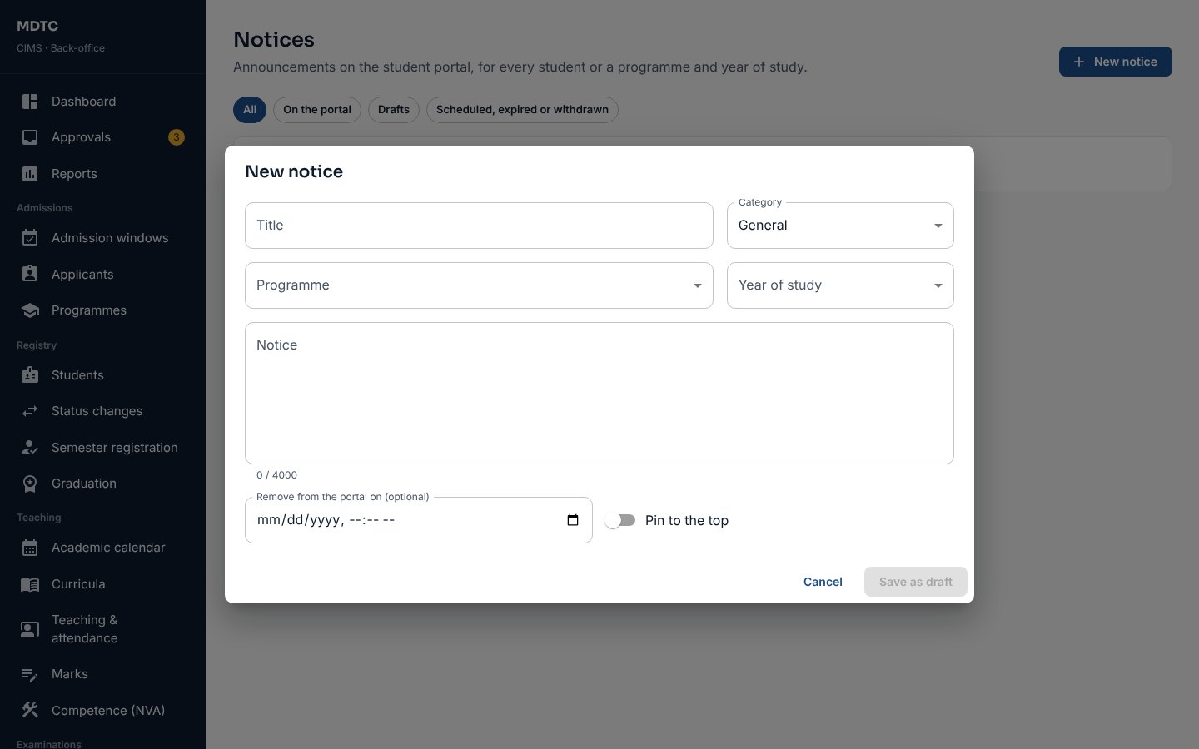
Figure 28: Writing a notice

5.6 Messages (SMS)
This section explains how to see the SMS balance and delivery, and send messages to students or applicants.
Communication › Messages shows the SMS bundle balance, messages and cost this month, and the delivery rate. Its tabs are Overview, Send a message, Sent bulk messages, Message log and Event messages.
- Open Send a message. Under Who choose Students, Applicants or A list of numbers, then narrow by status, year, programme, or Only students who owe fees.
- Type a Title (for your records) and the Message. Use Insert to add {firstName}, {balance} and similar fields.
- Click Preview recipients and cost to see how many people, how many SMS parts and the cost against the bundle.
- Send. Follow delivery under Sent bulk messages and resend failures.
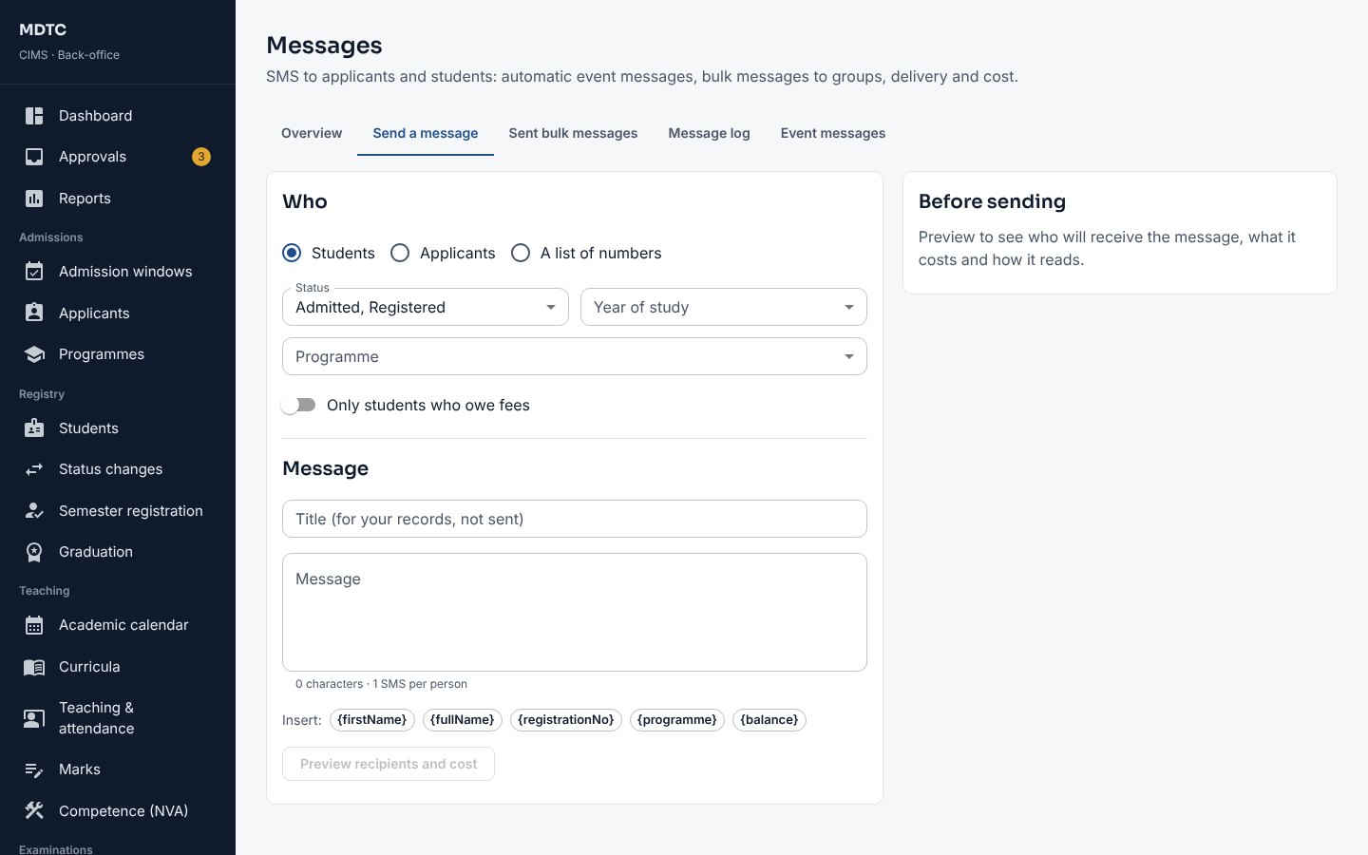
Figure 29: Sending a bulk SMS
Tip: Event messages lists the 58 automatic messages (Appendix C). Each institution can reword any of them in English and Kiswahili or switch it off.

5.7 Email and scheduled reports
This section explains how email is used alongside SMS and how to have reports sent automatically on a schedule.
Messages go by email as well as SMS when the person has confirmed an email address. Open Messages › Email to see the email outbox (queued, sent and failed emails) and the scheduled reports.
- Under Scheduled reports click Schedule a report.
- Choose the Report, the Format (Excel or PDF), How often (daily, weekly or monthly), the day and the hour.
- Choose who receives it under Send to (staff with a confirmed email) and save. Send now runs it at once.
Note: Each run uses the roles of the person who set it up, so a report shows only what they may see.
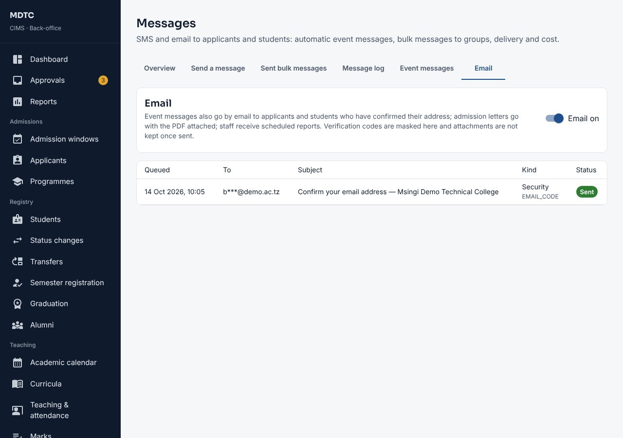
Figure 30: Messages › Email: the email outbox and scheduled reports

6. Institution Administrator
This chapter is for the Institution Administrator: the person who manages staff accounts, the institution's settings and its security. It explains, step by step, how to create users and give them roles, keep the institution profile, record decisions that need a second person, and look after security, personal data, imports and integrations.
The Institution Administrator manages staff accounts and the institution profile, and records the decisions that need a second person (Governing Board confirmation of results, graduand approval, result amendments). The administrator can open every page.

6.1 Staff users and roles
This section explains how to create staff accounts, give each person the roles they need and lock or reset an account.
- Open Administration › Users & roles. The list shows each account, roles, status and last sign-in.
- Click New user. Enter the full name, username, email and phone.
- Tick one or more roles. For Head of Department choose the department; for Programme Coordinator the programme; for IPT Coordinator optionally a department; for Sponsor Officer the sponsor.
- Save. CIMS shows a temporary password once; give it to the person. They must choose their own at first sign-in.
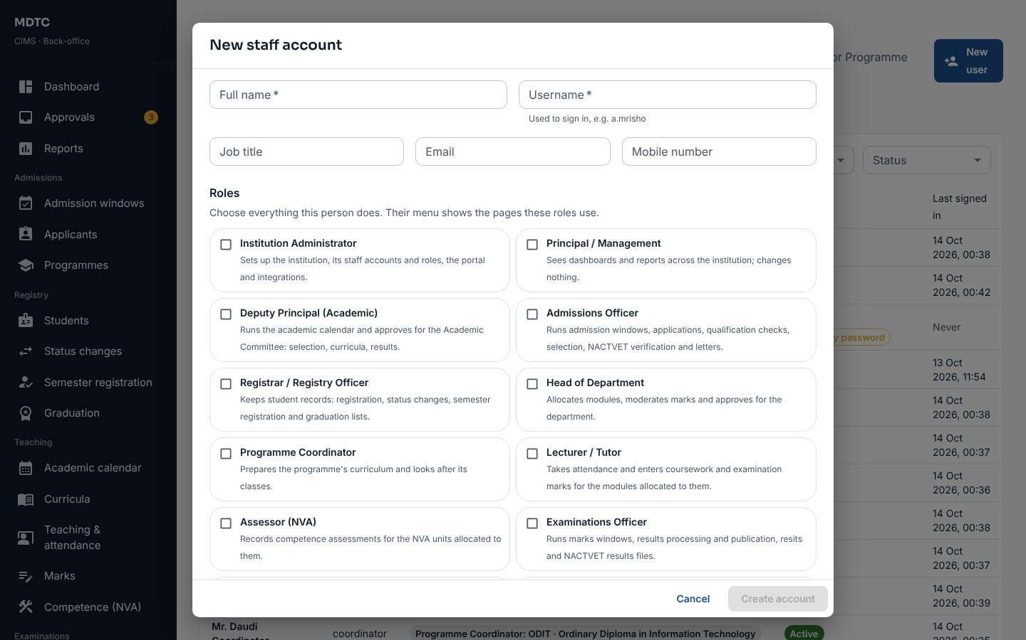
Figure 31: Creating a staff account
Open an account to change its roles, reset the password, disable it with a reason, enable it again or unlock it after too many wrong passwords. Changing roles, disabling or resetting ends the person's open sessions at once.
Note: The institution always keeps at least one active administrator; CIMS refuses to disable or demote the last one.

6.2 Institution profile and campus photo
This section explains how to update the institution's details and the campus photo shown on the admission portal.
- Open Administration › Institution.
- Under Campus photo click Upload photo and choose a JPEG, PNG or WebP picture (up to 5 MB, at least 800 pixels wide).
- Add a Caption if you wish. The photo appears on the admission portal home page straight away.
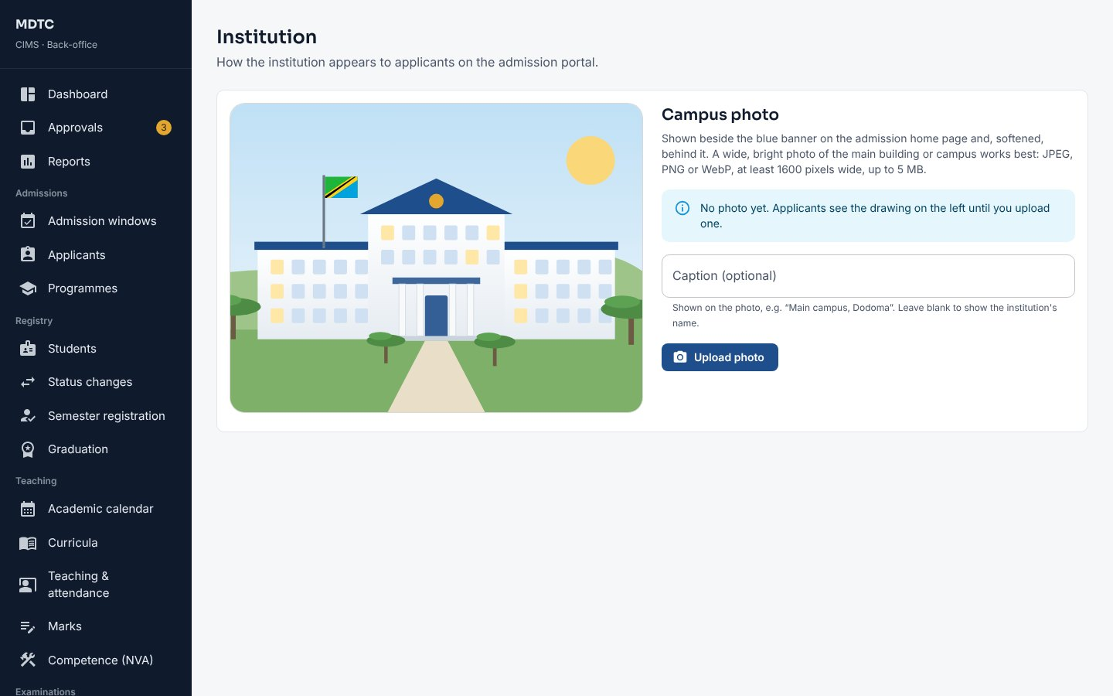
Figure 32: Institution page with the campus photo

6.3 Decisions that need a second person
Some decisions, such as Governing Board confirmation of results, must be recorded by the administrator. This section explains each one.
- Governing Board confirmation of results: open the class result sheet from Approvals and click to confirm with the Board's minute reference. After this the results are locked (section 14.5).
- Graduand approval: open the graduation from Approvals and record the Board's approval with the minute reference, or return it (section 10.7).
- Result amendments: open Examinations › Result amendments, compare confirmed and corrected marks, and approve or reject (section 14.8).
- Waivers and refunds above the threshold: approve as the second level, like the Principal (section 15.3).

6.4 Audit trail
The audit trail records who did what and when. This section explains how to search it.
- Open Administration › Audit trail.
- Choose the period (today, 7 days, 30 days or a range up to a year) and filter by area, person, action or text. Security events shows sign-ins, failed sign-ins and locked accounts.
- Click a record to see its full history, or a person to see their activity. Export CSV downloads the list (the export itself is recorded).
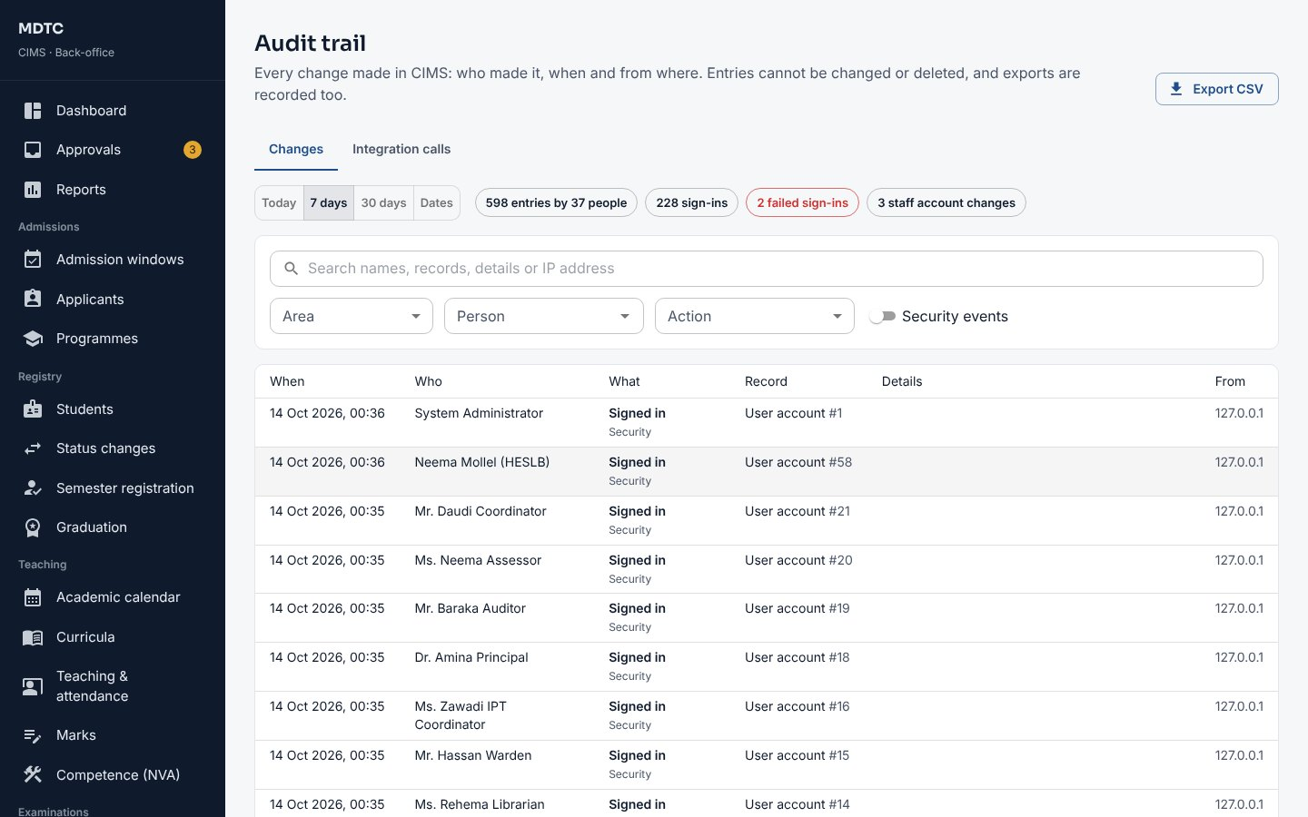
Figure 33: The audit trail

6.5 Two-step sign-in and sign-out times
This section explains how to decide which roles must use two-step sign-in and how long an idle session stays open.
- Open Administration › Security & privacy, tab Sign-in & sessions.
- Under Who must use it choose Optional, Required for administrators, management, admissions, registry, examinations and finance, or Required for all staff. Set it up on your own account first (section 2.7).
- Under Sign out after no activity set the minutes for staff, students and applicants, and click Save.
If someone loses their phone, open their account in Users & roles and click Reset two-step sign-in; they set it up again at their next sign-in. Another administrator must reset yours.
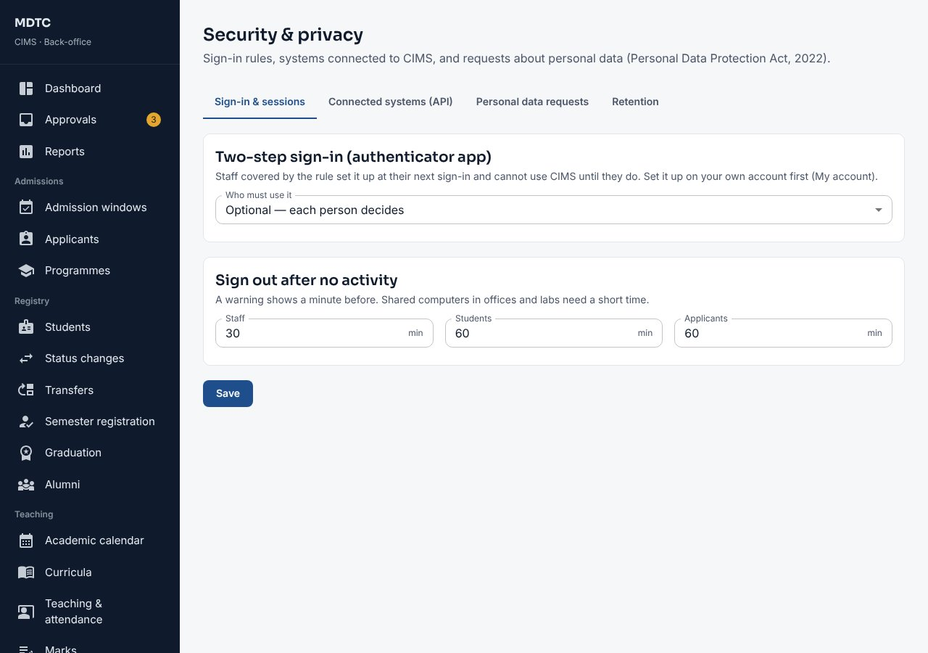
Figure 34: Security & privacy: two-step sign-in and sign-out times

6.6 Connected systems (API)
Other systems can be allowed to read selected CIMS data. This section explains how to register such a system and control what it sees.
- In Security & privacy open Connected systems (API) and click Add a system.
- Give it a Name and tick what it may read (programmes, students, results, payments).
- Copy the Client ID and Client secret shown and give them to the system's administrator securely. The secret is not shown again; New secret replaces it.
Switch a system Off to stop it at once. Last used shows when it last connected.

6.7 Personal data requests and retention
Under the data protection law, people may ask what data is held about them. This section explains how to handle such requests and set how long records are kept.
- In Security & privacy open Personal data requests. Requests from applicants, students and staff are listed with the date the answer is due; Overdue ones are flagged.
- Open a request, act on it (for a correction, change the person's record first), choose the Outcome and write the Answer to the person. For an applicant who never joined you can erase the personal details; for a student, explain what must be kept and why.
- Under Retention set how long to keep applicants who did not join and SMS and email texts, review Due now, and click Apply now, or tick Apply automatically each month.

6.8 Data import
This section explains how to bring records from before CIMS into the system: students, earlier results, opening balances and external selections.
Use Administration › Data import to bring in records from before CIMS: Students, Earlier results, Opening balances and External selections (section 9.9).
- Choose the kind of record and download the Template. Fill it in Excel or as CSV.
- Click Upload and check. Every row is checked; a file with problems shows them per row (Problems (CSV)) and nothing is saved.
- Correct the file and upload it again until it shows no problems.
- Someone other than the uploader opens the file, checks the first rows and clicks Sign off and apply (or Discard).
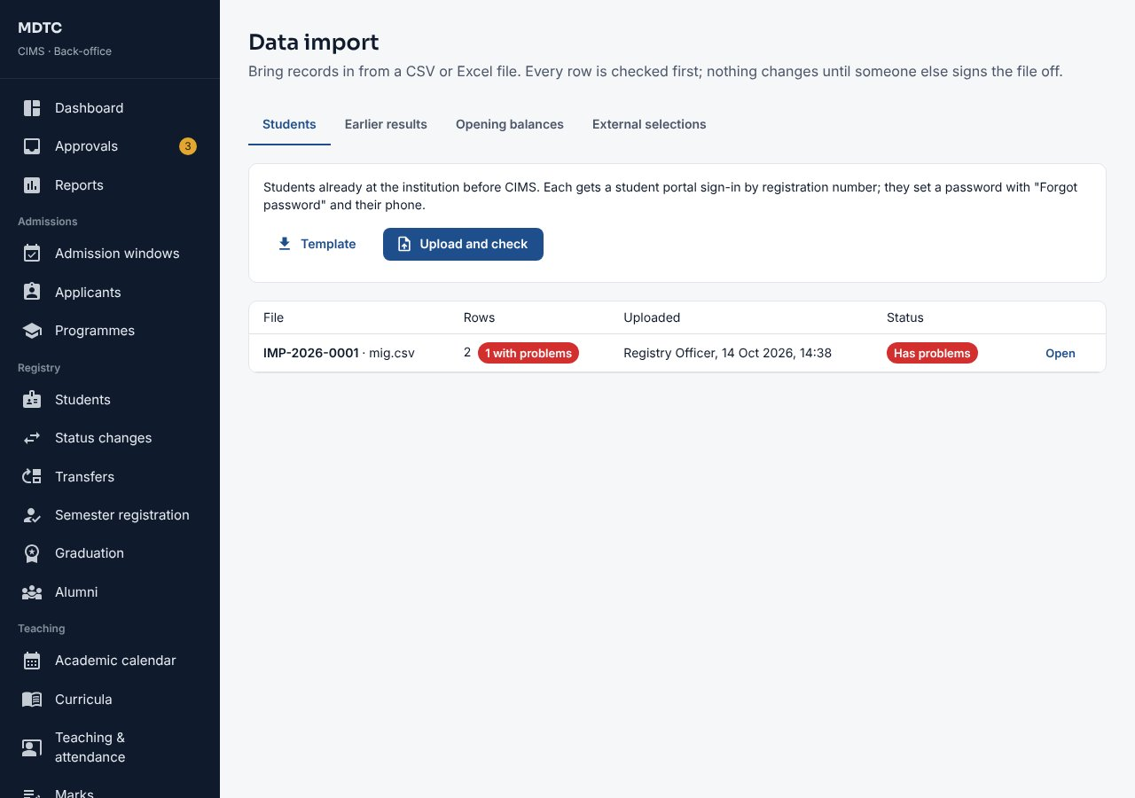
Figure 35: Data import with a checked file

6.9 Letter wording
This section explains how to change the wording of the admission letter and the training placement letter.
- Open Administration › Letter wording and choose a part of the admission letter (opening, conditions and closing, payment notice) or of the IPT placement letter.
- Write the wording. A blank line starts a paragraph, "- " starts a bullet and **text** is bold; click a value such as {applicantName} or {programmeName} to insert it.
- Click Preview sample letter, then Save.
Note: Letters already issued keep the wording they were issued with; new wording applies from now on.
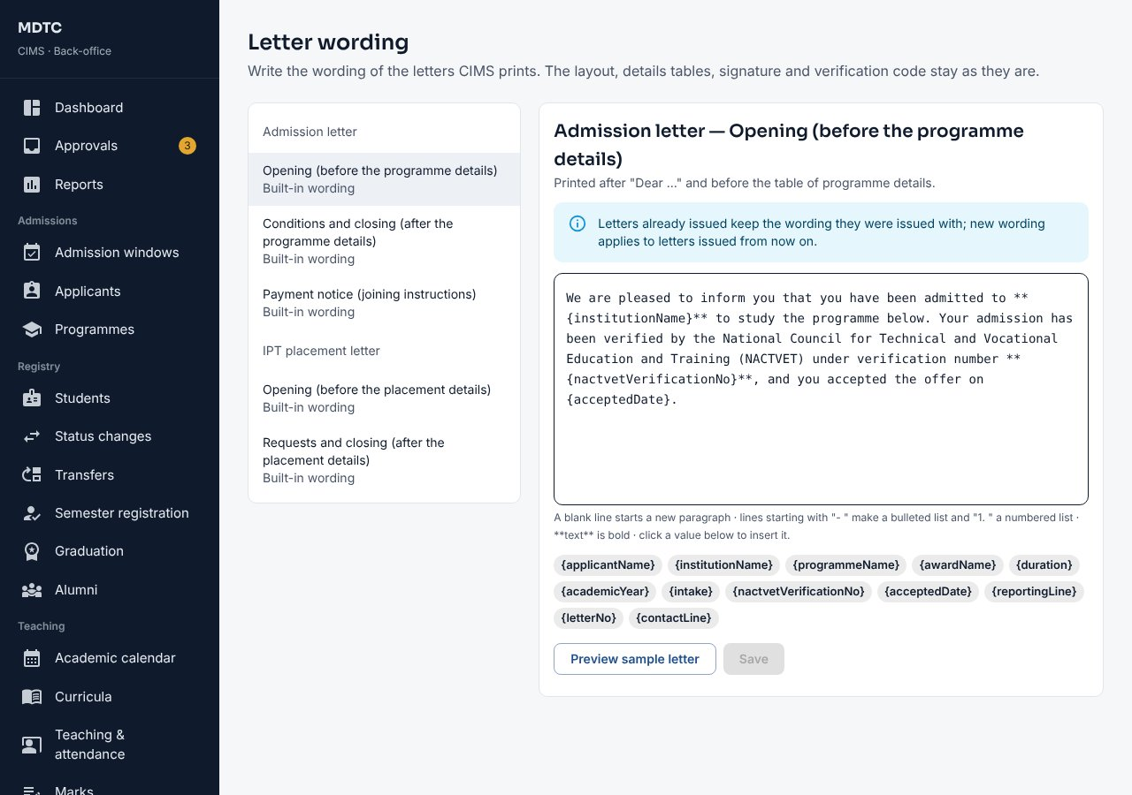
Figure 36: Letter wording with the values that can be inserted

6.10 Integrations
This section explains how to record the institution's codes at outside bodies and follow the exchanges with them.
Administration › Integrations holds the institution's codes at outside bodies and the exchanges with them. Connections shows whether each one is simulated or live; Msingi switches a connection to live once the body has given access.
- On Settings enter the GePG SP code, Sub SP code, System id and Default GFS code.
- Switch on the optional exchanges the institution uses (HESLB loans, TAMISEMI selections, MUSE fee postings, NIDA checks, NHIF health insurance) and enter the codes asked for. Click Save.
- For NHIF health insurance enter the code at NHIF if it differs, NHIF's student contribution per year (0 when the institution pays NHIF itself), and tick Students need health insurance before semester registration if they must be covered before registering (section 10.12).
- The other tabs run the exchanges: NACTVET registration (section 10.10), HESLB (section 16.7), MUSE postings (section 15.7) and TAMISEMI selections (section 9.9).
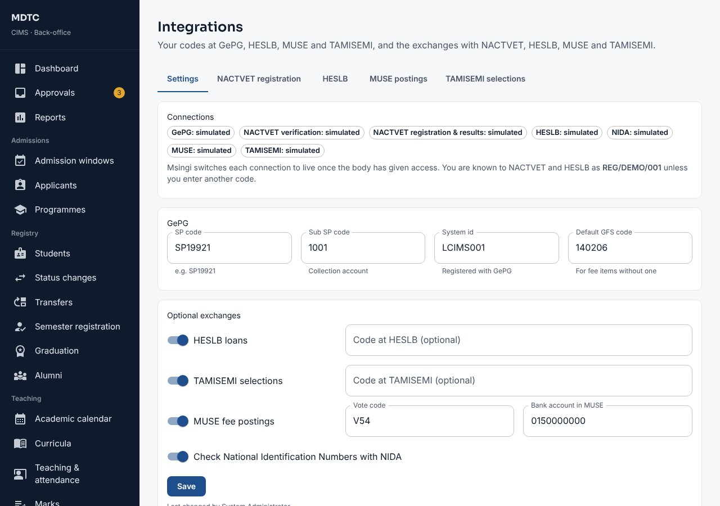
Figure 37: Integrations: codes and connections

6.11 Campuses, departments and faculties
This section explains how to set up campuses, faculties and departments.
- Open Admissions › Programmes, tab Campuses, and click New campus. Enter the code, name, region, district and address; tick Main campus for one campus only.
- On Faculties / schools add faculties if the institution groups departments; on Departments choose each department's faculty.
- Open a programme and choose the campuses it is Taught at. A programme with none is taught at the main campus.
Note: Students are placed at their programme's campus at hand-over and move only by an approved transfer (section 10.8).
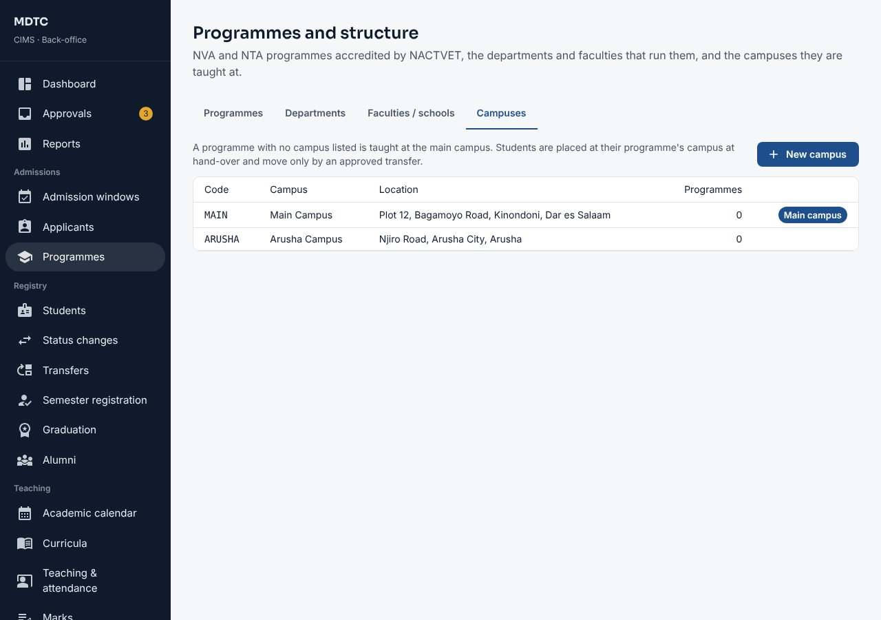
Figure 38: Campuses

7. Principal / Management Viewer
This chapter is for the Principal or a member of management: who sees the whole institution without changing records. It explains, step by step, how to read the institution overview and approve large waivers and refunds.
The Principal sees the whole institution read-only, and approves large waivers and refunds as the second level.

7.1 Institution overview
This section explains the institution overview: students, admissions, results and finances at a glance.
- Sign in. The dashboard opens on Institution overview.
- Choose the Academic year. The cards show current students by sex, new students against accredited places, fees collected and outstanding, the pass rate from published results and applicants per place.
- The table by programme, and Needs attention, show programmes below the stated thresholds.
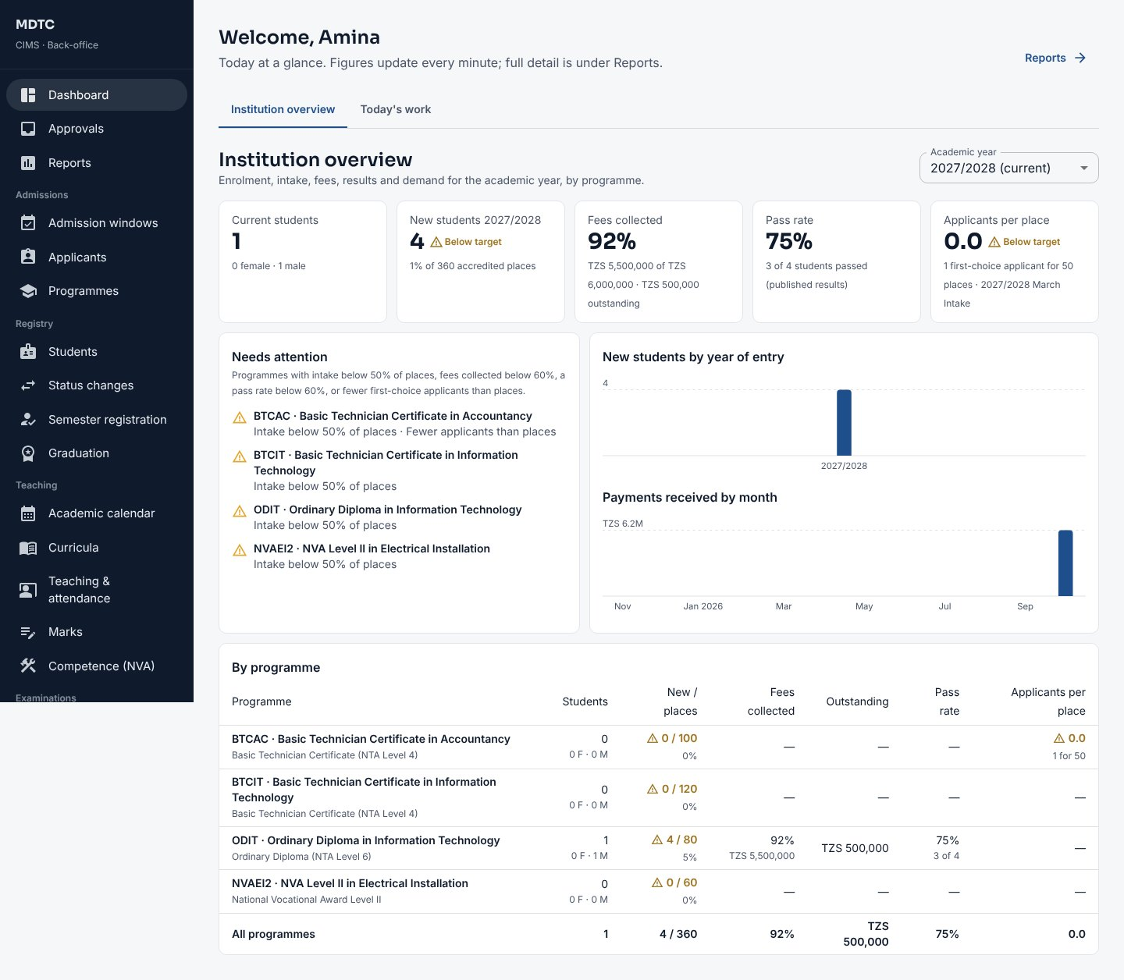
Figure 39: Institution overview for the Principal

7.2 Approving large waivers and refunds
Waivers and refunds above the threshold need the Principal's approval. This section explains how to decide them.
- Open Approvals (or Finance › Waivers & refunds). Requests above the threshold that the Bursar has endorsed show Waiting for the Principal.
- Read the reason and evidence, then click Approve or Reject (a rejection needs a note).
Note: Lists of named people are hidden from management views; figures and summaries are shown.

8. Deputy Principal (Academic)
This chapter is for the Deputy Principal (Academic): who keeps the academic calendar and regulations and takes the academic approvals. It explains, step by step, how to set the calendar and examination regulations and approve curricula, selections, results, exemptions, status changes and transfers.
The Deputy Principal (Academic) keeps the academic calendar and regulations, approves curricula and selection rounds, chairs the Academic Committee for results, decides examination exemptions and decides student status changes.

8.1 Academic calendar
This section explains how to set the semesters and key dates of the academic year.
- Open Teaching › Academic calendar and choose the Academic year.
- Click Add semester: set the teaching dates, the registration opening and closing dates, late registration and the examination marks window. With a late period you can set a Late registration fee (TZS): CIMS bills it once to each student who registers late.
- Under Key dates click Add date for teaching, examination, results and holiday dates.
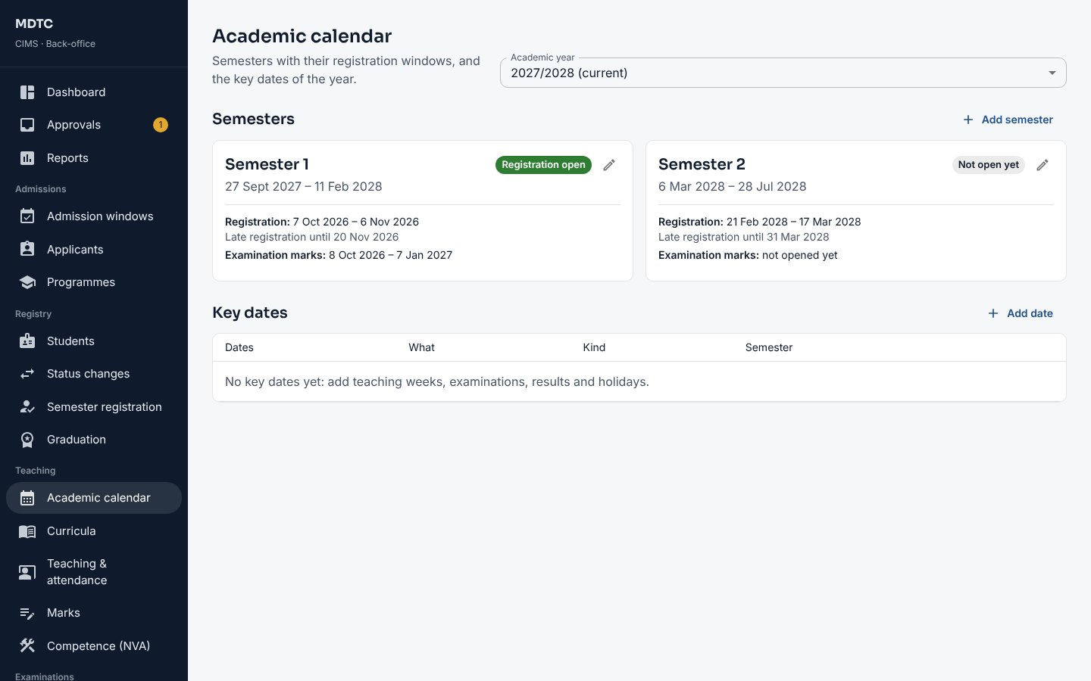
Figure 40: Academic calendar

8.2 Approving a curriculum
This section explains how to check and approve a curriculum prepared by a Head of Department.
- Open Teaching › Curricula and click the draft curriculum (prepared by a Head of Department).
- Check each year and semester. Under Before it can be approved CIMS lists problems such as a semester with no modules or an unmet elective rule.
- Set Applies from the intake of and add Notes (for example the NACTVET approval reference).
- Click Approve. You cannot approve a curriculum you prepared yourself.
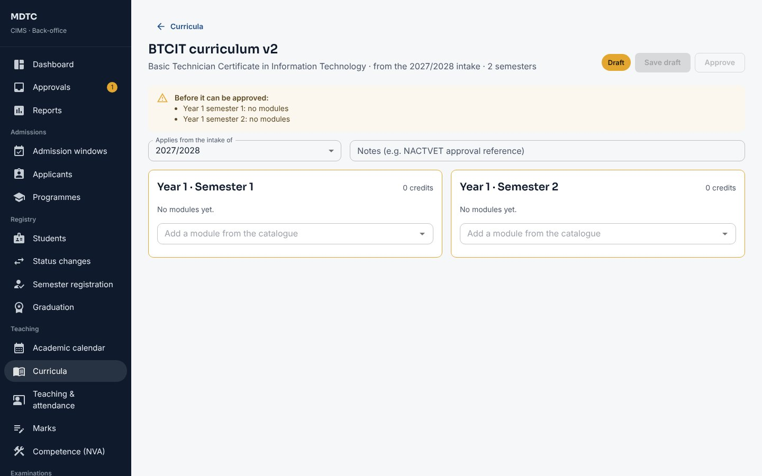
Figure 41: A draft curriculum waiting for approval

8.3 Examination regulations
This section explains how to set the examination rules: attendance, grading, pass marks and progression.
- Open Examinations › Exam regulations.
- Under Examination eligibility set the Minimum attendance %, Warn students after (sessions), and whether Every coursework item marked and Examination fees clearance are required. Click Save.
- Under Remarks and appeals set the Appeal period (days) and Fee per module (TZS); under NVA competence assessment the Attempts per task.
- Each award level has a regulation set (grading scale, CA/SE weights and pass marks, GPA rounding, supplementary and classification rules). Use New regulations to add a version that applies from an academic year. A set is locked once results use it.
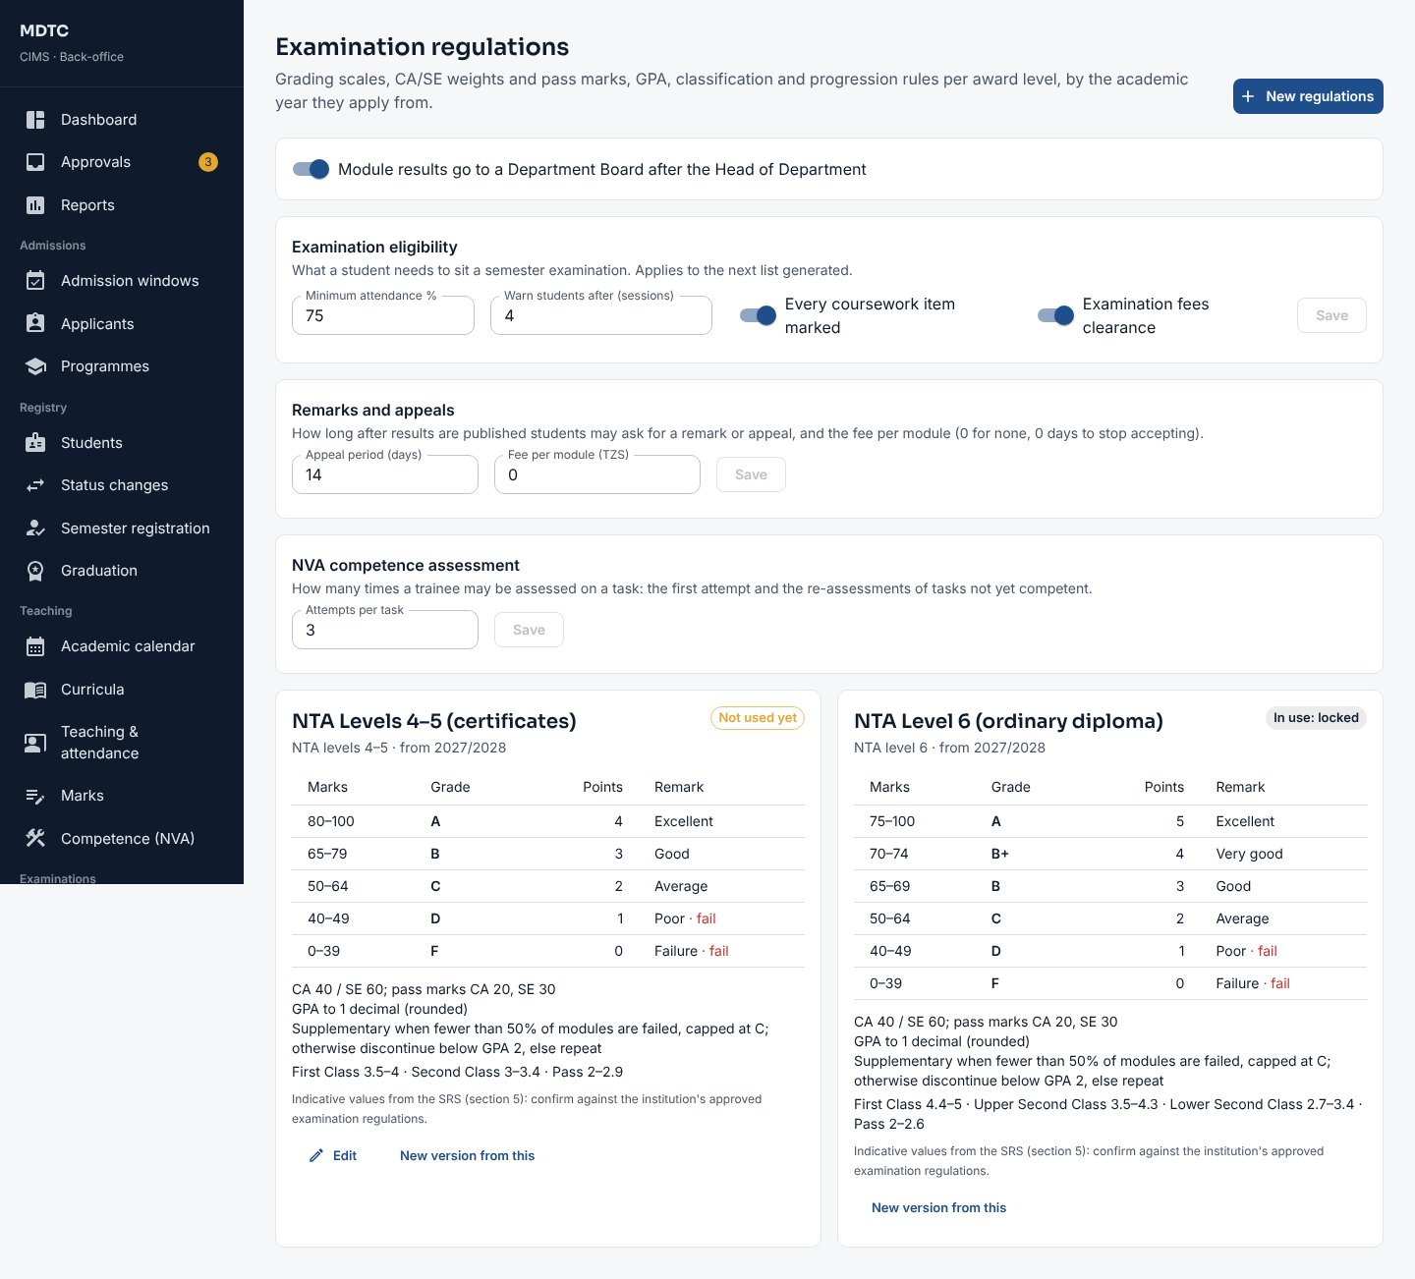
Figure 42: Examination regulations

8.4 Selection rounds, results, exemptions and status changes
This section explains the approvals of selection rounds, class results, exemptions and student status changes.
- Selection: open the round from Approvals, review the statistics and list, then approve with the committee's minute reference (section 9.5).
- Class results (Academic Committee): on the result sheet change any proposed decision with a reason, then Recommend it to the Governing Board, or return it (section 14.5).
- Exemptions: decide examination exemptions requested by a Head of Department or the examinations office (section 14.3).
- Status changes: open Registry › Status changes; after the Head of Department's recommendation, approve or reject. The change applies on its effective date and the student is told by SMS.
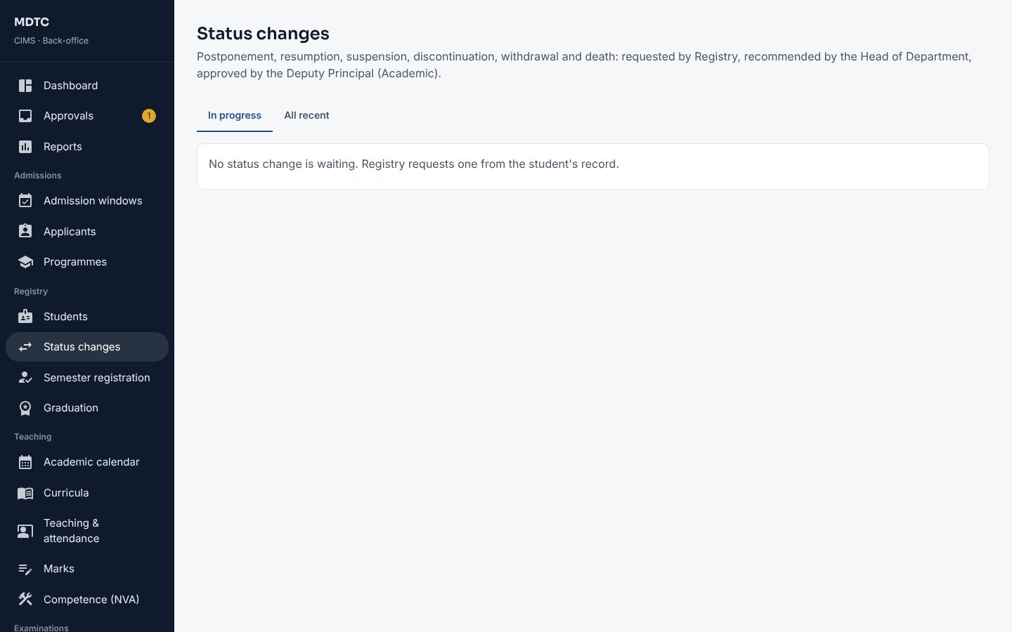
Figure 43: Status changes in progress

8.5 Programme and campus transfers
This section explains how to approve a student's transfer to another programme or campus.
Transfers recommended by the Head of the receiving department wait for you in Approvals and in Registry › Transfers. Open one, check the reason, the new programme or campus and the year of study, and click Approve or Reject with a reason. The student is told by SMS; an approved transfer takes effect on its date and the registration number stays the same.
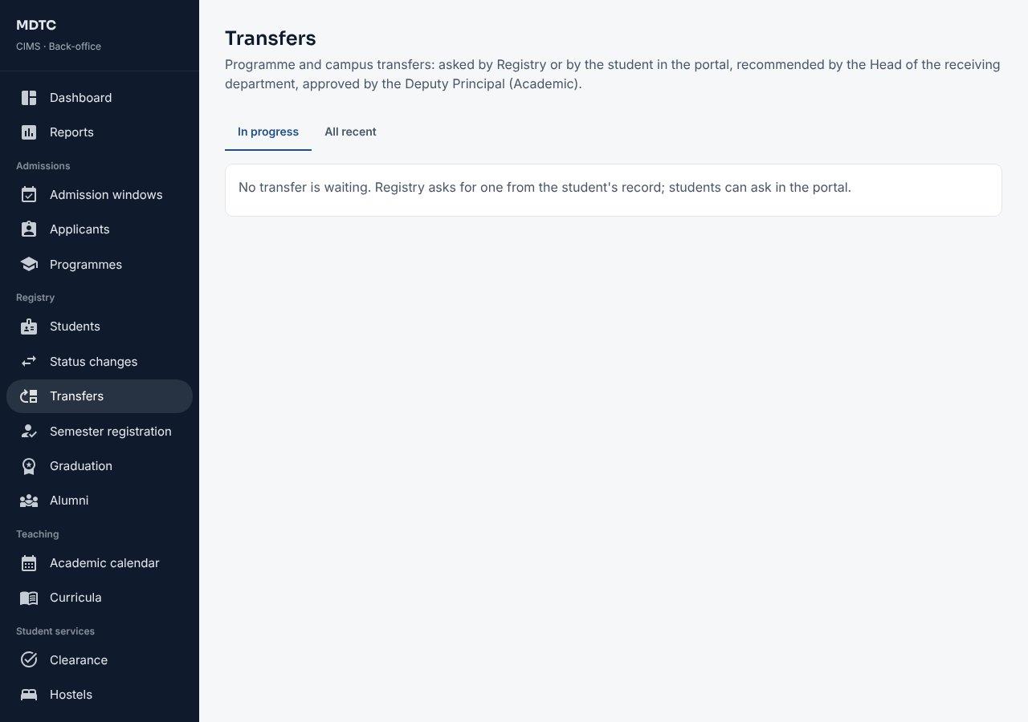
Figure 44: Registry › Transfers

8.6 Class timetable and venues
This section explains how to build the weekly class timetable of a semester, check it for clashes and publish it to students.
Open Teaching › Timetable and choose the Semester. The modules come from the semester's module offerings; before students register, click Modules from curricula to add every module the approved curricula place in this semester, then have the Heads of Department allocate lecturers (section 11.2).
- On the Venues tab check the rooms: code, type, campus, Capacity and Examination seats (the candidates a room holds when spaced out). Click Add venue for a new room; a room no longer used is switched off, not deleted.
- On Class timetable click Add a class (or Add a class beside a module under Modules this semester). Choose the module, the type, the day and times, the venue and, when the module has several lecturers and only one takes this class, the lecturer. A Group is for part of the class (for example two practical groups at the same time in two laboratories).
- Click Save. CIMS refuses a class in a room that is already in use, a lecturer who is already teaching, or two classes of one module at once unless they are for different groups.
- The week shows every class; filter it by Class (programme and year), Venue or Lecturer. Click a class to change or remove it.
- Look at Clashes and checks: classes that are both core for one programme and year at the same time (before registration), registered students with two classes at once, rooms too small for the students registered, and modules without a class. Click Show to highlight the classes concerned.
- To start from an earlier semester click Copy a semester: each module offered in both gets the same classes, unless it already has some; classes that would clash are left out and listed.
- Click Publish to students and leave Send an SMS to registered students ticked. Students see their own classes under Timetable; changes made later are marked as changed. Withdraw hides the timetable again. Excel downloads it for printing.
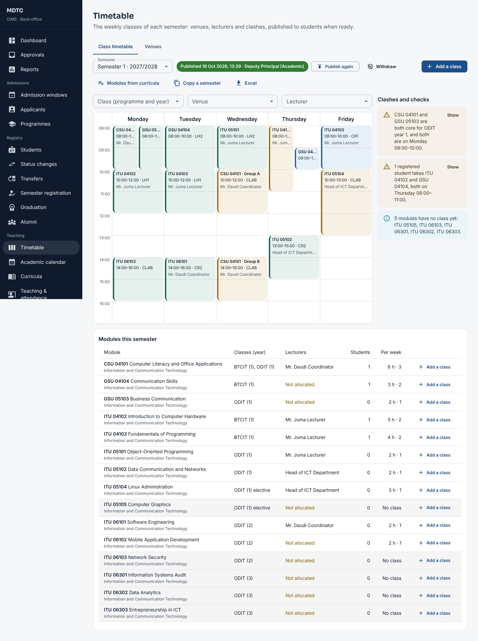
Figure 45: Teaching › Timetable: the week, the clash checks and the modules of the semester
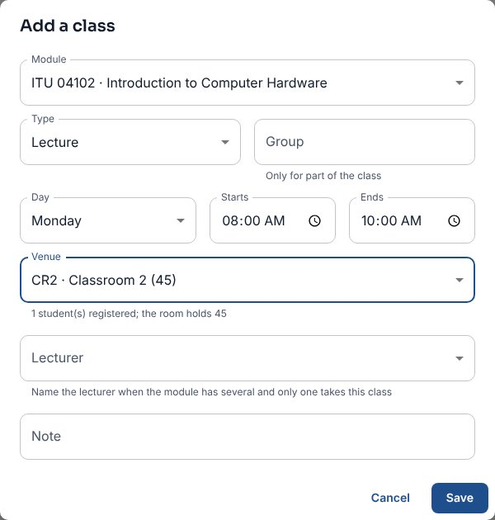
Figure 46: Adding a class
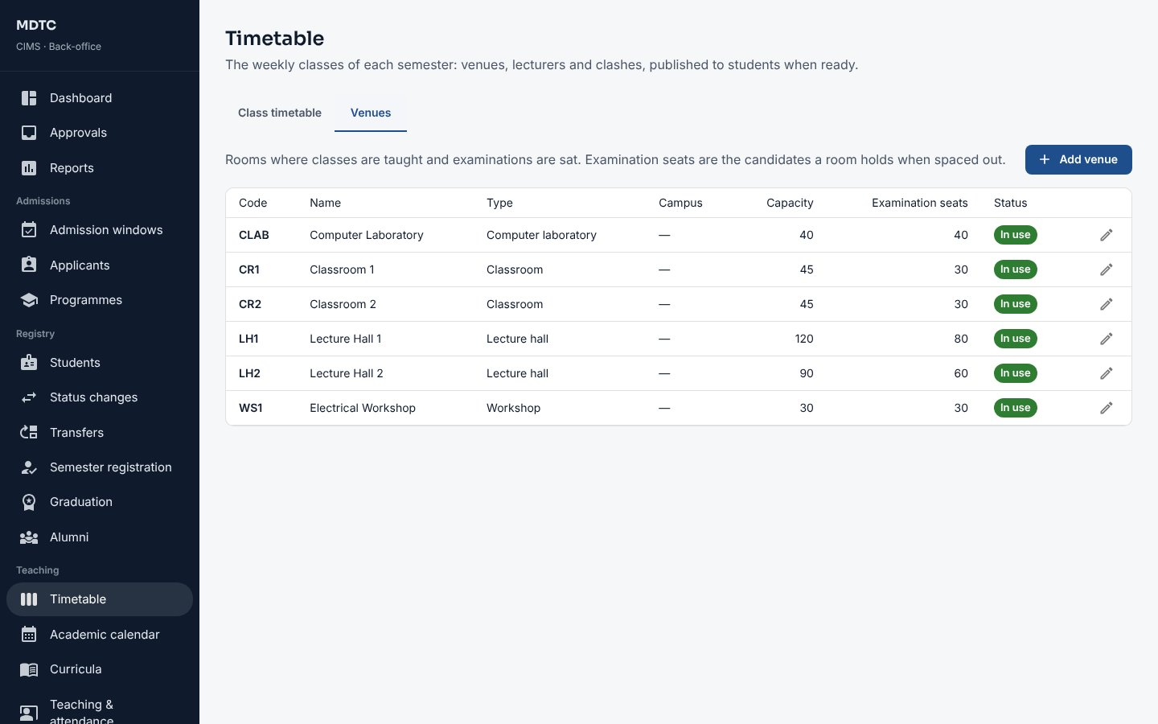
Figure 47: Teaching › Timetable › Venues

9. Admissions Officer
This chapter is for the Admissions Officer: who runs the institution's admissions. It explains, step by step, how to open admission windows, check applicants and their qualifications, run selection, submit to NACTVET and issue offers and admission letters.
The Admissions Office runs admission windows, checks qualifications, runs selection, submits selected applicants to NACTVET, follows offers and issues admission letters. Pages are under Admissions.

9.1 Create an admission window
This section explains how to open an admission window with its dates, fee and programmes.
- Open Admissions › Admission windows and click New window.
- Enter the Name, Academic year and Intake, the Opens and Closes dates and times, the Application fee (TZS), the number of Programme choices and the Days to accept an offer. Add Instructions shown to applicants if needed. Leave Remind applicants by SMS ticked to remind applicants who got a control number but have not paid: once two days later and once three days before the window closes.
- Click Create draft. The window opens as a draft.
- On the window page click Add programme for each programme on offer: choose the programme, set the Places and the NACTVET minimum entry requirements. A requirement is made of routes: an applicant qualifies through any one route (for example Form Four, or an NVA Level 3 award), and within a route every condition must be met (for example 4 CSEE passes and a pass in Basic Mathematics). Use Add condition and Add another route, choose the subjects from the list, and click Write from the rules to fill in the Summary shown to applicants (you can reword it).
- Under Joining instructions click Edit to set the reporting date and venue, the documents and items to bring, a fees note and who signs the letter.
- Click Publish window to publish it to open on its opening date, or Open now to open it at once.
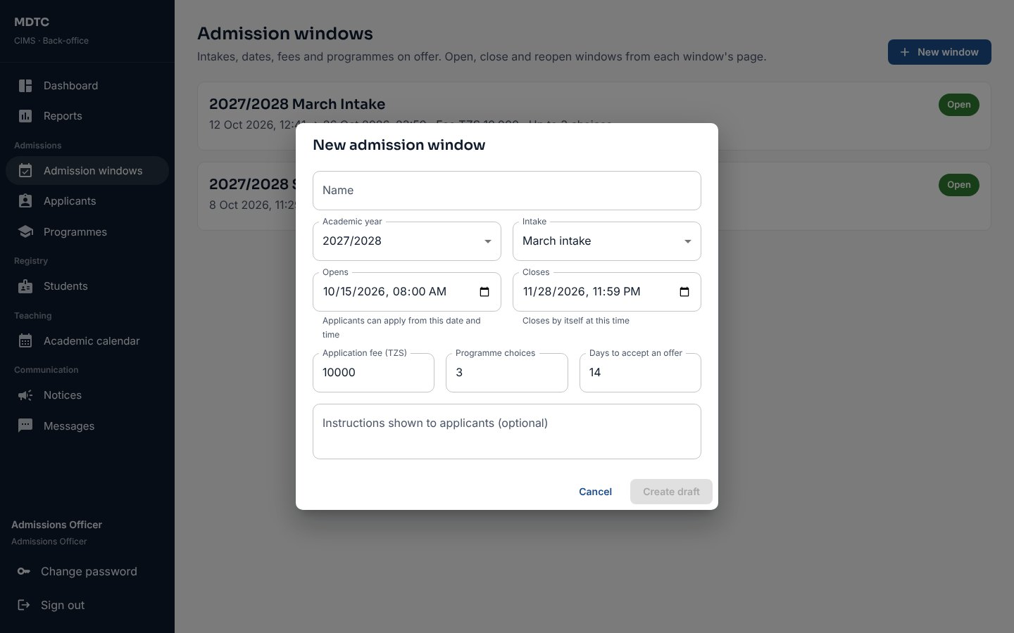
Figure 48: Creating an admission window
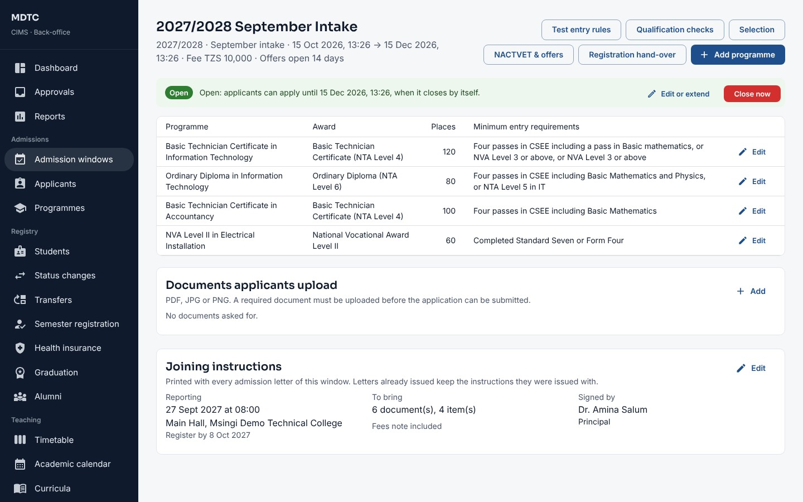
Figure 49: An admission window with its programmes and joining instructions
To change a programme already offered, click Edit on its row: change the Places or the entry requirements and click Save changes. This is possible until the window closes. Applicants who already chose the programme keep their choice; use Qualification checks and Test entry rules (section 9.10) to see who meets the new requirements. Each change is recorded in the audit log with the old and new requirements.

9.2 Close, reopen or extend a window
This section explains how to close a window early, reopen it or extend its closing date.
- Close now closes the window early; give a reason. Applicants who started but did not submit are told by SMS.
- Edit or extend changes the closing date. A closed window can be reopened with a new closing date until selection starts.
- A window closes by itself when its closing date passes. Every change is kept in the window's opening and closing record.

9.3 Find and review applicants
This section explains how to search for applicants and review an application.
- Open Admissions › Applicants.
- Search by name, index number, phone, email or reference, or filter by Admission window, Status, Programme chosen, Sex, Fee, submission dates or Qualifications to check.
- Click an applicant to see the application, qualifications, choices and history. Print gives a PDF application file.
- Click Export CSV to download the list (the export is recorded).
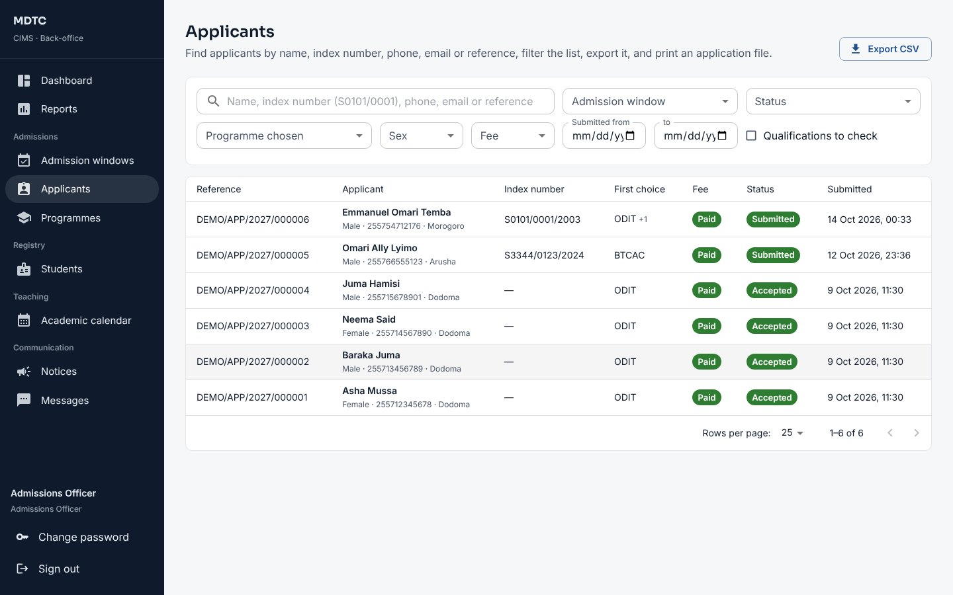
Figure 50: The Applicants list

9.4 Check declared qualifications
Qualifications that cannot be checked online must be checked by the office. This section explains how.
- On the window page click Qualification checks. The Waiting tab lists NVA, other and typed-in NTA awards that applicants declared.
- Compare each with the certificate. Click to verify it, or mark it not accepted with a reason. The applicant sees the reason and gets an SMS.
Note: Only verified qualifications count for eligibility and selection.

9.5 Run selection
This section explains how to rank eligible applicants and allocate places within capacity.
- On the window page click Selection, then Run selection. CIMS re-checks eligibility, ranks applicants by merit and allocates places across their choices within capacity.
- Review the proposal per programme with statistics by sex and region. Exclude an applicant with a recorded reason if needed; click Run selection again to re-run while the round is open.
- Download the CSV for the committee pack.
- The Admissions Committee chair (Deputy Principal or administrator) approves the round from Approvals with the minute reference. The person who ran the selection cannot approve it.
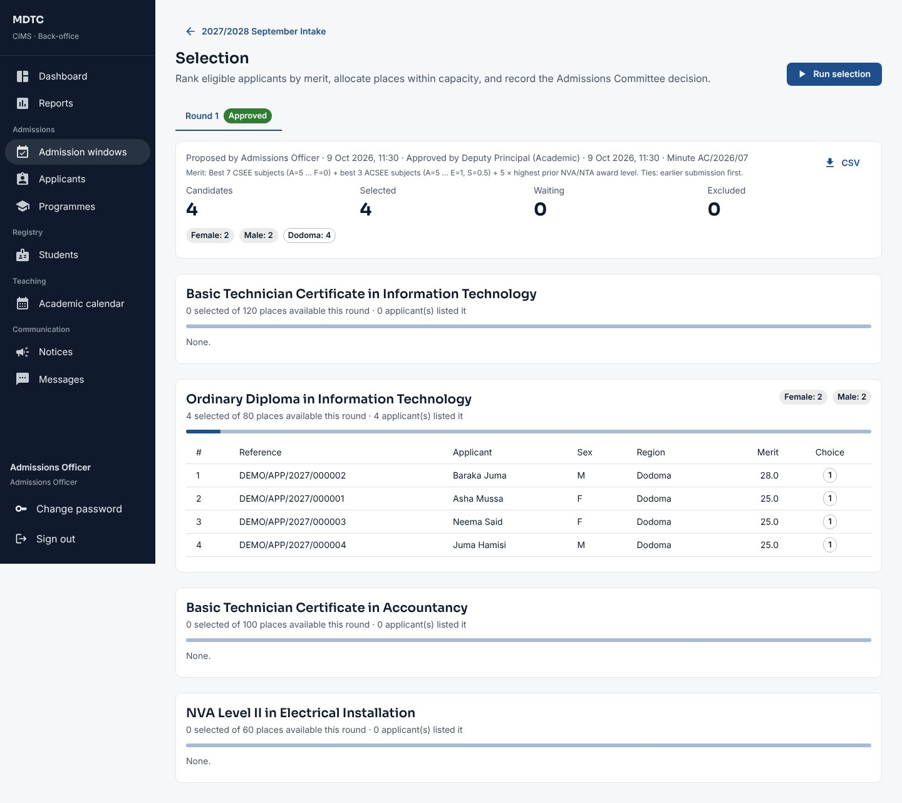
Figure 51: A selection round with ranked applicants

9.6 Submit to NACTVET and record outcomes
Selected applicants must be verified by NACTVET before an offer is made. This section explains how to submit them and record the outcomes.
- On the window page click NACTVET & offers. Ready to submit lists approved selections with a check of each record; fix any issues shown.
- Click Submit to NACTVET and choose Send through the NACTVET API or Prepare a file to upload to NACTVET. For the API, enter the payment reference (control number) of the NACTVET verification fee: NACTVET needs it with every upload. Click Submit.
- API: CIMS uploads the applicants to NACTVET one programme at a time. If NACTVET refuses a programme, its applicants stay in Ready to submit and the message says why; the other programmes go ahead. On the Submissions tab each batch shows its intake and payment reference; click Fetch outcomes. CIMS reads NACTVET's verification feedback for the intake, and applicants NACTVET has not decided yet stay pending, so fetch again later. File: the file is in NACTVET's upload template; upload it on the NACTVET portal, then click Import outcomes and choose NACTVET's outcome file.
- Verified applicants receive an offer by SMS automatically. Queried applicants move to the Queries tab: correct the record, click Resolve with a note, and submit again.
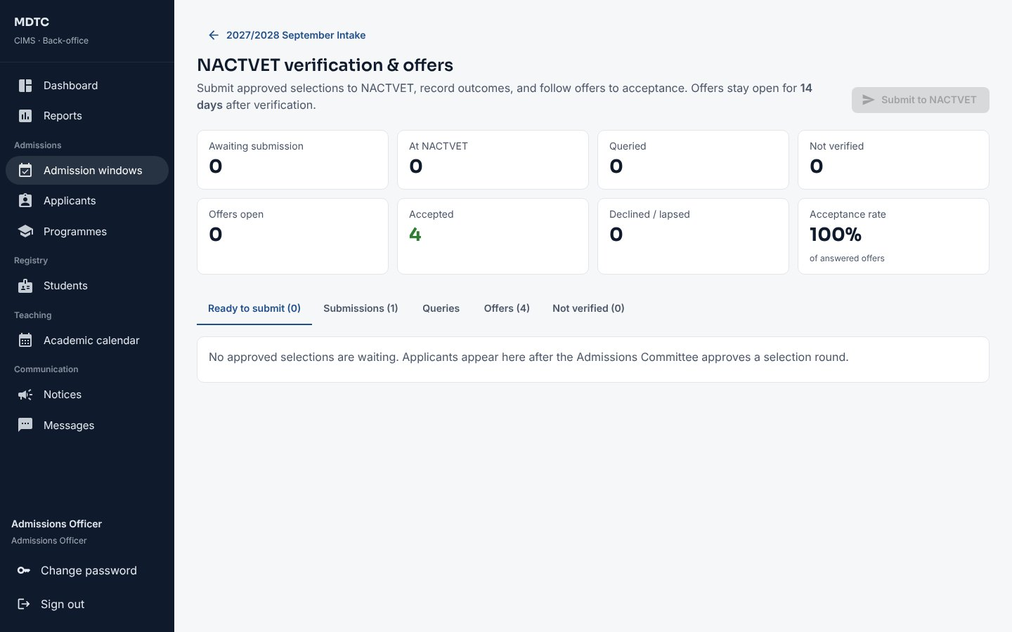
Figure 52: NACTVET verification and offers
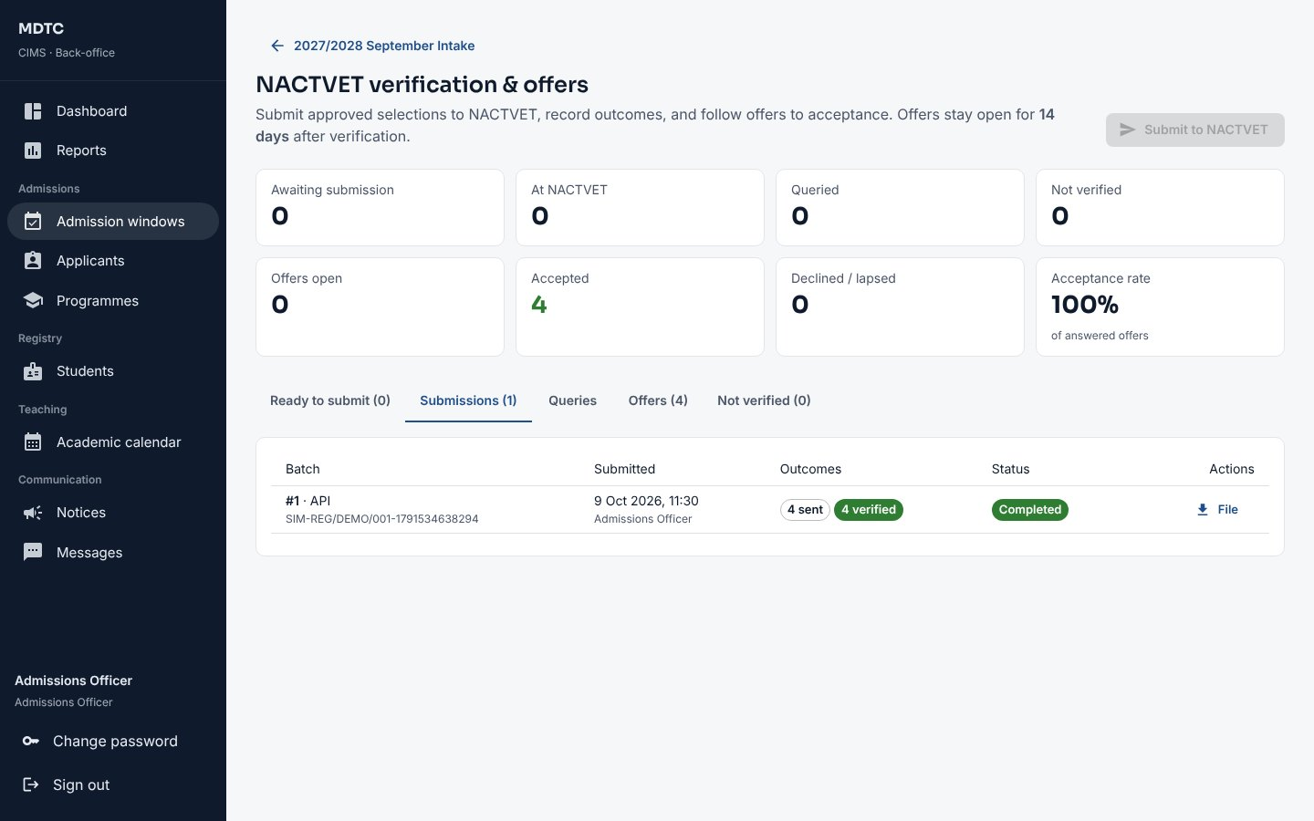
Figure 53: Submissions to NACTVET with Fetch outcomes
Note: Only the Admissions Officer and the administrator can submit to NACTVET. Other roles see the page read-only.

9.7 Follow offers and issue admission letters
This section explains how to follow offers and issue admission letters to applicants who accept.
- The Offers tab shows each offer, its deadline and status (offered, accepted, declined, lapsed) and the acceptance rate.
- On acceptance CIMS issues the admission letter with the joining instructions automatically. If any accepted applicant has no letter, click Issue … letter(s).
- Download a letter, Reissue a corrected edition (the old code then verifies as superseded) or Revoke it (Deputy Principal or administrator).
- Places released by declines and lapses are filled by the next selection round.
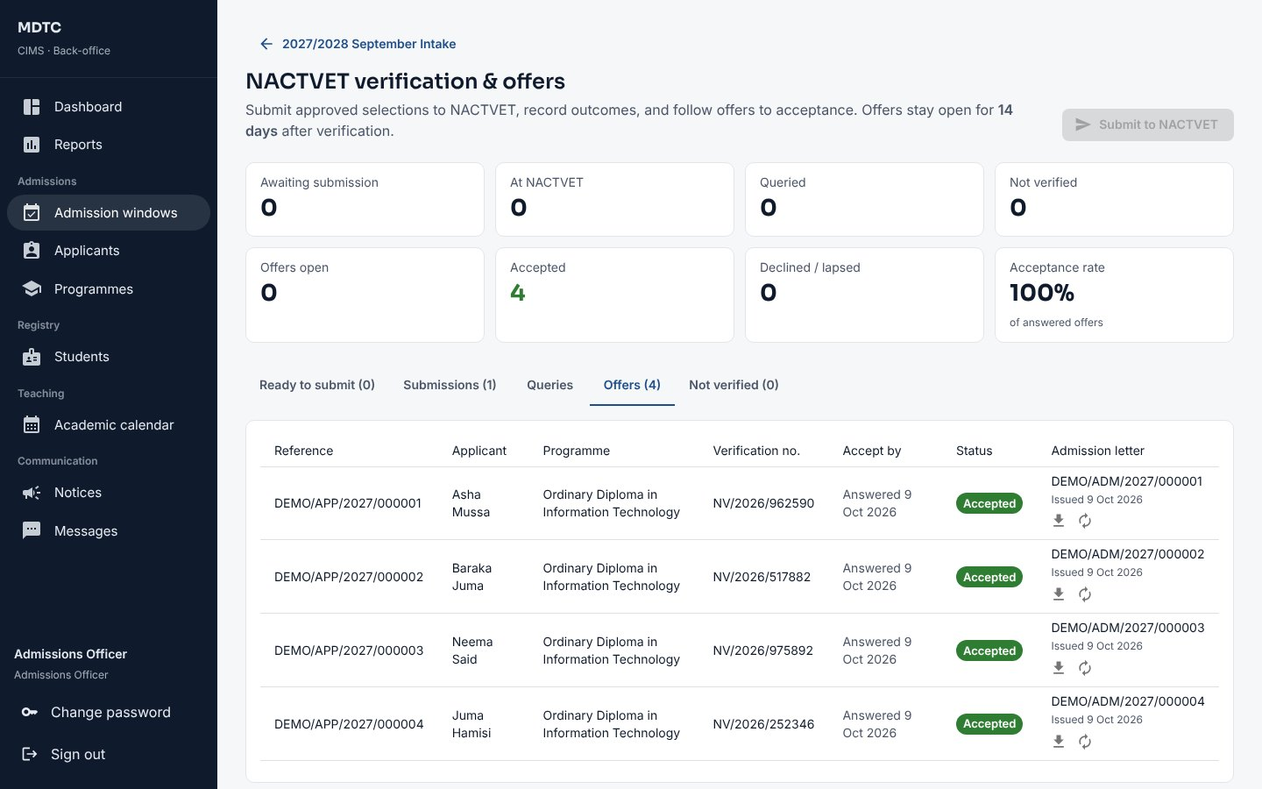
Figure 54: Offers and admission letters

9.8 Documents applicants upload
This section explains how to set the documents applicants must upload with their application.
- Open the window and, under Documents applicants upload, click Add.
- Enter the Name, a Code, optional Guidance for applicants, the Size limit, and whether it is Required before submitting.
- When reviewing an application, open each document and click Accept, or Not accepted… with a reason; the applicant gets an SMS and can upload it again.
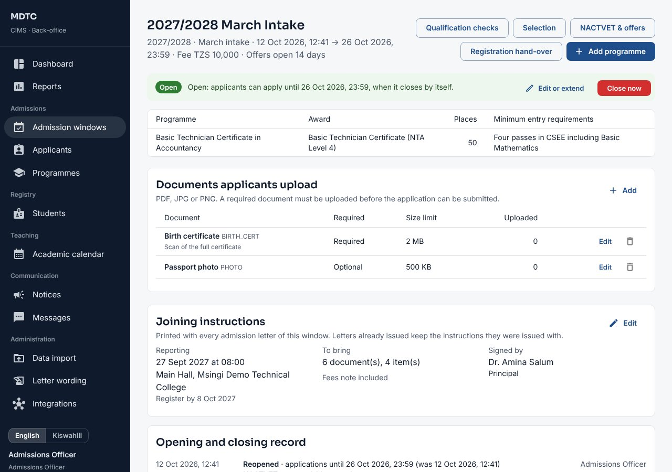
Figure 55: Documents applicants upload, on the window page

9.9 Students selected by TAMISEMI or another body
This section explains how to bring in students selected by TAMISEMI or another body.
- Open Administration › Data import › External selections, choose the Admission window and who they were Selected by, and upload the file; or, on Integrations › TAMISEMI selections, click Fetch selections and Open import.
- After the file is checked, someone else signs it off. The students join the window as selected and are told by SMS to sign up with their index number.
- They then go to NACTVET verification and receive offers like other applicants (section 9.6).

9.10 Test entry rules
This section explains how to check entry requirements with a sample applicant's results before applicants meet them, and how to try changed requirements before saving them.
- On the window page click Test entry rules.
- Under Sample applicant type the Form Four (CSEE) subjects and grades. Tick Also has Form Six (ACSEE) results to add those, and choose an NTA or NVA award and its level if the applicant holds one.
- Click Check against every programme. CIMS shows the level this applicant may apply at and, for each programme, whether they are at its entry level and meet its requirements. Click Why? to see each requirement and what was found.
- To try different requirements for one programme, tick Try changed requirements, choose the programme, set the passes, grade, subjects or prior award, and check again. Nothing is saved: change the programme on the window page when satisfied.
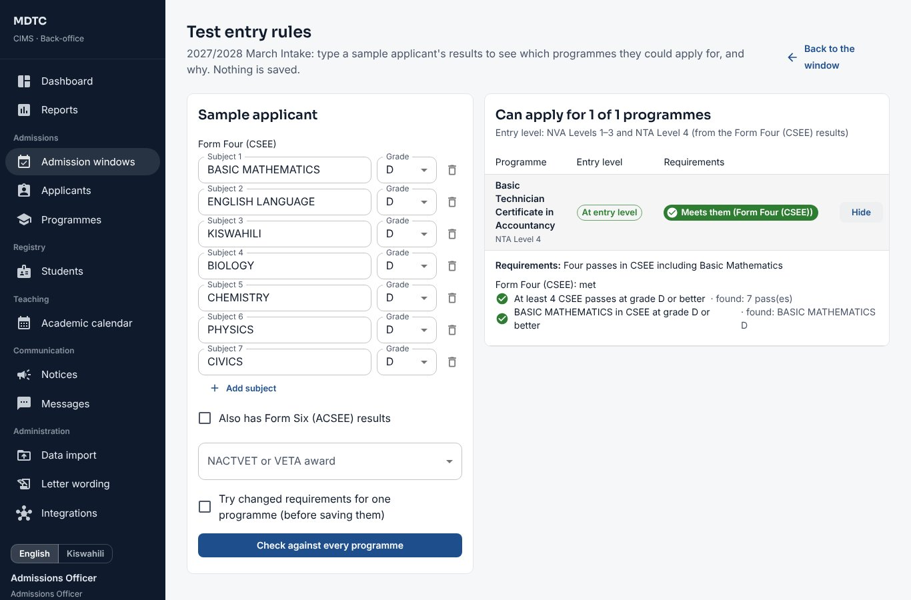
Figure 56: Testing entry rules with a sample applicant
Note: Note: The test uses the same rules applicants meet, with the sample results treated as verified.

10. Registrar / Registry Officer
This chapter is for the Registrar and Registry Officers: who turn accepted applicants into students and keep their records. It explains, step by step, how to hand over applicants, register students, approve semester registration, record status changes, issue ID cards and run clearance, graduation and alumni records.
Registry turns accepted applicants into students, approves registrations, keeps student records and runs clearance and graduation.

10.1 Hand over accepted applicants
This section explains how to turn accepted applicants into students with registration numbers.
- Open Admissions › Admission windows, open the window and click Registration hand-over.
- Check the registration number pattern shown (set under Numbering; numbers already issued never change).
- Tick the applicants to hand over, or leave all unticked, and click Hand over selected or Hand over all.
For each applicant CIMS creates the student record and registration number, moves the fees invoice to the student, turns the applicant account into the student portal sign-in and sends a welcome SMS with the reporting date. The student starts as Admitted.
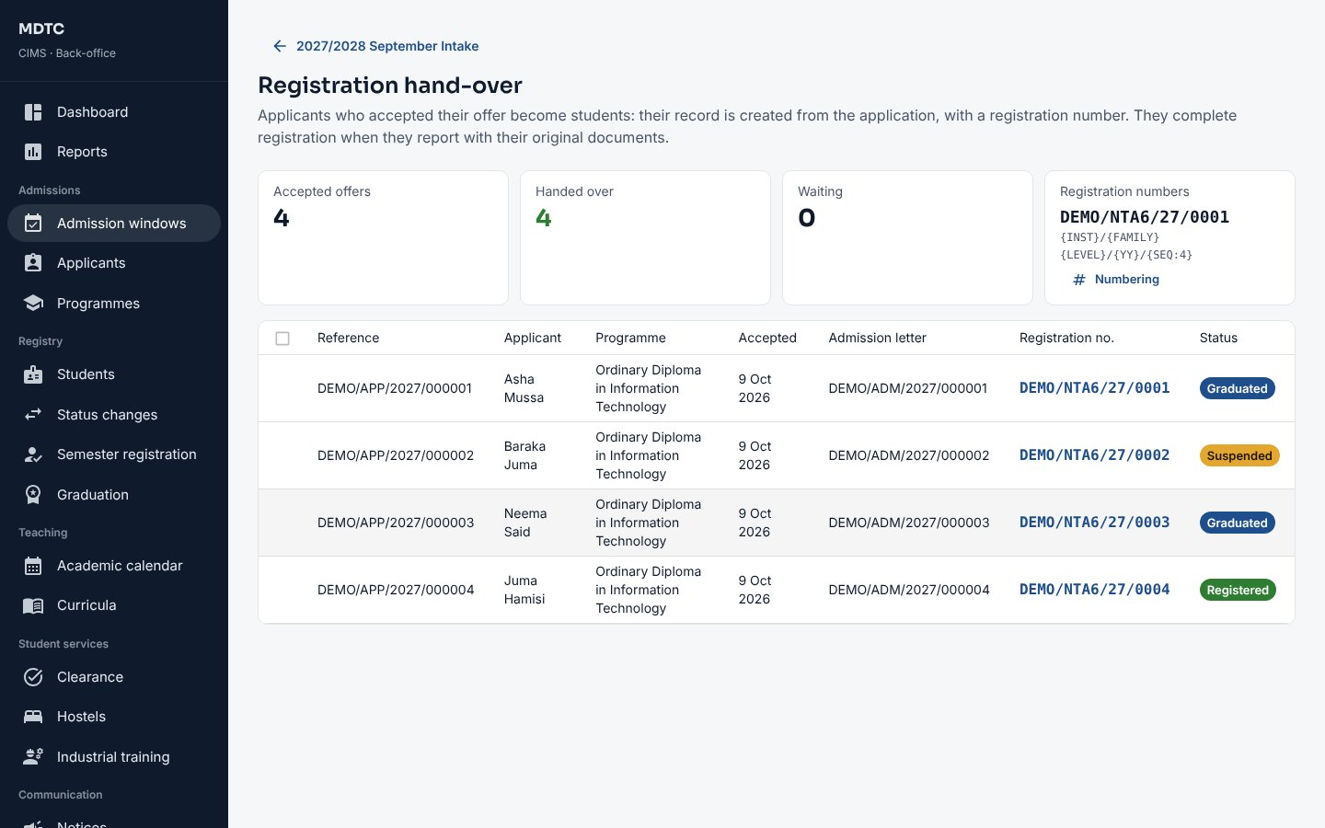
Figure 57: Registration hand-over

10.2 First registration at reporting
This section explains how to record the original documents a new student presents on reporting.
- Open Registry › Students and click the student.
- In the First registration card tick each original document you have seen (the list comes from the joining instructions).
- Click Save checklist (you can save as often as needed), then Approve registration. Approval is refused while any document is unticked.
The student becomes Registered (active) and receives an SMS.
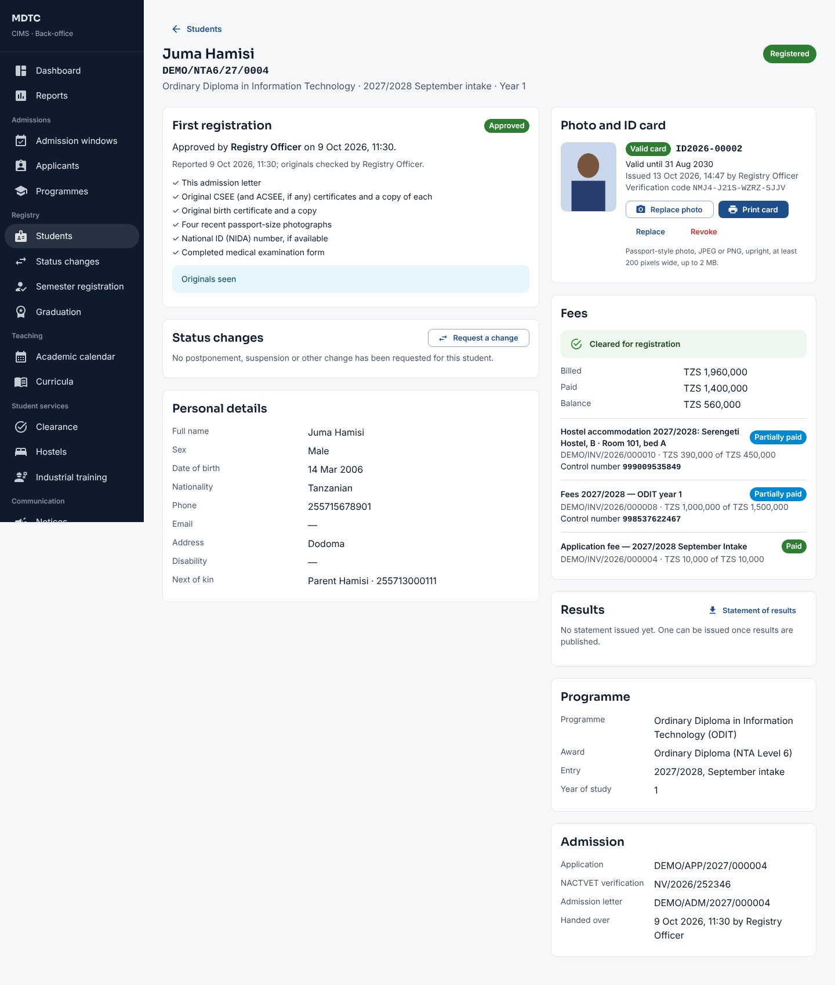
Figure 58: A student record with first registration, ID card and fees

10.3 Approve semester registrations
This section explains how to approve students' semester registrations.
- Open Registry › Semester registration and choose the Semester. The cards show waiting, approved and not yet registered.
- Under Waiting for approval, open a registration to check the modules, or approve all at once. CIMS re-checks fee clearance and skips students who are not cleared.
- To send one back, return it with a note. The student is told by SMS either way.
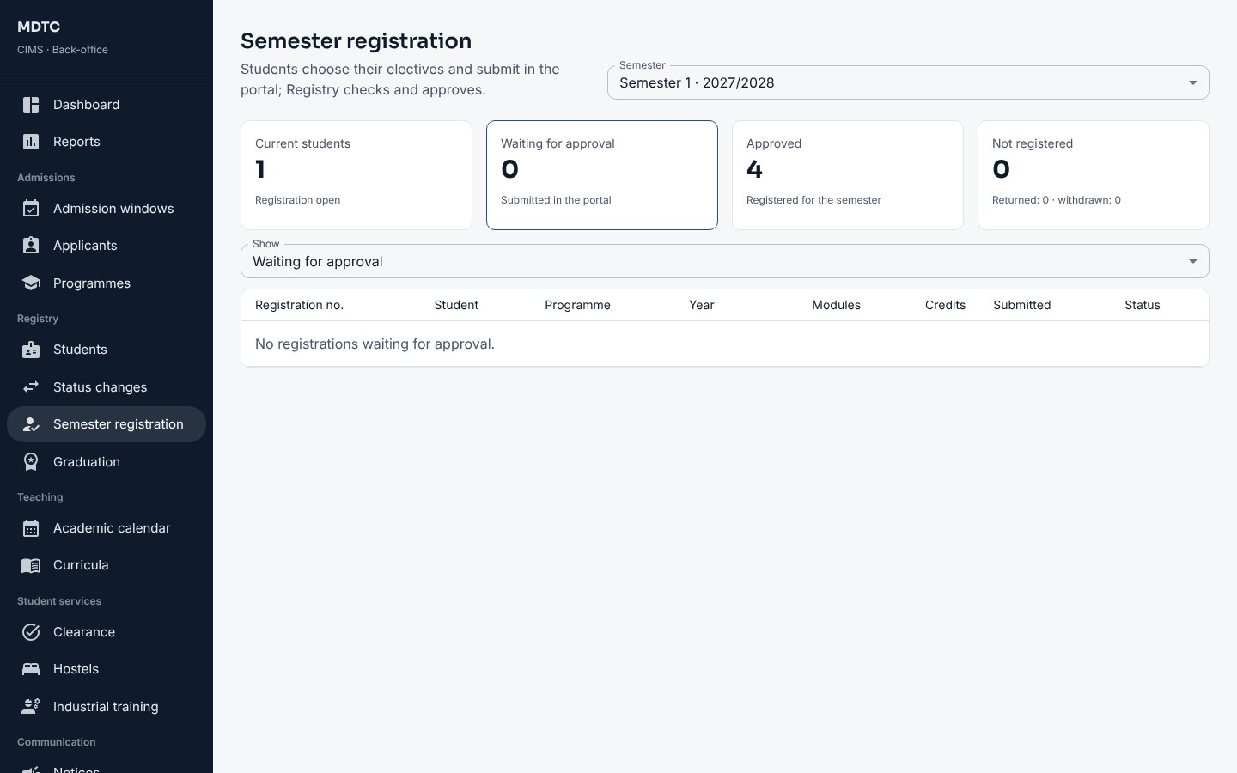
Figure 59: Semester registration

10.4 Student status changes
This section explains how to request and record a change in a student's status, such as postponement or withdrawal.
- On the student's page click Request a change under Status changes.
- Choose the change (postponement, resumption, suspension, discontinuation, withdrawal or death), the effective date, the reason and the documents reference. Submit.
- The Head of the student's department recommends it and the Deputy Principal decides (both from Approvals). On the effective date CIMS applies it and sends an SMS. When studies stop (postponement, discontinuation, withdrawal or death) CIMS asks the bursary to waive the fees the student still owes, through waiver requests it approves, reduces or rejects, and releases a hostel bed not yet paid for; a resumed student is billed for the year.
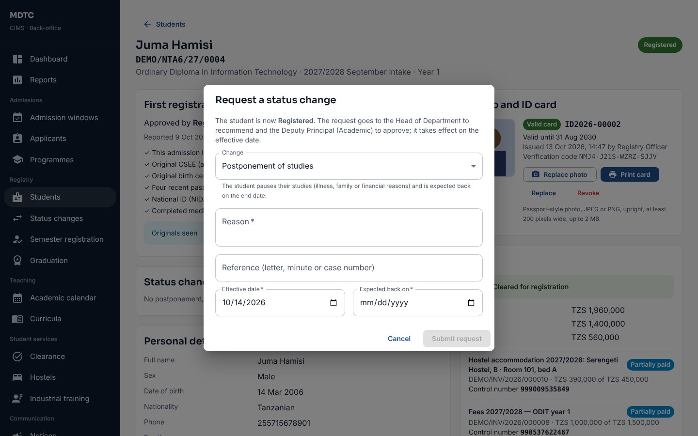
Figure 60: Requesting a status change

10.5 ID cards and detail-change requests
This section explains how to print ID cards and handle students' requests to correct their details.
- On the student's page, under Photo and ID card, upload or replace the photo, then Print card. A card can be Replaced or Revoked; each card has a verification code.
- Students' requests to correct their details appear on Registry › Students (Update requests). Approve or reject each with a reason; a name or date of birth change needs the original documents.

10.6 Clearance offices
This section explains how to set up the offices that clear finalists before graduation.
Registry sets up the clearance offices: the student's Head of Department, finance (clears itself when nothing is owed), and offices with assigned officers (library, hostel, sports and games by default). Students start clearance on the portal, or Registry starts it.

10.7 Graduations and certificates
This section explains how to prepare a graduation, approve the graduand list and issue certificates and transcripts.
- Open Registry › Graduation and click New graduation with the ceremony name and date.
- Generate the graduand list. CIMS includes finalists with the award and full clearance, and shows who is not ready and why.
- Click Send to the Governing Board. Another administrator clicks Record Board approval with the minute reference (or Return to Registry). Graduates are told by SMS.
- Download the NACTVET graduand file and Record NACTVET submission with NACTVET's response.
- Click Issue certificates to number them, then Print all certificates or print one by one. Every print is logged; a Reprint needs a reason.
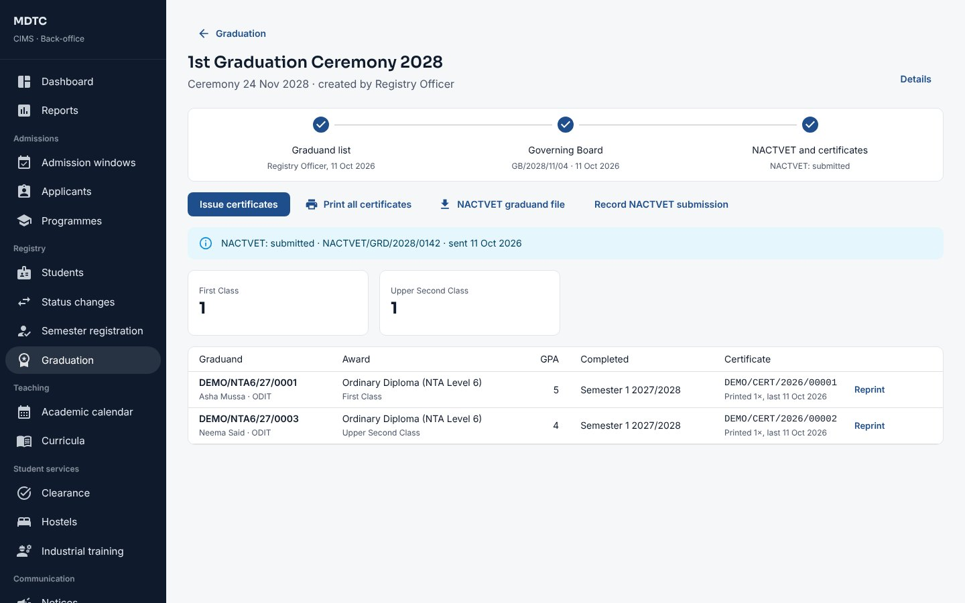
Figure 61: A graduation with graduands and certificates

10.8 Programme and campus transfers
This section explains how to record a student's transfer to another programme or campus.
- Open the student and, under Campus, category and transfers, click Request a transfer; or open a request the student sent from the portal in Registry › Transfers (Asked by the student).
- Choose the new Programme and/or Campus, the Year of study in the new programme (usually year 1) and the reason, and click Submit request.
- The Head of the receiving department recommends and the Deputy Principal (Academic) approves (section 8.5). Registry can Cancel a request that is no longer needed.

10.9 National Identification Numbers
This section explains how to record and check students' National Identification Numbers with NIDA.
On the student's page, National ID (NIN) shows the number (last four digits) and its NIDA check. Registry can enter or correct it and click Check with NIDA again. A number already held by another student is refused.

10.10 NACTVET student registration
This section explains how to register new students with NACTVET.
- Open Administration › Integrations, tab NACTVET registration.
- Click Send to NACTVET: active students who entered this year and are not yet registered are sent as a batch.
- Each student shows Registered or Queried with NACTVET's reason. Correct queried students and send them again.

10.11 Alumni and tracer surveys
This section explains how to keep in touch with graduates and run tracer surveys of what they do after graduating.
- Open Registry › Alumni. Graduates lists every graduate with contact details and what they do now; open one to update it, or tick Do not contact.
- On Tracer surveys click New survey, give a Title, choose the programme and graduation, and Create.
- Click Open and invite: each graduate who may be contacted gets an SMS with a personal link. Answers update the alumni records; Close the survey when done.
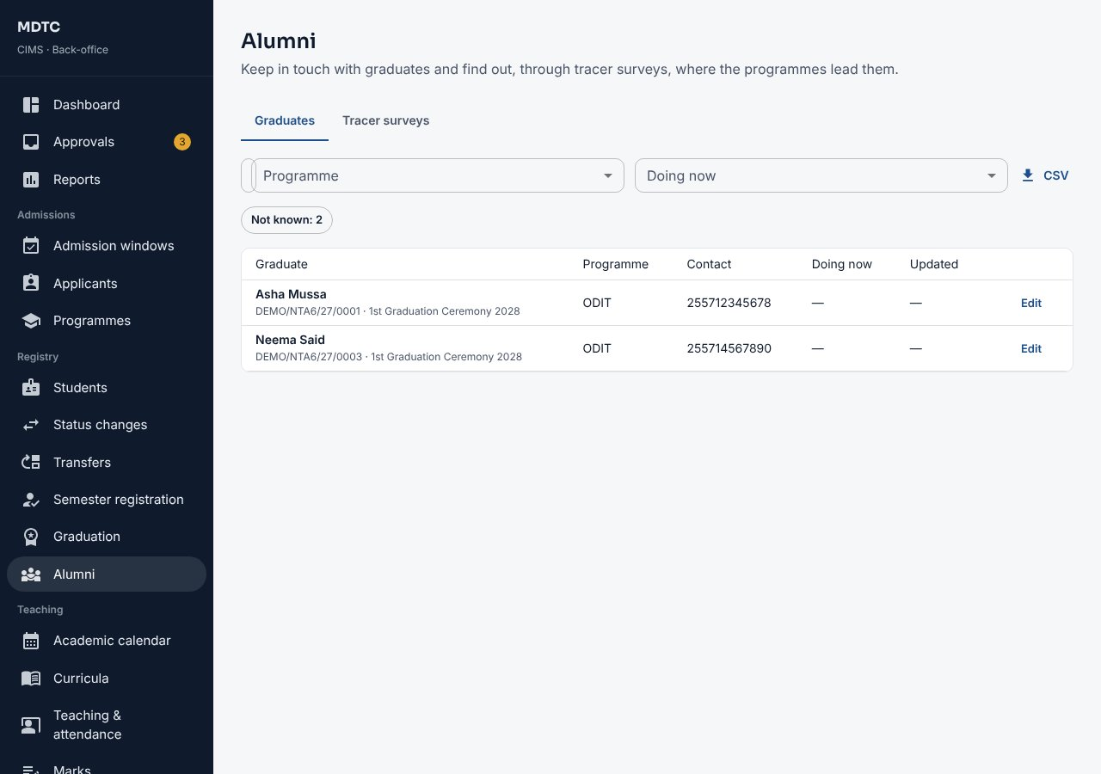
Figure 62: Alumni

10.12 Health insurance (NHIF)
This section explains how to follow students' health insurance with NHIF.
- Open Registry › Health insurance and choose the Academic year. The figures show how many current students are covered, how many have registration under way and how many are not covered; By programme and Students show who is where (filter by Situation or search).
- Students give their own NHIF card number in the student portal; on a student's page, Health insurance (NHIF) lets Registry enter it or register the student through the institution. Each card is checked with NHIF: active, not expired and in the student's name.
- Students without a card are billed NHIF's contribution (by themselves, or by the bursary, section 15.8). When contributions are paid, click Send paid students to NHIF: NHIF's card numbers come back and each student is told by SMS. On a batch still with NHIF, click Ask NHIF. File for NHIF's portal gives the same students in a file, when sending them through NHIF's own portal.
- Click Check own cards with NHIF again from time to time: a card whose cover has ended shows as not accepted, and the student is asked again. Reports REG-08 (cover by programme) and REG-09 (students without cover) are under Reports.
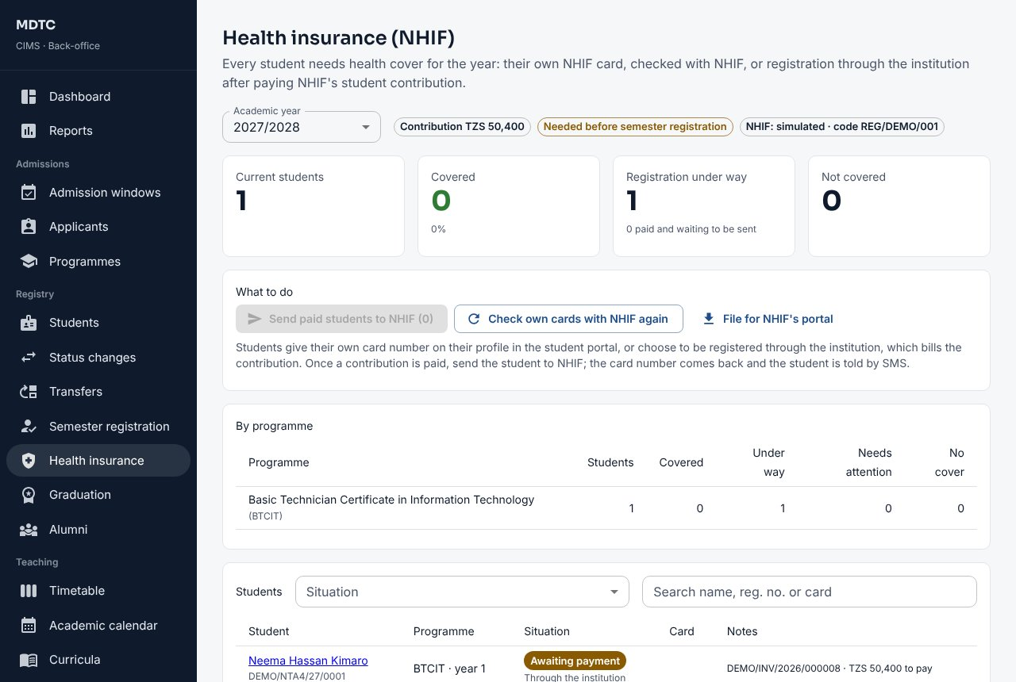
Figure 63: Registry › Health insurance
Note: When the institution requires cover, a student can register for a semester only once covered, or once the contribution is paid and registration with NHIF is under way. A contribution already paid is not refunded automatically if the student later gives an own card: a refund is the bursary's decision (section 15.3).

11. Head of Department and Programme Coordinator
This chapter is for the Head of Department and Programme Coordinator: who look after the programmes, students and modules of one department. It explains, step by step, how to prepare curricula, allocate lecturers, moderate marks and take the department's other decisions.
A Head of Department works only with the department shown under their name in the menu: its programmes, students, curricula, modules and results. A Programme Coordinator is limited in the same way to one programme. CIMS refuses other records even by direct link.

11.1 Prepare a curriculum
This section explains how to prepare a curriculum: the modules of each year and semester.
- Open Teaching › Curricula, choose the Programme and click New curriculum (or New version from this on the approved one).
- For each year and semester, add modules from the Module catalogue as core or elective, and set how many electives a student must choose.
- Set Applies from the intake of, then Save draft. The Deputy Principal (Academic) approves it (section 8.2). Students stay on the version they started.
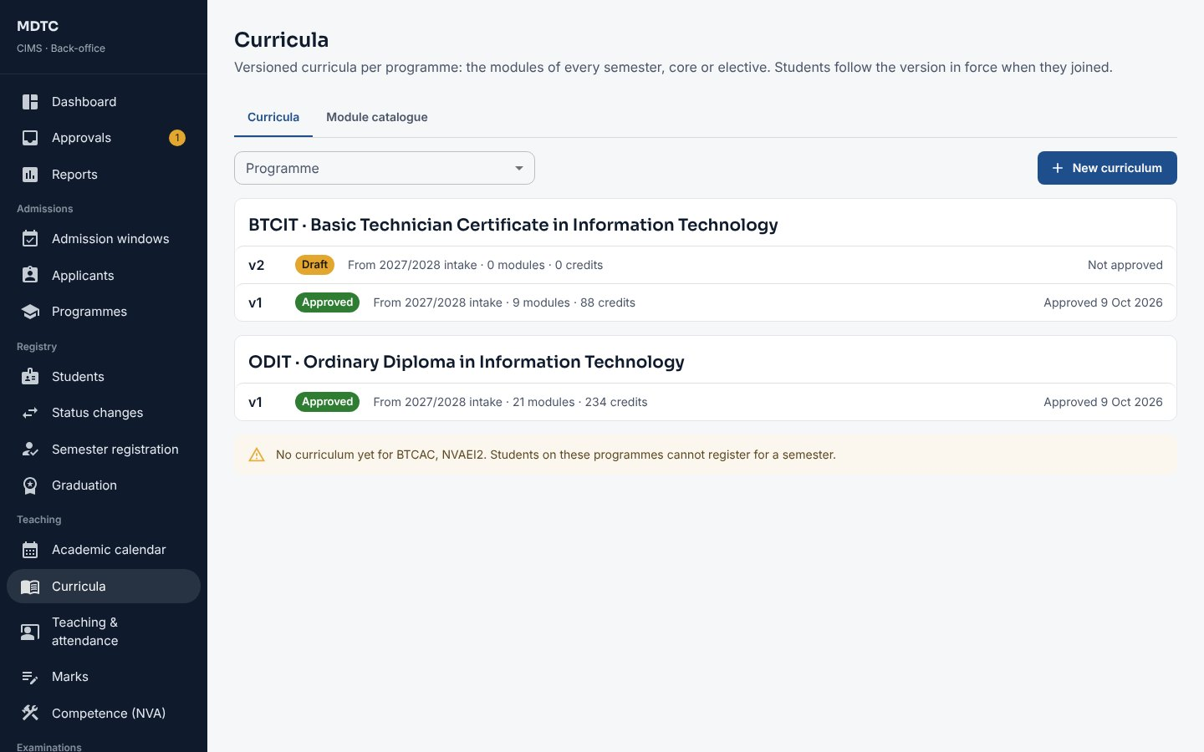
Figure 64: Curricula and the module catalogue

11.2 Allocate lecturers
This section explains how to allocate lecturers to the modules offered in a semester.
- Open Teaching › Marks and choose the Semester. If modules are not yet set up, click Set up modules from registrations (or ask the examinations office); before students register, Modules from curricula on Teaching › Timetable adds the modules of the approved curricula so you can allocate lecturers and plan classes early.
- Open a module and, under Lecturers, choose the lecturer(s) who teach it. Lecturers see only the modules allocated to them.
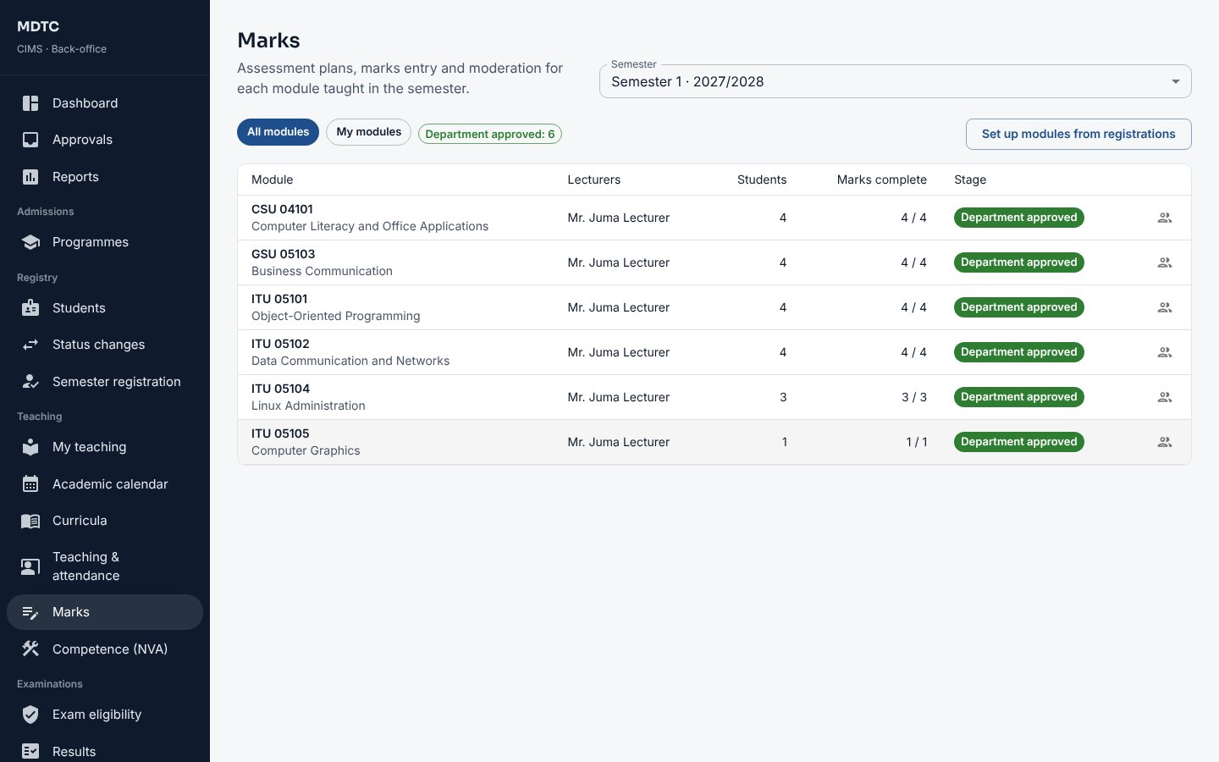
Figure 65: Modules of the semester with their stage

11.3 Moderate marks
This section explains how to check and approve the marks submitted by lecturers.
- Open Approvals or Teaching › Marks. Modules a lecturer has submitted show With Head of Department.
- Open the module. Check the marks, the grade distribution and any anomaly flags under Results so far.
- Click Approve results, or Return to the lecturer with a comment. If the institution uses a Department Board, record its approval with Record Board approval.
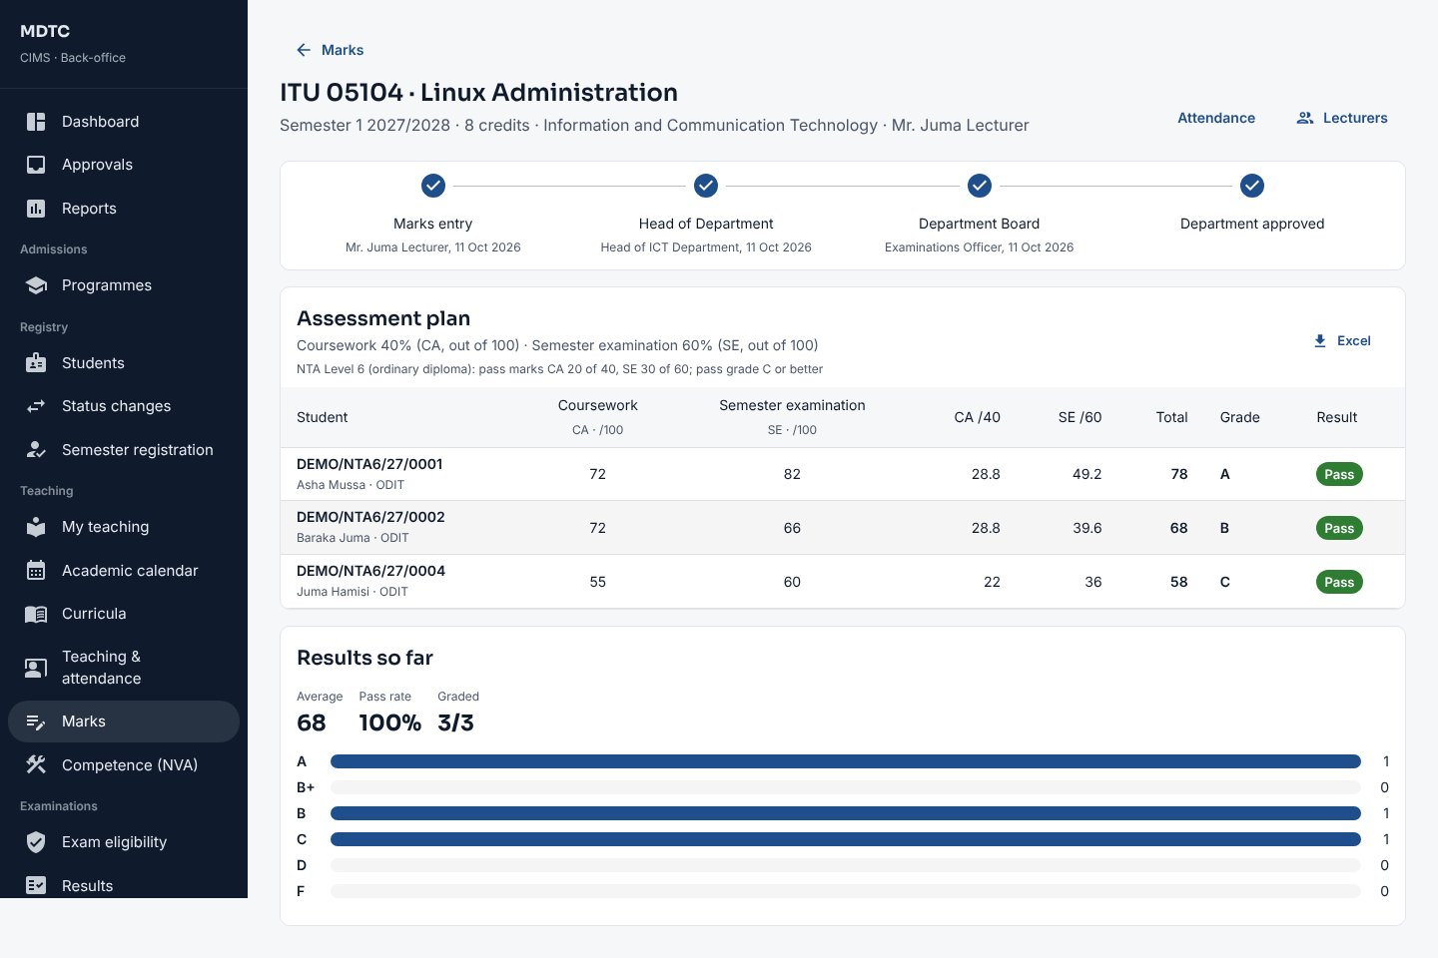
Figure 66: Moderating a module's marks

11.4 Other decisions
This section explains the department's other decisions, such as competence verification, resit marks and transfers.
- Competence verification (NVA): open the unit from Approvals and click Verify, or Return to the assessor with a comment (chapter 13).
- Resit marks: approve with Approve resit marks or Return the resit marks.
- Status changes: recommend requests for students of your department from Approvals (section 10.4).
- Exemptions: on Examinations › Exam eligibility, use Ask for exemption with a reason for a student who should sit despite not meeting a rule; someone else in academic management decides.
- Attendance: Teaching › Teaching & attendance shows attendance per module and students below the threshold in your department; Lecturer workload shows each lecturer's load.
- Clearance: you clear finalists of your department on Student services › Clearance (chapter 20).

Transfers: a transfer into your department waits for you in Approvals. Open it and click Recommend (or Reject with a reason); the Deputy Principal (Academic) then decides. Approval stages: if the institution has added stages for module results or result sheets (section 14.10), the role named for a stage approves or returns at that stage.

11.5 Classes of your department's modules
This section explains how a Head of Department keeps the weekly classes of the department's modules.
On Teaching › Timetable you can add, change and remove the classes of your department's modules in the same way as in section 8.6; the Deputy Principal (Academic) publishes the timetable. Allocate the lecturers first, so CIMS can check that no lecturer is in two places at once.

12. Lecturer / Tutor
This chapter is for the Lecturer or Tutor: who teaches modules. It explains, step by step, how to use My teaching, record attendance, run QR check-in, enter marks and handle class lists, remarks and training supervision.
Lecturers land on My teaching, which brings everything about their modules for a semester onto one page.

12.1 My teaching
My teaching brings everything about a lecturer's modules onto one page. This section explains it.
For the chosen Semester, the cards at the top show your modules, sessions recorded and hours taught, students below the attendance threshold and the marks entry window. Next lists what to do (for example "no attendance yet", "marks entry closes in 5 days", "results returned with a comment"). Each module card shows its class, attendance, CA and SE progress and where the results stand, with buttons for Attendance, Marks and Class list.
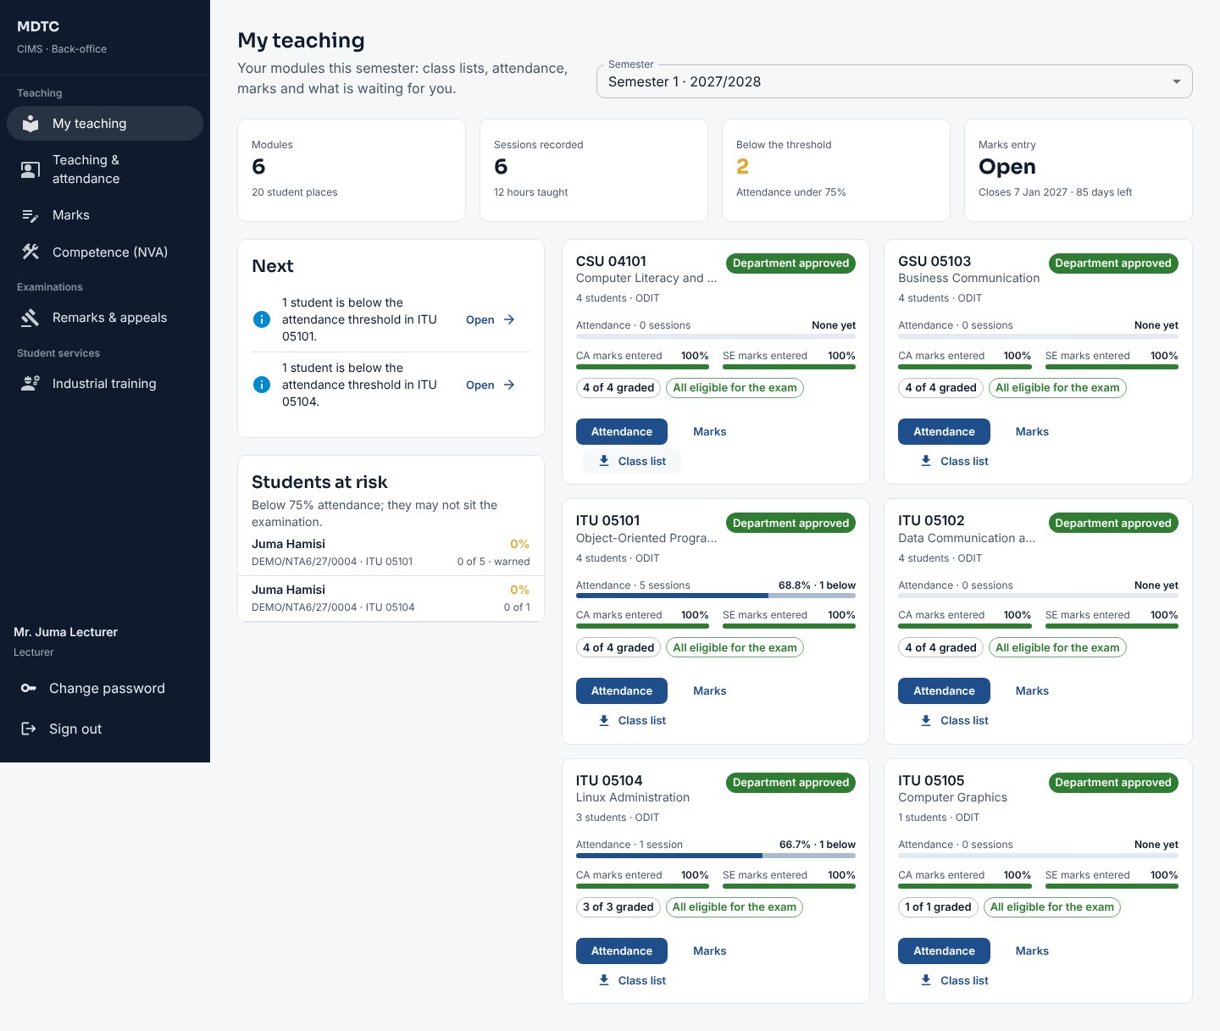
Figure 67: My teaching

12.2 Record attendance
This section explains how to record attendance for a class session.
- On the module card click Attendance (or open Teaching › Teaching & attendance and the module).
- Click Record session. Set the Date, Start, Length, Type (lecture, tutorial, practical, seminar) and an optional Topic.
- Everyone starts as present. Tap a student to mark late, absent or excused; the counts update at the top.
- Save. A student who falls below the threshold gets an SMS warning once.
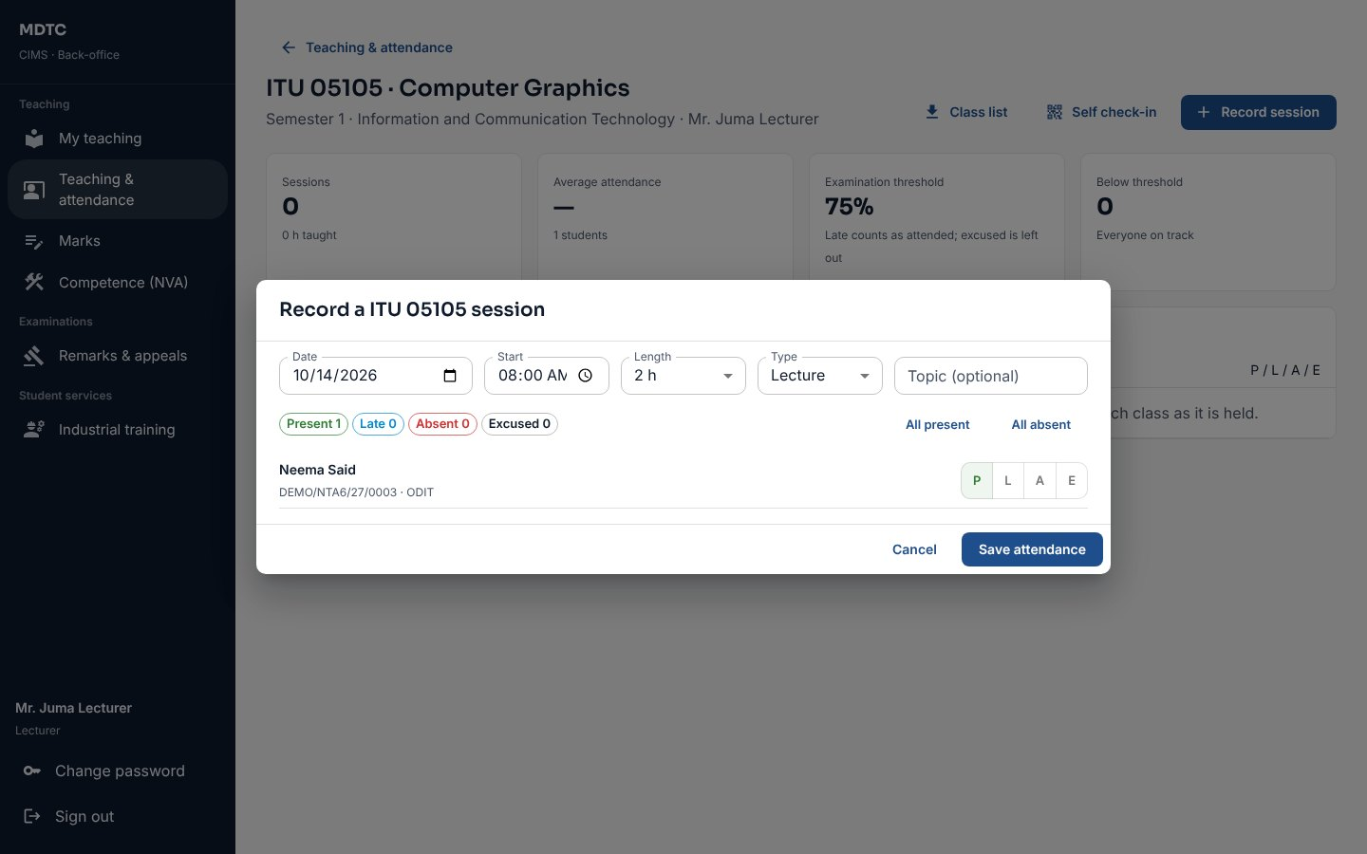
Figure 68: Recording a class session
Tip: Attendance works on a phone or tablet. If the connection drops, the session is kept on the device and sent when the connection returns, and it is never recorded twice.
Note: Sessions can be corrected or deleted until the module's results are submitted.

12.3 Self check-in with a QR code
This section explains how students can check themselves in to a class by scanning a QR code.
- On the module's attendance page click Self check-in.
- Choose the Type, Length of the class, an optional Topic, how long Check-in stays open and when a student counts as late. Start it.
- Project the screen: it shows a six-digit code that changes every 20 seconds, its QR code and who has checked in.
- Students scan the code or type it on the student portal. A phone used for more than one student is flagged to you.
- Close check-in (or let it close on time). Everyone else is marked absent, warnings go out, and you can still correct the register.
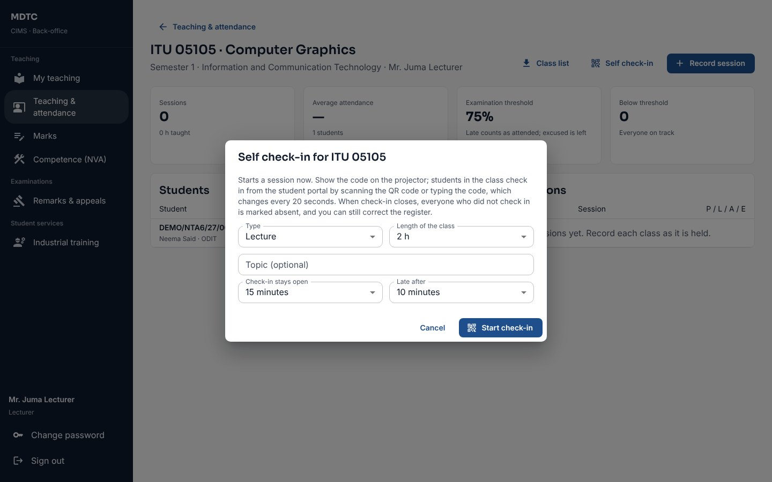
Figure 69: Starting self check-in

12.4 Enter marks
This section explains how to set the assessment plan and enter and submit marks.
- On the module card click Marks. Set the Assessment plan first with Edit plan (tests, assignments, practicals and the examination with their weights).
- Type each student's coursework and examination marks. Type ABS for absent; Enter moves down. CA, SE, total, grade and result are worked out as you type.
- Click Save marks as you go.
- Or click Excel to download the marks template, fill it in and Upload it. If any row is wrong nothing is saved and the problems are listed.
- When all marks are in, click Submit to Head of Department. You can no longer edit unless the module is returned.
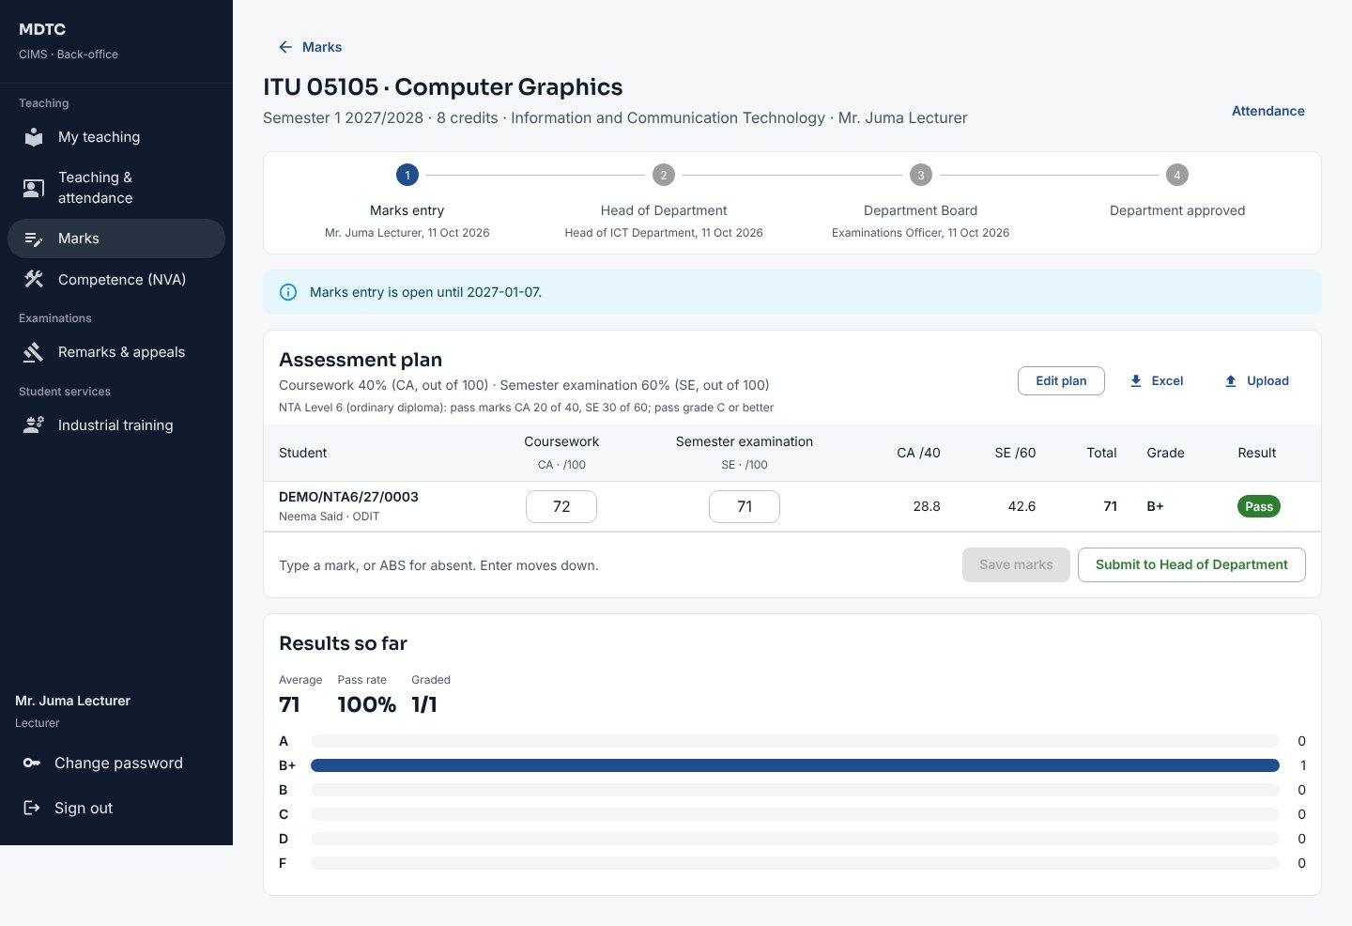
Figure 70: Entering marks for a module
Note: A student who is not eligible for the examination cannot be given an examination mark; the marks sheet shows why.

12.5 Class lists, remarks and IPT supervision
This section explains how to download class lists, handle remarks and supervise students on industrial training.
- Class list downloads a printable PDF that doubles as a paper register, or Excel with each student's attendance so far.
- Remarks assigned to you by the examinations office appear on My teaching; record the new marks with a comment (section 14.7).
- If you supervise IPT students, Student services › Industrial training › My students lists them: approve or return logbook weeks, Record visit and enter your mark.

12.6 My timetable
This section explains where lecturers see their own classes and the examinations of their modules.
Open Teaching › Timetable. My timetable shows your classes for the semester (the classes named for you and those of your modules with no lecturer named) and the papers of your modules, with those you invigilate marked Invigilating. You see them before they are published to students.
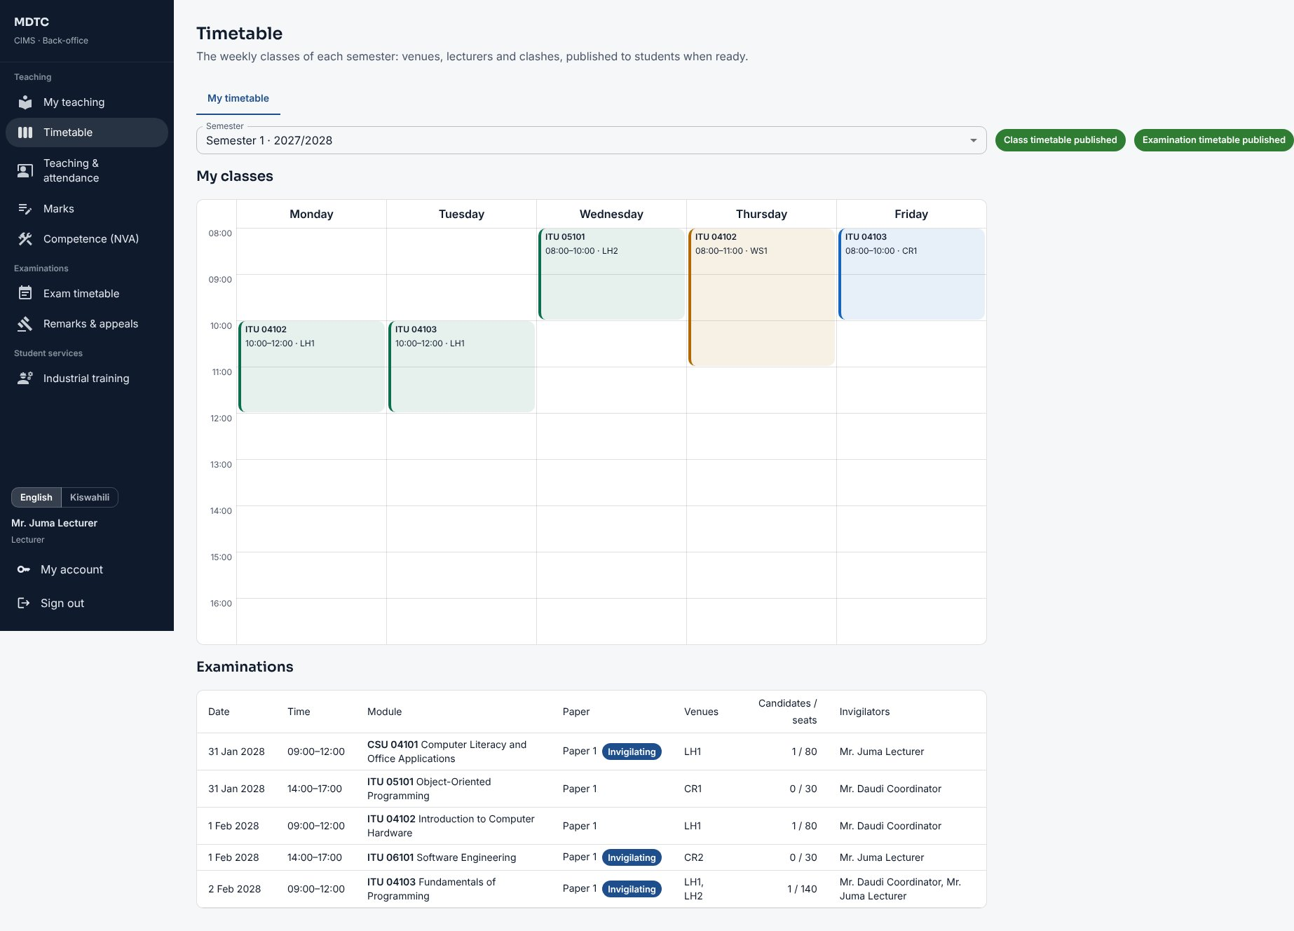
Figure 71: My timetable for a lecturer

13. Assessor (NVA)
This chapter is for the Assessor of NVA programmes: who records competence-based assessment. It explains, step by step, how to record each student's competence outcomes for a unit.
Assessors record competence outcomes for National Vocational Award units. They land on My teaching, where each unit allocated to them has a card.

13.1 Record competence outcomes
This section explains how to record whether each student is competent in each task of a unit.
- On My teaching click Assess on the unit card (or open Teaching › Competence (NVA) and the unit).
- The unit page lists the Tasks (with the evidence required) and each trainee's outcome per task.
- Click Assess beside a trainee. For each task choose Competent or Not yet, optionally enter practical and theory percentages, the Evidence reference and a comment.
- For a later attempt on a task not yet competent, tick This is a re-assessment (up to the number of attempts in the regulations).
- Click Save outcomes. When every required task has an outcome, click Submit for the Head of Department to verify.
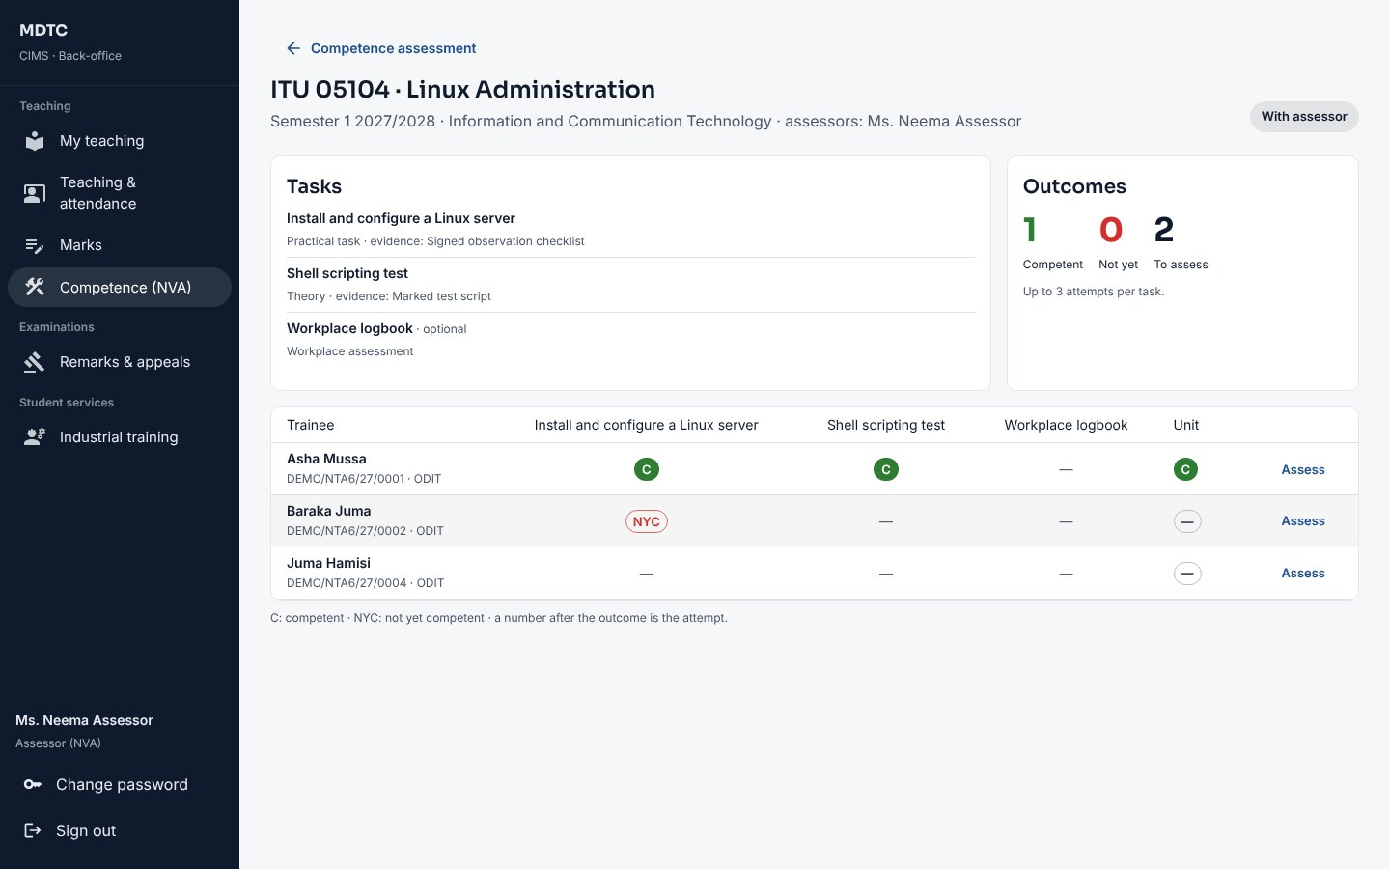
Figure 72: A competence unit with outcomes per task
Note: A competent task cannot be re-assessed. Once verified, attempts are locked; the examinations office can reopen a unit for re-assessment.

14. Examinations Officer
This chapter is for the Examinations Officer: who runs examinations and results for the institution. It explains, step by step, how to set up modules and marks windows, produce eligibility lists and result sheets, submit results to NACTVET and manage resits, remarks, amendments and statements.
The Examinations Officer lands on the Examinations office board, which shows for a semester where marks, eligibility, result sheets, resits and appeals stand, with a Next list linking to each task.
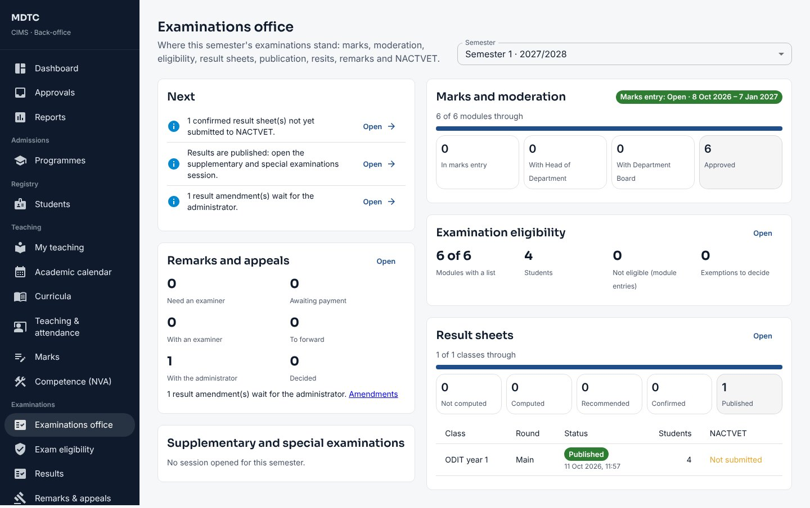
Figure 73: The Examinations office board

14.1 Set up modules and the marks window
This section explains how to set up the semester's modules and the period for entering marks.
- Open Teaching › Marks, choose the Semester and click Set up modules from registrations. CIMS creates a module offering for each module students registered for (modules prepared earlier from the curricula are kept).
- Make sure each module has its lecturers (the Head of Department allocates them).
- Click Marks entry dates to set when lecturers can enter marks. They can enter marks only while the window is open.

14.2 Examination eligibility
This section explains how to produce the lists of students eligible to sit examinations.
- Open Examinations › Exam eligibility and choose the Semester.
- Click Regenerate lists. CIMS applies the rules (minimum attendance, coursework complete, examination fees clearance) and lists each student with the reasons.
- Open a module to see who is not eligible and why. Students who become ineligible get an SMS.
- Exemptions asked for appear under Exemptions awaiting a decision; someone other than the requester approves or rejects.
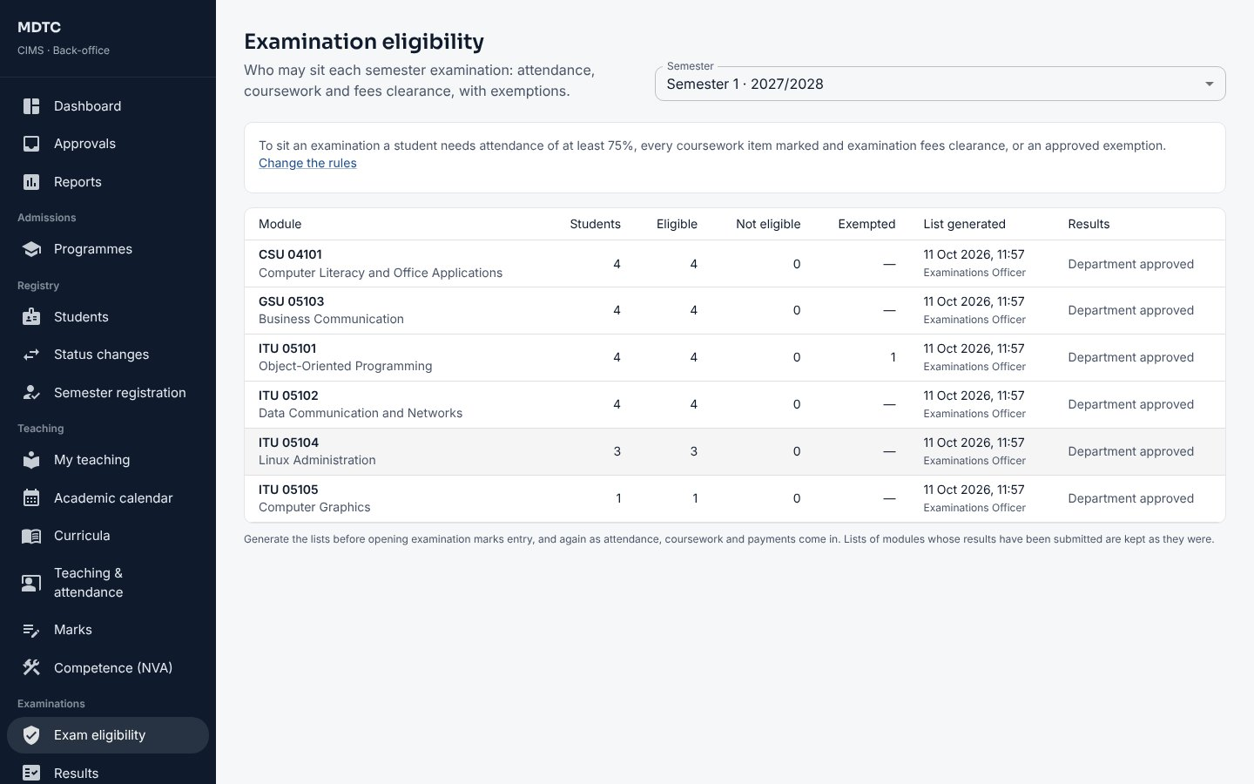
Figure 74: Examination eligibility per module

14.3 Result sheets
This section explains how to compute, check and send result sheets for approval.
- When every module of a class is approved, open Examinations › Results, choose the Semester and click Compute results beside the class (Recompute refreshes a computed sheet).
- The sheet shows each student's grades, GPA, CGPA, the decision proposed by the regulations and the provisional classification. Download it as Excel or PDF.
- The Deputy Principal changes decisions if needed and clicks Recommend to the Board; an administrator then clicks Confirm for the Board. The results are locked.
- Click Publish to students. Students see the results on the portal and receive an SMS; those without results clearance are withheld.
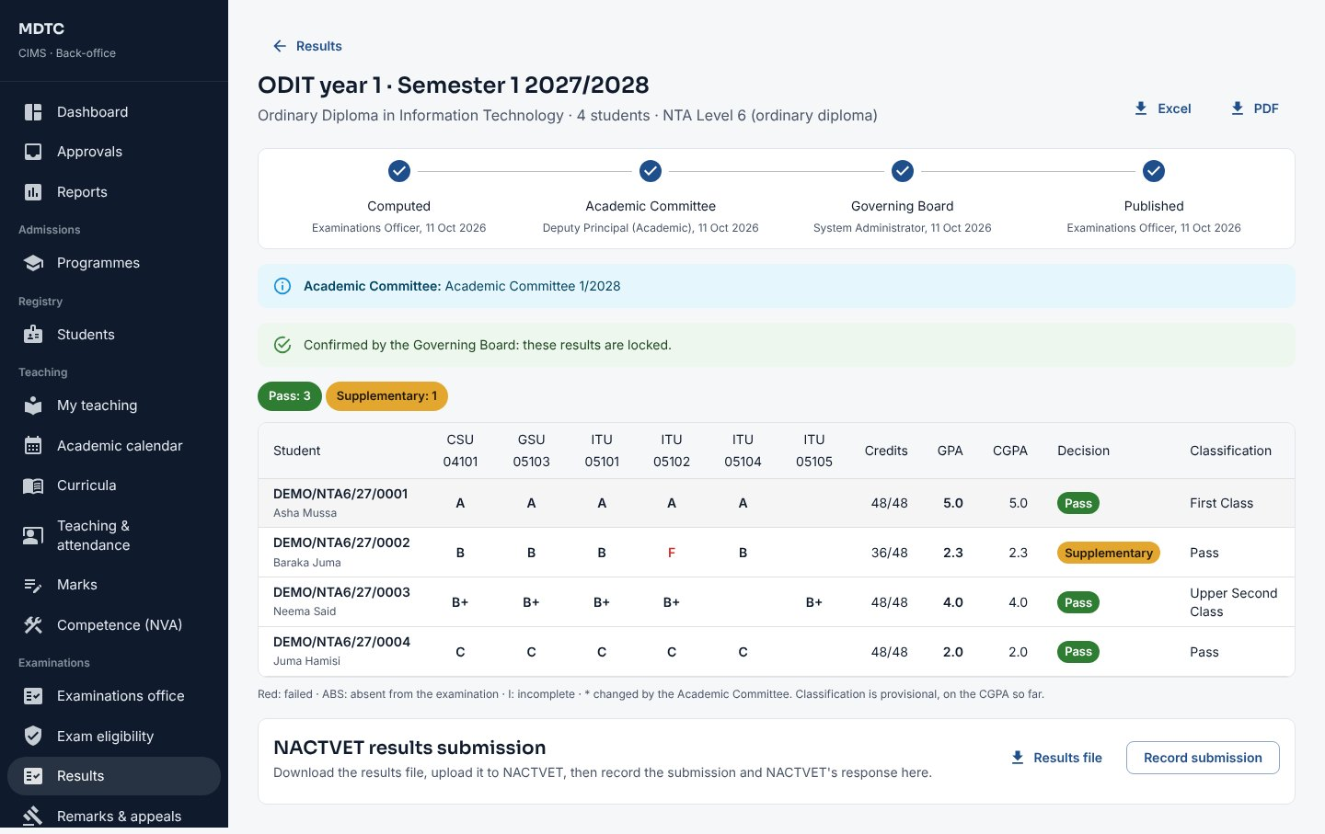
Figure 75: A class result sheet through to publication

14.4 NACTVET results submission
This section explains how to submit confirmed results to NACTVET and record the submission.
- On a confirmed result sheet, under NACTVET results submission, download the Results file.
- Upload it on the NACTVET portal, then click Record the submission to NACTVET and later record NACTVET's response (accepted or queried).

14.5 Supplementary and special examinations
This section explains how to open supplementary and special examinations and process them.
- On Examinations › Results click Open resits. Set the Fee per supplementary, Fee per special exam, the date Students register by and the Examination period. Save.
- Eligible students register in the portal and pay. Lecturers enter resit marks (only for students who paid); the Head of Department approves.
- Compute the resit result sheet; it follows the same committee, Board and publication steps. A module still failed becomes carry over.
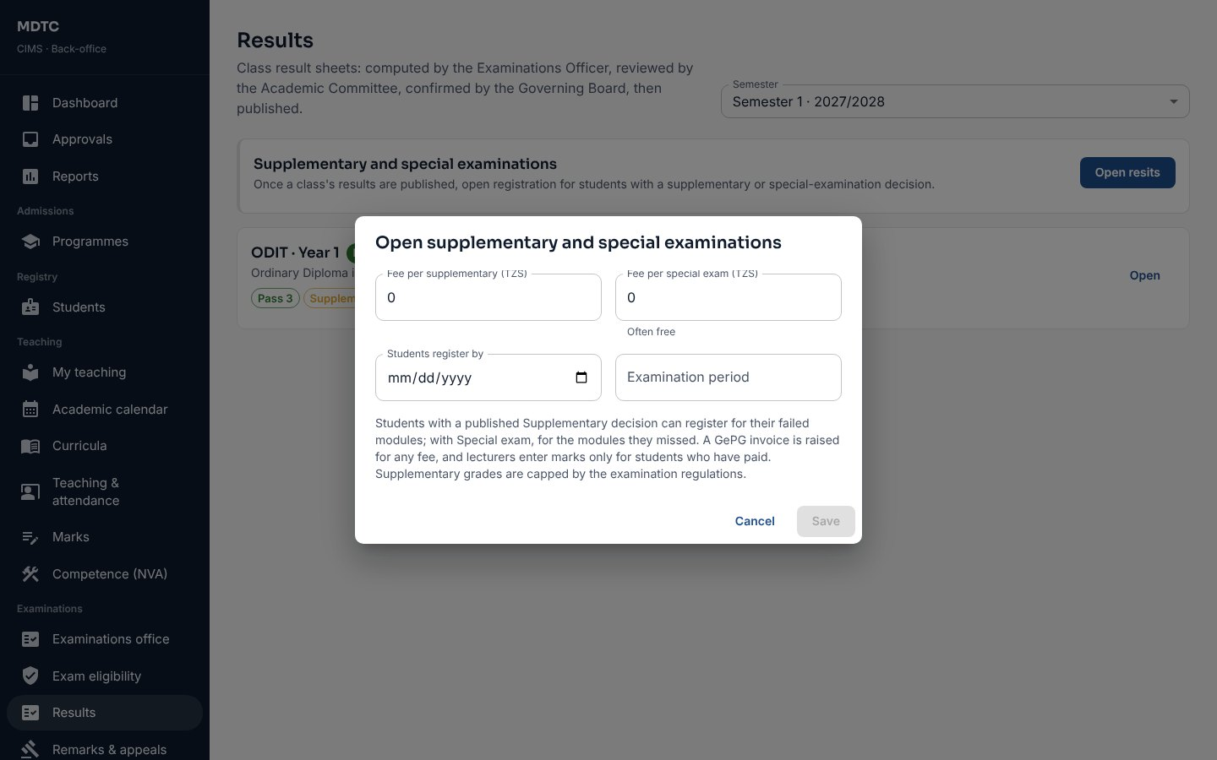
Figure 76: Opening supplementary and special examinations

14.6 Remarks and appeals
This section explains how to handle students' requests for remarking and appeals.
- Open Examinations › Remarks & appeals. Paid requests need an examiner.
- Click Assign an examiner and choose someone who did not teach the module (CIMS refuses the module's lecturers), or Decline with a reason.
- When the examiner has recorded new marks, click Forward outcome. Unchanged: the request closes and the student is told. Changed: it becomes a result amendment for the administrator.
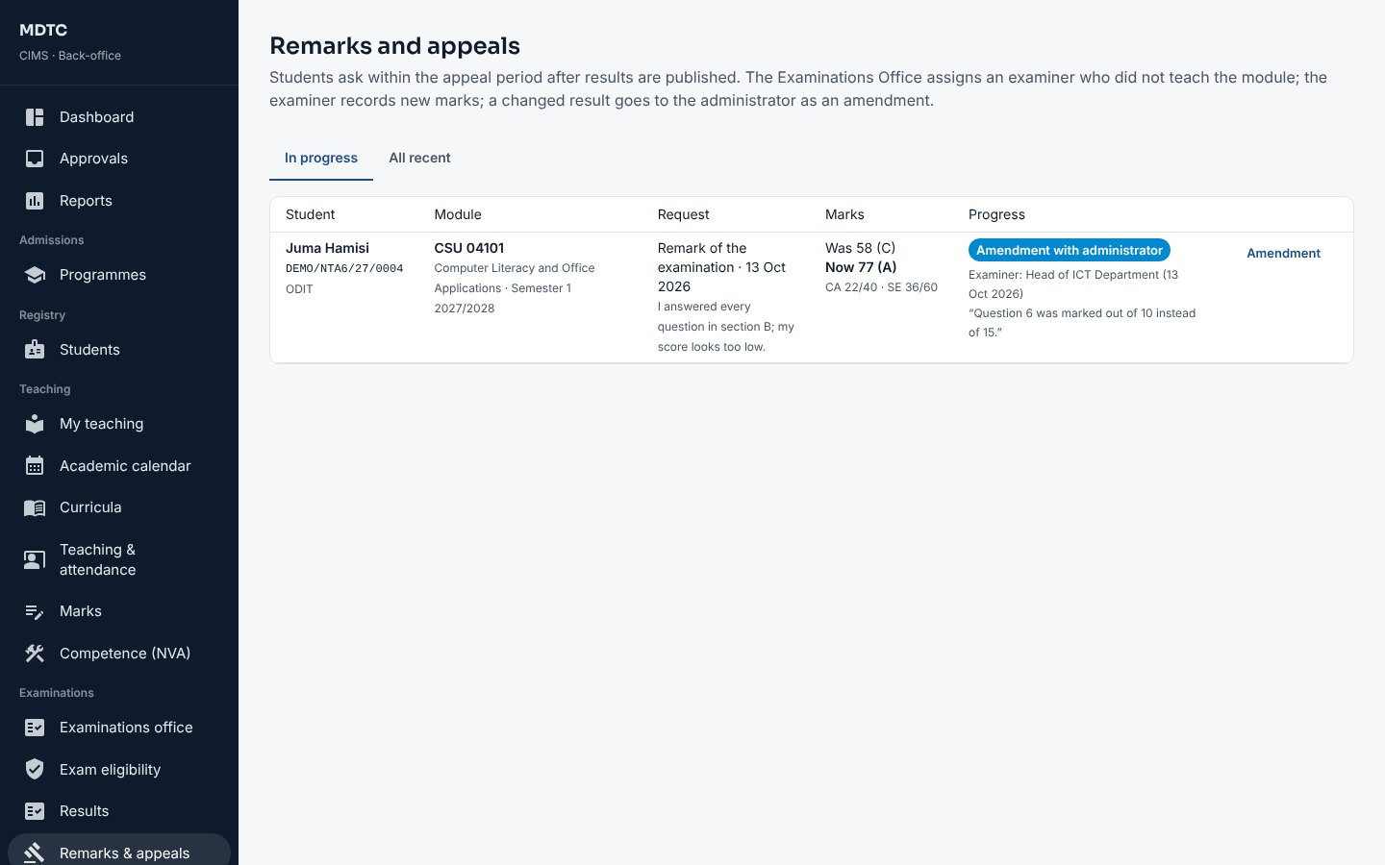
Figure 77: Remarks and appeals

14.7 Result amendments
This section explains how a confirmed result is corrected with justification and approval.
- On the student's results, click Request amendment for a confirmed result, enter the corrected marks, the reason and the evidence.
- An administrator opens Examinations › Result amendments and clicks Approve and apply or Reject. The result is re-graded, the GPA, CGPA and decision are recomputed and the student gets an SMS.
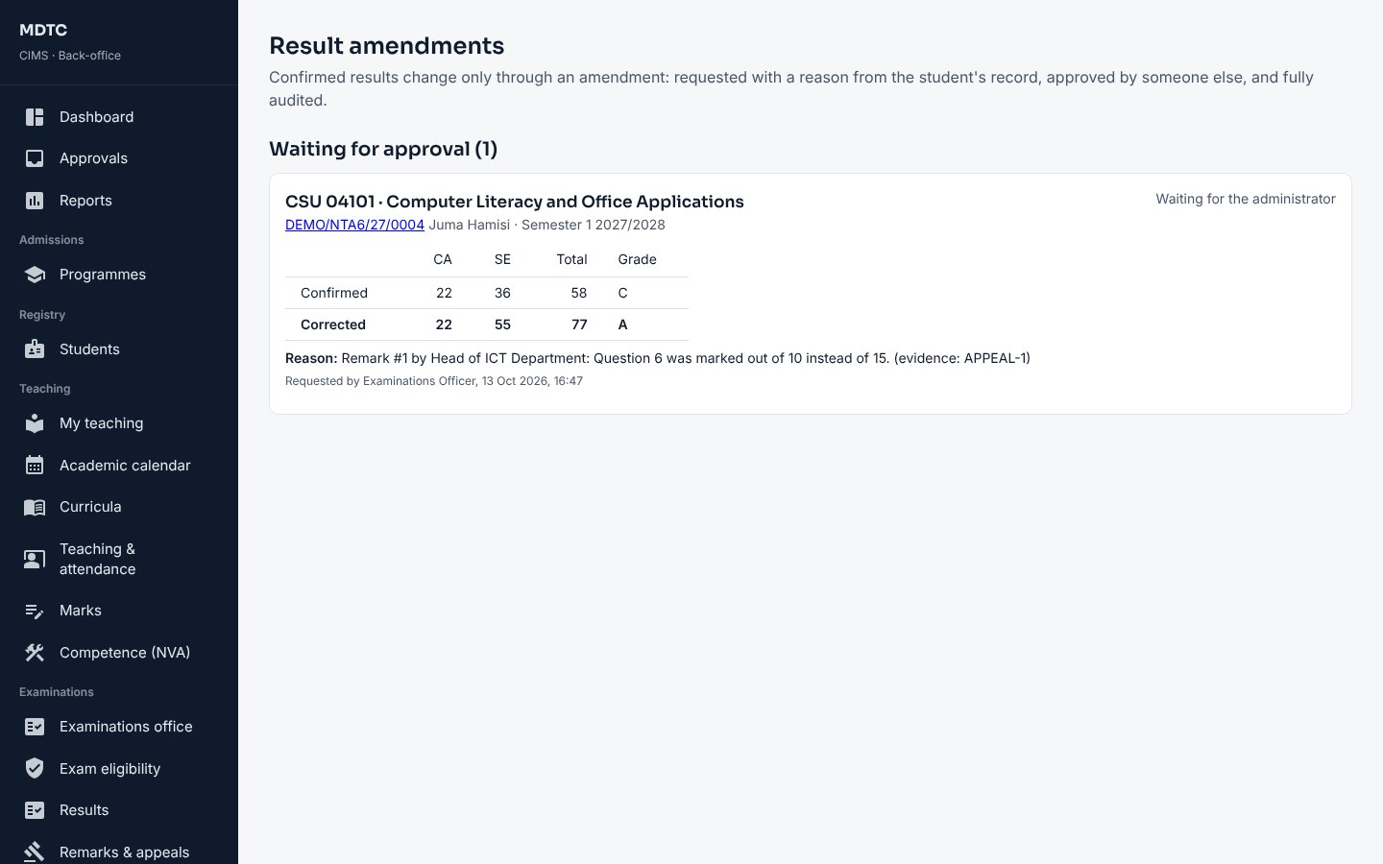
Figure 78: A result amendment waiting for the administrator

14.8 NVA competence units and award lists
This section explains how to set up competence units for NVA programmes and produce award lists.
- Open Teaching › Competence (NVA), choose the Semester and click Set up units. Each unit starts with a practical and a theory task.
- Open a unit to Change tasks (evidence required, optional tasks) and choose Assessors.
- After the Head of Department verifies the units, open the Award eligibility tab: trainees competent in every unit are eligible. Confirm the list and download it as Excel for NACTVET.
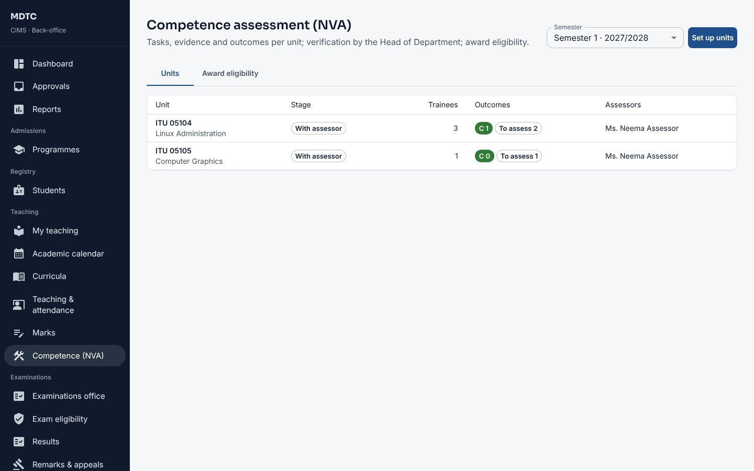
Figure 79: Competence units for a semester

14.9 Statements of results
This section explains how to issue a student's official statement of results.
From a student's results, Statement of results issues a PDF of every published semester with GPA, CGPA, classification and a QR code. It is reissued only when the record changes; earlier editions then verify as superseded.

14.10 Marks entry dates per item and approval stages
This section explains how to set different marks entry dates for particular items and the approval stages results pass through.
- On Examinations › Marks, Marks entry dates sets the semester's window; Dates per item sets different dates for one assessment item (for example the examination opening later than coursework).
- Click Approval stages. On Module results or Class result sheet, click Add a stage, name it and choose Who acts; up to six stages. Click Save.
- Each stage can return marks or a sheet with a comment; the next stage starts only after the previous one approves.
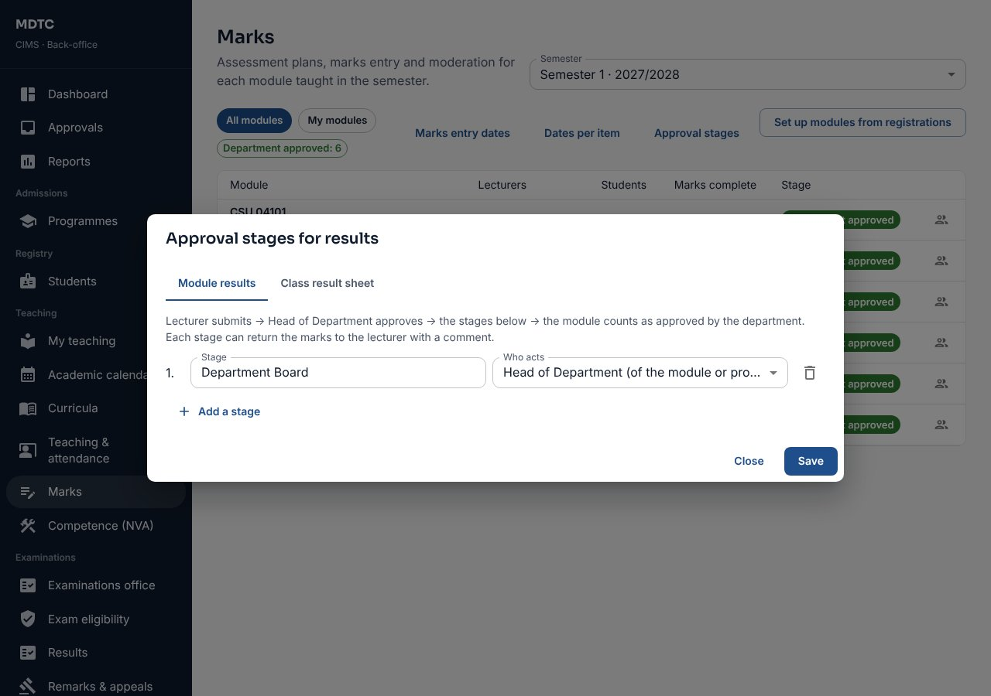
Figure 80: Approval stages for module results

14.11 Results across years
This section explains how to compare results across academic years.
On Examinations › Results, Across years shows, per programme and year of study, the pass rate, mean GPA and decisions by academic year, and module performance year on year, including results brought in from before CIMS.

14.12 Examination timetable
This section explains how to schedule the examination papers of a semester, check them and publish them to students.
- Open Examinations › Exam timetable and choose the Semester. Modules with candidates but no paper are listed beside the timetable.
- Click Add paper. Choose the module and name the paper (for example Paper 1 or Practical), set the date (within the semester) and times, choose one or more Venues and the Invigilators. The seats of the chosen venues are shown against the candidates registered.
- Click Save. CIMS refuses a paper when a registered student or an invigilator would be in two papers at once.
- Look at Clashes and checks: papers with more candidates than seats, venues shared by papers at the same time, and students with two papers on one day.
- Click Publish to students (with an SMS). CIMS checks again that no student has two papers at once; students see the date, time and venues of their papers under Timetable. Excel downloads the timetable for the notice board.
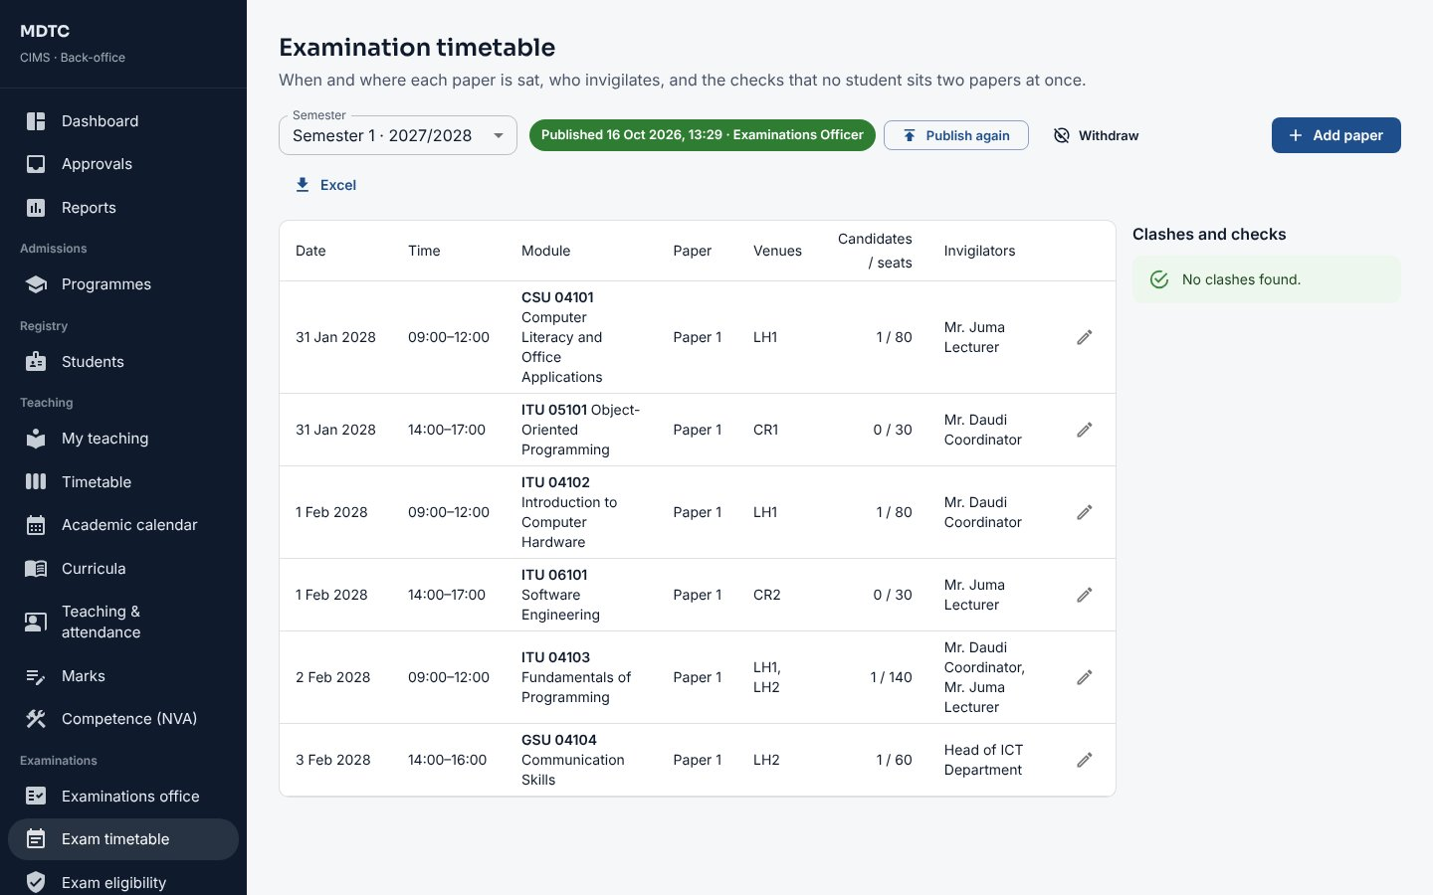
Figure 81: Examinations › Exam timetable
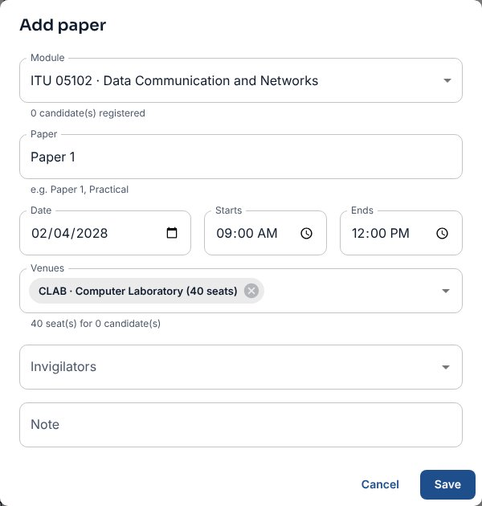
Figure 82: Adding an examination paper

15. Bursar / Finance Manager
This chapter is for the Bursar or Finance Manager: who leads the finance office. It explains, step by step, how to read the finance overview, set collection targets, approve fee structures, waivers and refunds, sign off reconciliation and manage instalments, schemes and postings.
The Bursar lands on the Finance overview, approves fee structures, waivers and refunds, sets collection targets and signs off reconciliation.

15.1 Finance overview
This section explains the finance overview: billing, collections, debts and waivers at a glance.
Choose the Academic year. The cards show annual fees billed, the percentage paid, what is still owed (and how much is due from sponsors), what was waived and money received this month. Below are Next (work waiting), Collections against targets, Money received, last 12 months, Annual fees by class, Debtors by age, Received by purpose, Largest debtors and Work in the bursary.
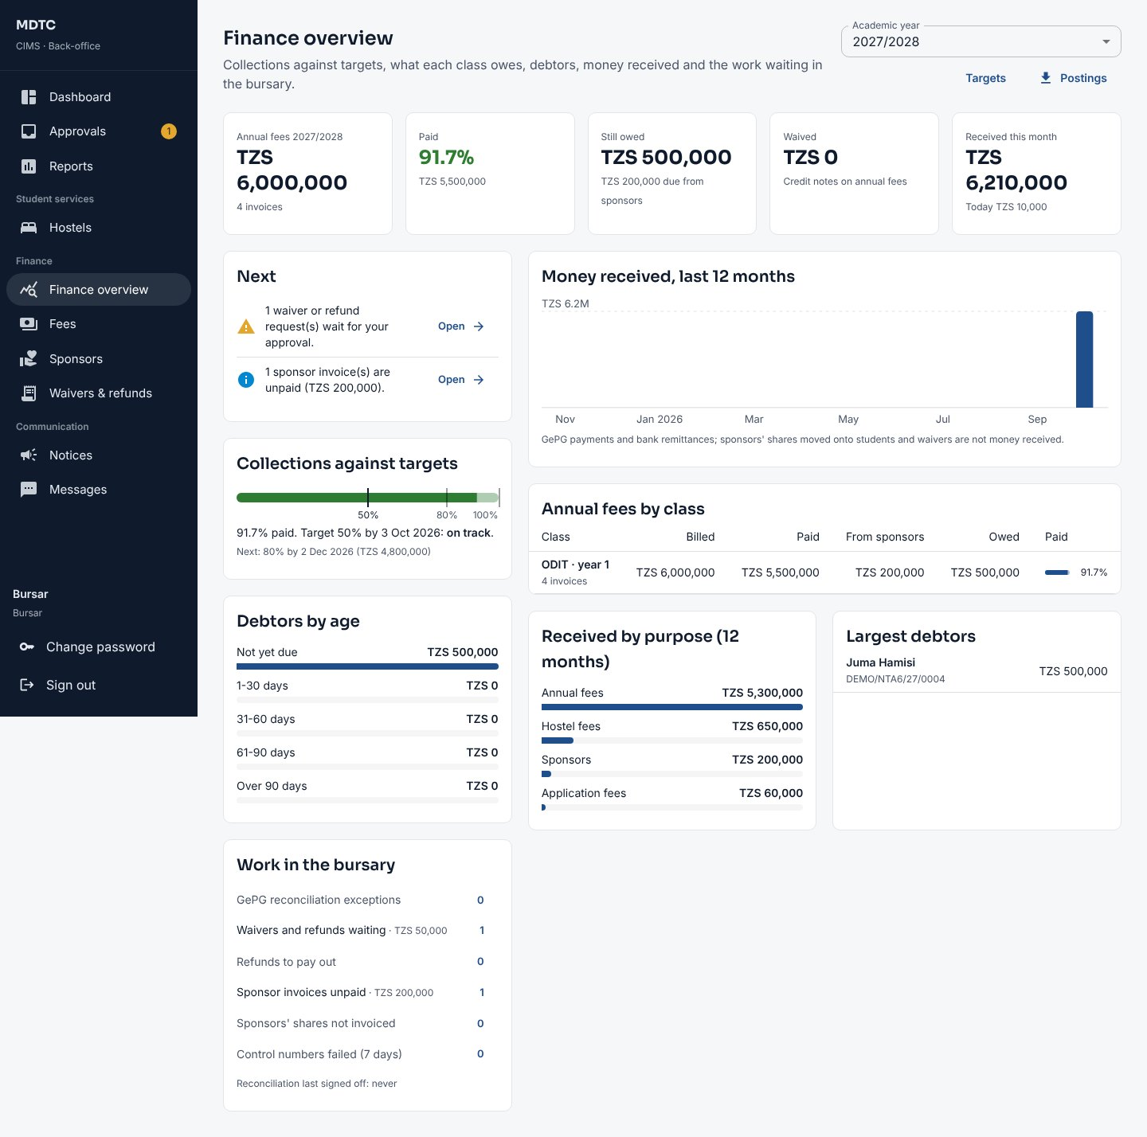
Figure 83: The Finance overview

15.2 Collection targets and postings
This section explains how to set collection targets and follow progress against them.
- Click Targets. Add milestones (for example 50% by October, 80% by December, 100% by March) with Add milestone; a later target cannot be lower. Click Save targets.
- The overview then says whether collections are on track and what the next target needs.
- Click Postings to download a CSV of every posting in a date range for the accounting system.
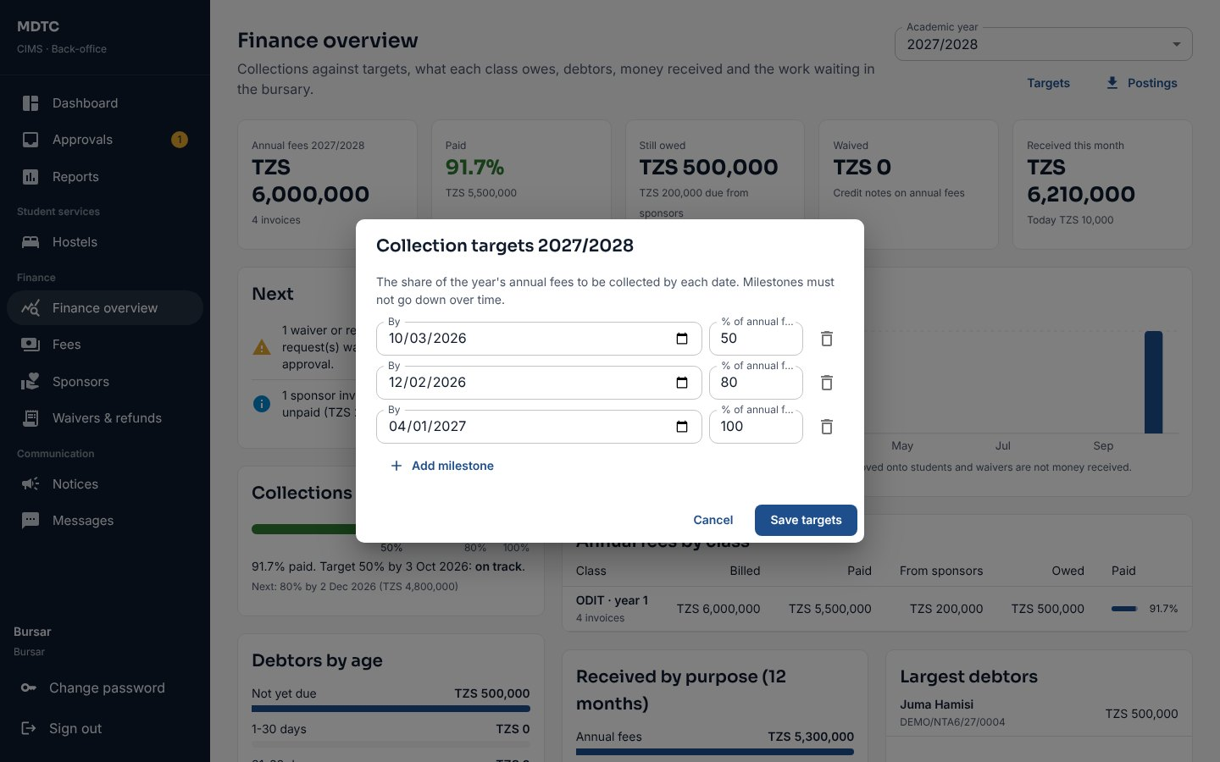
Figure 84: Setting collection targets

15.3 Approve fee structures, waivers and refunds
This section explains the Bursar's approvals of fee structures, waivers and refunds.
- Fee structures: open Finance › Fees; a structure prepared by the Accountant shows Approve. Check the amounts and approve. You cannot approve one you prepared.
- Waivers and refunds: open Finance › Waivers & refunds (or Approvals). Read the reason and evidence and click Approve or Reject (a rejection needs a note).
- Above the threshold your approval endorses the request and it goes to the Principal for the second approval. Click Threshold to change the amount (default TZS 500,000).
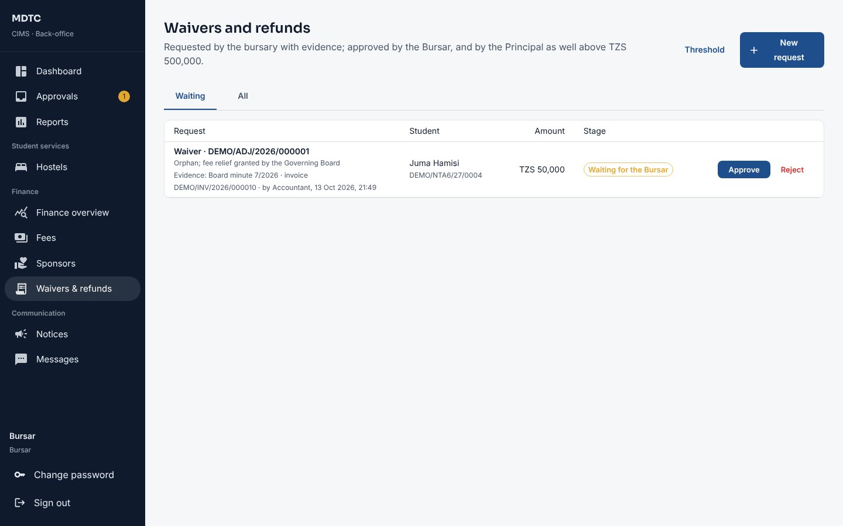
Figure 85: Waivers and refunds waiting for approval
An approved waiver is posted as a credit note that reduces the invoice. An approved refund uses the student's credit and gets a refund voucher; mark it paid when the money is paid out. The student is told by SMS. A refund can also pay back fees paid on an invoice (for example hostel fees for a stay that ended early): the invoice is reduced by a credit note. Requests that CIMS raised itself, after a status change or a hostel bed change, check-out or cancellation, carry a label saying so and are decided in the same way.

15.4 Monthly reconciliation sign-off
This section explains how to sign off the month's reconciliation of payments.
- Open Finance › Fees › GePG reconciliation and choose the Month.
- When every day with collections is closed by the Accountant, click Sign off month.

15.5 Instalments, reminders and penalties
This section explains how to set instalment due dates, automatic reminders and late payment penalties.
- Open Finance › Fees, tab Instalments and reminders, and choose the Academic year.
- Under Instalment due dates click Add instalment for each instalment number used in the fee structures, set its date and click Save dates. Fees without a date are not chased.
- Under Reminders and penalties switch on SMS reminders and set the Days before the due date.
- Choose a Late payment penalty (percentage of what is overdue, or a fixed amount) and the Grace days, then Save rules.
Reminders go before the due date, on the day and once when overdue. A penalty is added once per instalment after the grace period, as an invoice line paid last; it can be waived through Waivers. Penalties applied lists them.
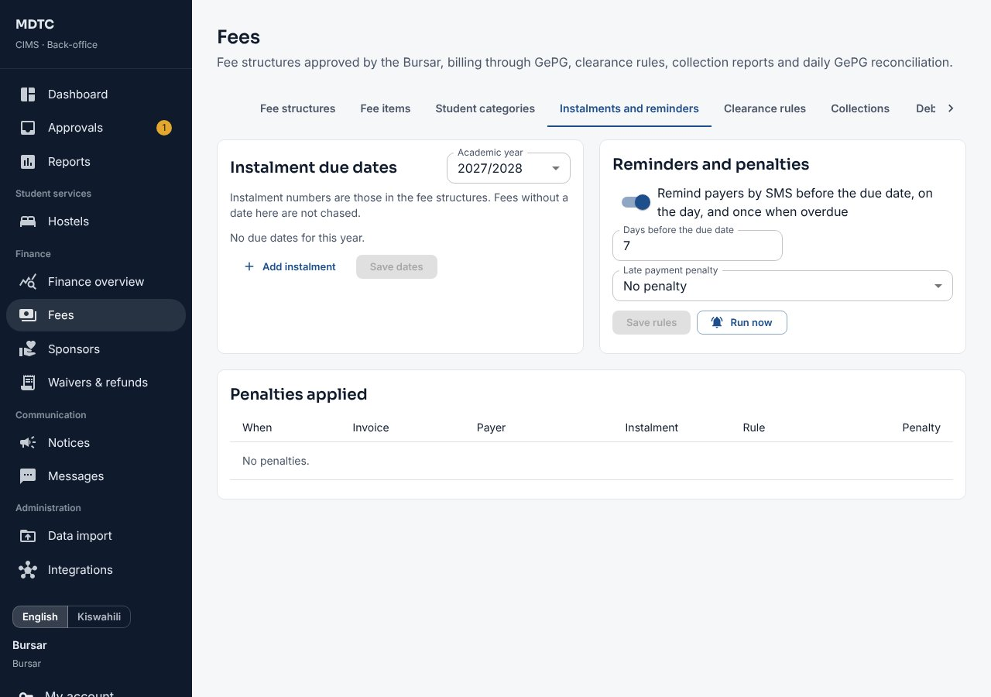
Figure 86: Instalments and reminders

15.6 Discount and scholarship schemes
This section explains how to set up discount and scholarship schemes.
- Open Finance › Waivers & refunds, tab Discount and scholarship schemes, and click New scheme.
- Give the name, choose Discount or Scholarship, the Basis (Percentage of a fee category, e.g. 10% of tuition, or Fixed amount) and what it Applies to, and save.
- The Accountant grants it to a student with New waiver, discount, scholarship or refund; each grant is approved like a waiver (section 15.3).

15.7 MUSE postings
This section explains how to post fee transactions to the government accounting system (MUSE).
- Open Administration › Integrations, tab MUSE postings.
- Choose the period From and To and click Preview the journal (accounts, GFS codes, debits and credits).
- Click Post to MUSE. Each period is posted once; Postings lists what was sent and MUSE's reference.

15.8 Health insurance contributions
This section explains how the bursary bills NHIF's student contribution.
- Under Administration › Integrations set NHIF's student contribution per year (0 when the institution pays NHIF itself).
- Open Registry › Health insurance and click Bill students without cover. Every current student with no cover recorded for the year is billed the contribution, with a control number sent by SMS. A student who then gives an active NHIF card of their own has the unpaid bill cancelled.
- Payments arrive as for any fee; once a contribution is paid, Registry sends the student to NHIF (section 10.12).

16. Accountant / Finance Officer
This chapter is for the Accountant or Finance Officer: who handles day-to-day billing and payments. It explains, step by step, how to prepare fee items and structures, bill students, reconcile payments daily, manage sponsors and request waivers and refunds.
The Accountant prepares fee structures, bills students, imports GePG reconciliation files, runs sponsors and requests waivers and refunds.

16.1 Fee items and fee structures
This section explains how to set up fee items and build fee structures for each programme and year.
- Open Finance › Fees › Fee items. Click New fee item for each item (tuition, examination, registration, hostel …) with its GFS code, category and allocation Priority (payments go to items in this order).
- On Fee structures choose the Academic year and click New fee structure: choose the programme and year of study and enter the amounts for Tanzanian and other nationalities, and the instalments.
- Click Save draft. The Bursar approves it. To change an approved structure use Revise (new version).
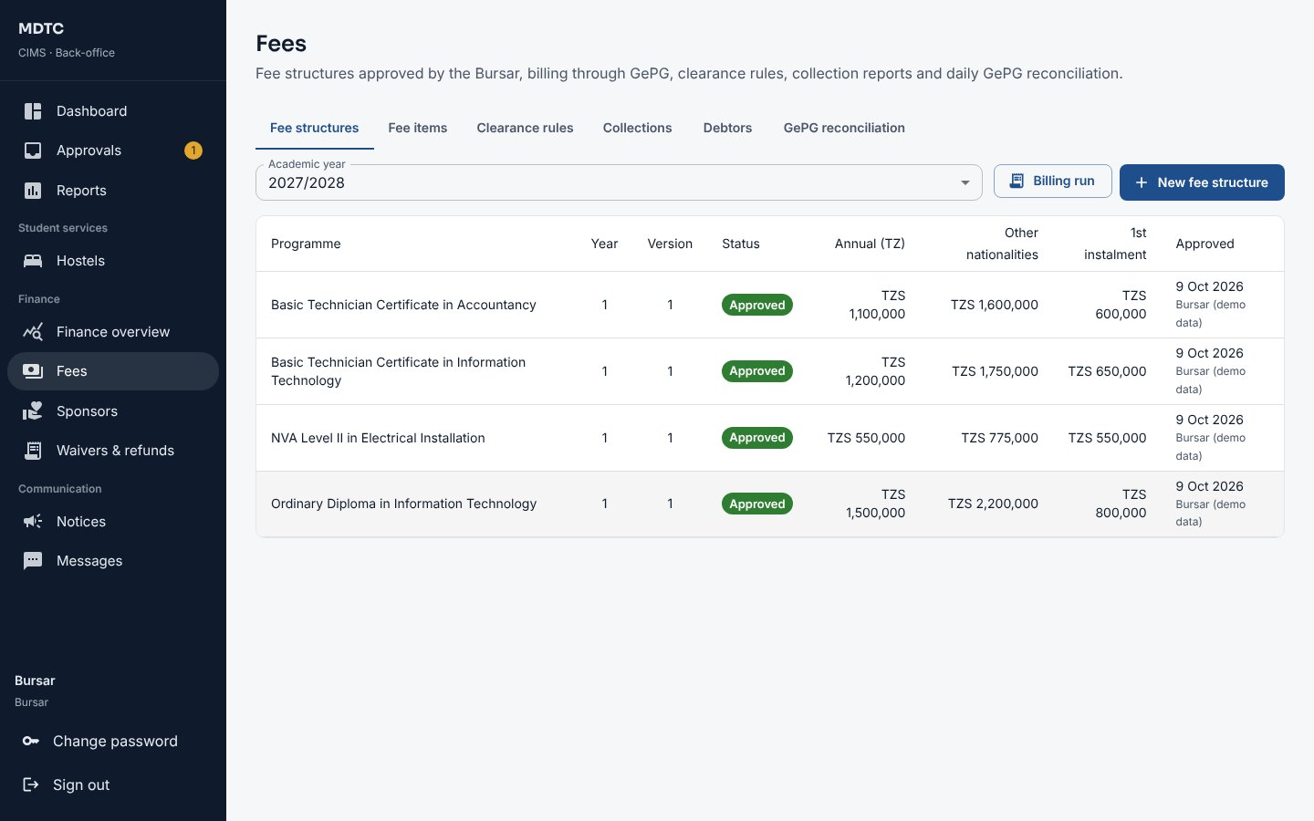
Figure 87: Fee structures
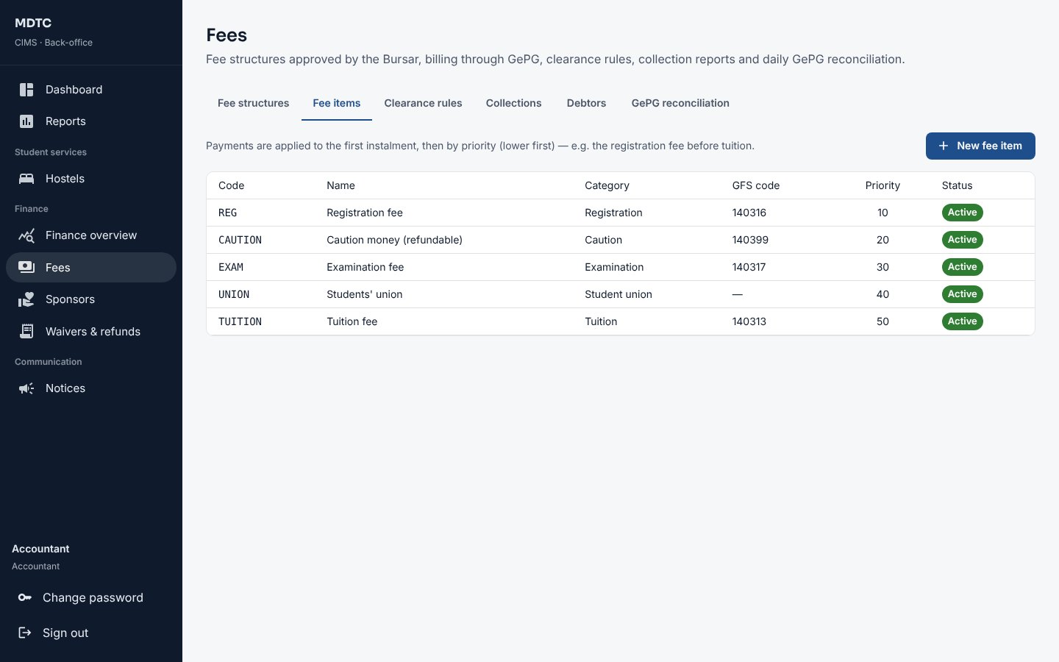
Figure 88: Fee items with GFS codes and priority

16.2 Billing and clearance rules
This section explains how students are billed and the rules that hold back services until fees are paid.
- Applicants are billed automatically when they accept an offer, and the invoice moves to the student at hand-over. Billing run bills continuing students for a year; it never bills anyone twice.
- Each invoice gets a GePG control number, sent to the payer by SMS. Payments are allocated to fee items by priority; an overpayment is held as credit.
- Clearance rules sets, for registration, examinations, results, hostel and graduation, whether the rule is Enabled, the Minimum paid percentage and whether the First instalment is required.
- Collections and Debtors show money received by day or fee item and balances by age, with CSV downloads.
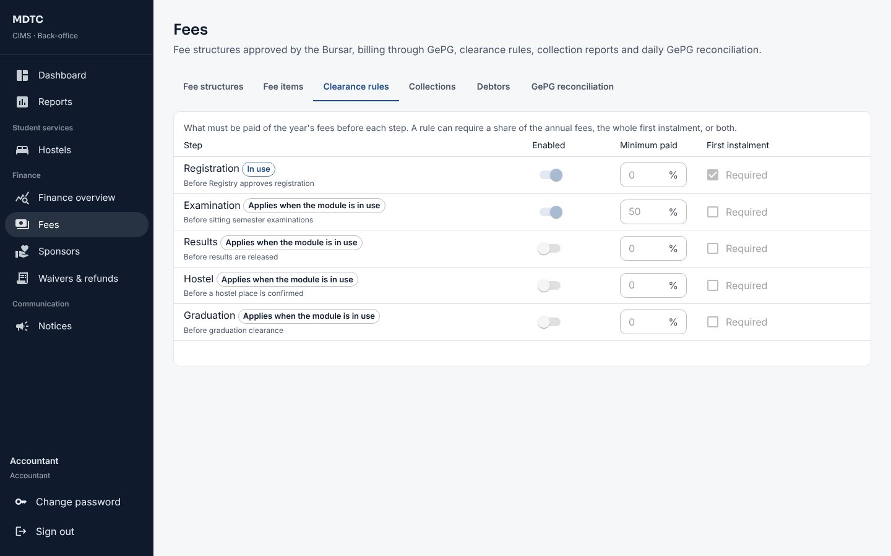
Figure 89: Clearance rules

16.3 Daily GePG reconciliation
This section explains how to reconcile each day's payments with GePG records.
- Open Finance › Fees › GePG reconciliation and choose the Month. Each day shows CIMS payments and whether it is reconciled.
- Click Import on a day and choose GePG's reconciliation file. Click Import and match. Nothing is saved if any line is invalid.
- Work through the Exceptions: a payment GePG has but CIMS missed (Post payment from GePG), a CIMS payment not in the file, a different amount, a repeated line or an unknown bill. Explain or Resolve each.
- When no exception is open, click Close day. The Bursar signs off the month.
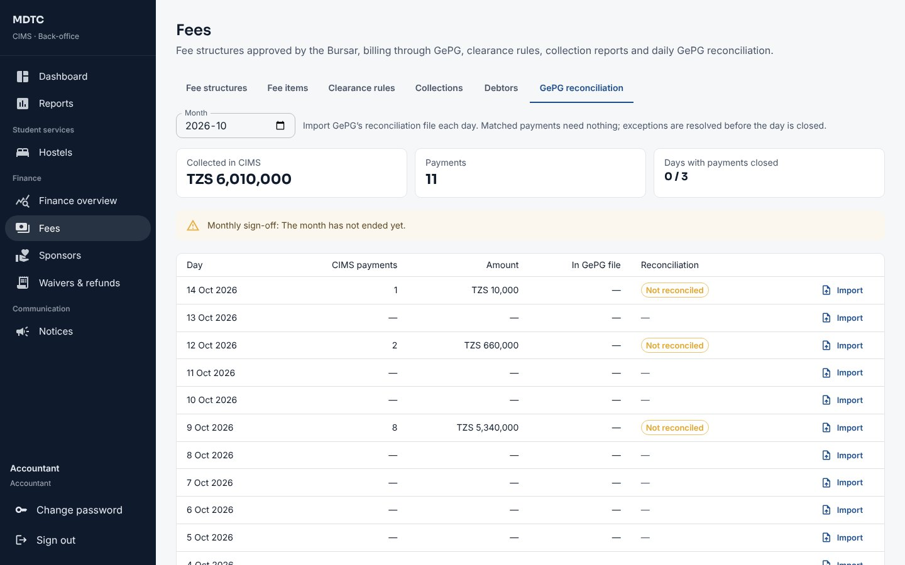
Figure 90: GePG reconciliation by day

16.4 Sponsors
This section explains how to record sponsors such as HESLB and the students they pay for.
- Open Finance › Sponsors and click Add sponsor (for example HESLB, a government body, an NGO or a company) with a contact.
- Open the sponsor and click Add student for each sponsored student: a percentage of all fees or chosen fee items, an optional cap and the sponsor's reference. Or Import list to load the sponsor's CSV list by registration number.
- Click Invoice the sponsor. One invoice is raised with a line per student, never more than the student still owes.
- When the sponsor pays, use Get control number for GePG or Record bank payment for a bank transfer. Each student's share moves onto their invoice.
- Click Statement for the sponsor's Excel statement.
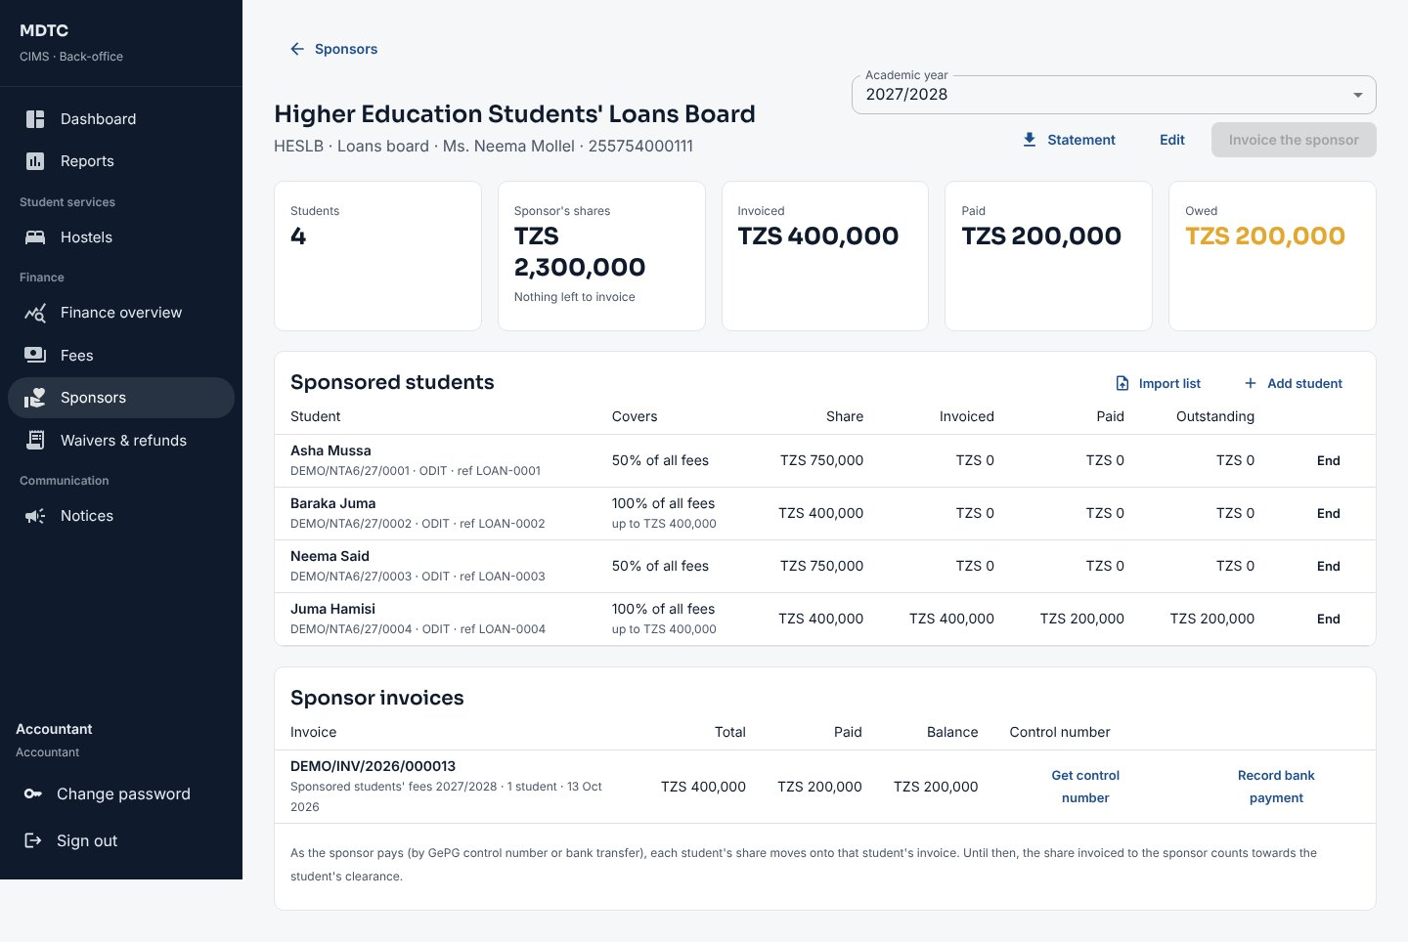
Figure 91: A sponsor with sponsored students and invoices

16.5 Request a waiver or refund
This section explains how to request a waiver or a refund for a student.
- Open Finance › Waivers & refunds and click New request.
- Choose the Kind: Waiver (reduces what is owed on an invoice) or Refund. A refund pays back the student's credit, or, if you tick Refund fees paid on an invoice, part of what was paid on the invoice you choose. Enter the Registration number and click Find.
- Choose the invoice, enter the amount, the reason and the evidence, and Submit. The Bursar (and above the threshold the Principal) decides.
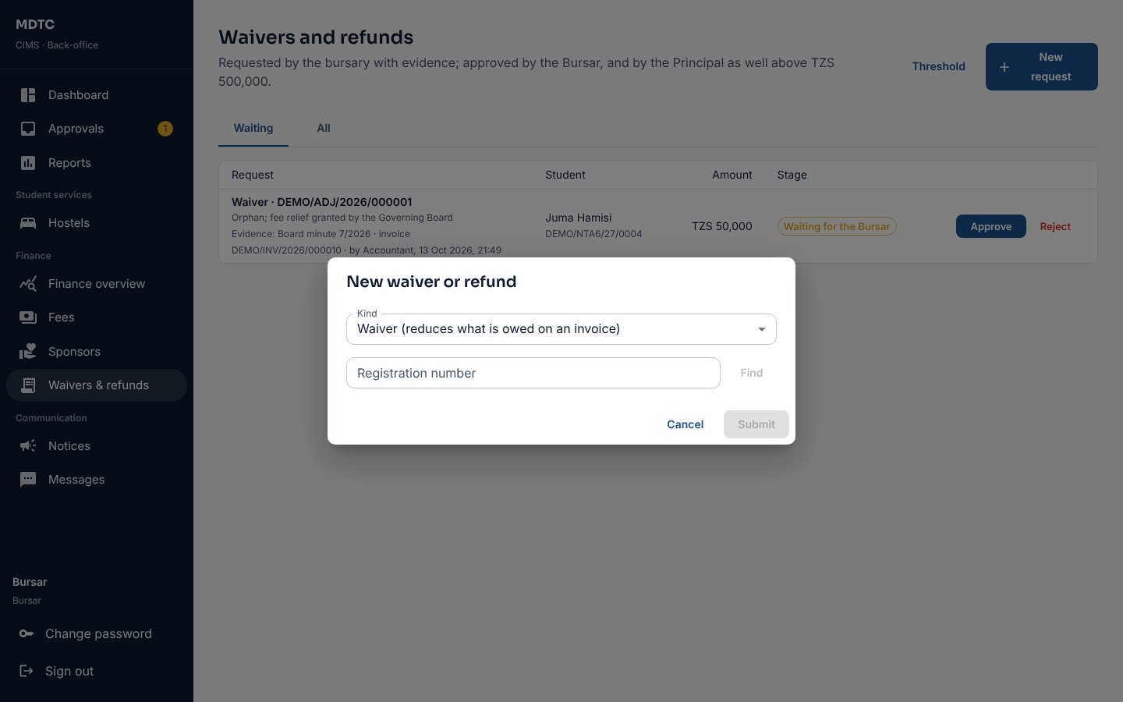
Figure 92: Requesting a waiver or refund

16.6 Fees by intake and student category
This section explains how to charge different fees by intake and by student category.
On Finance › Fees, tab Student categories, add categories priced differently (for example regular, evening, weekend or distance). A fee structure can then be made for one intake and/or one category; students are billed under theirs, otherwise under the general structure.

16.7 HESLB exchange
This section explains how to exchange student and payment data with HESLB.
- Open Administration › Integrations, tab HESLB (switched on in Settings).
- Click Send first-year registration or Send continuing students to give HESLB the students' data.
- Click Fetch beneficiaries: HESLB's loan list becomes capped sponsorships on the HESLB sponsor.
- Click Fetch disbursements, then Record payment against the HESLB sponsor invoice for each disbursement.

17. Sponsor Officer
This chapter is for Sponsor Officers, who work for a sponsor such as HESLB. It explains what they can see and do for the students their sponsor pays for.
A Sponsor Officer works for a sponsor such as HESLB and sees only that sponsor. The Institution Administrator creates the account with the sponsor it belongs to.
- Sign in at /staff. You land on your sponsor's page.
- Choose the Academic year. See the sponsored students with each share, what was invoiced, paid and outstanding, and the sponsor's invoices.
- Use Get control number to pay an invoice through GePG, and Statement to download the Excel statement.
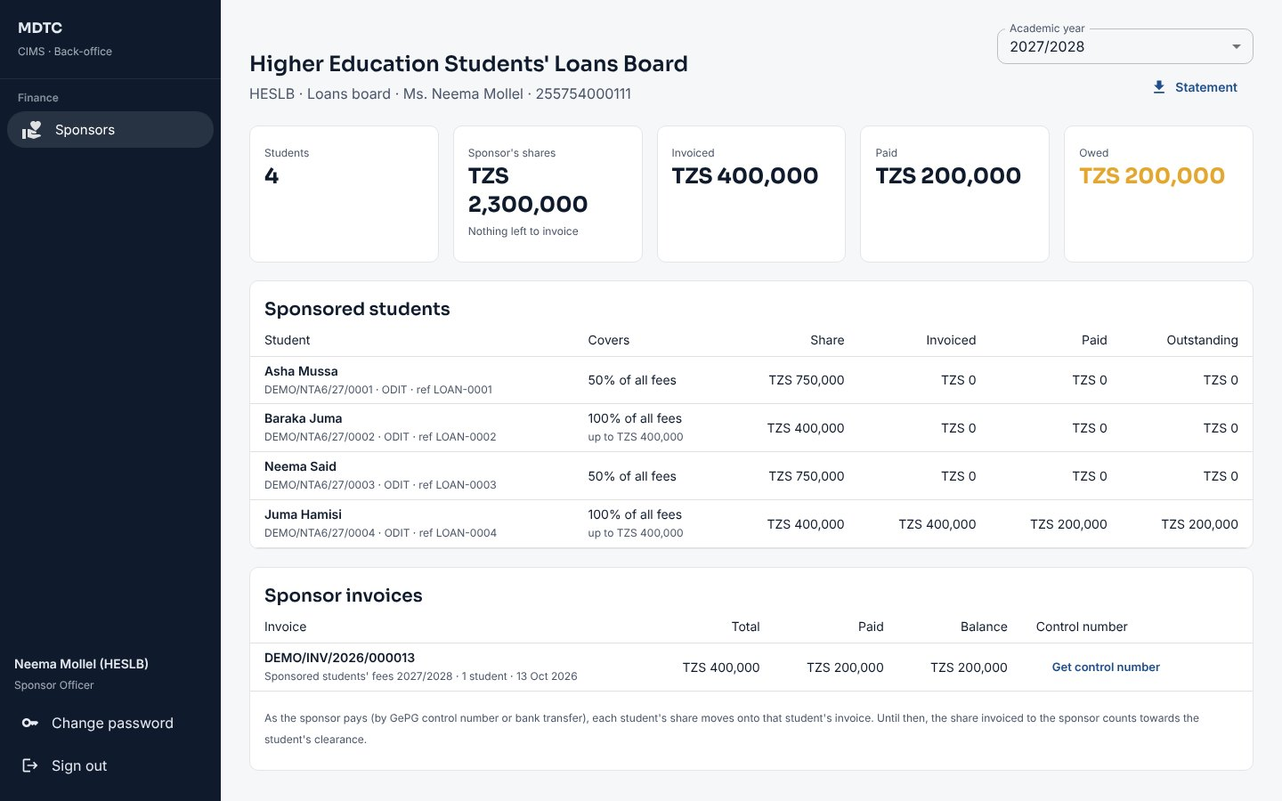
Figure 93: The Sponsor Officer's view
Note: Sponsor Officers cannot change sponsorships or record payments.

18. Dean of Students / Hostel Warden
This chapter is for the Dean of Students and Hostel Wardens: who manage student accommodation. It explains, step by step, how to set up hostels, rooms and fees, open application windows, allocate beds, and handle check-in, check-out and repairs.
Wardens land on Hostels. A warden assigned to particular hostels works only on those; a warden with no assignment (for example the Dean of Students) works on all.

18.1 Inventory, fees and windows
This section explains how to set up hostels, rooms, beds and fees and open an application window.
- On Fee categories click New fee category with the fee per bed per academic year.
- On Hostels and rooms click New hostel: name, code and designation (Female students, Male students or Mixed (each room female or male)). Add rooms with block, floor, type, gender, accessibility and beds; a bed can be put out of service.
- An administrator uses Assign wardens on a hostel to limit wardens to it.
- On Application windows click New window with the dates, the payment period and the priority rules.
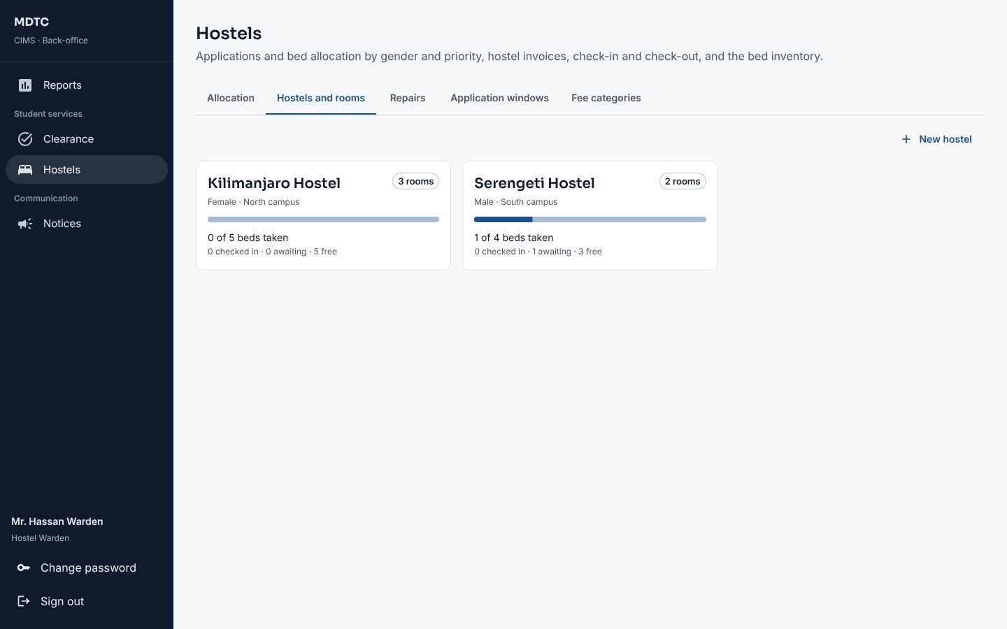
Figure 94: Hostels and rooms

18.2 Allocate beds
This section explains how beds are allocated to applicants, automatically or by hand.
- On Allocation choose the Window. Applications are listed with preferences and special needs.
- Click Allocate beds to allocate automatically: never against gender; special needs, first years and fee clearance first; then who applied first. Students without a bed go on the waiting list (SMS).
- Or allocate one student by hand with Allocate. Each allocation is invoiced with a control number (SMS).
- Unpaid allocations are released every morning after the payment period; Release unpaid does it at once and offers the beds to the waiting list.
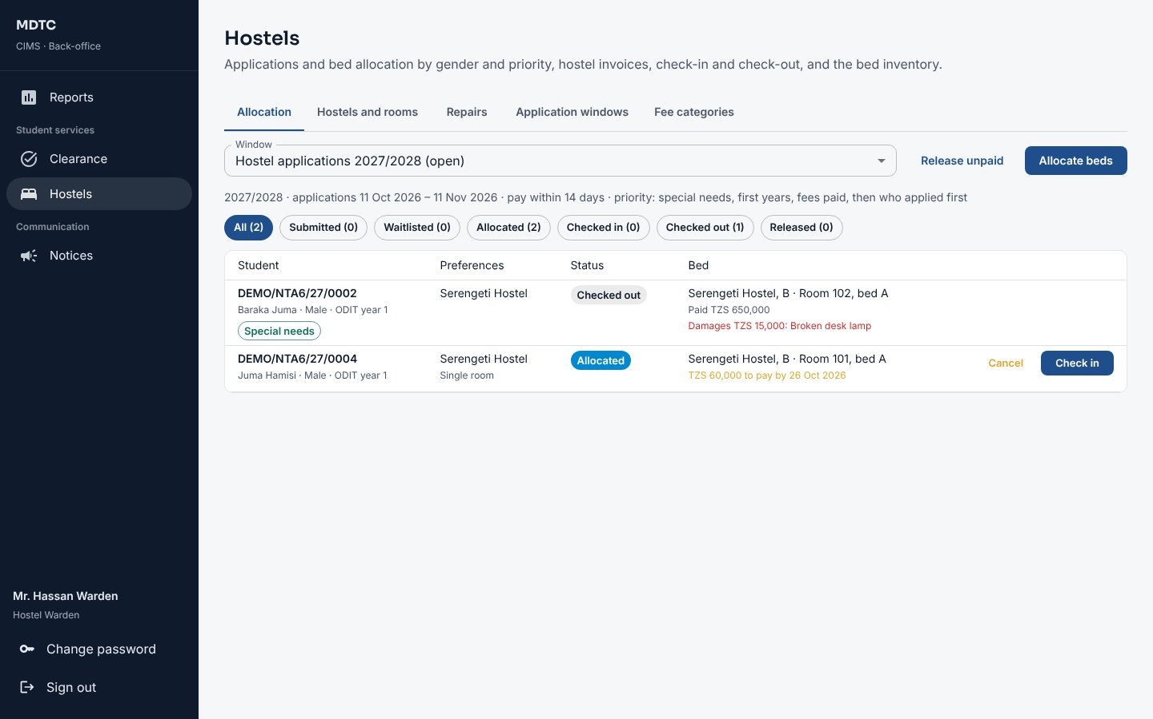
Figure 95: Hostel allocation

18.3 Check-in, check-out and repairs
This section explains how to check students in and out and handle repair requests.
- Check in a student once the fee is paid, recording the room's condition.
- Check out records the condition and any damages; a damage charge is invoiced. Tick Refund the unused part of the hostel fee when a student leaves early: CIMS works out the amount from the occupancy dates and raises a refund for the bursary. Cancelling a bed that was paid for raises a refund of what was paid.
- On Repairs click Log a repair (category, urgency, room or common area). Students' reports appear here too. Use Update to move a repair to Being fixed, Fixed or Close without fixing with a note; the student is told by SMS.
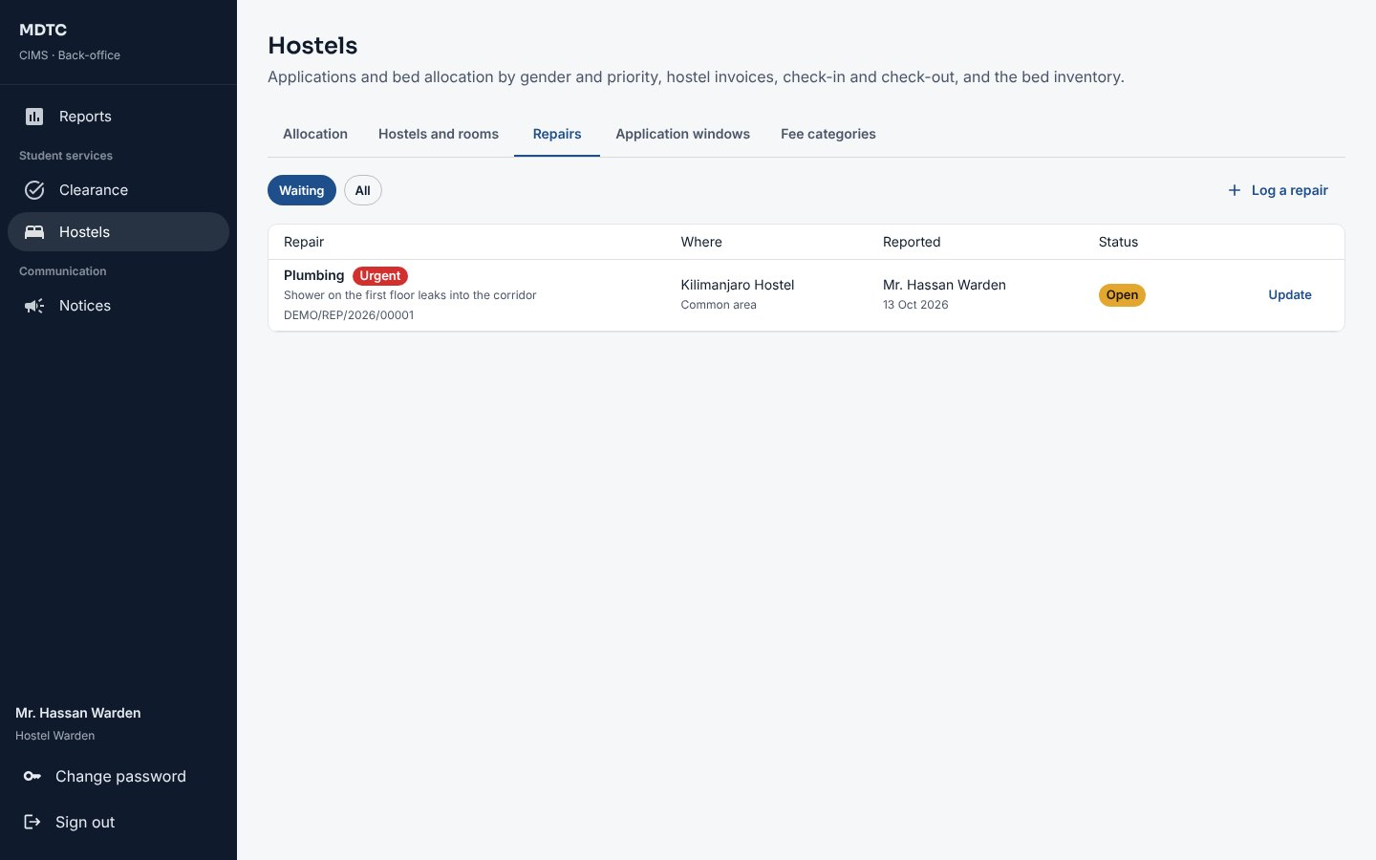
Figure 96: Repairs

18.4 Move a student to another bed
This section explains how to move a student to another bed and what happens to the hostel fee.
- On Allocation find the student and click Move.
- Choose a free bed (only beds of the student's gender and in your hostels are listed, with each room's fee) and give the reason.
- Click Move. The student is told by SMS. If the new room costs more, the difference for the rest of the occupancy period is billed on a new invoice; if it costs less, a waiver (if still unpaid) or a refund (if paid) goes to the bursary for approval.
- Click the Moved label on the allocation to see every move, the difference and the invoice or request it led to.
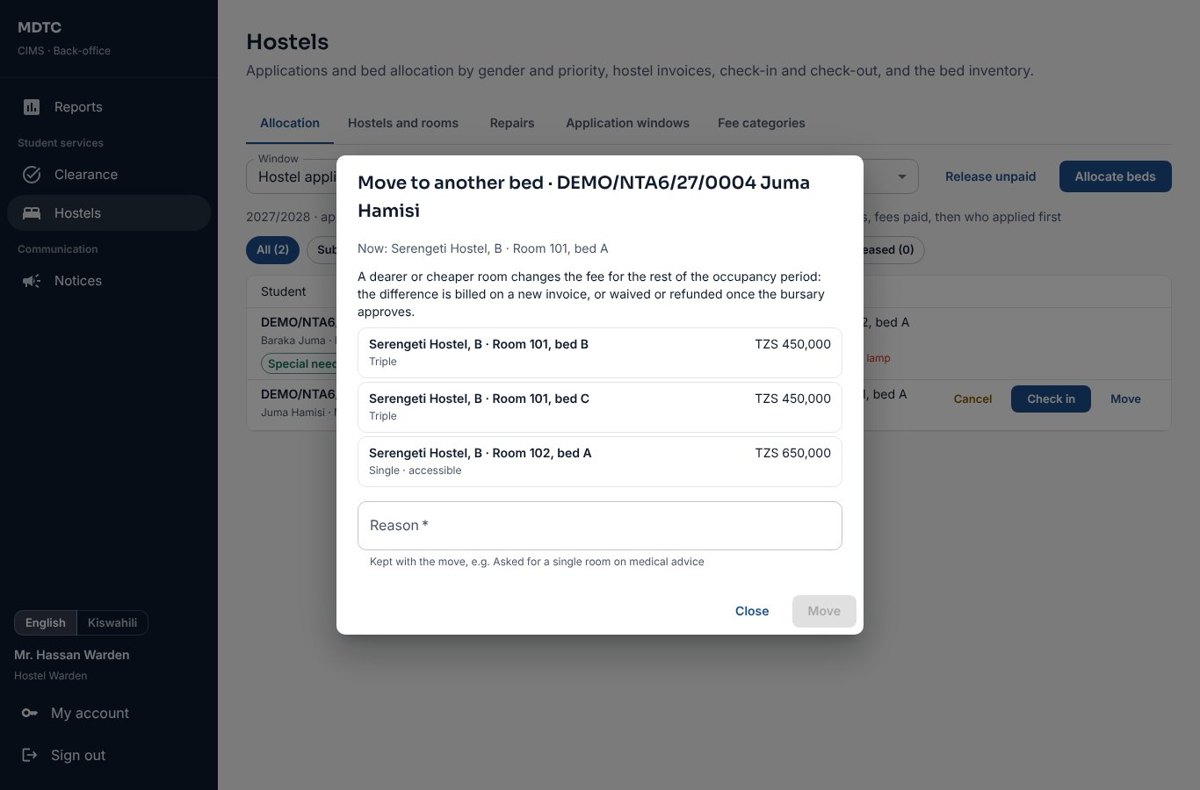
Figure 97: Moving a student to another bed

19. IPT Coordinator
This chapter is for the IPT Coordinator, who manages industrial practical training: placement organisations, periods, placements, supervision and marks.
The IPT Coordinator manages industrial practical training on Student services › Industrial training. A coordinator can be limited to one department.
- On Organisations click New organisation with contacts and how many students it can take.
- On IPT periods click New period: the semester, the IPT module, the dates, the weights of the three marks (workplace supervisor, institution supervisor, logbook; adding up to 100) and the logbook weeks needed.
- On Placements, review students' requests: Confirm placement with an institution supervisor (never beyond capacity) and Confirm and issue letter, or Decline with a note. Or Place a student directly. Students are told by SMS.
- Follow each placement: logbook weeks approved, visits recorded and the three marks. The IPT mark is computed when all three are in.
- Send the IPT marks to the IPT module's results. They then follow the normal moderation, approval and publication (chapter 14).
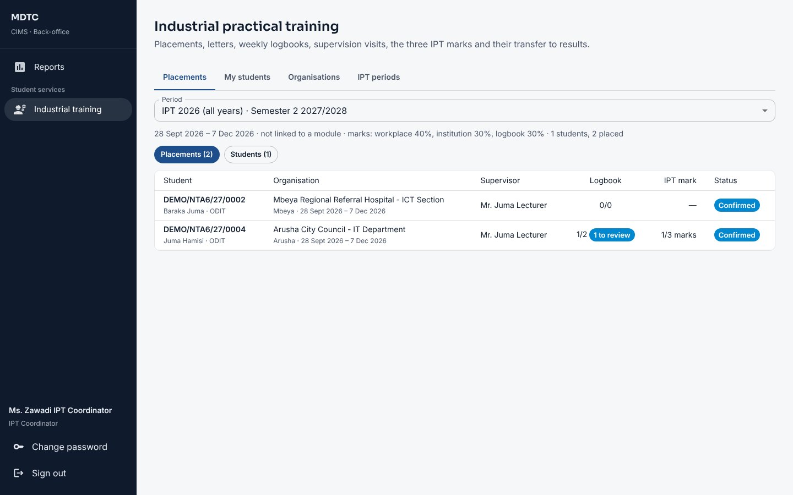
Figure 98: Industrial practical training placements
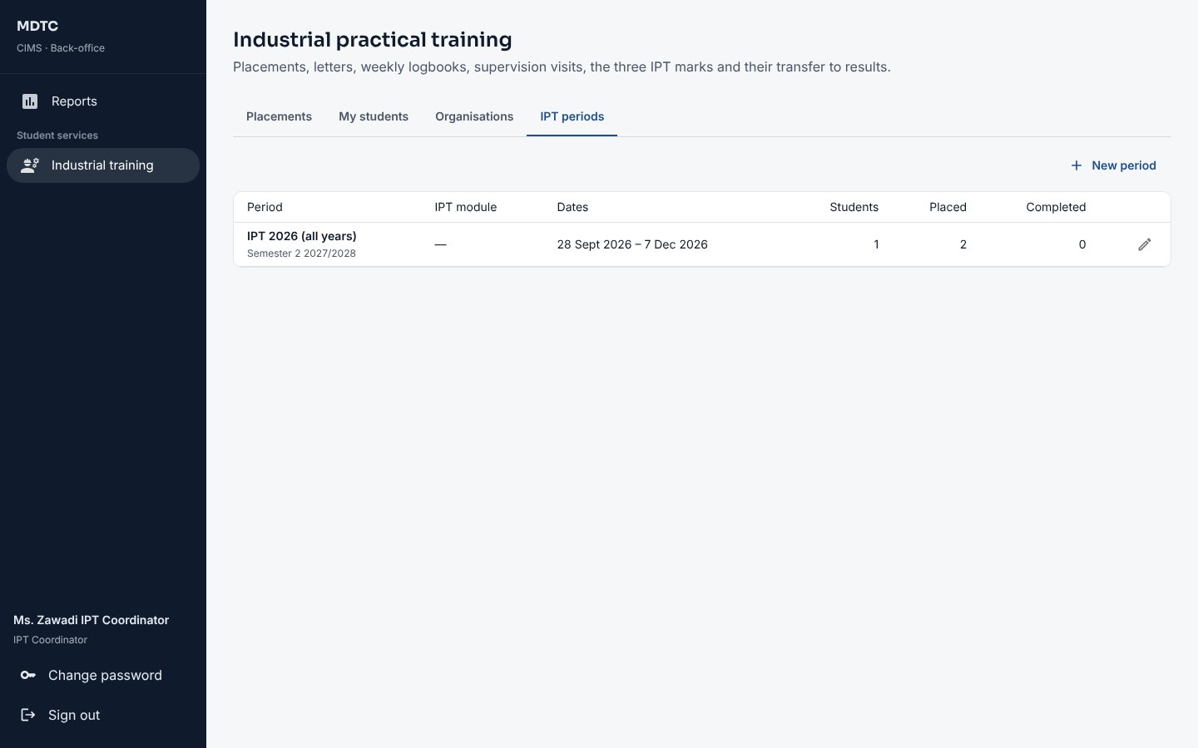
Figure 99: IPT periods

Workplace assessment by link: on a confirmed placement click Send workplace assessment link. The workplace supervisor gets an SMS or email with a personal link, rates the student on each point (1 to 5) without an account, and the rating becomes the workplace mark. Copy link gives the link to send another way.

20. Clearance Officer
This chapter is for Clearance Officers, such as the Librarian, who clear or hold finalists for their own office before graduation.
Clearance Officers (for example the Librarian) land on Clearance and see only their office.
- Choose your Office if you hold more than one. To decide lists finalists waiting for your office; Everyone shows all.
- Click Clear for a student with nothing outstanding, or Hold with a reason (for example an unreturned book). The student sees the reason and gets an SMS.
- When every office has cleared, the clearance completes and the student is told.
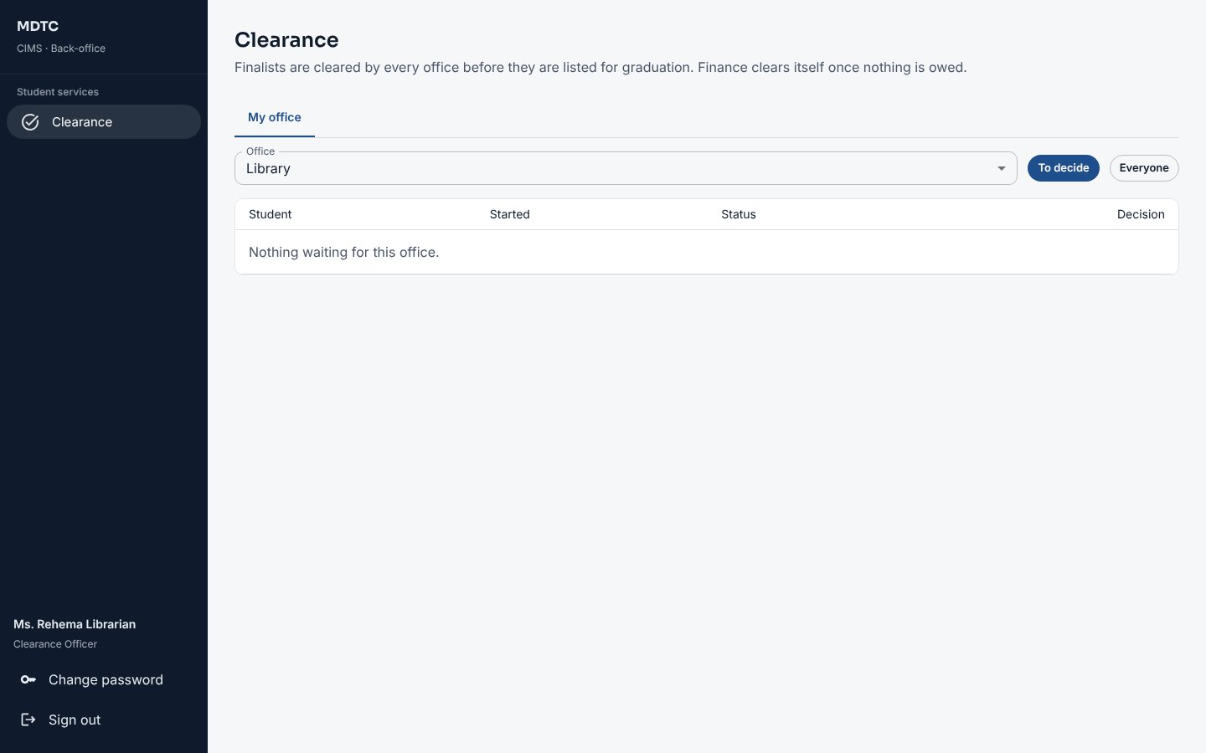
Figure 100: The clearance queue of an office

21. Auditor
This chapter is for Auditors. It explains what they can review read-only: records, users, messages, the audit trail and the integration log.
The Auditor has read-only access to records, users and messages, and to the Audit trail and the integration log.
- Administration › Audit trail: who did what, when, on which record and from which address; security events; a record's history; CSV export (section 6.4).
- Administration › Users & roles: every account with roles, status and last sign-in (read-only). Report GOV-01 gives the periodic access review.
- Reports: GOV-02 Audit log extract and the finance reports (receipts register, reconciliation exceptions).
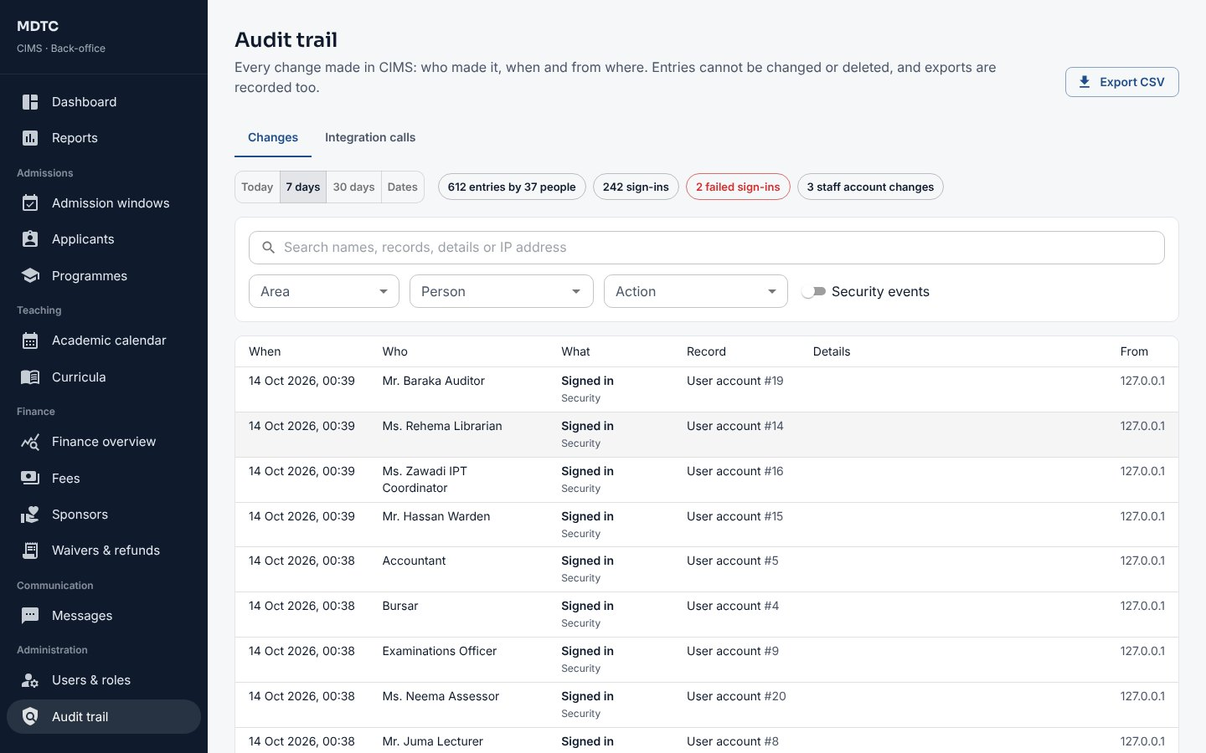
Figure 101: The audit trail as seen by the Auditor
Part D — Msingi Platform

22. Msingi Platform Administrator
This chapter is for Msingi Technologies staff. It explains the platform console, where institutions are onboarded, managed and monitored.
Msingi Technologies staff sign in to the platform console at /platform. It is separate from every institution.
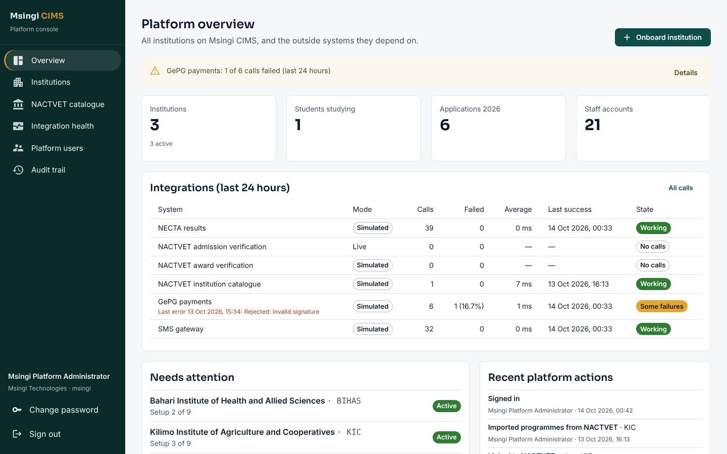
Figure 102: Platform overview

22.1 Onboard an institution
This section explains how to add a new institution from the NACTVET catalogue and give it its first administrator.
- Open NACTVET catalogue and find the institution (synchronised from NACTVET's list of registered institutions and programmes).
- Click to onboard it, or open Institutions › Onboard institution. Enter the Code (fixed for good), Full name, NACTVET registration number, ownership, contacts, colour and Web address(es).
- Enter the First administrator: username, full name, email and phone. Click Onboard institution.
- Choose the programmes to import from the catalogue; their NACTVET boards become starting departments. Give the administrator the temporary password.
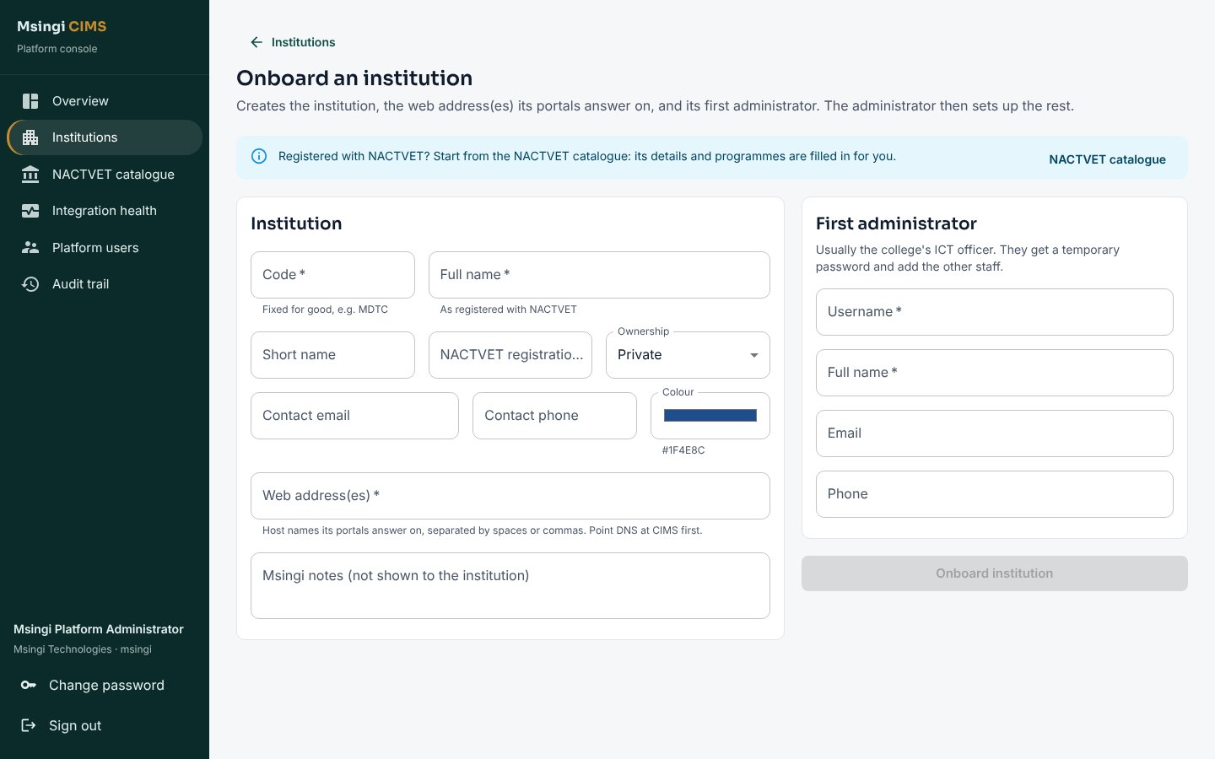
Figure 103: Onboarding an institution

22.2 Manage an institution
This section explains how to change an institution's details, suspend or reactivate it, and manage its administrators and SMS bundles.
- Edit details and web addresses; Suspend (portals answer "temporarily unavailable"; data and GePG payments are kept) and reactivate.
- Add administrator or Reset password of an administrator.
- Credit SMS bundles; see usage, staff accounts, applications and a setup checklist.
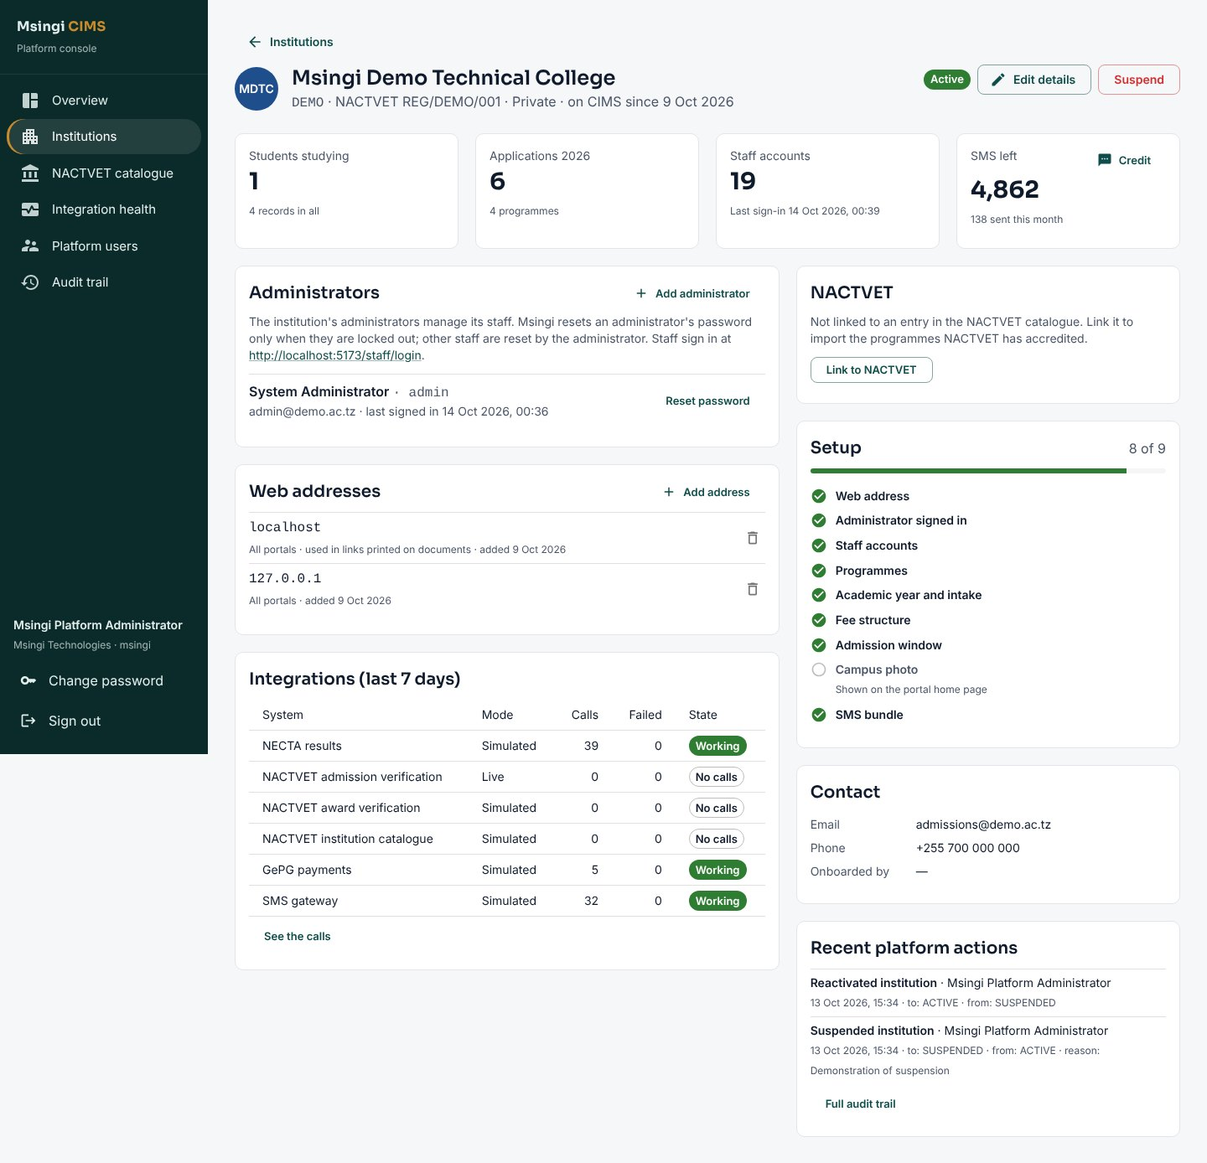
Figure 104: An institution in the platform console

22.3 Integration health and audit
This section explains how to follow the health of the connections to outside systems and the platform audit trail.
- Integration health shows calls to NECTA, NACTVET, GePG and the SMS gateway in the last 24 hours, failures and the mode (simulated or live), with the call log.
- Platform users manages Msingi staff accounts; Audit trail records every platform action (actions inside an institution also appear in that institution's audit trail).
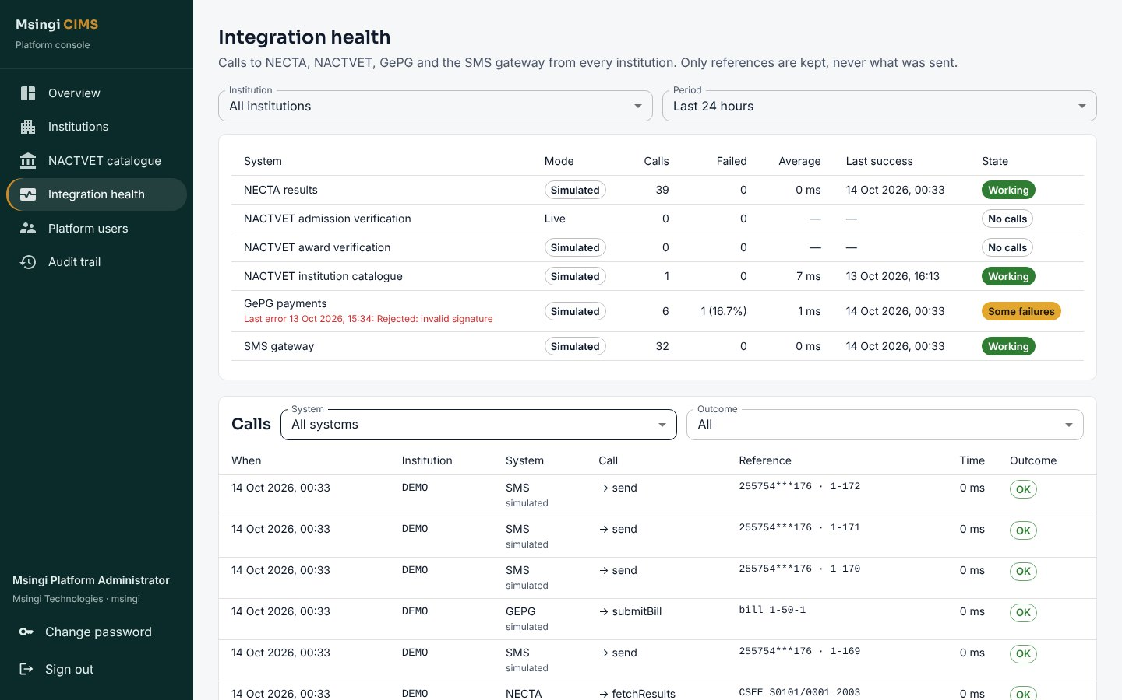
Figure 105: Integration health
Appendices

Appendix A. Abbreviations and glossary
This appendix explains the abbreviations and specialised terms used in this manual and on CIMS screens. Only terms that appear in this manual are listed.
Term | Meaning
ACSEE | Advanced Certificate of Secondary Education Examination (Form Six), results from NECTA.
Admission window | A period, for one academic year and intake, during which applicants can apply for the programmes offered.
API | Application Programming Interface: the way two systems exchange data automatically.
CA / SE | Continuous assessment (coursework, tests, practicals) / semester examination.
CGPA | Cumulative grade point average over all semesters of a programme.
CIMS | College/Institution Management System, the system these documents describe.
Clearance gate | A fees rule that must be met before registration, examinations, results, hostel or graduation.
Control number | The GePG number used to pay an invoice through a bank or mobile money.
Credit note | A document that reduces an invoice, used for approved waivers, discounts, scholarships and refunds of fees paid.
CSEE | Certificate of Secondary Education Examination (Form Four), results from NECTA.
CSV | Comma-separated values: a plain spreadsheet file that most systems can import and export.
Entry level | The level an applicant may apply at, set by their highest verified qualification (as in NOAS).
GePG | Government electronic Payment Gateway: issues control numbers and confirms payments for public institutions.
GFS code | Government Finance Statistics code: the revenue classification of a fee item used by GePG and MUSE.
GPA | Grade point average for a semester or year, computed under the regulations of the award level.
Hand-over | Registry turning an accepted applicant into a student: record, registration number and portal sign-in.
HESLB | Higher Education Students' Loans Board: funds eligible students in eligible programmes.
ID card | Student identity card, printed from CIMS with a verification code.
Invigilator | A member of staff who supervises candidates during an examination paper.
IPT | Industrial practical training: assessed field attachment in a workplace.
Multiple admission | An applicant admitted by more than one institution; NACTVET sends a confirmation code to choose one.
MUSE | The government financial management (ERP) system to which public institutions post revenue.
NACTVET | National Council for Technical and Vocational Education and Training: the regulator of TVET institutions and awards.
NECTA | National Examinations Council of Tanzania: source of CSEE and ACSEE results.
NGO | Non-governmental organisation.
NIDA / NIN | National Identification Authority / National Identification Number.
NTA | National Technical Award, Levels 4–8 (Basic Technician Certificate to Bachelor Degree).
NVA | National Vocational Award, Levels I–III (certificates of competence, awarded through VETA).
NYC | Not yet competent: an NVA competence outcome.
PDF | Portable Document Format, used for letters, statements, certificates and reports.
QR code | A square barcode printed on documents; scanning it opens the verification page.
Refund voucher | The document that authorises paying money back to a student after an approved refund.
Registration number | The student's permanent number, generated at hand-over and never changed or reused.
Segregation of duties | The rule that the person who prepares or requests something cannot also approve it.
Simulator | A stand-in for an outside system (for example NACTVET or GePG) used for testing until the live interface is available.
SMS | Short message service: text messages to mobile phones.
TAMISEMI | President's Office – Regional Administration and Local Government, which selects some students centrally.
Tenant | One institution's isolated space within the shared CIMS platform, with its own branding, users, data and settings.
TZS | Tanzanian shilling.
Verification code | The code printed (with a QR code) on letters, statements, certificates and ID cards, checked on the verification page.
VETA | Vocational Education and Training Authority, which runs NVA assessment.
Waiver | An approved reduction of what a student owes on an invoice.
Table 5: Abbreviations and glossary

Appendix B. Common Messages
This appendix lists the messages users see most often when CIMS refuses an action, with what to do about each.
When CIMS refuses an action it says why in plain words. The most common messages and what to do:
Message | What to do
You do not have permission to perform this action | Your roles do not include this action. Ask the Institution Administrator, or ask the office that does it.
You requested this change, so someone else must decide it (and similar) | Segregation of duties: another authorised person must approve.
NECTA results could not be reached. Please try again in a few minutes. | NECTA did not answer. Wait and try again; nothing was lost.
NACTVET could not be reached. Please try again in a few minutes. | NACTVET did not answer. Fetch or submit again later, or use the file option.
NACTVET refused the institution's credentials … | The NACTVET settings are wrong or expired. Tell Msingi support.
Originals not yet verified: … | Tick every original document seen on the first registration checklist, then approve.
This student already has a status change waiting; finish or cancel it first | Decide or cancel the open status change request before starting another.
Every accepted applicant already has a student record | Hand-over is complete for this window; nothing more to do.
You already have a request for this module in progress. | A student can have one open remark or appeal per module.
That confirmation code is not correct. … attempt(s) left. | Applicant: type the code exactly as NACTVET sent it. After the attempts run out, contact the admissions office.
You cannot remove your own administrator role. Ask another administrator. | Another administrator must make the change; an institution always keeps an administrator.
Account locked | Too many wrong passwords. Staff: ask the Institution Administrator to unlock. Applicants and students: contact the institution.
Table 6: Common messages and what to do

Appendix C. SMS Messages
This appendix lists the automatic SMS messages CIMS sends, when each is sent and how institutions can reword them.
CIMS sends 58 automatic SMS messages. Each institution can reword any of them in English and Kiswahili, or switch it off, under Communication › Messages › Event messages. Verification codes are sent immediately and never stored. Every SMS leaves only after the action that caused it is saved, so nothing is sent for work that failed.
Area | Events
Applicants | OTP_CODE, APPLICATION_RECEIVED, APPLICATION_FEE_REMINDER, ADMISSION_WINDOW_CLOSED, ADMISSION_WINDOW_REOPENED, QUALIFICATION_NOT_ACCEPTED, OFFER_MADE, OFFER_MADE_MULTIPLE, NACTVET_NOT_VERIFIED, OFFER_ACCEPTED, OFFER_DECLINED, OFFER_LAPSED, LETTER_ISSUED, LETTER_REISSUED, DOCUMENT_NOT_ACCEPTED, EXTERNAL_SELECTION
Fees | CONTROL_NUMBER, PAYMENT_RECEIVED, FIN_ADJUSTMENT_DECIDED, SPONSOR_ASSIGNED, PAYMENT_REFERENCE, FEE_REMINDER, FEE_PENALTY
Registry | STUDENT_WELCOME, STUDENT_WELCOME_NO_DATE, REGISTRATION_COMPLETE, STUDENT_STATUS_CHANGED, SEMESTER_REGISTRATION_APPROVED, SEMESTER_REGISTRATION_REJECTED, DETAILS_CHANGE_APPROVED, DETAILS_CHANGE_REJECTED, STUDENT_TRANSFERRED, NHIF_CARD_ISSUED, NHIF_REGISTRATION_REJECTED
Teaching and examinations | TIMETABLE_PUBLISHED, EXAM_TIMETABLE_PUBLISHED, ATTENDANCE_LOW, EXAM_NOT_ELIGIBLE, EXAM_EXEMPTION_APPROVED, RESULTS_PUBLISHED, RESULTS_WITHHELD, RESULT_AMENDED, APPEAL_OUTCOME, COMPETENCE_NYC
Hostel and IPT | HOSTEL_ALLOCATED, HOSTEL_BED_CHANGED, HOSTEL_WAITLISTED, HOSTEL_RELEASED, HOSTEL_REPAIR_UPDATED, IPT_PLACEMENT_CONFIRMED, IPT_PLACEMENT_DECLINED, IPT_LOGBOOK_RETURNED, IPT_WORKPLACE_ASSESSMENT
Clearance, graduation and notices | CLEARANCE_HELD, CLEARANCE_COMPLETE, GRADUATION_APPROVED, NOTICE_ALERT, TRACER_SURVEY
Table 7: Automatic SMS messages by area

