TIRDO
Tanzania Industrial Research and Development Organization
Website Comprehensive User Manual
Public Website & Content Administration Guide

Version 1.1 · October 2026
For public website visitors and content administrators

Contents
This manual is in four parts: an introduction, a guide for people using the public website, a guide for staff who administer content, and a reference section. Use the contents below to jump to a topic; in Word, press Ctrl+Click on an entry, or update the field (right-click → Update Field) if page numbers look stale.

Part I — About This Manual
This opening part explains what the manual covers, who it is for, and the conventions used throughout so that every later section reads the same way. Read it once before you use the rest of the manual.

Purpose
This section states what the document is for and what you should be able to do after using it.
This manual explains how to use the TIRDO website — both the public site that anyone can visit and the content-management system (CMS) that TIRDO staff use to keep the site up to date. It is written so that a first-time visitor and a new staff editor can each find what they need without prior training. The screenshots throughout are taken from the live TIRDO site.

Who this manual is for
This section describes the two audiences the manual serves and how the document is organised around them.
The manual serves two audiences in one document:
- Public website visitors — citizens, industry, researchers, students and partners who browse TIRDO's information and services. Part II is for you.
- Content administrators — TIRDO staff who sign in to the CMS to publish news, manage services and handle enquiries. Part III is for you.
Part IV is a shared reference (quick links, glossary, troubleshooting and support contacts) useful to both audiences.

How to use this manual
This section tells you how to navigate the document and get to the right instructions quickly.
Each section opens with a short preamble — the indented, italic paragraph marked with a gold bar — that tells you what the section covers before the detailed steps. Skim the preambles to locate what you need, then follow the numbered steps. Use the Contents page to jump directly to a topic.

Conventions used
This section defines the visual cues and wording used consistently across the manual.
- Preamble — an italic, gold-barred paragraph introducing each section.
- Bold — on-screen labels, buttons and menu names, e.g. Publish.
- Paths — page addresses are shown after the site domain, e.g. /technology means https://www.tirdo.or.tz/technology.
- Figures — numbered screenshots of the live site illustrate key screens.
- Numbered steps — an ordered procedure to follow in sequence.

Quick reference: public pages
This section is a map of the whole public site so you can go straight to any page by its address.
Page | Address | What you'll find
Home | / | Highlights, quick links, latest news and key statistics
About Us | /about | Mandate, vision, structure, board, administration, COMSATS
Departments | /departments | Research, engineering and technology divisions
Services | /services | The catalogue of TIRDO services
Technology Catalogue | /technology | Proven technologies available for transfer
Laboratory Services | /laboratory | Accredited testing and the NILIMS gateway
Consultancy & Advisory | /consultancy | Technical consultancy and the CIAP gateway
Training | /training | Short courses and the TeLTP gateway
Research & Projects | /projects | Ongoing and featured research
Publications | /publications | Reports, papers and downloads
News / Events / Gallery / Documents | /news … | The Media Centre
Careers | /careers | Job vacancies
Tenders | /tenders | Procurement notices
e-Services | /e-services | Sign-in and the client portal
Search | /search | Site-wide search
Contact Us | /contact | Address, map and enquiry form

Part II — Using the Public Website
This part walks a visitor through the public TIRDO website from first arrival to every major area of content. Each section stands alone, so you can read only the parts you need.

1. Getting started
This section helps you open the site and understand what you are looking at when the page loads.
The TIRDO website works in any modern web browser (Chrome, Edge, Firefox or Safari) on a computer, tablet or phone — no app or account is needed to browse. Open your browser and go to the TIRDO web address. Every page shares the same layout:
- Utility bar (top) — social links, contact shortcuts, the language switch and the sign-in button.
- Masthead — the national emblem, TIRDO's name and the organisation logo.
- Main menu — the teal navigation bar, which stays pinned to the top as you scroll.
- Footer (bottom) — quick links, related institutions, contact details and legal pages.

2. Navigating the site
This section explains how the main menu is organised so you can find any topic in a click or two.
The main menu groups the site into themed areas. Hover (or tap on mobile) to open a menu and reveal its items:
- About Us — mission & vision, organisation structure, board of directors, administration, success stories and the COMSATS Centre.
- Our Work / Departments — the research, engineering and technology-development divisions.
- Services — research, energy auditing, feasibility studies, and the dedicated Consultancy, Laboratory and Training sections.
- Research & Innovation — projects, the Technology Catalogue, T-Hub, the Industrial Information Centre and publications.
- Media Centre — news, events, gallery and documents.
- Analytics and Contact Us — site statistics and how to reach TIRDO.
On a phone, tap the menu (☰) icon to open the same navigation as a vertical list.

3. Choosing your language
This section shows how to read the site in English or Kiswahili and what changes when you switch.
- Find the English / Kiswahili switch in the top utility bar.
- Select your preferred language; the interface updates immediately.
- Your choice is remembered on your device for future visits.
Menus, headings and labels switch language. Some long articles may still appear in English until their Kiswahili translation is published; you will never see a blank page — English is shown as a fallback.

4. Searching the site
This section explains how to find anything on the site quickly and how to narrow the results.
- Click the search icon in the menu, or go to /search.
- Type at least two characters — suggestions appear as you type.
- Press Enter to see the full list of results.
- Filter results by type (News, Publications, Projects, Services, Departments, Technologies, Vacancies, Tenders) using the chips above the results.
Matching words are highlighted, and your search stays in the address bar so results are easy to share and the browser's Back button works as expected.
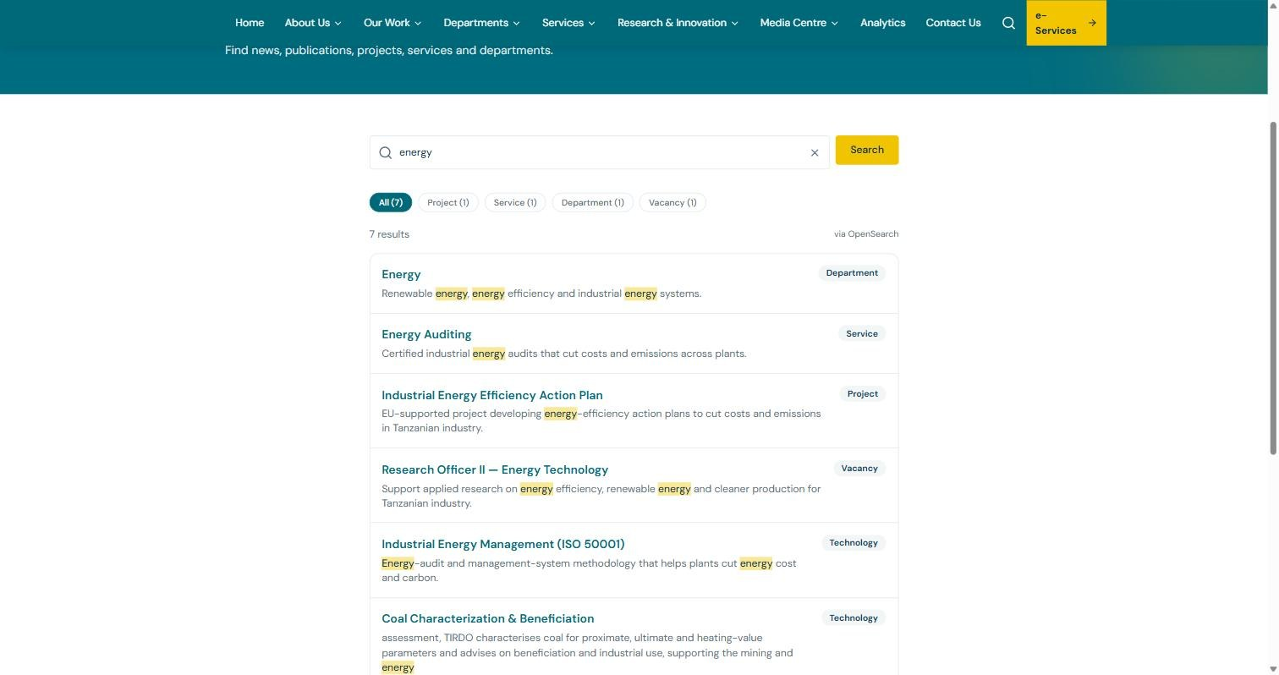
Figure 1. Search results for “energy”, filtered by type with matching terms highlighted.

5. The home page
This section introduces what the home page presents and how to use it as a springboard into the site.
The home page opens with a rotating banner of highlights, followed by quick-access cards to the most-used areas, key statistics about TIRDO, and the latest news. The banner pauses automatically if your device is set to reduce motion, and offers a pause control.
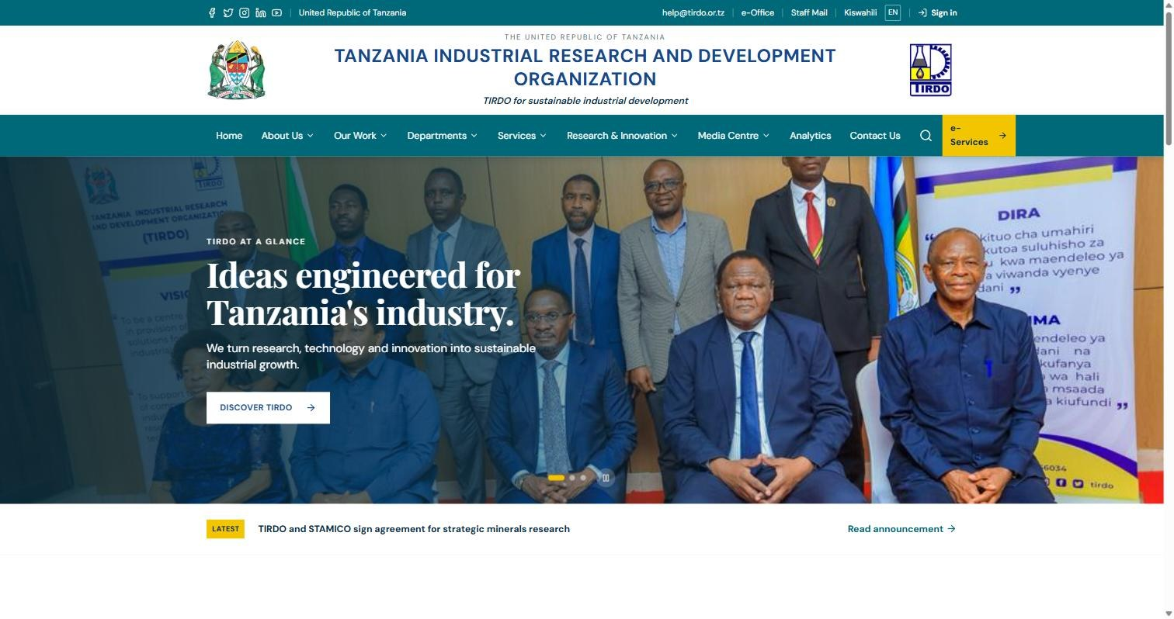
Figure 2. The TIRDO home page: utility bar, masthead, pinned main menu and the highlights banner.

6. About TIRDO
This section points you to the organisational information under the About Us area.
The About Us pages describe who TIRDO is and how it is run: its mission and vision, the organisation structure, the Board of Directors, top management (administration), success stories from the laboratory to industry, and the COMSATS Centre for Climate and Sustainability hosted at TIRDO.

7. Departments & divisions
This section explains how to explore TIRDO's technical divisions and what each page tells you.
Open Departments to see the divisions grouped by Industrial Research, Engineering Development, and ICT & Technology Development, plus Finance and Human Resources & Administration. Select any division to read its mandate, focus areas and the services it offers.

8. Services
This section describes the services catalogue and how to move from an overview to requesting a service.
The Services page lists TIRDO's core services — research, energy auditing, feasibility studies, consultancy, laboratory analytical services, and training. Select a service to read what it covers and what you receive, then use Contact TIRDO to make an enquiry. Consultancy, Laboratory and Training each have a fuller dedicated section (covered next).
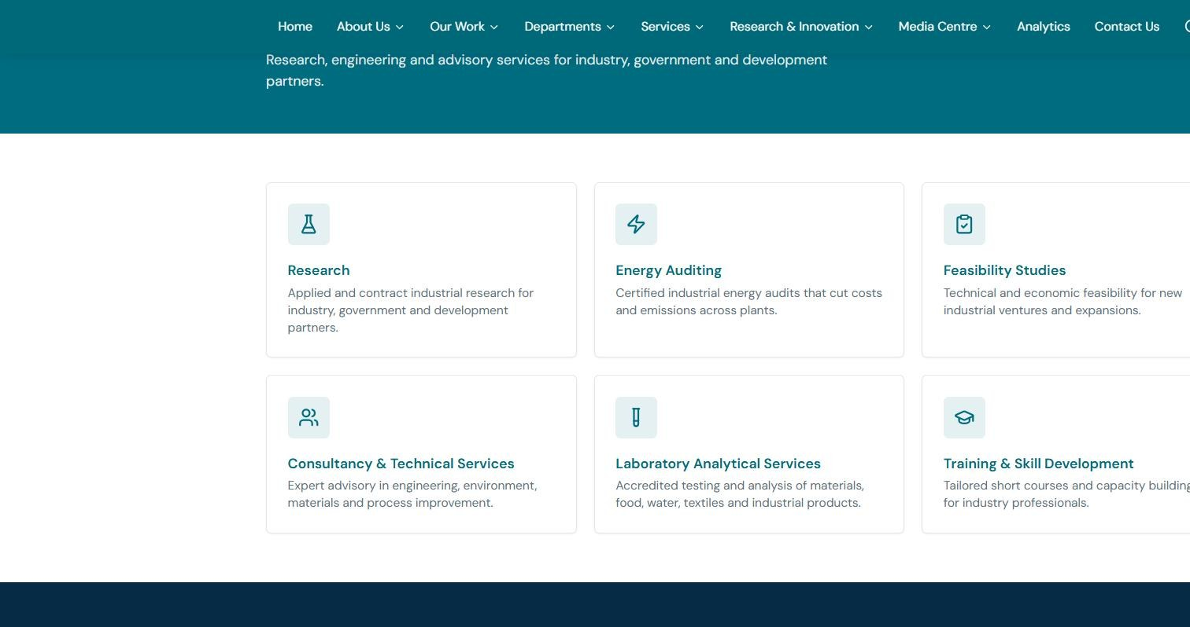
Figure 3. The Services catalogue — select any card to open the full description of that service.

9. Technology Catalogue
This section explains how to browse the technologies TIRDO has developed and how to ask to adopt one.
- Open Research & Innovation → Technology Catalogue (/technology).
- Filter by sector (Energy, Food & Biotechnology, Materials, Environment, Textile & Leather, ICT) and by maturity (Concept, Pilot, Commercial, Mature).
- Select a technology to read its summary, benefits and applications.
- Use Request technology transfer to contact TIRDO about adopting or licensing it.
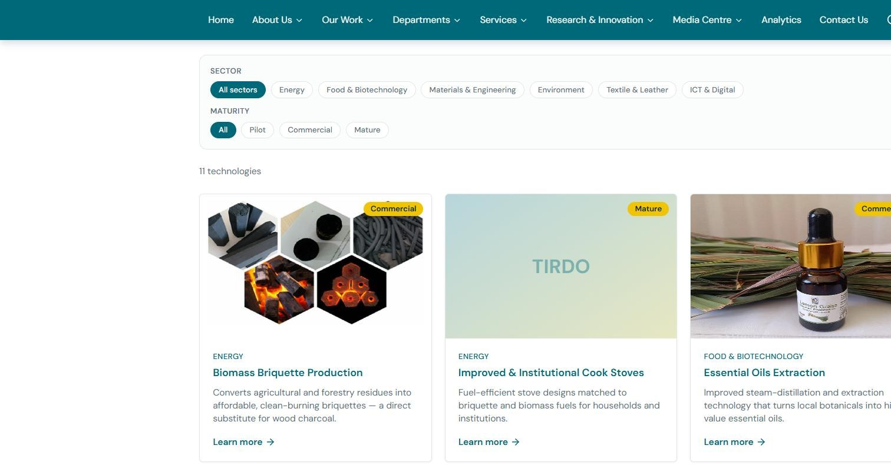
Figure 4. The Technology Catalogue — filter by sector and maturity; each card opens a full profile.

10. Laboratory Services & NILIMS
This section covers TIRDO's laboratory testing pages and how to submit samples online.
The Laboratory section (/laboratory) describes TIRDO's accredited laboratories — food and microbiology, industrial chemistry, materials and engineering, energy, and environment — and the standards behind them. It also explains the sample-submission process. Use the NILIMS gateway to register a sample, track your job and download certified results online through the National Industrial Laboratory Information Management System.
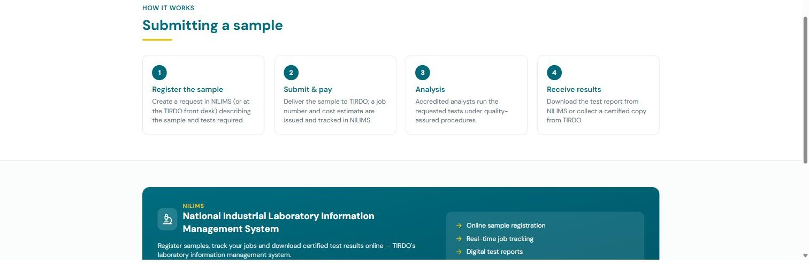
Figure 5. Laboratory Services — the sample-submission steps and the NILIMS portal gateway.

11. Consultancy & Advisory (CIAP)
This section covers TIRDO's consultancy service lines and how engagements are requested and tracked.
The Consultancy section (/consultancy) sets out TIRDO's advisory service lines — quality assurance and NDT, energy audits, feasibility studies, environmental services, materials and process engineering, and food safety — and the engagement process from request to closure. Use the CIAP gateway (Consultancy & Industrial Advisory Portal) to submit and follow a consultancy request.
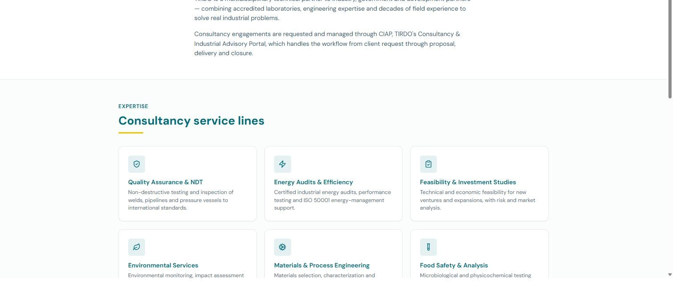
Figure 6. Consultancy & Advisory — the six service lines; the CIAP gateway follows further down the page.

12. Training & Skills Development (TeLTP)
This section covers TIRDO's short-course catalogue and how to enrol.
The Training section (/training) lists short courses by area, duration and mode, and shows upcoming training. Use the TeLTP gateway (TIRDO e-Learning & Training Platform) to browse the course calendar, register online and access learning materials.
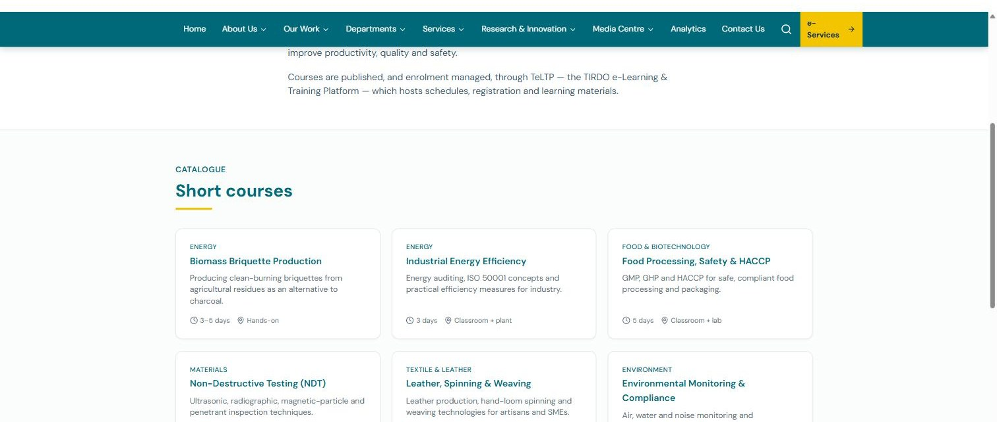
Figure 7. Training & Skills Development — the short-course catalogue with area, duration and mode.

13. Research & Projects
This section explains how to browse TIRDO's research projects and filter to what interests you.
Open Research & Projects (/projects) to see ongoing and featured research. Filter by research area and by status (Featured, Ongoing, Completed) to focus the list.

14. Publications
This section explains how to find and download TIRDO's reports and papers.
- Open Publications (/publications).
- Filter by type and year, or search by title, author or keyword.
- Expand a row to see the abstract, keywords, DOI and citation.
- Download the PDF from the entry.
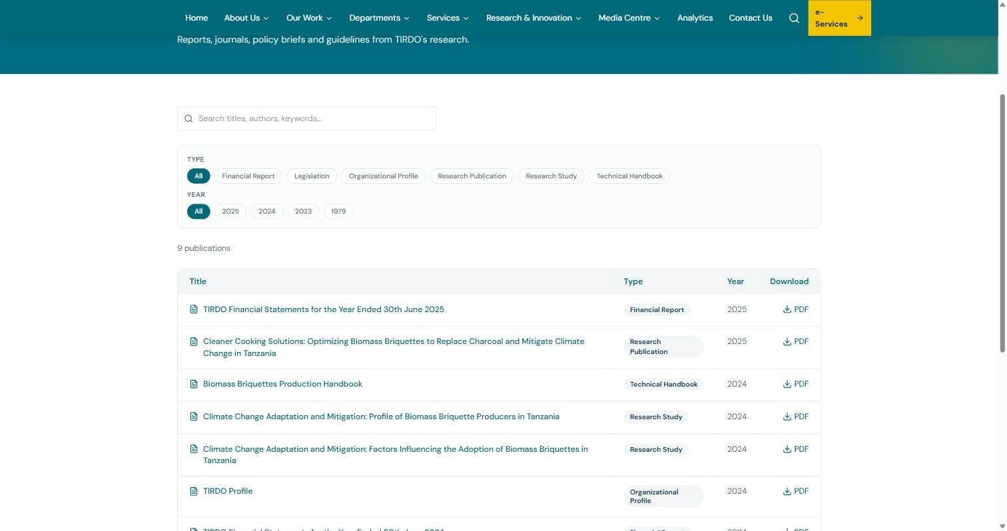
Figure 8. The Publications library — filter by type and year, search, and download PDFs.

15. Media Centre — News, Events, Gallery, Documents
This section points you to TIRDO's news and media resources.
- News (/news) — announcements and stories; open an item to read the full article.
- Events (/events) — trainings, workshops and exhibitions with dates and locations.
- Gallery (/gallery) — photographs of TIRDO activities and facilities.
- Documents (/documents) — downloadable forms, guidelines and official documents.

16. Careers
This section explains how to find open vacancies and apply.
- Open Careers (/careers).
- Browse open vacancies; filter by category if needed.
- Closed positions are hidden by default — toggle Include closed to see them.
- Use Apply to reach the Government recruitment portal.
Vacancies close automatically at the end of their closing date, so the list always reflects what is currently open.

17. Tenders
This section explains how to find procurement notices and their documents.
Open Tenders (/tenders) for active procurement notices with reference numbers and downloadable documents. Tenders archive automatically after their deadline passes.

18. Contact & enquiries
This section explains how to reach TIRDO and send an enquiry through the website.
- Open Contact Us (/contact) for TIRDO's address, phone, email and a location map.
- Complete the enquiry form: name, email, subject and message (phone and organisation are optional).
- Submit — a confirmation appears and your message is delivered to the TIRDO team.
Working hours are Monday to Friday, 08:00–16:30 (EAT).
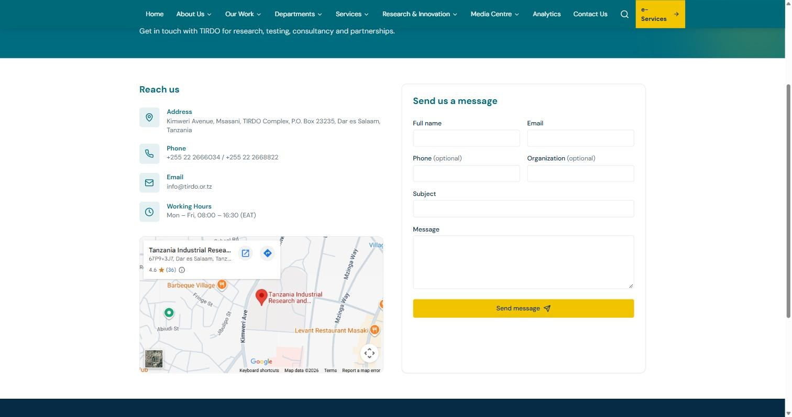
Figure 9. The Contact page — TIRDO's address, phone, email and map alongside the enquiry form.

19. e-Services & signing in
This section explains the e-Services area and how to sign in securely.
The e-Services page (/e-services) is the gateway to TIRDO's online systems. Registered users and staff sign in once using TIRDO single sign-on (Keycloak). Signed-in users see a client portal with their service requests and documents; staff see additional tools by role. Privileged accounts are protected by multi-factor authentication (an authenticator app code) at sign-in.

20. Analytics
This section describes the public analytics page.
The Analytics page (/analytics) shows selected site statistics gathered by TIRDO's own first-party analytics, which respects visitor privacy and works without third-party trackers.

21. Accessibility features
This section lists the built-in features that make the site usable for everyone.
The site targets WCAG 2.1 AA. It provides a “Skip to content” link, fully keyboard-navigable menus, visible focus indicators, sufficient colour contrast, descriptive image text, labelled form fields, and reduced-motion support (the home banner does not auto-advance when reduced motion is set).

22. Downloads
This section explains how documents are delivered and how to save them.
Publications, documents and tender files open or download as PDFs. To save a copy, right-click the link and choose “Save link as”.

Part III — Content Administration (Staff)
This part is for TIRDO staff who maintain the website's content through the Strapi CMS. It covers signing in, the publishing workflow, every content type, day-to-day tasks, translations, and the controls that keep the site trustworthy. If you only browse the site, you do not need this part.

1. How content reaches the website
This section explains the relationship between the CMS and the public site so the rest of the part makes sense.
The public website reads its content from the Strapi CMS. When you publish or change an entry, the update appears on the site within about a minute (content is briefly cached). Entries you leave as drafts are never shown publicly.

2. Signing in & security
This section explains how to access the CMS and the security expected of every account.
- Open the CMS admin at the address your ICT team provides (the /admin path of the CMS).
- Sign in with your Strapi admin account.
- If prompted, complete multi-factor authentication with your authenticator app.
Keep your credentials private, use a strong unique password, and enrol an authenticator app when asked. Roles and permissions are managed under Settings → Administration Panel → Roles.

3. The draft & publish workflow
This section explains the states every piece of content moves through and the approval gate between them.
Every content type has Draft and Published states. Editing creates a draft; the public site shows only Published entries. The recommended flow is: an Author creates and edits a draft, an Editor/Approver reviews it, and then it is Published. Publishing is the approval gate, and every publish is recorded in the audit log.

4. Content types reference
This section lists each type of content you can manage and the key fields on each, so you know where every part of the site comes from.
Content type | Appears at | Key fields
Article (News) | /news | Title, slug, excerpt, body, category, date, cover image, source URL
Research Project | /projects | Title, summary, body, department, status, research area, year, funder, cover
Publication | /publications | Title, type, year, abstract, authors, keywords, DOI, citation, file
Service | /services | Title, description, icon, body
Department | /departments | Title, group, blurb, body
Technology | /technology | Title, summary, sector, maturity, body, benefits, applications, related service, image
Vacancy | /careers | Title, department, category, location, description, body, posted & closing dates, apply URL
Tender | /tenders | Title, reference, category, description, posted & closing dates, document
Page | various | Title, slug, body
Contact Message | (inbox) | Name, email, phone, organisation, subject, message, handled
About slugs: the slug is filled automatically from the title and becomes the page's web address. Keep it stable once an entry is published, so existing links keep working.

5. Everyday tasks
This section gives step-by-step recipes for the most common content jobs.

Post a news article
- Content Manager → Article → Create new entry.
- Fill in the title, excerpt, body, category and date; upload a cover image with descriptive alternative text.
- Save, review, then Publish.

Add a technology to the catalogue
- Content Manager → Technology → Create new entry.
- Set the title and summary; choose the sector and maturity.
- Add the body, benefits and applications; optionally link a related service and an image.
- Save and Publish — it appears under /technology with the right filters.

Advertise a vacancy
- Content Manager → Vacancy → Create new entry.
- Set the category, department, location, description and the closing date; add the apply URL.
- Publish — it shows under /careers and archives itself after the closing date.

Publish a tender
- Content Manager → Tender → Create new entry.
- Set the reference, category, description and closing date; upload the tender document.
- Publish — it shows under /tenders and archives after the deadline.

Add a publication
- Content Manager → Publication → Create new entry.
- Set the type, year, authors, abstract, keywords, DOI and citation; upload the PDF.
- Publish.

Unpublish something
- Open the entry and choose Unpublish.
- It disappears from the public site but remains in the CMS and the audit log.

6. Media & files
This section explains how to upload and manage images and documents.
Upload images and documents through the media field on an entry, or via the Media Library. Use descriptive file names and always add alternative text to images for accessibility. Files are stored securely in TIRDO's object storage.

7. Bilingual content (English / Kiswahili)
This section explains how to provide Kiswahili versions of content so both languages read well.
- Open an entry and use the locale switch (top-right of the entry) to select Kiswahili (sw).
- Enter the translated title, summary and body; leave anything untranslated and it falls back to English on the site.
- Save and Publish the Kiswahili version.
A drafted set of Kiswahili translations for the main content is available to start from; have a fluent speaker review before publishing. Coordinate with the ICT team before large content drives so translations are captured.

8. Auto-archiving of vacancies & tenders
This section explains the automatic closing behaviour so you set dates correctly and never archive by hand.
A vacancy or tender is shown as Open until the end of its closing date, then becomes Closed automatically and drops out of the default list (visitors can still reveal closed items). Set the closing date accurately — no manual archiving is required.

9. Handling contact enquiries
This section explains where website enquiries arrive and how to work through them.
Messages submitted through the Contact form are stored under Contact Messages in the CMS and a notification email is sent to the configured TIRDO inbox. Open a message to read the sender's details (including phone and organisation) and mark it handled once actioned. Obvious spam is filtered out automatically before it reaches the inbox.

10. Keeping search up to date
This section explains how search stays current and what to do after a large import.
Content edits are indexed for search automatically. After a large import or bulk change, the ICT team can force a full rebuild of the search index using the reindex endpoint (protected by an admin token). Day to day, no action is needed.

11. The audit log
This section explains the tamper-evident record of all content changes and why it matters.
Every create, edit, delete and publish is recorded in an append-only, tamper-evident Audit Log (Content Manager → Audit Log, read-only) showing who did what and when. It cannot be edited or deleted, and its integrity can be verified. This is the authoritative record of who published what, and it supports accountability and governance.

12. Editorial roles & good practice
This section recommends how to divide responsibilities so publishing stays controlled.
- Author — can create and edit drafts but not publish.
- Editor / Approver — reviews drafts and publishes.
- Administrator — manages users, roles and settings.
Configure these under Settings → Roles. Keep titles and slugs consistent, write clear summaries, add alt text to every image, and review drafts before publishing — the audit log will always show who approved each change.

Part IV — Reference
This closing part collects quick answers, definitions and where to turn for help — useful to both visitors and staff.

Troubleshooting & FAQ
This section answers the questions people ask most often about the site.
Question / issue | What to do
The page is in the wrong language | Use the English / Kiswahili switch in the top bar; your choice is remembered per device.
I can't find something | Use the search icon; type two or more characters and filter results by type.
An article shows in English only | Its Kiswahili translation may not be published yet; English is shown as a fallback.
A vacancy or tender disappeared | It likely passed its closing date and was archived automatically; use Include closed on Careers to reveal closed items.
My enquiry didn't send | Check that name, email and message are filled and the email is valid, then submit again.
A published change isn't visible yet | Content is cached briefly — wait about a minute and refresh.
I can't sign in to the CMS | Confirm the admin address, your account and your authenticator code; contact the ICT team if it persists.

Glossary
This section defines the terms and system names used across the site and this manual.
Term | Meaning
CMS | Content Management System — where staff manage the site's content (Strapi).
Draft / Published | Content states; only Published entries appear on the public site.
Slug | The readable part of a page's web address, generated from its title.
NILIMS | National Industrial Laboratory Information Management System — sample submission, tracking and results.
CIAP | Consultancy & Industrial Advisory Portal — request and track consultancy engagements.
TeLTP | TIRDO e-Learning & Training Platform — course catalogue, enrolment and materials.
SSO | Single sign-on — one secure login (Keycloak) across TIRDO systems.
MFA | Multi-factor authentication — an authenticator-app code in addition to your password.
Audit log | Tamper-evident record of every content change.
WCAG 2.1 AA | The accessibility standard the site is built to meet.

Getting help & further documentation
This section says who to contact and where the deeper technical guides live.
For website content questions, contact the TIRDO ICT team. For general enquiries use the Contact Us page, email info@tirdo.or.tz, or call the numbers listed in the site footer.
Companion technical documents in the project repository include the Deployment guide, Administrator manual, API reference, Accessibility and Internationalisation guides, the Backup & DR runbook, and the Go-Live runbook. Ask the ICT team if you need access to these.
— End of manual —

