### **Fun Follow Me Puzzle VR game For All Ages**

As the growth in popularity of VR continues, puzzle games are a great way to introduce this technology to users who have never had experiences with it before. It offers a simple and easy to understand design, but allows users to engage and feel the new immersive experiences that VR offer. Users of all ages can also pick it up quickly as the main controls are clicking and orienting in the VR space.

### **Key features**

The key game mechanics of the game is similar to Simon Says, in that we try to follow a sequence of the clicking on orbs in a specific order after watching the game system go through the random sequence. Users who successfully follow will win the game, otherwise they will need to restart.

## **Puzzler VR**

Puzzler was designed for all ages and can be easily picked up by kids and adults. The ambience created by the soundtrack along with the medieval themed atmosphere gives the user a certain feel and experience. It can be viewed on a Google Cardboard compatible viewer and is ideal for first VR experiences.

##### **Watch this video with a VR viewer**

[**https://youtu.be/kUALb032WtQ**](https://youtu.be/kUALb032WtQ)

## **How it's made?**

***Statement of purpose:*** Puzzler VR is a mobile based VR game app that allows users to engage the new experiences of VR by selecting orbs based in a specific order as demonstrated by the game system.

### **Persona**

Katie, 27

Smartphone User

She is a Bachelor graduate currently working full time. She loves to go out shopping and play games on her iPhone. She likes to try out new technology and especially loves having a hands on experience. Having heard the new VR rumors she wants to try it out for her opinions, she doesn’t want to invest too much yet so being able to try out on her iPhone is definitely a good selling point.

### **Sketches and screenshots and game**

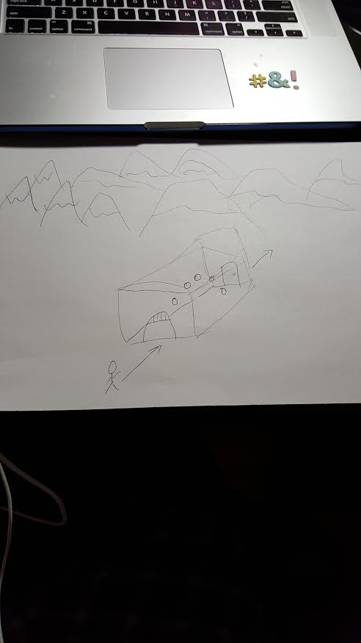

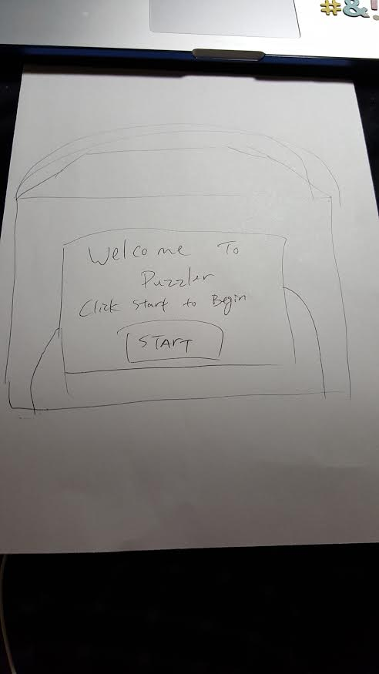

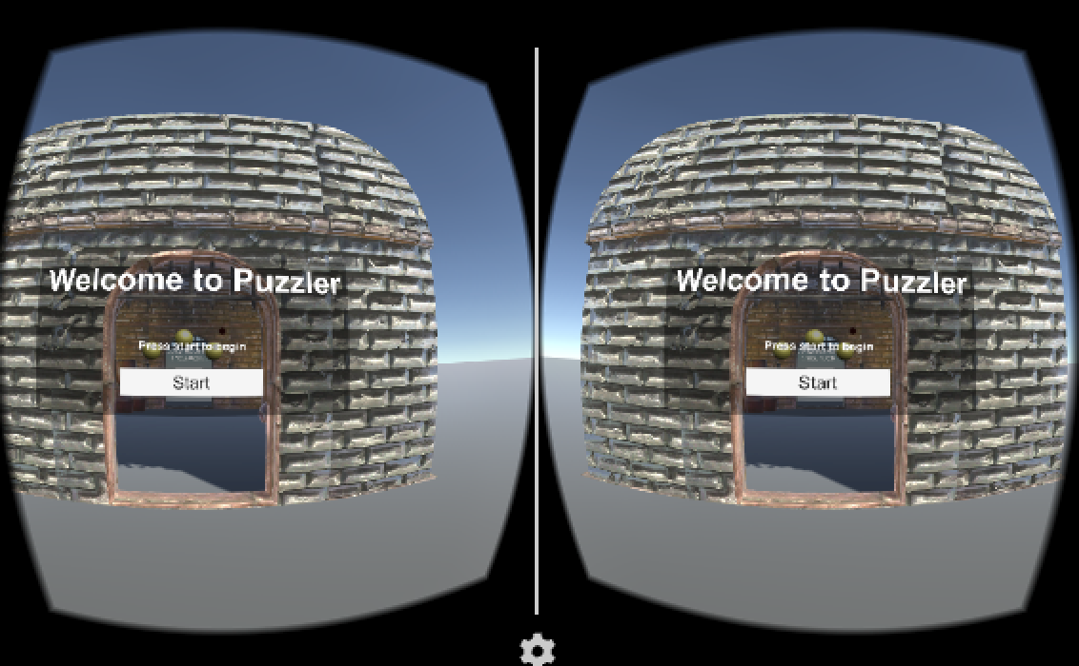

Users start at the start menu where they can click on the start button and they will be taken inside the cabin where the orbs are.

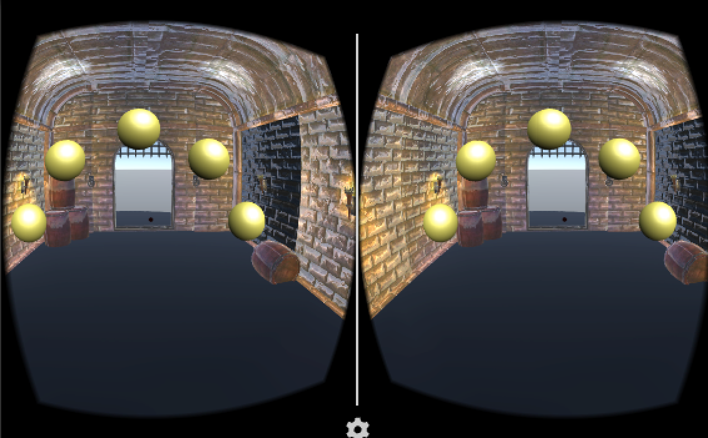

Users are then moved and glided into the cabin. Once there they can look around and they will also see the orbs light up with the correct pattern.

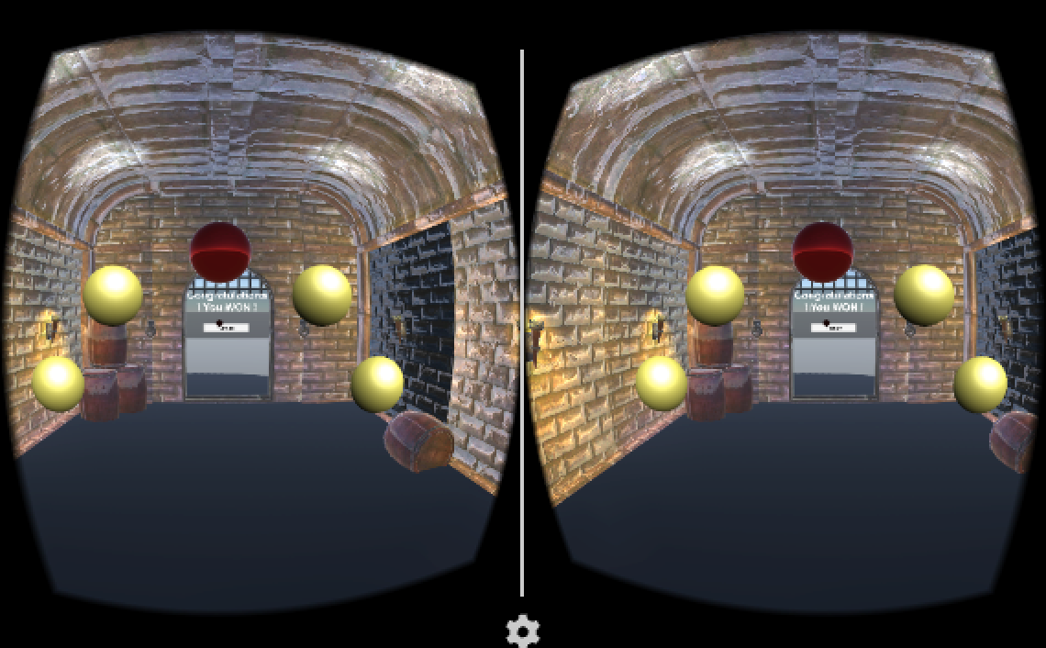

Users can select the orbs and if they fail then the pattern will restart. If they succeed in selecting the right combination they are then taken to the congrats menu.

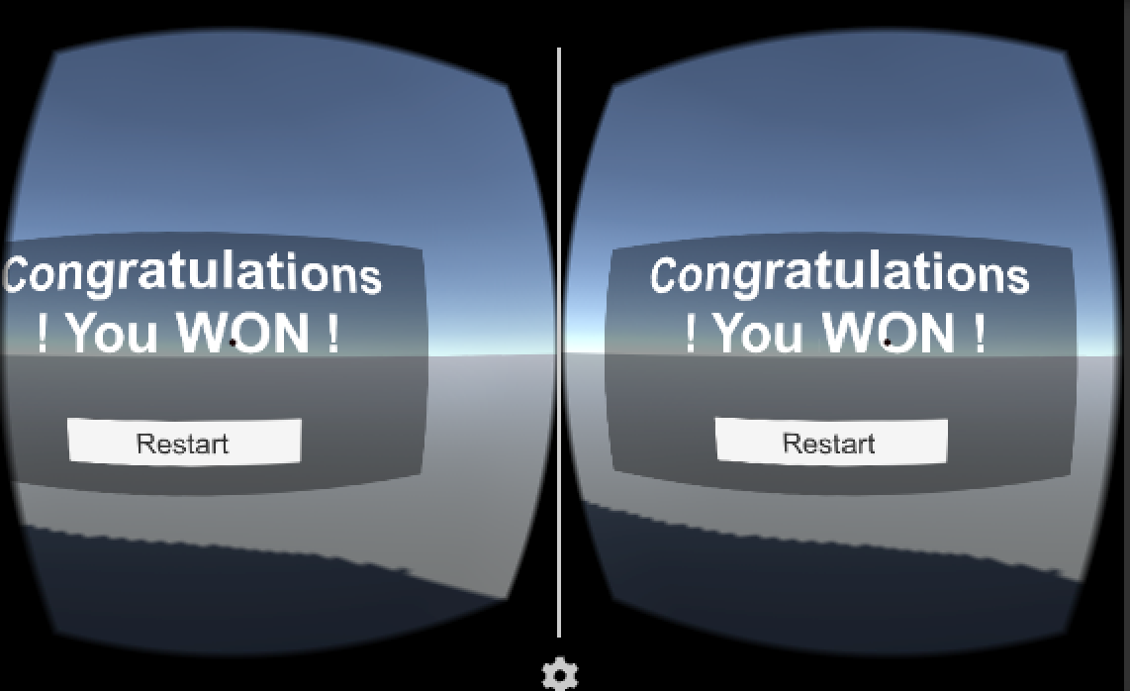

This is the congrats menu where users can hit the restart button and be take back to the start menu.

### **User testing**

### **User test 1**

This is what the tester said after using the app

Scale : Items see very glitchy if I move too quickly so sometimes I need to slow down the head turn.

Comfort: Not bad, but graphics could be better when turning since sometimes things can become a blur. However, once I stopped moving things seemed less blurry and details were definitely more visible.

### **User test 2**

Here is what the same tester said:

Interviewer: What do you see?

Interviewee: I see a big billboard with some welcome text and a start button.

Interviewer: What do you think happens when you press the start button?

Interviewee: It starts the game I would think.

Interviewer: Correct. Now press it and let me know what you see.

Interviewee: Oh it says I won, that was fast.

Interviewer: The game is actually not finished. I just wanted you to test the interface. Thanks again!

Interviewee: Ok definitely, let me know when the game is actually done, I’m curious about what happens.

### **User test 3**

This is done with the same tester:

Interviewer: Hello, thank you again for your time. I would like you to help me test the motion mechanics of the project. Implemented improperly can lead to motion sickness and a definite bad user experience because you might feel sick and/or disoriented. If you feel any sign of this, please remove the headset immediately and tell me about it.

Interviewee: OK cool let’s start.

Interviewer: Go on, put the headset and push the same start button you saw before.

Interviewee: Ok now I’m moving.

Interviewer: Good. Did you arrive in the room?

Interviewee: Yes. I see these yellow balls in front of me. So now what?

Interviewer: Nothing yet. Tell me about the movement. Did you feel comfortable?

Interviewee: Yeah I felt the same.

Interviewer: And did you feel any kind of discomfort?

Interviewee: Some of the graphics could have been better, but overall I’m good

Interviewer: OK. Thanks for the input on that. I’ll try to fix this issue later on.

Interviewee: How do I play with the balls?

Interviewer: For now, there is nothing you can do with them. Soon there will be and you will be able to test it.

Interviewee: OK.

Interviewer: So, please remove the headset and thank you for your time.

The graphics complaint was due to the movement being too fast, so I slowed it a bit to decrease blurriness.

### **User test 4**

In this final test the tester was given the chance to finish the experience from end to end. After I asked the following questions: How does it feel? What you like? What you dislike?

She replied that overall she liked the improvements I made when moving between screens. She also liked the game as a whole and was interested in more VR apps and games. It felt immersive despite the few control functionalities.

## **Conclusion**

Puzzler VR is a great way to showcase the new features and world of VR. It boasts easy controls and a simple game mechanic that allows users to be immersed and experience the VR world around them. It is Cardboard compatible only at the moment, but can support iPhone and Android based phones.

### **Next steps**

We would like to expand the feature set to allow for different levels in difficulty along with ways to store a scoreboard of the past games played. Ideally we would also like to connect to social media and allow users to share their scores with their friends and other gamers.

### **Link to additional work**

The complete source code and documentation can be accessed here:

<https://github.com/vincentdu101/udacity_puzzler>