

**User Manual**

***Version 0.9.5***

**Vincent Paul Fiestada**

March 27, 2014

Email: [vffiestada@upd.edu.ph](mailto:vffiestada@upd.edu.ph)

Contents

Getting Started 3

Opening Tree Fort 3

Creating User Accounts 4

Logging In 6

Users and Friendships 7

Adding Friends 7

Friendship Statuses 7

Unfriending Users 8

Status Updates 9

The Newsfeed 9

Timelines 10

Manipulating Status Posts 10

Messaging 11

Conversations 11

New Conversations and Messages 12

Manipulating Conversations 13

Notifications 14

Editing User Profiles 15

Profile Information 15

Deleting Profiles 16

# Getting Started

*Tree Fort* is a simulated social networking platform created with Python. If you’ve ever been on a social network like Facebook, you can imagine *Tree Fort* as sort of like an offline mock-up of Facebook.

*Tree Fort* is built using Python release 2.7, and to use it you must have the Python interpreter installed on your system. Please note that other versions of Python, especially older ones, might not support all of the features used by *Tree Fort*, causing the program to break. You can download Python 2.7 from <http://python.org/>.

## Opening Tree Fort

To open *Tree Fort*, use the Python interpreter to start up the file **‘main.py’**. It is highly recommended that you do this from the terminal and not from IDLE. The Python Integrated Development Environment uses the Tkinter module, which *Tree Fort* also uses. Using IDLE together with other Tkinter applications may prevent you from getting the best experience.

When you first open *Tree Fort*, you will be greeted by a window like this:

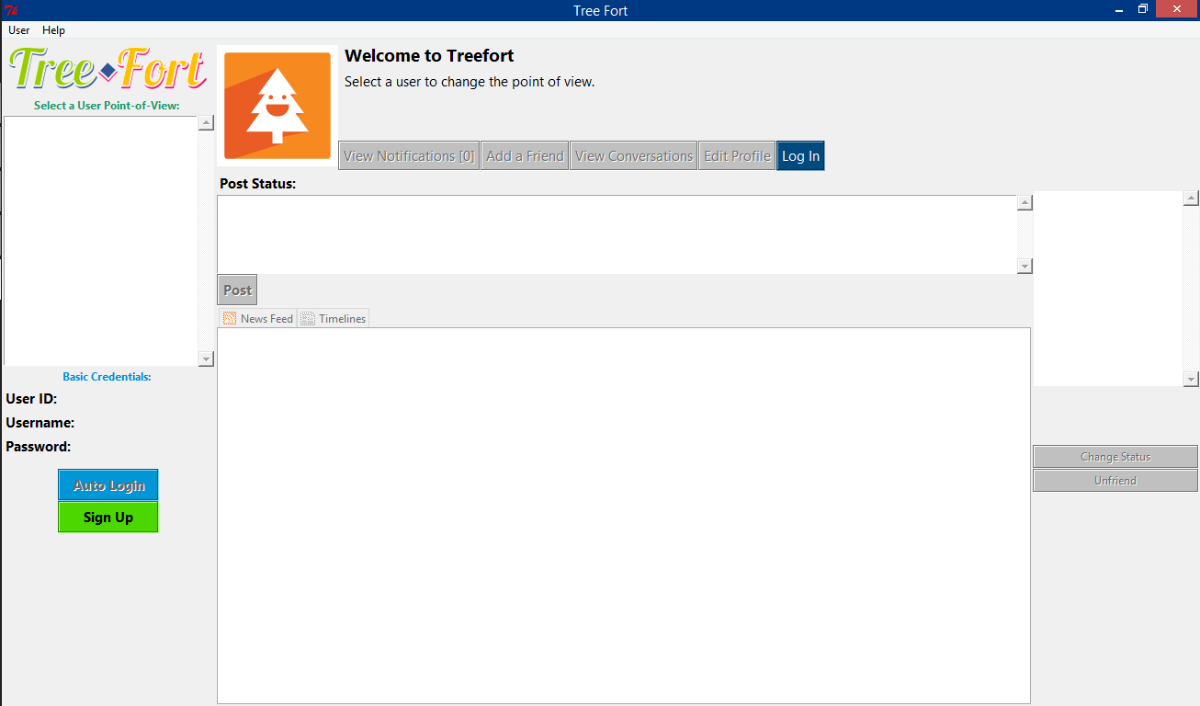

Figure 1. Tree Fort main window; running on Windows 8.1

The Main Window is divided into two panes. The left pane, colored red in the image below, is the **Admin pane**. It lets you create a new user, view basic user credentials, and switch from different user points-of-view. The right pane, shown below in blue, is the **User pane**, which displays what the selected user would see if *Tree Fort* was a real social network. It shows the perspective of the user.

*Admin’s Controls*

*Selected User’s Perspective*



Figure 2. Admin Pane and User Pane

## Creating User Accounts

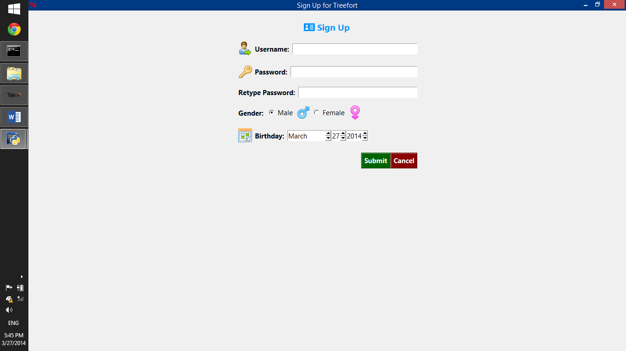Right now, there are no user accounts you can switch to. To create a new user, click on the **Sign Up** **button** in the Admin pane. You are required to provide a username and password, which will be used as your login credentials later. Each username must be unique. No two users can have the same username at any given time. Usernames can be composed of letters A-Z, a-z, the digits 0-9, and the special characters underscore (_), hyphen (-) and spaces.

Leading and trailing whitespaces are automatically removed from the username and password you enter. Because *Tree Fort* is only a simulated social network, the information is not actually encrypted. It is stored in a standard text file, and the Admin pane displays the login credentials for each user.

Click the **Submit button**, and the program will validate your credentials and create the user account.

If there are one or more user accounts, they will be displayed in the Admin pane’s **User list box**.

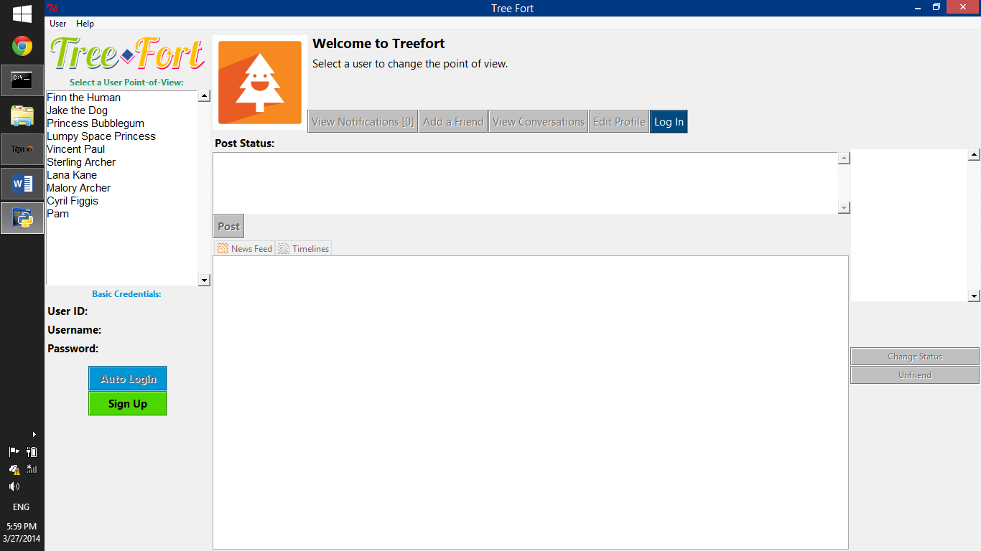

Figure 3. The user list box lists all user accounts

Click on any user’s name to change the point-of-view to that user. The Admin pane will also display that user’s basic credentials, including the User ID, Username, and Password.

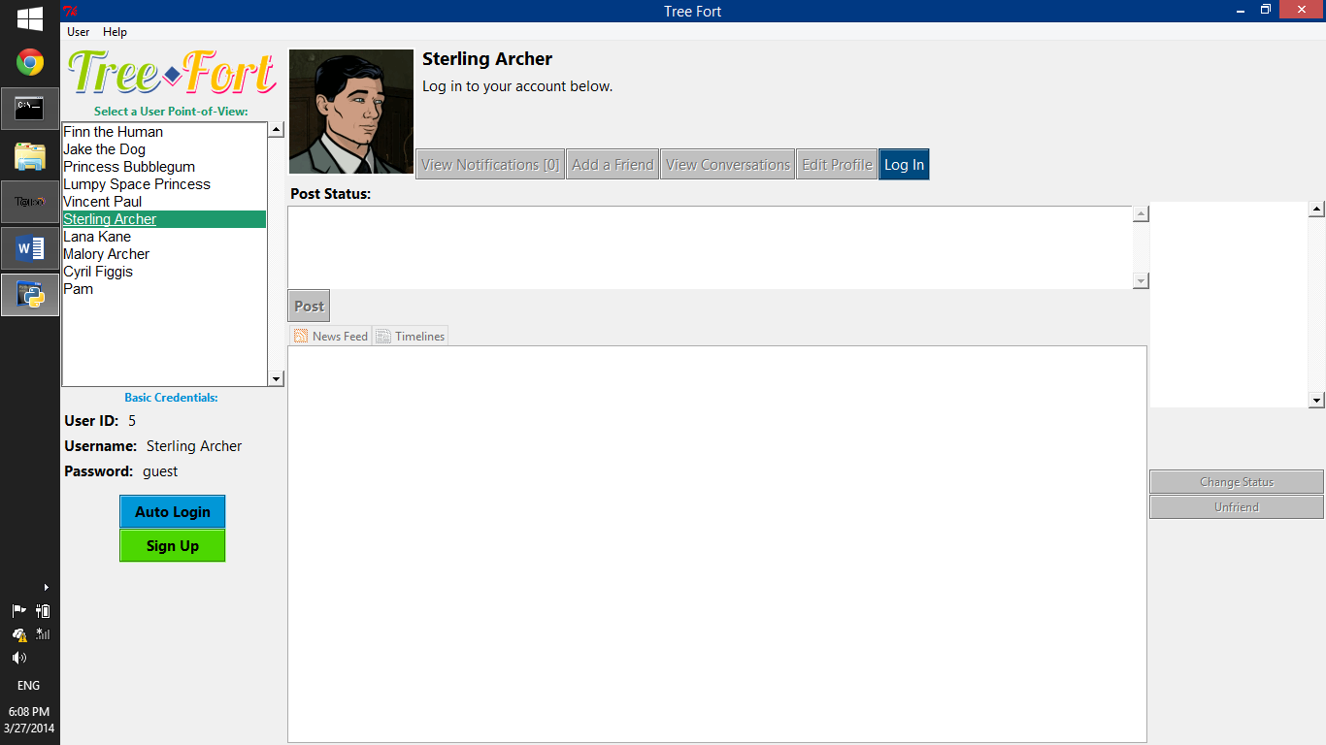

Figure 4. Point-of-view of a logged out user

## Logging In

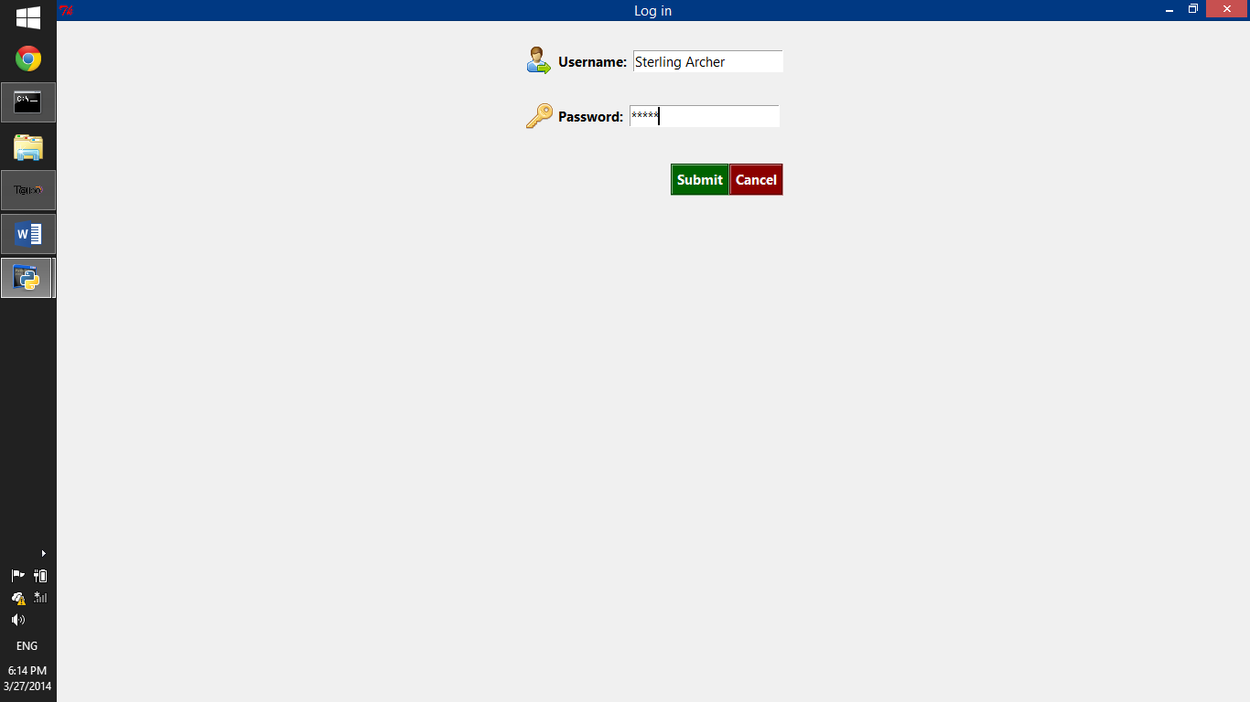There are two ways to log in. You can click the **Log In button** found in the User pane and enter a user’s credentials manually. You must enter the username and password to log in.

Remember that the currently selected user’s credentials are displayed in the Admin pane. You can also enter any username and password, and if the user exists and the password is correct, that user will be logged in. The perspective will also automatically switch to that user.

Multiple users can be logged in at the same time. You just need to click on a user’s name in the User list box to switch to that user’s perspective.

You can also automatically log in the currently selected user by clicking the **Auto Login button** in the Admin pane. If you use this button, it is understood that you are doing it as the admin, and so you won’t need to enter any credentials.

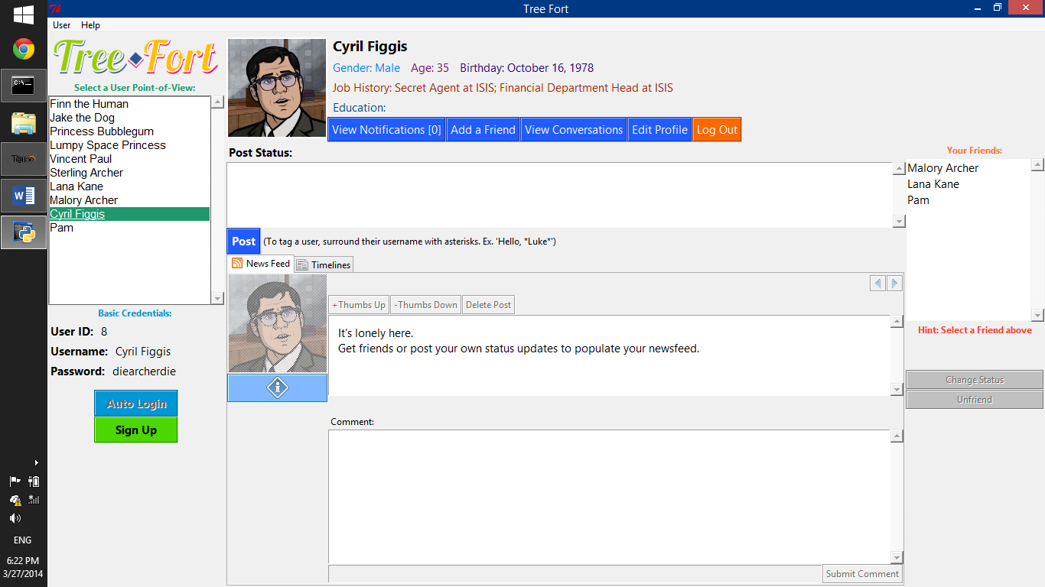

Figure 5. Point-of-view of a logged-in user

Logged In users can interact with each other through messages, status posts, etc. Technically speaking, there can be multiple logged in users—but the graphical user interface only shows you the perspective of one user at a time. This is due to the limitations of Tkinter, but because ***each user is represented as an independent object,*** there is absolutely no reason for a different interface (such as a terminal or web-based one) to display multiple windows for each logged in user.

# Users and Friendships

## Adding Friends

Generally, users can only interact with other users if they are friends. To add a user as a friend, click the **Add a Friend button** and enter a username.

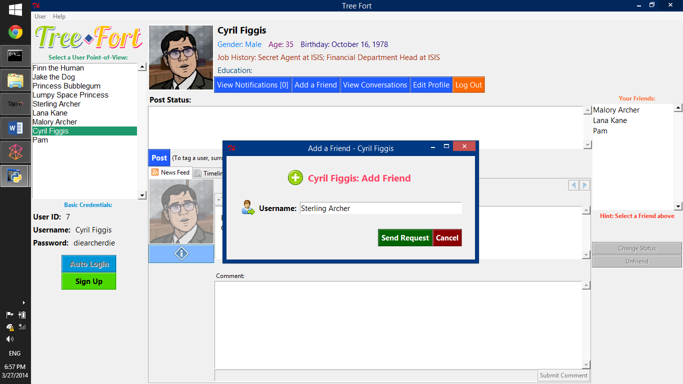

Figure 6. Add a Friend window

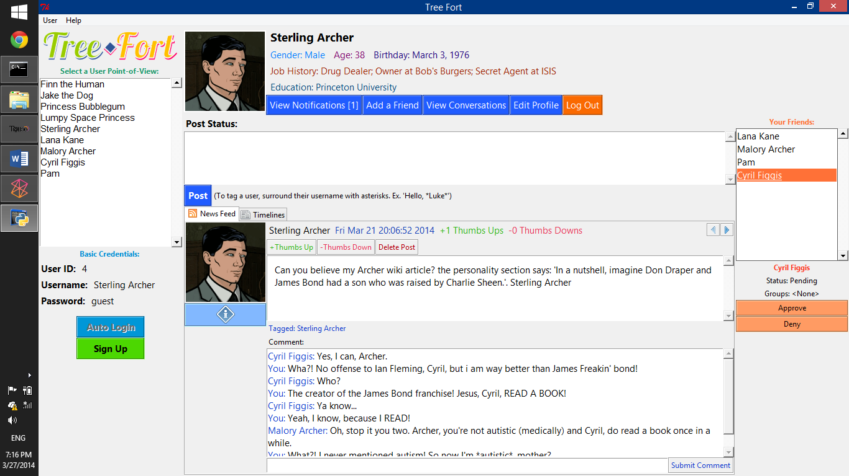After sending a friend request, the user will appear in your friends list, but you still won’t be able to interact with them and view their status updates. Friend requests must first be approved first.

Figure 7. Friends list box

To approve a friend request sent to you, click on the username(s) in the **Friend list box** and click **Approve/Change Status**.

## Friendship Statuses

You can also edit the friendship statuses of your friends. To do so, select one or more friends by clicking on their names in the **Friends list box** and click the **Change Status button**.

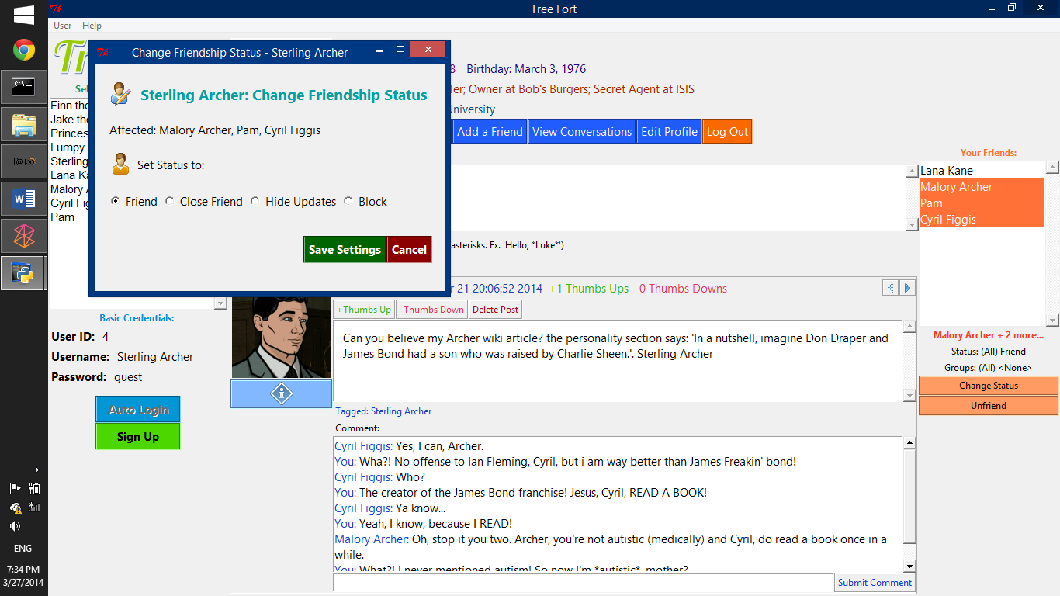

Figure 8. Changing friendship status

Here are the friendship statuses that you might encounter:

* ***Requested (automatic)*** – the status for users whom you’ve sent a friend request to, but have not yet approved. You cannot edit the status of this user until your friend request has been approved.
* ***Pending (automatic)*** – the status for users who have sent you a friend request, but whom you haven’t approved yet. You can choose to approve/deny pending friend requests.
* ***Friend*** (automatic, can be manually set) – the default status for approved friends; when you approve a friend request, your friendship statuses will both be set to “Friend”.
* ***Close friend (manually set)*** – if you mark a user as a close friend, you will receive Notifications every time that user posts a status or edits his/her profile.
* ***Hidden Updates (manually set)*** – you won’t see this user’s status updates in your news feed, and you won’t be able to view his/her timeline.
* ***Blocked (manually set)*** – Same as Hidden Updates, and you won’t see this user’s messages in Conversations. You also won’t have the option to invite this user to Conversations.

Each user’s friendship with another user is an independent object. So, you can set a user as a “Close Friend”, while that same user’s status for you is just “Friend”, or even “Hidden Updates”.

## Unfriending Users

To unfriend a user or cancel your friend request, select the username(s) in your **Friend list box**, and click the **Unfriend/Cancel Request button**. Your friendships with each other will be deleted once you confirm.

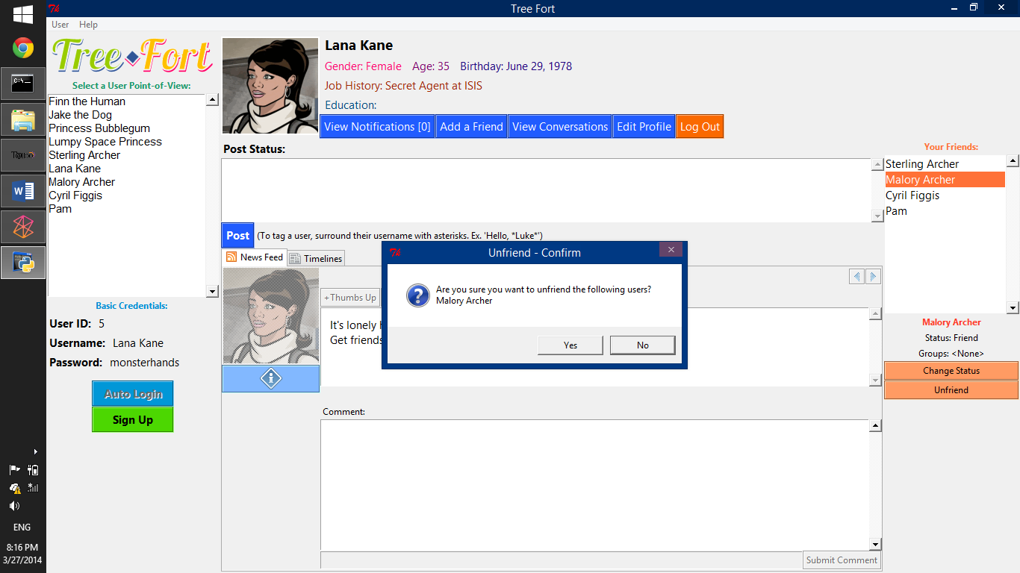

Figure 9. Unfriend confirm dialog box

# Status Updates

## The Newsfeed

The newsfeed is where you can view the posts of your friends (except those whose status is either “Requested”, “Pending”, “Hidden Updates”, or “Blocked”). The newsfeed is aggregated and sorted in two different ways, depending on how many friends you have.

If you have 14 or less friends, the statuses of your friends are aggregated and sorted based solely on the date they were posted.

If you have 15 or more friends, the statuses are aggregated and sorted using the same algorithm used by Reddit. This algorithm ranks statuses based on both the date and the number of Thumbs Ups and Thumbs Downs given to the post.

In Tree Fort, the newsfeed is displayed as a slideshow. To navigate through your newsfeed, click the **Next Status** or **Previous Status button**.

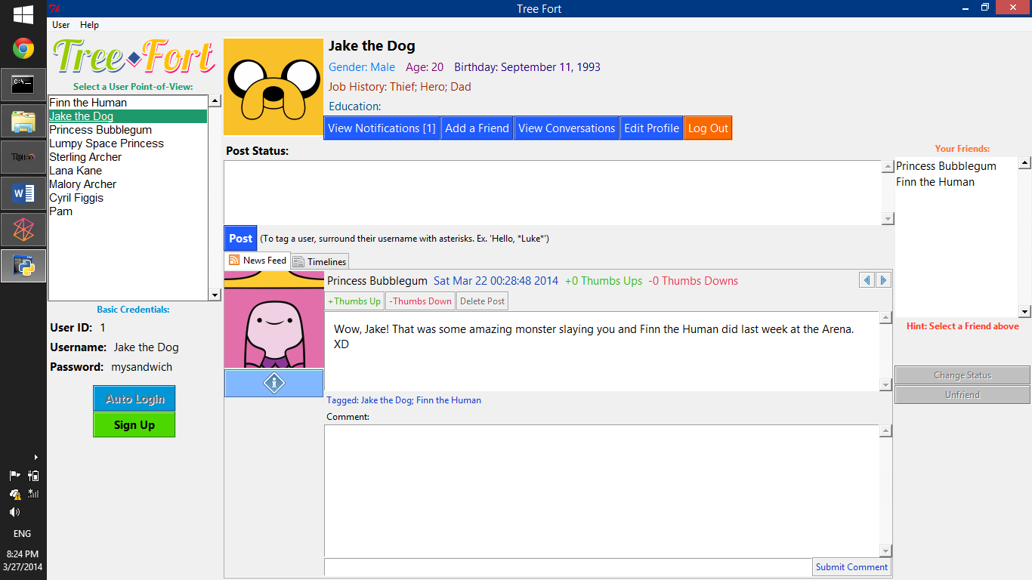



Figure 10. The newsfeed slideshow, with the navigation buttons zoomed in.

## Timelines

Click on the **Timelines tab** to switch to the timelines view, where you can view just the statuses of specific friends or yourself. To view a specific user’s timeline, select a username from the drop-down list box.

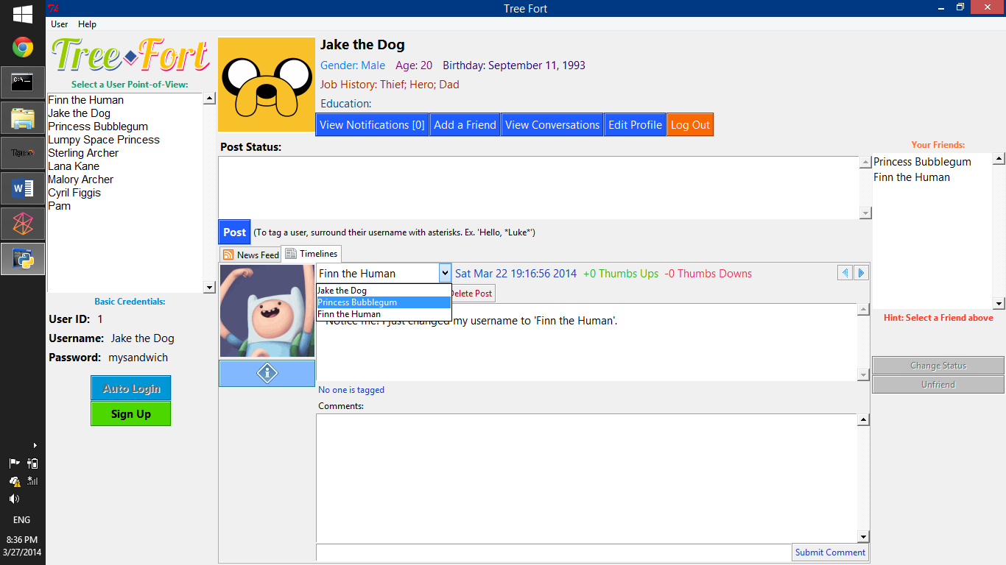

Figure 11. Timelines view

Unlike your newsfeed, which is a collection of your and your friends’ statuses, the timelines view just displays a specific user’s status posts. The controls and navigation are similar to the newsfeed controls.

## Manipulating Status Posts

Through the newsfeed and timelines, you can manipulate status posts made by yourself and your friends.

The following are the actions you can do to status posts:

* **Delete Status** – you can delete your own status posts
* **Give Thumbs Up** – express your approval of the post. Depending on a user’s number of friends, this may be used to rank statuses in a newsfeed. (see The Newsfeed)
* **Give Thumbs Down** – express your disapproval of the post. Depending on a user’s number of friends, this may be used to rank statuses in a newsfeed.
* **Comment** – post a comment on the status post. The comment can still be seen by all users who can see the status post, even if they aren’t your friends.
* **View Poster Information** – There is a button below the status poster’s profile picture which allows you to view information about the poster, including username, profile picture, age, gender, birthday, job history, and education history.

# Messaging

## Conversations

Each logged in user can also participate in conversations and send messages to each other (if they are friends). After logging in, click on the **View Conversations** **button**.

The Conversations window is divided into two panes. In the left pane, you can select conversations to view. In the right pane, you can read messages in the currently selected conversation and send new messages.

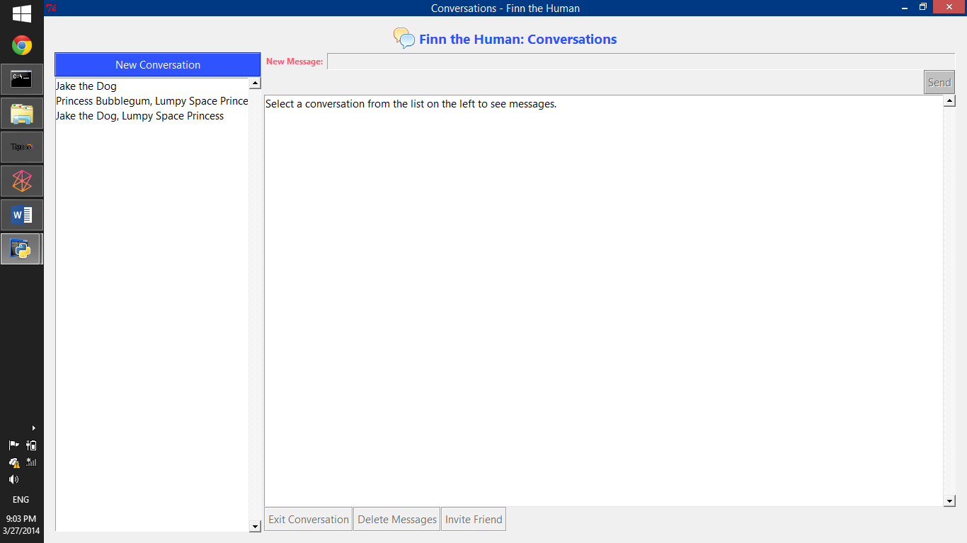

Figure 12. Conversations window

In *Tree Fort*, messages are not sent to any particular user. Instead, all messages are grouped inside conversations, and all members of those conversations can see those messages (unless the user who sent them is not their friend, or is blocked).

Each conversation can have multiple members, which is how group messaging is facilitated in *Tree Fort*.

## New Conversations and Messages

Click on the **New Conversation button** to start a new conversation. You can invite any friend whose status is “Friend”, “Close Friend”, or “Hidden Updates”.

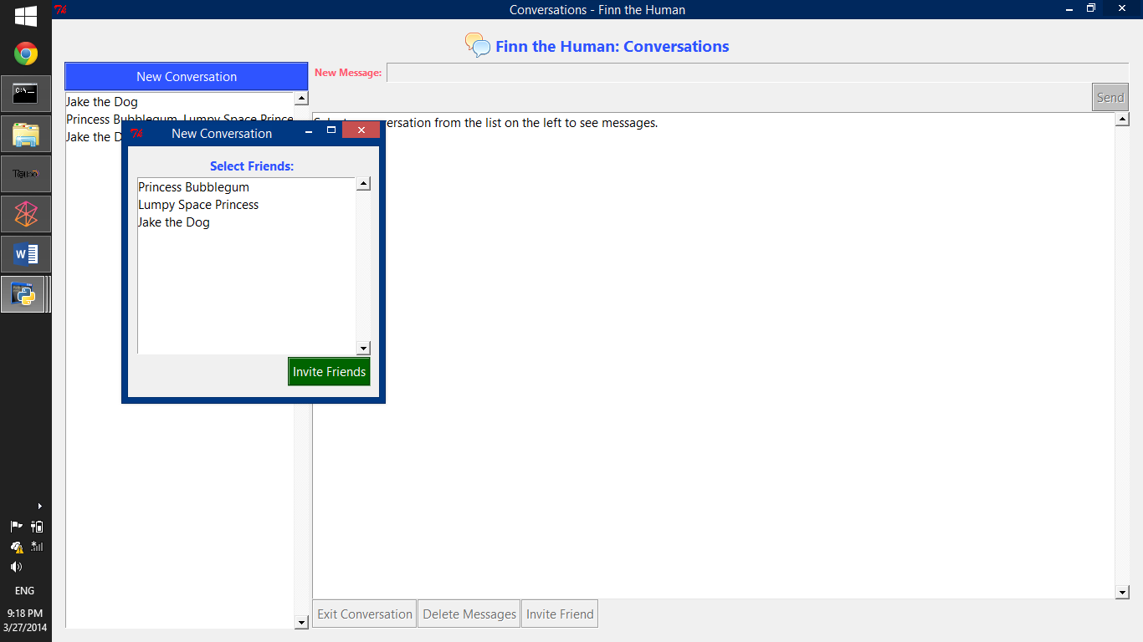

Figure 13. New conversation window

Select one or more friends in the New Conversation window and then click on the **Invite Friends button**. After that, you can start sending messages which will be seen by the members (for exceptions, see Friendship Statuses).

To send a new message, select a conversation, the enter text into the New Message textbox and click the **Send button**.

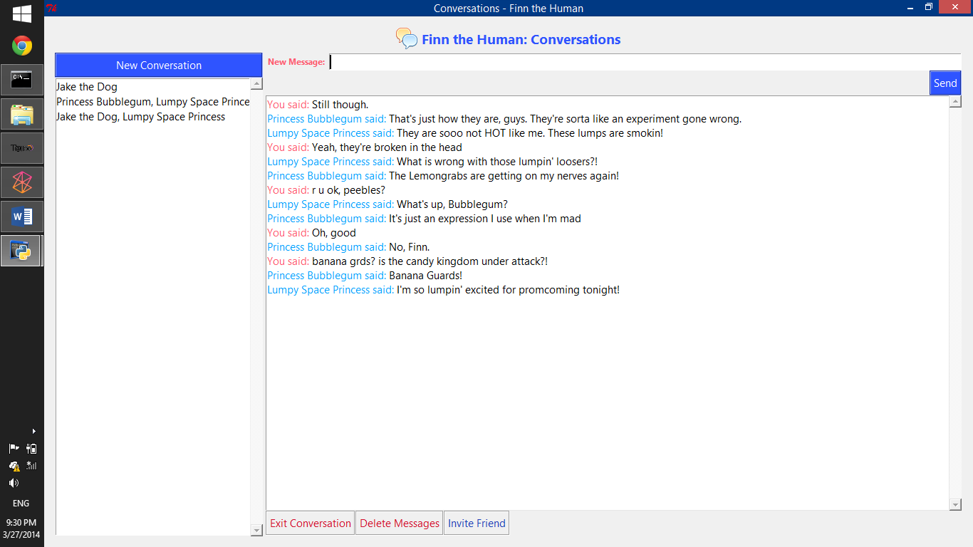

Figure 14. Send a new message

## Manipulating Conversations

Aside from sending new messages and starting new conversations, there are a bunch of other things you can do with a conversation:

* **Exit the Conversation** – remove the conversation from your list of conversations. The messages you sent in that conversation, however, will still remain as long as the conversation exists and your user account exists.
* **Delete the Conversation** – this action is only available if you are the last and only member of the conversation. Deleting a conversation deletes all messages in it and permanently removes it from your conversations list.
* **Delete Messages** – applies only to messages that you have sent. You have the option to delete all your messages in the selected conversation; or you can delete just the last message you sent.
* **Invite Friends** – add members to an existing conversation. Users do not have to approve the invitation, but they can choose not to participate or to exit the conversation.

# Notifications

Notifications are simply alerts in the form of textual messages that you will receive when certain things happen in the network, such as when “Close Friends” post statuses or edit their profile, or when you get a new friend request.

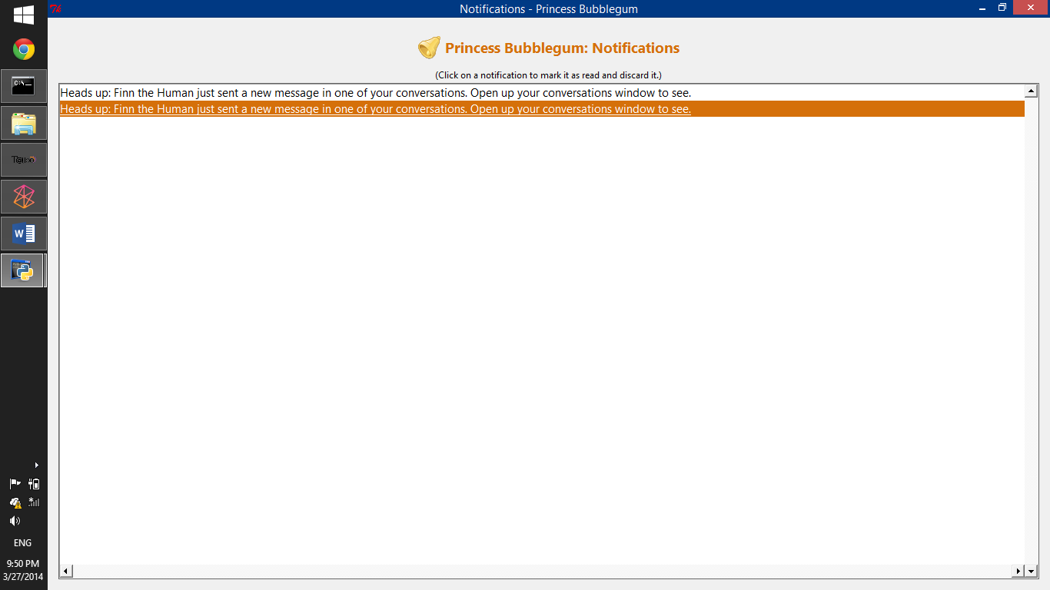

Figure 15. Notifications window

To view your notifications, click on the **View Notifications** **button**. The same button also displays how many unread notifications you have.

Click on a notification to mark it as read and to discard it. Discarded notifications will not be exported and will forever be lost into the abyss.

# Editing User Profiles

## Profile Information

To edit the currently selected user’s profile information, click the **Edit Profile button.** This will open up the Edit Profile window, where you can edit your username, password, profile picture, gender, birthday, job history and education history.

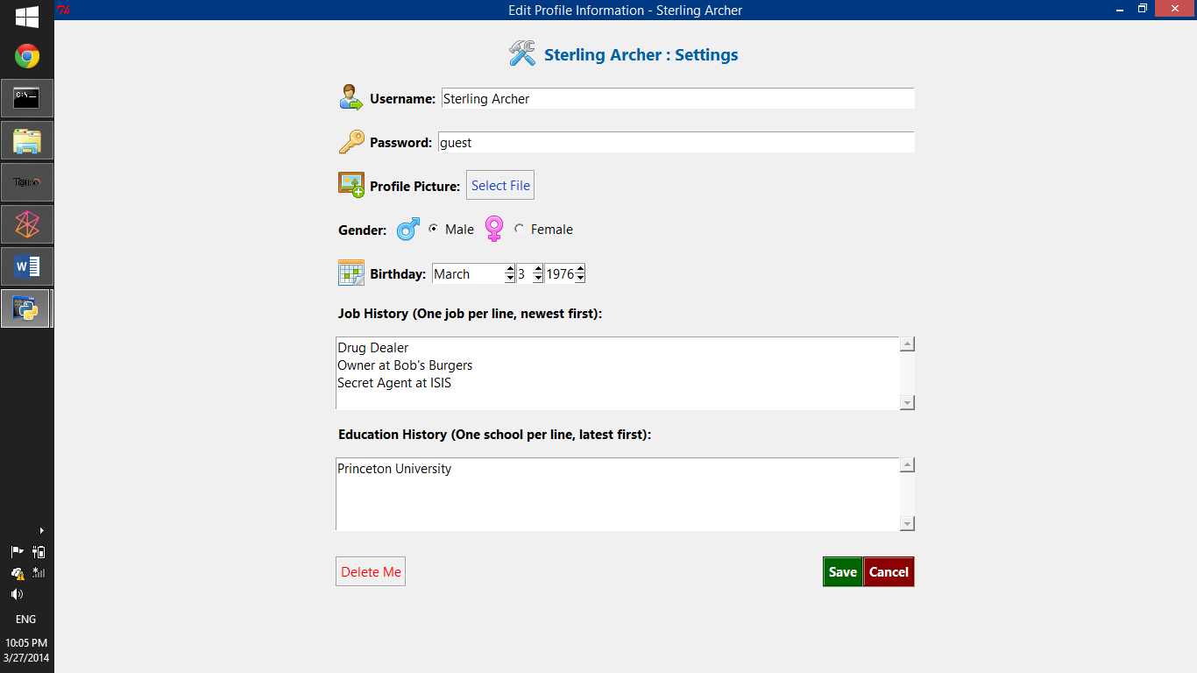

Figure 16. Edit profile window

When selecting a new profile picture, you can only select a file with a .gif file extension (Graphics Interchange Format). Again, because of the lackluster avenues provided by Tkinter. The program will copy the image file into a special folder for your user profile, so one it has been set as your profile picture, you can delete the original file. It is recommended that you choose a 128 pixel by 128 pixel image for your profile picture.

The job history and education history can be set by entering each job or school in each line of their respective textboxes. Leading and trailing whitespaces, as well as empty lines will be deleted. They will be displayed from left to right in the same top-down order that you enter them.

## Deleting Profiles

To delete your user profile, click on the **Delete Me button** found in the Edit Profile window. Once you confirm the deletion, the program will delete the user profile’s posts, tags, thumbs ups, thumbs downs, messages, empty conversations, and unfriend with all friends. The folder that stores the user’s profile picture and other information, as well as entries in all databases will be deleted.