CS 131 Problem 5

A pin fin is a slender extension attached to a surface in order to increase the surface area and enable greater heat transfer. When convection and radiation are included in the analysis, the steady-state temperature distribution, $T(x)$, along a pin fin can be calculated from the solution of the equation.

$$\frac{d^{2}T}{dx^{2}}=\frac{h_{C}P}{kA_{C}}\left(T-T_{S}\right)-\frac{εσ_{SB}P}{kA_{C}}\left(T^{4}-T_{S}^{4}\right)=0, 0≤x≤L$$

The Stefan-Boltzmann constant W/m2K4.

# Details

Let $w≔\frac{dT}{dx}$. From the above equation, we derive the following system of first order ODEs.

$$\frac{dT}{dx}=w$$

$$\frac{dw}{dx}=\frac{h_{C}P}{kA_{C}}\left(T-T_{S}\right)+\frac{εσ_{SB}P}{kA_{C}}\left(T^{4}-T_{S}^{4}\right)$$

And we know that $T\left(0\right)=473$, $T\left(0.1\right)=293$

The guesses $w\left(0\right)=-1000$ and $w\left(0\right)=-3500$ were successively used. The next guess, $-2706.980522$**,** calculated using the Secant Method.

The RK-2 output for each guess is given the following screenshot.

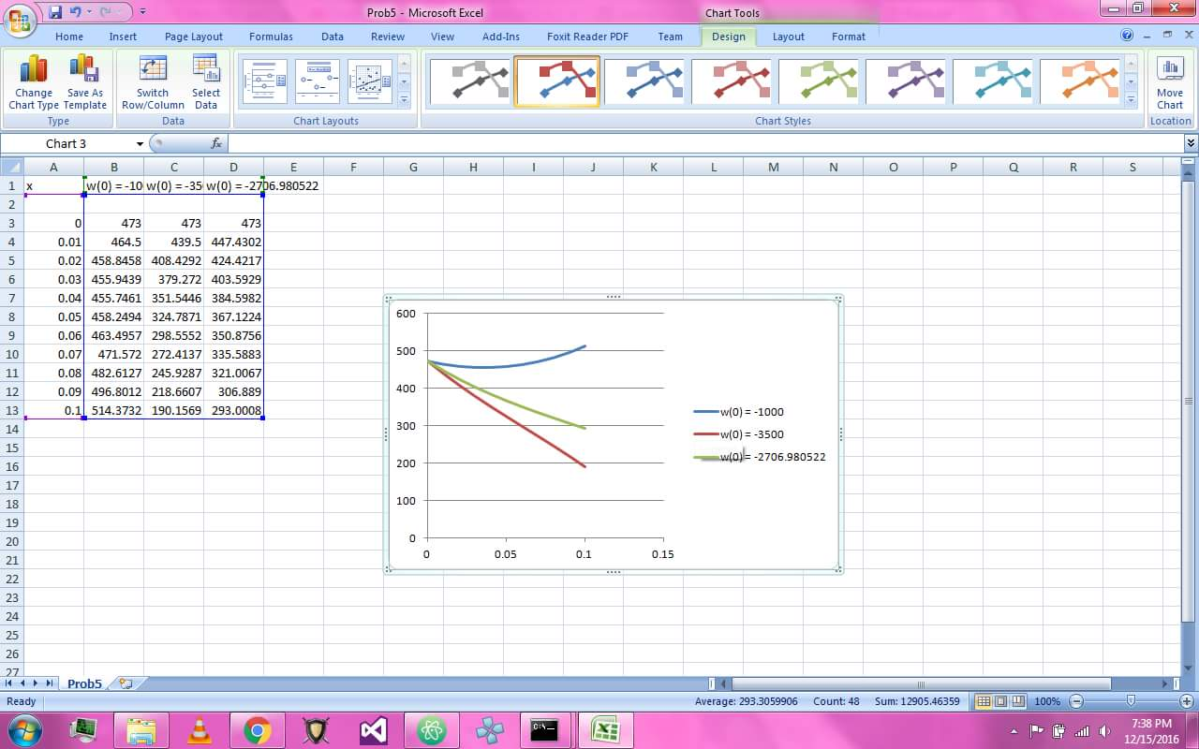

# Discussion

1. In the given equation, the convection term is

$$\frac{h_{C}P}{kA_{C}}\left(T-T_{S}\right)$$

as it was stated that $h_{C}$ is the convective heat transfer coefficient.

and the radiation term is

$$\frac{εσ_{SB}P}{kA_{C}}\left(T^{4}-T_{S}^{4}\right)$$

which uses the Stefan-Boltzmann constant and an emissivity factor. The Stefan-Boltzmann constant is a proportionality constant applied to thermal radiation.

1. The output looks like the provided graph.

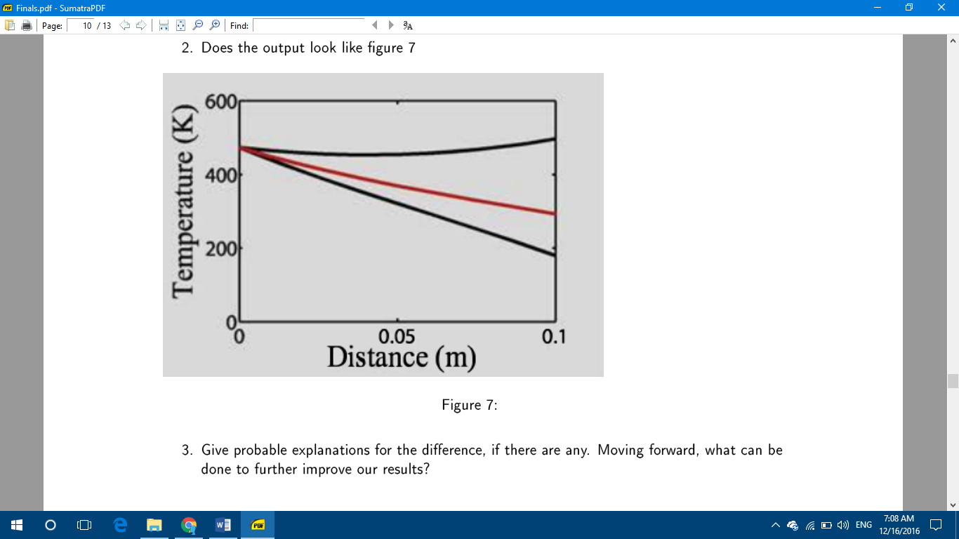

1. The RK-2 output is already significantly similar to the expected graph. Results can be improved further by comparing it with results using more guesses made using the Secant Method.