Packet Tracer Enterprise Lab
Documentation and Feature Summary
Vincent Funk

Main Office Subnetting
192.168.0.0/26 Vlan10 Access User PCs
192.168.0.64/26 Vlan20 Voice VoIP phones
192.168.0.128/27 Vlan30 Admin Servers, admin PC, layer 2 switch management IP’s
192.168.0.160/27 Building2
192.168.0.192/27 Building3
192.168.0.224-255 Range for router /30 point to point links
192.168.1.0/24 Vlan40 Wireless Wireless clients, WLC, LAP, DHCP Server

Main Office Topology Map

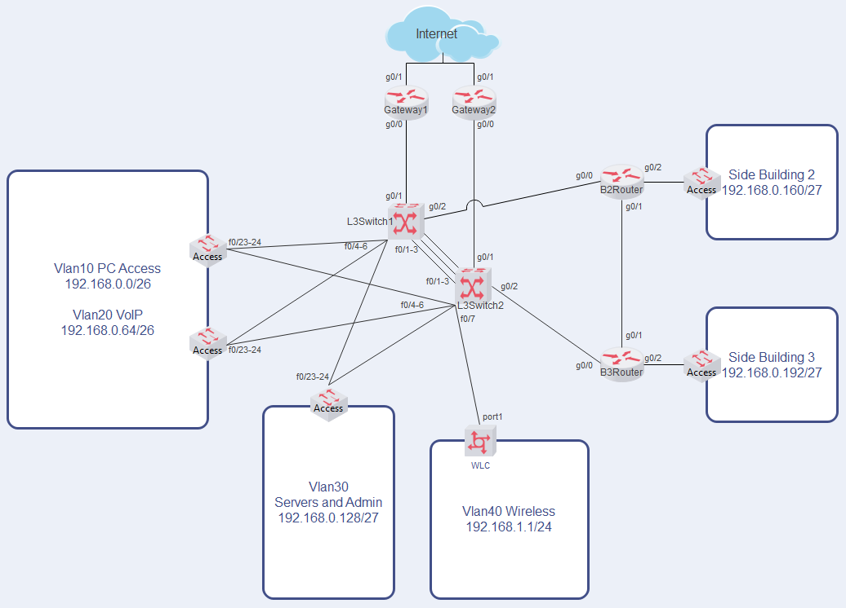

Main Office Feature Summary

Office Servers
- Web and DNS at 192.168.0.157(internal) 200.1.1.2(external)
- DHCP at 192.168.1.253, uses a router configured with “no ip routing”
- TFTP and Syslog at 192.168.0.155
- TACACS+/NTP at 192.168.0.156

All networking devices
- NTP provided by NTP Server
- Syslog with timestamps to Syslog Server
- AAA remote logins using Tacacs+
- Enable password uses local login

Routing Protocol
- Single area OSPF
- Gateway 1 spreads default route to Internet

Access switches
- Portfast and BPDUguard on access ports
- Port-security with a maximum of 2 sticky MAC addresses, violation mode restrict
- DHCP snooping rate limited to 5 on untrusted ports, no option 82 insertion
- ARP inspection with source MAC, destination MAC, and IP validation
- Server switch is the VTP server, all other switches set to VTP client

Layer 3 switches
- Provide HSRP default gateway for all Vlans
- STP root priorities synced with HSRP for load balancing
- Connected to each other with LACP Etherchannel
- Multilayer Switch 1 is lowest priority root for vlan10,30
- Multilayer Switch 2 is lowest priority root for vlan20,40
- Multilayer Switch 2 uses static route to Gate2 instead of OSPF spread default from Gate1
- Floating static route to the other Layer 3 Switch in case matching gateway goes down

Gateways
- Dynamic NAT with overload for outgoing traffic
- Static NAT translation provides external access to Web and DNS Server
Website at office.com
DNS at 200.1.1.2
- ACL blocks all telnet and ssh traffic from the outside

Buildings 2 and 3 Routers
- ACL
Blocks access to NTP/AAA/TFTP/Syslog except from internal switch
Permits only traffic from correct subnets and DHCP traffic

Wireless
- WLC provides configuration and DHCP to LAPs
- End devices receive DHCP from DHCP server on the same subnet

Remote Branch Office
- Local device logins only
- Default gateway router provides DHCP

SOHO
- Typical home-router
- Broadband cable Internet
- DHCP received from ISP

Internet
- Routers use static routes to simulate connectivity of separate locations over the Internet

Login Information

- Only upperAccess, lowerAccess, serverSwitch, building 2 router and switch configured for demonstration
- Remote office router and switch use local logins instead of AAA
- SSH input only
- Console uses no login but still requires enable password

Main Office
- AAA Username: secure Password: secret
- Enable Password: enable
- Local backup Username: admin Password: Cisco (used when AAA server is inaccessible)
- WLC Gui Username: admin Password: Cisco123!

Remote Office
- Local Username: admin Password: Cisco
- Enable Password: enable

*passwords used for lab only and are not secure*

