Testing and Evaluation of the Beneficiary Qualification Algorithm

Methodology
The beneficiary qualification algorithm was tested in a Jupyter notebook (test_algorithm.ipynb) that applies the system’s screening rule to a real citizen registry export. The rule evaluates each resident through three sequential conditions: (1) membership in one of the eight recognized beneficiary classes — Solo Parent, PWD, Senior Citizen, Construction Worker, Rice Farmer, Market Vendor, Tricycle Driver, and Lactating Mother — taken directly from the VALID_CLASSES list in the system’s checker/logic.py module; (2) absence of any grant received within the preceding three months; and (3) absence of any household member who received a grant within the same period. A resident who satisfies every condition is reported as “Passes screen”; a resident who fails any condition is reported as “Not qualified,” together with the reason for the rejection.
Before the registry data was used, the rule was verified with 13 unit tests: five hand-picked cases that exercise every branch of the rule (an unrecognized class, a missing class, a recent grant, a household member’s recent grant, and a fully eligible applicant), plus one check for each of the eight recognized beneficiary classes. These tests do not depend on the registry file, so they remain a valid regression check even if the data used in later stages changes.
The rule was then applied to a citizen registry of 43,435 residents from 47 barangays. Each record contains 15 fields, including birthdate, age, gender, civil status, educational attainment, occupation (PSOC), barangay, and solo-parent and PWD status. Because the registry does not record a beneficiary class directly, each resident’s class was derived from these fields using a fixed priority order: PWD, then Solo Parent, then Senior Citizen (age 60 and above), then an occupation keyword match on the PSOC field (Tricycle Driver, Construction Worker, Rice Farmer, or Market Vendor). The priority order assigns exactly one class to residents who qualify under several categories. Lactating Mother cannot be derived because the registry has no pregnancy or maternity field.
The registry also has no grant-history field. To exercise the second condition at the registry’s real scale, a synthetic recent-grant flag was generated for every resident with a 10% probability using a fixed random seed (42), which flagged 4,295 residents (9.9%). This flag is a placeholder used only for testing; it is not real grant data and was never written back to the registry. Because the registry also lacks household linkage, the household condition was verified through the unit tests but was not applied to the registry screening. The decision and reason for every resident were exported to algo_test_results.xlsx.
To determine how well a machine-learning model could reproduce the screening outcome, a Random Forest classifier (scikit-learn RandomForestClassifier) was trained in two passes. In the first pass, a sanity check, the model received the exact inputs used by the rule: the derived beneficiary class and the simulated grant flag. In the second pass, the model received only the raw fields that a real intake interview would collect, each distorted by a simulated self-reporting error: age was shifted by random measurement error (standard deviation of 2.5 years), the PWD and solo-parent flags were each flipped with a 5% probability, and four occupation-keyword flags derived from the PSOC field were each flipped with an 8% probability. The simulated grant flag was kept unchanged, and the training labels always came from the true, error-free screening outcome. The data were split into training and test sets using an 80/20 stratified split (random_state = 42), giving 34,748 training and 8,687 test records; the second model used 300 trees with a maximum depth of 8. Performance on the test set was measured using a confusion matrix, accuracy, precision, recall, F1-score, and the area under the ROC curve (ROC-AUC), with Qualified (a resident who passes the screen) as the positive class. Recall was also computed separately for each beneficiary class, and feature importance was used to identify which inputs the model relied on.

Results and Discussion

Unit Test Results
All 13 unit tests passed (Table 1). Each rejection path returned the expected reason, and each of the eight recognized beneficiary classes, including Lactating Mother, passed the screen when no recent grant was recorded. This confirms that the rule behaves as specified before it is applied to real data.
Table 1. Unit test cases for the screening rule.
No. | Test case | Expected result | Actual result | Status
1 | Unrecognized class (“Barangay Captain”), no recent grant | Not qualified | Not qualified — not a member of any valid beneficiary class | Passed
2 | No class (missing value), no recent grant | Not qualified | Not qualified — not a member of any valid beneficiary class | Passed
3 | PWD with a grant in the last 3 months | Not qualified | Not qualified — received a grant within the last 3 months | Passed
4 | PWD, no personal grant, household member received a grant | Not qualified | Not qualified — a family member received a grant within the last 3 months | Passed
5 | Senior Citizen, no recent grant | Passes screen | Passes screen | Passed
6 | Each of the 8 recognized classes, no recent grant | Passes screen | Passes screen (8 of 8) | Passed

Rule-Based Decision Tree
Figure 1 shows the decision tree that was applied to the registry. A resident who does not belong to a valid beneficiary class is rejected immediately. A class member is then checked for a grant received within the last three months: a recent grant leads to rejection, while no recent grant leads to “Passes screen.” The class list in the figure is the same VALID_CLASSES list used by the system, so the test and the implementation apply the same eight classes.
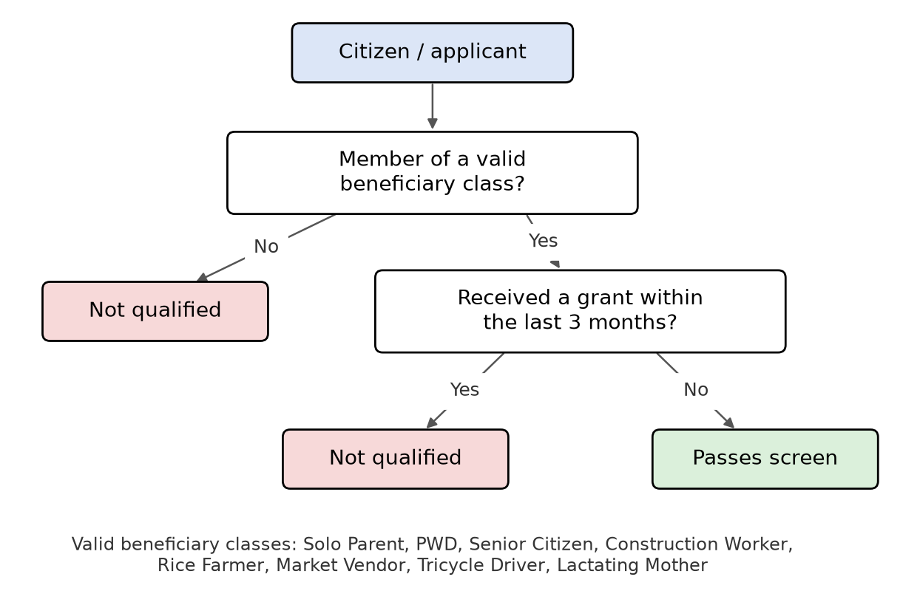
Figure 1. Decision tree of the screening rule applied to the registry: class membership followed by recent-grant history.

Derived Beneficiary Classes
Of the 43,435 residents, 12,403 (28.6%) were assigned to a recognized beneficiary class, while 31,032 (71.4%) did not match any class (Figure 2). Senior Citizen was by far the largest class with 6,895 residents, or 55.6% of all class members, followed by Construction Worker (1,762), PWD (1,039), Solo Parent (1,008), Rice Farmer (749), Tricycle Driver (487), and Market Vendor (463). A total of 1,656 residents matched two or more classes and were assigned by the priority order; for example, 7,549 residents are aged 60 or above, but 654 of them were counted as PWD or Solo Parent instead of Senior Citizen. No resident was assigned to Lactating Mother, which reflects the missing maternity data rather than a defect in the algorithm.
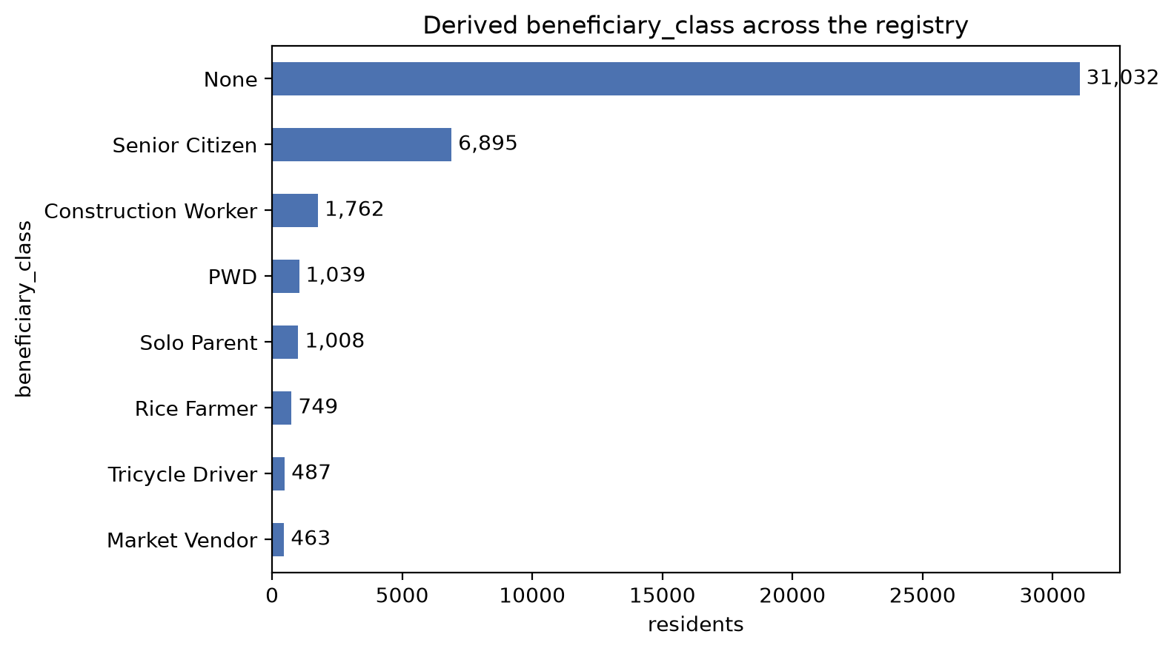
Figure 2. Derived beneficiary class of the 43,435 registry residents (None = not a member of any recognized class).

Screening Results
Screening the full registry on class membership and recent-grant history found that 11,145 residents (25.7%) passed the screen. Of the 32,290 residents who were not qualified, 31,032 (71.4% of the registry) were rejected because they do not belong to any recognized beneficiary class, and 1,258 (2.9%) belonged to a valid class but were blocked by the simulated recent-grant flag (Figure 3).
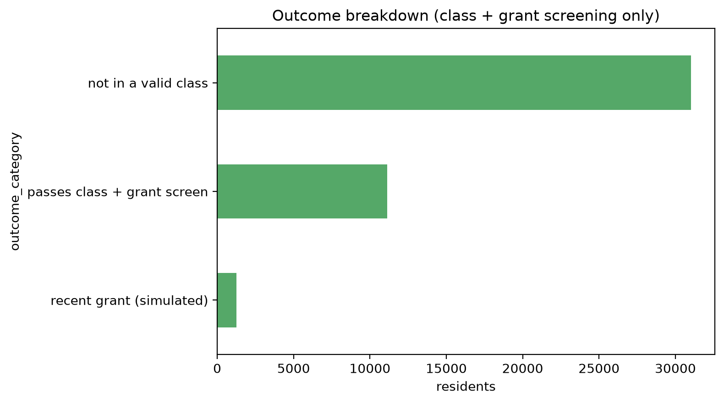
Figure 3. Screening outcome for the 43,435 registry residents.
Among the 12,403 residents who belong to a valid class, 89.9% passed the screen, and the pass rate was nearly the same for every class, ranging from 89.6% to 91.1% (Table 2). This uniformity is expected: the only condition that can reject a class member is the simulated grant flag, which was assigned at random with a 10% probability, so about one in ten members of every class was blocked. The differences between classes therefore reflect random variation in the simulated flag rather than any property of the classes themselves. Class membership, not grant history, is what decides the outcome for most residents: nearly three quarters of the registry was rejected at the first condition.
Table 2. Screening results by derived beneficiary class.
Beneficiary class | Residents | Passed the screen | Blocked by recent grant | Pass rate
Senior Citizen | 6,895 | 6,179 | 716 | 89.6%
Construction Worker | 1,762 | 1,581 | 181 | 89.7%
PWD | 1,039 | 942 | 97 | 90.7%
Solo Parent | 1,008 | 918 | 90 | 91.1%
Rice Farmer | 749 | 671 | 78 | 89.6%
Tricycle Driver | 487 | 439 | 48 | 90.1%
Market Vendor | 463 | 415 | 48 | 89.6%
Lactating Mother | 0 | 0 | 0 | —
Not in a valid class | 31,032 | 0 | — | 0.0%
Total | 43,435 | 11,145 | 1,258 | 25.7%

At the barangay level, Poblacion had the most residents passing the screen (962 of 3,719, or 25.9%), followed by Baroro (667 of 2,635) and Cabaroan (465 of 1,916), as shown in Figure 4. Pass rates across the 47 barangays ranged from 18.0% (Sapilang) to 32.1% (Arosip), mainly reflecting differences in how many residents of each barangay belong to a recognized beneficiary class.
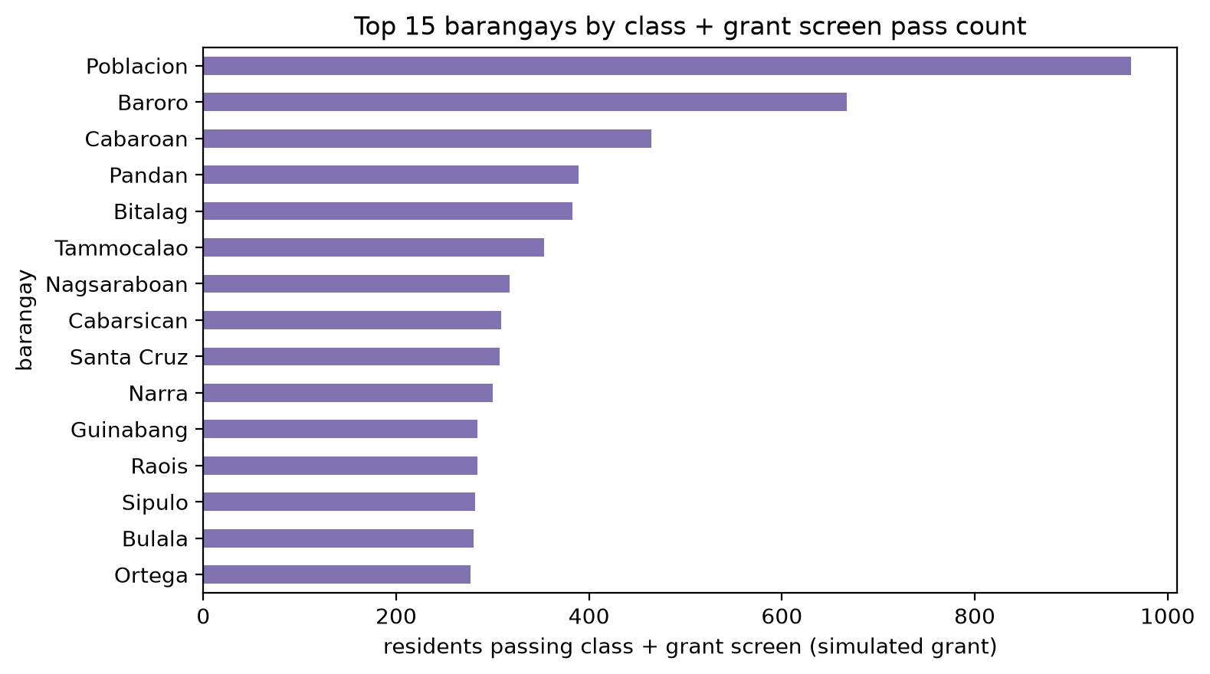
Figure 4. The 15 barangays with the most residents passing the screen (recent-grant flag simulated).

Random Forest Performance Evaluation
In the sanity-check pass, where the model received the exact beneficiary class and grant flag used by the rule, it reached 100% accuracy on the test set. This result is expected, because the screening outcome is a fixed function of those two inputs, and it confirms that the training and evaluation setup is correct. It is not evidence that a trained model can replace the rule.
In the realistic pass, where the model received only self-reported fields with simulated reporting errors, it correctly classified 7,748 of the 8,687 test records (Figure 5). Of the 6,458 residents who were truly not qualified, 6,130 were correctly rejected and 328 were incorrectly predicted as qualified (false positives). Of the 2,229 residents who truly passed the screen, 1,618 were correctly identified (true positives) and 611 were missed (false negatives).
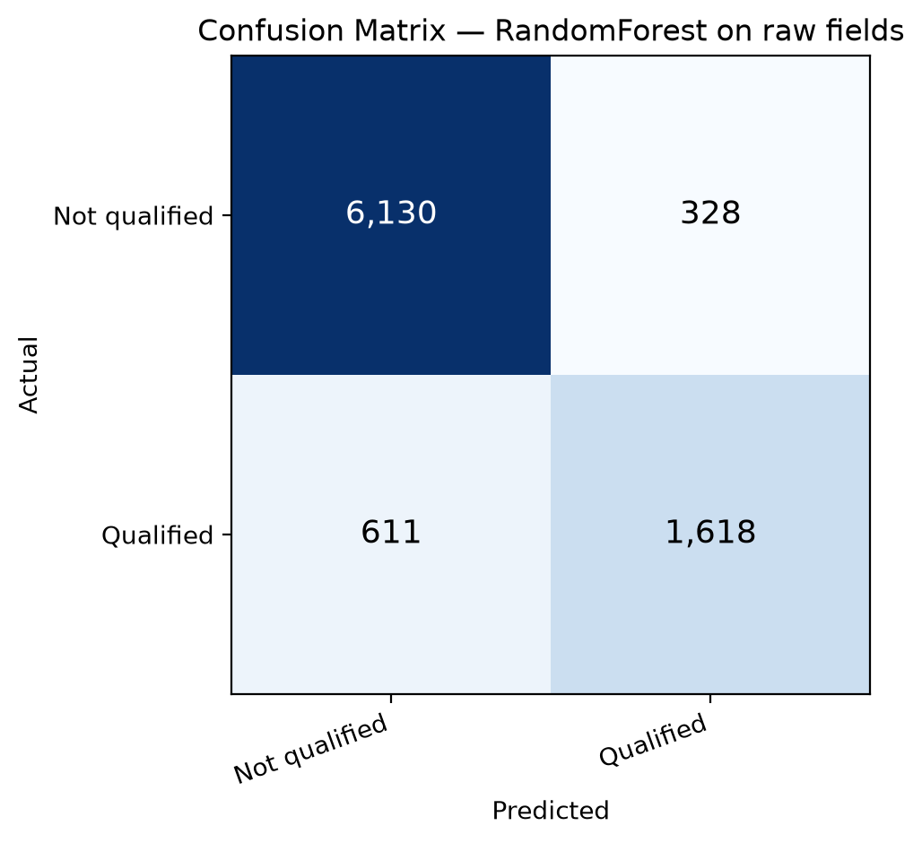
Figure 5. Confusion matrix of the Random Forest classifier trained on self-reported fields (Not qualified = negative class, Qualified = positive class).
Figure 6 summarizes the model’s performance. The model reached an accuracy of 89.2%, a precision of 83.1%, a recall of 72.6%, an F1-score of 77.5%, and a ROC-AUC of 95.4%. A precision of 83.1% means that about five of every six residents the model predicted as qualified actually passed the screen. A recall of 72.6% means the model missed more than one in four residents who truly passed. The ROC-AUC of 95.4% shows that the model still ranks residents well by their likelihood of passing, which suggests that a lower decision threshold than the default of 0.5 would recover more qualified residents, at the cost of more false positives.
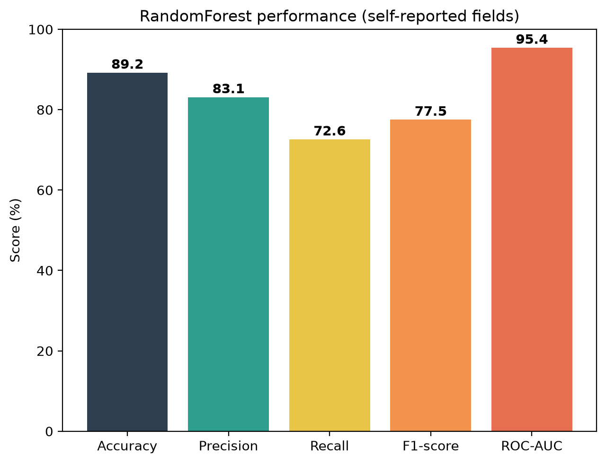
Figure 6. Model performance metrics (accuracy, precision, recall, F1-score, and ROC-AUC) of the Random Forest classifier on the test set.
The missed residents are not spread evenly across classes (Table 3). The model identified 95.8% of qualified Senior Citizens (1,170 of 1,221) but only 44.4% of qualified residents in the other classes combined, so 560 of the 611 false negatives are not Senior Citizens. Recall fell to 68.1% for Construction Workers, 48.2% for Solo Parents, 44.2% for PWDs, and 30.2% for Rice Farmers, and below 10% for Market Vendors (9.4%) and Tricycle Drivers (8.3%).
Table 3. Recall of the Random Forest classifier by beneficiary class (test set).
Beneficiary class | Qualified residents in test set | Correctly predicted | Recall
Senior Citizen | 1,221 | 1,170 | 95.8%
Construction Worker | 329 | 224 | 68.1%
Solo Parent | 199 | 96 | 48.2%
PWD | 172 | 76 | 44.2%
Rice Farmer | 116 | 35 | 30.2%
Market Vendor | 96 | 9 | 9.4%
Tricycle Driver | 96 | 8 | 8.3%
Total | 2,229 | 1,618 | 72.6%

Figure 7 helps explain this pattern. Self-reported age accounts for 76.3% of the model’s total feature importance, followed by the grant flag (10.0%) and the construction-worker occupation flag (5.8%); every other flag contributes 2.5% or less. Age is a strong signal because a single field decides membership in Senior Citizen, the largest class, and an error of a few years only matters near the age-60 boundary. The other classes depend on rare yes/no flags, which the simulated misreporting affects far more: only 2.4% of residents are PWD, so flipping 5% of the 42,396 non-PWD residents is expected to create about 2,100 false “Yes” flags, roughly twice the number of genuine PWD residents. The same effect, at an 8% error rate, weakens the occupation flags. The model therefore learned to rely on age and largely failed to recognize qualified residents whose class depends on these noisy flags.
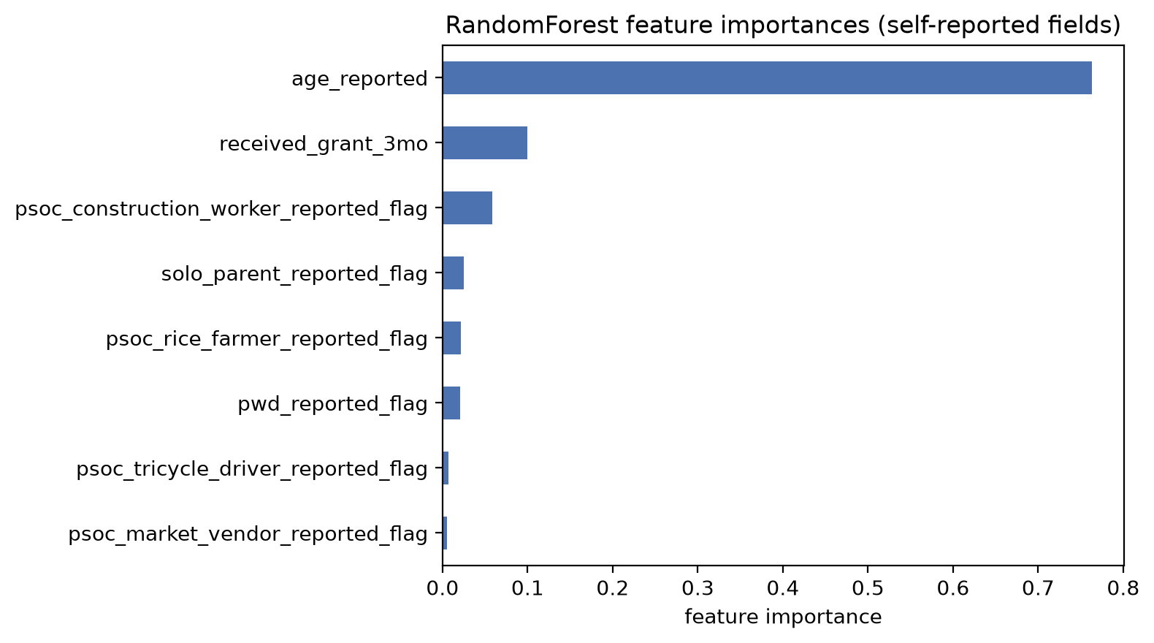
Figure 7. Random Forest feature importances for the model trained on self-reported fields (importances sum to 1).
In a social welfare screening setting, false negatives are the more serious error: each one is an eligible resident who would be screened out and might never reach a manual review, while a false positive only adds one applicant to that review. With a recall of 72.6% overall, and below 50% for PWDs, Solo Parents, Rice Farmers, Market Vendors, and Tricycle Drivers, the trained model is not suitable as a replacement for the rule-based algorithm. Eligibility should continue to be decided by the deterministic rule, which applies the class and grant conditions exactly; the Random Forest serves only as a test of how well those conditions can be recovered from imperfect, self-reported data.

Summary
The screening rule passed all 13 unit tests and was then applied to a registry of 43,435 residents from 47 barangays. Beneficiary classes derived from the registry fields covered 12,403 residents (28.6%), and 11,145 residents (25.7%) passed the class and simulated grant-history screen. Class membership decided the outcome for most residents: 31,032 (71.4%) did not belong to any recognized class, while the simulated grant flag blocked only 1,258 (2.9%).
A Random Forest classifier trained on self-reported fields with simulated reporting errors reproduced the screening outcome with 89.2% accuracy, 83.1% precision, 72.6% recall, a 77.5% F1-score, and a 95.4% ROC-AUC. Its errors were concentrated among residents whose class depends on rare yes/no fields: recall reached 95.8% for Senior Citizens but only 44.4% for the other classes combined. The rule-based algorithm therefore remains the appropriate method for eligibility decisions, and the model is useful only as a test of how well the screening outcome can be recovered from self-reported data.
These results are subject to the limits of the registry export. The recent-grant flag was simulated, so the grant-related results show how the algorithm behaves rather than actual grant history, and the household condition could not be applied because the registry has no household linkage. Lactating Mother could not be assessed because the registry has no maternity field. Replacing the simulated flag with the grant records already stored in the system would turn this test into an actual eligibility count for the registry.

