Testing and Evaluation of the Beneficiary Qualification Algorithm

Methodology
The qualification algorithm implemented in the system (the evaluate() function) determines a resident’s eligibility for assistance through three sequential conditions: (1) membership in one of eight recognized beneficiary classes (Solo Parent, PWD, Senior Citizen, Construction Worker, Rice Farmer, Market Vendor, Tricycle Driver, and Lactating Mother), (2) absence of any grant received within the preceding three months, and (3) a monthly household income below the threshold of Php 15,000.00. An applicant is classified as Qualified only if all three conditions are satisfied.
To test the algorithm at scale, it was applied to a citizen registry dataset of 43,435 residents across 47 barangays. Profiling the export showed that monthly_income — a required input to evaluate() — is 100% absent from every record, and no grant-history or household-linkage field exists either. Because monthly_income cannot be observed or reasonably simulated for a specific person without fabricating a result, this primary evaluation does not assign anyone an income value; a separate, clearly-labeled hypothetical extension of this methodology, described below, is the sole exception. Beneficiary class was instead derived directly from existing registry fields (PWD status, solo-parent status, age, and occupation), and, since recent-grant history is also absent, that single remaining input was simulated at a 10% incidence rate strictly to exercise the class and grant-history branches of the algorithm at realistic scale. Every resident was then screened on only those two branches; residents who pass both are reported as “Qualified (income unverified)” rather than a fabricated final decision, since the income branch of evaluate() was never run.
To evaluate how well a learned model could reproduce this two-factor screen under realistic data-collection conditions, a Random Forest classifier (scikit-learn RandomForestClassifier) was trained in two passes. First, as a sanity check, the model was given the exact features the screen uses (beneficiary class and the simulated grant flag); since the target is a noise-free deterministic function of those two inputs, near-perfect accuracy here is the expected, correct result rather than evidence of predictive skill. Second, and more informatively, the model was given only the raw registry fields a real intake form would collect — age, PWD status, solo-parent status, and occupation-keyword flags — each passed through a small simulated misreport rate (age distorted by random measurement error; PWD, solo-parent, and occupation flags each independently flipped with 5–8% probability) to imitate the self-reporting and transcription error typical of household surveys, while the label the model was trained to predict still came from the true, clean registry values. The dataset was split into training and test subsets using an 80/20 stratified split (random_state = 42, 34,748 training / 8,687 test records), and the classifier’s predictions on the held-out test set were compared against the true class-and-grant screening outcome using a confusion matrix, standard classification metrics, the Receiver Operating Characteristic (ROC) curve, and feature-importance ranking. No income feature was used at any point in this evaluation.
As a separate, clearly-labeled extension of this methodology, a hypothetical scenario was constructed to demonstrate the algorithm’s third condition, which the primary evaluation above could not exercise for any real resident. A random, reproducible sample of 1,556 residents (3.6% of the registry, random_state = 2024) was selected, and each was assigned a synthetic monthly-salary figure drawn from a log-normal distribution (mean Php 9,000, seeded for reproducibility) — not real income for any named person, and never written back to the registry export. With all three inputs available for this sample, the unmodified evaluate() function was run end-to-end, yielding a genuine Qualified / Not qualified outcome rather than the income-unverified placeholder used elsewhere. To test how well a learned model could recover that complete, three-branch outcome, a second RandomForestClassifier was trained on this same 1,556-person sample using only self-reported-style raw fields — age, PWD status, solo-parent status, occupation-keyword flags, the simulated grant flag, and a noisily self-reported version of the synthetic salary (distorted by a random measurement-error term of about 20%, following the same self-report simulation approach used above) — again using an 80/20 stratified split (random_state = 42).

Results and Discussion

Rule-Based Decision Tree
Figure 1 illustrates the complete, three-branch qualification algorithm as implemented in the system: class membership, recent-grant history, and the income threshold. It is generated programmatically from the same VALID_CLASSES and INCOME_THRESHOLD constants the system uses internally, so it can never drift out of sync with the implementation; showing the income branch here does not require any registry data, since the figure depicts the algorithm’s logic rather than any resident’s actual values. Only the class-membership and recent-grant branches could be exercised against the full registry in the section immediately below, for the reasons given above — the income branch shown here is exercised later, against the hypothetical 1,556-resident sample described in a later section.
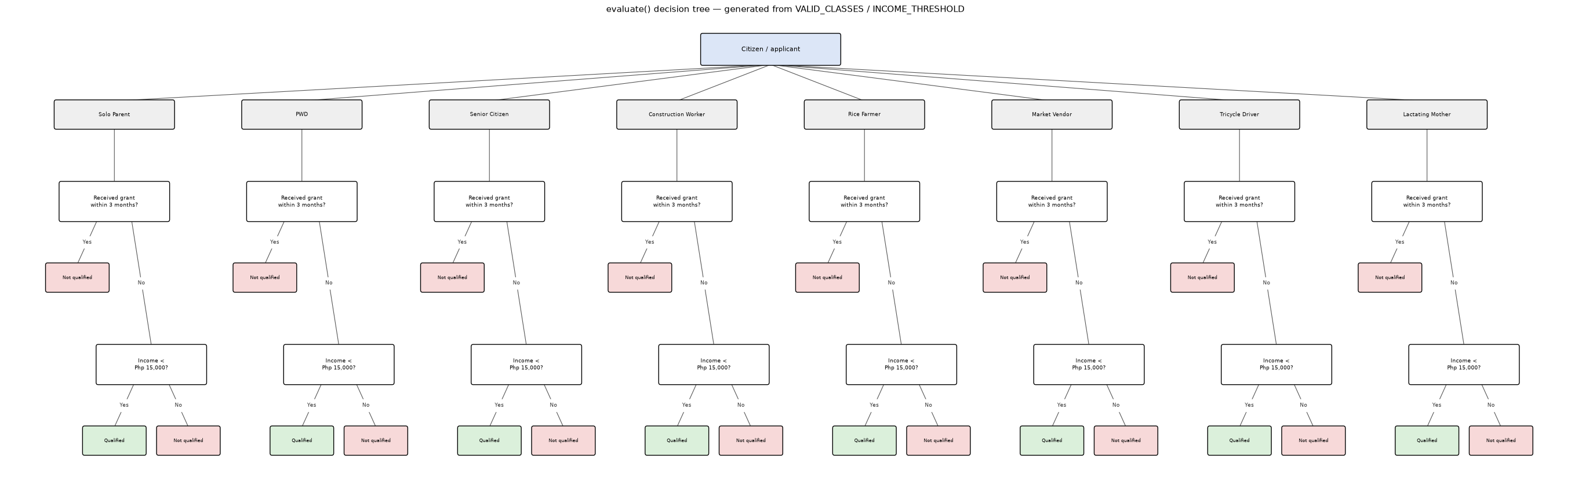
Figure 1. Decision tree of the complete qualification algorithm — class membership, recent-grant history, and the income threshold — generated programmatically from the system’s VALID_CLASSES and INCOME_THRESHOLD constants.

Class + Grant-History Screening Results
Screening all 43,435 registry residents on the class-membership and recent-grant branches alone — the only two evaluate() inputs available for this export — found that 31,032 residents (71.4%) do not belong to any recognized beneficiary class, 1,258 residents (2.9%) belong to a valid class but are blocked by the simulated recent-grant flag, and the remaining 11,145 residents (25.7%) pass both checks and are reported as “Qualified (income unverified).” None of these 11,145 residents can be confirmed as actually eligible without a genuine monthly-income source for this registry, since the income branch of evaluate() was never run against fabricated data.

RandomForest Performance Evaluation
The sanity-check pass, in which the model was given the exact beneficiary-class and grant-flag inputs used by the screen, reached 100% accuracy on the held-out test set, confirming that the target is fully recoverable when the model is handed the same information the rule uses — this is expected and is not, by itself, evidence that a learned model is a suitable substitute for evaluate().
The more informative pass — in which the model instead received only self-reported-style raw fields distorted by simulated misreport noise — reached an overall accuracy of 89.2% on the 8,687-record test set. Of the 6,458 residents truly screened as Not qualified, 6,130 were correctly classified as such, while 328 were incorrectly predicted as passing the screen (false positives). Of the 2,229 residents truly screened as Qualified (income unverified), 1,618 were correctly identified (true positives), while 611 were misclassified as Not qualified (false negatives).
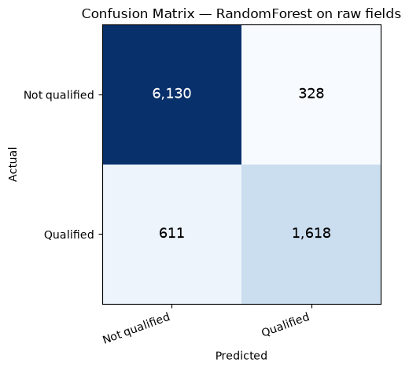
Figure 2. Confusion matrix of the Random Forest classifier, trained on self-reported-style fields with simulated misreport noise, evaluated against the true class + grant-history screening outcome (Not qualified = negative class, Qualified (income unverified) = positive class).
Figure 3 summarizes the classifier’s performance using five standard evaluation metrics together with its ROC curve. Precision for the Qualified class was 83.1%, meaning that of all residents the model predicted as passing the screen, 83.1% genuinely did under the true class-and-grant logic. Recall reached only 72.6%, indicating that more than a quarter of the residents who truly passed the screen were missed by the model, and the corresponding F1-score of 77.5% reflects that gap between precision and recall. The Area Under the ROC Curve (AUC) of 95.4% shows the model can still rank residents by likelihood of passing the screen reasonably well across thresholds, even though its default-threshold recall is comparatively weak.
In the context of a social welfare pre-screening application, this recall shortfall is the more consequential number: a false negative here corresponds to an otherwise-eligible household being filtered out before it would even reach the (still-required) income-verification step, whereas a false positive merely adds one extra applicant to that manual review. A recall of 72.6% therefore argues against using this surrogate model as a substitute for the real evaluate() screen; it is presented here strictly as a fidelity check on how well the class-and-grant rule can be approximated from noisy self-reported fields, not as a component suitable for production eligibility decisions.
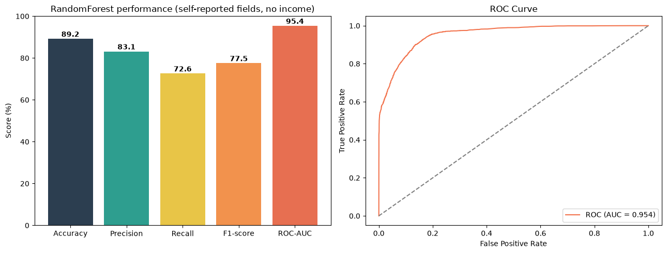
Figure 3. Model performance metrics (accuracy, precision, recall, F1-score, and ROC-AUC) and the corresponding ROC curve for the Random Forest classifier.
Figure 4 ranks the features by importance within the trained Random Forest. The (noisily) self-reported age field dominates, accounting for roughly 76% of total importance, considerably ahead of the simulated grant flag (10%) and the occupation-keyword flags (individually 1–6%). This is consistent with the underlying rule: age alone determines Senior Citizen membership, one of the largest beneficiary classes in this registry, so even a noisy age value carries most of the signal needed to approximate the class-membership branch, while the grant flag — despite being an exact, un-noised input — contributes comparatively less simply because it blocks a much smaller share of residents (2.9% of the full registry).
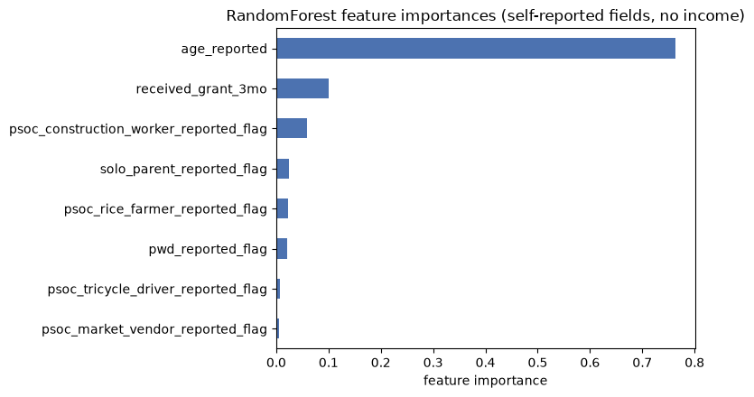
Figure 4. Random Forest feature importances for the self-reported-field model, with no income feature used.

Hypothetical Income-Inclusive Scenario
Because monthly_income does not exist anywhere in the registry export, the class-and-grant screening results above cannot be resolved into a final eligibility determination for any resident. To illustrate what the complete algorithm produces once income is available, the hypothetical 1,556-resident sample described in the Methodology was screened with the real, unmodified evaluate() function using its synthetic salary figures. Of the 1,556 residents in this sample, 396 (25.5%) had passed the class-and-grant screen as “Qualified (income unverified),” consistent with the registry-wide rate reported above; once the income branch was actually evaluated for them, 313 residents (20.1% of the sample) were confirmed Qualified and the remaining 83 were reclassified as Not qualified on income grounds. The other 1,160 residents in the sample had already been rejected on class membership or recent-grant history, so the income branch made no difference to their outcome, exactly as the decision tree in Figure 1 specifies. Figure 5 compares these two screenings side by side for the same 1,556 residents.
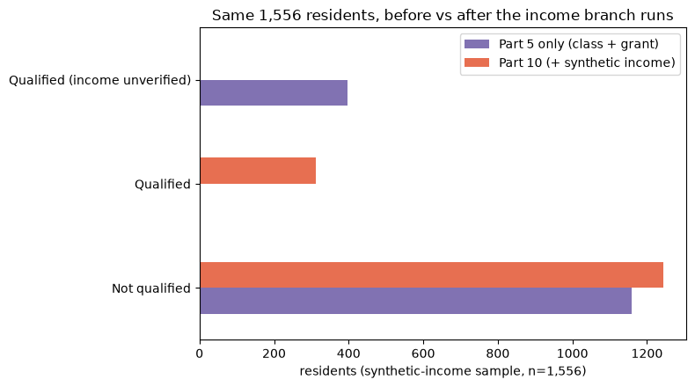
Figure 5. The same 1,556 residents, screened before (class and grant-history branches only) and after (all three branches, using synthetic salary) the income branch is exercised.

RandomForest Performance Evaluation With Synthetic Salary
The RandomForest methodology described above was repeated on this same 1,556-resident sample, now predicting the complete three-branch outcome (Qualified / Not qualified) rather than the two-branch screen, and with a noisily self-reported version of the synthetic salary added to the raw feature set. On a held-out test set (20% of the 1,556-person sample, stratified, random_state = 42), the classifier reached 89.1% accuracy, 85.4% precision, 55.6% recall, an F1-score of 67.3%, and a ROC-AUC of 94.7% (Figure 6, Figure 7). These figures are not directly comparable to the two-branch model reported above: this test uses a much smaller sample (1,556 versus 43,435 residents) against a strictly harder target, since a correct prediction here also requires recovering a noisy income signal rather than only class membership and grant history.
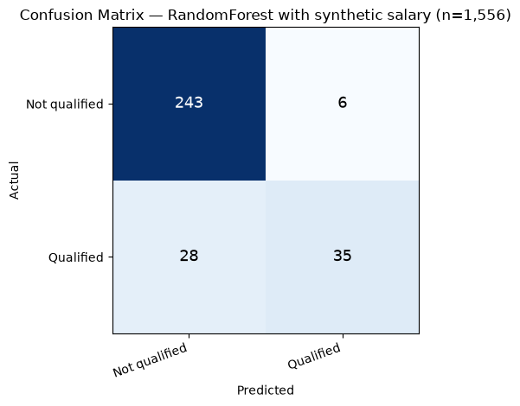
Figure 6. Confusion matrix of the Random Forest classifier, trained on self-reported fields including synthetic salary, evaluated against the true three-branch evaluate() outcome for the 1,556-resident sample.
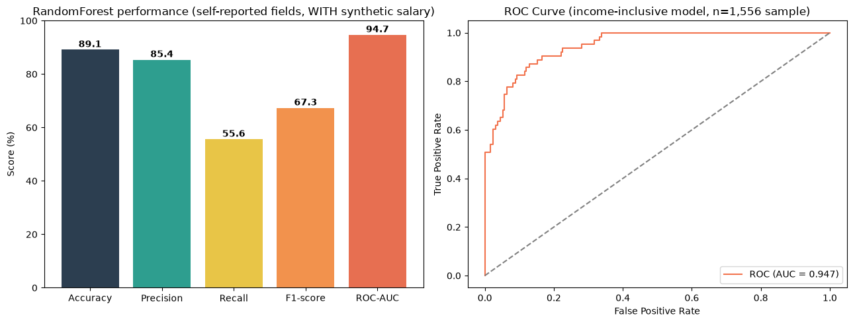
Figure 7. Model performance metrics (accuracy, precision, recall, F1-score, and ROC-AUC) and the corresponding ROC curve for the salary-inclusive Random Forest classifier.
Figure 8 ranks feature importances for this model: the (noisily) self-reported age field again dominates at 57.4% of total importance, but the self-reported salary field is now the second-largest contributor at 19.4% — ahead of grant history (8.5%) and every occupation-keyword flag (individually 1.0–5.2%) — consistent with income directly gating the algorithm’s third branch.
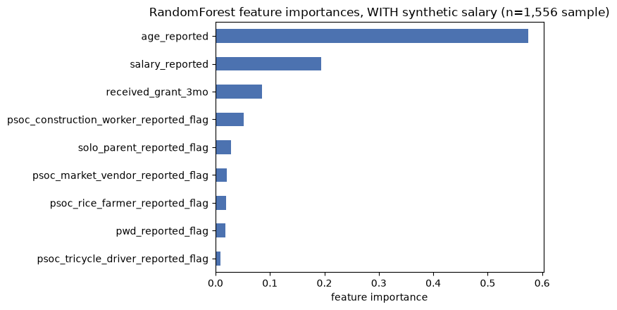
Figure 8. Random Forest feature importances for the self-reported-field model, with synthetic salary included.

Summary
Because the citizen registry export used for this testing exercise contains no monthly-income or grant-history data, this evaluation deliberately stopped short of fabricating an income figure for any resident: the rule-based evaluate() function was screened only as far as beneficiary-class membership and (simulated) recent-grant status, and 25.7% of the registry (11,145 residents) passes that partial screen with income left explicitly unverified. A Random Forest classifier trained on realistic self-reported fields (no income, no pre-computed class label) reproduces that class-and-grant outcome with 89.2% accuracy but only 72.6% recall, a gap significant enough that it should not be used as a substitute for the real screen in an eligibility-determination workflow. The system itself continues to apply the exact, deterministic evaluate() function — rather than a trained model — to render actual eligibility decisions; the classifier evaluated here is a surrogate used strictly for testing purposes. Before this registry export can support a genuine eligibility determination, it will need to be joined against an actual income source and the grant-history records already used elsewhere in the system.
A separate, clearly-labeled hypothetical extension illustrates what the complete algorithm produces once income is available: applying evaluate() end-to-end to a synthetic-salary sample of 1,556 residents resolved 313 of them (20.1% of the sample) to a genuine Qualified outcome and reclassified 83 from income-unverified to Not qualified, while leaving the remaining 41,879 registry residents — and every result reported above — untouched. A RandomForestClassifier trained on that same sample, with a noisily self-reported version of the synthetic salary added to its features, reached 89.1% accuracy but only 55.6% recall at recovering the full three-branch decision, with the salary field ranking as the second most important input behind self-reported age. As with the class-and-grant model above, this classifier remains a surrogate used strictly for testing purposes; the synthetic salary is not real income for any named resident and is never written back to the registry export, and — like the rest of this registry export — a genuine eligibility determination still requires joining against an actual income source.

