BAGNOS
MULTI-PURPOSE COOPERATIVE

System User Manual
Point-of-Sale · Inventory · Members · Loans · Savings · Share Capital · Palay Trade
A complete, step-by-step guide for cashiers, staff, and administrators
Version 2.0
Issued: August 2026

Table of Contents
Table of Contents 2
1. Introduction 5
1.1 What the system does 5
1.2 Modules at a glance 5
1.3 User roles 5
2. Getting Started — Logging In 7
2.1 Sign in with an RFID card 7
2.2 Sign in manually (username & password) 7
2.3 Where you land after login 8
3. The Dashboard (Command Center) 9
3.1 Reading the dashboard 9
3.2 The navigation menu 10
3.3 Generating the daily report 13
4. Kiosk Self-Checkout (Point of Sale) 14
4.1 Ringing up a sale step by step 14
4.2 Browsing the product catalogue 15
4.3 Payment methods explained 15
4.4 Kiosk settings 16
4.5 Sale unit options 16
5. Inventory Management 17
5.1 What you can see 17
5.2 Adding a new product 18
5.3 Editing a product 18
5.4 Searching and filtering 18
5.5 Recording giveaways 18
5.6 Sending stock alerts by email 18
5.7 Exporting and printing 18
5.8 Product categories 19
5.9 Discounts dashboard 19
6. Member Management 20
6.1 Member list overview 20
6.2 Adding a new member 21
6.3 Editing a member 21
6.4 Refilling an RFID card balance 21
6.5 Managing credit (utang) 21
6.6 Member types 22
6.7 Backup and restore member data 22
6.8 Bulk import and export 22
7. Transactions & Receipts 23
7.1 View tabs 23
7.2 Searching and filtering 24
7.3 Viewing a transaction 24
7.4 Managing a transaction (Admin only) 24
7.5 Receipt types 24
7.6 Exporting transactions 24
8. Refunds & Returns 25
8.1 How to process a refund 25
8.2 Viewing refund requests 25
8.3 Return window 26
9. Loans — Cooperative Credit Workflow 27
9.1 Loan KPI cards 27
9.2 The 13-step loan pipeline 28
9.3 Key loan screens 28
9.4 Loan settings explained 34
9.5 Disbursement 34
9.6 Recording loan repayments 35
10. Savings 37
10.1 Savings KPI cards 37
10.2 Opening a savings account 37
10.3 Savings account detail 38
10.4 Deposits and withdrawals step by step 39
10.5 Interest calculation and export 40
10.6 Savings products 40
11. Share Capital 42
11.1 Share capital KPI cards 42
11.2 Recording a contribution 42
11.3 Viewing a member's capital detail 43
11.4 Share capital products 44
12. Palay Trade 46
12.1 Palay overview indicators 46
12.2 Recording a trade 47
12.3 Palay products and varieties 47
12.3 Palay trade detail 48
12.4 Palay products and varieties 49
12.5 Palay credit desk (utang) 50
12.6 Palay credit overview 51
12.7 Palay credit settings 52
12.8 Exporting palay reports 53
13. Staff Sales Report 54
13.1 Reading the report 54
13.2 Drilling into a staff member's sales 54
14. Member Self-Service 56
14.1 RFID gate 56
14.2 Member self-service hub 56
14.3 My Transactions 57
14.4 My Savings 58
14.5 My Loans 60
14.6 Requesting a loan (member-initiated inquiry) 62
14.7 My Palay 63
15. Audit Trail & Security 65
15.1 Security counters 65
15.2 Using the filter bar 65
15.3 Reading audit records 66
16. Reports & Exports 67
16.1 Daily sales report (Generate Report) 67
16.2 Staff sales report 67
16.3 Inventory reports 67
16.4 Transaction reports 67
16.5 Member reports 67
16.6 Cooperative financial reports 67
17. Everyday Tips & Troubleshooting 69
17.1 Best practices for cashiers 69
17.2 Best practices for administrators 69
17.3 Troubleshooting 69
17.4 Glossary 69

1. Introduction
This manual explains every feature and function of the BAGNOS Multi-Purpose Cooperative management system — an all-in-one platform that runs the cooperative store, tracks members, and manages the cooperative's financial services. Every screen shown in this guide is captured directly from the live system so you can match what you see on your own monitor.

1.1 What the system does
- Store & self-checkout (Kiosk): scan or search products, attach a member, and take payment by cash, member account (debit), or credit (utang).
- Admin dashboard: a single "Command Center" showing real-time sales, transactions, inventory alerts, and refunds with live charts.
- Inventory: manage products, prices, stock levels, categories, discounts, giveaways, barcodes, and purchase history.
- Members: register members, manage RFID cards, card balances, credit limits, and unpaid credit (utang).
- Transactions & refunds: review every sale, reprint receipts, manage/void items, and process refunds or returns.
- Cooperative services: Loans (13-step credit workflow), Savings accounts, Share Capital contributions, and Palay (rice) trading.
- Reports & audit trail: daily sales reports, staff performance reports, inventory exports, and a complete log of all system activity.
- Member self-service: members log in via RFID to view their own transactions, savings, loans, and palay records.

1.2 Modules at a glance
Module | What you use it for | Who uses it most
Kiosk / POS | Ring up sales, take payment, print receipts | Cashier, Members
Dashboard | Monitor sales & business health | Admin, Manager
Inventory | Products, stock, prices, discounts, barcodes | Admin, Staff
Members | Member records, RFID cards, credit, balance | Admin, Cashier
Transactions | Sales history, receipts, manage/void | Admin, Cashier
Refunds | Returns and money-back processing | Admin, Cashier
Loans | Member loan applications & payments | Loan Officer, Committee
Savings | Member savings accounts & interest | Admin, Staff
Share Capital | Member share contributions | Admin, Staff
Palay Trade | Buying/selling rice (palay) and credit | Admin, Staff
Staff Sales | Per-cashier performance reports | Admin, Manager
Audit Trail | Security & activity log | Admin
Member Self-Service | Members view own records | Member

1.3 User roles
What you can see and do depends on your role. When you log in the system shows a coloured role badge so you always know your access level.
Role |  | Typical access
Administrator |  | Full access to every module, settings, and reports.
Cashier |  | Kiosk checkout, members, transactions, and refunds.
Staff |  | Day-to-day operations such as inventory and coop services.
Loan Officer |  | The loan pipeline — inquiries, applications, disbursement.
Committee |  | Reviews and approves or rejects loan applications.
Member |  | Self-service: view own transactions, savings, and loans.
 | Note Screens and buttons that your role cannot access are hidden automatically. If a menu item is missing, it usually means your account does not have permission — ask an administrator.

2. Getting Started — Logging In
The login screen is the first page everyone sees. There are two ways to sign in: tapping an RFID card, or typing a username and password. The system automatically takes you to the correct screen for your role.

2.1 Sign in with an RFID card
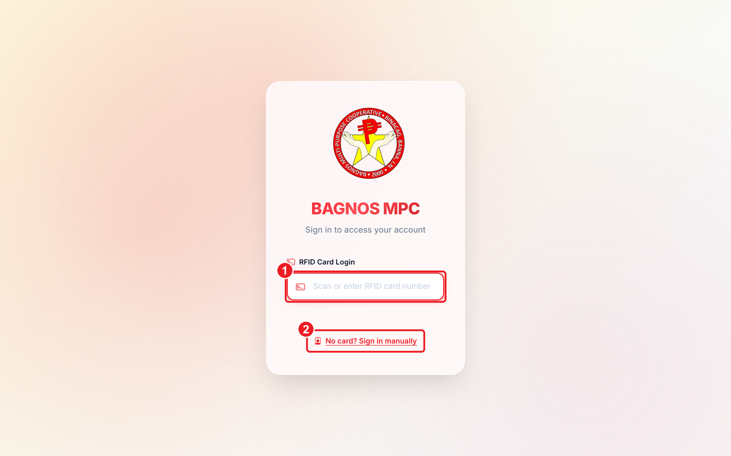
Login screen — tap or scan your RFID card to sign in instantly.
What's on this screen
① RFID login box — Tap your RFID card on the reader (or type the card number) to sign in instantly.
② Manual sign-in link — No card? Click here to show the username and password fields.

- Place your RFID card on the card reader attached to the computer (or type the card number in the box).
- The system reads the card number and signs you in automatically — no password needed.
- You are taken to the screen that matches your role (dashboard for staff, self-service hub for members).

2.2 Sign in manually (username & password)
If you do not have a card, or your card is lost, click "No card? Sign in manually" to reveal the login fields.
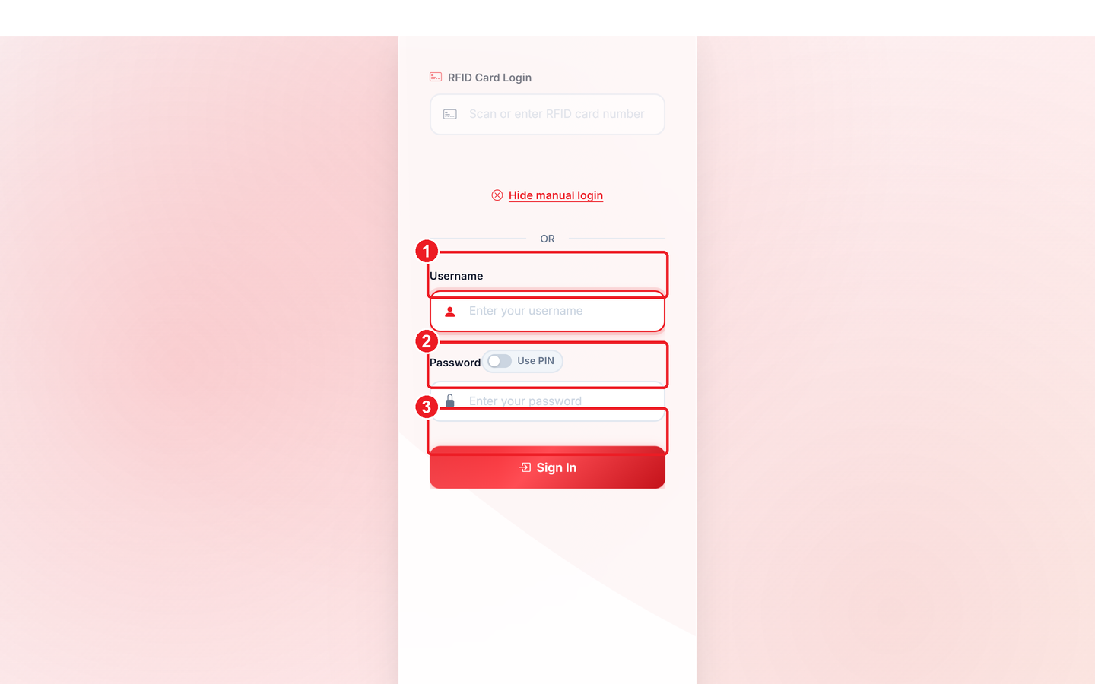
Manual sign-in — enter your username and password, then click Sign In.
What's on this screen
① Username field — Type the username given to you by the administrator.
② Password field — Type your password — keep it secret.
③ Sign In button — Click to log in; you are taken to the screen for your role.

- Click the "No card? Sign in manually" link below the RFID box.
- Type your username in the first box and your password in the second.
- Click the Sign In button. Wrong credentials show an error — check for typos.

2.3 Where you land after login
If you are a… |  | You are taken to…
Administrator or Cashier |  | The Dashboard (Command Center)
Loan Officer / Committee |  | The Loan desk overview
Member |  | Your self-service hub (transactions, savings, loans, palay)
 | Note Always log out when you leave the counter. Click the red Logout button so the next person cannot use your account.

3. The Dashboard (Command Center)
The Dashboard is the home screen for administrators and cashiers. It gives a live picture of how the cooperative store is performing and is the launch pad for every other module.
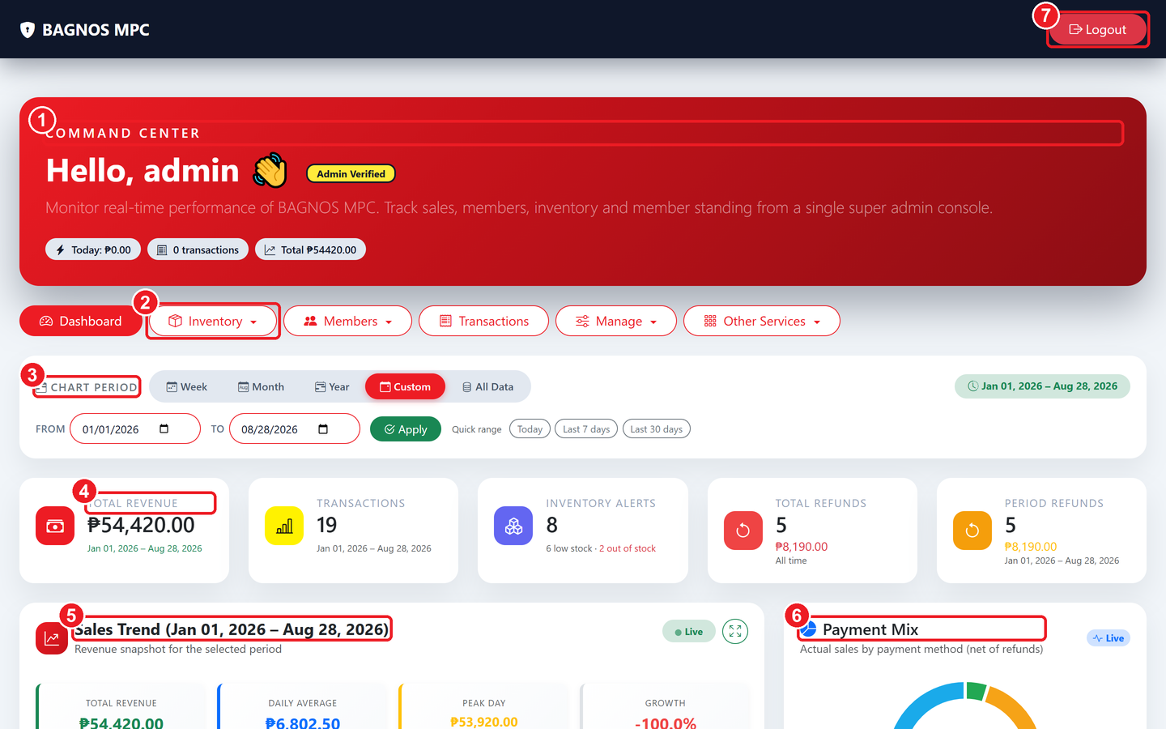
The Command Center — greeting, navigation menu, date filter, KPI cards, and live charts.
What's on this screen
① Command Center banner — Greets you by name, shows your role badge, today's sales, transaction count, and the all-time total.
② Navigation menu — The main menu — Dashboard, Inventory, Members, Transactions, Manage, and Other Services.
③ Chart Period filter — Choose Week, Month, Year, Custom or All Data; every number below follows this date range.
④ KPI cards — Quick totals — revenue, transactions, inventory alerts, and refunds for the selected period.
⑤ Sales Trend chart — Live revenue graph with daily average, peak day, and growth.
⑥ Payment Mix chart — Shows how much was paid by cash, member account (debit), and credit.
⑦ Logout — Always sign out here when leaving the counter.

3.1 Reading the dashboard
- Command Center banner: greets you by name, shows your role badge, and displays today's sales total, transaction count, and all-time grand total.
- KPI cards: Total Revenue, Total Transactions, Inventory Alerts (low/out of stock), Total Refunds, and Period Refunds — all update as you change the date range.
- Chart Period filter: choose Week, Month, Year, Custom, or All Data. For Custom: pick From/To dates and click Apply; use Today / Last 7 days / Last 30 days quick buttons.
- Sales Trend chart: a live revenue graph with running total, daily average, peak day, and growth percentage.
- Payment Mix chart: a doughnut chart showing the share of cash, member account (debit), and credit payments.

3.2 The navigation menu
The row of red buttons below the banner is the main menu. Four of the buttons open drop-down panels. Hover or click to expand.

Inventory drop-down
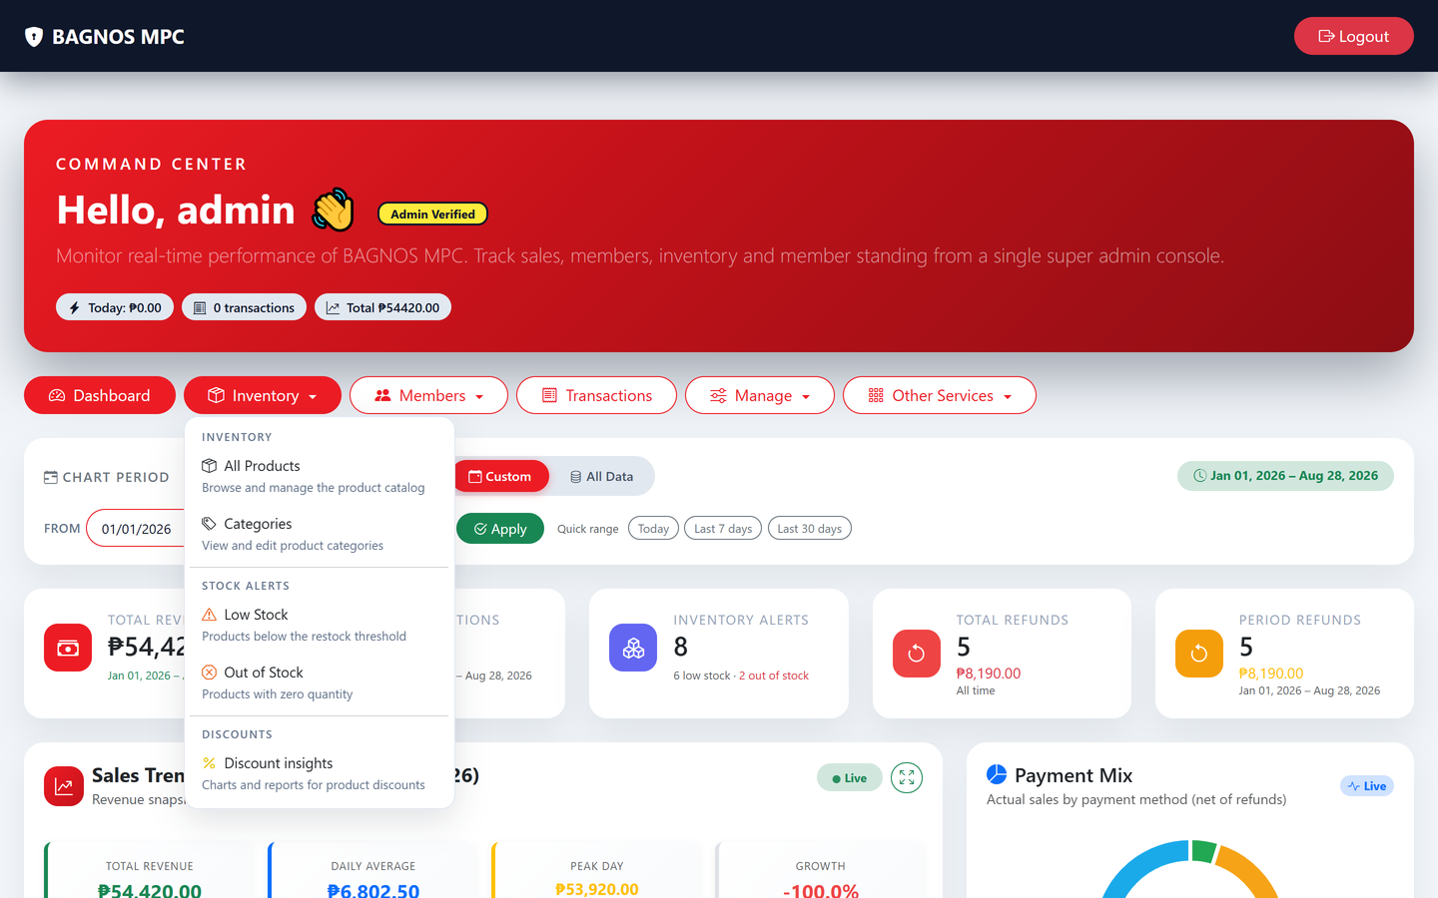
Inventory menu — products, low-stock shortcuts, categories, and the discount dashboard.
- Product Catalogue — opens the full inventory list.
- Low Stock — filters to only items at or below the reorder threshold.
- Out of Stock — filters to items with zero stock.
- Categories — manage the product category list.
- Discount Dashboard — set and review manual discounts and segment pricing.

Members drop-down
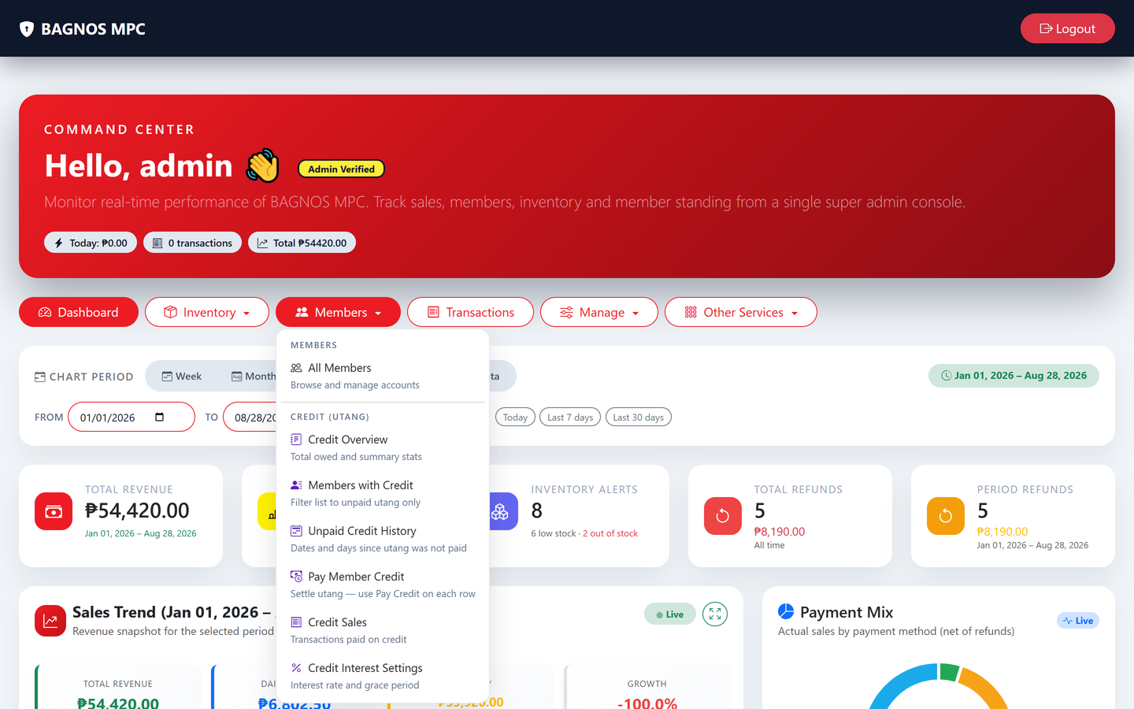
Members menu — member list, credit summary, unpaid-credit history, and refill balance.
- Member List — opens the full member management page.
- Credit Summary — jump straight to the outstanding utang overview.
- Unpaid Credit History — full history of all unpaid credit by member.
- Refill Card Balance — top up a member's RFID card balance.

Manage drop-down
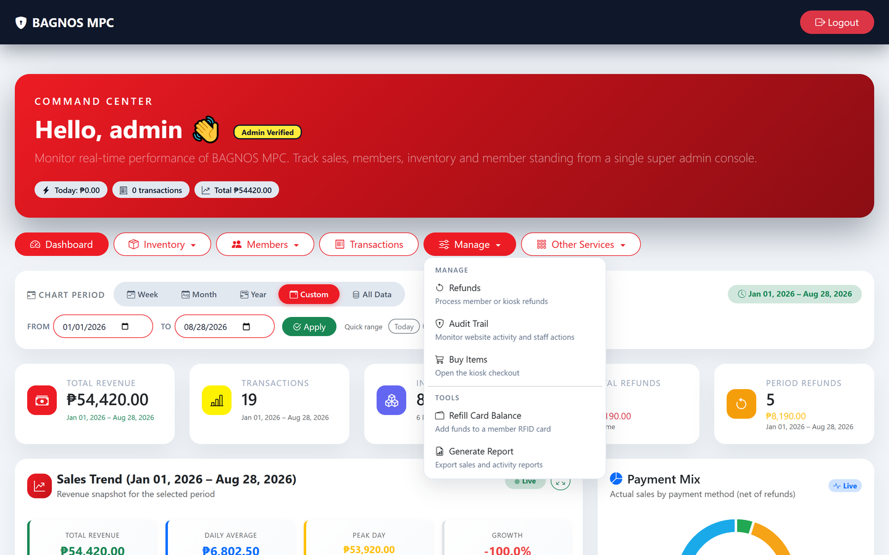
Manage menu — refunds, audit trail, kiosk, balance refill, and report generator.
- Process Refund — go to the refund desk for a sale return.
- Audit Trail — view the full security and activity log.
- Buy Items (Kiosk) — open the point-of-sale kiosk checkout.
- Refill Card Balance — add funds to a member's RFID card.
- Generate Report — produce and download a daily sales PDF report.

Other Services drop-down
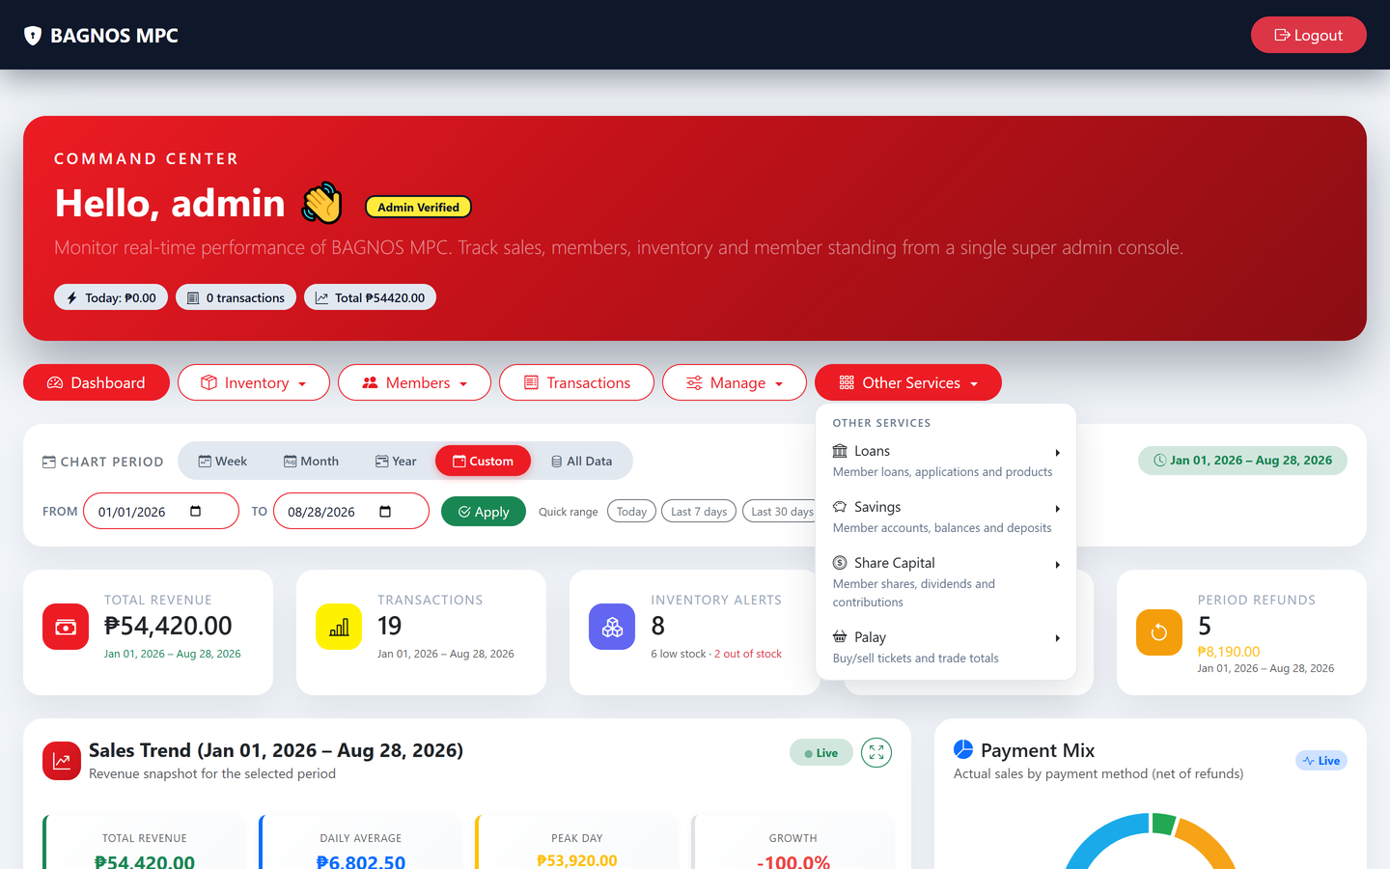
Other Services menu — the cooperative financial modules: Loans, Savings, Share Capital, and Palay.
- Loans — the 13-step cooperative credit workflow.
- Savings — member savings accounts, deposits, and interest.
- Share Capital — member ownership contributions.
- Palay Trade — rice buying, selling, and credit desk.

3.3 Generating the daily report
From the Manage menu, click Generate Report to produce a full-day PDF summary. The report is also sent automatically by email each morning if that setting is enabled by the administrator.
Tip The daily report covers total sales, payment breakdown, refunds, top products, and per-staff summaries. Keep a copy for your cooperative's accounting records.

4. Kiosk Self-Checkout (Point of Sale)
The Kiosk is where every sale happens. A cashier scans items, optionally attaches a member for credit or discounts, chooses a payment method, and completes the sale. Members with self-checkout access can also use this screen directly.
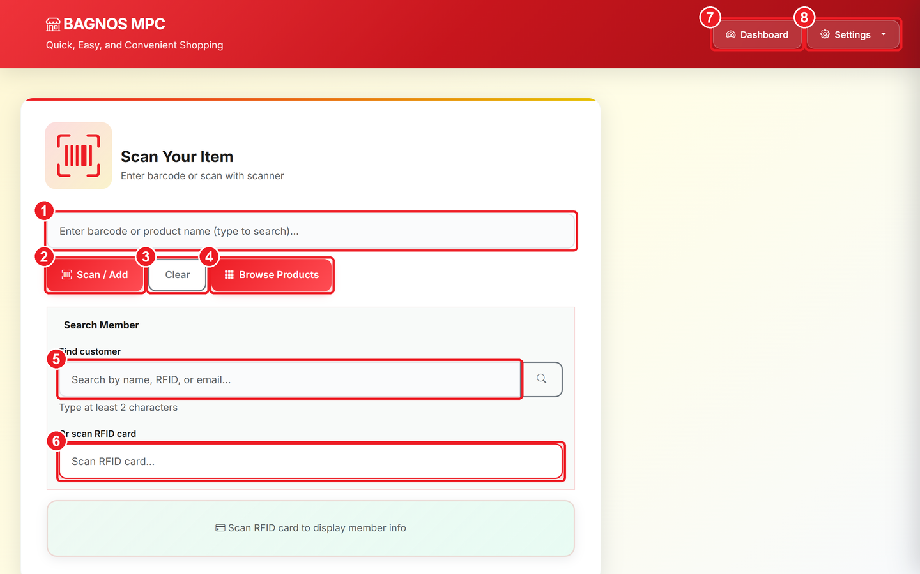
Kiosk checkout — scan products, find a member, choose payment, and ring up the sale.
What's on this screen
① Product search box — Type a product name or barcode here, or scan an item with the barcode scanner.
② Scan / Add button — Adds the scanned or typed product to the cart.
③ Clear button — Empties the input box so you can start again.
④ Browse Products — Opens the visual product catalogue to pick items by category.
⑤ Member search — Find a member by name, RFID number, or email to attach them to the sale.
⑥ RFID scan box — Tap the member's RFID card here — their account is attached instantly.
⑦ Dashboard shortcut — Returns staff to the admin dashboard.
⑧ Settings menu — Kiosk options such as tax settings and printing.

4.1 Ringing up a sale step by step
- Scan or type — scan a barcode with the handheld scanner, or type the product name/barcode in the search box and click Scan / Add. The item is added to the cart on the right.
- Adjust quantity — in the cart, use the + and − buttons to change the quantity, or type directly in the quantity field. Click the bin icon to remove an item.
- Browse by category — click Browse Products to open the visual catalogue and pick items by category without a barcode.
- Attach a member (optional) — search by name, RFID number, or email in the Member search box, or tap the member's RFID card on the "Scan RFID card" reader. Attaching a member enables discounts, debit payment, and credit (utang).
- Choose payment method — Cash (walk-in or card-holding member), Debit (from RFID balance), or Credit/Utang (on account, within the member's credit limit).
- Complete the sale — confirm the total and click the payment button. The system records the sale and prompts to print a receipt.
- Print receipt — a thermal receipt prints automatically if a printer is connected. You can also reprint from the Transactions page later.

4.2 Browsing the product catalogue
The Browse Products screen shows every available product grouped by category, making it easy to find items when a barcode is missing or for new staff still learning the inventory.
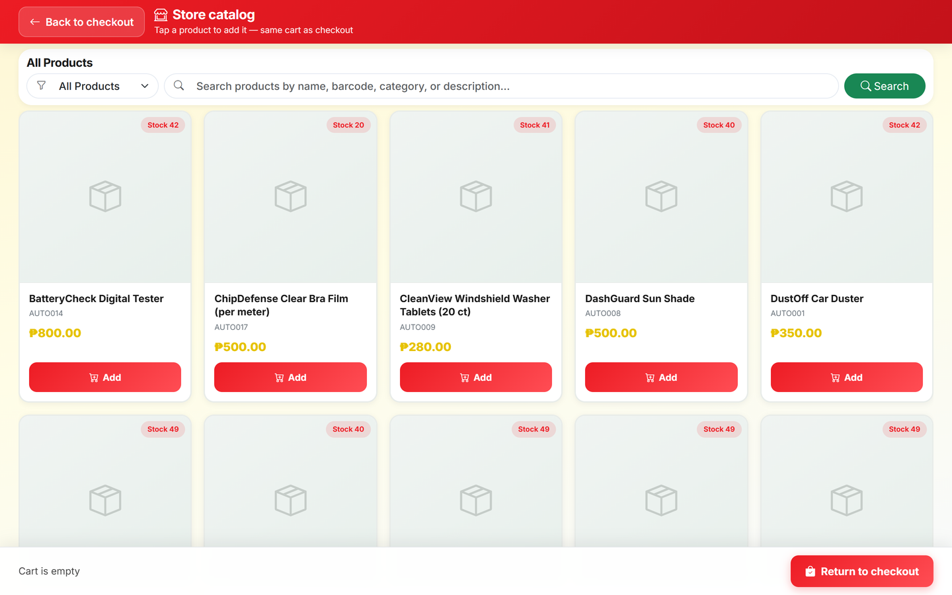
Browse Products — pick items visually by category instead of scanning a barcode.

4.3 Payment methods explained
Method |  | How it works | Requirement
Cash |  | Customer pays in cash; enter the amount and the system shows change. | No member needed
Debit (Member Account) |  | Deducted from the member's pre-loaded RFID card balance. | Member must be attached + have enough balance
Credit (Utang) |  | Charged to the member's credit account to pay later. | Member must be attached + have credit limit set
 | Note Credit (utang) and debit payment are only available after a member is attached. A member's credit limit is set in the Members module by an administrator.

4.4 Kiosk settings
Click the Settings button (gear icon) on the kiosk to access operational options.
- Tax toggle: enable or disable VAT on sales. When enabled, the tax amount is shown separately on the receipt and included in the cart total.
- Tax rate: set the tax percentage (e.g., 12%) applied to taxable items.
- Printer settings: configure thermal receipt printer port and paper size.

4.5 Sale unit options
Some products are sold in multiple units — for example, rice can be sold per kilo or per sack. When a product has multiple sale units, a selection prompt appears when the item is added to the cart.

5. Inventory Management
The Inventory module is the central record of everything the cooperative sells. It manages product details, prices, stock levels, purchase history, categories, discounts, giveaways, and barcodes.
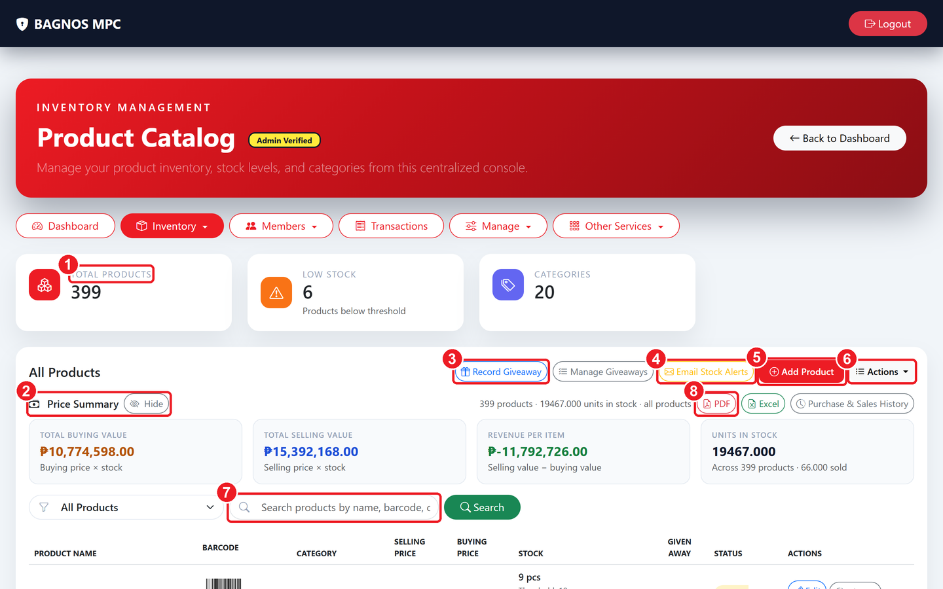
Inventory — product totals, price summary, search/filter, and the full product list.
What's on this screen
① Summary cards — Total products, low-stock count, and number of categories.
② Price Summary — Total buying value, selling value, projected revenue, and units in stock.
③ Record Giveaway — Log items given away free so stock stays accurate.
④ Email Stock Alerts — Send a low-stock / out-of-stock alert email to staff.
⑤ Add Product — Create a new product — name, barcode, prices, category, and opening stock.
⑥ Actions menu — Bulk tools — import/export, print barcodes, and more.
⑦ Search & filter — Find a product by name, barcode or category; the drop-down filters low/out-of-stock.
⑧ Export buttons — Download the price report as PDF or Excel, or open Purchase & Sales History.

5.1 What you can see
- Summary cards: Total Products, Low Stock count (at or below the reorder threshold), and number of Categories.
- Price Summary panel: total buying value of stock on hand, total selling value, projected revenue (selling minus buying), and total units.
- Product list: each row shows product name, barcode, category, selling price, buying price, stock quantity, given-away count, and status (Active / Inactive).

5.2 Adding a new product
- Click Add Product (top right of the inventory page).
- Enter the product name, category, and description.
- Enter the buying price (cost) and selling price (retail). The system can auto-generate a barcode, or you can enter one manually.
- Set the opening stock quantity and the reorder / low-stock threshold.
- If the product is sold in multiple units (e.g., kilo and sack), add each sale unit with its own conversion and price.
- Click Save. The product appears in the list immediately.

5.3 Editing a product
- Find the product in the list (use the search box or filters).
- Click Edit on the product's row.
- Change the fields you need — price, stock, category, status, or name.
- Click Save. Changes take effect immediately on the kiosk.

5.4 Searching and filtering
- Search box: type a product name, barcode, or category. The list filters as you type.
- All Products drop-down: switch to Low Stock Only or Out of Stock Only to focus on items needing attention.
- Category filter: narrow the list to a single category.

5.5 Recording giveaways
Products given away free (samples, spoilage, promotions) must be logged so stock figures stay accurate.
- Click Record Giveaway.
- Search for the product, enter the quantity given away, and add an optional note (e.g., "community event").
- Click Save. The given-away count increases on the product row and stock decreases by the same amount.
- To view or edit past giveaways, click the given-away count on any product row to open its giveaway history.

5.6 Sending stock alerts by email
Click Email Stock Alerts to immediately send an email to all configured staff addresses listing every product that is low or out of stock. This is in addition to the dashboard alert badge.

5.7 Exporting and printing
- Price report (PDF or Excel): a complete price and stock report — click the PDF or Excel icon at the top of the inventory page.
- Purchase & Sales History: opens a detailed ledger of every stock purchase and sale event, exportable to Excel.
- Per-product purchase history: click the history icon on a product row to see its buying-price history and stock changes.
- Barcode sheet: click Actions ▸ Download Barcodes to generate a printable PDF sheet of all product barcodes.
- Bulk import/export: use Actions ▸ Import Products (CSV/Excel) or Export Products to move data in bulk.

5.8 Product categories
Categories group products (e.g., Beverages, Rice & Grains, Canned Goods). Open the Inventory menu and click Categories to add, rename, or deactivate a category.
Tip Keeping products in correct categories helps the Browse Products screen on the kiosk stay organised for cashiers and members.

5.9 Discounts dashboard
The Discounts dashboard (Inventory menu ▸ Discount Dashboard) manages all pricing rules that reduce the standard selling price.
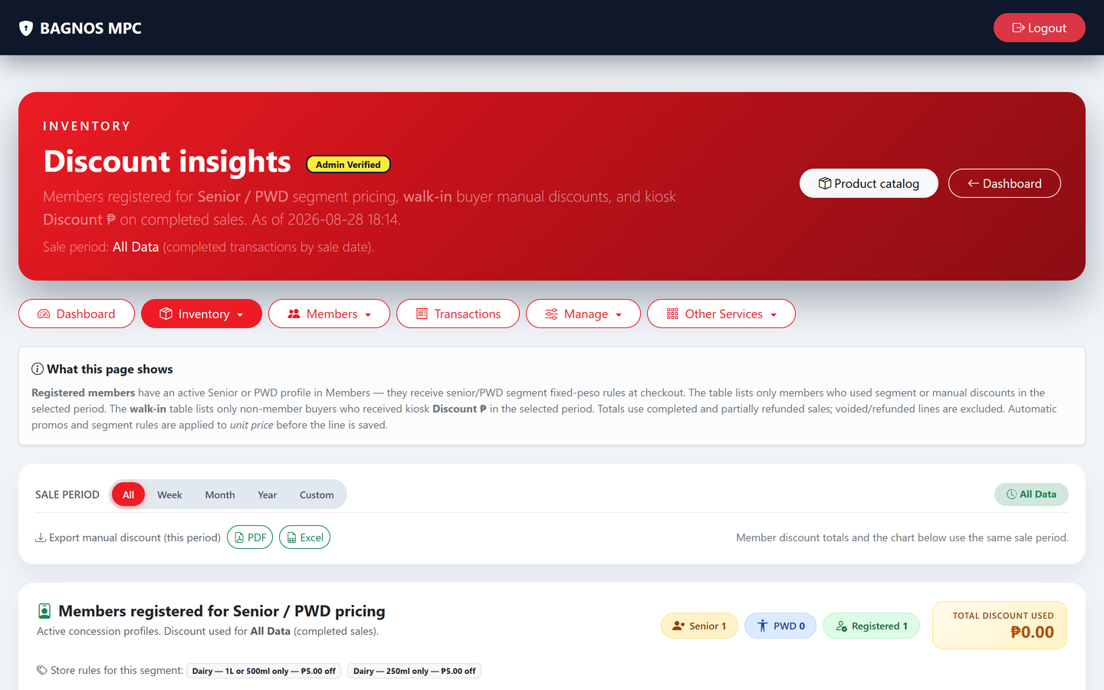
Inventory Discounts dashboard — manual discounts, discount groups, and member-segment pricing.
- Manual discount periods: set a temporary percentage or flat discount on any product for a specific date range (e.g., Christmas sale).
- Discount groups: create named groups of products that share the same discount rule.
- Member-segment discounts: set different prices for senior citizens, PWD members, or other member segments — discounts are applied automatically at checkout when the member is attached.
- Export discount report: download a history of all applied discounts for accounting.

6. Member Management
Members are the heart of the cooperative. This module stores member records, manages RFID cards, card balances, credit (utang) limits, and member types. Every financial benefit — discounts, credit, debit payments — flows through the member record.
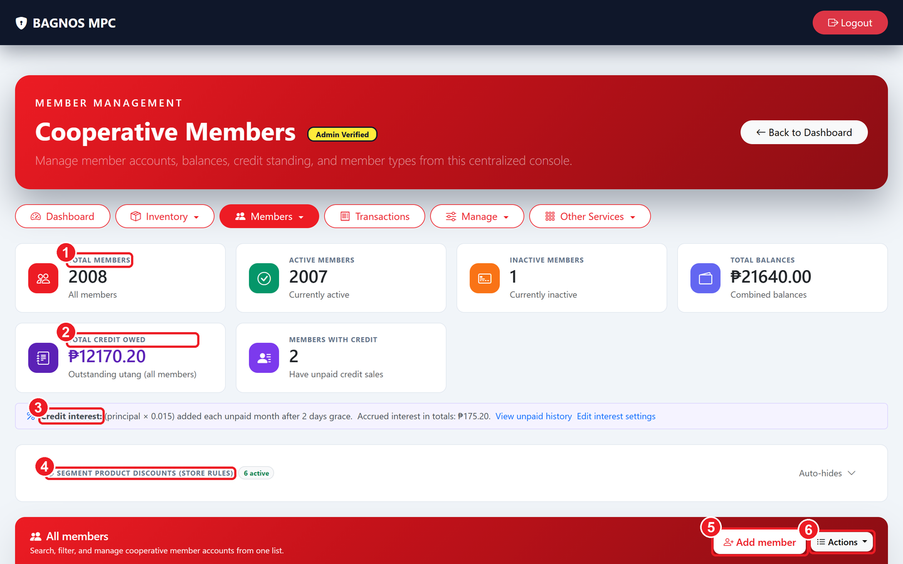
Member Management — member list with balances, credit totals, discount rules, and search.
What's on this screen
① Member summary cards — Totals for members, active/inactive, and combined card balances.
② Credit summary — Outstanding utang across all members and how many members owe.
③ Credit interest rule — Shows the interest formula applied to unpaid credit, with links to history and settings.
④ Store discount rules — Discount rules for member segments (seniors, PWD, etc.).
⑤ Add member — Register a new cooperative member and issue their RFID card.
⑥ Actions menu — Bulk member tools — import, export, and backups.

6.1 Member list overview
- Summary cards: Total Members, Active, Inactive, and combined card balances across all members.
- Credit summary: total outstanding utang (credit owed), number of members with unpaid credit, credit interest rule, and links to credit history and settings.
- Segment discount rules: a quick view of the discount percentages applied for member segments (seniors, PWD, etc.).
- Member rows: each row shows name, RFID card status, card balance, credit owed, member type, and status (Active/Inactive).

6.2 Adding a new member
- Click Add Member.
- Fill in the member's full name, birthday, address, and contact number.
- Assign a member type (Regular, Senior Citizen, PWD, etc.).
- Enter or scan the RFID card number — the card is linked to the member's account.
- Set the credit limit (how much utang the member may have at one time). Leave at 0 to disable credit.
- Click Save. The system auto-generates a username the member can use for self-service login.

6.3 Editing a member
- Find the member in the list (search by name, RFID, or email).
- Click Edit on the member's row.
- Update the details you need — the system keeps a full edit history so any change can be reviewed or reversed.
- Click Save.
Note Editing a member requires an administrator PIN for sensitive changes such as credit limit or RFID card number, protecting against accidental or unauthorised changes.

6.4 Refilling an RFID card balance
A card balance is the pre-paid amount a member loads onto their RFID card to use for debit payment at checkout.
- Open the member's record and click Refill Balance, or use the Members menu ▸ Refill Card Balance shortcut.
- Enter the amount to add and the payment method (usually cash).
- Click Confirm. The balance is added instantly; the member can use it at the kiosk.
- To reverse a refill (if a mistake was made), open the Balance Refills tab in Transactions and click Reverse.

6.5 Managing credit (utang)
- Set credit limit — in the member's record, set the maximum amount they may owe at any time.
- Pay credit — open a member and click Pay Credit to record a payment against their outstanding balance. A credit-payment receipt is printed.
- Credit interest — from the Members page, open Credit Settings to configure the interest formula applied to unpaid balances.
- Credit history — click Credit / Utang History (Members menu) to see every credit event and payment for all members.
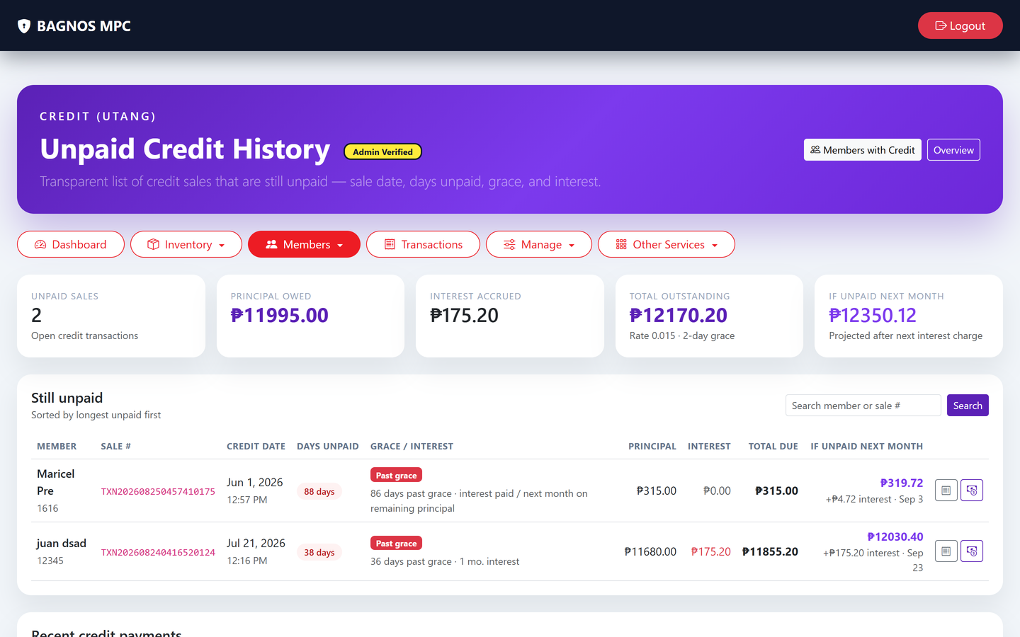
Unpaid credit (utang) history — outstanding balances, interest, and payment records for all members.

6.6 Member types
Member types determine discount eligibility. Go to Members and open the Member Types section to create or update types. Each type can have its own discount percentage that is applied automatically at the kiosk.

6.7 Backup and restore member data
- Backup — open Members ▸ Actions ▸ Backup to download a JSON export of all member records. Store this file safely as a disaster-recovery copy.
- Restore — use Actions ▸ Restore and upload the backup file to reinstate member records. Only administrators can restore.
Note Run a backup before any major system change or software update to protect against data loss.

6.8 Bulk import and export
- Import members (Excel/CSV): use Actions ▸ Import to add many members at once from a spreadsheet.
- Export members: use Actions ▸ Export to download the full member list as Excel for reporting or auditing.

7. Transactions & Receipts
The Transactions page stores every completed sale. Use it to look up a sale, check details, manage or void items, monitor refund requests, track card refills, and reprint any receipt.
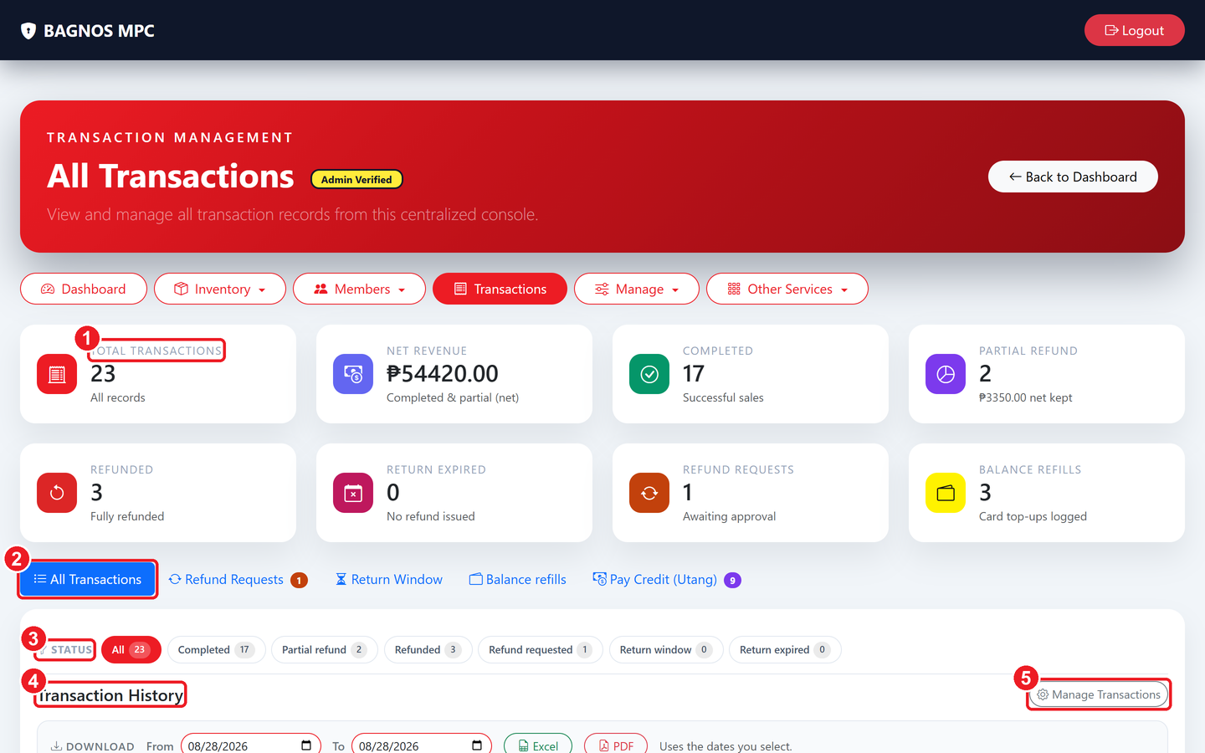
Transaction history — summary cards, view tabs, status filters, and the searchable sale list.
What's on this screen
① Transaction summary — Counts and totals — all records, net revenue, completed, and refund figures.
② View tabs — Switch between All Transactions, Refund Requests, Return Window, Balance Refills, and Pay Credit (Utang).
③ Status filter chips — One click filters the list by status — completed, refunded, refund requested, and more.
④ Transaction list — The searchable table of every sale; open a row to see items and reprint receipts.
⑤ Manage Transactions — Administrator tools for editing or voiding transactions.

7.1 View tabs
Tab | What it shows
All Transactions | Every sale in the system — completed, refunded, cancelled, or pending.
Refund Requests | Sales where a refund has been requested and is awaiting processing.
Return Window | Sales still within the allowed return period (items can still be returned).
Balance Refills | Card top-up events — when a member's RFID card was refilled and by how much.
Pay Credit (Utang) | Payments recorded against a member's outstanding credit balance.

7.2 Searching and filtering
- Search box: search by transaction reference, member name, or cashier.
- Status chips: click a chip — Completed, Refunded, Refund Requested, Cancelled — to filter the list instantly.
- Date range: pick a From and To date to narrow results to a specific period.
- Payment method filter: filter by Cash, Debit, Credit, or any combination.

7.3 Viewing a transaction
- Click any row in the list to open the transaction detail panel.
- The panel shows all items, quantities, unit prices, discounts, subtotals, payment method, cashier, and timestamp.
- Click Print Receipt to reprint the original receipt at any time.

7.4 Managing a transaction (Admin only)
- Void an item — in the transaction detail, click Void Item on any line to remove that item and recalculate the total.
- Edit transaction — the Manage Transactions button opens an admin panel for adjusting transaction details.
- Delete a transaction — permanently removes the record (use carefully; this is logged in the audit trail).
- Confirm a return — in the Return Window tab, click Confirm Return to finalise a product return and adjust stock.
- Expire return window — manually close the return window for a sale before the period ends if the item is not eligible.

7.5 Receipt types
Receipt | When it is printed
Cash receipt | For sales paid in cash — shows items, totals, and change given.
Debit / Credit receipt | For sales paid from a member account balance (debit) or charged to utang (credit).
Credit-payment receipt | When a member pays down their utang — shows amount paid and remaining balance.
Refund receipt | When a refund is processed — shows refunded items and the refund amount.

7.6 Exporting transactions
Click Download at the top of the Transactions page to export the transaction history. Choose PDF for a printable report, or Excel for use in accounting software. Specify a date range before exporting.

8. Refunds & Returns
Use the Refund desk to give money back for a returned or cancelled sale. Every refund is tied to the original transaction, adjusts the related stock, and generates a refund receipt.
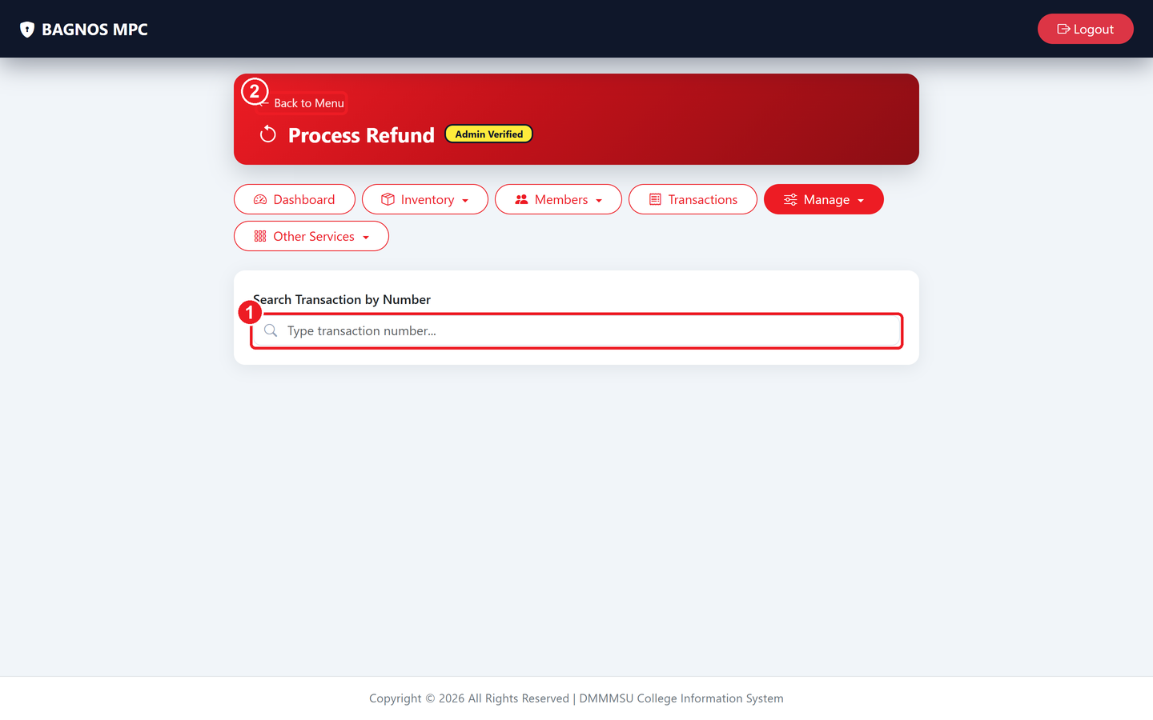
Process Refund — search for the original sale then select items to refund.
What's on this screen
① Transaction search — Type the receipt/transaction number of the original sale to start a refund.
② Back to Menu — Return to the previous screen without processing anything.

8.1 How to process a refund
- Go to Manage ▸ Process Refund (or click the Refund button from inside a transaction).
- Type the transaction number (receipt reference) in the search box and press Enter or click Search.
- The original sale appears with all its items. Tick the items being returned (or all items for a full refund).
- Select a refund reason (wrong item, damaged, customer changed mind, etc.).
- Click Process Refund. The system calculates the refund amount, reverses the payment, and restores stock.
- A refund receipt is generated. Print it and hand it to the customer.

8.2 Viewing refund requests
When a refund is requested but not yet approved, it appears in the Refund Requests tab on the Transactions page. An administrator reviews and either approves or denies the request.

8.3 Return window
The system tracks an automatic return window (e.g., 7 days) after each sale. During this period, items can be returned without additional approval. Sales in the window appear in the Return Window tab.
Note Refunds are written to the audit trail and appear on the dashboard's Total Refunds and Period Refunds KPI cards.

9. Loans — Cooperative Credit Workflow
The Loans module manages the cooperative's member lending from the first inquiry through to disbursement and full repayment. It follows a formal 13-step credit pipeline so every application is properly documented, reviewed, and approved.
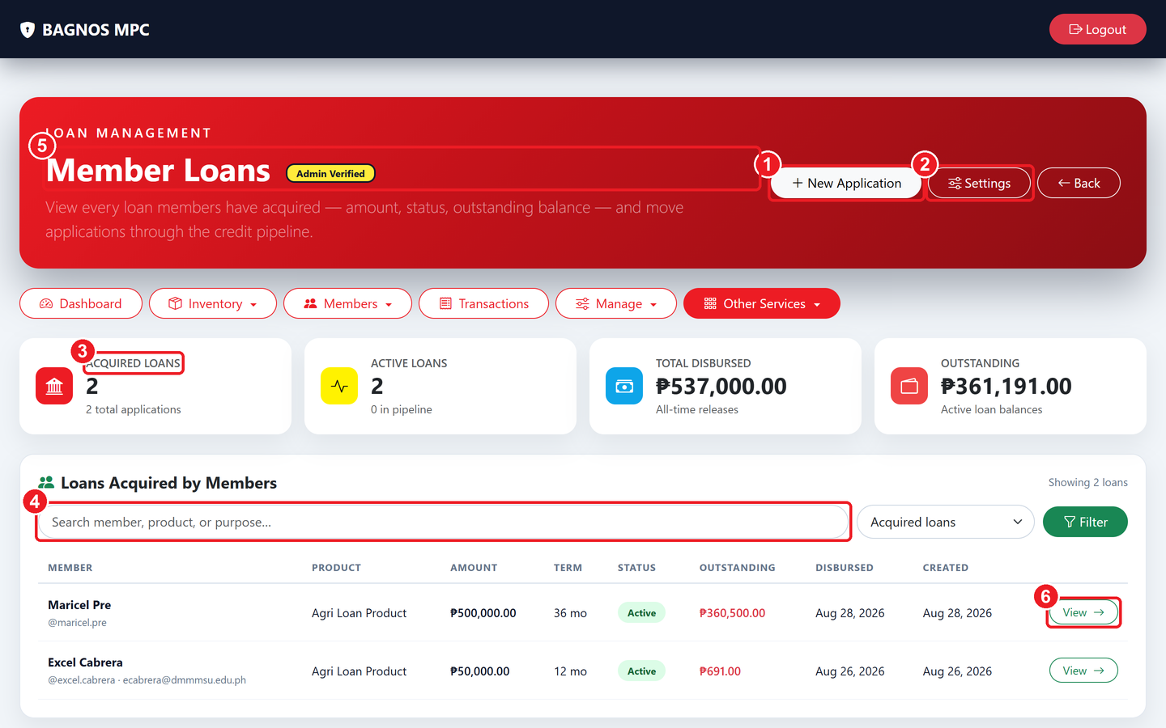
The Loan desk — loan KPI cards, search/filter, and every acquired loan with its status.
What's on this screen
① New Application — Start a new loan application for a member.
② Loan Settings — Global loan rules — interest, penalties, and workflow options.
③ Loan KPI cards — Totals — acquired loans, active loans, total disbursed, and outstanding balances.
④ Search & filter — Find a loan by member, product, or purpose; filter by status.
⑤ Loans table — Every loan with amount, term, status, outstanding balance, and dates.
⑥ View button — Opens the loan detail — move it through the pipeline, record payments, print receipts.

9.1 Loan KPI cards
- Acquired Loans: total number of loans ever created.
- Active Loans: loans currently in progress (not yet fully repaid or closed).
- Total Disbursed: total amount of money released to members across all loans.
- Outstanding Balance: total amount still owed by all members across active loans.

9.2 The 13-step loan pipeline
A loan moves through these stages. Each step is handled by the person with the right role — loan officer, credit committee, or administrator.
Step | Name | What happens
1 | Inquiry | A member expresses interest; basic details are captured to assess initial eligibility.
2 | Application | A formal loan application is filed for a specific loan product and amount.
3 | Eligibility Verification | The system and officer verify the member meets the cooperative's requirements.
4 | Credit Investigation | The member's repayment capacity and credit history are reviewed.
5 | Committee Review | The credit committee receives the file and deliberates.
6 | Approve / Reject | The application is approved or declined; the member is notified.
7 | Insurance Enrollment | Required loan insurance is enrolled for approved applications.
8 | Documentation | Promissory notes and other loan documents are signed.
9 | Disbursement | Funds are released to the member; a disbursement voucher/receipt is issued.
10 | Repayment | Payments are collected according to the amortization schedule.
11 | Penalty Tracking | Late payments are tracked and penalties applied per the loan settings.
12 | Restructuring | If needed, the loan terms can be restructured with committee approval.
13 | Closure | When fully repaid, the loan is marked closed and archived.

9.3 Key loan screens

Loan applications list (staff view)
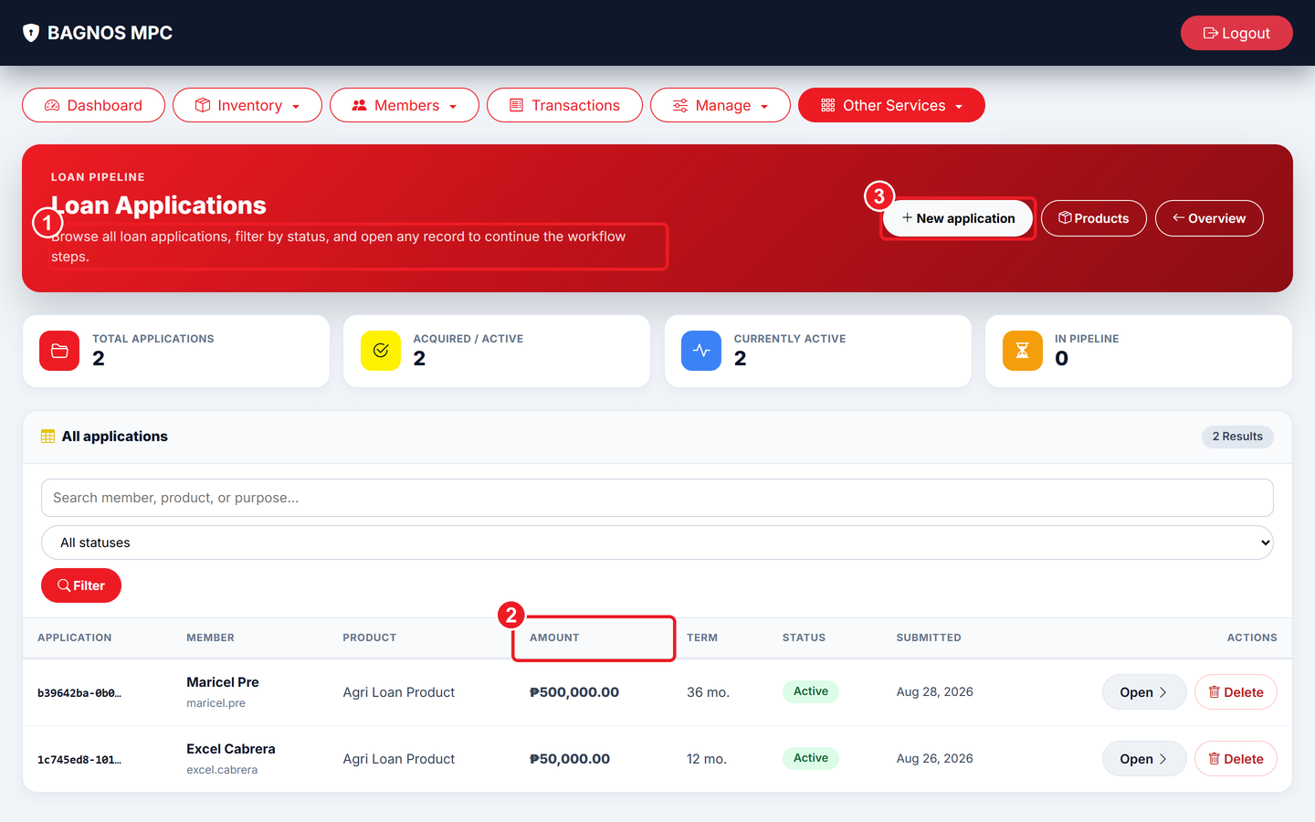
Loan applications list — every application with its current pipeline stage, amount, and member.
What's on this screen
① Status column — Current pipeline stage of each loan — Inquiry, Application, Under Review, Approved, etc.
② Amount column — The loan amount requested or approved.
③ New Application — Start a fresh loan application for a member.

The applications list is the main working screen for loan officers. Each row shows the member, the loan product, the amount, the current stage, and a View button to open the loan.

Loan application detail
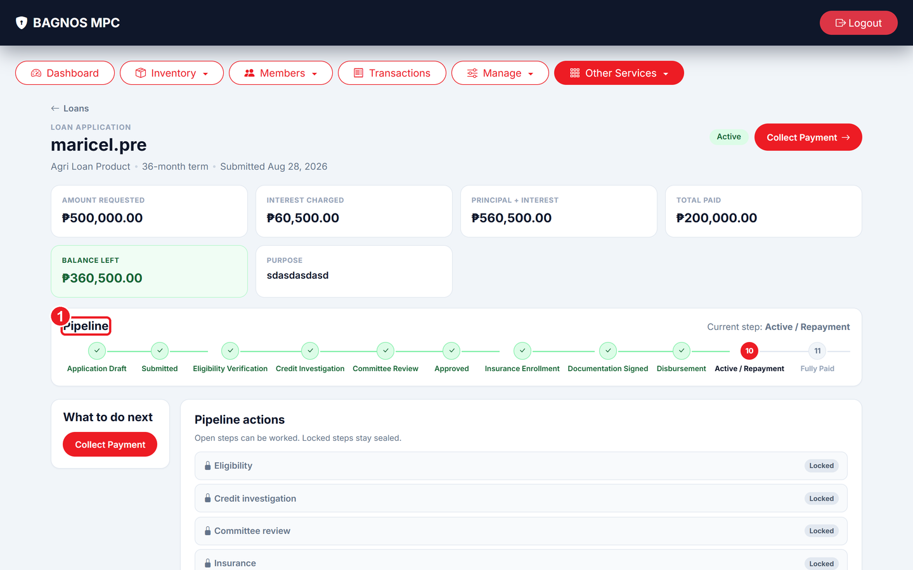
Loan application detail — member info, loan terms, pipeline tracker, and audit trail.
What's on this screen
① Pipeline steps — Visual tracker showing completed and current stages of the application.

Opening a loan shows the full detail: member name and contact, loan product, amount and term, purpose, current pipeline step, all previous steps, and a complete audit trail of actions. From here the loan officer advances the loan to the next step by clicking the action button for the current stage (e.g., Complete Eligibility Verification, Send to Committee, Approve).

Start an inquiry
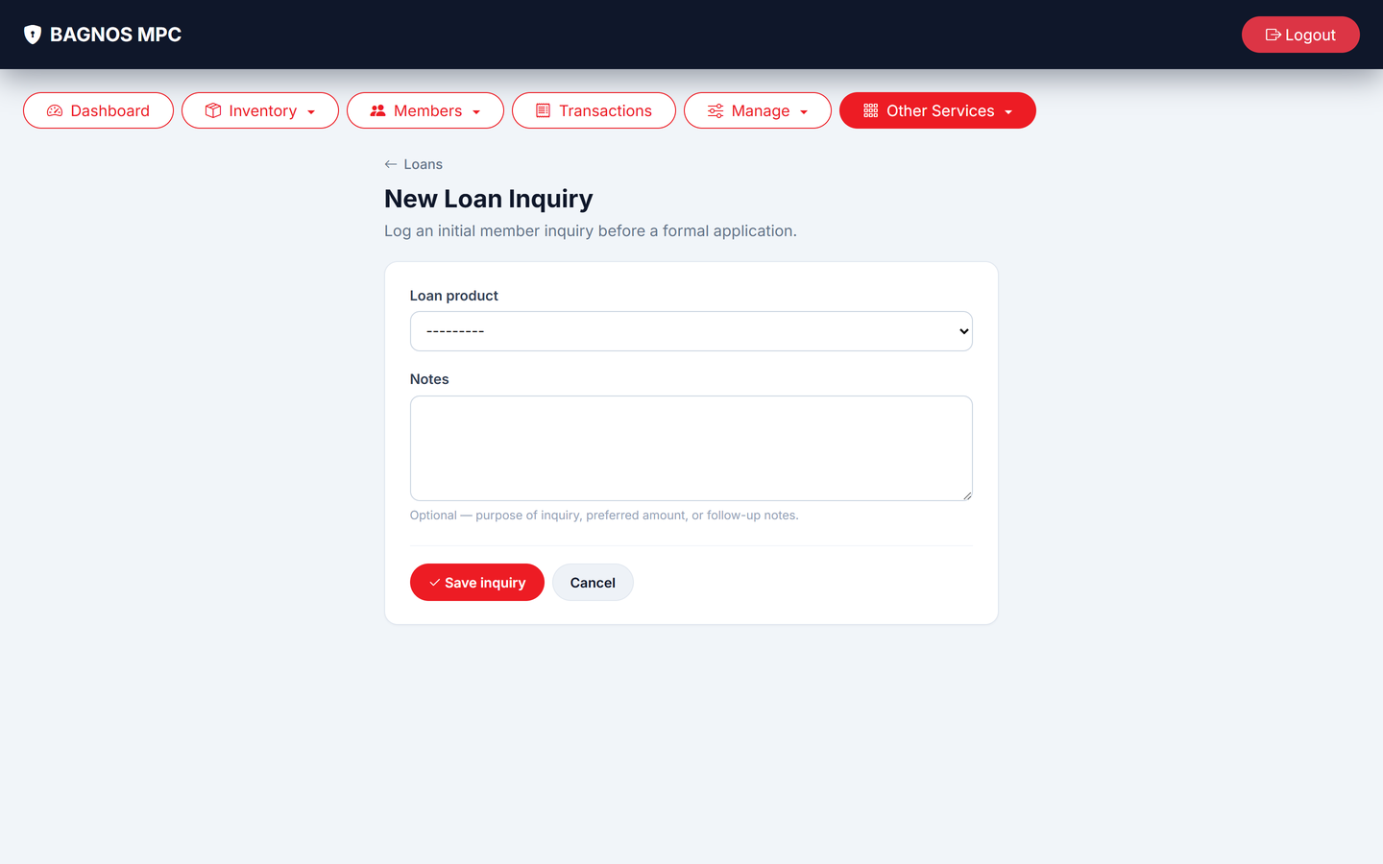
New loan inquiry — capture the member's initial loan request and basic details.

Create a formal application
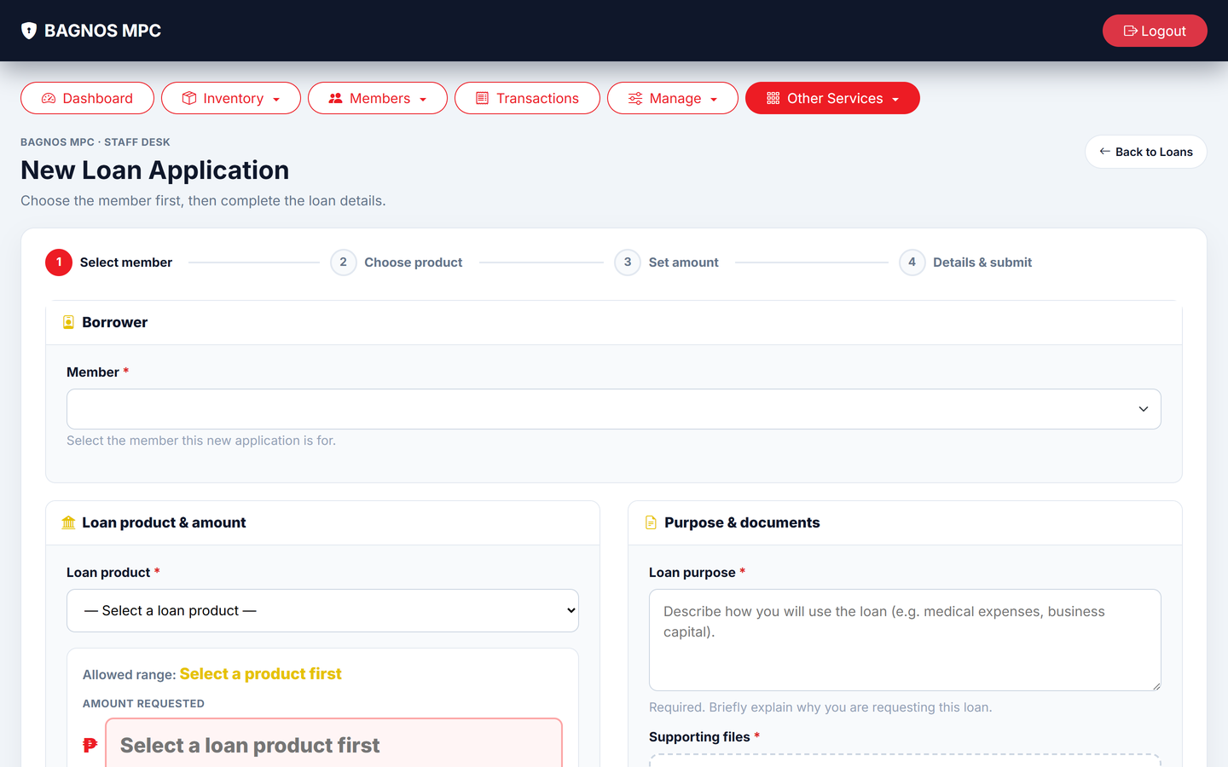
New loan application — choose the loan product, enter the amount, term, and purpose.

Loan products
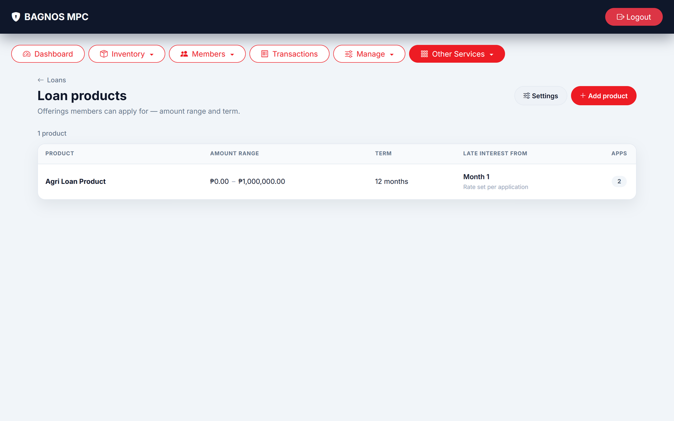
Loan products — the loan types the cooperative offers, each with interest rate, maximum term, and rules.

Loan settings
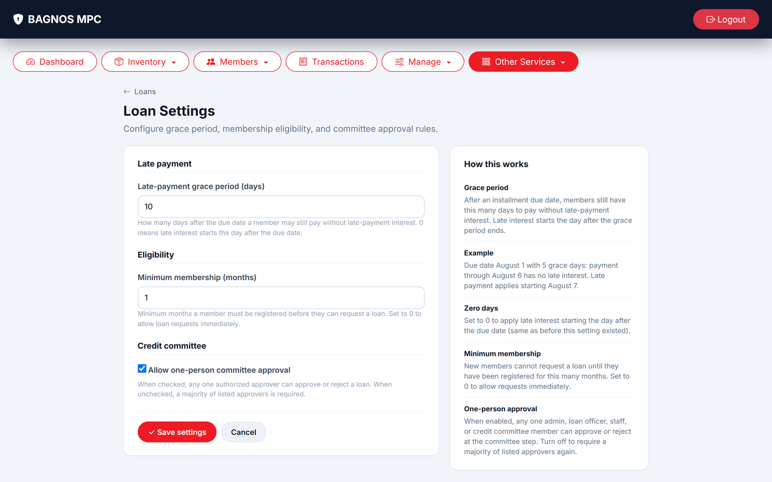
Loan settings — global rules for interest calculation, penalties, and workflow behaviour.

9.4 Loan settings explained
Setting | What it controls
Interest rate | The annual or monthly rate applied to loans of each product type.
Penalty rate | Late-payment penalty percentage applied after the due date.
Penalty grace period | Number of days after due date before penalties start accruing.
Workflow automation | Whether certain steps (eligibility, documentation) are skipped for small loans.
Insurance requirement | Whether loan insurance is mandatory and which provider to use.
Payment option | Amortization method — straight-line, diminishing balance, or other.

9.5 Disbursement
After the loan is fully approved and documented, the loan officer completes disbursement to release funds.
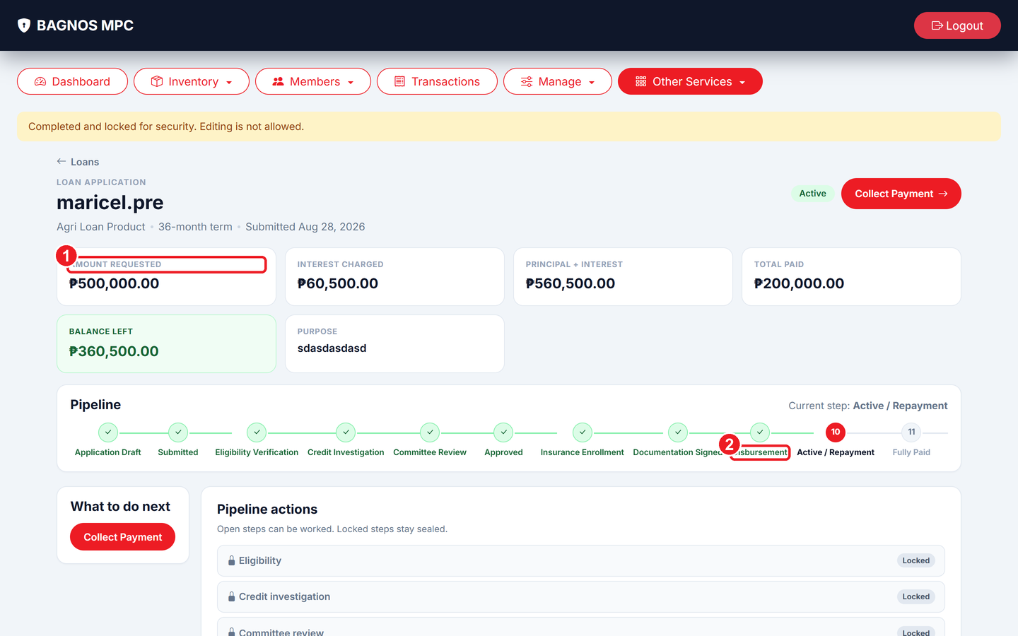
Disbursement form — confirm the amount and release funds to the member.
What's on this screen
① Disbursement amount — The approved loan amount to be released to the member.
② Disburse button — Confirm and release the funds; a voucher is generated.

- Open the approved loan and navigate to the Disbursement step.
- Confirm the disbursement amount and the release date.
- Click Disburse. The system marks the loan as disbursed and generates an official disbursement voucher/receipt.
- Print the voucher and have the member sign to acknowledge receipt of funds.

9.6 Recording loan repayments
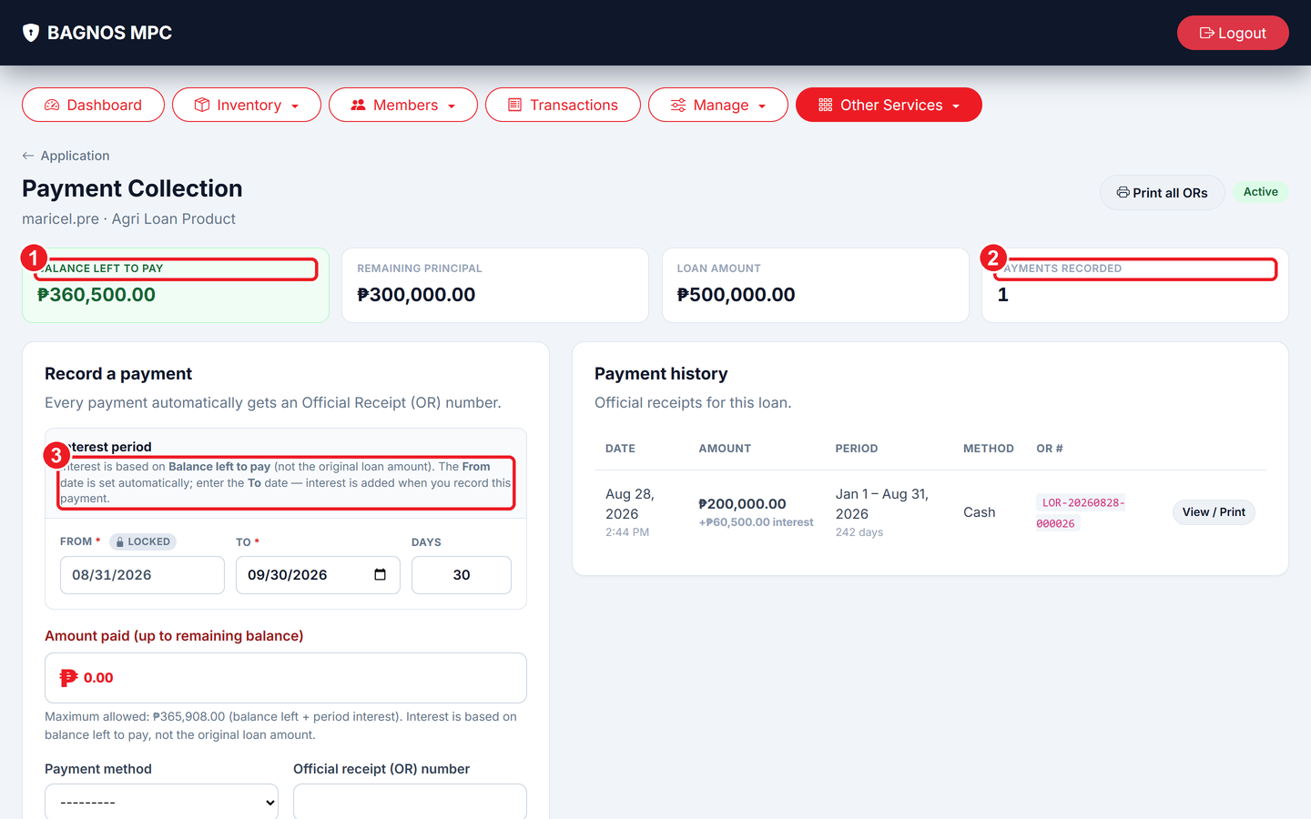
Loan payments — outstanding balance, amortization schedule, Record Payment button, and payment history.
What's on this screen
① Outstanding Balance — The remaining amount the member still owes.
② Record Payment — Click to record a loan repayment from the member.
③ Payment history — A list of all payments received, with dates and amounts.

- Open the active loan and go to the Payments tab.
- Review the outstanding balance and the next payment due date from the amortization schedule.
- Click Record Payment and enter the amount, payment date, and method (cash, bank transfer, etc.).
- The outstanding balance updates automatically; a payment receipt is issued to the member.
- Repeat each time the member makes a scheduled or advance payment.
Note Loan officers can search loans by member, product, purpose, or status using the search and filter bar on the Loan desk. Use the Print Receipts button to batch-print all payment receipts for a loan.

10. Savings
The Savings module lets the cooperative hold member savings accounts, accept deposits and withdrawals, track interest, and report on all account activity.
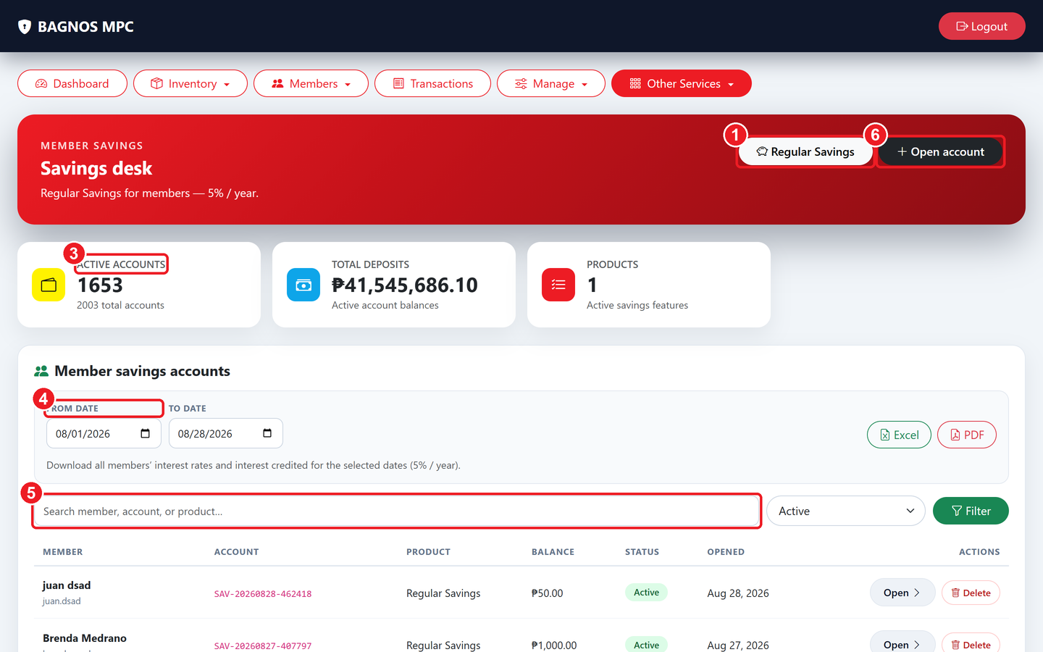
Savings overview — active accounts, total deposits, savings products, and account search.
What's on this screen
① Savings products — Review the savings products (interest rate, rules).
② Open account — Open a new savings account for a member.
③ Savings summary — Active accounts, total deposits held, and product count.
④ Interest report — Pick dates and export members' credited interest to Excel or PDF.
⑤ Search accounts — Find an account by member name, account number, or product.
⑥ Open account detail — Opens the account — record deposits, withdrawals, and print receipts.

10.1 Savings KPI cards
- Active Accounts: number of members with an open savings account.
- Total Deposits Held: total amount held across all member savings accounts.
- Products Count: number of savings product types on offer.

10.2 Opening a savings account
- Click Open Account.
- Search for and select the member.
- Choose the savings product (e.g., Regular Savings, Time Deposit).
- Enter the opening balance (initial deposit). Record payment method.
- Click Save. The account is created and the member can deposit or withdraw immediately.
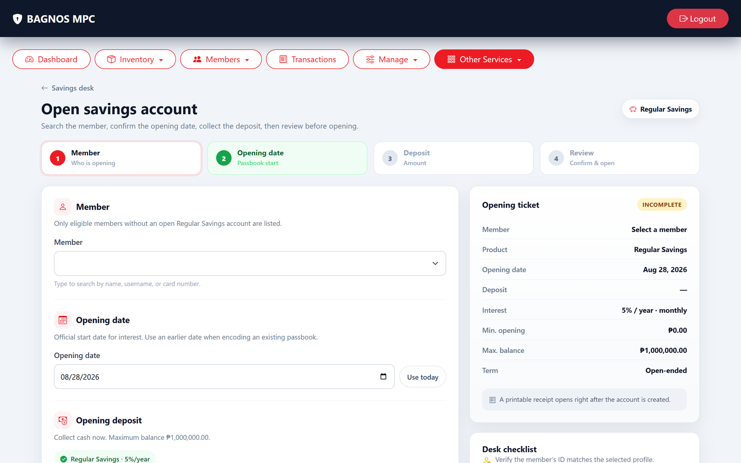
Open a savings account — select the member and savings product.

10.3 Savings account detail
Click Open on any account row to open its full detail view — the primary screen for managing a member's savings.
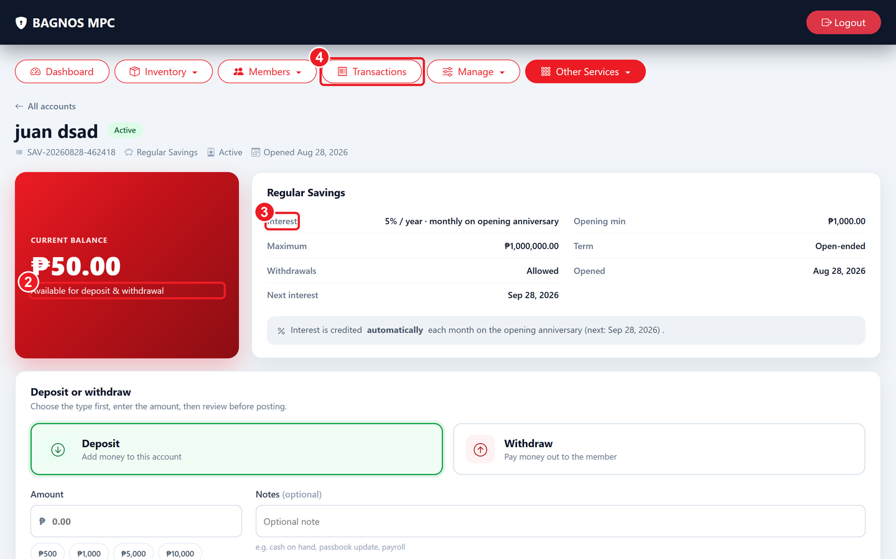
Savings account detail — balance, deposit/withdrawal buttons, interest credit, transaction history, and close account.
What's on this screen
① Deposit button — Click to record a new deposit into this savings account.
② Withdraw button — Click to record a withdrawal from this savings account.
③ Credit Interest — Manually credit interest to this account.
④ Transaction history — Every deposit and withdrawal with date, amount, and running balance.

- Account Balance: the member's current total balance, prominently displayed at the top.
- Deposit button: record a new deposit — enter the amount and date; a receipt is generated.
- Withdraw button: record a withdrawal — the system checks the account has enough balance and the product's withdrawal rules.
- Credit Interest button: manually credit computed interest for this account if automatic crediting is not enabled.
- Transaction history: a chronological list of every event — date, type (deposit/withdrawal/interest), amount, and running balance.
- Print Receipts: batch-print all receipts for this account, or open individual receipts from any transaction row.
- Move Account: transfer the account to a different savings product.
- Close Account: permanently close the account — only possible when the balance is zero.

10.4 Deposits and withdrawals step by step
- Find the account using the search box on the Savings overview (member name, account number, or product).
- Click Open to open the account detail.
- Click Deposit or Withdrawal, enter the amount and date, and confirm.
- A transaction receipt is generated for the member's records.
- The running balance updates immediately in the transaction history.

10.5 Interest calculation and export
Interest is applied at the rate and frequency defined by the savings product. To export an interest report:
- On the Savings overview, find the Interest Report section.
- Pick the From Date and To Date for the period you want.
- Click Excel or PDF to download the interest credited per member.

10.6 Savings products
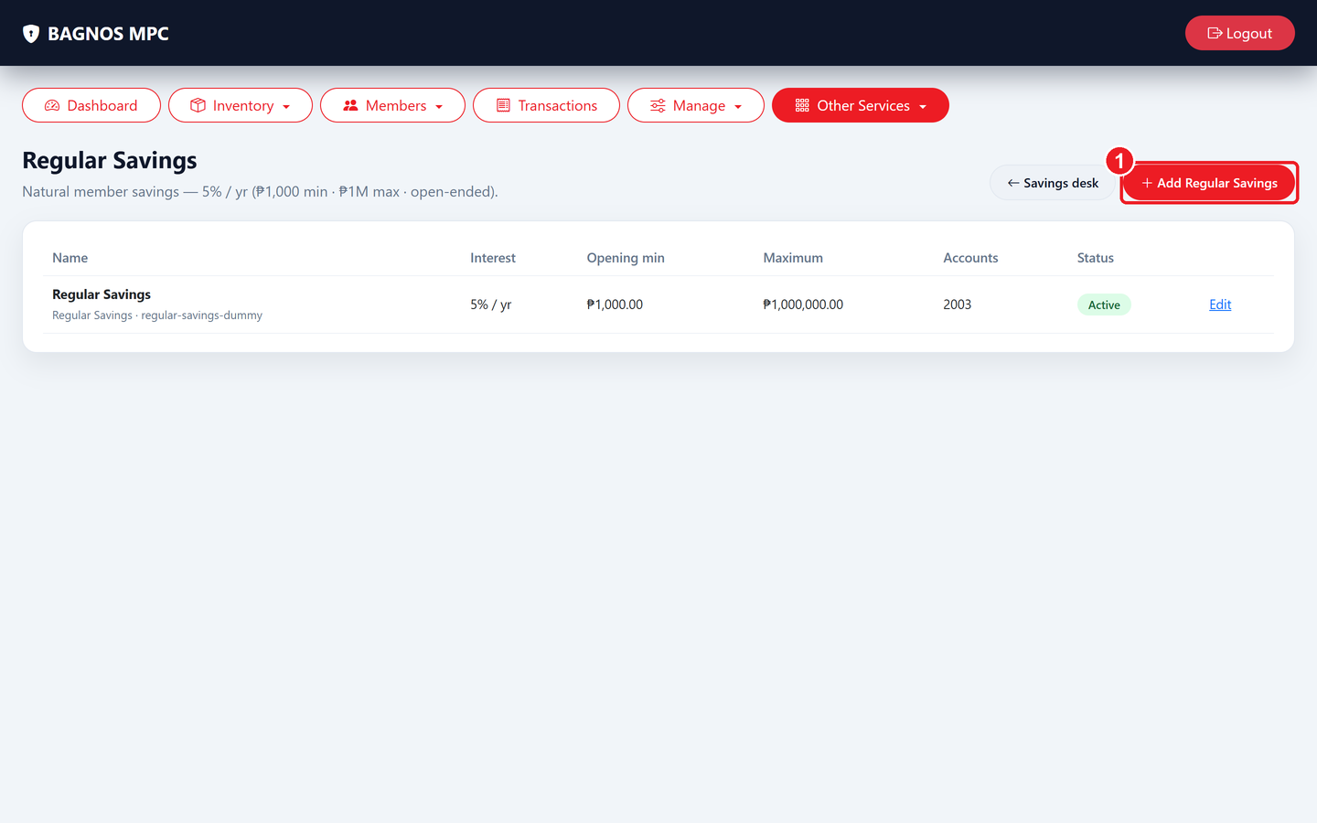
Savings products list — product name, interest rate, and Edit button for each type.
What's on this screen
① Add product — Create a new savings product type.

Click Regular Savings (or any product name) to view or edit its rules. Each product defines:
- Interest rate: the annual or periodic rate credited to account holders.
- Compounding frequency: how often interest is calculated and credited (daily, monthly, quarterly, yearly).
- Minimum balance: the minimum amount the account must maintain.
- Withdrawal restrictions: whether withdrawals are allowed and any notice period required (e.g., time deposits).
Click Add Product to create a new savings product type, or Edit on an existing product to update its rate and rules.

11. Share Capital
Share Capital tracks each member's ownership contributions to the cooperative. As members pay in capital, their ownership stake grows. Share capital is the basis for dividends when declared.
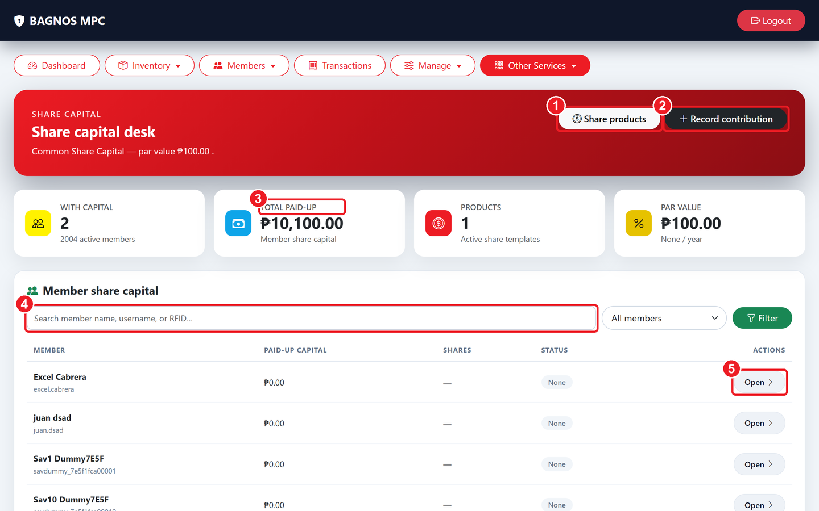
Share Capital overview — total paid-up capital, member records, and contribution history.
What's on this screen
① Share products — The share templates the cooperative offers (par value, rules).
② Record contribution — Record a member's share-capital payment.
③ Capital summary — Members with capital, total paid-up amount, products, and par value.
④ Search members — Find a member's capital record.
⑤ Open member detail — See a member's full contribution history.

11.1 Share capital KPI cards
- Members with Capital: count of members who have made at least one contribution.
- Total Paid-Up Capital: the sum of all member contributions on record.
- Products: number of share-capital product types defined (e.g., Common Share, Preferred Share).
- Par Value: the nominal value per share unit as set in the share products.

11.2 Recording a contribution
- Click Record Contribution.
- Search for the member.
- Choose the share-capital product.
- Enter the amount contributed and the date.
- Click Save. The contribution is added and a receipt can be printed.
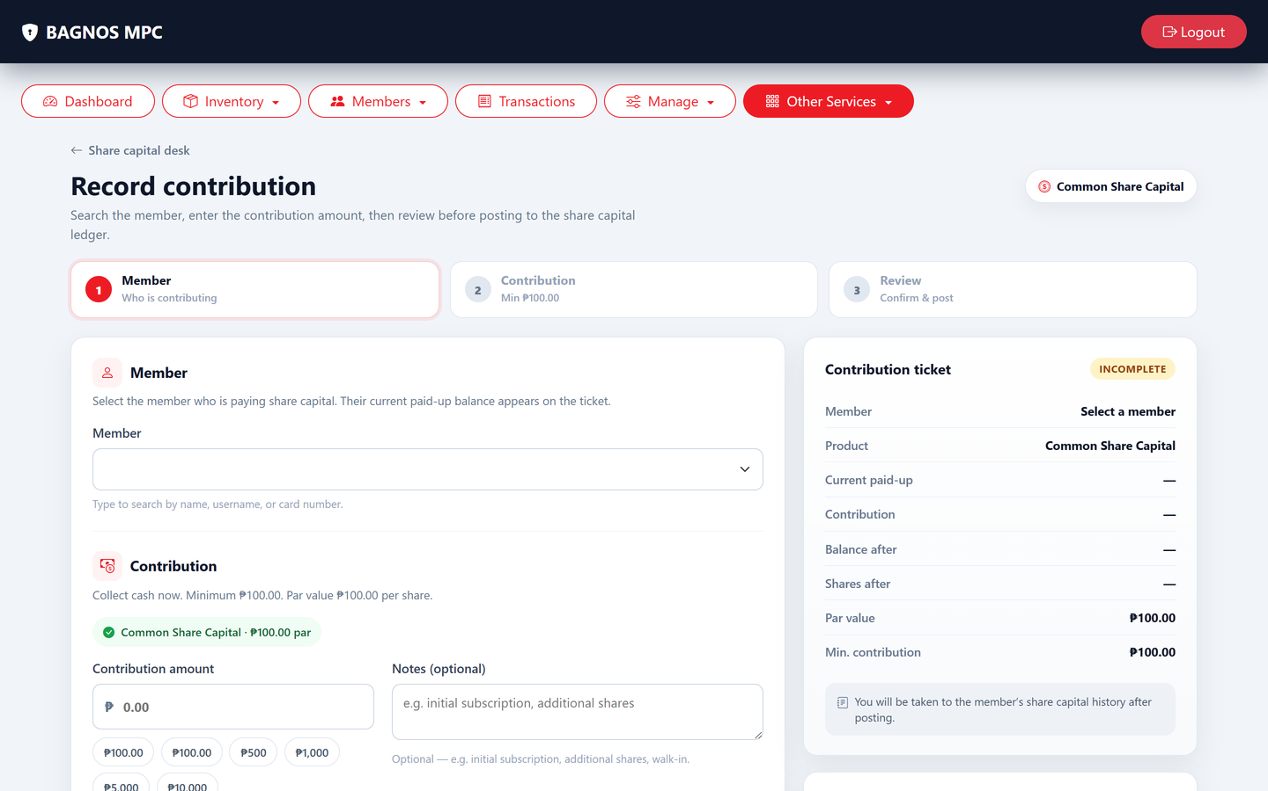
Record a share-capital contribution — member, product, and amount.

11.3 Viewing a member's capital detail
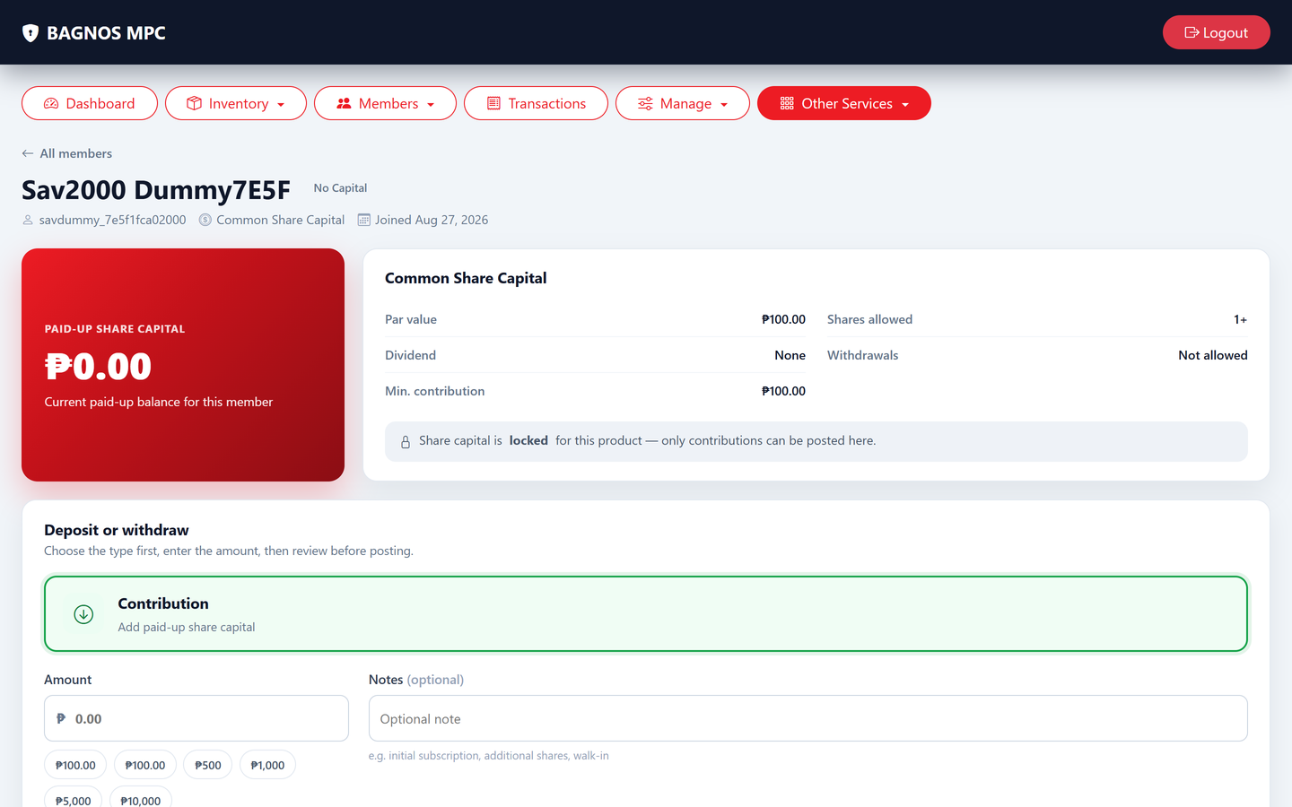
Share capital member detail — total paid-up, contribution history, and Record Contribution button.
- Search for the member in the Share Capital overview.
- Click Open to open the member's capital detail page.
- The page shows their total paid-up capital, their share product, and a full contribution history — every payment with date and cumulative running total.
- Click Record Contribution from this page to add another payment directly.
- Use Move to transfer the member's capital from one share product to another if the cooperative redefines its product structure.

11.4 Share capital products
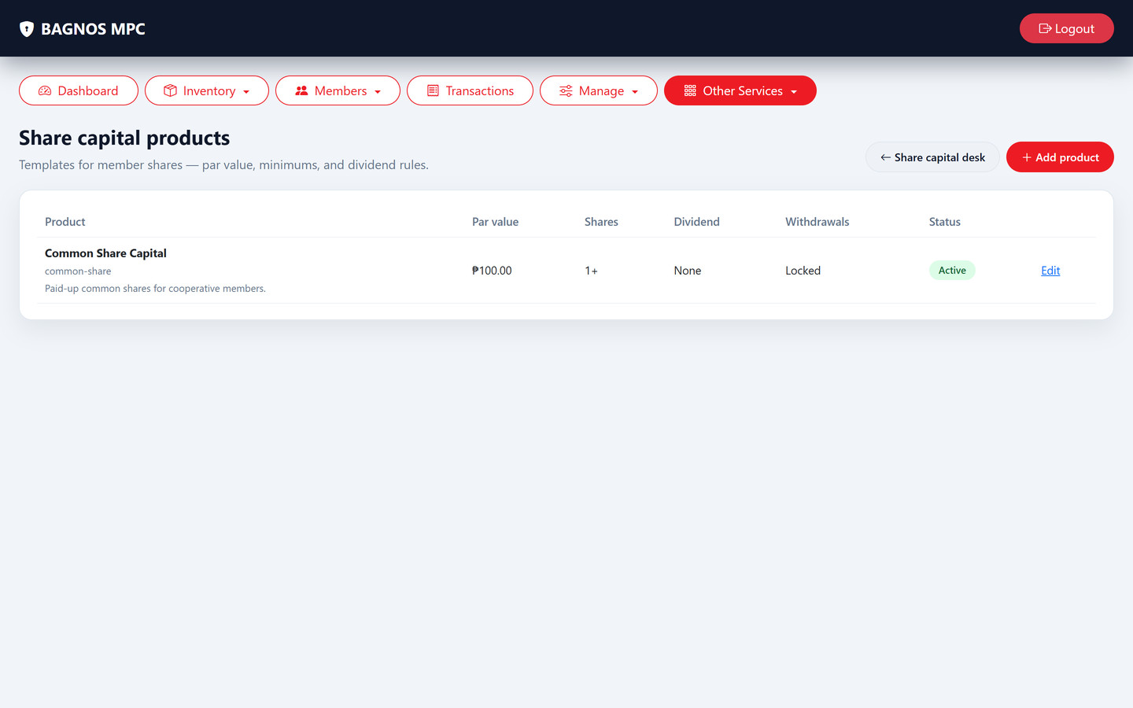
Share-capital products — the contribution types the cooperative offers.
Each share product defines the par value and any rules about minimum contributions or transfer restrictions. Click Share Products to add, edit, or deactivate a product.
- Product name: e.g., Common Share Capital, Preferred Share.
- Par value: the nominal face value of one share unit.
- Minimum contribution: the smallest amount a member may contribute per transaction.
- Active/Inactive: inactive products are hidden from the contribution form but their history is preserved.

12. Palay Trade
The Palay module handles the cooperative's rice trading business — buying palay from members or farmers, selling processed rice (bigas), and managing palay-related credit. It has its own products, varieties, stock tracking, and credit desk.
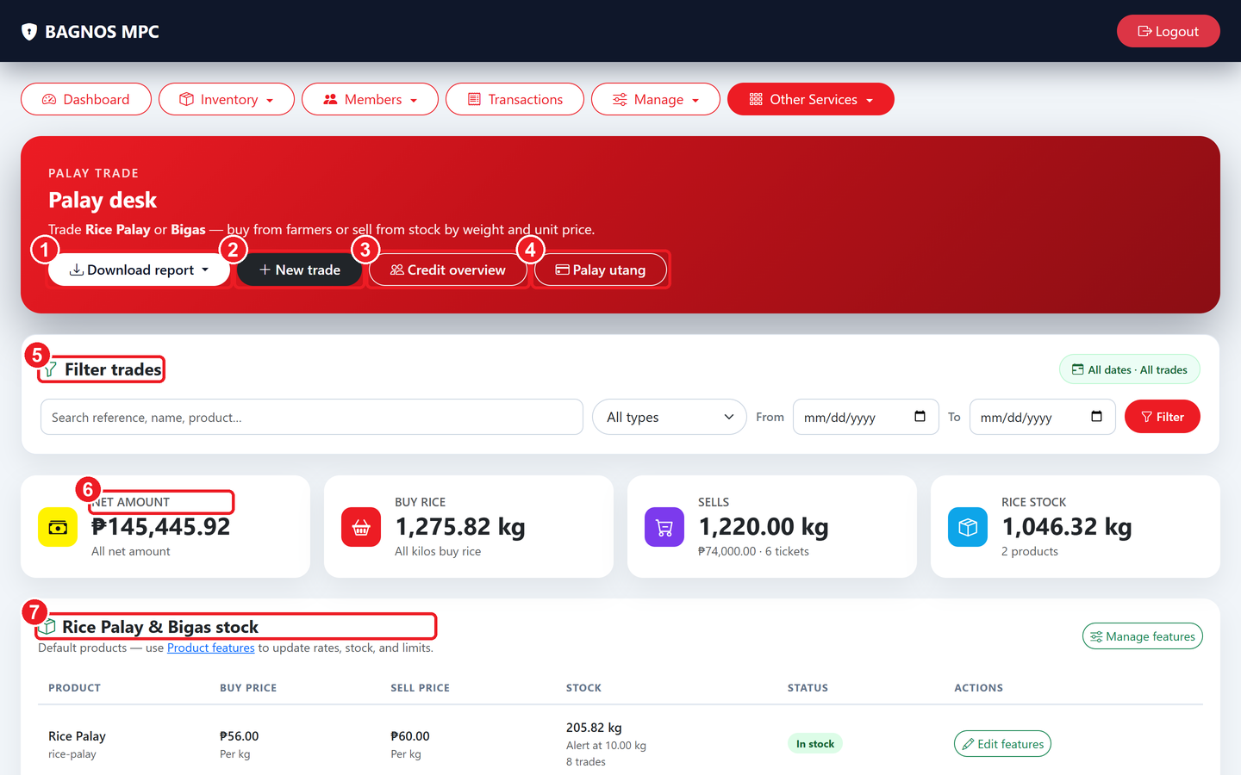
Palay overview — trade totals (kilo bought/sold, net amount, rice stock) and recent trade history.
What's on this screen
① Download report — Export palay in/out reports.
② New trade — Record a palay purchase (from farmers) or a sale (from stock).
③ Credit overview — Outstanding palay-related credit at a glance.
④ Palay utang — The palay credit desk for advances and utang.
⑤ Filter trades — Search past trades by reference, name, product, type, or date.
⑥ Trade totals — Net amount, kilos bought, kilos sold, and current rice stock.
⑦ Stock table — Buy/sell prices and stock per product — Edit features to change rates and limits.

12.1 Palay overview indicators
- Net Amount: total money in (sales) minus money out (purchases) for the period.
- Kilos Bought: total palay (rough rice) purchased from farmers/members.
- Kilos Sold: total rice (bigas) sold to buyers.
- Rice/Palay stock table: current stock per variety — buying price, selling price, and quantity on hand.

12.2 Recording a trade
- Click New Trade.
- Choose the trade type: Buy (purchasing from a farmer/member) or Sell (selling from stock).
- Select the palay or rice product/variety.
- Enter the weight (kilos), unit price, and select the member or supplier.
- Click Save. A trade receipt is generated and stock is updated automatically.
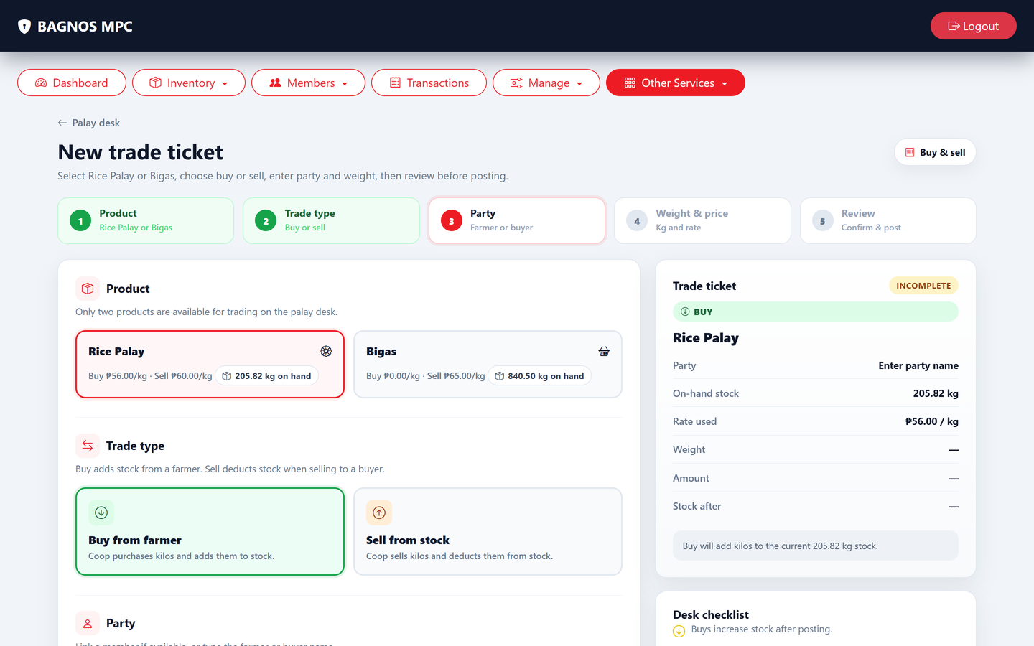
New palay trade — record a buy (from farmers) or a sell (from stock).

12.3 Palay products and varieties
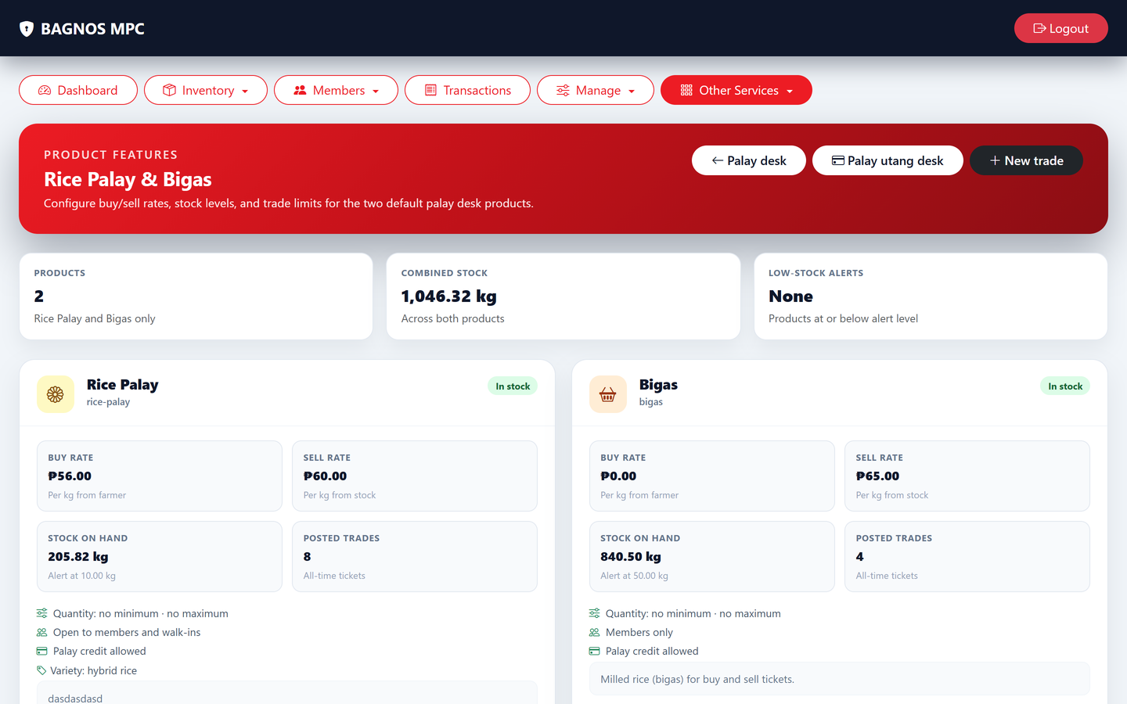
Palay products and varieties — each grade with buying and selling prices.
Each palay product defines the variety (e.g., Dinorado, RC222), the current buying price, and the current selling price. Click Edit on any row to change rates or stock limits.

12.3 Palay trade detail
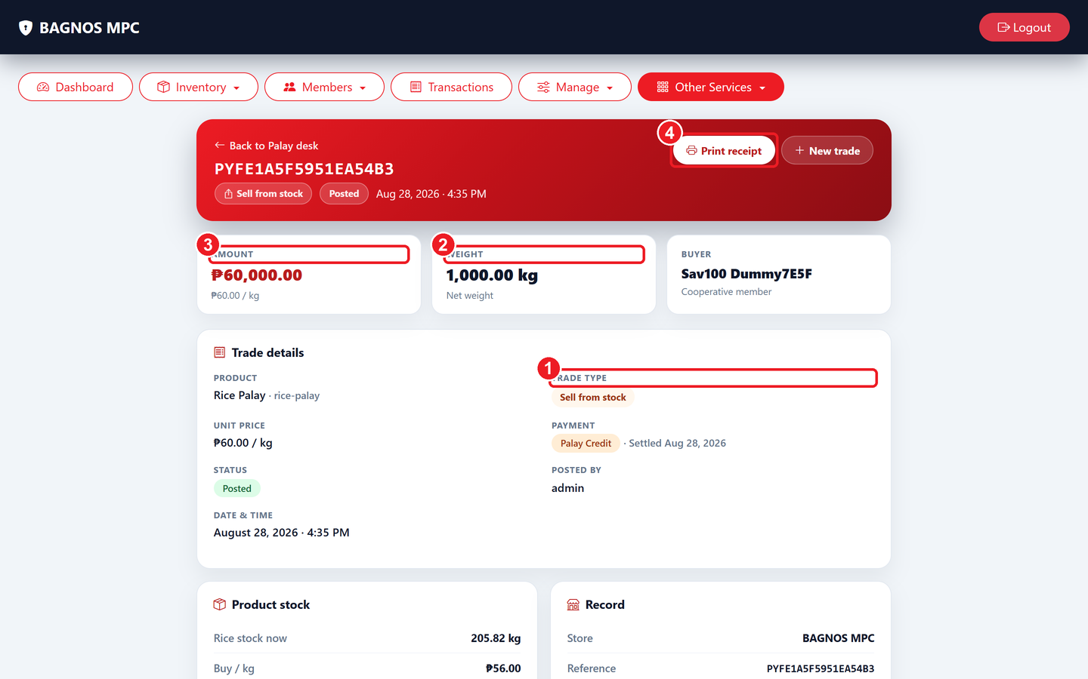
Palay trade detail — trade type, weight, amount, member/supplier, and receipt print button.
What's on this screen
① Trade type — Buy (purchasing palay from farmer) or Sell (selling rice from stock).
② Weight / kilos — The quantity of palay or rice in this trade.
③ Total amount — The total value of the trade transaction.
④ Print receipt — Print the official trade receipt for this transaction.

Open any trade from the overview list to see its full record: trade type (Buy/Sell), product variety, weight in kilos, price per kilo, total amount, member or supplier name, date, and reference number. Click Print Receipt to produce the official trade receipt.

12.4 Palay products and varieties

Palay products — varieties with current buying and selling prices, editable per row.
Each variety has its own buying price (paid to farmers), selling price (charged to buyers), and stock limit. Click Edit on any row to update prices or limits. Changes take effect immediately on the New Trade form.

12.5 Palay credit desk (utang)
Members or traders may take palay on credit — receiving rice now and paying later. The credit desk manages these advances.
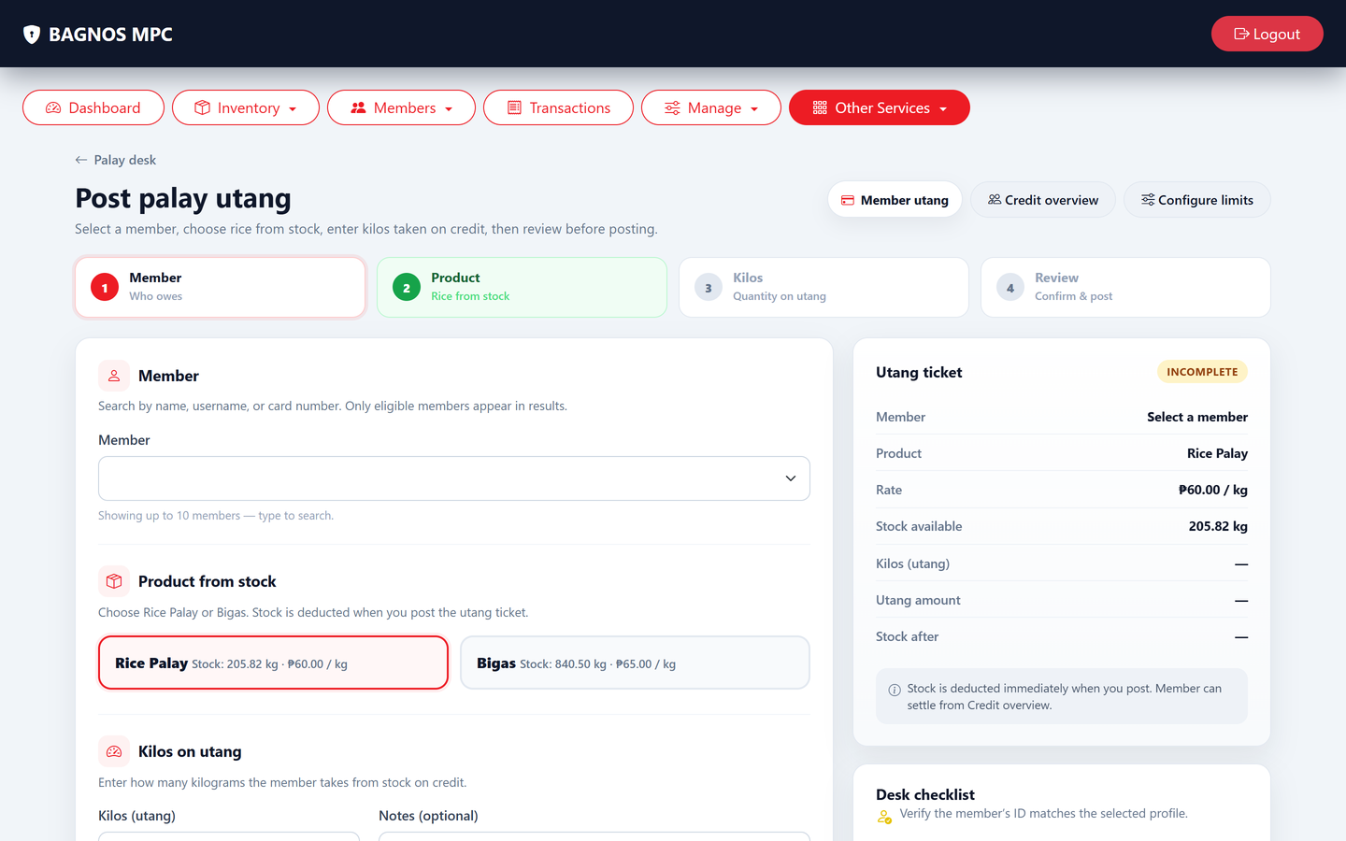
Palay credit desk — track individual palay credit accounts, balances, and settlement history.
- Member search: find a member's palay credit account by name or RFID.
- Credit balance: how much the member owes for palay taken on credit.
- Settle credit: record a partial or full payment against the member's palay credit balance.
- Transaction history: every credit advance and payment for that member.

12.6 Palay credit overview
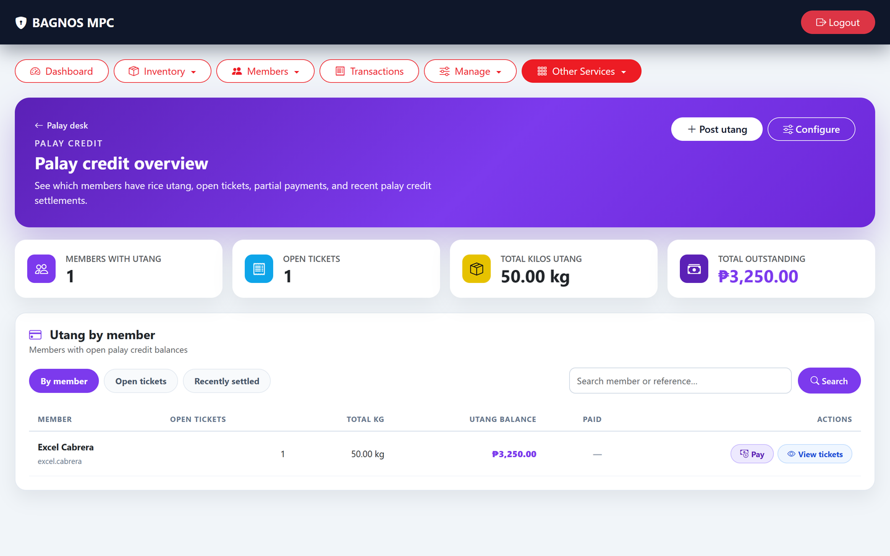
Palay credit overview — all outstanding palay credit balances across all members.
The credit overview shows every member with outstanding palay credit — total owed, last advance date, and a Settle button. Use this page for collections follow-up and to get the total palay credit exposure of the cooperative.

12.7 Palay credit settings
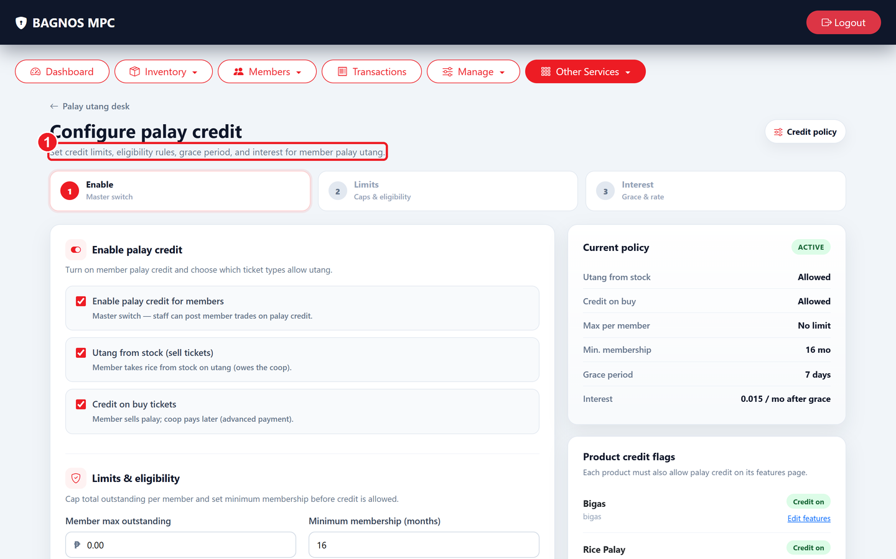
Palay credit settings — interest rate and rules applied to outstanding palay credit.
What's on this screen
① Interest rate — The interest rate applied to outstanding palay credit balances.

Go to Palay ▸ Credit ▸ Settings to configure the interest rate and terms applied to outstanding palay credit balances. Changes take effect from the next interest calculation cycle.

12.8 Exporting palay reports
Click Download Report on the Palay overview to export a full trade history (buys, sells, credit advances, and settlements) for the selected period as PDF or Excel.

13. Staff Sales Report
The Staff Sales report shows how much each cashier or staff member has sold, making it easy to monitor performance and ensure accountability. It is available from the Dashboard ▸ Manage menu to administrators.
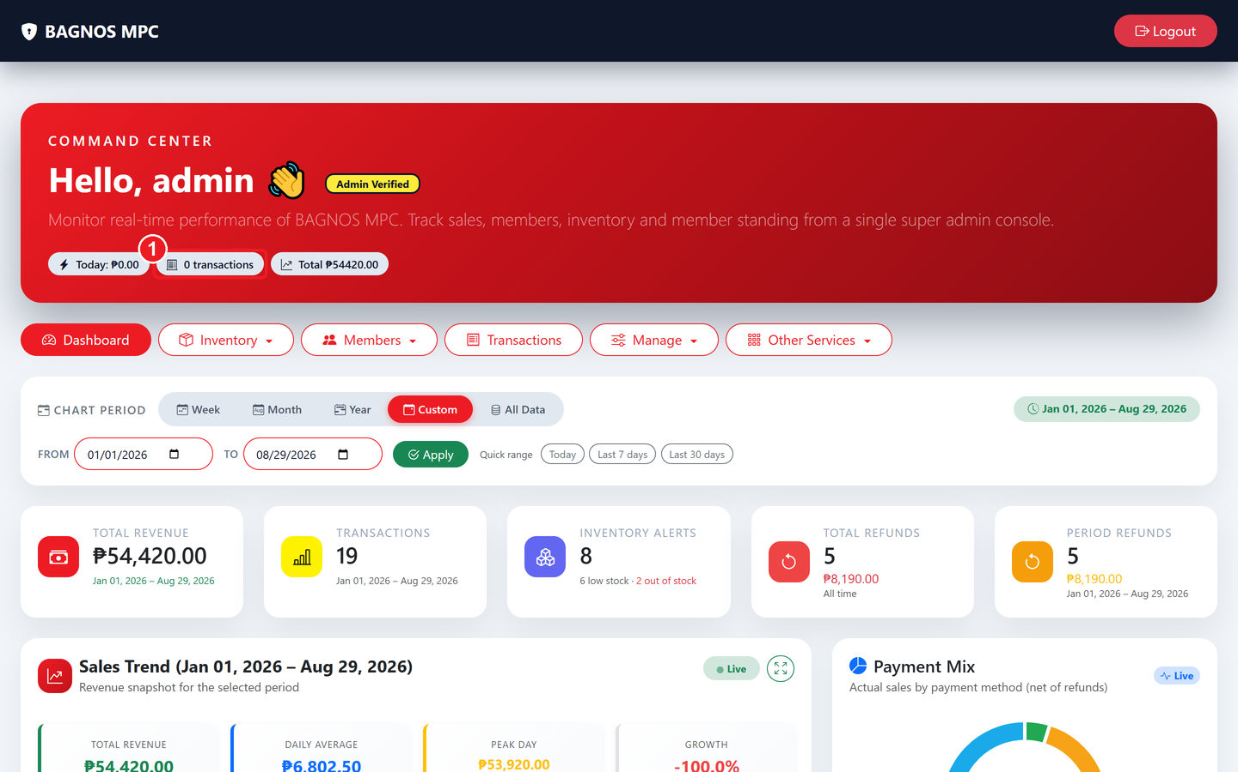
Staff Sales overview — each staff member's total sales, transaction count, and period.
What's on this screen
① Transactions column — Number of sales completed by each staff member.

13.1 Reading the report
- Staff list: every active staff member who made at least one sale in the selected period.
- Total Sales: the total peso value of sales processed by that person.
- Transactions: the number of individual sales completed.
- Average per transaction: total sales divided by transaction count — a measure of basket size.

13.2 Drilling into a staff member's sales
- Click on any staff member's row to open their individual sales detail.
- The detail page lists every transaction that staff member processed — date, items, amount, and payment method.
- Click Export to download the detail as PDF or Excel for payroll or auditing.
Note Staff sales data is available only to administrators. This report cannot be seen by cashiers or regular staff.

14. Member Self-Service
Members have their own limited view of the system. After a member signs in (usually by tapping their RFID card), they see only their own information — no staff tools, no other members' data.

14.1 RFID gate
At some kiosk stations, members first tap their RFID card on the RFID gate screen before being taken to their self-service hub.
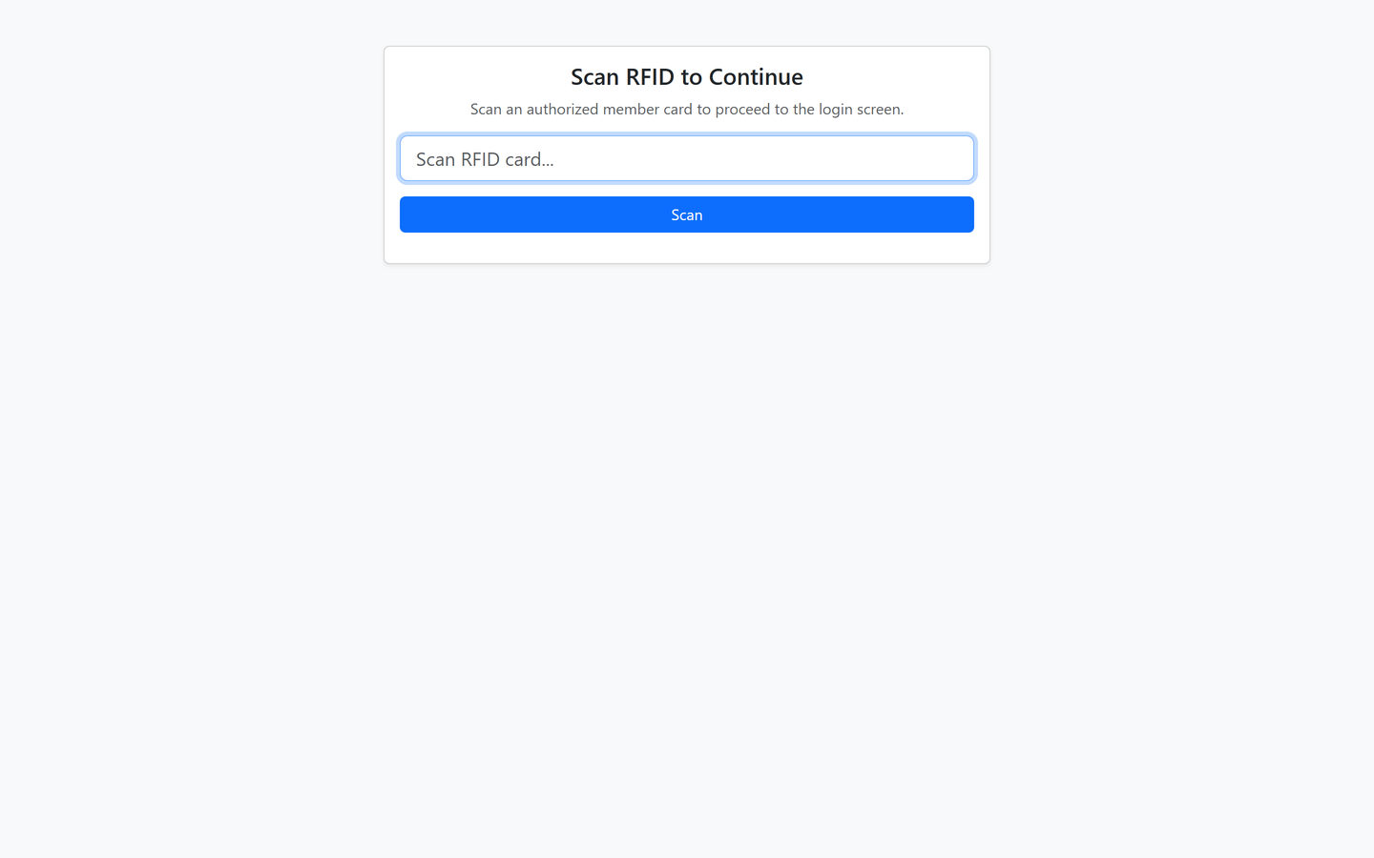
RFID gate — a member taps their card to unlock their self-service hub.

14.2 Member self-service hub
After passing the RFID gate (or logging in manually), the member sees their self-service hub — a simple menu to access their own records.
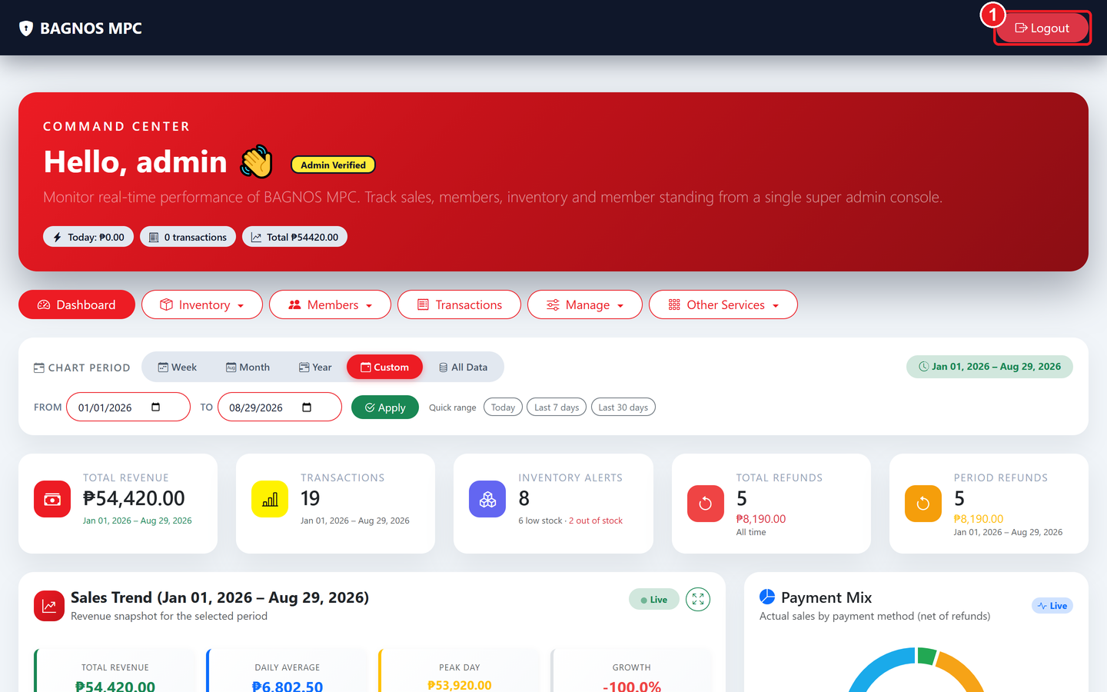
Member self-service hub — choose which records to view (transactions, savings, loans, or palay).
What's on this screen
① Logout button — Sign out securely when you are done.

- My Transactions: the member's own purchase history — date, items, total, and payment method for every sale attached to their account.
- My Savings: the member's savings account balances, available products, and deposit/withdrawal history.
- My Loans: the member's active and past loan applications, outstanding balances, and payment schedule.
- My Palay: the member's palay trading records and any outstanding palay credit.

14.3 My Transactions
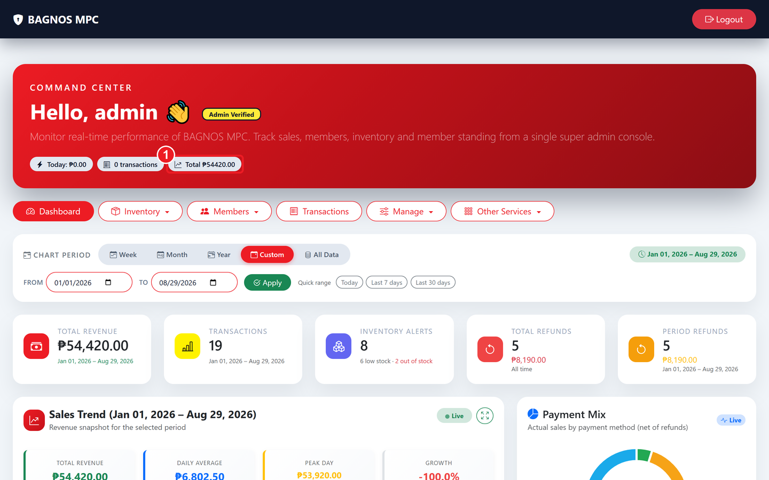
My Transactions — the member's personal purchase history with dates, totals, and payment methods.
What's on this screen
① Total column — The total amount for that transaction.

- From the self-service hub, tap My Transactions.
- The list shows every sale that was attached to this member's account — date, items, total, and payment method.
- Tap any row to open the full receipt detail, including individual items and prices.

14.4 My Savings
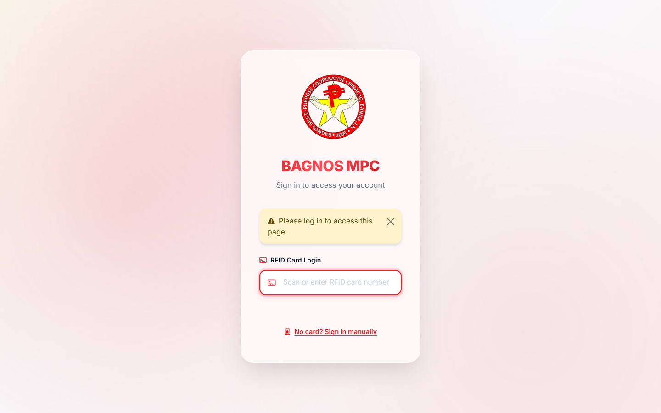
My Savings — a list of all the member's savings accounts with current balances.
From the self-service hub, tap My Savings to see a list of all savings accounts under this member's name.
- Account name: the savings product type (e.g., Regular Savings).
- Account number: the unique account identifier for reference.
- Balance: the current total balance in the account.
- Open button: tap to view the account's full transaction history.
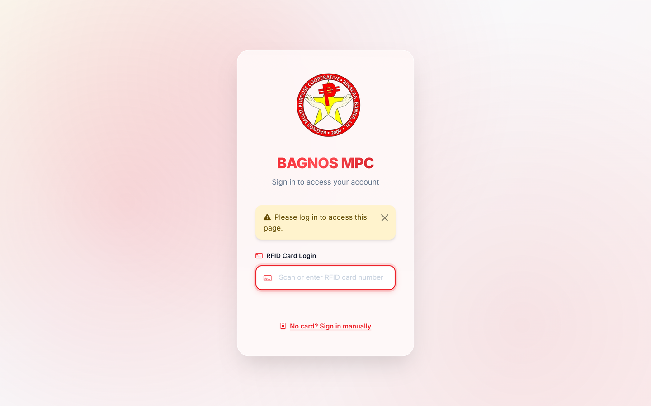
My Savings account detail — balance and individual transaction history.
The savings account detail shows the balance, every transaction (deposit, withdrawal, and interest credit) with date and amount, and a Receipt button on each row to download or print the receipt.
Note Members cannot make deposits or withdrawals through self-service — those transactions require a staff member at the counter.

14.5 My Loans
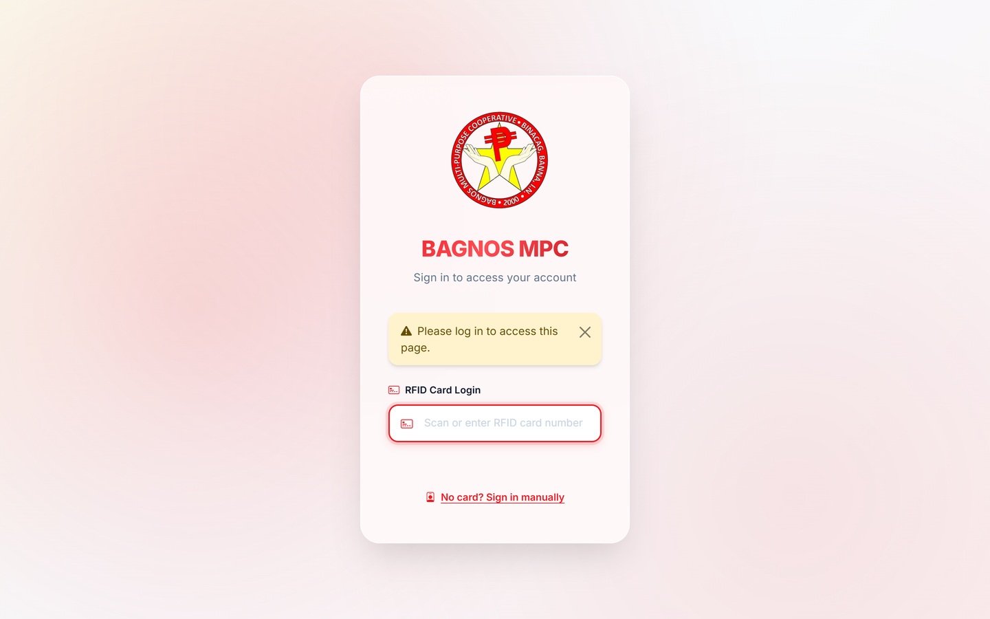
My Loans — all loan applications with status and outstanding balance.
From the self-service hub, tap My Loans to see every loan the member has applied for.
- Loan product: the type of loan (e.g., Emergency Loan, Agricultural Loan).
- Amount: the amount applied for or approved.
- Status: the current pipeline stage — Inquiry, Under Review, Approved, Disbursed, Active, Closed.
- Outstanding balance: how much is still owed (for active/disbursed loans).
- View button: open the loan detail to see the repayment schedule and payment history.
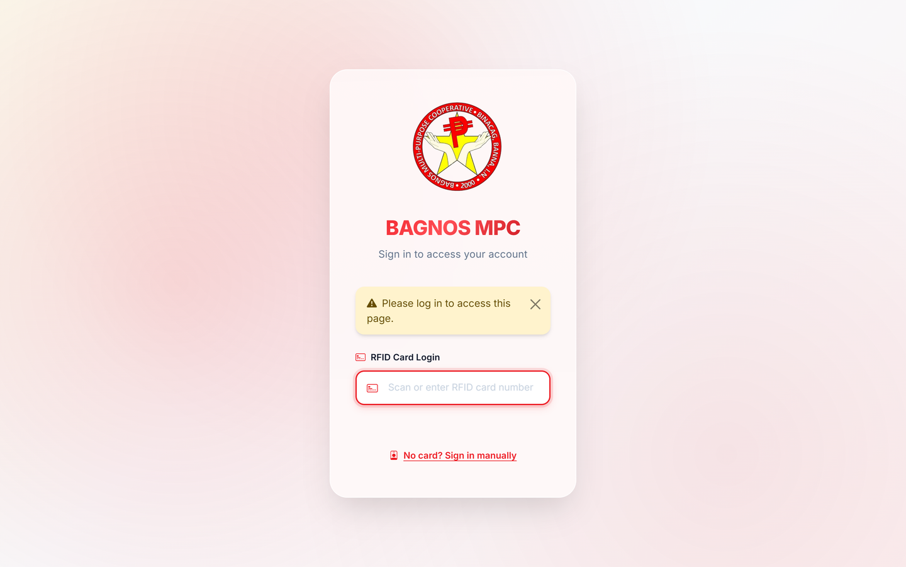
My Loan detail — outstanding balance, next payment, amortization schedule, and payment history.
The loan detail view shows the full amortization schedule (all planned payments), the outstanding balance, the next payment date and amount, and a history of every payment already made.

14.6 Requesting a loan (member-initiated inquiry)
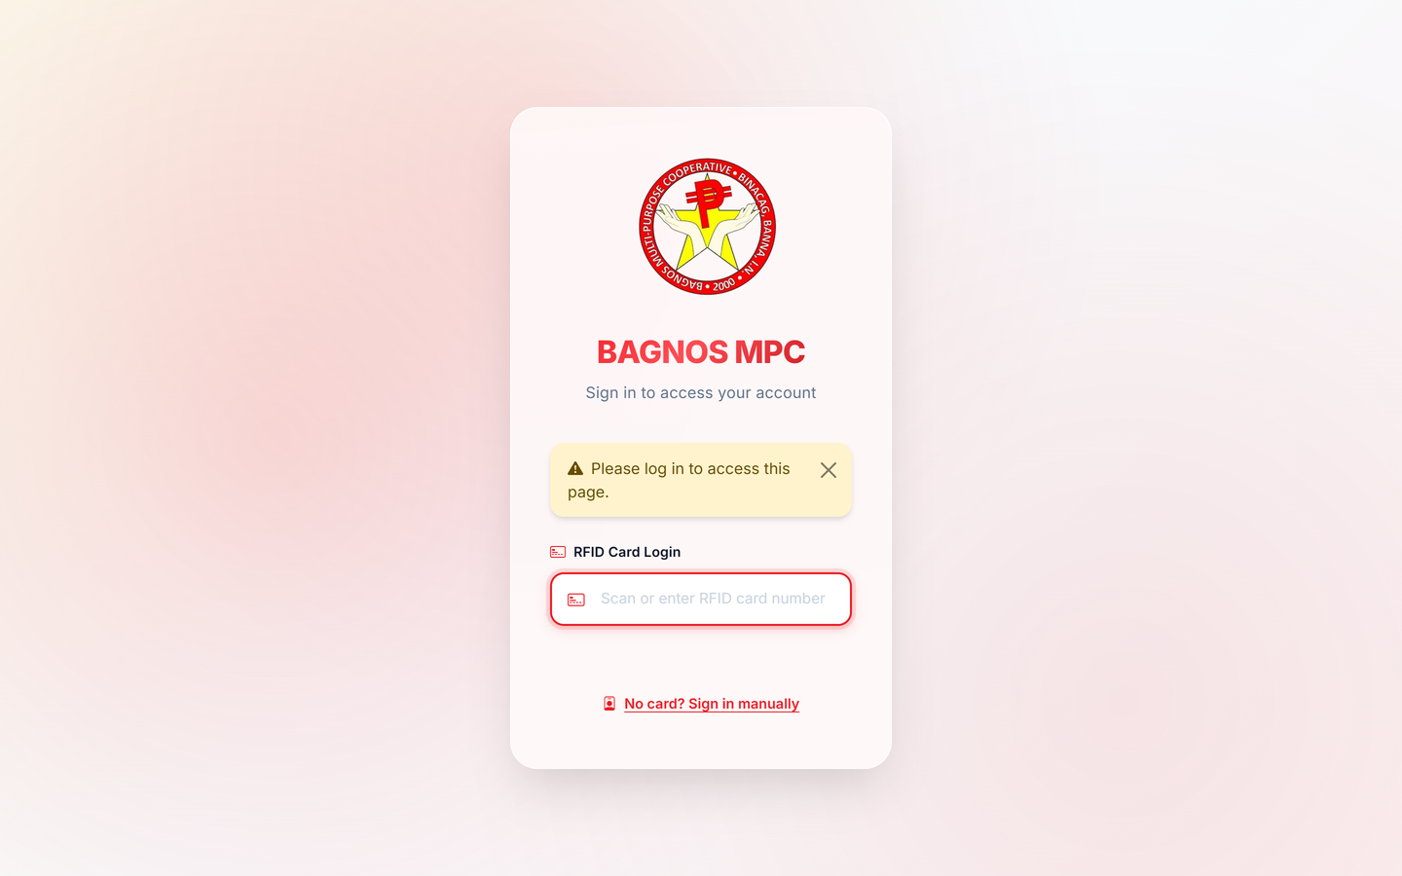
Loan request form — member enters purpose, amount, and submits the request.
From My Loans, a member can tap Request a Loan to submit a loan inquiry directly to the cooperative. The loan officer will receive the request and begin the formal application process.
- Tap Request a Loan from the My Loans page.
- Enter the loan purpose (what you need the money for).
- Enter the amount you want to borrow.
- Tap Submit. The request is sent to the loan officer for review — you will be contacted with next steps.

14.7 My Palay
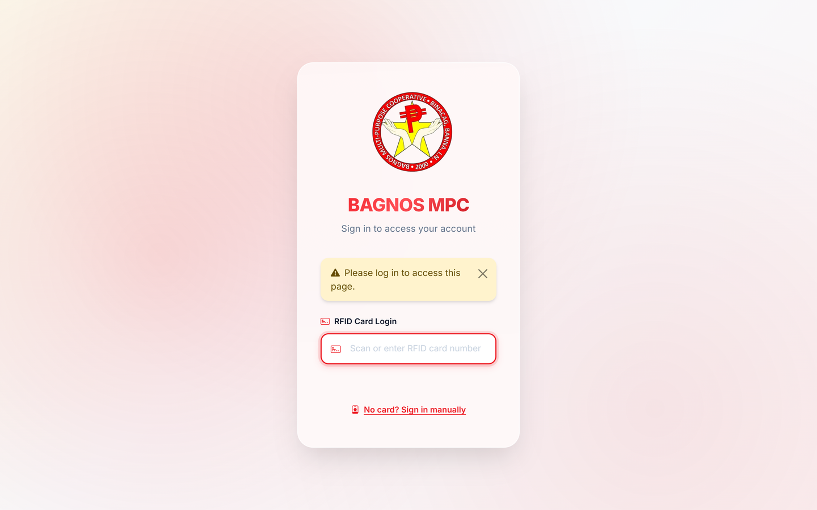
My Palay — the member's palay credit balance and trading history.
From the self-service hub, tap My Palay to see any outstanding palay credit (rice taken on credit) and a history of palay trades associated with this member.
- Credit balance: how much the member currently owes for palay taken on credit.
- Trade history: a list of every palay buy/sell trade associated with this member.
Note Members only ever see their own data. Staff screens, other members' records, and administrative settings are never visible in the member self-service view.

15. Audit Trail & Security
The Audit Trail records every important action across the system — who did it, what they did, when, from which screen, and from which IP address. It is the primary tool for investigating discrepancies or security concerns.
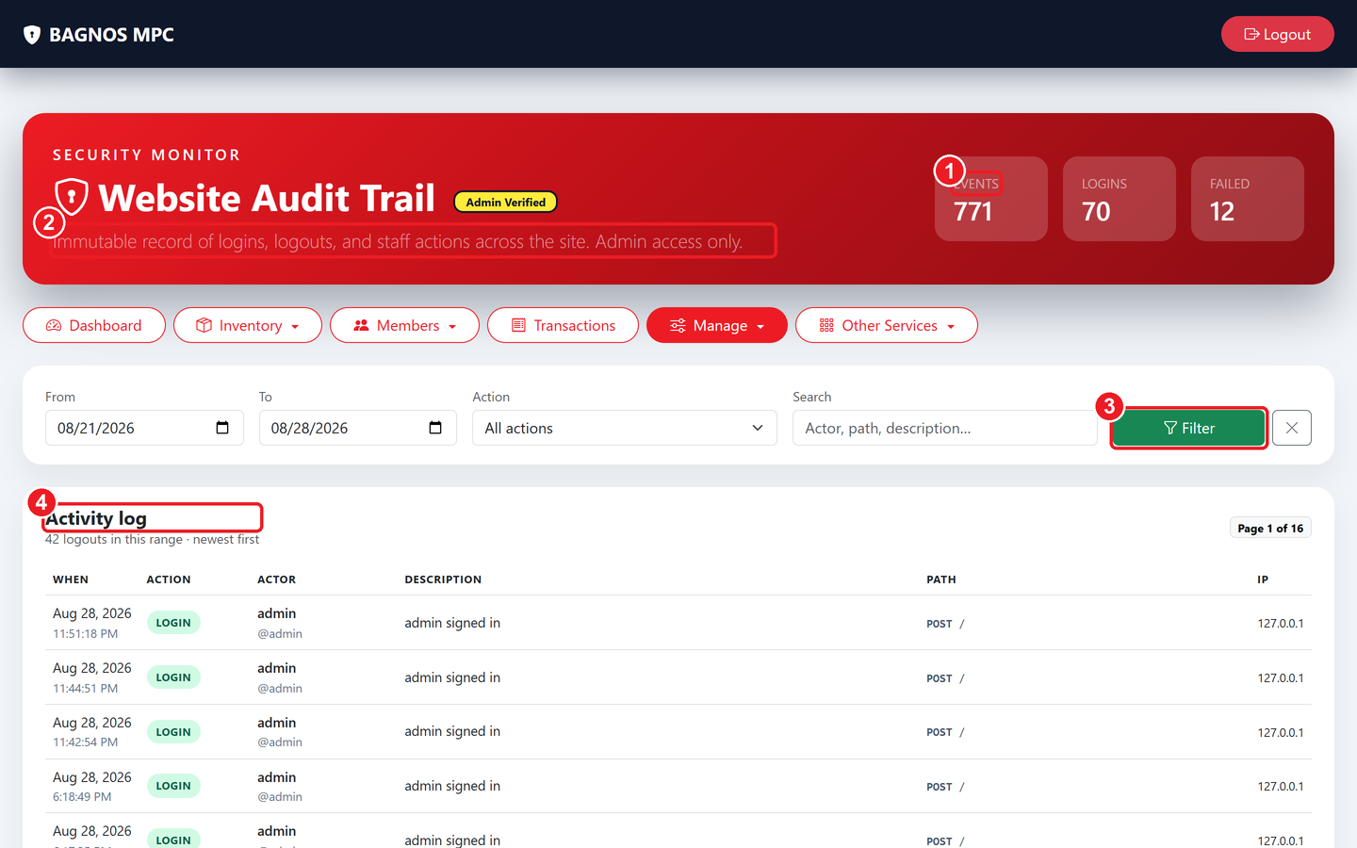
Audit Trail — time-stamped log of all system activity with login/event counters.
What's on this screen
① Security counters — Total events, successful logins, and failed login attempts.
② Filter bar — Narrow the log by date range, action type, or free-text search.
③ Filter button — Apply the chosen filters to the activity log.
④ Activity log — Time-stamped list of every action — who, what, where (path), and from which IP.

15.1 Security counters
- Total Events: the total number of recorded actions in the system.
- Successful Logins: how many times users have successfully signed in.
- Failed Login Attempts: how many times a login attempt failed — a sudden spike may indicate an intrusion attempt.

15.2 Using the filter bar
- Date range: pick From and To dates to narrow the log.
- Action type: filter by action category — login, logout, sale, refund, member edit, inventory change, etc.
- Free-text search: search by username, IP address, or any keyword in the action description.
- Filter button: click Filter to apply the selected criteria.

15.3 Reading audit records
Each row in the log shows: timestamp, username (who), action type (what), page path (where in the system), and IP address (from where). Click any row to expand the full detail.
Tip If you notice a transaction was edited or a member's credit limit changed without your knowledge, the audit trail will show exactly who made the change and when.

16. Reports & Exports
The system can produce reports and data exports from almost every module. This section summarises all available reports and where to find them.

16.1 Daily sales report (Generate Report)
Go to Manage ▸ Generate Report to produce a daily summary PDF covering total sales, payment breakdown, refunds, and top-selling products. The system can also email this report automatically every morning — ask your administrator to set up the email schedule.

16.2 Staff sales report
Dashboard ▸ Staff Sales shows each cashier's performance for the selected period. Exportable to Excel or PDF per person or for all staff.

16.3 Inventory reports
- Price report (PDF/Excel): full product price list and stock valuation. Download from the Inventory page.
- Purchase & Sales History: a chronological ledger of every stock-in and stock-out event. Download from Inventory ▸ Export.
- Per-product purchase history: click the history icon on any product row for that item's specific buying-price history.
- Barcode sheet: Actions ▸ Download Barcodes generates a printable PDF of all product barcodes.
- Discount report: Inventory ▸ Discount Dashboard ▸ Export — history of all discounts applied.

16.4 Transaction reports
Transactions ▸ Download — export the full transaction history for any date range as PDF or Excel. Includes payment method breakdown and member information.

16.5 Member reports
- Member export: Members ▸ Actions ▸ Export downloads all member records as Excel.
- Credit / Utang history export: Credit History page has its own download for outstanding credit records.
- Member backup: Members ▸ Actions ▸ Backup produces a full JSON backup of member data.

16.6 Cooperative financial reports
- Savings interest report: Savings overview ▸ Interest Report — credited interest per member for a date range.
- Palay trade report: Palay overview ▸ Download Report — buys, sells, and credit for any period.
- Loans export: export loan applications and repayment histories from the Loan desk.
Report | Location | Formats
Daily sales summary | Manage ▸ Generate Report | PDF
Staff sales | Dashboard ▸ Staff Sales ▸ Export | PDF, Excel
Inventory price list | Inventory ▸ PDF/Excel icon | PDF, Excel
Transaction history | Transactions ▸ Download | PDF, Excel
Member list | Members ▸ Actions ▸ Export | Excel
Credit / utang history | Members ▸ Credit History ▸ Download | PDF, Excel
Savings interest | Savings ▸ Interest Report | PDF, Excel
Palay trade history | Palay ▸ Download Report | PDF, Excel
Barcode sheet | Inventory ▸ Actions ▸ Download Barcodes | PDF
Discount history | Discount Dashboard ▸ Export | PDF, Excel

17. Everyday Tips & Troubleshooting

17.1 Best practices for cashiers
- Always attach the member before choosing a payment method — credit and debit are only available when a member is attached.
- Confirm the cart total and payment amount before clicking Complete to avoid the need for refunds.
- If a product is not scanning, try typing the barcode manually or use Browse Products.
- Reprint a receipt any time from the Transactions page — you never need to redo a sale just to get another copy.
- Log out whenever you step away from the counter — even briefly.
- Check the Inventory Alerts card on the dashboard every morning and restock low items before the store opens.

17.2 Best practices for administrators
- Run a member data backup monthly and before any software update.
- Review the audit trail regularly for unexpected login failures or unusual edits.
- Keep credit limits accurate — set them based on each member's payment history.
- Use the daily report to compare actual sales with receipts and catch discrepancies early.
- Keep savings product and loan settings up to date so interest and penalties calculate correctly.
- Export inventory and transaction data quarterly for your accounting records.

17.3 Troubleshooting
Problem | What to try
RFID card won't scan at login | Use "Sign in manually" with username/password. Have the card checked for damage or deregistration.
A menu item is missing | Your role may not have access — ask an administrator to check your account permissions.
Can't charge to credit | Attach the member first; check their credit limit is greater than zero and they haven't exceeded it.
Wrong item or price on a receipt | Process a refund for the incorrect item, then ring it up correctly in a new sale.
Dashboard numbers look wrong | Check the Chart Period filter — you may be viewing the wrong date range.
Stock count seems incorrect | Check the Purchase & Sales History and giveaway logs for the product.
Print receipt button does nothing | Check the printer is connected and powered on. Try reprinting from Transactions.
Member not found at kiosk | Ensure the member is Active and their RFID card is registered in the Members module.
Interest not calculating | Verify the savings product or loan product settings have the correct rate and compounding frequency.

17.4 Glossary
Term | Meaning
RFID card | A tap card that identifies a member and can hold a cash balance.
Utang / Credit | A purchase charged to a member's account to be paid later, subject to a credit limit.
Debit | Payment taken from the pre-loaded balance on a member's RFID card.
KPI | Key performance indicator — a summary number on the dashboard such as Total Revenue.
Disbursement | The release of approved loan funds to a member.
Amortization | The loan repayment schedule — how much is due each period.
Share capital | A member's ownership contribution to the cooperative.
Par value | The nominal face value of one share unit as defined in the share-capital product.
Palay | Unmilled (rough) rice — the commodity the cooperative buys from farmers.
Bigas | Milled (processed) rice — the commodity sold to buyers.
Giveaway | An item distributed free of charge and recorded to keep stock counts accurate.
Return window | The time period after a sale during which items may be returned without special approval.
Segment | A member category (e.g., Senior Citizen, PWD) that carries a special discount.
Audit trail | A tamper-evident log of every significant system action, used for security and accountability.

BAGNOS Multi-Purpose Cooperative — System User Manual
End of manual · Version 2.0 · August 2026

