Vincent Hu

Project 03PWM

**Circuit Diagram:**

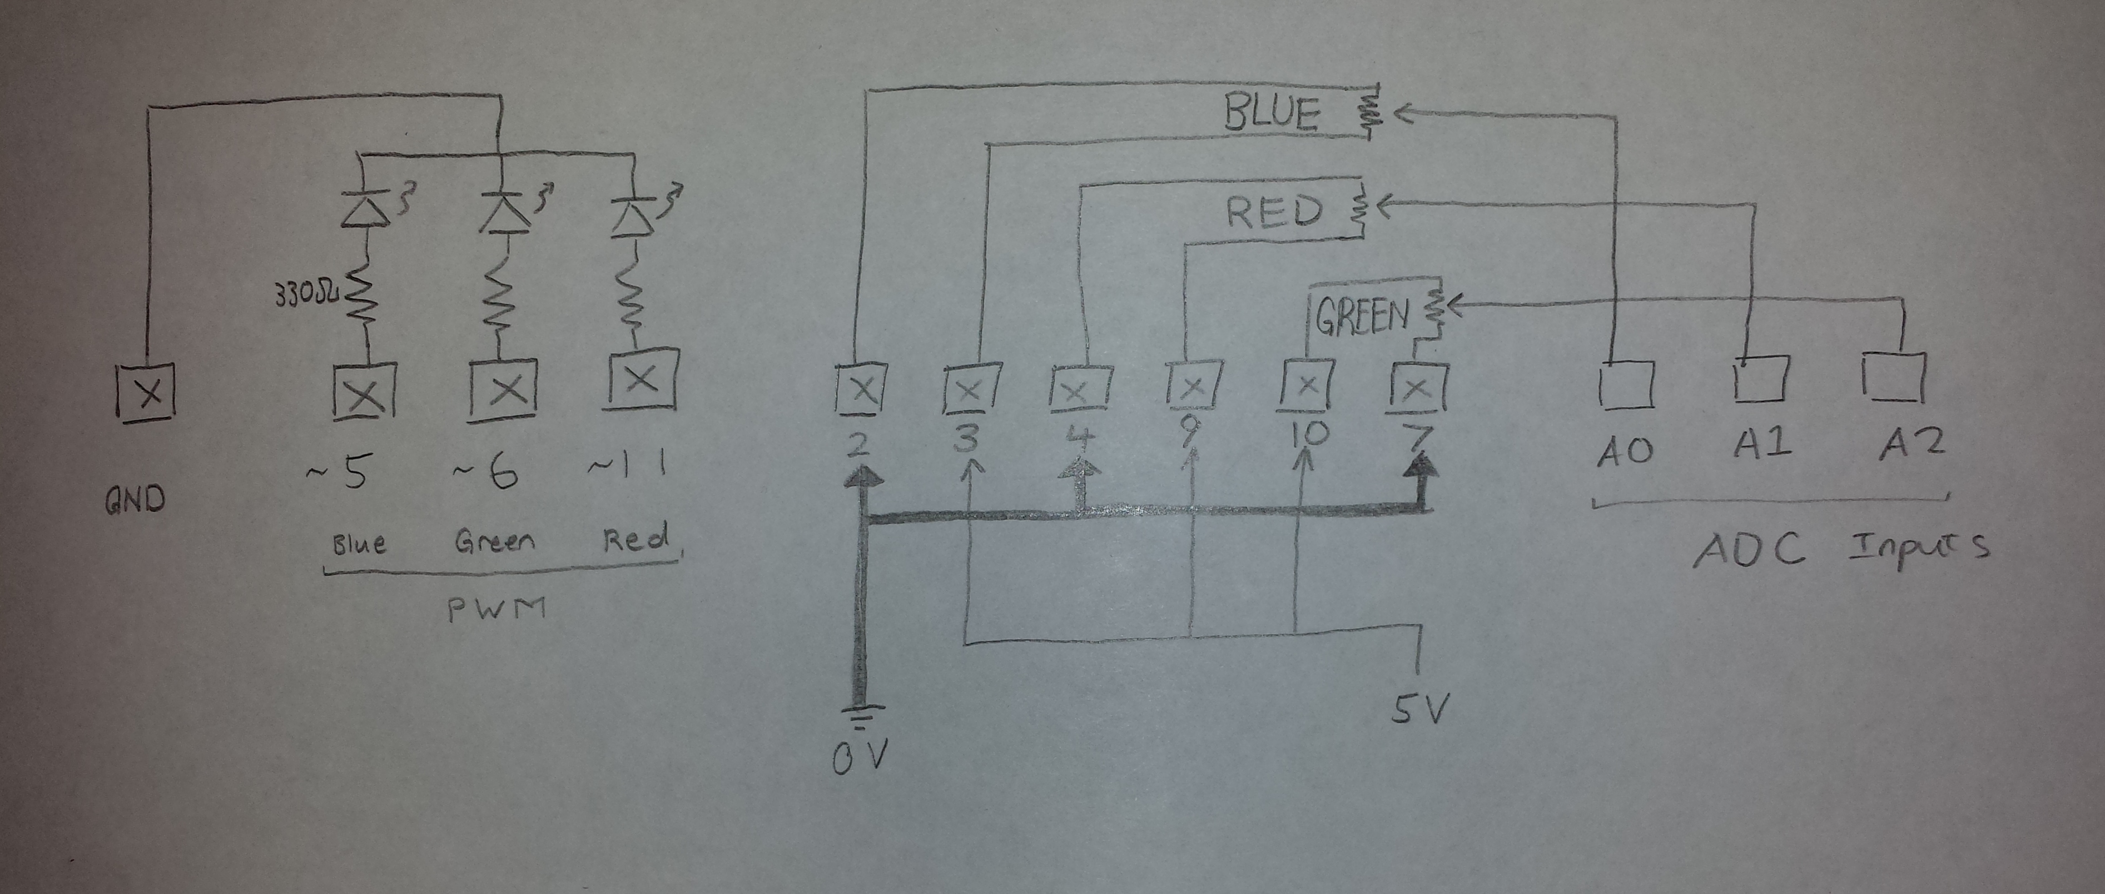

**a.) What is the period of your Timer() fast PWM signal?**

T = 1/f = (division ratio *256) / clock freq = (1024 * 256) / 16MHz = **16.38 ms**

**b.) What are the register settings that produced this period?**

For each register:

On TCCR0A: COM0A1 = COM0B1 = 1 (Clear OC0A and OC0B on Compare Match)

WGM01 = WGM00 = 1 (Fast PWM)

On TCCR0B: CS02 = 1, CS01 = 0, CS00 = 1 (Division ratio 1024)